CHAPTER 4 AIRPORTS

GENERAL
4.1.1. INTRODUCTION
This document is to provide information to pilots such that they can meet the requirements of VAR
14.100 and company procedures. This section provides information to pilots on each airport that VNA aircraft operates to on a regular basis as well as Alternates and ADQs airports.
The information contained in the LIDO Route Manual is not normally repeated in this document except by way of clarification or to reinforce certain features of an airport or route. Pilots must study the LIDO Aerodrome information, NOTAMs and other such information to gain a thorough understanding and knowledge of the intended port of operation.
CAUTION: * Whilst every effort is made to keep this manual current, unless otherwise advised, where a difference in information is detected between the LIDO Route Manual, or NOTAMs, and this manual then those sources take precedence.
* AMM charts are for reference only .

    - DECODE
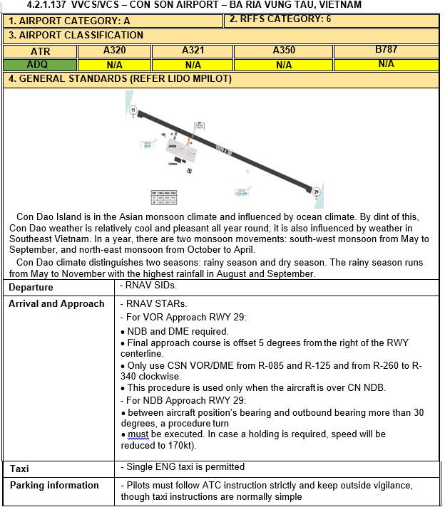
Example of an airport information:
0) Header: ICAO/ IATA identifier &
the airport (full) name, city, country
4) General standards: Contain general information of the airport such as departure, arrival and approach, taxi, parking information,..
3) Airport classification which is either:
* ADQ: Adequate Airport
* N/ A: Not Available
- Airport category: For category
identify, please refer to FOM chapter 8.1
- RFFS category: ICAO Annex 14

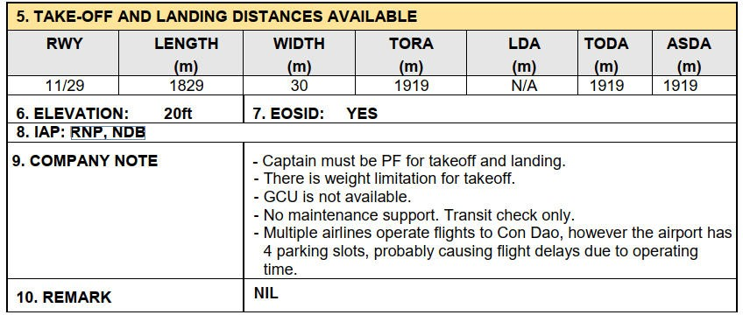
10) Remark: Note for other information
8) IAP: Instrument Approach Procedure at the airport
- Elevation: Airport elevation
- EOSID: Available (Yes) or Not (No)
5) Take off and landing distances available: Contain the information of the Runway’s length, width, TORA (Take off Runway available), LDA (Landing distances available), TODA (Take off distances available), ADSA (Accelerate Stop Distance Available),

9) Company note: Crew post flight note.
4.1.3. ALTIMETER SETTING
Pilots use altimeters to measure aircraft altitude. However, altimeters rely on barometric pressure, and that pressure changes with weather conditions. To ensure consistent and safe altitude readings, pilots adjust their altimeters using specific pressure settings: QNH, QFE. Depending on the setting, the altimeter shows different reference heights.
- QNH – Pressure at Sea Level (MSL Reference):
- Sets the altimeter to display altitude above mean sea level (AMSL).
- When set on the ground, the altimeter shows the airport elevation.
- Used for departure, enroute (below transition altitude), and arrival procedures.
- Provided in hPa (hectopascal) by ATIS or ATC (e.g., “QNH 1018”).
- QFE – Pressure at Airfield Elevation (Ground Reference)
- Sets the altimeter to display height above airport elevation.
- When set on the ground, the altimeter reads zero.

The QNH–QFE conversion can be found on the relevant airport charts, as illustrated below:
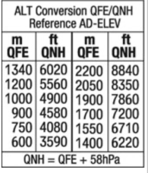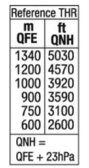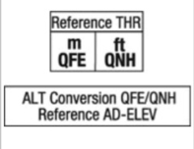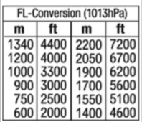
The relationship between QNH and QFE can be easily understood from the following illustration:
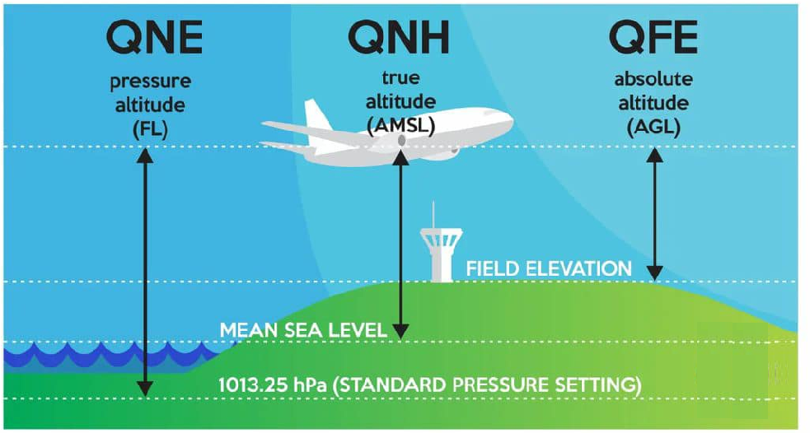

For more details, refer to LIDO eRoute Manual – chapter 1.8.3
If the airport chart does not provide the required QNH–QFE conversion values, the following figure is recommended as a reference for manual conversion and calculation:
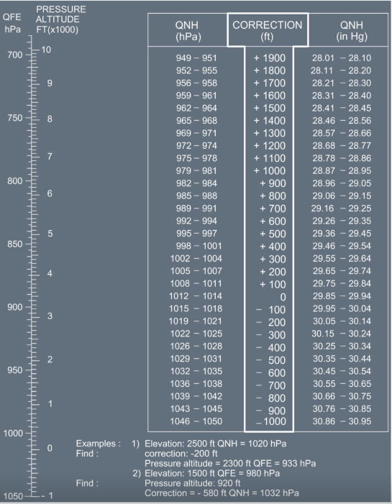

4.2. AIRPORT DIRECTORY

4.2.1. Airport general information

CYVR/ YVR - VANCOUVER (VANCOUVER INTL’), BRITISH COLUMBIA, CANADA
- AIRPORT CATEGORY: A |  |  |  |  |  |  | - RFFS CATEGORY: 10
- AIRPORT CLASSIFICATION
ATR |  | A320 |  |  | A321 |  | A350 |  |  | B787
ADQ |  | ADQ |  |  | ADQ |  | ADQ |  |  | ADQ
- GENERAL STANDARDS
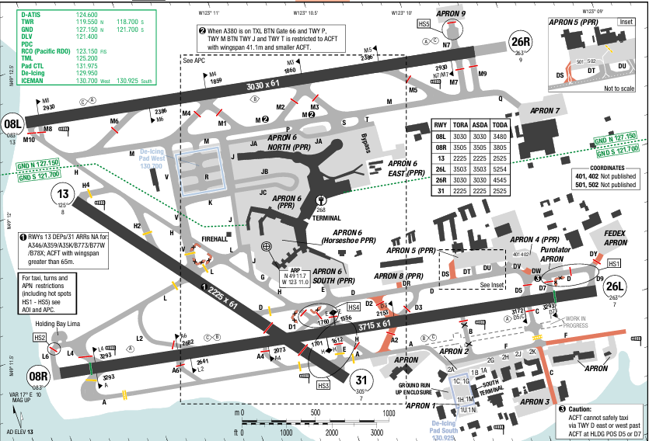
Vancouver International Airport (IATA: YVR, ICAO: CYVR) is an international airport in Richmond, British Columbia. It is located 12 km (7.5 mi) from Downtown Vancouver. It is often described as a trans-Pacific hub, with more direct flights to China than any other airport in North America or Europe.
The summers are short, comfortable, and partly cloudy and the winters are long, very cold, wet, and mostly cloudy. Over the course of the year, the temperature typically varies from 2°C to 23°C and is rarely below -4°C or above 27°C. The snowy period of the year lasts for 3 months, from December to February.
Departure |  |  | - Transition altitude is 18,000ft  - LOSS COMM procedure  - DE-ICING PROCEDURE is specified in airport briefing. Crews shall study carefully in case De-icing needed.  - LVO (RVR 1,200 – 600): Arrivals and Departure with RVR ≤ 600 are not authorized. When LVO is enforce, ATIS broadcast: “Low visibility procedures in effect for (name of applicable RWY)”  + The primary RWY to be used are 08R/ 26L.  + Pilot shall not cross an illuminated red stop bar
Arrival and Approach |  |  | - Safety Altitude within 100NM is 12,800ft  - Transition level at FL180  - LOC reliable only within 10° either side of centerline  - LNAV/ VNAV NOT authorized below -18°C or above 54°C for uncompensated Baro-VNAV systems
Taxi |  |  | - Pilots must keep their XPD on at all time when maneuvering on the airport (turned on prior to brake release and on arrival, on until final ENG shutdown). In case of not having XPD code issued, pilot shall squawk 1,000 when taxiing.  - During LVO  + Taxi routes are equipped with green inset centerline lighting. Some TXW/ TXW intersections are identified with 3 inset yellow centerline lights.  + Midfield crossing of 08R/ 26L are not permitted.
Parking information |  |  | Advise ATC if ground crew not present at gate
- TAKE-OFF AND LANDING DISTANCES AVAILABLE
RWY | LENGTH  (m) |  |  | WIDTH  (m) |  | TORA  (m) |  | LDA  (m) | TODA  (m) |  | ASDA  (m)
08L | 2930 |  |  | 61 |  | 2810 |  | 2810 | 2810 |  | 2810
08R/ 26L | 3293 |  |  | 61 |  | 3505 |  | 3293 | 3505 |  | 3505
13/ 31 | 2225 |  |  | 61 |  | 2225 |  | 2225 | 2225 |  | 2225
26R | 2930 |  |  | 61 |  | 2810 |  | 2810 | 2930 |  | 2810
6. ELEVATION: 13ft | 7. EOSID: NO
8. IAP: ILS (CAT I, II, III), LOC
9. COMPANY NOTE | - Altimeter Setting in Inches  - Airspace border of the United States closed to the South of the airfield  - Migratory birds (snow goose) in vicinity of airport from October- April  - Frequent VFR float aircraft activity on river south side of airport  - Advise ATC if ground crew not present at gate
10. REMARK | NIL

CYXS/ YXS - PRINCE GEORGE (PRINCE GEORGE INTL’) – CANADA
- AIRPORT CATEGORY: A |  |  |  |  |  |  | - RFFS CATEGORY: 7
- AIRPORT CLASSIFICATION
ATR |  | A320 |  |  | A321 |  | A350 |  | B787
ADQ |  | ADQ |  |  | ADQ |  | ADQ |  | ADQ
- GENERAL STANDARDS
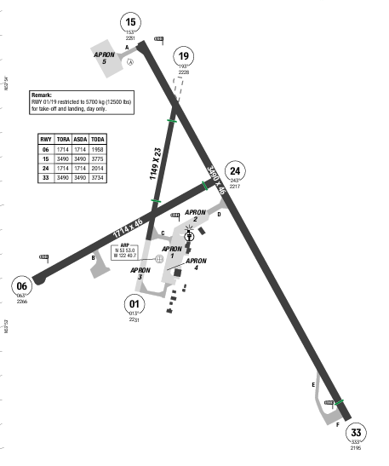
Prince George Airport (IATA: YXS, ICAO: CYXS) is an airport that serves Prince George, British Columbia, Canada, and the surrounding area. It is located just within the southern boundary of the city, 2.8 nautical miles southeast, and is run by the Prince George Airport Authority.
In Prince George, the average percentage of the sky covered by clouds experiences significant seasonal variation over the course of the year. The snowy period of the year lasts for 6 months, from October to April, with a sliding 31-day liquid-equivalent snowfall of at least 0.1 inches.
Departure |  |  | - Transition altitude is 18,000ft  - LOSS COMM procedure: On recognition failure 5 mins or less after take-off and in IFR conditions,  proceed as follow:  + XPD 7600  + Proceed directly to course  + MAINTAIN last assigned altitude for 5 mins after recognition of failure  + Climb to flight plan altitude  - Expect radar vector after departure.  - RWY 19, 24, 33 Right hand circuits  - SID with high climb gradient, Pilots need to briefing carefully before T/ O
Arrival and Approach |  |  | - Transition level at FL180  - RWY 19, 24, 33 Right hand circuits  - When using CYQX altimeter setting, add 190‘ to all procedure altitudes.
Taxi |  |  | No
Parking information |  |  | No
- TAKE-OFF AND LANDING DISTANCES AVAILABLE
RWY | LENGTH  (m) |  |  | WIDTH  (m) |  | TORA  (m) |  | LDA  (m) | TODA  (m) | ASDA  (m)
01 | 1149 |  |  | 23 |  | 1149 |  | 849 | 1149 | 1149
06 | 1714 |  |  | 46 |  | 1714 |  | 1714 | 1714 | 1714
15 | 3490 |  |  | 46 |  | 3490 |  | 3490 | 3490 | 3490
19 | 1149 |  |  | 23 |  | 1149 |  | 1035 | 1149 | 1149
24 | 1714 |  |  | 46 |  | 1714 |  | 1592 | 1714 | 1714
33 | 3490 |  |  | 46 |  | 3490 |  | 3338 | 3490 | 3490
6. ELEVATION: 2266ft | 7. EOSID: NO
8. IAP: ILS (CAT I)
9. COMPANY NOTE | - Para jumping activity frequently happens in the vicinity of Beaverly aerodrome 8NM SW. Monitor 122.1  - Radiosonde balloon launches daily between the hours of 1115Z – 1345Z and 2315Z – 0145Z  - Extensive bird activity during spring and fall  - Pilot controlled lighting 118.3
10. REMARK | NIL

CYXY/ YXY - WHITEHORSE (WHITEHORSE NIELSEN INTL’) – CANADA
- AIRPORT CATEGORY: A |  |  |  |  |  |  | - RFFS CATEGORY: 7
- AIRPORT CLASSIFICATION
ATR |  | A320 |  |  | A321 |  | A350 |  |  | B787
ADQ |  | ADQ |  |  | ADQ |  | ADQ |  |  | ADQ
- GENERAL STANDARDS
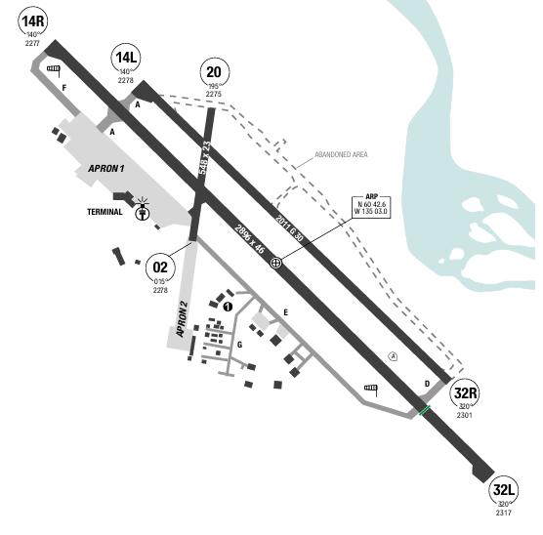
Erik Nielsen Whitehorse International Airport (IATA: YXY, ICAO: CYXY) is an international airport located in Whitehorse, Yukon, Canada. The terminal handled 294,000 passengers in 2012, representing a 94% increase in passenger traffic since 2002. By 2017, this number had risen to 366,000.
The clearer part of the year begins around March and lasts for 6 months, ending around September. The cloudier part of the year begins around September and lasts for 6 months, ending around March. The rainy period of the year lasts for 6 months, from May to October, with a sliding 31-day rainfall of at least 0.5 inches.
Departure |  |  | - Transition altitude is 18,000ft.  - Take-off Runway 02/ 20 not authorized.  - RWY 02, 14L, 20, 32R: Pilots are responsible for determining minimum climb gradient and/ or routing for obstacle and terrain avoidance. Pilots may depart IFR by using a take-off visibility that will allow avoidance of obstacles on departure, in no case less than 1/ 2 mile.
Arrival and Approach |  |  | - Transition level at FL180  - Safety Altitude within 100NM is 11,200ft  - ILS RWY 32L: LOC reliable only within 10° either side of centerline  - For uncompensated Baro-VNAV systems LNAV/ VNAV not authorized below -23°C and above 54°C for RNAV approach RWY 14R  - Pay attention to NDB approach RWY 14R with final approach course offset 13.6° left from RWY  centerline.
Taxi |  |  | No
Parking information |  |  | No
Other information |  |  | - Altimeter Setting in Inches  - Radios on de balloon launches approximately 1.25 NM Northwest from threshold RWY 14R on extended RWY centerline 1115-1130Z and 2315-2330Z daily with an ascent rate of 1000 ft/ min  - Hang/ paragliding activity within 7 NM of aerodrome  - RWY 32L & 32R right-hand circuit  - RWY 14L/ 32R: Limited winter maintenance.
- TAKE-OFF AND LANDING DISTANCES AVAILABLE
RWY | LENGTH  (m) |  |  | WIDTH  (m) |  | TORA  (m) |  | LDA  (m) | TODA  (m) |  | ASDA  (m)
02/ 20 | 378 |  |  | 23 |  | 378 |  | 378 | 378 |  | 378
14L | 1625 |  |  | 30 |  | 1625 |  | 1625 | 1625 |  | 1625
14R | 2896 |  |  | 46 |  | 2896 |  | 2639 | 2896 |  | 2896
32L | 2896 |  |  | 46 |  | 2896 |  | 2468 | 2896 |  | 2896
32R | 1625 |  |  | 30 |  | 1625 |  | 1224 | 1625 |  | 1625
6. ELEVATION: 2317ft | 7. EOSID: YES
8. IAP: ILS (CAT I), LOC, LPV
9. COMPANY NOTE | - Power line parallel to RWY 14R final approach area, approximately 550' West of extended RWY centerline
10. REMARK | NIL

EBBR/ BRU – BRUSSELS NATIONAL AIRPORT – BRUSSELS, BELGIUM
1. AIRPORT CATEGORY: A |  |  |  |  |  |  |  | 2. RFFS CATEGORY: 10
3. AIRPORT CLASSIFICATION
ATR |  | A320 |  |  | A321 |  |  | A350 |  |  | B787
ADQ |  | ADQ |  |  | ADQ |  |  | ADQ |  |  | ADQ
4. GENERAL STANDARDS
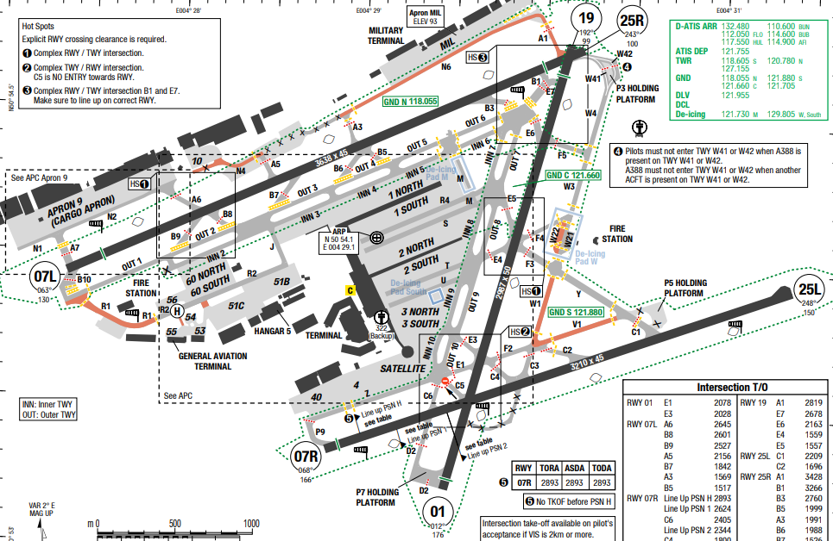
Brussels Airport (IATA: BRU, ICAO: EBBR) is the main international airport of Belgium It is located 6.5 NM (12.0 km; 7.5 mi) northeast of Brussels, the capital of Belgium. The surrounding area’s MSA is within 1700ft to 2200ft.
Winter is cold on the coast, but not freezing. The average temperature is about 3.5 °C Summer is pretty cool on the coast, with maximum temperatures reaching 21/ 22 °C. Spring and autumn are cool and cloudy seasons. Autumn can be windy and cloudy, especially on the coast.
Departure |  |  | - Deicing area is available, read in airport charts for deicing procedures.  - Departure clearance can be requested by CPDLC, but flight crews must maintain listening watch on Brussels Delivery 121.955  - Special NADP is required to follow. Read in AOI CHART for more details.  - SID with high climb gradient
Arrival and Approach |  |  | - RNAV arrivals and LVO approaches are available.  Runway 25L/ R is approved for CAT II/ III approach
Taxi |  |  | - Taxi ways are equipped with instruments that assist flight crew to taxi in LVO.  - DGS is also available.
Parking information |  |  | - Pilots taxiing to APN 10 must stop on the APN 10 hold sign. Pilots leaving APN 10 must be towed to the tow disconnect point, after which they can continue on their own PWR.
5. TAKE-OFF AND LANDING DISTANCES AVAILABLE
RWY | LENGTH  (m) |  |  | WIDTH  (m) |  |  | TORA  (m) |  | LDA  (m) | TODA  (m) |  | ASDA  (m)
01 | 2987 |  |  | 50 |  |  | 2987 |  | 2941 | 2987 |  | 2987
07L | 3211 |  |  | 45 |  |  | 3638 |  | 3350 | 3638 |  | 3638
07R | 3638 |  |  | 45 |  |  | 2893 |  | 3089 | 2893 |  | 2893
19 | 2987 |  |  | 50 |  |  | 2987 |  | 2767 | 2987 |  | 2987
25L | 3638 |  |  | 45 |  |  | 3211 |  | 3211 | 3211 |  | 3211
25R | 3211 |  |  | 45 |  |  | 3638 |  | 3339 | 3638 |  | 3638
6. ELEVATION: 175ft |  |  |  |  |  | 7. EOSID: NO |  |  |  |  |  |  | 175ft
8. IAP: ILS (CAT I,II,III), LOC, RNP, VOR
9. COMPANY NOTE |  |  |  |  |  | NIL
10. REMARK |  |  |  |  |  | NIL

EDDB/ BER – BRANDENBURG INTL AIRPORT – BERLIN, GERMANY
1. AIRPORT CATEGORY: A |  |  |  |  |  |  |  | 2. RFFS CATEGORY: 10
3. AIRPORT CLASSIFICATION
ATR |  | A320 |  |  | A321 |  |  | A350 |  |  | B787
ADQ |  | ADQ |  |  | ADQ |  |  | ADQ |  |  | ADQ
4. GENERAL STANDARDS
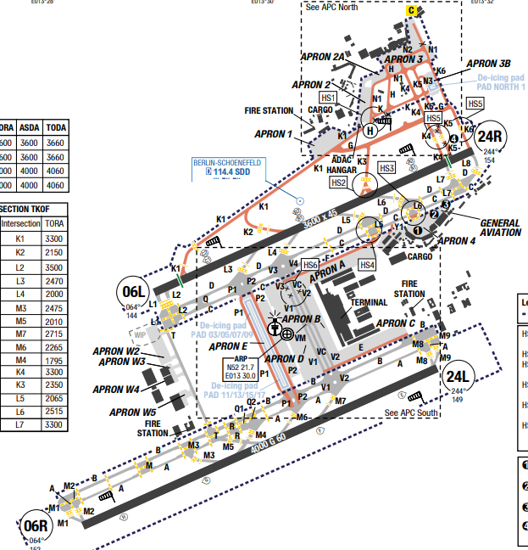
Berlin Brandenburg Airport is an international airport in Schonefeld, just south of the German capital and state of Berlin, in the state of Brandenburg. The airport named after the former West Berlin mayor and West German chancellor Willy Brandt, it is located 18 kilometres south-east of the city centre.
Brandenburg has a temperate climate with comfortable summers and cold, snowy winters, showing continental influences due to its eastern location. Average annual temperatures typically range from -2°C to 25°C. The climate is generally humid, with variations in cloud cover and precipitation throughout the year.
Departure |  |  | - RNAV SIDs available  - A-CDM concept in use at this airport.  - If there are no restrictions on SIDs regarding climb gradient, ICAO Standard NADP1 is recommended with jet ACFT.  - Climb with a MAX gradient up to 3000ft:  + Configure ACFT for high lift;  + Change TKOF thrust to climb thrust at 1500ft
Arrival and Approach |  |  | - RNAV STARs available  - If RWY conditions permit, the rapid exit TWYs shall be used (Refer to LIDO AOI)  - For FMS RNAV transitions leading to all instrument APCH refer to best AVBL APCH PROC (IAC) leading to the respective RWY.  - NAP: The use of ENG reverse thrust is only permitted if required for flight safety. This does not apply to idle reverse thrust.
Taxi |  |  | - Only ACFT up to code letter E can hold at IHP BTN TWY A and B and BTN TWY C and D.  - Code letter F can use TWY T when guided by follow-me  - Taxiing via TWY K4 to/from RWY 06L/24R allowed for ACFT up to code letter D.  - Taxi restrictions north of RWY 06L/24R:  + Follow-me mandatory on all TWYs north of TWY G for ACFT code letter D or larger  + Taxiing on north of TWYs of RWY 06L/24R code letter E and F ACFT equipped with 4 ENG may run the outer ENG at idle PWR only
Parking information |  |  | - Taxi with MNM PWR on APN and TXLs.  - All guest/visiting ACFT from/to APN 1 shall be accompanied by a follow-me vehicle.  - Parking ACFT at stands without a Visual Docking Guidance System (VGDS) is only permitted with the aid of the marshaller's signal.  - Honeywell Visual Docking Guidance System (VGDS) AVBL  - Crossing of APN service road on TXL VC AVBL to ACFT with wingspan above 36m / 118ft only.
5. TAKE-OFF AND LANDING DISTANCES AVAILABLE
RWY | LENGTH  (m) |  |  | WIDTH  (m) |  |  | TORA  (m) |  | LDA  (m) | TODA  (m) |  | ASDA  (m)
06L/ 24R | 3600 |  |  | 45 |  |  | 3600 |  | 3600 | 3600 |  | 3600
06R/ 24L | 4000 |  |  | 60 |  |  | 4000 |  | 4000 | 4060 |  | 4000
6. ELEVATION: 150ft |  |  |  |  |  | 7. EOSID: NO
8. IAP: ILS (CAT I,II,III) , LOC, RNP
9. COMPANY NOTE |  |  |  |  |  | - NAP and LVP available  - Close in obstacles  - Birds in vicinity of AD and on movement area  - De-icing on APNs south of RWY 06L/24R
10. REMARK |  |  |  |  |  | NIL

EDDF/ FRA – FRANKFURT/ MAIN AIRPORT – FRANKFURT/ MAIN, GERMANY
1. AIRPORT CATEGORY: A |  |  |  |  |  |  |  | 2. RFFS CATEGORY: 10
3. AIRPORT CLASSIFICATION
ATR |  | A320 |  |  | A321 |  |  | A350 |  |  | B787
ADQ |  | ADQ |  |  | ADQ |  |  | ADQ |  |  | ADQ
4. GENERAL STANDARDS
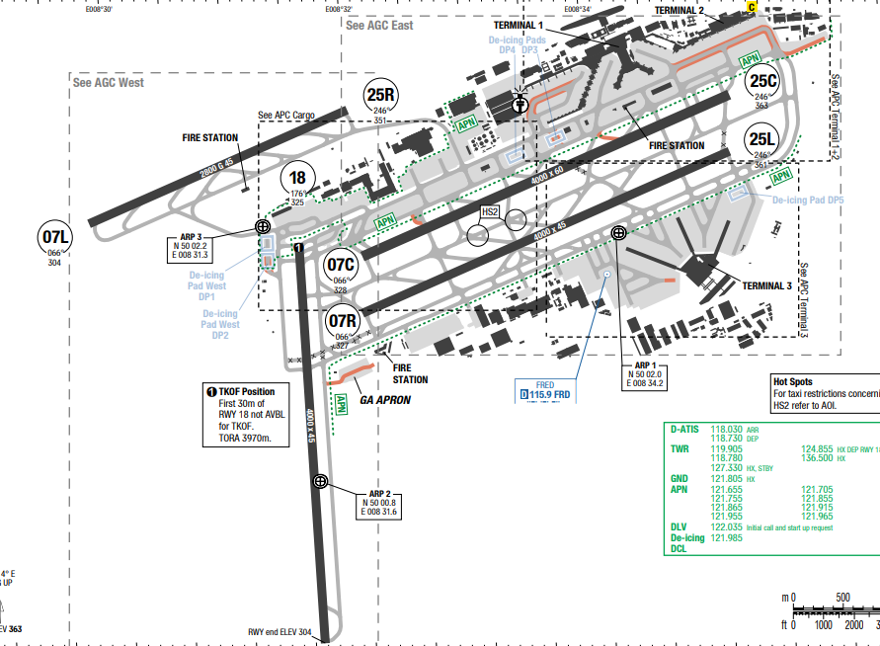
Frankfurt has a continental climate, which means that it has cold winters but warm summers. The city receives a moderate amount of rainfall, which is spread fairly evenly through the year.
The spring is one of the driest seasons in Frankfurt, but spring showers are always a possibility. Overcast days and fog are common in the autumn. It almost never snows, but rain can be quite heavy through the winter.
Departure |  |  | - RNAV SIDs (Expect SULUS7S for RWY18; SULUS7F for RWY25L/ C; SULUS9D for RWY07C/ R)  - SIDs are noise abatement procedures (strictly follow)  - SID with high climb gradient
Arrival and Approach |  |  | - RNAV STARs (Expect PSA, KERAX transition for RWY07L/ R and RWY25L/ R/ C)  - Expect level at the transfer point from ACC to APP  - RWY 25 will preferably be assigned to landing ACFT, provided the tailwind component does not exceed 5 KT.  - Some of approaches have angle more than of 3.0°  - MAINTAIN downwind track beyond end point if no succeeding instruction (vector/ clearance for approach) is received.  - Speed restriction on APPR  - Expect intercept GP for ILS approach at 5000’
Taxi |  |  | - ACFT shall operated no more than idle power taxiing in TEM area
Parking information |  |  | - Expect parking at Pier J, Terminal 3 (Note: upward slope)
5. TAKE-OFF AND LANDING DISTANCES AVAILABLE
RWY | LENGTH  (m) |  |  | WIDTH  (m) |  |  | TORA  (m) |  | LDA  (m) | TODA  (m) |  | ASDA  (m)
07L/ 25R | 2800 |  |  | 45 |  |  | 2800 |  | 2800 | 2800 |  | 2800
07C/ 25C | 4000 |  |  | 60 |  |  | 4000 |  | 4000 | 4000 |  | 4000
07R/ 25L | 4000 |  |  | 45 |  |  | 4000 |  | 4000 | 4000 |  | 4000
6. ELEVATION: 175ft |  |  |  |  |  | 7. EOSID: NO
8. IAP: ILS (CAT I,II,III) , LOC, RNP
9. COMPANY NOTE |  |  |  |  |  | - Operation of mode S transponder  - Glider areas in vicinity of APT  - Early arrival before 0500LT is not permitted.
10. REMARK |  |  |  |  |  | Ground Handling Frequency: 131.885 MHz

EDDH/ HAM – HAMBURG AIROPRT, HAMBURG, GERMANY
1. AIRPORT CATEGORY: A |  |  |  |  |  |  |  | 2. RFFS CATEGORY: 10
3. AIRPORT CLASSIFICATION
ATR |  | A320 |  |  | A321 |  |  | A350 |  |  | B787
ADQ |  | ADQ |  |  | ADQ |  |  | ADQ |  |  | ADQ
4. GENERAL STANDARDS
Hamburg Airport is a major international airport in Hamburg, the second-largest city in Germany. Since November 2016 the airport has been named after the former German chancellor Helmut Schmidt. It is located 8.5 km north of the city centre.
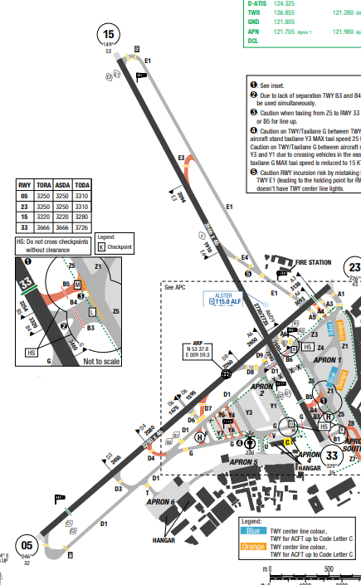
Hamburg has a moderate maritime climate influenced by the North Sea, characterized by mild, damp winters and warm, often rainy summers. Temperatures are generally mild with no extreme, long-lasting fluctuations, though summers can reach 22°C and winters can drop to freezing. Rain is frequent, averaging 11-16 days per month, and high humidity is common.
Departure |  |  | - RNAV SIDs  - For EDDH 1B/1C/1D/1G file "EDDH DCT ELSOB" and expect clearance by ATC.  - DEP RWY 33:  • ACFT up to code letter C, taxiing on the northern part of APN 1, will be assigned Checkpoint M (TWY B5).  • ACFT up to code letter E will be assigned Checkpoint L (TWY B4).
Arrival and Approach |  |  | - RNAV STARs. On downwind expect vectors to final  - Do not mistake EDHI 9NM SW of EDDH when APCH RWY 05  - COMM FAIL Procedure  - NAP: Unless otherwise instructed by ATC, pilots should aim for a low noise continuous descent APCH below FL 70 without level flight segment.
Taxi |  |  | - Do not leave RWY 05 via TWY A5 after LDG  - TWY B3: ACFT crossing RWY 33 via TWY B3 or in direction of taxilane G, may only taxi along yellow taxi guide lines  - Size Limitations and Wingspan Limitations
Parking information |  |  | - ACFT with a wingspan of 80m / 262ft or more (higher than ICAO code letter F) must wait in front of the gateway with the ENGs turned off. They will then be towed through the open gateway in the presence of a wingwalker.  - ACFT with wingspan of 65m / 213ft or more (from code letter F ACFT) will be guided by an escort vehicle on TXL T in both directions. On TXL T and APN 6, they must be towed in the presence of a wingwalker.  - ACFT with a wingspan of less than 80m / 262ft (up to ICAO code letter F) may taxi through the gateway under own PWR. ACFT taxiing onto APN 6 under own PWR will be requested to stop by a GND marking after passing through the gateway. The ENGs shall be turned off  there and the ACFT will then be towed to its destination.
5. TAKE-OFF AND LANDING DISTANCES AVAILABLE
RWY | LENGTH  (m) |  |  | WIDTH  (m) |  |  | TORA  (m) |  | LDA  (m) | TODA  (m) |  | ASDA  (m)
05/ 23 | 3250 |  |  | 46 |  |  | 3250 |  | 3250 | 3310 |  | 3250
15 | 3666 |  |  | 46 |  |  | 3220 |  | 3666 | 3280 |  | 3220
33 | 3666 |  |  | 46 |  |  | 3666 |  | 3666 | 3726 |  | 3666
6. ELEVATION: 53ft |  |  |  |  |  | 7. EOSID: NO
8. IAP: ILS (CAT I,II,III) , LOC, RNP
9. COMPANY NOTE |  |  |  |  |  | - No TKOF/LDG between 2200-0500 UTC  - TKOF from RWY 33. Exceptions permitted only if required by the TFC situation or for reasons of air TFC safety.  - Between 2100-0600 UTC: LDG on RWY 15. Exceptions are permitted only if the WX minima established for IFR APCH procedure to RWY 15 are not met or in exceptional TFC situations  - Birds in vicinity of AD
10. REMARK |  |  |  |  |  | NIL

EDDK/ CGN – COLOGNE-BONN AIRPORT – COLOGNE-BONN, GERMANY
1. AIRPORT CATEGORY: A |  |  |  |  |  |  | 2. RFFS CATEGORY: 10
3. AIRPORT CLASSIFICATION
ATR |  | A320 |  |  | A321 |  |  |  | A350 |  | B787
ADQ |  | ADQ |  |  | ADQ |  |  |  | ADQ |  | ADQ
4. GENERAL STANDARDS
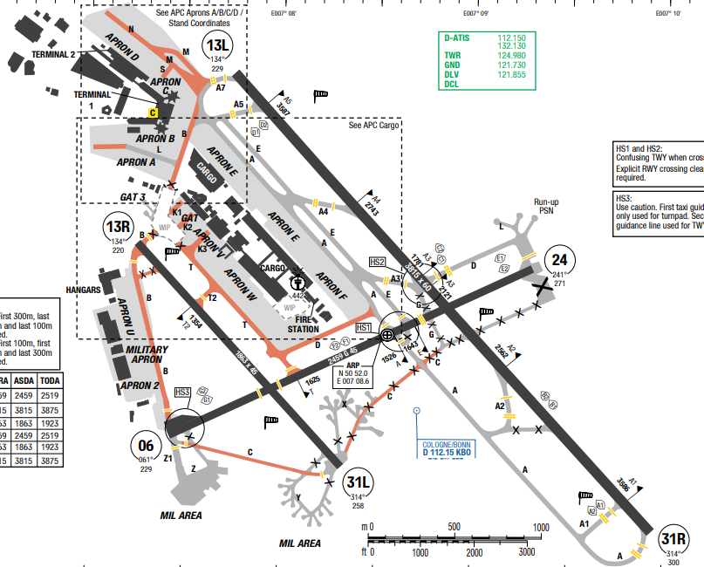
Located in the Rhine-Ruhr area, Cologne is one of the warmest cities in Germany. It has a temperate–oceanic climate with cool winters and warm summers. It is also one of the cloudiest cities in Germany, with just 1,567.5 hours of sun a year. Its average annual temperature is 10.7 °C to 15.4 °C during the day and 6.1 °C at night.
Departure |  |  |  | - SID with high climb gradient, Pilots need to briefing carefully before T/ O
Arrival and Approach |  |  |  | - Continuous descend APPR
Taxi |  |  |  | - Standard Taxi Route available  - LVP applied
Parking information |  |  |  | No
5. TAKE-OFF AND LANDING DISTANCES AVAILABLE
RWY | LENGTH  (m) |  | WIDTH  (m) |  |  | TORA  (m) |  | LDA  (m) |  | TODA  (m) |  | ASDA  (m)
06/ 24 | 2459 |  | 45 |  |  | 2459 |  | 2459 |  | 2518 |  | 2459
14L/ 32R | 3815 |  | 60 |  |  | 3815 |  | 3815 |  | 3875 |  | 3815
14R/ 32L | 1863 |  | 45 |  |  | 1863 |  | 1863 |  | 1923 |  | 1863
6. ELEVATION: 302ft |  |  |  |  |  |  | 7. EOSID: YES
8. IAP: ILS (CAT I, II, III), LOC, RNP
9. COMPANY NOTE |  |  |  |  |  |  | NIL
10. REMARK |  |  |  |  |  |  | NIL

EDDL/ DUS–DUESELDORT–GERMANY
1. AIRPORT CATEGORY: A |  |  |  |  |  |  |  | 2. RFFS CATEGORY: 9
3. AIRPORT CLASSIFICATION
ATR |  | A320 |  |  | A321 |  |  | A350 |  |  | B787
ADQ |  | ADQ |  |  | ADQ |  |  | ADQ |  |  | ADQ
4. GENERAL STANDARDS
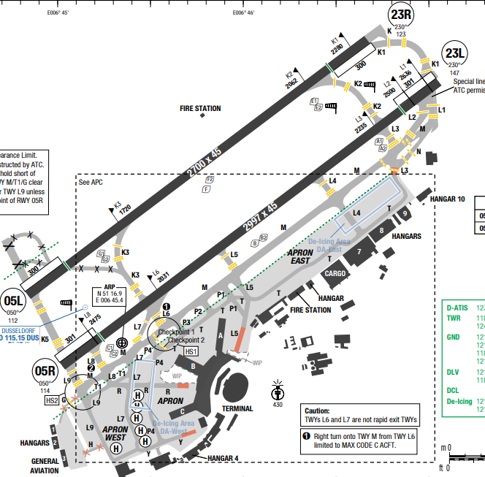
Düsseldorf Airport (IATA: DUS, ICAO: EDDL), known as Düsseldorf International Airport until March2013, is an international airport serving Düsseldorf, the capital of the German state of North Rhine-Westphalia. It is about 7 kilometres north of downtown Düsseldorf and some 20 kilometres southwest of Essen in the Rhine-Ruhr area, Germany's largest metropolitan area.
In Dueseldorf, a city located in Western Germany, along the banks of the Rhine River, and the capital of North Rhine-Westphalia, the climate is sub-oceanic. Winters are cold but not freezing, while summers are mild or pleasantly warm.
Departure |  |  | - For noise abatement the take-off and climb procedure NADP 1 is recommended for all jet aircraft departures.
Arrival and Approach |  |  | - For flight and descent planning purposes expect the following levels at the transfer points from Langen ACC to Duesseldorf APP:  + BIKMU between FL080 and FL110  + DOMUX between FL100 and FL140  + XAMOD between FL100 and FL140  + TEBRO between FL130 and FL150  These levels shall only be used for planning purposes. The actual transfer level will be cleared by ATC individually
Taxi |  |  | - TWY G, H width 12.5m / 41ft.  - Taxiing from TWY P1 to stand A05 up to MAX code letter D ACFT  - Intersection TWY L3 and M: Taxiing from TWY M to T and vice versa only possible for ACFT up to code letter C.  - In the APN area between TWY P1 and TWY L5, parallel taxiing of B744/ B777/ A350 is restricted to a MAX wingspan of 60.5m / 198ft (largest possible ACFT A330/ A343). MAX wingspan 61m / 200ft.
Parking information |  |  | - Aircraft size restriction
5. TAKE-OFF AND LANDING DISTANCES AVAILABLE
RWY | LENGTH  (m) |  |  | WIDTH  (m) |  |  | TORA  (m) |  | LDA  (m) | TODA  (m) |  | ASDA  (m)
06/ 24 | 2459 |  |  | 45 |  |  | 2459 |  | 2459 | 2518 |  | 2459
14L/ 32R | 3815 |  |  | 60 |  |  | 3815 |  | 3815 | 3875 |  | 3815
14R/ 32L | 1863 |  |  | 45 |  |  | 1863 |  | 1863 | 1923 |  | 1863
6. ELEVATION: 147ft |  |  |  |  |  | 7. EOSID: NO
8. IAP: ILS (CAT I, II, III), LOC, RNP
9. COMPANY NOTE |  |  |  |  |  | - Delayed TKOF may be granted until 0000UTC.No SKED LDG 0000-0700UTC  - Delayed LDG may be granted until 0030UTC  - Delayed LDG of ACFT which are owned by airlines that have their local main MAINT facility at Dusseldorf AD as recognized by approving authority are not permitted 0100-0600 UTC  - The following shall apply to PROP ACFT exceeding 9000kg / 19842lbs.  - AD AVBL as an ALTN for meteorological, technical or safety reasons.  - RWY 05L/ 23R: 2300-0700 to be used as ALTN RWY only
10. REMARK |  |  |  |  |  | NIL

EDDM/ MUC– MUNICH INTL AIRPORT - MUNICH–GERMANY
1. AIRPORT CATEGORY: A |  |  |  |  |  |  |  | 2. RFFS CATEGORY: 10
3. AIRPORT CLASSIFICATION
ATR |  | A320 |  |  | A321 |  |  | A350 |  |  | B787
ADQ |  | ADQ |  |  | ADQ |  |  | ADQ |  |  | ADQ
4. GENERAL STANDARDS
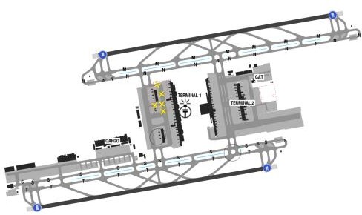
Munich Airport Franz Josef Strauss (IATA: MUC, ICAO: EDDM) is an international airport serving
Munich and Upper Bavaria. To the German Aeronautical Information Publication, it is known as Muenchen Airport. It is the second-busiest airport in Germany in terms of passenger traffic after Frankfurt Airport.
Humid Continental climate - Variable weather patterns and a large seasonal temperature variance. Sumare often warm and humid with frequent thunderstorms and winters can be very cold with frequent snow and persistent snow cover.
Departure |  |  | - Initial climb: FL070  - Each SID designator refer to exactly one runway.  - RWY 08L for DEP to NW, N, NE.  - RWY 08R for DEP to SW, S, SE.  - RWY 26L for DEP to SW, S, SE, NW.  - RWY 26R for DEP to N, NE.
Arrival and Approach |  |  | - Noise abatement: Reverse thrust other than Idle shall only be used to extent necessary for safety required.  - Arriving ACFT will be guided to final by radar vectoring or RNAV guidance (transitions/ waypoints).  - For arriving ACFT via ROKIL/ LANDU (from the North), RWY 08L/ 26R will be basically assigned.  - For arriving ACFT via NAPSA/ BETOS (from the South), RWY 08R/ 26L will be basically assigned.  - If Director is online, you are instructed to contact them with your call sign only, do not report your current or cleared altitude, or inbound waypoint
Taxi |  |  | - To obtain push back instructions from a nose in position, pilots must request permission from MUNICH Apron.  - Taxi procedure: On the aprons ACFT must taxi on or along yellow, blue or orange taxing guidelines.  For ACFT taxiing without flight plan shall select STBY.
Parking information |  |  | - Expect parking at Terminal 1, gate 103-108.
5. TAKE-OFF AND LANDING DISTANCES AVAILABLE
RWY | LENGTH  (m) |  |  | WIDTH  (m) |  |  | TORA  (m) |  | LDA  (m) | TODA  (m) |  | ASDA  (m)
08L/ 26R | 4000 |  |  | 60 |  |  | 4000 |  | 4000 | 4060 |  | 4000
08R/ 26L | 4000 |  |  | 60 |  |  | 4000 |  | 4000 | 4060 |  | 4000
6. ELEVATION: 147ft |  |  |  |  |  | 7. EOSID: NO
8. IAP: ILS (CAT I, II, III), LOC, RNP, NDB, VOR
9. COMPANY NOTE |  |  |  |  |  | - Closed to aircraft without functioning two-way radio.  - No TKOF/ LDG 2300-0700UTC
10. REMARK |  |  |  |  |  | NIL

EDFH/ HHN – FRANKFURT HAHN – GERMANY
1. AIRPORT CATEGORY: A |  |  |  |  |  |  | 2. RFFS CATEGORY: 10
3. AIRPORT CLASSIFICATION
ATR |  | A320 |  | A321 |  |  | A350 |  |  | B787
ADQ |  | ADQ |  | ADQ |  |  | ADQ |  |  | ADQ
4. GENERAL STANDARDS
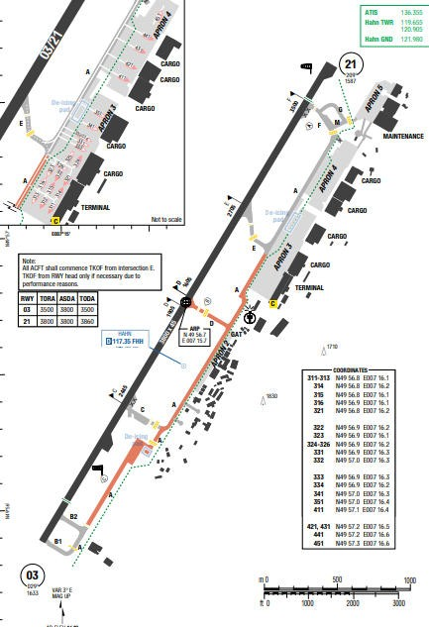
Frankfurt–Hahn Airport (IATA: HHN, ICAO: EDFH) is an international airport in the municipality of Hahn, Rhineland-Palatinate, Germany. The airport is 10 km from the town of Kirchberg and 20 km from both Simmern and Traben-Trarbach.
Frankfurt offers a traditionally continental German climate and is known locally as 'Frankfurt am Main'. Frankfurt experiences warm summer weather, with only occasionalshowers and fairly low levels of overall precipitation. The summer season often enjoys highs which exceed25°C, with July and August regularly being the hottest months of the year.
Departure |  | - All aircraft for which the available distances from intersection take-off E, direction 21, are sufficient shall commence take-off from the displaced take- off point.
Arrival and Approach |  | - RNAV STARs available, on downwind expect vectors to final.  - RNAV RWY 03: Maintain last cleared FL to the IAF.  Descend in HLDG PROC to 6000ft for standard instrument APCH.  - RNAV RWY 21: Maintain last cleared FL to the IF.  Descend in HLDG PROC to 5000ft for standard instrument APCH
Taxi |  | - Turn pad south (RWY 03) may only be used by ACFT up to code letter D and RVR 350m or above.  - Taxiing is allowed only at reduced speed. Stopping on sloped areas is not permitted.  - Due to slope changes, a line of sight of 3m / 10ft above TWY is not ensured over a distance of 300m / 984ft on all TWY.
Parking information |  | - To avoid incidents on ramp 2, wheelchocks shall be used while parking due to steep slope.  Weelchocks are AVBL on the east side of ramp 2.  APN 3 and APN 4: ACFT are permitted to taxi on APN only at indispensable MNM ENG speed when taxiing into stands. ACFT are not allowed to increase ENG PWR considerably beyond idle motion speed.  - APN 5: Taxiing of ACFT with more than 14t / 30865lbs MTOM under own PWR prohibited. ACFT take-over and release between TWY F and ILS holding position on TWY M.  - B748/ A124: Taxiing to stands on APN 3 and 4 via TWY E or F only.  - Parking stands A1-A6, B1-B5: if taxiing on APN is interrupted, GND shall be informed before continuing to taxi.  - Taxiing shall be conducted via TWY E.
5. TAKE-OFF AND LANDING DISTANCES AVAILABLE
RWY | LENGTH  (m) |  | WIDTH  (m) |  |  | TORA  (m) |  | LDA  (m) | TODA  (m) |  | ASDA  (m)
21 | 3800 |  | 45 |  |  | 3800 |  | 3500 | 3860 |  | 3800
03 | 3500 |  | 45 |  |  | 3500 |  | 3500 | 3500 |  | 3800
6. ELEVATION: 147ft |  |  |  |  | 7. EOSID: NO
8. IAP: ILS (CAT I, II, III), LOC, RNP, NDB
9. COMPANY NOTE |  |  |  |  | - Training flights are not permitted at the airport except for the following; Military training, airline transition flights, cross muntry flying.  - Closed to aircraft without functioning two-way radio.  - No TKOF/ LDG 2300-0700UTC  - TKOF/ LDG 2300-0130+UTC and 0600-0700UTC
10. REMARK |  |  |  |  | NIL

EETN/ TLL – TALLINN (LENNART MERI) – ESTONIA
- AIRPORT CATEGORY: A |  |  |  |  |  |  | - RFFS CATEGORY: 8
- AIRPORT CLASSIFICATION
ATR |  | A320 |  |  | A321 |  | A350 |  |  | B787
ADQ |  | ADQ |  |  | ADQ |  | ADQ |  |  | ADQ
- GENERAL STANDARDS
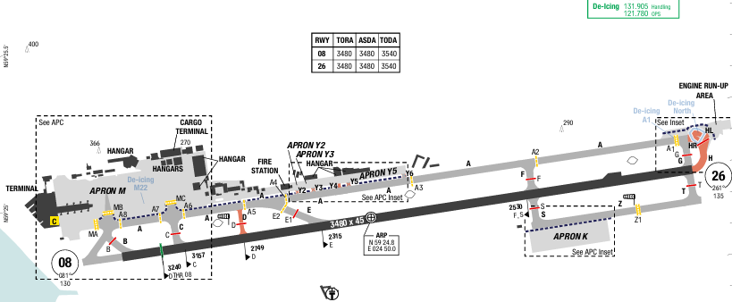
Tallinn Airport (IATA: TLL, ICAO: EETN) is the largest airport in Estonia. The MSA is 2200ft.
Tallinn has a humid continental climate with mild, rainy summers and cold, snowy winters. Winters are cold, but mild for its latitude, owing to its coastal location.
Spring starts out cool, with freezing temperatures common in March and April, but gradually becomes warmer in May. Snowfall is common in March and can occur in April.
Fall starts out mild, with a September average daily mean of 12.0 °C.

Departure |  |  | - Noise abatement procedure are applied  - RNAV SIDs has required initial climb altitude: 4000ft.  - SID with high climb gradient, Pilots need to briefing carefully before T/ O
Arrival and Approach |  |  | - RNAV STARs are available.  - Aircraft unable to follow RNAV STAR will be provided RADAR vectors for approach.  - ALT/ FL/ Speed constraints must always be followed, unless cancelled by ATC.  - Descent clearances will be given separately by ATC. Plan your descent to perform continuous descent approach from at least FL100.  - Temperature correction is added to MSA by ATC if ground temperature falls below -7°C.
Taxi |  |  | - Taxiing lanes limit wingspan
Parking information |  |  | No
- TAKE-OFF AND LANDING DISTANCES AVAILABLE
RWY | LENGTH  (m) |  |  | WIDTH  (m) |  | TORA  (m) |  | LDA  (m) | TODA  (m) |  | ASDA  (m)
08 | 3480 |  |  | 45 |  | 3480 |  | 3240 | 3540 |  | 3480
26 | 3480 |  |  | 45 |  | 3480 |  | 3480 | 3540 |  | 3480
6. ELEVATION: 135ft | 7. EOSID: NO
8. IAP: ILS (CAT I, II), LOC, RNP
9. COMPANY NOTE | - ACFT de-icing is only carried out in areas specifically designated by the APT.
10. REMARK | NIL

EFHK/ HEL – HELSINKI (VANTAA) – FINLAND
- AIRPORT CATEGORY: A |  |  |  |  |  |  | - RFFS CATEGORY: 9
- AIRPORT CLASSIFICATION
ATR |  | A320 |  |  | A321 |  | A350 |  |  | B787
ADQ |  | ADQ |  |  | ADQ |  | ADQ |  |  | ADQ
- GENERAL STANDARDS
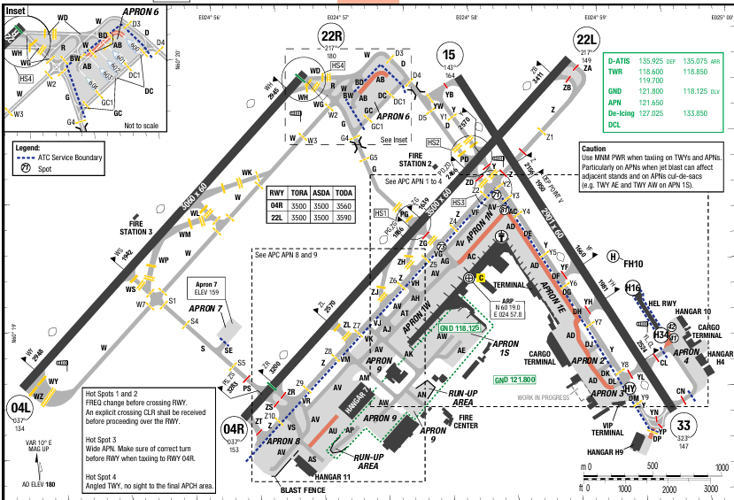
Vantaa Airport (IATA: TLL, ICAO: EETN) is located in the neighbouring city of Vantaa, about 5 kilometres west of Tikkurila, the administrative centre of Vantaa and 9.2 NM north of Helsinki's city centre. Helsinki has a humid continental climate. Temperatures during the winter is around −4 °C in January and February.The average maximum temperature from June to August is around 19 to 22 °C. Precipitation is received from frontal passages and thunderstorms. Thunderstorms are most common in the summer.
Departure |  |  | - CDM is applied.  - RNAV SIDs are available and SIDs require minimum climb gradient.
Arrival and Approach |  |  | - RNAV STARs are available.  - Continuous decent operations.  - ALT/ FL/ Speed constraints must always be followed, unless cancelled by ATC.
Taxi |  |  | - Minimum RWY occupation time (designate rapid taxi way to exits)
Parking information |  |  | No
- TAKE-OFF AND LANDING DISTANCES AVAILABLE
RWY | LENGTH  (m) |  |  | WIDTH  (m) |  | TORA  (m) |  | LDA  (m) | TODA  (m) |  | ASDA  (m)
04L/ 22R | 3060 |  |  | 60 |  | 3060 |  | 3060 | 3060 |  | 3060
04R | 3550 |  |  | 60 |  | 3500 |  | 2879 | 3500 |  | 3500
15/ 33 | 2901 |  |  | 60 |  | 2901 |  | 2901 | 2901 |  | 2901
22L | 3550 |  |  | 60 |  | 3500 |  | 3500 | 3500 |  | 3500
6. ELEVATION: 180ft | 7. EOSID: NO
8. IAP: ILS (CAT I, II, III), LOC, RNP, VOR
9. COMPANY NOTE | - Minimum runway occupancy time: use designated RWY intersections or departure points, unless otherwise requested by the pilot and rapid exit.  - ACFT de-icing is only carried out in areas specifically designated by the APT.
10. REMARK | NIL

EGCC/ MAN – MANCHESTER INTL AIRPORT – UNITED KINGDOM
1. AIRPORT CATEGORY: A |  |  |  |  |  |  |  | 2. RFFS CATEGORY: 10
3. AIRPORT CLASSIFICATION
ATR |  | A320 |  |  | A321 |  |  | A350 |  |  | B787
ADQ |  | ADQ |  |  | ADQ |  |  | ADQ |  |  | ADQ
4. GENERAL STANDARDS
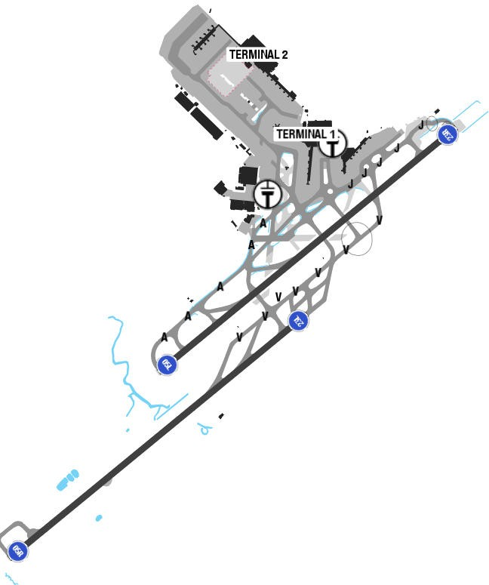
Manchester Airport (IATA: MAN, ICAO: EGCC) is an international airport in Ringway, Manchester, England, 7 miles (11 km) south-west of Manchester city centre.Terrain is flat and mostly developed. The river’s closest point is 2NM to the southwest.
The climate of Manchester is oceanic, with quite cold winters and mild summers, and with frequent rains all year round. July is the hottest month in Manchester with an average temperature of 16°C (61°F) and the coldest is January at 4°C (39°F) with the most daily sunshine hours at 5 in August.
Departure |  |  |  | - Conventional SIDs.  Do not climb above SID level until instructed by ATC
Arrival and Approach |  |  |  | - RNAV STARs.  - Speed contrains.  - Depend on STAR, there are some warning and descent planning must follow.  - Landing on 23R in strong northwesterly winds, of the possibility of turbulence and large wind shear effects.  - Avoid use of reverse thrust consistent with the safe operation of ACFT, especially between 2300-0700L.
Taxi |  |  |  | - Shall vacate RWY via rapid taxiway.
Parking information |  |  |  | No
5. TAKE-OFF AND LANDING DISTANCES AVAILABLE
RWY | LENGTH  (m) |  | WIDTH  (m) |  |  |  | TORA  (m) |  | LDA  (m) | TODA  (m) |  | ASDA  (m)
05L | 3048 |  | 45 |  |  |  | 3014 |  | 2587 | 3229 |  | 3014
05R | 3050 |  | 45 |  |  |  | 3047 |  | 2864 | 3347 |  | 3047
23L | 3050 |  | 45 |  |  |  | 3047 |  | 2864 | 3350 |  | 3350
23R | 3048 |  | 45 |  |  |  | 2897 |  | 2714 | 3197 |  | 2897
6. ELEVATION: 257ft |  |  |  |  |  | 7. EOSID: YES
8. IAP: ILS (CAT I, II, III), LOC, RNP, VOR
9. COMPANY NOTE |  |  |  |  |  | - Fix Electrical GPU must be used where available, use of GPUs and APUs should be limited.
10. REMARK |  |  |  |  |  | NIL

EGKK/ LGW – GATWICK INTL AIRPORT – LONDON, UNITED KINGDOM
1. AIRPORT CATEGORY: A |  |  |  |  |  |  | 2. RFFS CATEGORY: 10
3. AIRPORT CLASSIFICATION
ATR |  | A320 |  |  | A321 |  | A350 |  | B787
ADQ |  | ADQ |  |  | ADQ |  | ADQ |  | ADQ
4. GENERAL STANDARDS
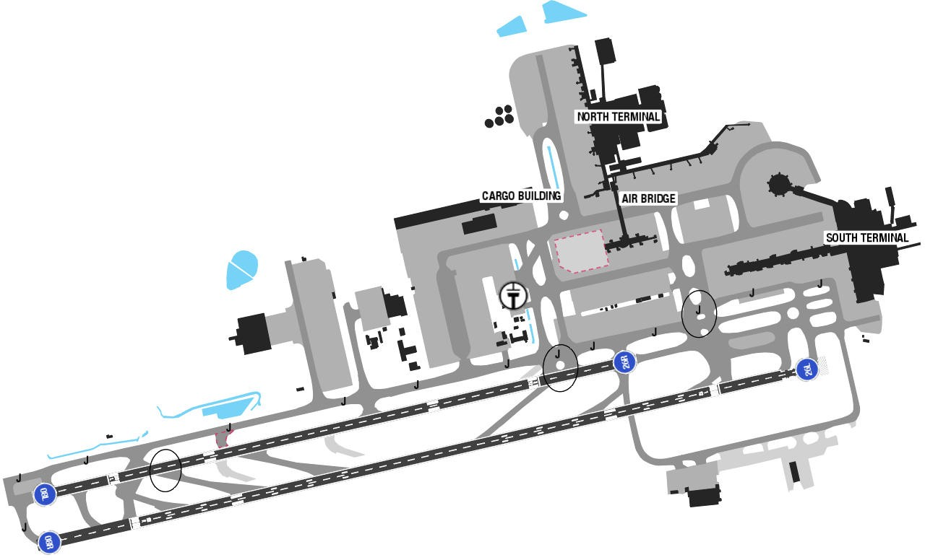
Gatwick Airport is a major international airport near Crawley, West Sussex, England, 47.5 km south of Central London. There is no terrain surrounding the airport.
At London Gatwick Airport, the summers are short, comfortable, and partly cloudy and the winters are long, very cold, windy, and mostly cloudy. Over the course of the year, the temperature typically varies from 35°F to 72°. Fog averages 17 days per month while smoke/ haze averages 14 days per month. Snowfall occurs from November through April with peak activity occurring in January and February (averaging 6 days per month during that period).
Departure |  |  | -ACDM procedures  - Conventional and RNAV SIDs.  - Noise abatement procedure  - Require minimum climb gradient
Arrival and Approach |  |  | - RNAV STARs.  - Speed restrictions  - Special landing procedures (landing following landing, landing follow departure…)
Taxi |  |  | - Minimum RWY occupation time requires ACFT to exit RWY at fastest speed via design rapid exit taxiway.  - Wingspan restrictions
Parking information |  |  | No
5. TAKE-OFF AND LANDING DISTANCES AVAILABLE
RWY | LENGTH  (m) |  |  | WIDTH  (m) |  | TORA  (m) |  | LDA  (m) |  | TODA  (m) | ASDA  (m)
08L | 2561 |  |  | 45 |  | 2561 |  | 2241 |  | 3040 | 3040
08R | 3317 |  |  | 45 |  | 3159 |  | 2765 |  | 3311 | 3233
26L | 3317 |  |  | 45 |  | 3255 |  | 2830 |  | 3399 | 3399
26R | 2561 |  |  | 45 |  | 2515 |  | 2146 |  | 2657 | 2515
6. ELEVATION: 203ft |  |  |  | 7. EOSID: NO
8. IAP: ILS (CAT I, II, III), LOC, RNP
9. COMPANY NOTE |  |  |  | - Fix Electrical Ground Power must be used whenever available and serviceable. APU must be shut down after arrival and only restarted before departure  - Mode S transponders are able to operate when ACFT is on the ground  - RWY 08L/ 26R will only be used when RWY 08R/ 26L is temporarily non-operational
10. REMARK |  |  |  | NIL

EGLL/ LHR – HEATHROW INTL AIRPORT – LONDON, UNITED KINGDOM
1. AIRPORT CATEGORY: A |  |  |  |  |  |  |  | 2. RFFS CATEGORY: 10
3. AIRPORT CLASSIFICATION
ATR |  | A320 |  |  |  | A321 |  | A350 |  |  | B787
ADQ |  | ADQ |  |  |  | ADQ |  | ADQ |  |  | ADQ
4. GENERAL STANDARDS
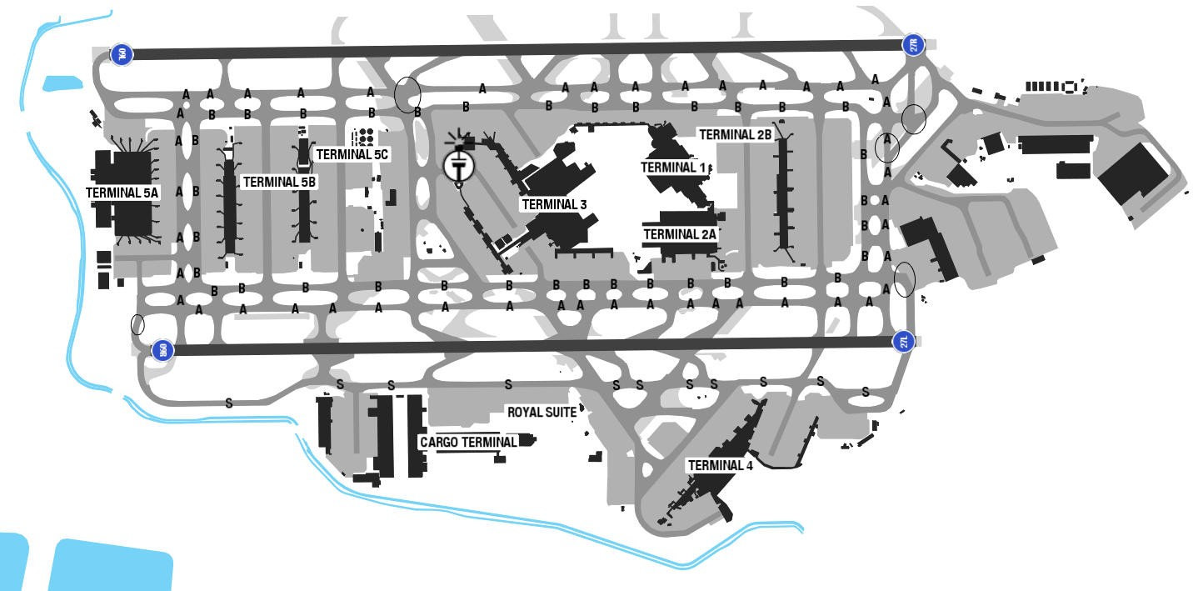
HEATHROW Airport is located in southeast England, west London metropolitan area.
The climate of London is temperate, with modest daily high temperatures (about 21 degrees Celcius) during summer and winter lows that seldom fall below freezing. Rainfall is fairly regular, occurring throughout the year. Obstruction to visibility, mostly due to smoke and haze, averages 17 days per month throughout the year. Fog is reported an average of 9 days per month. Snow is reported about 2-3 days each month during winter, bringing 3 inches of snow. Broken ceilings are the predominant sky conditions throughout the year.
Departure |  |  | - RNAV SID available  - Speed restrictions  - NADP available at this airport  - To comply restriction for SID DET2F/2G, crew shall:  • Climb at least 1000ft AAL within 3.5NM from start of Take-off roll.  • FMS/FMC Setting:  - For A350 A/C:  • Inserted speed below 210kts (flap 1/A350 speed) in FMS. Maintain speed below 210 KT until completing the initial turn to ensure accurate tracking of the noise-preferential route and prevent overshoot.  - For B787A/C:  + Before take-off: Set speed constrain < 200KT on both LEGS page (waypoint EPM) and VNAV CLB page (200KT/4000ft).  +In-flight: Flight crew shall continuously monitor the aircraft track. If the aircraft shows any tendency to overshoot turns or deviate outside the NPR corridor, immediate intervention is required by selecting HDG/TRK mode with a 25° bank angle.  - •Cross appropriate Noise Monitoring Terminal (*) at or above 1000ft AAL, there after maintain a minimum climb gradient of 4%until passing 4000ft in accordance with EGLL noise abatement procedures. ACFTwho are unable to conform to the published climb gradients and/SID altitudes are required to inform Heathrow DLV prior to push back.
Arrival and Approach |  |  | - RNAV STARs  - Expect: LOGAN 2H with initial app (from LAM). In case of no clearance when approaching LAM, expect hold over LAM.  - In case of NO Radar Control from BIG VOR to ILS (INITIAL APPROACH FROM BIG, be advised that the procedure is not available in Nav database from FMC but available in Terminal Chart from EFB onboard or VNA Library from iPad.  - Please inform to ATC controller as soon as possible for separation purpose and better flight planning  - Headings and flight levels/ altitudes by ATC. ACFT will be radar vectored.  - An estimate of track distance to touch down will be passed with descent clearance. Further distance information will be given between descent clearance and the intercept heading to ILS LOC.  - *Continuous Descent Approach (CDA)  - - Continuous descent APCH should be used whenever practicable. On receipt of descent CLR the pilot should descend at the judged rate and best suited to the achievement of continuous descent, the objective being to join the glide path at the appropriate height for the distance without recourse to level flight.  - - A descent will be deemed to have been continuous provided that no segment of level flight longer than 2.5NM occurs below 6800ft QNH and level flight is interpreted as any segment of flight having a height change of not more than 50ft over a track distance of 2NM or more, as recorded in the AD noise and track-keeping system.
Taxi |  |  | - MIN RWY occupation time requires ACFT to vacate RWY via rapid exit TWY  - After crossing RWY 09R/ 27L and having report RWY vacated. In absence of further clearance pilot should turn on the first available TWY and STOP.  - Set transponder on Mode S signals, and associated Mode A code, from the request for push-back or taxi, whichever is earlier and after landing, continuously until ACFT is fully parked on stand. After parking, Mode A code 2000 must be set before selecting OFF or STDBY.
Parking information |  |  | - Expect: gate 411- 419 on Terminal 4
5. TAKE-OFF AND LANDING DISTANCES AVAILABLE
RWY | LENGTH  (m) |  |  | WIDTH  (m) |  |  | TORA  (m) |  | LDA  (m) | TODA  (m) |  | ASDA  (m)
09L | 3901 |  |  | 50 |  |  | 3901 |  | 3592 | 3901 |  | 3901
09R | 3658 |  |  | 50 |  |  | 3658 |  | 3350 | 3658 |  | 3658
27L | 3658 |  |  | 50 |  |  | 3658 |  | 3658 | 3658 |  | 3658
27R | 3901 |  |  | 50 |  |  | 3882 |  | 3882 | 3960 |  | 3882
6. ELEVATION: 83ft |  |  |  |  | 7. EOSID: NO
8. IAP: ILS (CAT I, II, III), LOC, RNP
9. COMPANY NOTE |  |  |  |  | - Restrictions on the use of APUs  - Clearance will not be issued if requested later than 15 minutes after EOBT  - Turbulence and windshear may occur when landing on RWY 27R  - If for any reason pilots are unable to comply with the 250 kt IAS speed restriction the pilot should inform ATC when requesting start-up clearance, stating the minimum speed acceptable. In this case the pilot will be informed before take-off of any higher speed limitation.
10. REMARK |  |  |  |  | Ground Handling Frequency: 131.585 MHz

(*) Noise Monitoring Terminal at Heathrow Airport
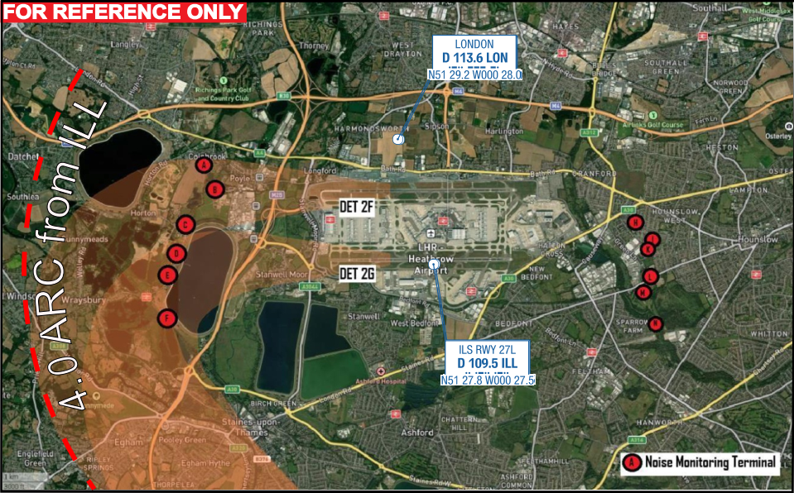

Noise Monitoring | Location | Name
A | N51 28.9 W000 31.4 | Colnbrook
B | N51 28.7 W000 31.3 | Poyle
C | N51 28.3 W000 31.8 | Horton
D | N51 27.9 W000 31.9 | Thames Water, Wraysbury
E | N51 27.4 W000 32.2 | Coppermill
F | N51 27.4 W000 32.2 | Wraysburry Reservoir (South)
H | N51 28.4 W000 23.8 | Hounslow West
I | N51 28.2 W000 23.6 | Houslow Cavalry Barracks North
K | N51 28.1 W000 23.6 | Houslow Cavalry Barracks
L | N51 27.8 W000 23.7 | Hounslow Heath
M | N51 27.6 W000 23.8 | Hobbledown
N | N51 27.2 W000 23.6 | East Feltham

(*) Reference chart for SID DET2F/ DET2G
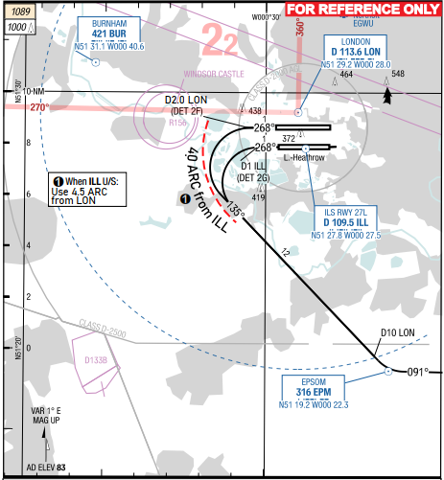

EHAM/ AMS - SCHIPHOL AIRPORT, AMSTERDAM, NETHERLANDS
- AIRPORT CATEGORY: A |  |  |  |  |  |  | - RFFS CATEGORY: 9
- AIRPORT CLASSIFICATION
ATR |  | A320 |  |  | A321 |  | A350 |  |  | B787
ADQ |  | ADQ |  |  | ADQ |  | ADQ |  |  | ADQ
- GENERAL STANDARDS
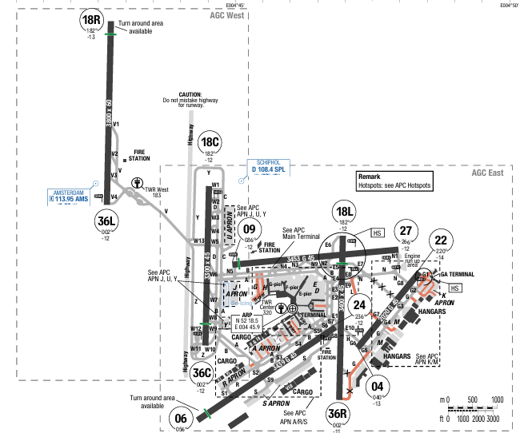
Schiphol Airport (IATA: AMS, ICAO: EHAM) is located 9 km (5.6 miles) southwest of Amsterdam, in the municipality of Haarlemmermeer in the province of North Holland.
Amsterdam has an oceanic climate strongly influenced by its proximity to the North Sea to the west, with prevailing westerly winds. Summers are moderately warm with a number of hot days every month. Amsterdam's average annual precipitation is 838 mm (33 in).

Departure |  |  | - Deicing service is available.  - NADP1 is applied.  - SID with high climb gradient, Pilots need to briefing carefully before T/ O
Arrival and Approach |  |  | - Follow speed restriction.  - Low visibility procedure is applied.
Taxi |  |  | - Follow ATC clearance carefully due to big and busy airport.
Parking information |  |  | No
- TAKE-OFF AND LANDING DISTANCES AVAILABLE
RWY | LENGTH  (m) |  |  | WIDTH  (m) |  | TORA  (m) |  | LDA  (m) | TODA  (m) |  | ASDA  (m)
04 | 2029 |  |  | 45 |  | 1909 |  | 2020 | 1909 |  | 1909
06 | 3439 |  |  | 45 |  | 3439 |  | 3195 | 3439 |  | 3439
09 | 3453 |  |  | 45 |  | 3434 |  | 3363 | 3434 |  | 3434
18L | 3400 |  |  | 45 |  | 3400 |  | 2825 | 3400 |  | 3400
18C | 3300 |  |  | 45 |  | 3271 |  | 3300 | 3271 |  | 3271
18R | 3800 |  |  | 60 |  | 3800 |  | 3800 | 3800 |  | 3800
22 | 2029 |  |  | 45 |  | 2015 |  | 2020 | 2015 |  | 2015
24 | 3439 |  |  | 45 |  | 3435 |  | 3439 | 3435 |  | 3435
27 | 3453 |  |  | 45 |  | 3453 |  | 3163 | 3453 |  | 3453
36L | 3800 |  |  | 60 |  | 3800 |  | 3800 | 3800 |  | 3800
36C | 3300 |  |  | 45 |  | 3300 |  | 2524 | 3300 |  | 3300
36R | 3400 |  |  | 45 |  | 3400 |  | 3400 | 3400 |  | 3400
6. ELEVATION: 11ft | 7. EOSID: NO
8. IAP: ILS (CAT I, II, III), LOC, RNP
9. COMPANY NOTE | - Lost communication procedure is available.
10. REMARK | NIL

EHEH/ EIN - EINDHOVEN AIRPORT, EINDHOVEN, NETHERLANDS
- AIRPORT CATEGORY: A |  |  |  |  |  |  | - RFFS CATEGORY: 8
- AIRPORT CLASSIFICATION
ATR |  | A320 |  |  | A321 |  | A350 |  |  | B787
ADQ |  | ADQ |  |  | ADQ |  | ADQ |  |  | ADQ
- GENERAL STANDARDS
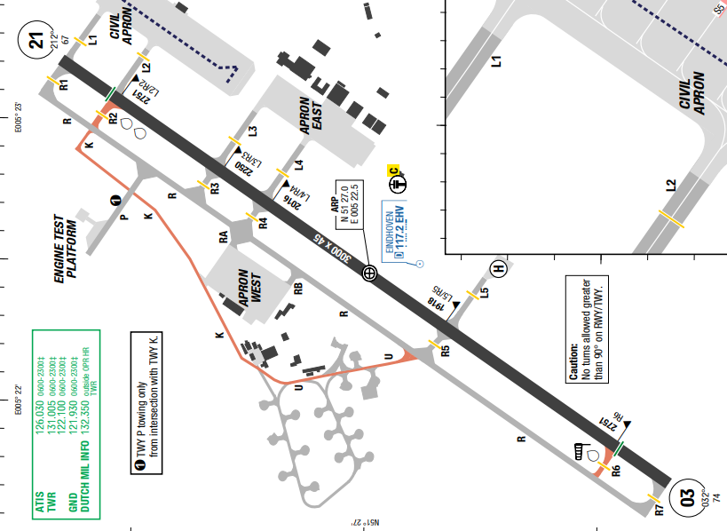
Eindhoven Airport (IATA: EIN, ICAO: EHEH) is an international airport located 7.6 km west of Eindhoven, Netherlands.
Eindhoven has a temperate maritime climate, characterized by mild summers, cool winters, and consistent rainfall throughout the year. Temperatures are generally moderate, with January being the coldest month (around 2°C average) and July often seeing higher rainfall. It rarely experiences extremes, making it accessible year-round.

Departure |  |  | - RNAV SIDs available.  - COMM FAIL procedure avaialbe  - NADP1 is applied. If for operational reasons compliance with  PROC is not possible, NADP2 may be used.  - RNAV DEP RWY 21 only allowed for ACFT up to code letter C.
Arrival and Approach |  |  | - RNAV STARs available  - COMM FAIL procedure available  - RWY 21 right-hand circuit.  - Traffic patterns at 1500ft  - Circling APCH are not allowed.  - NAP available:  + Arrivals RWY 21 are requested to apply a reduced-engine taxi in (RETI) procedure.  + Reduced flaps landing procedures are recommended.
Taxi |  |  | - TWY with width Resrtiction  - Code D ACFT and above: Expect progressive taxi instructions
Parking information |  |  | - Marshaller mandatory.  - Follow-me AVBL O/R.  - ACFT with hazardous cargo will be parked at the hot cargo platform situated at INT TWY L5 SE side.
- TAKE-OFF AND LANDING DISTANCES AVAILABLE
RWY | LENGTH  (m) |  |  | WIDTH  (m) |  | TORA  (m) |  | LDA  (m) | TODA  (m) |  | ASDA  (m)
03/ 21 | 3000 |  |  | 45 |  | 3000 |  | 3000 | 3060 |  | 3000
6. ELEVATION: 74ft | 7. EOSID: NO
8. IAP: ILS, LOC, RNP
9. COMPANY NOTE | - Birds in vicinity of AD.
10. REMARK | NIL

EKBI/ BLL – BILLUND INTL AIRPORT, DENMARK
- AIRPORT CATEGORY: A |  |  |  |  |  |  | - RFFS CATEGORY: 8
- AIRPORT CLASSIFICATION
ATR |  | A320 |  |  | A321 |  | A350 |  |  | B787
ADQ |  | ADQ |  |  | ADQ |  | ADQ |  |  | ADQ
- GENERAL STANDARDS
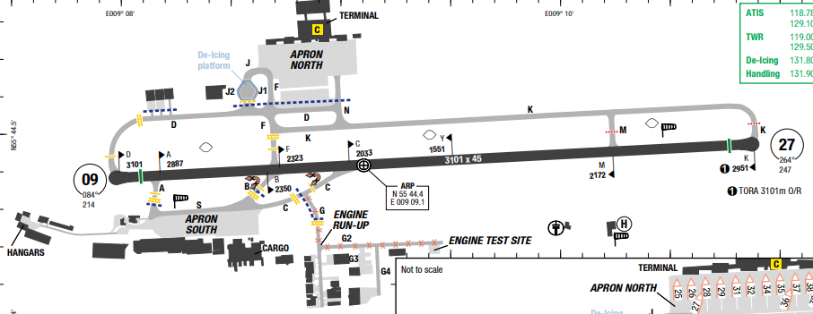
Billund Airport is an international airport in Denmark. Located 1 nautical mile (1.9 km) northeast of Billund, it serves as one of the country's busiest air cargo centres, as well as a charter airline destination.
Billund's climate is influenced by its location in the North Temperate Zone and its proximity to the coast. The variable weather means it's always wise to pack layers and rain gear, no matter the season. Billund has a temperate climate with mild winters and cool summers, averaging around 7.7°C annually. January is the coldest month, while July and August are the warmest. Precipitation is spread throughout the year, with slightly higher levels in the autumn.

Departure |  |  | - RNAV SIDs available  - If unable to follow P-RNAV SID, state inability at first contact with TWR.  - Aircraft requesting cruising LVL at or above FL250 in Hannover UIR are advised to arrange the climb to be at or above FL250 within 45NM from EKBI. If unable advise Billund TWR upon CLR request.  - Contact TWR for ATC CLR before TOBT. CLR AVBL earliest 30min prior EOBT. State ACFT type, stand number and preferred TKOF PSN if RWY 09 in use.  * NAP  - RWY 09:  + If traffic permits, TKOF shall be initiated from PSN B/F if possible.  - RWY 27:  + Right turn MNM 30° shall be initiated when passing 700ft MSL and DME DIST to LEL is above 1NM. In case of radar vectoring to the south, the extended RWY CL must not be passed closer than 2NM west of THR RWY 09.  + Between 2100-0600UTC TKOF on RWY 27 shall be avoided if possible, if RWY 09 is RWY in use
Arrival and Approach |  |  | - RNAV STARs available  - RWY 09 right-hand circuit  - LVP available  * NAP  - Avoid overflying the city of Billund.  - Between 2100-0600UTC LDG on RWY 09 shall be avoided if possible, if RWY 27 is RWY in use.
Taxi |  |  | - Code Letter D and E ACFT taxiing from TWY M to TWY K eastbound and vice versa requires marshaller.  - Code Letter F ACFT taxiing requires marshaller.
Parking information |  |  | - Entry on stands require marshaller presence.  - PPR to enter APN South via intermediate HLDG PSN west of stand 1. Request must be obtained from TWR 129.505
- TAKE-OFF AND LANDING DISTANCES AVAILABLE
RWY | LENGTH  (m) |  |  | WIDTH  (m) |  | TORA  (m) |  | LDA  (m) | TODA  (m) |  | ASDA  (m)
09 | 3100 |  |  | 45 |  | 3100 |  | 3100 | 3100 |  | 3100
27 | 3100 |  |  | 45 |  | 2951 |  | 3100 | 2951 |  | 3100
6. ELEVATION: 247 ft | 7. EOSID: NO
8. IAP: ILS (CAT I, II, III), LOC, RNP
9. COMPANY NOTE | - Turning area at both ends on RWY, width 72m / 236ft including connecting TWYs north of RWY.  - ACFT with a MTOM of 40T or greater: 180° turn on designated turning areas at RWY end only, unless otherwise instructed by ATC.  - Disused Vandel APT South of EKBI Do not mistake for EKBI
10. REMARK | NIL

EKCH/ CPH - KASTRUP AIRPORT, COPENHAGEN, DENMARK
- AIRPORT CATEGORY: A |  |  |  |  |  |  | - RFFS CATEGORY: 9
- AIRPORT CLASSIFICATION
ATR |  | A320 |  |  | A321 |  | A350 |  |  | B787
ADQ |  | ADQ |  |  | ADQ |  | ADQ |  |  | ADQ
- GENERAL STANDARDS
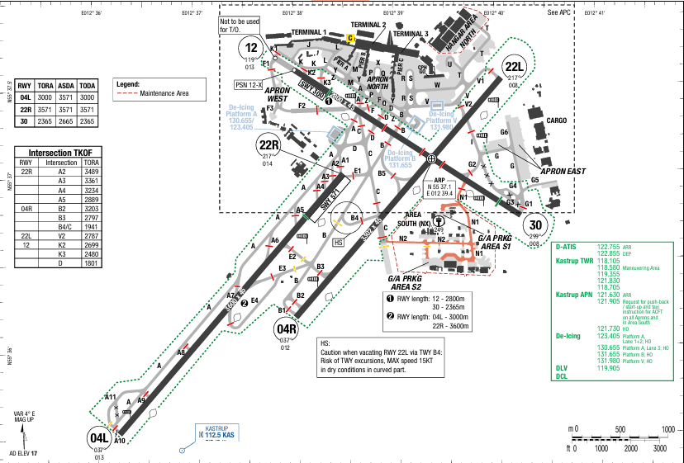
Kastrup Airport (IATA: CPH, ICAO: EKCH) is located on the island of Amager, 8 kilometres (5.0 mi) south of Copenhagen city centre, and 24 kilometres (15 mi) west of Malmö city centre. The MSA of surrounding area is within 1600ft to 2100ft.
Copenhagen is in the oceanic climate zone Its weather is subject to low-pressure systems from the Atlantic which result in unstable conditions throughout the year.

Departure |  |  | - Deicing area is available, read in airport charts for deicing procedures.  - Departure clearance can be requested by CPDLC  - SID with high climb gradient, Pilots need to briefing carefully before T/ O  - COMM FAIL Procedure available  - Collaborative Decision Making concept in use at this airport  - For ACFT not following SID, minimum turning altitude after TKOF is 600ft, unless further restricted by NAP for the relevant RWY.  - Expect radar vectors for a SIMEG departure SID overflyig Swedish airspace  * NAP:  - RWY 22L  + TKOF shall be commenced from TWY V1 or V2.  + Departure shall be performed with climb on RWY track to cross D2.0 KAS (LEVDO) before turn is commenced.  - RWY 22R  + Departures shall be performed with climb on RWY track to cross D2.0 KAS (RUBAT) before turn is commenced.  - RWY 12  + TKOF shall be commenced from TWY K3.  + When instructed by ATC, JET ACFT are allowed to commence TKOF from TKOF PSN 12-X or TWY K2.  + When instructed by ATC, PROP ACFT are allowed to commence TKOF from TWY K2 or TWY D.  + Departure shall be performed with climb on RWY track to SEZAC before turn is commenced.  - RWY 30  + TKOF shall be commenced from TWY G1.  + Departure shall be performed with climb on RWY track to BAFIQ before turn is commenced.  - RWY 04R  + 2200-0500UTC: unless otherwise instructed by ATC, TKOF with light or medium ACFT must, when possible, be commenced from TWY B3 or B4.  - Note: Departures crossing the sector boundaries shown on NAP SID will be investigated by the authorities.
Arrival and Approach |  |  | - RNAV arrivals and LVO approaches are available.  - Pilots who intend to carry out a CAT II/III APCH shall request this to either MALMO CTL or COPENHAGEN CTL and it shall be confirmed on first contact with APP.  - At first contact with APP state type of ACFT. At initial contact with FINAL state call sign only.  - After landing, remain on TWR until otherwise instructed by ATC.  - COMM FAIL Procedure available  - Simultaneous Close Parallel Approaches  + Dependent Parallel Approaches  + Dependent parallel approaches will be performed to RWY 04L/04R or 22L/ 22R and may be expected daily 0500-2200UTC if VIS is 800m or above.  + When weather and RWY conditions permit RWY 04L (22L) can be expected if not otherwise instructed by ATC  - For final APCH to RWY 04L, 22L a MNM radar separation of 2.5NM may be used within 10NM from the threshold.  - NAP avilable
Taxi |  |  | - Taxi route for A350-900 is stated in AOI CHART  - Caution to taxi speed should be exercised after vacating RWY 22L via rapid exit TWY B4.  - Due to risk of taxiway excursions be aware that the curved part of TWY B4 is designed for MAX 15 KT in dry conditions.  - TWY with width restriction: N1, N2  - TWY W: Max taxi speed 10KT for code E Aircraft  - TWYs N1 and N2 have no TWY edge LGT. Marshaller AVBL O/R.  - Exit via TWY C towards North not permitted for RWY 22L ARR.  - TWY B2 not AVBL when RVR falls below 400m.  - Preferred Taxi Routes for Arrival:  + RWY 04L: RWY 04L – TWY A – hold short of RWY 12/30  + RWY 22L: TWY B to hold short of TWY C
Parking information |  |  | - 180° turns on TWY in APN areas are not allowed  - In strong cross wind conditions, REQ for parking into the wind will be approved for certain ACFT and under provision that:  • ACFT operator can substantiate either a technical, structural or operational need for such parking, and  • stand is designated for such parking  - ACFT must not simultaneously taxi into and/or taxi out/push-back from any two adjacent stands.  - Code letter D and E ACFT must enter stand B10 via TWY Z and TWY M  - Follow-me, VDGS and Marshaller available
- TAKE-OFF AND LANDING DISTANCES AVAILABLE
RWY | LENGTH  (m) |  |  | WIDTH  (m) |  | TORA  (m) |  | LDA  (m) | TODA  (m) |  | ASDA  (m)
04L | 3600 |  |  | 45 |  | 3000 |  | 2722 | 3000 |  | 3000
04R | 3300 |  |  | 45 |  | 3300 |  | 2985 | 3300 |  | 3300
12 | 2800 |  |  | 45 |  | 2800 |  | 2365 | 2800 |  | 2800
22L | 3300 |  |  | 45 |  | 3300 |  | 3300 | 3300 |  | 3300
22R | 3600 |  |  | 45 |  | 3600 |  | 3000 | 3600 |  | 3600
30 | 2800 |  |  | 45 |  | 2365 |  | 2095 | 2365 |  | 2365
6. ELEVATION: 17ft | 7. EOSID: NO
8. IAP: ILS (CAT I, II, III), LOC, RNP
9. COMPANY NOTE | - The use of APU is limited, read AOI chart for information about airport’s regulation of APU usage.  - RWY 04L/22R Normally not in use for EMERG situations  - Taxiing on RWY 12/30 AVBL O/R.  - Preferential RWYs: RWY 04L/R, 22L/R..  - Bird activity in the vicinity of the aerodrome, especially active during Nov-Feb  * From 0500-2200 UTC:  - When RWY 04L/R is in use:  • RWY 04R shall be used for TKOF;  • RWY 04L shall be used for LDG.  - When RWY 22L/R is in use:  • RWY 22R shall be used for TKOF;  • RWY 22L shall be used for LDG.  (The restrictions above are not applied when one of the RWYs cannot be used due to snow clearance, disabled ACFT, work on the RWY, or RWY conditions.)  - RWY 12 and RWY 30 may be used when one or both of the preferential RWYs cannot be used due to:  • crosswind component on the preferential RWYs exceeding 15 KT;  • reported RWYCC lower than 5 on any third of the preferential RWYs;  • MET CONDs being below minima for LDG on the preferential RWYs;  • due to snow clearance/disabled ACFT/work on RWYs or taxiways; or  • due to condition of the RWYs.  - RWY 30 may, however, be used for LDG without restrictions.  *From 2200-0500 UTC:  - TKOF is allowed only with advance approval of AD operator. In the period of 2200-0000 UTC no advance approval is required for delayed TKOFs.  - When RWY 04L/R is in use:  • RWY 04R shall be used for TKOF;  • RWY 04L shall be used for LDG.  - The restrictions above are not applied when one of the RWYs cannot be used due to snow clearance, disabled ACFT, work on the RWY, or RWY conditions.  - EXC ACFT which due to their size are not able to use RWY 04L/22R.  - When RWY 22L/R is in use: RWY 22L shall be used for TKOF and LDG unless it cannot be used due to snow clearance, disabled ACFT, work on the RWY, RWY conditions, when RWY 22L is used for ILS CAT II+III APCHs or when an extraordinary TFC situation causes delays of more than 1HR.  - RWY 12 and RWY 30 are closed for TKOF and LDG, however, RWY 30 may be used for LDG when the crosswind component on the preferential RWYs exceeds 15KT or the preferential RWYs are not available due to disabled ACFT, snow clearance, work on the RWYs, etc.  - RWY 12 and RWY 30 may, however, be used in the following cases:  • For TKOF and LDG by vital flights such as ambulance and transplantation flights and similar flights if RWY 04L/R - 22L/R are not available
10. REMARK | NIL

ENGM/ OSL – OSLO AIRPORT, GARDERMOEN, NORWAY
- AIRPORT CATEGORY: A |  |  |  |  |  |  | - RFFS CATEGORY: 9
- AIRPORT CLASSIFICATION
ATR |  | A320 |  |  | A321 |  | A350 |  |  | B787
ADQ |  | ADQ |  |  | ADQ |  | ADQ |  |  | ADQ
- GENERAL STANDARDS
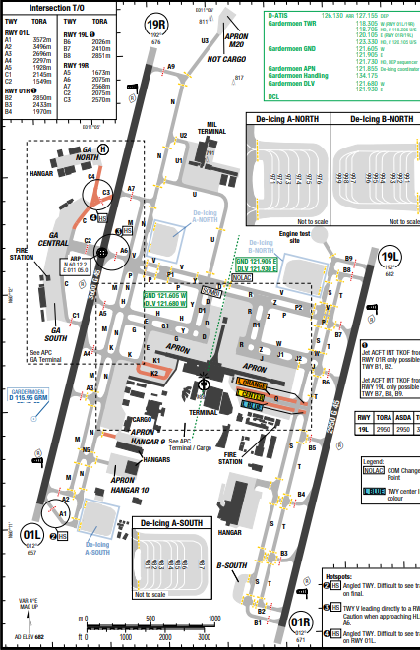
Oslo Airport — alternatively referred to as Oslo Gardermoen Airport or simply Gardermoen — is an international airport serving Oslo, the capital and most populous city of Norway. The airport is the second largest in Scandinavia and the Nordics.
Gardermoen has a temperate oceanic climate with mild summers and cold, snowy winters. It experiences moderate precipitation year-round, with heavier rainfall in the summer and snowfall during winter. The region's climate is similar to Oslo's, which is humid continental, bordering on oceanic, with warmer summers and colder winters.

Departure |  |  | - RNAV SIDs are available and require high climb gradient (10% to 1100ft). When being vectored or cleared for DCT routing, climb gradient still applies  - COMM FAIL procedure available  - Omnidirectional DEP: Maintain last cleared and acknowledged track and LVL for 2min, then climb to cruising LVL stated in CPL and join the cleared ATS route.  - A-CDM concept in use at this airport  - Simultaneous parallel DEP in progress.  - Noise Abatement Procedures (NAP) for Departure  + RWYs 01L/19L: Use ICAO standard NADP 2.  + RWY 01R/19R: Use ICAO standard NADP 1.
Arrival and Approach |  |  | - RNAV STARs are available  - COMM FAIL procedure available  - BTN 2330-0500 UTC the shortest distance from STAR starting point to the merge point (MP) may be considered as the expected track to the start of the IAP. Deviation from the track may be regarded as delaying action.  - Noise Abatement Procedures (NAP) for approach available  - LVP available
Taxi |  |  | - Code F Aircraft with limitation  - Follow me available  - TWY P, TWY V between TWY D with weight limitation
Parking information |  |  | - Follow-me / Marshaller  - APN Cargo, GA Central, GA South: Marshaller mandatory.  - Stand 40: GPU is not AVBL before bridge is connected. Consider start of APU.  - A-VDGS AVBL at terminal stands, except stands 2, 3 and 7.
- TAKE-OFF AND LANDING DISTANCES AVAILABLE
RWY | LENGTH  (m) |  |  | WIDTH  (m) |  | TORA  (m) |  | LDA  (m) | TODA  (m) |  | ASDA  (m)
19R/ 01L | 3600 |  |  | 45 |  | 3600 |  | 3600 | 3600 |  | 3600
19L | 2950 |  |  | 45 |  | 2950 |  | 2950 | 3350 |  | 2950
01R | 2950 |  |  | 45 |  | 2950 |  | 2950 | 2950 |  | 2950
6. ELEVATION: 681ft | 7. EOSID: NO
8. IAP: ILS (CAT I, II, III), LOC, RNP, VOR
9. COMPANY NOTE | - RWY 01L/19R is prefer for normal operation  - During de-icing and/or snow clearance:  • Northerly traffic flow: RWY 01L in use, de-icing on A-SOUTH.  • Southerly traffic flow: RWY 19L in use, de-icing on B-NORTH.  - LVP in force:  • Northerly traffic flow: RWY 01L.  • Southerly traffic flow: RWY 19L, exceptionally RWY 19R.  - FOD found by pilots during pre-/post-flight check must be reported to APT Operational Center Safety.  - Birds in vicinity of AD.  - In case of indications of hot brakes, inform ATC. ACFT shall not taxi to TRML before inspected.  - Cargo stands 205-208 slope: +1.2%.  - Stand 11 slope: >+2.1%.
10. REMARK | NIL

EPWA/ WAW - CHOPIN AIRPORT, WARSAW , POLAND
- AIRPORT CATEGORY: A |  |  |  |  |  |  | - RFFS CATEGORY: 9
- AIRPORT CLASSIFICATION
ATR |  | A320 |  |  | A321 |  | A350 |  |  | B787
ADQ |  | ADQ |  |  | ADQ |  | ADQ |  |  | ADQ
- GENERAL STANDARDS
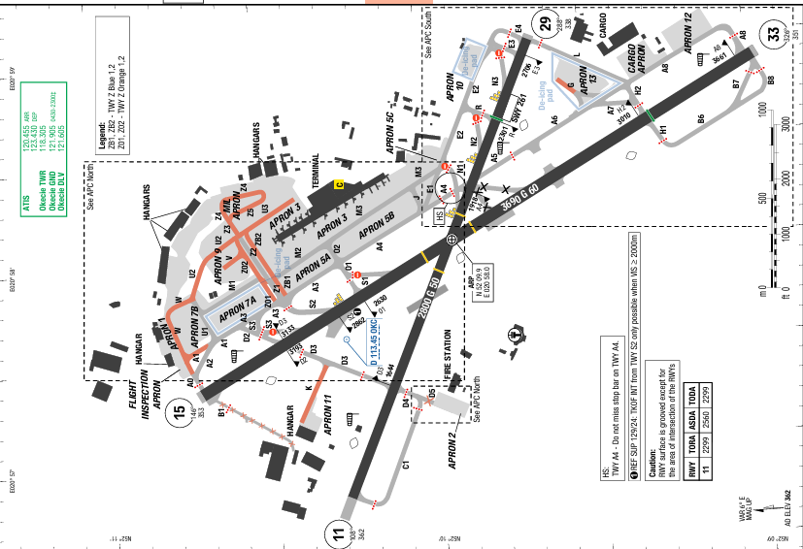
Warsaw Chopin Airport (IATA: WAW, ICAO: EPWA) is an international airport in the Włochy district of Warsaw, Poland. There is no terrain surrounding the airport
At Warsaw Chopin Airport, the summers are comfortable and partly cloudy and the winters are long, freezing, snowy, windy, and mostly cloudy. Over the course of the year, the temperature typically varies from -5°C to 24°C and is rarely below -14°C or above 30°C.
Departure |  |  | - RNAV SIDs are available.
Arrival and Approach |  |  | - RNAV STARs are available.
Taxi |  |  | - Wingspan restriction.
Parking information |  |  | No
- TAKE-OFF AND LANDING DISTANCES AVAILABLE
RWY | LENGTH  (m) |  |  | WIDTH  (m) |  | TORA  (m) |  | LDA  (m) | TODA  (m) |  | ASDA  (m)
11 | 2800 |  |  | 50 |  | 2299 |  | 2560 | 2299 |  | 2560
15 | 3690 |  |  | 60 |  | 3690 |  | 3690 | 3690 |  | 3690
29 | 2800 |  |  | 50 |  | 2800 |  | 2299 | 2800 |  | 2800
33 | 3690 |  |  | 60 |  | 3690 |  | 3029 | 3690 |  | 3690
6. ELEVATION: 362ft | 7. EOSID: NO
8. IAP: ILS (CAT I, II, III), LOC, RNP, VOR
9. COMPANY NOTE | - The use of APU is limited, read AOI chart for information about airport’s regulation of APU usage.
10. REMARK | NIL

ESGG/ GOT – GOTEBORG AIRRPOT, LANDVETTER, SWEDEN
- AIRPORT CATEGORY: A |  |  |  |  |  |  | - RFFS CATEGORY: 9
- AIRPORT CLASSIFICATION
ATR |  |  | A320 |  | A321 |  | A350 |  |  | B787
ADQ |  |  | ADQ |  | ADQ |  | ADQ |  |  | ADQ
- GENERAL STANDARDS
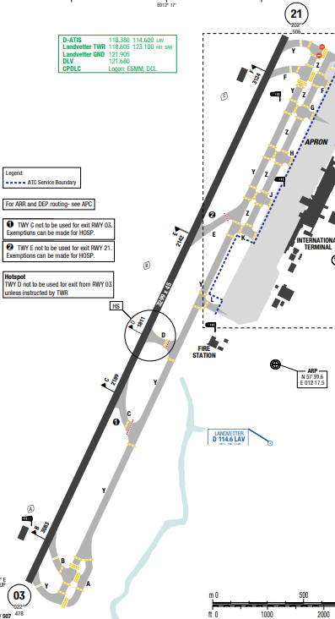
Göteborg Landvetter Airport, also known as Gothenburg Landvetter Airport, is an international airport serving the Gothenburg region in Sweden. With just over 5.3 million passengers in 2024, it is Sweden's second-largest airport after Stockholm Arlanda.
Landvetter, Sweden, has a temperate maritime climate featuring comfortable, partly cloudy summers and long, cold, snowy, and overcast winters. Temperatures typically range from -4°C to 21°C annually, with July being the warmest month average high of 20°C and February the coldest -4°C average low.
Departure |  | - RNAV SIDs and require high climb gradient (Highest 7.3% to GG701)  - SID DETNA 3M: may not to be used 2100-0500 UTC. Replacing SID is TAKOV 3R.  - SID SABAK 3M: may not to be used 2100-0500 UTC. Replacing SID is TISAB 3R  - TISAB/TAKOV: only to be used 2100-0500 UTC  - Use TKOF PROC NADP2 for RWY 03 and 21
Arrival and Approach |  | - Continuous Descent Operations (CDO):  + Descent speed IAS 260KT or less from the cross over ALT. Advise ATC if higher descent speed is requested.  + When established on final APCH, ACFT shall maintain IAS 160KT or more until passing OM (3.7NM to RWY 03/21) unless otherwise instructed. If this is not practicable, inform ATC.  - COMM FAIL Procedure available  - RNAV STARs
Taxi |  | - TWY with Max Wingspan restriction (Detailed in AOI Chart)  - ARR:  + TWY D not to be used for exit RWY 03 unless instructed by ATC.  + After vacating RWY, hold postion on TWY Y until taxi CLR is obtained.
Parking information |  | - Marshalling AVBL H24.  - Use MNM power on APN.  - TWY F is to be used to/from stand 1-3.  - ARR: Taxi via TWY Y/ DEP: Taxi via TWY Z  - SAFEDOCK AVBL at stands 21, 22A, 22, 22B, 23A, 23 and 23B.  - FMT APIS AVBL at gates 5A, 8-17, 19-20, 30-41A.
- TAKE-OFF AND LANDING DISTANCES AVAILABLE
RWY | LENGTH  (m) |  |  | WIDTH  (m) |  | TORA  (m) |  | LDA  (m) | TODA  (m) |  | ASDA  (m)
03/21 | 3300 |  |  | 45 |  | 3300 |  | 3300 | 3300 |  | 3300
6. ELEVATION: 507ft | 7. EOSID: NO
8. IAP: ILS (CAT I, II, III), LOC, RNP, VOR
9. COMPANY NOTE | - Avoid overflying of central parts of Goteborg and do not operate below 2000ft.  - Use of APU is restricted to 5min after on-block and MAX 5min before off-block
10. REMARK | NIL

ESSA/ARN – STOCKHOLM INTL – ARLANDA – SWEDEB
- AIRPORT CATEGORY: A |  |  |  |  |  |  | - RFFS CATEGORY: 10
- AIRPORT CLASSIFICATION
ATR |  |  | A320 |  | A321 |  | A350 |  |  | B787
ADQ |  |  | ADQ |  | ADQ |  | ADQ |  |  | ADQ
- GENERAL STANDARDS
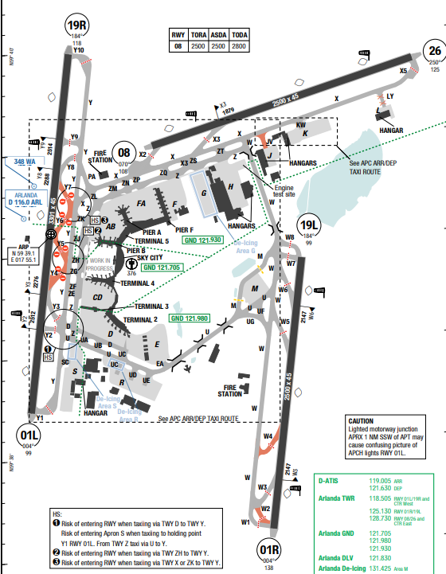
Stockholm Arlanda Airport (IATA: ARN, ICAO: ESSA) is the main international airport serving Stockholm, the capital of Sweden. It is located in Sigtuna Municipality, 37 km north of Stockholm and nearly 40 km southeast of Uppsala. The airport is located within Stockholm County.
Stockholm has a humid continental climate with warm summers and cold winters. Average high temperatures range from around 22°C in July to 0°C in January, with temperatures rarely falling below -4°C in winter and not exceeding 22°C in summer. Rainfall occurs throughout the year, but May is typically the driest month and November is often the wettest.
Departure |  | - RNAV SIDs  - Require minimum climb gradients.  - High Intensity Runway Operation (HIRO)  - Outbound TFC shall be planned via following exit points: ARS, BABAP, PETEV, KOGAV,TOVRI, NOSLI, RESNA and TRS.
Arrival and Approach |  | - Inbound TFC shall be planned via following entry points: NILUG, XILAN, HMR and ELTOK.  - Between 2330-0430UTC, the shortest distance from the TMA entry point to the FAP may be seen as the expected track to start IAP. Deviation from the track  may be regarded as a delaying action.  - ACFT will be radar vectored from IAF to final APCH  *Continuous Descent Approach (CDA)  - The use of CDA is recommended if it is consistent with ATCC speed control requirements.  - ATCC may give descent CLR which do not comply with CDA PROC when TFC situation so require.  - Do not use more than idle reverse if possible between 2100-0500UTC
Taxi |  | - Clockwise taxiing PROC where parallel TWY are established.  - Arriving ACFT shall not leave RWY exit TWY with turn exceeding 90°.
Parking information |  | - ATC is not provided on APNs.  - MAX wingspan 24m / 79ft for taxiing on APN S south of TWY SC.  - Taxi in/out: See special APC taxi route chart.
- TAKE-OFF AND LANDING DISTANCES AVAILABLE
RWY | LENGTH  (m) |  |  | WIDTH  (m) |  | TORA  (m) |  | LDA  (m) | TODA  (m) |  | ASDA  (m)
01L/19R | 3300 |  |  | 45 |  | 3300 |  | 3300 | 3300 |  | 3300
01R/19L | 2500 |  |  | 45 |  | 2500 |  | 2500 | 2500 |  | 2500
008/26 | 2500 |  |  | 45 |  | 2500 |  | 2500 | 2500 |  | 2500
6. ELEVATION: 138 ft | 7. EOSID: NO
8. IAP: ILS (CAT I, II, III), LOC, RNP
9. COMPANY NOTE | NIL
10. REMARK | NIL

EVRA/ RIX – RIGA (RIGA) – LATVIA
- AIRPORT CATEGORY: A |  |  |  |  |  |  | - RFFS CATEGORY: CAT 9 (O/ R)
- AIRPORT CLASSIFICATION
ATR |  | A320 |  |  | A321 |  | A350 |  |  | B787
ADQ |  | ADQ |  |  | ADQ |  | ADQ |  |  | ADQ
- GENERAL STANDARDS
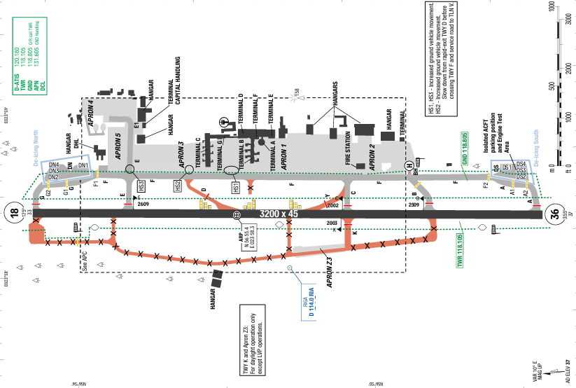
Riga International Airport (IATA: RIX, ICAO: EVRA) is the international airport of Riga, the capital of Latvia, and the largest airport in the Baltic states. The MSA is 2300ft.
The climate of Riga is humid continental. The coldest months are January and February, when average temperature is −5 °C but temperatures as low as −20 to −25 °C can be observed almost every year on the coldest days. The proximity of the sea causes frequent autumn rains and fogs. Continuous snow cover may last eighty days. The summers in Riga are mild and rainy with an average temperature of 18 °C.

Departure |  |  | - A-CDM is available.  - Noise abatement procedures are applied
Arrival and Approach |  |  | - Low visibility procedure  - Speed restrictions
Taxi |  |  | - High speed vacates taxi way.  - Standard taxi routes
Parking information |  |  | No
- TAKE-OFF AND LANDING DISTANCES AVAILABLE
RWY | LENGTH  (m) |  |  | WIDTH  (m) |  | TORA  (m) |  | LDA  (m) | TODA  (m) |  | ASDA  (m)
18/ 36 | 3200 |  |  | 45 |  | 3200 |  | 3200 | 3200 |  | 3200
6. ELEVATION: 37ft | 7. EOSID: NO
8. IAP: ILS (CAT I, II), LOC, RNP, VOR
9. COMPANY NOTE | No
10. REMARK | NIL

EYVI/ VNO – VILNIUS (VILNIUS INTL) – LITHUANIA
- AIRPORT CATEGORY: A |  |  |  |  |  |  | - RFFS CATEGORY: 7
- AIRPORT CLASSIFICATION
ATR |  | A320 |  |  | A321 |  | A350 |  | B787
ADQ |  | ADQ |  |  | ADQ |  | ADQ |  | ADQ
- GENERAL STANDARDS
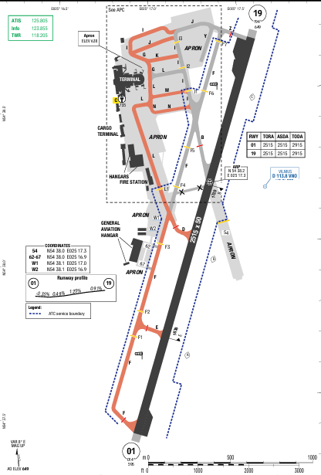
Vilnius International Airport (IATA: VNO, ICAO: EYVI) is the airport of Vilnius, the capital of Lithuania. It is located 5.9 km south of the city center.The climate of Vilnius is humid continental. The average temperature in January is −3.9 °C, in July it is 18.7 °C. The average precipitation is about 691 mm per year. Summer days are warm and sometimes hot, especially in July and August, Winters can be very cold, with temperatures rarely reaching above freezing – temperatures below −25°C may occur in January and February.

Departure |  |  | - Noise abatement procedure should be applied  - RNAV SIDs are available.  - Passing 2500ft contact with VILNIUS Approach.  - SID with high climb gradient, Pilots need to briefing carefully before T/ O
Arrival and Approach |  |  | - RNAV STARs are available.  - Expect direct routing/ shortcut by ATC when possible.  - Speed/ Altitude restrictions on arrival.  - Noise abatement procedure
Taxi |  |  | - Wingspan restrictions
Parking information |  |  | No
- TAKE-OFF AND LANDING DISTANCES AVAILABLE
RWY | LENGTH  (m) |  |  | WIDTH  (m) |  | TORA  (m) |  | LDA  (m) | TODA  (m) | ASDA  (m)
01/ 19 | 2515 |  |  | 50 |  | 2515 |  | 2515 | 2915 | 2515
6. ELEVATION: 649ft | 7. EOSID: NO
8. IAP: ILS (CAT I, II), LOC, RNP, VOR
9. COMPANY NOTE | - Birds in the vicinity of the airport.
10. REMARK | NIL

KLAS / LAS- HARRY REID INTL AIRPORT – LAS VEGAS, U.S.A
1. AIRPORT CATEGORY: A |  |  |  |  |  |  |  | 2. RFFS CATEGORY: 10
3. AIRPORT CLASSIFICATION
ATR |  | A320 |  |  |  | A321 |  | A350 |  |  | B787
ADQ |  | ADQ |  |  |  | ADQ |  | ADQ |  |  | ADQ
4. GENERAL STANDARDS
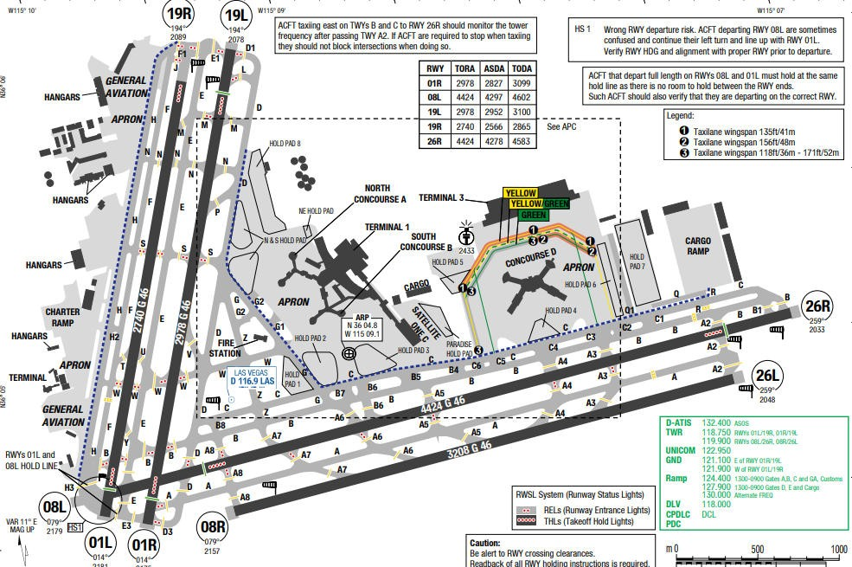
REID (McCarran) International Airport is in the southeast corner of Nevada. The airport is near the center of the Las Vegas Valley and is surrounded by mountains. This valley runs north to south and terrain along the floor is flat. To the northeast, Frenchman Mountain rises to 3954 feet MSL within 10 NM. To the west, terrain within the Spring Mountains rises from 4000 feet MSL within 11 NM, to above 8000 feet MSL within 17 NM. Several peaks that rise above 10000 feet MSL are within 25 NM to the northwest, with Mount Charleston rising to nearly 12000 feet MSL.
Highly variable winds often occur in the spring. Winds over 100 km/ h can occur during major storms. During these storms visibility may be reduced due to blowing dust and sand
Departure |  |  |  |  | - There are Obstacle Departure Procedures for all runways
Arrival and Approach |  |  |  |  | - Conventional and RNAV STARs
Taxi |  |  |  |  | - Aircraft operating near the intersection of TWYs S, D, G and the N end of TWY Z, should be alert as there are closely aligned TWY centerlines and radius turn.  - Aircraft taxiing westbound on TWY B near TWY E use care not to enter the RWY on TWY Y. Aircraft taxiing westbound on TWY W near TWY E use care not to enter the runway on TWY U.
Parking information |  |  |  |  | No
5. TAKE-OFF AND LANDING DISTANCES AVAILABLE
RWY | LENGTH  (m) |  |  | WIDTH  (m) |  |  | TORA  (m) |  | LDA  (m) | TODA  (m) |  | ASDA  (m)
01R | 2978 |  |  | 46 |  |  | 2978 |  | 2978 | 2978 |  | 2678
01L | 2740 |  |  | 46 |  |  | 2740 |  | 2740 | 2740 |  | 2561
08L | 4424 |  |  | 46 |  |  | 4424 |  | 4424 | 4424 |  | 3645
08R/ 26L | 3208 |  |  | 46 |  |  | 3208 |  | 3208 | 3208 |  | 3208
19L | 2978 |  |  | 46 |  |  | 2978 |  | 2978 | 2978 |  | 2685
19R | 2740 |  |  | 46 |  |  | 2740 |  | 2740 | 2740 |  | 2566
26R | 4424 |  |  | 46 |  |  | 4424 |  | 4424 | 4424 |  | 3852
6. ELEVATION: 2181ft |  |  | 7. EOSID: YES
8. IAP:ILS, LOC, LPV, VOR
9. COMPANY NOTE |  |  | - Aircraft that depart full length of RWYs 01L and 08L must hold at the same hold line as there is no room to hold between the RWY ends and such aircraft should verify that they are on the correct runway  - Aircraft with wingspan greater than 135', prior permission required from the Dept of Aviation to use TWY H.  - Minimum power until passing the power-up point on RWY. Power-up point is 348' E of blast pad and marked with sign and standard markings for beginning of RWY
10. REMARK |  |  | - EXTSV glider/soaring operations weekends & holidays; SR-SS; LAS R187/020; altitudes up to but not including FL180. Gliders remain clear of the TCA but otherwise operate within the entire SW quadrant of the TCA veil.  - All non-standard RUNWAY operations PPR from DEPARTMENT OF AVIATION.  - TBJT departures not permitted on RUNWAY 01R/19L or RUNWAY 01L/19R from 2000-0800. Exceptions for WEATHER or operational necessity.  - AIRCRAFT may experience reflection of sun from glass hotels located NW of AIRPORT. Reflection may occur at various altitudes, headings, & distances from AIRPORT.  - GENERAL AVIATION PARKING very limited. For PARKING availability, contact either FIXED BASE OPERATOR (702) 736-1830 or (702) 739-1100.  - RUNWAY 08L 589 ft CLEARWAY; RUNWAY 26R 645 ft CLEARWAY.  - Lighted golf range 1400 ft south of RUNWAYS 01L/19R and 01R/19L.  - Tiedown fee.  - (E98) plus 64 shelters & 24 sheds.  - AIRCRAFT using full-length departure on RUNWAY 08L use minimal power until passing the power-up point on RUNWAY. Power-up point is 348 ft east of blast pad and marked with sign and standard markings for beginning of RUNWAY.  - Large number of birds and bats in vicinity of AIRPORT between SS and SR.  - AIRCRAFT departing RUNWAY 19R use minimal power until passing the RUNWAY threshold. RUNWAY 19R threshold has standard RUNWAY markings and is 780 ft south of the blast pad.  - AIRCRAFT operating near the intersection of TAXIWAYS S, D, G, and the north end of TAXIWAY Z should be alert as there are closely aligned TAXIWAY centerlines and radius turns.  - AIRCRAFT that depart full length of RUNWAYS 01L and 08L must hold at the same hold line as there is no room to hold between the RUNWAY ends and such AIRCRAFT should verify that they are on the correct RUNWAY.  - GENERAL AVIATION customs and IMMIGRATION located west side of AIRFIELD between FIXED BASE OPERATORS.  - AIRCRAFT with wingspan greater than 135 ft PPR from DEPARTMENT OF AVIATION to use TAXIWAY H.  - Numerous helicopter operations on the west side of AIRPORT.  - AIRCRAFT taxiing westbound on TAXIWAY B near TAXIWAY E use care not to enter the RUNWAY on TAXIWAY Y. AIRCRAFT taxiing westbound on TAXIWAY W near TAXIWAY E use care not to enter the RUNWAY on TAXIWAY U.  - RUNWAY status lights are in operation.  - Planned authorized between 0200 & 0600.  - Caution PAJA in vicinity of AIRPORT.  - When special event PARKING PPR program NOTAM is active, transient AIRCRAFT operators not permanently based need to obtain a PPR number from a FIXED BASE OPERATOR for each landing.  - All AIRCRAFT contact RAMP CONTROL on frequency 124.4 for operations at A, B, C gates, and GENERAL AVIATION, customs. Contact RAMP CONTROL frequency 127.9 for operations at D and E gates and cargo ramp prior to entering ramp or pushing back from gate or PARKING spot. RAMP CONTROL operating hours 0500-0100L. When ramp is closed (0100-0500L) broadcast all non-movement area operations on UNICOM 122.95.  - Pilots conducting ENHANCED FLIGHT VISION SYSTEM operations; be aware LED APPROACH LIGHT SYSTEM in use.

KLAX/ LAX – LOS ANGELES INTL AIRPORT – CA, USA
1. AIRPORT CATEGORY: A |  |  |  |  |  |  | 2. RFFS CATEGORY: 10
3. AIRPORT CLASSIFICATION
ATR |  | A320 |  |  | A321 |  | A350 |  |  | B787
ADQ |  | ADQ |  |  | ADQ |  | ADQ |  |  | ADQ
4. GENERAL STANDARDS
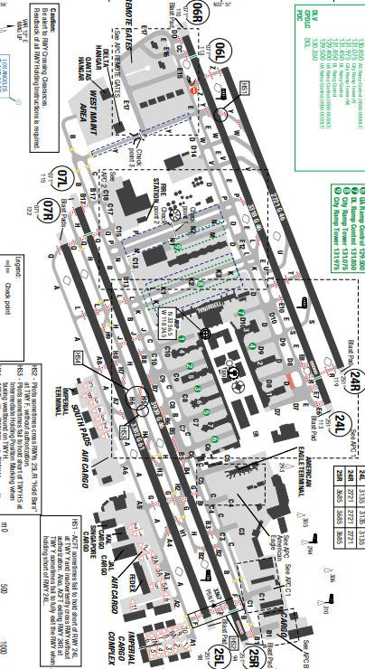
Los Angeles International Airport is located near the western edge of the Los Angeles Basin.
Coastal mountains are in the northwest and northeast quadrant within 14 NM. The airport is within a mile of Santa Monica Bay’s eastern shoreline and except for the seaside, it is surrounded by heavy urban development. The highest close-in obstacles in the area are building up to 1387 feet MSL 10 NM to the northeast. Also, to the northeast, the San Gabriel Mountain Range, with terrain rising to 8100 feet MSL, are within 34 NM.
Obstruction to visibility averages 21 days per month throughout the year. Smoke/ haze is reported an average of 20 days per month while fog averages 9 days per month. Approximately 2 thunderstorms occur annually. Overcast ceiling is the predominant sky condition in May and June
Departure |  |  | - There are Obstacle Departure Procedures for all runways
Arrival and Approach |  |  | - Conventional and RNAV STARs
Taxi |  |  | - Read back Runway and Hold short instructions.  - Taxiway N, P, and AA are not visible from the Air Traffic Control Tower.
Parking information |  |  | No
5. TAKE-OFF AND LANDING DISTANCES AVAILABLE
RWY | LENGTH  (m) |  |  | WIDTH  (m) |  | TORA  (m) |  | LDA  (m) | TODA  (m) |  | ASDA  (m)
06L | 2721 |  |  | 46 |  | 2721 |  | 2611 | 2721 |  | 2611
06R | 3318 |  |  | 46 |  | 3135 |  | 2971 | 3135 |  | 3135
07L | 3939 |  |  | 46 |  | 3685 |  | 3432 | 3685 |  | 3685
07R/ 25L | 3382 |  |  | 61 |  | 3382 |  | 3382 | 3382 |  | 3382
24L | 3318 |  |  | 46 |  | 3135 |  | 2890 | 3135 |  | 3135
24R | 2721 |  |  | 46 |  | 2721 |  | 2721 | 2721 |  | 2721
25R | 3939 |  |  | 46 |  | 3685 |  | 3394 | 3685 |  | 3685
6. ELEVATION: 128ft |  |  |  | 7. EOSID: NO
8. IAP: ILS (CAT I, II, III), LOC, LPV, RNP
9. COMPANY NOTE |  |  |  | - Numerous birds are present on and in the airport vicinity.  - There are numerous airports in the area, resulting in a very high density of an IFR/ VFR traffic mix  - The airport is equipped with a low level windshear alert system (LLWAS)
10. REMARK |  |  |  | - Nmrs birds on and in vcnty of ARPT.  - Turb may be deflected upward fm the blast fence 180 ft end of RWY 25R.  - Noise sens ARPT on westerly takeoffs: no turns before crossing shoreline. Over-ocean APCHs utilized 0000-0630.  - Practice instrument APCHs & touch and go landings are prohibited.  - RWY 7R/25L preferred emerg RWY.  - TWY D btn TWY D7 and D8 (N of TRML one) clsd to ACFT with wingspan gtr than 157 ft.  - West remote gates: ACFT use of open gates as taxi path is prohibited (gates 406, 407, 408, 409).  - ACFT use minimal pwr when TXG vcnty TRMLs due blast haz.  - Major construction on airport, daily.  - American Eagle TRML southbound taxiing ACFT use mnm pwr due to blast haz.  - Any ACFT that comes to a stop or has its momentum intrpd while turning and TXG into its PRKG psn, must stop and be towed.  - ACFT with len gtr than 240 ft are prohibited on TXLs C7, C8 and C9 btn TXL C and TWY B.  - ACFT with wingspan gtr than 198 ft obnd fm TXL D8 may not turn wbnd onto TXL D.  - RWY status LGTS in opn.  - ACFT with wingspan gtr than 155 ft wb on TXL C are not authd to make left turn on TWY C10 under pwr.  - Pilots should use ctn for poss laser act in the LAX area.

KSEA/ SEA – SEATTLE TACOMA INT AIRPORT – USA
- AIRPORT CATEGORY: A |  |  |  |  |  |  | - RFFS CATEGORY: 9-10
- AIRPORT CLASSIFICATION
ATR |  | A320 |  |  | A321 |  | A350 |  |  | B787
ADQ |  | ADQ |  |  | ADQ |  | ADQ |  |  | ADQ
- GENERAL STANDARDS
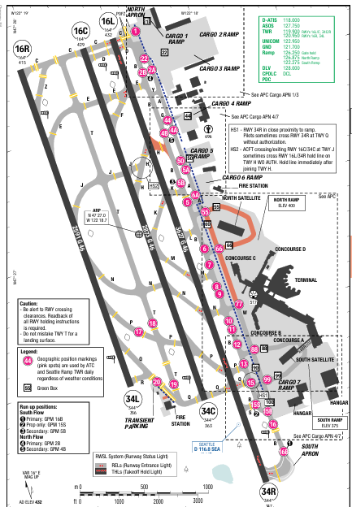
Seattle-Tacoma INT Airport (IATA: SEA, ICAO: KSEA) is the primary commercial airport serving the Seattle metropolitan area in the U.S. state of Washington. It is in the city of SeaTac, approximately 14 Miles (23km) South of Downtown Seattle and 18 miles (29km) north-northeast of Downtown Tacoma.
In Seattle, the summers are short, warm, dry, and partly cloudy and the winters are very cold, wet, and mostly cloudy. Over the course of the year, the temperature typically varies from 2°C to 26°C and is rarely below -2°C or above 31°F.
Departure |  |  | - Noise abatement procedures during take-off and climbing phase shall be executed by all ACFT.  - Takeoff Obstacle Notes
Arrival and Approach |  |  | - Transition level: FL180  - Communication failure procedures / LIDO AOI Chart  - Turbojet Aircraft descend via Mach Number until 280kt. Maintain 280kt until slowed by the star.
Taxi |  |  | - 3 Runways.  - Taxiway Tango (T) has been mistaken for Rwy 16C. Need to be careful.  - Some Twy have wingspan limit down to 36m
Parking information |  |  | No
- TAKE-OFF AND LANDING DISTANCES AVAILABLE
RWY | LENGTH  (m) |  |  | WIDTH  (m) |  | TORA  (m) |  | LDA  (m) | TODA  (m) |  | ASDA  (m)
16L/ 34R | 3627 |  |  | 46 |  | 3627 |  | 3627 | 3627 |  | 3627
16C/ 34C | 2873 |  |  | 46 |  | 2873 |  | 2873 | 2873 |  | 2873
16R/ 34L | 2591 |  |  | 46 |  | 2591 |  | 2591 | 2591 |  | 2591
6. ELEVATION: 432ft | 7. EOSID: NO
8. IAP: ILS (CAT I, II, III), LOC, LPV
9. COMPANY NOTE | - Birds are present on and in the airport vicinity
10. REMARK | - Bird flocks within arpt vcnty - check lcl adzys.  - Flight notification service (ADCUS) avbl.  - Helicopters landing & departing avoid overflying fuel farm lctd at the SE corner of the arpt.  - (E110) continuous power arpt.  - (E94) WSO/WSFO.  - TWY A south of TWY G rstd to ACFT with wingspan 225 ft or less.  - Do not mistake TWY T for lndg sfc.  - Aces to air cargo 4 prkg and cargo areas rstd to ACFT with wingspan 170 ft or less.  - TWY for corporate hngr ramp rstd to ACFT with wingspan 62 ft or less for taxi ops. GA cust pkng is very ltd.  - PPR for all GA prkg & svcs, CTC 206-433-5481. Op hrs 0530L - 2100L, with a call out avbl upon req.  - Taxilane W rstd to ACFT with wingspan 135 ft or less N of TWY N and 167 ft or less south of TWY N. Seattle ramp TWR prvds adzy ctl only.  - GA landing fees payable by major credit cards only.  - Taxilane on N side of N STLT rstd to ACFT with wingspan 118 ft or less. Tri-taxilanes at N STLT: CNTR (green) taxilane rstd to ACFT with wingspan 135 ft or less. When an ACFT is on the CNTR (green) or OTR (orange/blue) taxilanes, no OTR ACFT can simul use the adj taxilane(s). Orange & blue taxilanes are rstd to ACFT with wingspan 118 ft or less. Two ACFT can simul use the outer taxilanes.  - RWY status lgts are in opn.  - ACFT with wingspans of 171 ft. or more parked at pax gates or cargo 7 must provide 30 min PPR prior to pushback to Seattle ramp TWR when vsby less than 2400 RVR.  - TWYs J & H E of TWY T rstd to ACFT with wingspan 167 ft or less.  - RWY 16L/34R rstd to ACFT with wingspan 260 ft or less.  - TWY H E of RWY 16L/34R rstd to ACFT with wingspan 118 ft or less when exiting RWY 16L/34R.  - TWY B S of TWY Q rstd to ACFT with wingspan 260 ft or less.  - TWY B south of air cargo 7 ramp rstd to ACFT with wingspan 260 ft or less.  - Air cargo 5 ramp dual ENG tax only.  - 100LL fuel not avbl.  - The use of reverse thrust byd what is nec for opnl or safety rsns is discouraged at all times. Noise abatement FLT procs in efct btn 2200-0600. For further info CTC SEA noise abatement ofc at 206-787-5393.  - Cons taxi to TKOFS at SEA. When practical, safe and avbl, cons taxi to TKOFS are encouraged. Cons taxi to TKOFS may rdc ACFT noise wi nearby communities.  - Rprt bird strikes to 206-787-7233.

KSFO/ SFO - SAN FRANCISCO (SAN FRANCISCO INTL), CA, USA
1. AIRPORT CATEGORY: A |  |  |  |  |  |  |  | 2. RFFS CATEGORY: 10
3. AIRPORT CLASSIFICATION
ATR |  | A320 |  |  |  | A321 |  | A350 |  |  | B787
ADQ |  | ADQ |  |  |  | ADQ |  | ADQ |  |  | ADQ
4. GENERAL STANDARDS
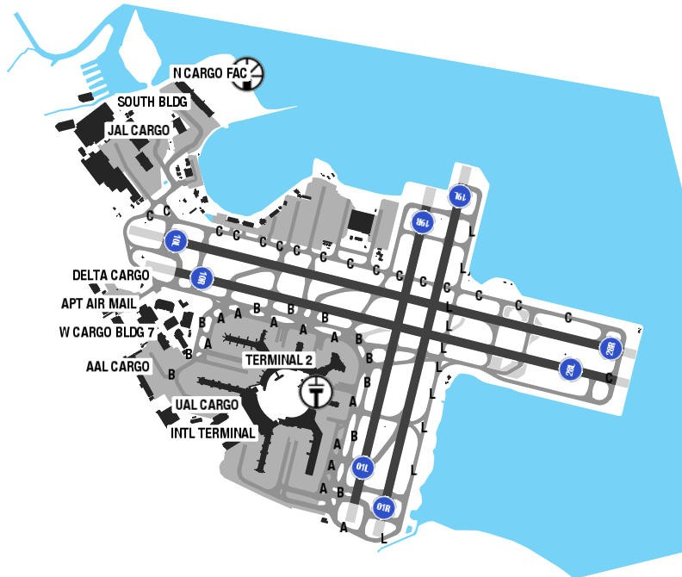
San Francisco International Airport is located near the Pacific coast of Central California. The airport is along the western shoreline of San Francisco Bay, on a peninsula that separates the Pacific Ocean from the bay.In San Francisco, the summers are long, comfortable, arid, and mostly clear and the winters are short, cold, wet, and partly cloudy. Over the course of the year, the temperature typically varies from 7°C to 22°C and is rarely below 4°C or above 28°C.
The warm season is from June to October, with an average daily high temperature above 21°C. The cool season lasts for 2 months, from December to February, with an average daily high temperature below 15°C.The rainy period of the year lasts for 7 months, from October to May, with a sliding 31-day rainfall of at least 0.5 inches.
Departure |  |  | - Refer to ODP–TAKEOFF OBSTACLES NOTES  for each RWY in AERODROMES for better flight planning.  When wind is favorable, expect RWY 28L and GNNRR for departure
Arrival and Approach |  |  | - RWY 28R is preferred RWY.  - Expected: ILS or Visual (TIP TOE or QUIET BRIDGE). Crew can request ILS if needed.  - ILS CAT1 RWY 28L/ R approaches: SIMUL APCH AUTH: require use of vertical guidance; maintain last assigned ALT until established on GS.  - TIP TOE or QUITE BRIDGE visual RWY 28L/ R: closely spaced parallel visual APCHs may be in progress.
- Crew situation awareness:
+ Due to high volume of traffic and parallel approach, ATC will give radar vector, high speed (180kts around 5NM) and shortcut for final that make aircraft is higher than profile.
+ Sun light (from the WEST) during landing makes it difficult for pilot to see the RWY (to report RWY IN SIGHT), which often leads to ATC giving late landing instructions
- As the ILS DME is located 1.9 NM beyond the runway threshold, the ILS DME shall not be used. Flight crews shall use the FMS “DIST TO” function to determine the distance to the runway threshold.
- Flight crews shall manage the vertical profile and airspeed using the FMS distance information and speed brakes as required until 1,000 ft AGL to ensure a stabilized approach.
- If ATC instructs “maintain 180 kt until 6 NM,” flight crews shall ensure that CONFIG 3 and landing gear down are established prior to reaching 6 NM.
Taxi |  |  | - Ground controller does not provide parking position, therefore flight crew must update parking position before landing.  - Be alert to RWY crossing clearances. Read back RWY assignments, RWY hold short instructions are required.  - Operate XPD with altitude reporting mode and ADS-B enabled on all airport surfaces.  - RWY status lights in operation.
Parking information |  |  | No
5. TAKE-OFF AND LANDING DISTANCES AVAILABLE
RWY | LENGTH  (m) |  |  | WIDTH  (m) |  |  | TORA  (m) |  | LDA  (m) | TODA  (m) |  | ASDA  (m)
01L | 2332 |  |  | 61 |  |  | 2332 |  | 2332 | 2332 |  | 2137
01R | 2637 |  |  | 61 |  |  | 2637 |  | 2637 | 2637 |  | 2466
10L | 3618 |  |  | 61 |  |  | 3618 |  | 3618 | 3618 |  | 3412
10R | 3469 |  |  | 61 |  |  | 3469 |  | 3469 | 3469 |  | 3263
19L | 2637 |  |  | 61 |  |  | 2637 |  | 2637 | 2637 |  | 2637
19R | 2332 |  |  | 61 |  |  | 2332 |  | 2332 | 2332 |  | 2332
28L | 3469 |  |  | 61 |  |  | 3469 |  | 3469 | 3469 |  | 3132
28R | 3618 |  |  | 61 |  |  | 3618 |  | 3618 | 3618 |  | 3425
6. ELEVATION: 13ft |  |  |  |  | 7. EOSID: YES
8. IAP: ILS (CAT I, II, III), , LOC, LPV
9. COMPANY NOTE |  |  |  |  | - Birds in vicinity of airport  - Wake turbulence due to heavy jet traffics.  - High terrain in the south and northwest. Terrain rises rapidly to the west within 5NM.
10. REMARK |  |  |  |  | - Flocks of birds feeding along shoreline adj to ARPT; on occasions fly across various parts of the ARPT.  - High speed TWY (T) GRVD full width btn RWY 28R and 28L.  - Noise sensitive ARPT; for noise abatement procedures CTC ARPT noise office Mon-Fri 0800-1700 by calling 650-821-5100.  - Several RWY hold position signs are on the right rather than the left side of the TWYs.  - RWY 10 preferred RWY btn 0100-0600 weather and flight conditions permitting.  - Airline pilots shall strictly follow the painted nose gear lines and no oversteering adjustment is permitted.  - PAEW APCH end RWYs 28L, 28R, 19L indefly.  - All OUBD TWY Zulu 2 HVY ACFT with a wingspan of 171 FT or GTR under power prohibited from entering WB TWY Zulu.  - Simultaneous operations in effect all RWYs.  - RWY 1L CLSD to departing trijet ACFT with wingspan greater than 155 FT.  - RWY status lights in OPN.  - TWY S btn TWY Z and TWY S2 CLSD to ACFT with wingspan over 215 FT.  - Due to OBSTD vision, SFO TWR is able to PRVD only LTD ARPT TFC CTL SVC on TWY A btn gates F20 and F21.

KSJC/ SJC – MINETA SAN JOSE INTL AIRPORT – SAN JOSE, CALIF, USA
1. AIRPORT CATEGORY: A |  |  |  |  |  |  |  | 2. RFFS CATEGORY: 10
3. AIRPORT CLASSIFICATION
ATR |  | A320 |  |  |  | A321 |  | A350 |  |  | B787
ADQ |  | ADQ |  |  |  | ADQ |  | ADQ |  |  | ADQ
4. GENERAL STANDARDS
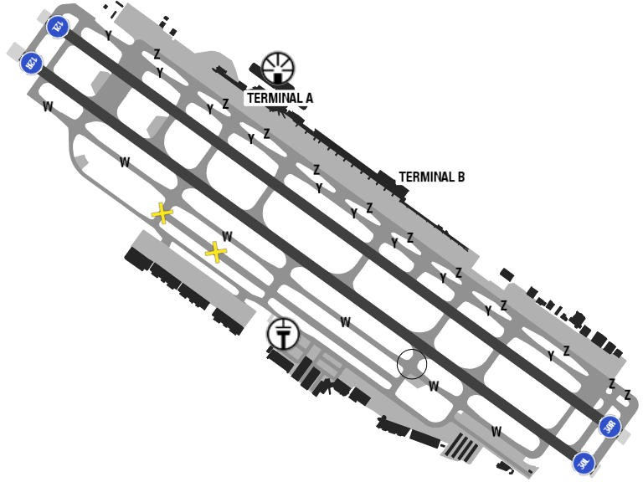
Mineta San Jose International Airport is located in west central California. In summer, fog moves in from the bay and burns off by the afternoon. As much as 25% of the morning hours are IMC, with less than 1% occurring in the afternoon hours. Haze/ Smoke highest incidences occurs from July through January, averaging 17 days per month. Overcast ceilings is the predominant sky condition from December through March. Annual precipitation totals 13.5 in (34 cm).
Thunderstorm activity is generally associated with passing storm systems, with 6 or less occurrences per year. Trace amounts of small hail may occur.
Departure |  |  | - SID requires take-off minimum  - Obstacle departure procedure for RWY 12L/ R
Arrival and Approach |  |  | - Conventional and RNAV STARs
Taxi |  |  | - Taxiway restrictions wingspan
Parking information |  |  | No
5. TAKE-OFF AND LANDING DISTANCES AVAILABLE
RWY | LENGTH  (m) |  |  | WIDTH  (m) |  |  | TORA  (m) |  | LDA  (m) | TODA  (m) |  | ASDA  (m)
12L | 3353 |  |  | 46 |  |  | 3090 |  | 2692 | 3353 |  | 3353
12R | 3353 |  |  | 46 |  |  | 3012 |  | 2617 | 3353 |  | 3353
30L | 3353 |  |  | 46 |  |  | 3094 |  | 2321 | 3353 |  | 3353
30R | 3353 |  |  | 46 |  |  | 3089 |  | 2316 | 3353 |  | 3353
6. ELEVATION: 62ft |  |  |  |  | 7. EOSID: YES
8. IAP: ILS, LOC, LPV
9. COMPANY NOTE |  |  |  |  | - Birds are on and in the vicinity of the airport  - High intensity lights (lasers and large media screens) may cause cockpit illumination and glare effect reducing visibility, especially at night  - The airport is in close proximity to several general aviation airports. Expect heavy general aviation activity in the area, especially to the southeast.  San Francisco Class B airspace is within 1 NM west of the airport.  - Mountainous terrain  - A preferential runway program is in effect at this airport.  - Curfew hours 2300-0700LT FAR 36 Stage I, 2330-0630 FAR 36 Stage Ill aircraft listed on the schedule of authorized aircraft issued by the Director of Aviation. Delayed scheduled flights and alternate or emergency operations may be exempt from curfew hour restrictions
10. REMARK |  |  |  |  | - Birds frequently on or in vicinity of airport.  - TWY Y will be periodically restricted to ACFT with a wingspan of less than 171 ft (MD-11 or smaller) during B-787 and B-747 operations on RWY 12L/30R.  - TWY Z will be periodically restricted to ACFT with a wingspan of less than 118 ft (B-737-900 or smaller) during B-787 and B-747 operations. TWY Z between 200 ft NW of TWY H and 200 ft NW of TWY K limited to ACFT with wingspan of less than 135 ft (B-757-300 or smaller).  - TWY V limited to ACFT with wingspan of less than 118 ft (B-737-900 or smaller).  - Unscheduled operations by Group 5 ACFT (B747) and larger not authorized except with prior airport approval. Contact AMGR at (408) 392-3500.  - Noise abatement procedure: RWY 30L/12R is preferred arrival RWY for jet ACFT and RWY 12L/30R is the preferred departure RWY for jet ACFT. All jet ACFT takeoffs are to be initiated from EOR unless directed otherwise by ATCT.  - Curfew hours 2300-0700 FAR 36 Stage II, 2330-0630 FAR 36 Stage III ACFT listed on the schedule of authorized aircraft issued by the Director of Aviation. Delayed scheduled flights, and alternate/emergency operations may be exempt from curfew hour restrictions.  - Prior airport notification is required for all late/early arrivals. Contact manager on duty at (408) 392-3500.  - First 400 ft RWY 30R & RWY 30L closed for takeoff DC10, MD11, L1011.  - All turbine engine run-ups require prior airport approval. Contact manager on duty at (408) 392-3500.  - TWY D between TWY W and TWY V limited to ACFT with a wingspan of less than 118 ft (B-737-900 or smaller).  - TWY W between TWY J and TWY L can support Group IV ACFT.  - High intensity light activity: High intensity lights (lasers and large media screens) may be visible to arriving and departing ACFT to San Jose International Airport during events at the Levi Stadium Complex (37-24-15N/121-58-14W, SJC VORTAC R-303/2.1 DME). Flight crews should use caution when operating in this area during stadium events. Cockpit illumination and glare effect reducing visibility may be intensified during arrival and departure operations especially at night.  - RRP required from FBO for transient helicopter operations.  - For CD when ATCT is closed, contact NORCAL approach at 916-361-3748.

LBSF/ SOF - SOFIA AIRPORT, SOFIA, BULGARIA
- AIRPORT CATEGORY: A |  |  |  |  |  |  | - RFFS CATEGORY: 8
- AIRPORT CLASSIFICATION
ATR |  | A320 |  |  | A321 |  | A350 |  |  | B787
ADQ |  | ADQ |  |  | ADQ |  | ADQ |  |  | ADQ
- GENERAL STANDARDS
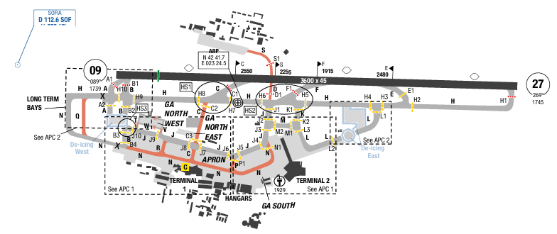
Sofia Airport (IATA: SOF, ICAO: LBSF) is the main international airport of Bulgaria, located 10 km (6.2 mi) east of the centre of the capital Sofia. MSA of the airport is from 7600ft to the highest of 10600ft. At Sofia Airport, the summers are warm and mostly clear and the winters are very cold, snowy, and partly cloudy. Over the course of the year, the temperature typically varies from -5°C to 29°C and is rarely below -12°C or above 34°C.
Departure |  |  | - RNAV SIDs are available.  - SID with high climb gradient, Pilots need to briefing carefully before T/ O
Arrival and Approach |  |  | - RNAV STARs are available.
Taxi |  |  | - This a small airport with one runway and simple taxi ways
Parking information |  |  | No
- TAKE-OFF AND LANDING DISTANCES AVAILABLE
RWY | LENGTH  (m) |  |  | WIDTH  (m) |  | TORA  (m) |  | LDA  (m) | TODA  (m) |  | ASDA  (m)
09/ 27 | 3600 |  |  | 45 |  | 3600 |  | 3300 | 3600 |  | 3600
6. ELEVATION: 1742ft | 7. EOSID: YES
8. IAP: ILS (CAT I, II, III), LOC, RNP, VOR
9. COMPANY NOTE | - Using transponder mode procedure.
10. REMARK | NIL

LDZA/ ZAG – FRANJO TUDMAN – ZAGREB, CROATIA
- AIRPORT CATEGORY: A |  |  |  |  |  |  | - RFFS CATEGORY: 9
- AIRPORT CLASSIFICATION
ATR |  | A320 |  |  | A321 |  | A350 |  |  | B787
ADQ |  | ADQ |  |  | ADQ |  | ADQ |  |  | ADQ
- GENERAL STANDARDS
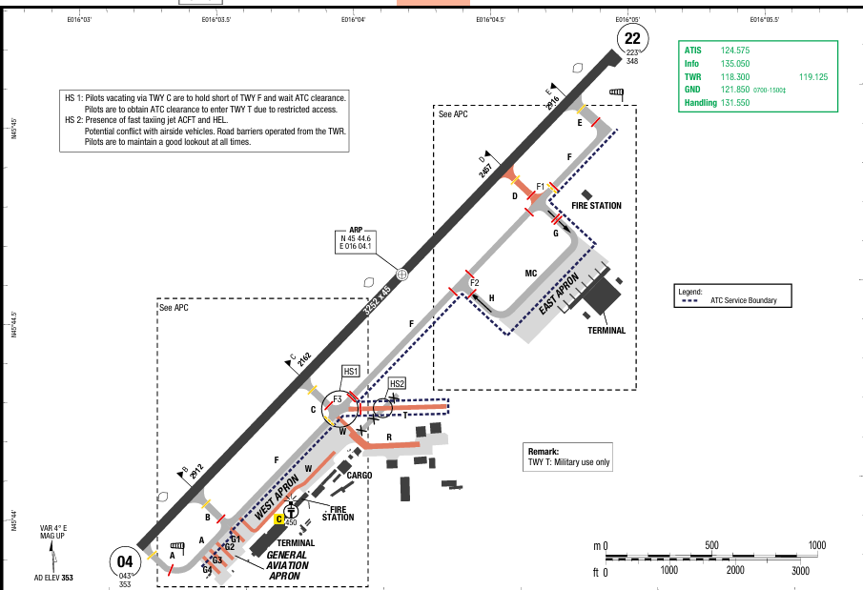
Zagreb Franjo Tuđman Airport or Zagreb Airport (IATA: ZAG, ICAO: LDZA) is an international airport serving Zagreb, Croatia. It is the largest and busiest airport in Croatia. In 2023 it handled 3.72 million passengers and some 10,859 tons of cargo.
In Zagreb, the summers are warm, the winters are very cold and snowy, and it is partly cloudy year-round. Over the course of the year, the temperature typically varies from -3°C to 28°C and is rarely below -9°C or above 33°C.

Departure |  |  | - RNAV SIDs.  - Close-in obstacle.  - Back up conventional [NON-RNAV] procedure, in case of loss of RNAV 1 capability or RNAV system failure, below minimum RADAR vectoring altitude, available for some SlDs  - After takeoff contact ZAGREB Radar.  - SID with high climb gradient, Pilots need to briefing carefully before T/ O
Arrival and Approach |  |  | - Speed restriction.  - LVP procedures.  - Aircraft shall report when landed and shall report RWY vacated when passing the end of the  colour coded yellow-green TWY CLL on TWR FREQ.  - Vacating the runway available via TWY E only.  - Expect stopbars on TWY F and TWY G.
Taxi |  |  | - MAX speed 30KT on all TWYs.
Parking information |  |  | No
- TAKE-OFF AND LANDING DISTANCES AVAILABLE
RWY | LENGTH  (m) |  |  | WIDTH  (m) |  | TORA  (m) |  | LDA  (m) | TODA  (m) |  | ASDA  (m)
04/ 22 | 3252 |  |  | 45 |  | 3252 |  | 3252 | 3252 |  | 3252
6. ELEVATION: 353ft | 7. EOSID: NO
8. IAP: ILS (CAT I, II, III), LOC, RNP
9. COMPANY NOTE | - Birds in vicinity of AD.  - Noise Abatement Procedures available.
10. REMARK | NIL

LEBL/ BCN - JOSEP TARRADELAS-EL PRAT, BARCELONA, SPAIN
- AIRPORT CATEGORY: A |  |  |  |  |  |  | - RFFS CATEGORY: 10
- AIRPORT CLASSIFICATION
ATR |  | A320 |  |  | A321 |  | A350 |  |  | B787
ADQ |  | ADQ |  |  | ADQ |  | ADQ |  |  | ADQ
- GENERAL STANDARDS
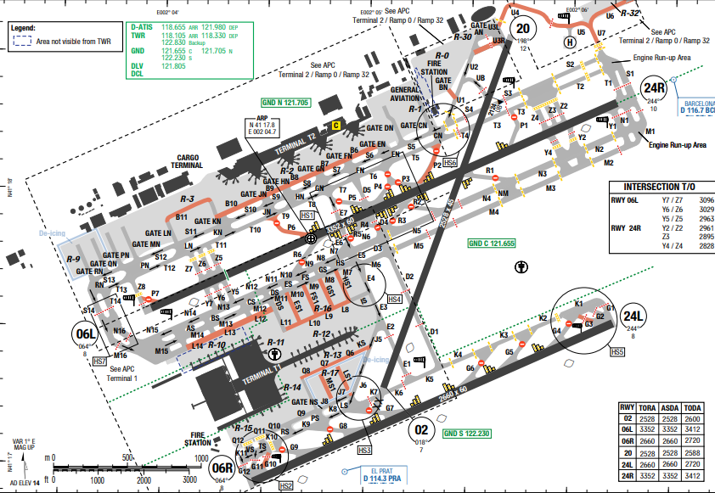
This is an international airport located 12 km (7.5 mi) southwest of the centre of Barcelona, lying in the municipalities of El Prat de Llobregat, Viladecans, and Sant Boi, in Catalonia, Spain.
To the north is a mountainous area with the highest MSA is 6500ft (within the MSA circle.)To the south is the Balearic sea.Barcelona has a hot summer Mediterranean climate, with mild winters and warm to hot summers, while the rainiest seasons are autumn and spring. Its average annual temperature is 21.2 °C during the day and 15.1 °C at night.

Departure |  |  | - Noise abatement procedure is applied.  - SID with high climb gradient, Pilots need to briefing carefully before T/ O
Arrival and Approach |  |  | - Read AOI Chart for rapid exit taxiway
Taxi |  |  | - VDGS is available.  - LVP taxi routes are available, read in charts for details.
Parking information |  |  | No
- TAKE-OFF AND LANDING DISTANCES AVAILABLE
RWY | LENGTH  (m) |  |  | WIDTH  (m) |  | TORA  (m) |  | LDA  (m) | TODA  (m) |  | ASDA  (m)
02 | 2528 |  |  | 45 |  | 2528 |  | 2528 | 2528 |  | 2528
06L | 3352 |  |  | 60 |  | 3352 |  | 2922 | 3352 |  | 3352
06R/ 24L | 2660 |  |  | 60 |  | 2660 |  | 2660 | 2660 |  | 2660
20 | 2528 |  |  | 45 |  | 2528 |  | 2528 | 2528 |  | 2528
24R | 3352 |  |  | 60 |  | 3352 |  | 3352 | 3352 |  | 3352
6. ELEVATION: 14ft | 7. EOSID: YES
8. IAP: ILS (CAT I, II, III), LOC, RNP, VOR
9. COMPANY NOTE | - Lost communication procedure is available.
10. REMARK | NIL

LEMD/ MAD - ADOLFO SUAREZ MADRID – BARAJAS, MADRID, SPAIN
- AIRPORT CATEGORY: A |  |  |  |  |  |  | - RFFS CATEGORY: 9
- AIRPORT CLASSIFICATION
ATR |  | A320 |  |  | A321 |  | A350 |  |  | B787
ADQ |  | ADQ |  |  | ADQ |  | ADQ |  |  | ADQ
- GENERAL STANDARDS
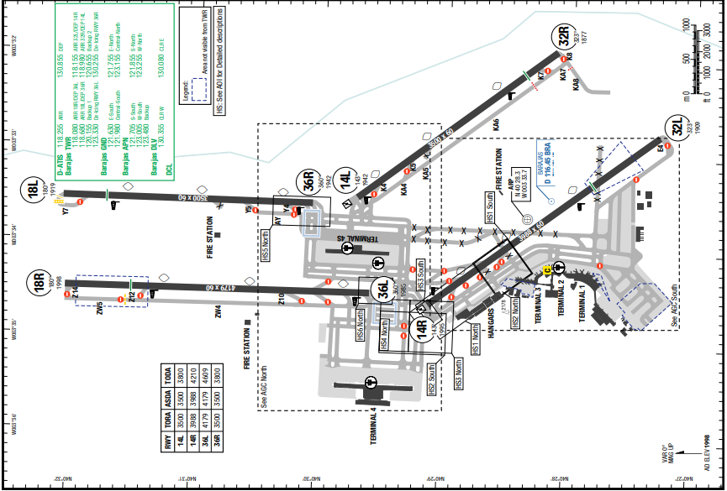
MSA of the airport is 10000ft from all directions.
Within the city limits of Madrid, it is 9 km (6 mi) from the city's financial district and 13 km (8 mi) northeast of the Puerta del Sol or Plaza Mayor de Madrid, Madrid's historic centre. Winters are cool due to its altitude including snowfalls and frequent frosts between December and February. Summers are hot, in the warmest month, July, average temperatures during the day range from 32 to 34 °C.
Departure |  |  | - Departure clearance is available to be requested by CPDLC.  - Deicing service is available.  - Noise abatement procedure is applied.  - SID with high climb gradient, Pilots need to briefing carefully before T/ O
Arrival and Approach |  |  | - Pilots must follow the speed restrictions in AOI CHART  - Low visibility operation is available.
Taxi |  |  | - Pay attention to ATC’s Taxi clearances due to this is a big and busy airport.
Parking information |  |  | - Parking around taxiway C7
- TAKE-OFF AND LANDING DISTANCES AVAILABLE
RWY | LENGTH  (m) |  |  | WIDTH  (m) |  | TORA  (m) |  | LDA  (m) | TODA  (m) |  | ASDA  (m)
14L/ 36R | 3500 |  |  | 60 |  | 3500 |  | N A | 3500 |  | 3500
14R | 3988 |  |  | 60 |  | 3988 |  | N A | 3988 |  | 3988
32L | 3988 |  |  | 60 |  | 3988 |  | 3988 | 3988 |  | 3988
32R/ 18L | 3500 |  |  | 60 |  | 3500 |  | 3500 | 3500 |  | 3500
18R | 4179 |  |  | 60 |  | 4179 |  | 4179 | 4179 |  | 4179
36L | 4179 |  |  | 60 |  | 4179 |  | 4179 | 4179 |  | 4179
6. ELEVATION: 1998ft | 7. EOSID: YES
8. IAP: ILS (CAT I, II, III), LOC, RNP, VOR
9. COMPANY NOTE | - Lost communication procedure is applied.
10. REMARK | NIL

LFBO/ TLS BLAGNAC AIRPORT - TOULOUSE, FRANCE
- AIRPORT CATEGORY: A |  |  |  |  |  |  | - RFFS CATEGORY: 7
- AIRPORT CLASSIFICATION
ATR |  | A320 |  |  | A321 |  | A350 |  |  | B787
ADQ |  | ADQ |  |  | ADQ |  | ADQ |  |  | ADQ
- GENERAL STANDARDS
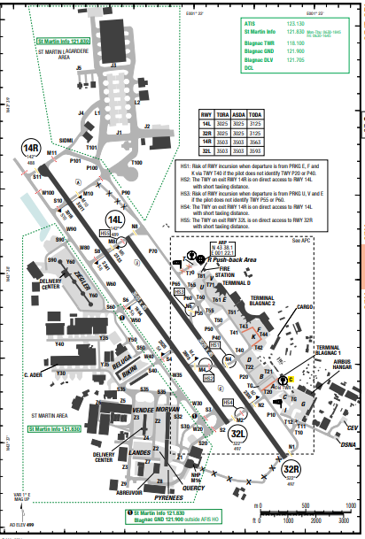
Blagnac International Airport (IATA: TLS, ICAO: LFBO) located in flat area, with sector of 3000ft to all areas. The city is on the banks of the river Garonne, 150 km from the Mediterranean Sea, 230 km from the Atlantic Ocean and 680 km from Paris.
Weather in Toulouse is influenced by Marine - Mild Winter climate. Mild with no dry season, warm summer. Average temperature of all months is lower than 22°C. At least four months with average temperatures are over 10°C. Rainfall spread equally all year around.
Departure |  |  | - Conventional and RNAV SIDs (also are minimum noise routing)  - SID with high climb gradient, Pilots need to briefing carefully before T/ O
Arrival and Approach |  |  | - Conventional and RNAV STARs  - Noise abatement procedure (GS intercept at or above 3000’, initial APCH descend 5.2%)
Taxi |  |  | No
Parking information |  |  | No
- TAKE-OFF AND LANDING DISTANCES AVAILABLE
RWY | LENGTH  (m) |  |  | WIDTH  (m) |  | TORA  (m) |  | LDA  (m) | TODA  (m) |  | ASDA  (m)
14L/ 32R | 3025 |  |  | 45 |  | 3025 |  | 3025 | 3025 |  | 3025
14R | 3503 |  |  | 45 |  | 3503 |  | 3170 | 3503 |  | 3503
32L | 3503 |  |  | 45 |  | 3503 |  | 3503 | 3503 |  | 3503
6. ELEVATION: 499ft | 7. EOSID: NO
8. IAP: ILS (CAT I, II, III), LOC, RNP, VOR
9. COMPANY NOTE | - Speed restriction.  - Nighttime restrictions.
10. REMARK | NIL

LFMN/ NCE– NICE AIRPORT – NICE – FRANCE
1. AIRPORT CATEGORY: A |  |  |  |  |  |  |  | 2. RFFS CATEGORY: 9
3. AIRPORT CLASSIFICATION
ATR |  | A320 |  |  |  | A321 |  | A350 |  |  | B787
ADQ |  | ADQ |  |  |  | ADQ |  | ADQ |  |  | ADQ
4. GENERAL STANDARDS
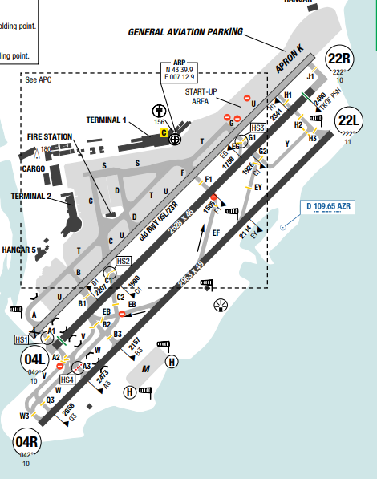
Nice Cote d'Azur airport is located on the southeastern coast of France, bordered by mountainous terrain to the north and the Mediterranean Sea to the south. Notable
terrain includes peaks rising to 4200ft MSL within 9NM and over 10000ft MSL within 29NM to the north and northeast. Short finals to RWY 22 and 04 are affected by surrounding topography, river valleys, and coastal wind patterns. Wind shear and turbulence are common.
Nice has a hot-summer Mediterranean climate, enjoying mild winters with moderate rainfall. It is one of the warmest Mediterranean climates for its latitude. Summers are warm to hot, dry, and sunny.
Departure |  |  | - RWY 04L/R preferred.  - Use NADP 1; avoid overflying land below 6000ft AGL  - MAX IAS 250KT below FL100.  - CDM in use. Push-back clearance valid for 1 minute only.  - Transponder ON/AUTO from start-up until fully parked
Arrival and Approach |  |  | - RWY 04L/R preferred.  - Prefer RNP A 04L or 04R followed by VPT A.  - MAX IAS 250KT below FL100.  - Avoid overflying populated areas (Antibes, Cannes, Villefranche-sur- Mer, Nice)  - Use continuous descent operations when possible.
Taxi |  |  | - TWY U (H1–J1): MAX wingspan 65m.  - TWY T (C–F): MAX wingspan 52m.  - Code F ACFT follow blue offset line on TWY U.  - MAX taxi speed: 17KT straight, 10KT curve
Parking information |  |  | - Stands on APN K require towing.  - VDGS/marshaller required before entering stand.  - Apron K stands 1B–1Q closed 2200–0500.
5. TAKE-OFF AND LANDING DISTANCES AVAILABLE
RWY | LENGTH  (m) |  |  | WIDTH  (m) |  |  | TORA  (m) |  | LDA  (m) | TODA  (m) |  | ASDA  (m)
04L | 2628 |  |  | 45 |  |  | 2628 |  | 2480 | 2480 |  | 2628
04R | 2963 |  |  | 45 |  |  | 2963 |  | 2963 | 2963 |  | 2963
22L | 2963 |  |  | 45 |  |  | 2963 |  | 2778 | 3503 |  | 3503
22R | 2628 |  |  | 45 |  |  | 2628 |  | 2480 | 2480 |  | 2628
6. ELEVATION: 12ft |  |  |  |  | 7. EOSID: YES
8. IAP: ILS, RNP, VOR
9. COMPANY NOTE |  |  |  |  | - APU restrictions:  + With alternative power: MAX 5min after ARR.  + Without: MAX 15min (<140t) / 30min (≥140t).  + Before DEP: MAX 10min (with alt. power), MAX 30min (without).  - Reverse thrust limited to idle unless operationally required.
10. REMARK |  |  |  |  | NIL

LFPG/ CDG - PARIS (CHARLES-DE-GAULLE) - FRANCE
1. AIRPORT CATEGORY: A |  |  |  |  |  |  |  | 2. RFFS CATEGORY: 10
3. AIRPORT CLASSIFICATION
ATR |  | A320 |  |  |  | A321 |  | A350 |  |  | B787
ADQ |  | ADQ |  |  |  | ADQ |  | ADQ |  |  | ADQ
4. GENERAL STANDARDS
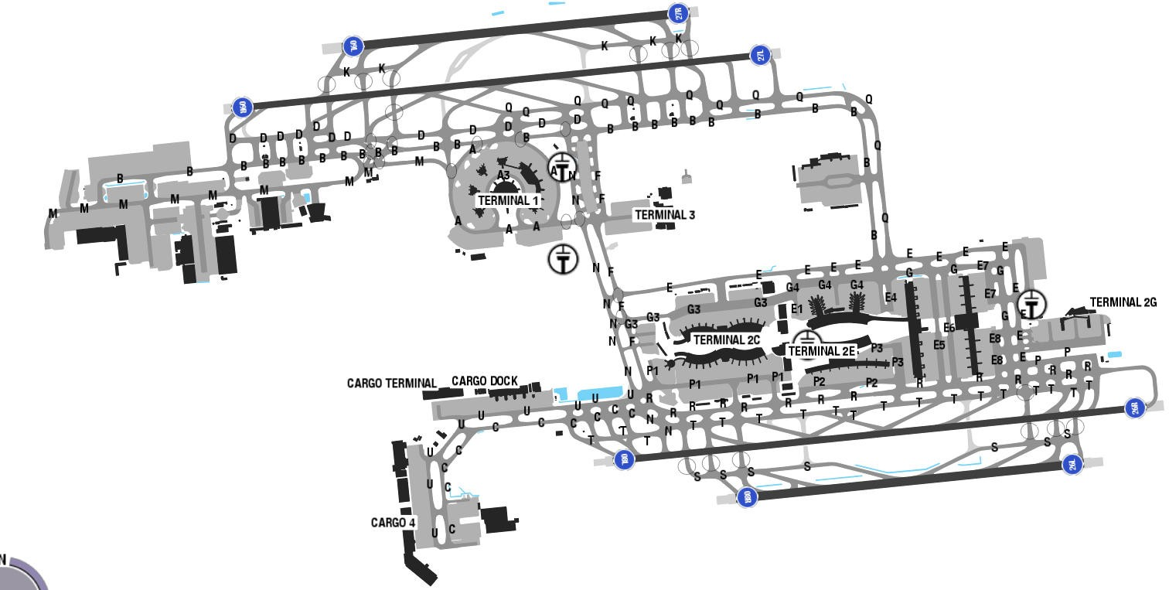
Charles De Gaulle Airport is located at flat area, 25 km (16 mi) to the northeast of Paris. There are no high terrains surround airport, but some high Man-made structures. Summer, from June till the end of September is warmest of the year with showers at times but often clearing quickly and rarely spoiling much of the day. Winter WX much colder and wet in December with temperature drop to 0º by day and frosty spells at night, early morning the poor visibility and low ceiling of cloud is a regular occurrence. Pilot should be careful with patches fog report (BCFG), it reduces slant visibility at low altitude very suddenly even vertical visibility quite good, sometime at flare phase or roll out phase.
Departure |  |  | - A-CDM procedures  - Expect RWY 09R/ 27, 08L/ 26R for departure  - EXPECT SIDs: BUBLI 1A/ B/ G/ H or LANVI 1A/ B/ G/ H  - Noise abatement procedures (NADP1)  - There are SIDs with high climb gradients. If these SIDs are used in operation, ensure that the all engine climb gradient of aircraft meets the required minimum climb gradient  - NADP available at this airport
Arrival and Approach |  |  | - RNAV STARs.  - Expect RWY 09L/ 27R, 08R/ 26L for arrival  - Expect STARs: VEDUS 6E/ W transition LORNI 3E/ W, then radar vectoring for final course.
Taxi |  |  | - After landing, all aircrafts are required to vacate RWY via “Rapid Exit taxiways” (except for LVP) and speed is limited by 50kts
Parking information |  |  | No
5. TAKE-OFF AND LANDING DISTANCES AVAILABLE
RWY | LENGTH  (m) |  |  | WIDTH  (m) |  |  | TORA  (m) |  | LDA  (m) | TODA  (m) |  | TODA  (m)
08L/ 26R | 4142 |  |  | 45 |  |  | 4142 |  | 4142 | 4201 |  | 4142
08R/ 26L | 2700 |  |  | 60 |  |  | 2700 |  | 2700 | 2760 |  | 2700
09L/ 27R | 2700 |  |  | 60 |  |  | 2700 |  | 2700 | 2760 |  | 2700
09R/ 27L | 4200 |  |  | 45 |  |  | 4200 |  | 4200 | 4260 |  | 4200
6. ELEVATION: 392ft |  |  |  |  | 7. EOSID: NO
8. IAP: ILS (CAT I, II, III), LOC, RNP
9. COMPANY NOTE |  |  |  |  | - Restriction use of APU  - The lack of ATC clearance to perform the initial approach may be caused by a late ACC/ APP handover (at or after the IAF), and/ or by an overloaded frequency. In such situation, on reaching the IAF, do not join the holding pattern, but perform by default the initial approach procedure, at the last assigned level which has been acknowledged. This rule has to be followed in all configurations, for all arrivals going to LFPG and using the IAF LORNI, VEBEK (facing West at LFPG), OKIPA and BANOX handled by DE GAULLE Approach.  - Pilot is requested to check all certificates, licenses, logbook, ID, yellow jacket and passport before the flight  - According to the regulation of Airport, person who is movement at apron must wear yellow jacket  - Commander should check all AC documents onboard and validity before flight, especially Residual Disinfection Certificate  - Valid Residual Disinsection Certificate should be present onboard as approval that the a/ c has been disinsected.  - Assigned frequency will not be transmitted by ATC when a/ c is being transferred from Ground to Apron or from Tower to Departure. Therefor crew has to prepare the next frequency in advance.  - All flight documents are brought to the A/ C by the ground handling agents about 60 minutes before the flight.  - The grassy lands on which the airport is located are notorious of rabbits, hares, and birds. Pilot pays more attention to bird strike even high-level flight
10. REMARK |  |  |  |  | Ground Handling Frequency: 131.855 MHz

LFPO/ ORY–ORLY–PARIS, FRANCE
1. AIRPORT CATEGORY: A |  |  |  |  |  |  |  | 2. RFFS CATEGORY: 9
3. AIRPORT CLASSIFICATION
ATR |  | A320 |  |  |  | A321 |  | A350 |  | B787
ADQ |  | ADQ |  |  |  | ADQ |  | ADQ |  | ADQ
4. GENERAL STANDARDS
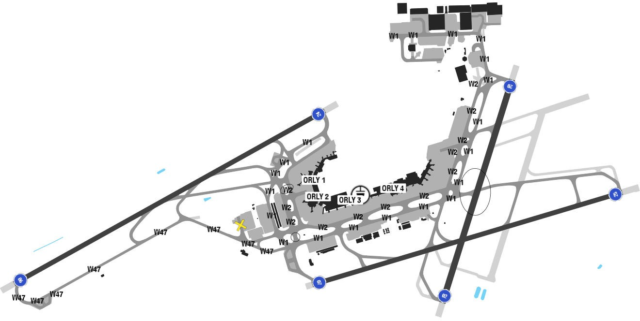
Paris Orly Airport (IATA: ORY, ICAO: LFPO) is one of two international airports serving Paris, France, the other one being Charles de Gaulle Airport (CDG).It is located partially in Orly and partially in Villeneuve-le-Roi, 13 km south of Paris.
Central Paris is home to a high concentration of large and dominating buildings, which absorb much of the daytime heat during the summer, releasing the warmth as evening approaches. At Paris Orly Airport, the summers are short, warm, and partly cloudy and the winters are very cold, windy, and mostly cloudy.
Departure |  |  | - All TKOFs between 2230-0500UTC (time of  brake release) will be performed either on RWY  25 or on RWY 24, according to the RWY availability, and with a tail-wind component not  more than 5KT (gusts included).  - RWY 02/ 20 is exceptionally used in case of:  • unavailability of a main RWY (it should be only used as additional RWY);  • strong winds from North or South sectors.
Arrival and Approach |  |  | - All LDGs between 2230-0500UTC (time of touchdown) will be performed either on RWY 07 or on RWY 06, according to the RWY availability, and with a tail-wind component not more than 5KT including gusts as far as the  operating conditions (like RWY adhesion) are practicable. In this later case, the PIC should justify the choice of another RWY in his flight report and the appropriate airline will send these justifications to the Paris Aerodrome Authority (ADP).
Taxi |  |  | - RETs (Rapid Exit Taxiway) are designed with turn angles and radius lower than regulatory recommendations.  - RET W35 is subject to a speed limitation when vacating the RWY:  • 30KT on wet pavement;  • 35KT on dry pavement.  - RETs W46, W45, W44, W43 are limited to 50KT on wet pavement
Parking information |  |  | - BTN 2230-0400, all ACFT movements on APN and all interventions on stands occupied by an ACFT must be preceded by a call to RPA APOC +331 6 71 76 19 99 to ensure compliance of the APN floodlighting.  - Procedure for North Industrial Apron (ZIN)  + This PROC allows all ACFT and vehicles to give information about movement intentions to other users via the FREQ "ORLY ZIN" on 131.510. COM will be conducted only in French.  + This FREQ must be used before taxiing in the ZIN and constantly monitored during all movements to ensure clearance between every ACFT or mobile units on the TWYs.
5. TAKE-OFF AND LANDING DISTANCES AVAILABLE
RWY | LENGTH  (m) |  |  |  | WIDTH  (m) |  | TORA  (m) |  | LDA  (m) | TODA  (m) | ASDA  (m)
02/ 20 | 2400 |  |  |  | 45 |  | 2400 |  | 2400 | 2400 | 2400
06/ 24 | 3650 |  |  |  | 45 |  | 3650 |  | 3350 | 3710 | 3650
07 | 3320 |  |  |  | 45 |  | 3320 |  | 3320 | 3320 | 3320
25 | 3320 |  |  |  | 45 |  | 3320 |  | 2885 | 3640 | 3320
6. ELEVATION: 392ft |  |  |  | 7. EOSID: NO
8. IAP: ILS (CAT I, II, III), LOC, RNP
9. COMPANY NOTE |  |  |  | - Preferred RWY West Configuration/ East Configuration: For TKOF RWY 24/ RWY 07, for LDG RWY 25/ RWY 06.
10. REMARK |  |  |  | NIL

LGAV/ ATH - ELEFTHERIOS VENIZELOS INTL, ATHENS – GREECE
- AIRPORT CATEGORY: A |  |  |  |  |  |  | - RFFS CATEGORY: 9
- AIRPORT CLASSIFICATION
ATR |  | A320 |  |  | A321 |  | A350 |  |  | B787
ADQ |  | ADQ |  |  | ADQ |  | ADQ |  |  | ADQ
- GENERAL STANDARDS
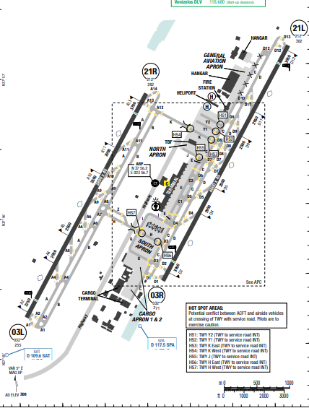
Athens International Airport Eleftherios Venizelos is the largest international airport in Greece, serving the city of Athens and region of Attica.MSA of the airport is from 3500ft to the highest of 7000ft (at surrounding of the airport).
At Athens Eleftherios Venizelos International Airport, the summers are hot, arid, and clear and the winters are long, cold, windy, and partly cloudy. Over the course of the year, the temperature typically varies from 5°C to 32°C and is rarely below 1°C or above 35°C.
Departure |  |  | - RNAV SIDs are available.  - SID with high climb gradient, Pilots need to briefing carefully before T/ O
Arrival and Approach |  |  | - RNAV STARs are available.
Taxi |  |  | - This a small airport with TWO runways and simple taxi ways
Parking information |  |  | No
- TAKE-OFF AND LANDING DISTANCES AVAILABLE
RWY | LENGTH  (m) |  |  | WIDTH  (m) |  | TORA  (m) |  | LDA  (m) | TODA  (m) |  | ASDA  (m)
03L | 3800 |  |  | 45 |  | 3800 |  | 3500 | 3800 |  | 3800
03R | 4000 |  |  | 45 |  | 4000 |  | 3700 | 4000 |  | 4000
21L | 3800 |  |  | 45 |  | 3800 |  | 3700 | 3800 |  | 3800
21R | 4000 |  |  | 45 |  | 4000 |  | 3500 | 4000 |  | 4000
6. ELEVATION: 308ft | 7. EOSID: NO
8. IAP: ILS (CAT I, II), LOC, RNP, VOR
9. COMPANY NOTE | - APU should not exceed 15mins
10. REMARK | NIL

LHBP/ BUD – LISZT FERENC INTL AIRPORT – BUDAPEST, HUNGARY
- AIRPORT CATEGORY: A |  |  |  |  |  |  | - RFFS CATEGORY: 9
- AIRPORT CLASSIFICATION
ATR |  | A320 |  |  | A321 |  | A350 |  |  | B787
ADQ |  | ADQ |  |  | ADQ |  | ADQ |  |  | ADQ
- GENERAL STANDARDS
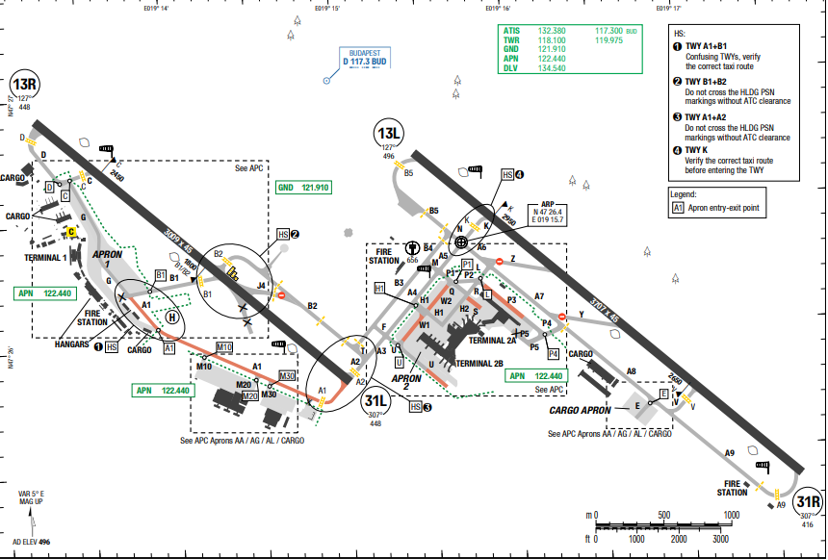
Budapest Ferenc Liszt International Airport, is by far the largest of the country's four commercial airports, ahead of Debrecen and Heviz–Balaton. Budapest has a humid subtropical climate when the 0 °C isotherm is used and warm summers.
Winter (November until early March) can be cold and receives little sunshine. Snowfall is frequent
in most years, and night time temperatures of −10 °Care not uncommon. The spring months (March and April) see variable conditions, with a rapid increase in the average temperature.
Departure |  |  | - RNAV SIDs are available.  - SID with high climb gradient, Pilots need to briefing carefully before T/ O
Arrival and Approach |  |  | - Speed restriction.
Taxi |  |  | - For wingspan and ground movement restrictions  - Taxi routes for arrival  - Taxi routes for departure
Parking information |  |  | No
- TAKE-OFF AND LANDING DISTANCES AVAILABLE
RWY | LENGTH  (m) |  |  | WIDTH  (m) |  | TORA  (m) |  | LDA  (m) | TODA  (m) |  | ASDA  (m)
13L/ 31R | 3707 |  |  | 45 |  | 3707 |  | 3707 | 3707 |  | 3707
13R/ 31L | 3009 |  |  | 45 |  | 3009 |  | 3009 | 3009 |  | 3009
6. ELEVATION: 496ft | 7. EOSID: YES
8. IAP: ILS (CAT I, II, III), RNP, VOR
9. COMPANY NOTE | - Birds in vicinity of AD.  - Noise Abatement Procedures available.
10. REMARK | NIL

LIMC/MXP – MILAN MALPENSA INTERNATIONAL AIRPORT – MILAN – ITALY
- AIRPORT CATEGORY: A |  |  |  |  |  |  | - RFFS CATEGORY: 9
- AIRPORT CLASSIFICATION
ATR |  | A320 |  |  | A321 |  | A350 |  |  | B787
ADQ |  | ADQ |  |  | ADQ |  | ADQ |  |  | ADQ
- GENERAL STANDARDS
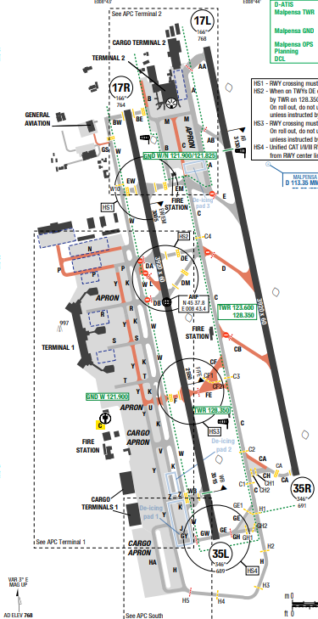
Malpensa airport is located on the edge of the inland plane with the Swiss Alps in the northern quadrants, beginning within 15nm. Terrain surrounding the immediate airport area is fairly flat. Heavily forested areas are west and northwest, while urban development is mostly in the eastern quadrants of the airport. To the northwest, terrain rises to 4625ft MSL within 21NM. To the north, terrain rises to 1614 feet MSL within 9nm. Beyond 60nm in the northern quadrants, peaks commonly rise between 10000 and 14000ft MSL
Departure |  |  | - RWY use for DEP:  + "First day" scheme:  RWY35L:  • 01JAN - 31 MAY and 01 SEP - 31 DEC: 0530-1430‡;  • 01 JUN - 31 AUG 0430- 1300.  RWY 35R:  • 01 JAN - 31 MAY and 01 SEP - 31 DEC: 1430-2300‡;  • 01 JUN - 31 AUG: 1300 - 2200.  + "Second day" scheme:  RWY 35R:  • 01 JAN - 31 MAY and 01 SEP - 31 DEC: 0530-1330‡;  • 01 JUN - 31 AUG: 0430-1300.  RWY35L:  • 01 JAN - 31 MAY and 01 SEP - 31 DEC: 1330-2300‡;  • 01 JUN - 31 AUG: 1300- 2200.  "First day" and "Second day" schemes alternate each other as follow:  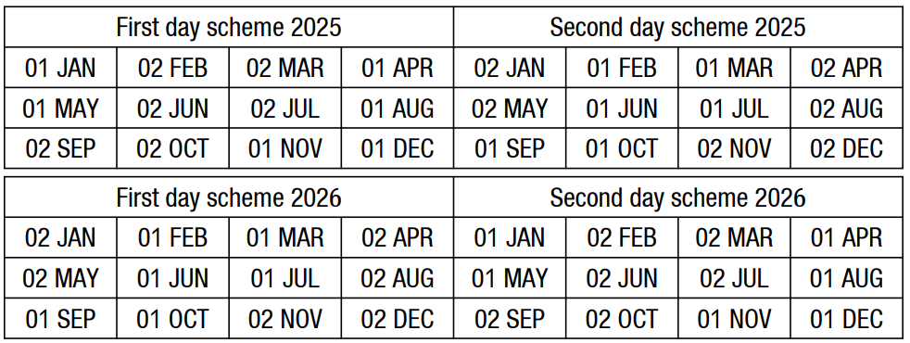  - RWY 35L and 35R used during daytime hours based on season.  - MAX IAS: 230KT until 6000ft; 250KT until FL100 unless instructed otherwise.  - A-CDM: Push-back must commence within 2 minutes of approval; taxi within 2–5 minutes of clearance  - RNAV SIDs available. SIDs with high climb gradient (8%)
Arrival and Approach |  |  | - RNAV STARs available  - Speed restrictions per STAR/IAC: 230KT below FL100, 210KT within 20NM, 160KT at 5NM.  - Simultaneous parallel approaches on RWY 35L/35R with radar only.  - Provide threshold distance to TWR on initial contact.
Taxi |  |  | - APN West: Taxi-in via TWY W, taxi-out via TWY K/Y.  - APN North: Taxi-in via TWY A/B, taxi-out via TWY C.  - Heavy ACFT vacating RWY 17L use TWY CA.  - Taxiway usage subject to restrictions and wing span limitations.
Parking information |  |  | - VDGS type 1 available at key stands (e.g., 401, 495, 701–730).  - Marshaller and follow-me available on request or mandatory in specific cases (e.g., maintenance, LVP).
- TAKE-OFF AND LANDING DISTANCES AVAILABLE
RWY | LENGTH  (m) |  |  | WIDTH  (m) |  | TORA  (m) |  | LDA  (m) | TODA  (m) |  | ASDA  (m)
17L | 3920 |  |  | 60 |  | 3869 |  | 3869 | 3989 |  | 3869
35R | 3920 |  |  | 60 |  | 3882 |  | 3882 | 4082 |  | 3882
17R | 3920 |  |  | 60 |  | 3914 |  | 3914 | 3979 |  | 3914
35L | 3920 |  |  | 60 |  | 3902 |  | 3902 | 4062 |  | 3902
6. ELEVATION: 768ft | 7. EOSID: YES
8. IAP: ILS (CAT I, II, III), LOC, RNP, VOR
9. COMPANY NOTE | - APU use restricted:  + GPU U/S: APU allowed 60min before STD.  + GPU AVBL: APU allowed 5min before engine start.  + After arrival: Shut off within 20min.  -Reverse thrust above idle only for safety/ operational necessity.  -LVP:  + Landing: Prefer RWY 35L.  + Takeoff: Prefer RWY 35R.  + Taxi restrictions apply; follow-me mandatory in low visibility.
10. REMARK | NIL

LIRF/ FCO – FIUMICINO AIRPORT – ROME, ITALY
- AIRPORT CATEGORY: A |  |  |  |  |  |  | - RFFS CATEGORY: 10
- AIRPORT CLASSIFICATION
ATR |  | A320 |  |  | A321 |  | A350 |  |  | B787
ADQ |  | ADQ |  |  | ADQ |  | ADQ |  |  | ADQ
- GENERAL STANDARDS
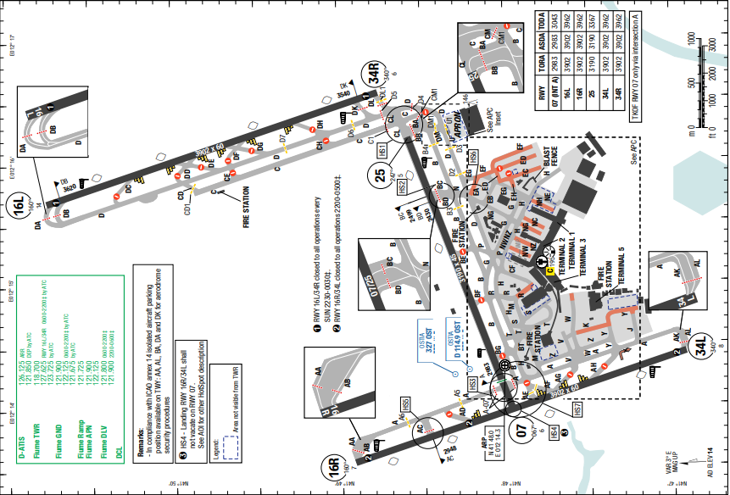
Rome–Leonardo da Vinci Fiumicino International Airport is an international airport in Fiumicino, Italy, serving Rome. It is the busiest airport in the country, the 9th busiest airport in Europe and the world's 46th-busiest airport with over 40.5 million passengers served in 2023.
The climate of Fiumicino airport is Mediterranean, with mild, rainy winters and hot, sunny summers. Airport occasionally affected by wind shear phenomena, more frequently in the months of March and November.
Departure |  |  | - ACDM procedure  - Conventional and RNAV SIDs (include noise  abatement routing)  - SID with high climb gradient, Pilots need to briefing carefully before T/ O
Arrival and Approach |  |  | - RNAV STARs are available.  - Speed restrictions
Taxi |  |  | - Shall vacate RWY via rapid exit TWY  - Wingspan restrictions  - Minimum RWY occupancy time  - LOW VIS taxi route.
Parking information |  |  | No
- TAKE-OFF AND LANDING DISTANCES AVAILABLE
RWY | LENGTH  (m) |  |  | WIDTH  (m) |  | TORA  (m) |  | LDA  (m) | TODA  (m) |  | ASDA  (m)
07 | 3307 |  |  | 45 |  | 3307 |  | 2892 | 3367 |  | 3307
16L/ 34R | 3902 |  |  | 60 |  | 3902 |  | 3902 | 3962 |  | 3902
16R/ 34L | 3902 |  |  | 60 |  | 3902 |  | 3902 | 3962 |  | 3902
25 | 3307 |  |  | 45 |  | 3307 |  | 3307 | 3367 |  | 3307
6. ELEVATION: 14ft | 7. EOSID: YES
8. IAP: ILS (CAT I, II, III), LOC, RNP, VOR
9. COMPANY NOTE | - Use Of APU
10. REMARK | NIL

LKPR/ PRG - VÁCLAV HAVEL AIRPORT PRAGUE
- AIRPORT CATEGORY: A |  |  |  |  |  |  | - RFFS CATEGORY: 10
- AIRPORT CLASSIFICATION
ATR |  | A320 |  |  | A321 |  | A350 |  |  | B787
ADQ |  | ADQ |  |  | ADQ |  | ADQ |  |  | ADQ
- GENERAL STANDARDS
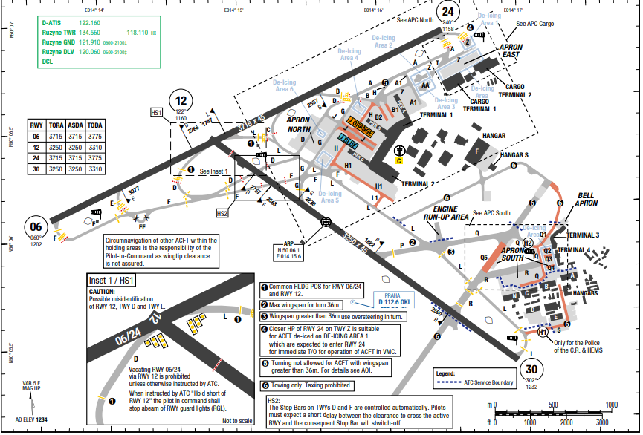
Václav Havel Airport Prague is the international airport of Prague, the capital of the Czech Republic.
At Prague Václav Havel Airport, the summers are comfortable; the winters are very cold, snowy, and windy; and it is partly cloudy year-round. Over the course of the year, the temperature typically varies from -4°C to 24°C and is rarely below -13°C or above 30°C.
Departure |  |  | - RNAV SIDs are available.  - SID with high climb gradient, Pilots need to briefing carefully before T/ O
Arrival and Approach |  |  | - RNAV STARs are available.
Taxi |  |  | - This a small airport with two runways and simple taxi ways
Parking information |  |  | No
- TAKE-OFF AND LANDING DISTANCES AVAILABLE
RWY | LENGTH  (m) |  |  | WIDTH  (m) |  | TORA  (m) |  | LDA  (m) | TODA  (m) |  | ASDA  (m)
06/ 24 | 3715 |  |  | 45 |  | 3715 |  | 3715 | 3775 |  | 3715
12/ 30 | 3250 |  |  | 45 |  | 3250 |  | 3250 | 3310 |  | 3250
6. ELEVATION: 1234ft | 7. EOSID: NO
8. IAP: ILS (CAT I, II, III), LOC, RNP, VOR
9. COMPANY NOTE | - HIRO procedures
10. REMARK | NIL

LOWW/ VIE - SCHWECHAT INTERNATIONAL AIRPORT, VIENNA, AUSTRIA
- AIRPORT CATEGORY: A |  |  |  |  |  |  | - RFFS CATEGORY: 10
- AIRPORT CLASSIFICATION
ATR |  | A320 |  |  | A321 |  | A350 |  |  | B787
ADQ |  | ADQ |  |  | ADQ |  | ADQ |  |  | ADQ
- GENERAL STANDARDS
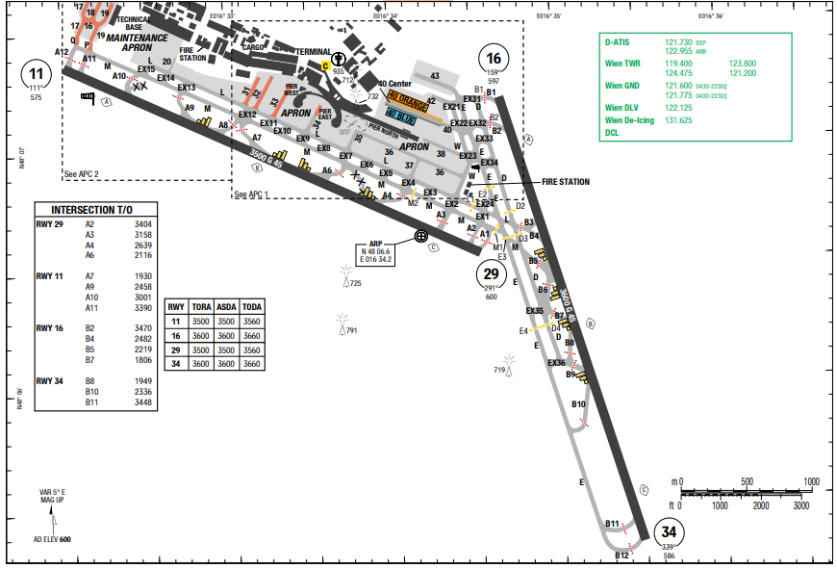
Vienna International Airport (IATA: VIE, ICAO: LOWW) is the international airport of Vienna, the capital of Austria, located in Schwechat, 18 km southeast of central Vienna and 57 kilometres (35 mi) west of Bratislava. MSA of the airport is from 2900ft to the highest of 4500ft (at surrounding of the airport). At Vienna International Airport, the summers are warm; the winters are very cold, snowy, and windy; and it is partly cloudy year round. Over the course of the year, the temperature typically varies from -3°C to 26°C.
Departure |  |  | - RNAV SIDs are available.  - SID with high climb gradient, Pilots need to briefing carefully before T/ O
Arrival and Approach |  |  | - RNAV STARs are available.
Taxi |  |  | - This a big airport with two runways and simple taxi ways
Parking information |  |  | No
- TAKE-OFF AND LANDING DISTANCES AVAILABLE
RWY | LENGTH  (m) |  |  | WIDTH  (m) |  | TORA  (m) |  | LDA  (m) | TODA  (m) |  | ASDA  (m)
11/ 29 | 3500 |  |  | 45 |  | 3500 |  | 3500 | 3500 |  | 3500
16/ 34 | 3600 |  |  | 45 |  | 3600 |  | 3600 | 3600 |  | 3600
6. ELEVATION: 600ft | 7. EOSID: YES
8. PBN AVAILABLE: Y | 9. LVO: Y
9. COMPANY NOTE | - Must inform ATC if using high engine power when maneuvering on ground
10. REMARK | NIL

LRCK/ CND - MIHAIL KOGĂLNICEANU AIRPORT – ROMANIA
- AIRPORT CATEGORY: A |  |  |  |  |  |  | - RFFS CATEGORY: CAT 7, CAT8/ 9 O/ R 48H
- AIRPORT CLASSIFICATION
ATR |  | A320 |  |  | A321 |  | A350 |  |  | B787
ADQ |  | ADQ |  |  | ADQ |  | ADQ |  |  | ADQ
- GENERAL STANDARDS
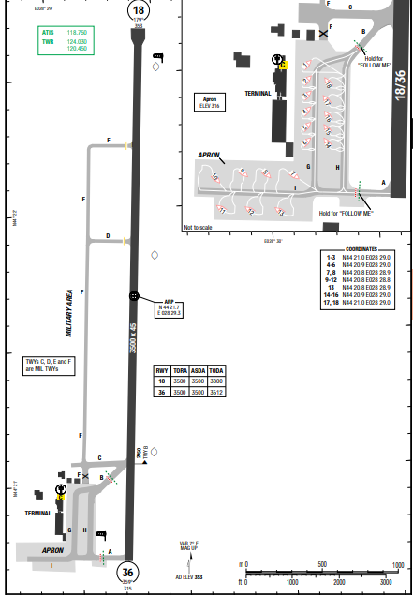
Mihail Kogălniceanu Airport (IATA: CND, ICAO: LRCK) is situated in southeastern Romania, in the commune of Mihail Kogălniceanu, 26 kilometres north-northwest of Constanța.
There is no terrain surrounding the airport.
At Mihail Kogălniceanu International Airport, the summers are warm, dry, and mostly clear and the winters are very cold, snowy, windy, and partly cloudy. Over the course of the year, the temperature typically varies from -3°C to 29°C and is rarely below -11°C or above 33°C.
Departure |  |  | - RNAV SIDs are available.  - SID with high climb gradient, Pilots need to briefing carefully before T/ O
Arrival and Approach |  |  | - RNAV STARs are available.
Taxi |  |  | - This a small airport with one runway and simple taxi ways
Parking information |  |  | No
- TAKE-OFF AND LANDING DISTANCES AVAILABLE
RWY | LENGTH  (m) |  |  | WIDTH  (m) |  | TORA  (m) |  | LDA  (m) | TODA  (m) |  | ASDA  (m)
18/ 36 | 3500 |  |  | 45 |  | 3500 |  | 3500 | 3500 |  | 3500
6. ELEVATION: 353ft | 7. EOSID: NO
8. IAP: ILS, LOC, RNP, VOR
9. COMPANY NOTE | NIL
10. REMARK | NIL

LROP/ OTP - HENRI COANDĂ AIRPORT, BUCHAREST, ROMANIA
- AIRPORT CATEGORY: A |  |  |  |  |  |  | - RFFS CATEGORY: 9
- AIRPORT CLASSIFICATION
ATR |  | A320 |  |  | A321 |  | A350 |  |  | B787
ADQ |  | ADQ |  |  | ADQ |  | ADQ |  |  | ADQ
- GENERAL STANDARDS
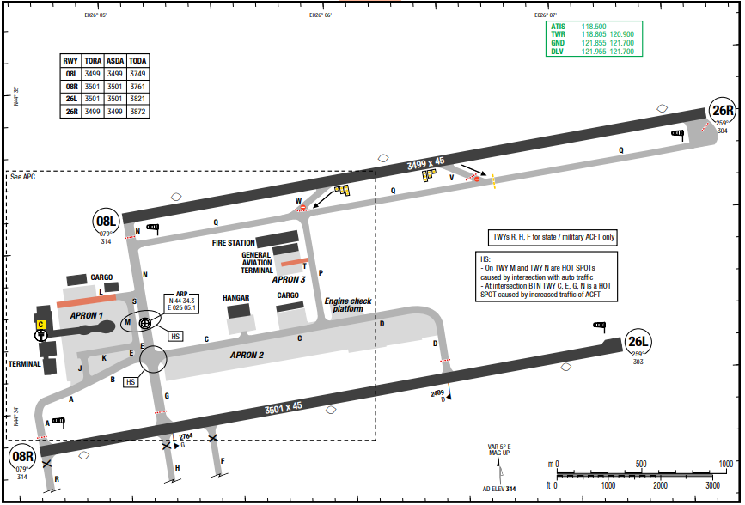
Bucharest Henri Coandă International Airport (IATA: OTP, ICAO: LROP) is Romania's busiest international airport, located in Otopeni, 16.5 km north of Bucharest's city centre.There is no terrain surrounding the airport. At Henri Coandă International Airport, the summers are warm and mostly clear and the winters are freezing, snowy, and partly cloudy. Over the course of the year, the temperature typically varies from -5°C to 30°C and is rarely below -13°C or above 34°C.
Departure |  |  |  | - RNAV SIDs are available.
Arrival and Approach |  |  |  | - RNAV STARs are available.
Taxi |  |  |  | - This a small airport with two runways and simple taxi ways
Parking information |  |  |  | No
- TAKE-OFF AND LANDING DISTANCES AVAILABLE
RWY | LENGTH  (m) |  | WIDTH  (m) |  |  | TORA  (m) |  | LDA  (m) | TODA  (m) |  | ASDA  (m)
08L | 3499 |  | 45 |  |  | 3499 |  | 3493 | 3749 |  | 3499
08R | 3501 |  | 45 |  |  | 3501 |  | 3495 | 3761 |  | 3501
26L | 3501 |  | 45 |  |  | 3501 |  | 3494 | 3821 |  | 3501
26R | 3499 |  | 45 |  |  | 3499 |  | 3493 | 3872 |  | 3499
6. ELEVATION: 314ft | 7. EOSID: NO
8. IAP: ILS (CAT I, II, III), LOC, NDB
9. COMPANY NOTE | - Birds.  - Operation of mode S when aircraft is on the ground
10. REMARK | NIL

LTAC/ ESB – ESENBOGA INTL – ANKARA, TURKEY
- AIRPORT CATEGORY: A |  |  |  |  |  |  | - RFFS CATEGORY: 10
- AIRPORT CLASSIFICATION
ATR |  | A320 |  |  | A321 |  | A350 |  |  | B787
ADQ |  | ADQ |  |  | ADQ |  | ADQ |  |  | ADQ
- GENERAL STANDARDS
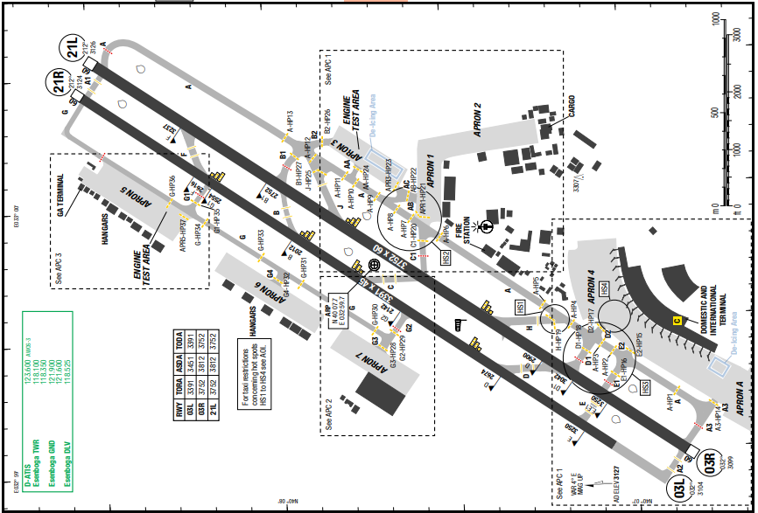
Ankara Esenboga Airport is the international airport of Ankara, the capital city of Turkey. It has been operating since 1955. In 2017, the airport has served more than 15 million passengers in total, 13 million of which were domestic passengers.
Ankara has a cold semi-arid climate. Under the Trewartha climate classification, Ankara has a temperate humid continental climate. Due to its elevation and inland location, Ankara has cold and snowy winters, hot and dry summers. Rainfall occurs mostly during the spring and autumn.
Departure |  |  | - Start-up, push-back and taxi procedures.  - Conventional and RNAV SIDs.  - Require minimum climb gradient.  - On departure, at first contact report call sign only  - Check ATIS for current departure frequency
Arrival and Approach |  |  | - RNAV STARs available  Speed restriction
Taxi |  |  | - ACFT vacating RWY via RET has priority. ACFT on other TWYs give the way to ACFT vacating  RWY via RETs unless otherwise is instructed.
Parking information |  |  | No
- TAKE-OFF AND LANDING DISTANCES AVAILABLE
RWY | LENGTH  (m) |  |  | WIDTH  (m) |  | TORA  (m) |  | LDA  (m) | TODA  (m) |  | ASDA  (m)
03L | 3391 |  |  | 45 |  | 3391 |  | 3391 | 3391 |  | 3451
03R/ 21L | 3752 |  |  | 60 |  | 3752 |  | 3752 | 3752 |  | 3812
21R | 3391 |  |  | 45 |  | 3391 |  | 3391 | 3391 |  | 3391
6. ELEVATION: 3127ft | 7. EOSID: YES
8. IAP: ILS (CAT I, II, III), LOC, NDB, VOR
9. COMPANY NOTE | - AD not AVBL for A380, B748, AN124 and AN225 except presidential ACFT and special permitted ACFT.  - RWY 21L and RWY 21R are the preferred RWYs for TKOF and LDG.  - Noise abatement procedures available
10. REMARK | NIL

LTAI/ AYT – ANTALYA INTL AIRPORT – ANTALYA, TURKEY
- AIRPORT CATEGORY: A |  |  |  |  |  |  | - RFFS CATEGORY: 10
- AIRPORT CLASSIFICATION
ATR |  | A320 |  |  | A321 |  | A350 |  |  | B787
ADQ |  | ADQ |  |  | ADQ |  | ADQ |  |  | ADQ
- GENERAL STANDARDS
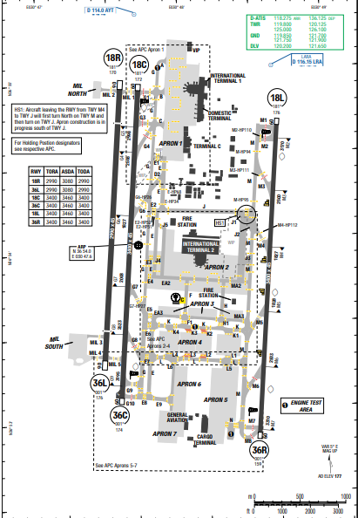
Antalya Airport (IATA: AYT, ICAO: LTAI) is an international airport located 13 km northeast of the city center of Antalya, Turkey.
At Antalya Airport, the summers are hot, humid, arid, and clear and the winters are long, cold, wet, and partly cloudy. Over the course of the year, the temperature typically varies from 6°C to 34°C and is rarely below 1°C or above 39°C.
Departure |  |  | - RNAV SIDs are available.  - SID with high climb gradient, Pilots need to briefing carefully before T/ O
Arrival and Approach |  |  | - RNAV STARs available
Taxi |  |  | - This a big airport with three runways and simple taxi ways
Parking information |  |  | No
- TAKE-OFF AND LANDING DISTANCES AVAILABLE
RWY | LENGTH  (m) |  |  | WIDTH  (m) |  | TORA  (m) |  | LDA  (m) | TODA  (m) |  | ASDA  (m)
18L/ 36R | 3400 |  |  | 45 |  | 3400 |  | 3400 | 3460 |  | 3460
18C/ 36C | 3400 |  |  | 45 |  | 3400 |  | 3400 | 3460 |  | 3460
18R/ 36L | 2990 |  |  | 45 |  | 2990 |  | 2990 | 3080 |  | 3080
6. ELEVATION: 177ft | 7. EOSID: YES
8. IAP: ILS (CAT I, II), LOC, NDB, VOR
9. COMPANY NOTE | - Mode S transponder from request for push-back or taxi and after landing until fully parked on stand.  - Birds in the vicinity of the airport.
10. REMARK | NIL

LTCE/ ERZ - ERZURUM AIRPORT, EZURUM, TURKEY
- AIRPORT CATEGORY: A |  |  |  |  |  |  | - RFFS CATEGORY: 9
- AIRPORT CLASSIFICATION
ATR |  | A320 |  |  | A321 |  | A350 |  | B787
ADQ |  | ADQ |  |  | ADQ |  | ADQ |  | ADQ
- GENERAL STANDARDS
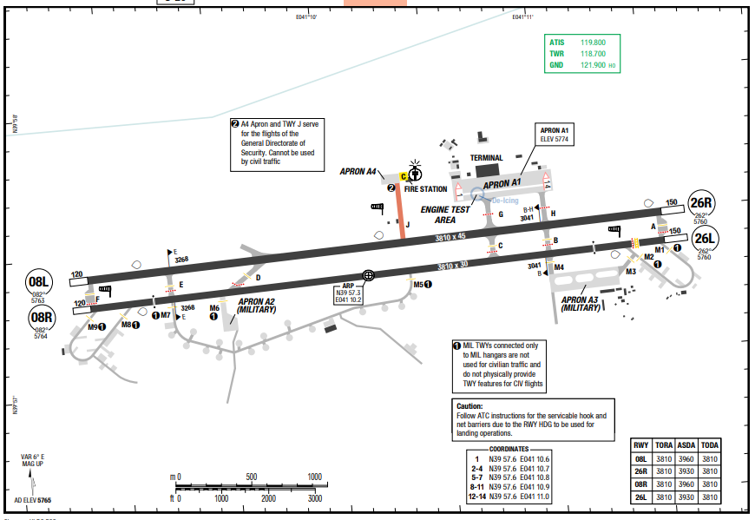
Erzurum Airport (IATA: ERZ, ICAO: LTCE) is a military and public airport serving the city of Erzurum in eastern Turkey. Inaugurated in 1966, it is 11 km far from the city.
MSA of the airport is from 12500ft to the highest of 13000ft (SURROUNDING of the airport).
At Erzurum Airport, the summers are warm, dry, and clear and the winters are freezing, snowy, and partly cloudy. Over the course of the year, the temperature typically varies from -15°C to 28°C and is rarely below -24°C or above 32°C.
Departure |  |  | - RNAV SIDs are available.  - SID with high climb gradient, Pilots need to briefing carefully before T/ O
Arrival and Approach |  |  | - RNAV STARs available
Taxi |  |  | - This a small airport with two runways and simple taxi ways
Parking information |  |  | No
- TAKE-OFF AND LANDING DISTANCES AVAILABLE
RWY | LENGTH  (m) |  |  | WIDTH  (m) |  | TORA  (m) |  | LDA  (m) | TODA  (m) | ASDA  (m)
08L | 3810 |  |  | 45 |  | 3810 |  | 3810 | 3810 | 3960
08R | 3810 |  |  | 45 |  | 3810 |  | 3810 | 3810 | 3960
26L | 3810 |  |  | 45 |  | 3810 |  | 3810 | 3810 | 3930
26R | 3810 |  |  | 45 |  | 3810 |  | 3810 | 3810 | 3930
6. ELEVATION: 5765ft | 7. EOSID: NO
8. IAP: ILS (CAT I, II, III), LOC, RNP, VOR, NDB
9. COMPANY NOTE | - Birds in the vicinity of the airport.
10. REMARK | NIL

LTCG/ TZX – TRABZON (TRABZON INTL) – TURKIYE
- AIRPORT CATEGORY: A |  |  |  |  |  |  | - RFFS CATEGORY: 8
- AIRPORT CLASSIFICATION
ATR |  | A320 |  |  | A321 |  | A350 |  |  | B787
ADQ |  | ADQ |  |  | ADQ |  | ADQ |  |  | ADQ
- GENERAL STANDARDS
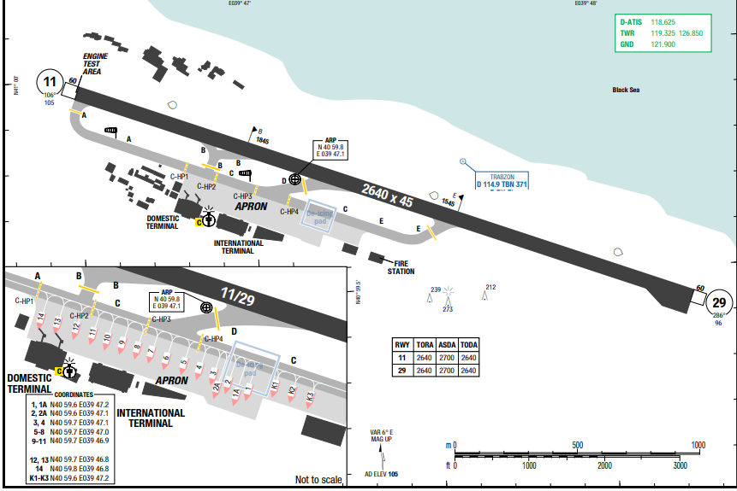
Trabzon Airport is an airport near the city of Trabzon in the eastern Black Sea region of Turkey. The highest MSA is 11500 to the South of the airport.Trabzon has a climate typical of the eastern Black Sea region, a humid subtropical climate near the coast. Summers are warm, the average maximum temperature is around 28 °C in August, while winters are generally cool, the lowest average minimum temperature is almost 5 °C in February.
Departure |  |  | - RNAV SIDs are available.  - SID with high climb gradient, Pilots need to briefing carefully before T/ O
Arrival and Approach |  |  | - RNAV STARs are available.  - Shortcut may be expected for approach.
Taxi |  |  | - Simple taxi route.
Parking information |  |  | No
- TAKE-OFF AND LANDING DISTANCES AVAILABLE
RWY | LENGTH  (m) |  |  | WIDTH  (m) |  | TORA  (m) |  | LDA  (m) | TODA  (m) |  | ASDA  (m)
11/ 29 | 2460 |  |  | 45 |  | 2640 |  | 2640 | 2640 |  | 2700
6. ELEVATION: 105ft | 7. EOSID: NO
8. IAP: ILS, LOC, NDB, VOR
9. COMPANY NOTE | NIL
10. REMARK | NIL

LTFH/ SZF – SAMSUN (CARSAMBA) – TURKEY
- AIRPORT CATEGORY: A |  |  |  |  |  | - RFFS CATEGORY: 8
- AIRPORT CLASSIFICATION
ATR |  | A320 |  |  | A321 | A350 |  |  |  | B787
ADQ |  | ADQ |  |  | ADQ | ADQ |  |  |  | ADQ
- GENERAL STANDARDS
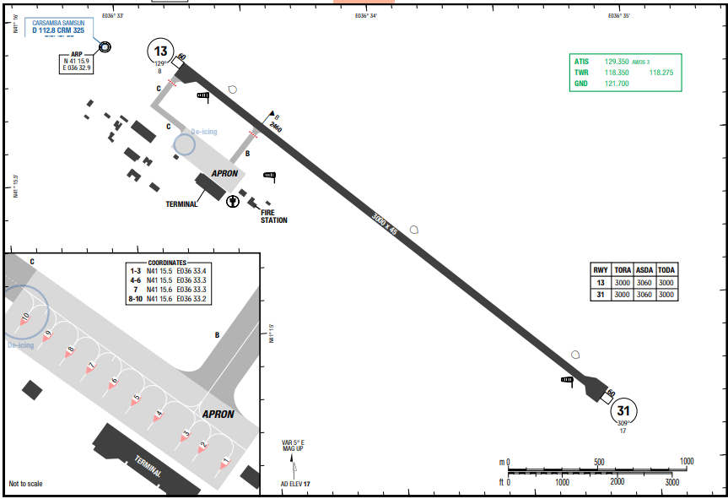
Samsun Caramba Airport is 23 km from Samsun.The highest MSA is 8000 in the south of the airport.
Summers are warm, the average maximum temperature is around 27 °C in August. Winters are cool to mild and wet; the lowest average minimum temperature is around 4 °C in January.
Precipitation is heaviest in late autumn and early winter. Snow sometimes occurs between the months of December and March, but temperatures below the freezing point rarely last more than a couple of days.
Departure |  |  | - RNAV SIDs are available.  - SIDs require minimum climb gradient.  - SID with high climb gradient, Pilots need to briefing carefully before T/ O
Arrival and Approach |  |  | - RNAV STARs are available. Shortcut may be expected.
Taxi |  |  | - TWY C not to be used in case large body ACFT parked at 45° stands.
Parking information |  |  | No
- TAKE-OFF AND LANDING DISTANCES AVAILABLE
RWY | LENGTH  (m) |  |  | WIDTH  (m) |  |  | TORA  (m) | LDA  (m) | TODA  (m) |  | ASDA  (m)
13/ 31 | 2460 |  |  | 45 |  |  | 3000 | 3000 | 3060 |  | 3000
6. ELEVATION: 17ft | 7. EOSID: NO
8. PBN AVAILABLE: Y | 9. LVO: Y
9. COMPANY NOTE | - Birds in vicinity of airport.
10. REMARK | NIL

LTFM/ IST - ISTANBUL AIRPORT, ISTANBUL, TURKEY
- AIRPORT CATEGORY: A |  |  |  |  |  | - RFFS CATEGORY: 10
- AIRPORT CLASSIFICATION
ATR |  | A320 |  |  | A321 | A350 |  |  |  | B787
ADQ |  | ADQ |  |  | ADQ | ADQ |  |  |  | ADQ
- GENERAL STANDARDS
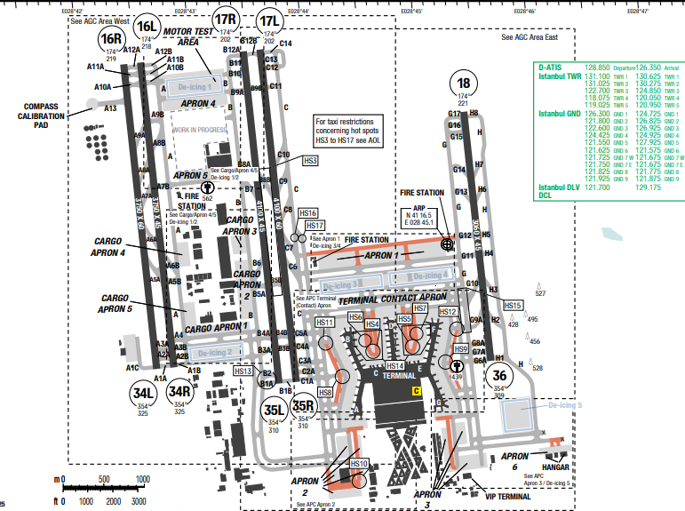
Istanbul Airport (IATA: IST, ICAO: LTFM) is the main international airport serving Istanbul, Turkey. It is located in the Arnavutköy district on the European side of the city.
MSA of the airport is from 3000ft to the highest of 3500ft (at surrounding of the airport)
In İstanbul, the summers are warm, humid, dry, and clear and the winters are long, cold, windy, and partly cloudy. Over the course of the year, the temperature typically varies from 4°C to 29°C and is rarely below -1°C or above 32°C.
Departure |  |  | - RNAV SIDs are available.  - SID with high climb gradient
Arrival and Approach |  |  | - RNAV STARs are available.
Taxi |  |  | - This a big airport with 10 runways and a lot of hot spot.
Parking information |  |  | No
- TAKE-OFF AND LANDING DISTANCES AVAILABLE
RWY | LENGTH  (m) |  |  | WIDTH  (m) |  |  | TORA  (m) | LDA  (m) | TODA  (m) |  | ASDA  (m)
16L/ 34R | 3750 |  |  | 45 |  |  | 3750 | 3750 | 3750 |  | 3750
16R/ 34L | 3750 |  |  | 45 |  |  | 3750 | 3750 | 3750 |  | 3750
17L/ 35R | 4100 |  |  | 60 |  |  | 4100 | 4100 | 4100 |  | 4100
17R/ 35L | 3750 |  |  | 60 |  |  | 3750 | 3750 | 3750 |  | 3750
18/ 36 | 3060 |  |  | 45 |  |  | 3060 | 3060 | 3060 |  | 3060
6. ELEVATION: 325ft | 7. EOSID: NO
8. IAP: ILS (CAT I, II, III), LOC, RNP, VOR
9. COMPANY NOTE | - APU usage limitation.  - Operation of mode S transponder.  - “Reduced engine taxi” not allowed during the RWY crossing  - Push-back Procedure.
10. REMARK | NIL

OEDF/ DMM – KING FAHD INTL AIRPORT – DAMMAM, SAUDI ARABIA
- AIRPORT CATEGORY: A |  |  |  |  |  | - RFFS CATEGORY: 9
- AIRPORT CLASSIFICATION
ATR |  | A320 |  |  | A321 | A350 |  |  |  | B787
ADQ |  | ADQ |  |  | ADQ | ADQ |  |  |  | ADQ
- GENERAL STANDARDS
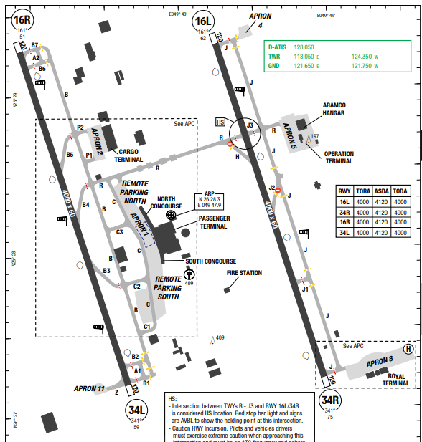
Dammam features a hot desert climate. Winter temperatures range from mild to warm, but regularly drop to as low as around 1 °C at night. Rainfall in Dammam is generally sparse, and usually occurs in small amounts in the winter months of November, December, and January, with periodic heavy thunderstorms. Hail generally falls during these months.
Summer temperatures are extremely hot, owing to the region's geographic location; and continually exceed 40 °C during daylight hours from March to October. Nights during summer generally feature temperatures higher than 35 °C and very high humidity.
Departure |  |  | LVP available
Arrival and Approach |  |  | - Speed restriction within aerodrome traffic circuit for turbine engine aircraft: 200kt, unless otherwise authorized by ATC. Elsewhere: 250 kt.  - RWY 34L is preferred and primary instrument RWY.  - All ACFT arrival at RWY 34L expect vacate via taxiway B3/ B4
Taxi |  |  | - Use of stop bar is mandatory. ACFT crossing red stop bar to enter the RWY even when in receipt of a clearance will be treated as RWY incursion.
Parking information |  |  | No
- TAKE-OFF AND LANDING DISTANCES AVAILABLE
RWY | LENGTH  (m) |  |  | WIDTH  (m) |  |  | TORA  (m) | LDA  (m) | TODA  (m) |  | ASDA  (m)
16L/ 34R | 4000 |  |  | 60 |  |  | 4000 | 4000 | 4120 |  | 4120
16R/ 34L | 4000 |  |  | 60 |  |  | 4000 | 4000 | 4120 |  | 4120
6. ELEVATION: 75ft | 7. EOSID: NO
8. IAP: ILS, LOC, RNP, VOR
9. COMPANY NOTE | - APU usage limitations.  - Push back Procedures.  - RWY 34R and 16R right-hand circuit.
10. REMARK | NIL

OIIE/ IKA – IMAM KHOMAINI INTERNATION AIRPORT, TEHRAN, IRAN
- AIRPORT CATEGORY: A |  |  |  |  |  |  | - RFFS CATEGORY: 9
- AIRPORT CLASSIFICATION
ATR |  | A320 |  |  | A321 |  | A350 |  |  | B787
ADQ |  | ADQ |  |  | ADQ |  | ADQ |  |  | ADQ
- GENERAL STANDARDS
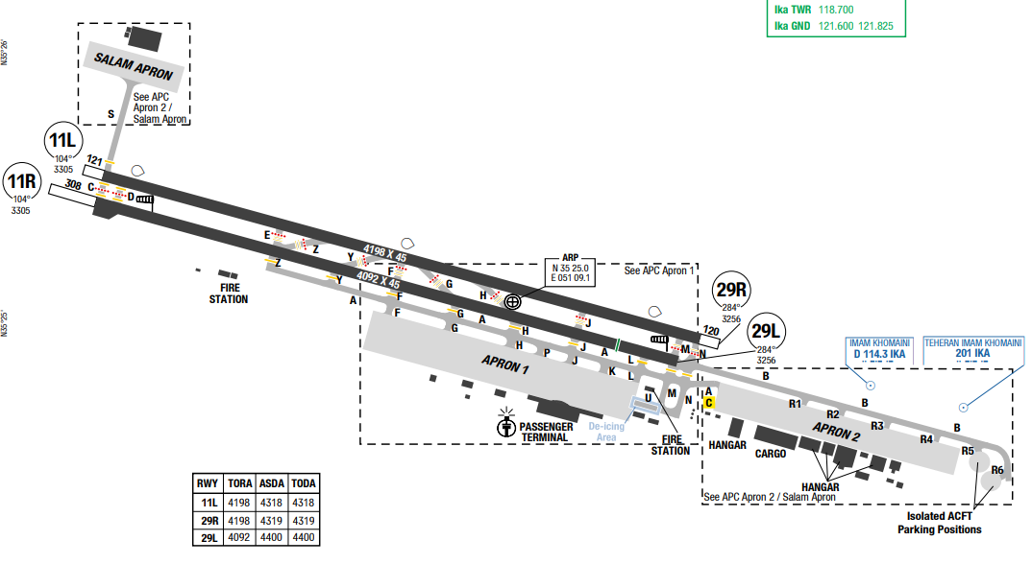
Tehran Imam Khomeini International Airport is the international airport of Tehran, the capital of Iran. It is located 2 kilometers of Vahnabad and 35 kilometres southwest of Tehran and is named for Ruhollah Khomeini, Iran's first supreme leader. The airport is operated by Imam Khomeini Airport City Company. It covers 13,400 hectares and has two terminals and two runways.
Tehran's climate is arid continental, with quite cold, relatively rainy winters and very hot, sunny summers. The city is the capital of Iran and is located in the north of the country, at 35 degrees north latitude.
Departure |  |  | - Preferential RWY 29 in use unless tailwind >10KT.  - MAX IAS: 250KT below FL100 in Class D/G; 270KT in TMA; 230KT in CTR.  - Take-off opposite to RWY in use is prohibited unless in emergency.  - COM failure procedures include detailed routing per SID.
Arrival and Approach |  |  | - RWY 29R preferred for ILS precision approach.  - All arrivals expect wind shear on final.  - Traffic pattern: 5000ft (heavy), 4500ft (others).
Taxi |  |  | - TWY F (between TWY A and APN): AVBL only HJ.  - No edge lights on TWY A/B and R1–R6.  - 180° turns allowed only at runway ends.
Parking information |  |  | No
- TAKE-OFF AND LANDING DISTANCES AVAILABLE
RWY | LENGTH  (m) |  |  | WIDTH  (m) |  | TORA  (m) |  | LDA  (m) | TODA  (m) |  | ASDA  (m)
11L/29R | 4198 |  |  | 45 |  | 4198 |  | 4198 | 4319 |  | 4319
11R/29L | 4092 |  |  | 45 |  | 4092 |  | 4092 | 4400 |  | 4400
6. ELEVATION: 3305ft | 7. EOSID: NO
8. IAP: ILS (CAT I/II), LOC, RNP, VOR
9. COMPANY NOTE | - Airport closed annually on June 4 from 2345–0400 UTC.  - De-icing available H24 at TWY A and TWY U.  - APU restrictions not specified, follow standard noise abatement if applicable
10. REMARK | NIL

OIMM/ MHD - MASHHAD INTERNATIONAL AIRPORT, MASHHAD, IRAN
- AIRPORT CATEGORY: A |  |  |  |  |  |  | - RFFS CATEGORY: 8
- AIRPORT CLASSIFICATION
ATR |  | A320 |  |  | A321 |  | A350 |  |  | B787
ADQ |  | ADQ |  |  | ADQ |  | ADQ |  |  | ADQ
- GENERAL STANDARDS
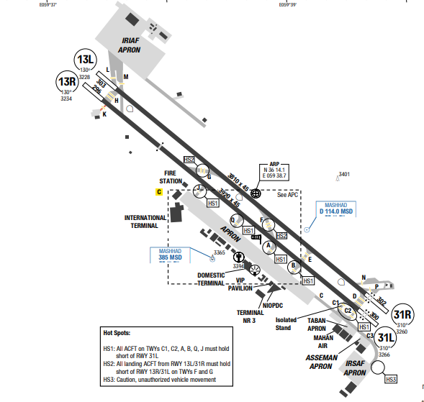
Mashhad International Airport (IATA: MHD, ICAO: OIMM) is an international airport located in Mashhad, Razavi Khorasan, Iran. MSA of the airport is from 8600ft to the highest of 11800ft. At Mashhad International Airport, the summers are hot, arid, and clear and the winters are very cold, snowy, and mostly clear. Over the course of the year, the temperature typically varies from -2°C to 35°C and is rarely below -8°C or above 38°C.
Departure |  |  | - RNAV SIDs are available.
Arrival and Approach |  |  | - RNAV STARs are available.
Taxi |  |  | - This a small airport with two runways and simple taxi ways
Parking information |  |  | No
- TAKE-OFF AND LANDING DISTANCES AVAILABLE
RWY | LENGTH  (m) |  |  | WIDTH  (m) |  | TORA  (m) |  | LDA  (m) | TODA  (m) |  | ASDA  (m)
13L/ 31R | 3810 |  |  | 45 |  | 3810 |  | 3810 | 4112 |  | 4112
13R | 3920 |  |  | 45 |  | 3920 |  | 3920 | 4220 |  | 4220
31L | 3920 |  |  | 45 |  | 3920 |  | 3920 | 4216 |  | 4216
6. ELEVATION: 3266ft | 7. EOSID: NO
8. IAP: ILS, LOC, NDB, VOR
9. COMPANY NOTE | - When tailwind < 8kts, RWY 31R will be used in preference  - Strolling dogs exist on the movement area  - Birds in the vicinity of the airport.
10. REMARK | NIL

OISS/ SYZ – SHAHID DASTGHAIB INTERNATIONAL AIRPORT – SHIRAZ – IRAN
- AIRPORT CATEGORY: A |  |  |  |  |  | - RFFS CATEGORY: 8
- AIRPORT CLASSIFICATION
ATR |  | A320 |  |  | A321 | A350 |  |  |  | B787
ADQ |  | ADQ |  |  | ADQ | ADQ |  |  |  | ADQ
- GENERAL STANDARDS
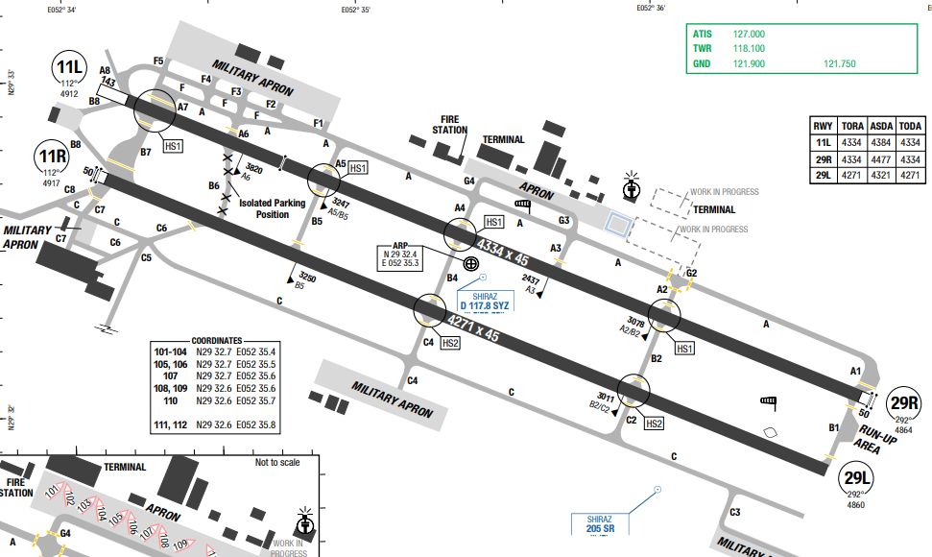
Shiraz Shahid Dastghaib International Airport is located in the southern part of Iran, surrounded by mountainous terrain. The airport is situated at an elevation of 4917 ft and experiences variable weather conditions. Terrain and obstacle considerations, strict wind limitations, and limited lighting/taxi guidance affect operations. In Shiraz, the summers are sweltering, arid, and clear and the winters are cold and mostly clear. Summers are hot and dry, with an average high temperature of 38.7 °C in July. Winters are cool and wet, with average low temperatures below freezing in January.
Departure |  |  | - RWY 29R preferred for departures.  - MAX IAS: 250KT below FL100 in Class D/G airspace.  - Intersection takeoffs are prohibited when visibility <1200m, braking action is poor, or full RWY length is unavailable.  - Start-up clearance valid for 10 minutes.
Arrival and Approach |  |  | - RWY 29L preferred for arrivals.  - MAX IAS: 270KT between FL200–FL150; 250KT below FL150.  - Traffic pattern: 6500ft for heavy aircraft, 6000ft for others.
Taxi |  |  | - 80° turns only allowed on turning pads.  - Heavy aircraft to use minimum power at all times.  - TWYs G2/G3/G4: Follow marshaller to stands.
Parking information |  |  | - Follow-me/marshaller required at apron entry.  - Use minimum power when taxiing on apron.  - De-icing available H24 on east side of civil apron with marshaller assistance
- TAKE-OFF AND LANDING DISTANCES AVAILABLE
RWY | LENGTH  (m) |  |  | WIDTH  (m) |  |  | TORA  (m) | LDA  (m) | TODA  (m) |  | ASDA  (m)
11L | 4334 |  |  | 45 |  |  | 4334 | 4334 | 4334 |  | 4384
29R | 4334 |  |  | 45 |  |  | 4334 | 4334 | 4334 |  | 4477
11R/29L | 4271 |  |  | 45 |  |  | 4271 | 4271 | 4271 |  | 4321
6. ELEVATION: 4917ft | 7. EOSID: NO
8. IAP: ILS, LOC, RNP, NDB, VOR
9. COMPANY NOTE | - Engine idle tests ≤5 min may be conducted on stand; longer runs at TWY B1.  - Arresting gear (net/hook barriers) installed on RWY 11L/29L.  - Operation stopped if:  + Crosswind > 15KT,  + Tailwind > 10KT,  + RWYCC ≤ 3.  - Noise Abatement:  + TKOF RWY 29L/R prohibited between 1930–0230 local unless tailwind ≥5KT or adverse WX.  + VIS right turns from RWY 29L/R also prohibited during those hours.
10. REMARK | NIL

OITT/ TBZ – TABRIZ INTL – TABRIZ – IRAN
- AIRPORT CATEGORY: A |  |  |  |  |  | - RFFS CATEGORY: 8
- AIRPORT CLASSIFICATION
ATR |  | A320 |  |  | A321 | A350 |  |  |  | B787
ADQ |  | ADQ |  |  | ADQ | ADQ |  |  |  | ADQ
- GENERAL STANDARDS
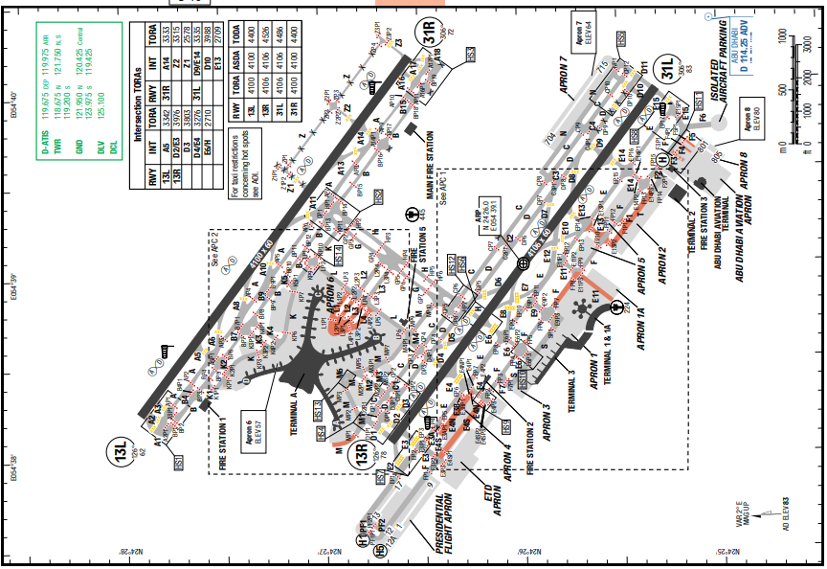
Zayed International Airport (IATA: AUH, ICAO: OMAA), also known as Abu Dhabi International Airport, is the primary international airport serving Abu Dhabi, the capital of the United Arab Emirates (UAE). It is the second busiest airport in the UAE after Dubai International Airport. In Abu Dhabi, the summers are long, sweltering, oppressive, arid, and partly cloudy and the winters are comfortable, dry, windy, and mostly clear. The winter season (December to mid-March) promises perfectly balmy weather with occasional rainfall and an average daytime temperature of 25°C. Summertime (late May to September) sees daytime temperatures soar to a sweltering 45°C and higher.
Departure |  |  | - The airport’s RNAV SIDs are available and require climb gradients.  - In LVP, use full length DEP from CAT III RWY and associated HLDG PSN and TKOF from:  + RWY 31L: TWY E15/ TWY D11;  + RWY 31R: TWY A17;  + RWY 13L: TWY A2.
Arrival and Approach |  |  | - Pilots should typically expect the following speed control restrictions to be enforced by ATC:  + 210 – 250 KTS from CTA entry to downwind;  + 180 – 230 KTS from downwind to base leg;  + 160 – 210 KTS on base leg and closing heading to final approach;  + 180 KTS to 10 NM from touchdown;  + 160 KTS or less to 4 NM from touchdown.  - Pilots shall maintain a minimum Indicated Air Speed of 160 KTS or greater to 4 NM from touchdown, unless otherwise instructed by ATC. ATC considers a zero tolerance with regards to the accuracy of speed control instructions and non-compliance with ATC instructions will be reported to the authority.
Taxi |  |  | - TWY F4, F5 are AVBL up to code letter C ACFT.  - TWY E11 (S of TWY F), E13 (S of TWY E), F (BTN TWY E9 and E11), F1, L1, L2 (W of TWY L), L3 (W of TWY L), L4, M (W of PRKG stand 602R), T (W of TWY E14) are AVBL up to code letter E ACFT.
Parking information |  |  | NIL
- TAKE-OFF AND LANDING DISTANCES AVAILABLE
RWY | LENGTH  (m) |  |  | WIDTH  (m) |  |  | TORA  (m) | LDA  (m) | TODA  (m) |  | ASDA  (m)
13L/ 31R | 4100 |  |  | 60 |  |  | 4100 | 4100 | 4400 |  | 4100
13R | 4106 |  |  | 60 |  |  | 4106 | 4106 | 4526 |  | 4106
31L | 4106 |  |  | 60 |  |  | 4106 | 4106 | 4486 |  | 4106
6. ELEVATION: 83ft | 7. EOSID: NO
8. IAP: ILS (CAT I, II, III), LOC, RNP, VOR
9. COMPANY NOTE | No
10. REMARK | NIL

OIZH/ ZAH – ZAHEDAN AIRPORT – ZAHEDAN – IRAN
- AIRPORT CATEGORY: A |  |  |  |  |  | - RFFS CATEGORY: 10
- AIRPORT CLASSIFICATION
ATR |  | A320 |  |  | A321 | A350 |  |  |  | B787
ADQ |  | ADQ |  |  | ADQ | ADQ |  |  |  | ADQ
- GENERAL STANDARDS
Zayed International Airport (IATA: AUH, ICAO: OMAA), also known as Abu Dhabi International Airport, is the primary international airport serving Abu Dhabi, the capital of the United Arab Emirates (UAE). It is the second busiest airport in the UAE after Dubai International Airport. In Abu Dhabi, the summers are long, sweltering, oppressive, arid, and partly cloudy and the winters are comfortable, dry, windy, and mostly clear. The winter season (December to mid-March) promises perfectly balmy weather with occasional rainfall and an average daytime temperature of 25°C. Summertime (late May to September) sees daytime temperatures soar to a sweltering 45°C and higher.
Departure |  |  | - The airport’s RNAV SIDs are available and require climb gradients.  - In LVP, use full length DEP from CAT III RWY and associated HLDG PSN and TKOF from:  + RWY 31L: TWY E15/ TWY D11;  + RWY 31R: TWY A17;  + RWY 13L: TWY A2.
Arrival and Approach |  |  | - Pilots should typically expect the following speed control restrictions to be enforced by ATC:  + 210 – 250 KTS from CTA entry to downwind;  + 180 – 230 KTS from downwind to base leg;  + 160 – 210 KTS on base leg and closing heading to final approach;  + 180 KTS to 10 NM from touchdown;  + 160 KTS or less to 4 NM from touchdown.  - Pilots shall maintain a minimum Indicated Air Speed of 160 KTS or greater to 4 NM from touchdown, unless otherwise instructed by ATC. ATC considers a zero tolerance with regards to the accuracy of speed control instructions and non-compliance with ATC instructions will be reported to the authority.
Taxi |  |  | - TWY F4, F5 are AVBL up to code letter C ACFT.  - TWY E11 (S of TWY F), E13 (S of TWY E), F (BTN TWY E9 and E11), F1, L1, L2 (W of TWY L), L3 (W of TWY L), L4, M (W of PRKG stand 602R), T (W of TWY E14) are AVBL up to code letter E ACFT.
Parking information |  |  | No
- TAKE-OFF AND LANDING DISTANCES AVAILABLE
RWY | LENGTH  (m) |  |  | WIDTH  (m) |  |  | TORA  (m) | LDA  (m) | TODA  (m) |  | ASDA  (m)
13L/ 31R | 4100 |  |  | 60 |  |  | 4100 | 4100 | 4400 |  | 4100
13R | 4106 |  |  | 60 |  |  | 4106 | 4106 | 4526 |  | 4106
31L | 4106 |  |  | 60 |  |  | 4106 | 4106 | 4486 |  | 4106
6. ELEVATION: 83ft | 7. EOSID: YES
8. IAP: ILS (CAT I, II, III), LOC, RNP, VOR
9. COMPANY NOTE | No
10. REMARK | NIL

OKKK/ KWI – KUWAIT INTL – KUWAIT
1. AIRPORT CATEGORY: A |  |  |  |  |  |  |  | 2. RFFS CATEGORY: 10
3. AIRPORT CLASSIFICATION
ATR |  | A320 |  |  |  | A321 |  | A350 |  |  | B787
ADQ |  | ADQ |  |  |  | ADQ |  | ADQ |  |  | ADQ
4. GENERAL STANDARDS
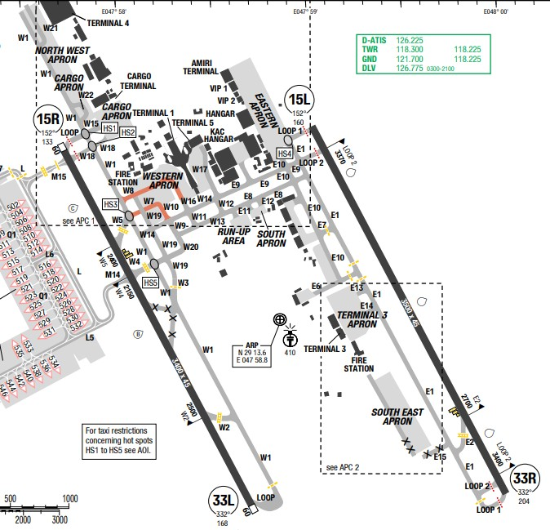
Kuwait International Airport (IATA: KWI, ICAO: OKKK) is an international airport located in the Farwaniya Governorate, Kuwait, 15.5 kilometers (9.6 mi) south of the centre of Kuwait City, spread over an area of 37.7 square kilometres (15.6 sq mi). Kuwait has a hyper arid desert
climate that is highly variable with recurrent extremes. The climate is marked by four distinct seasons, with long, hot and dry summers and short winters.
Departure |  |  | - RNAV SIDs.  - MAX IAS: 250KT below FL100.  - Start-up: Must report intended FL to DLV if different from FPL.  - Intersection TKOF permitted only via designated TWYs (e.g., W2, W4, E2, etc. under CAT II).  - ATC Slot clearance via DLV 10 min prior to startup request.
Arrival and Approach |  |  | - RNAV STARs.  - MAX IAS: 250KT below FL100 (Class D airspace).  - RWY 15R and 33R: Right-hand traffic circuit.  - Glidepath intercepts:  + RWY 15L: 320m past THR → 3180m landing distance remaining.  + RWY 33L: 326m past THR → 3074m remaining.  + RWY 33R: 326m past THR → 3174m remaining.
Taxi |  |  | - Expect complex taxi routing and loop usage depending on RWY config.  - Review hot spots before taxi especially near RWY 15R/33L.- W8: Up to code E  - W7/W10: Up to code C only
Parking information |  |  | - VDGS (Safegate) available at most terminal and remote stands.  - Engine run-up allowed only at idle power.
5. TAKE-OFF AND LANDING DISTANCES AVAILABLE
RWY | LENGTH  (m) |  |  | WIDTH  (m) |  |  | TORA  (m) |  | LDA  (m) | TODA  (m) |  | ADSA  (m)
08L/ 26R | 4142 |  |  | 45 |  |  | 4142 |  | 4142 | 4201 |  | 4142
08R/ 26L | 2700 |  |  | 60 |  |  | 2700 |  | 2700 | 2760 |  | 2700
09L/ 27R | 2700 |  |  | 60 |  |  | 2700 |  | 2700 | 2760 |  | 2700
09R/ 27L | 4200 |  |  | 45 |  |  | 4200 |  | 4200 | 4260 |  | 4200
6. ELEVATION: 205ft |  |  |  |  | 7. EOSID: NO
8. IAP: ILS (CAT I, II, III), LOC, RNP
9. COMPANY NOTE |  |  |  |  | - Non-noise certified aircraft are restricted from 1830–0530 UTC.  - Engine idle and reduced power use advised.  - No specific APU limitations stated, but noise policy implies restrictions may apply near terminals.  - Daily radio sonde and pilot balloon launches: 0001 & 1200 UTC; 0600 & 1800 UTC  - Dust storms prevalent from March to July.  - Lighted highway near RWY 33R/15L may cause visual confusion in low visibility/night.
10. REMARK |  |  |  |  | NIL

OMAA/ AUH – ZAYED INTL – ABU DHABI – U.A.E
- AIRPORT CATEGORY: A |  |  |  |  |  | - RFFS CATEGORY: 10
- AIRPORT CLASSIFICATION
ATR |  | A320 |  |  | A321 | A350 |  |  |  | B787
ADQ |  | ADQ |  |  | ADQ | ADQ |  |  |  | ADQ
- GENERAL STANDARDS
Zayed International Airport (IATA: AUH, ICAO: OMAA), also known as Abu Dhabi International Airport, is the primary international airport serving Abu Dhabi, the capital of the United Arab Emirates (UAE). It is the second busiest airport in the UAE after Dubai International Airport. In Abu Dhabi, the summers are long, sweltering, oppressive, arid, and partly cloudy and the winters are comfortable, dry, windy, and mostly clear. The winter season (December to mid-March) promises perfectly balmy weather with occasional rainfall and an average daytime temperature of 25°C. Summertime (late May to September) sees daytime temperatures soar to a sweltering 45°C and higher.
Departure |  |  | - The airport’s RNAV SIDs are available and require climb gradients.  - In LVP, use full length DEP from CAT III RWY and associated HLDG PSN and TKOF from:  + RWY 31L: TWY E15/ TWY D11;  + RWY 31R: TWY A17;  + RWY 13L: TWY A2.
Arrival and Approach |  |  | - Pilots should typically expect the following speed control restrictions to be enforced by ATC:  + 210 – 250 KTS from CTA entry to downwind;  + 180 – 230 KTS from downwind to base leg;  + 160 – 210 KTS on base leg and closing heading to final approach;  + 180 KTS to 10 NM from touchdown;  + 160 KTS or less to 4 NM from touchdown.  - Pilots shall maintain a minimum Indicated Air Speed of 160 KTS or greater to 4 NM from touchdown, unless otherwise instructed by ATC. ATC considers a zero tolerance with regards to the accuracy of speed control instructions and non-compliance with ATC instructions will be reported to the authority.
Taxi |  |  | - TWY F4, F5 are AVBL up to code letter C ACFT.  - TWY E11 (S of TWY F), E13 (S of TWY E), F (BTN TWY E9 and E11), F1, L1, L2 (W of TWY L), L3 (W of TWY L), L4, M (W of PRKG stand 602R), T (W of TWY E14) are AVBL up to code letter E ACFT.
Parking information |  |  | No
- TAKE-OFF AND LANDING DISTANCES AVAILABLE
RWY | LENGTH  (m) |  |  | WIDTH  (m) |  |  | TORA  (m) | LDA  (m) | TODA  (m) |  | ASDA  (m)
13L/ 31R | 4100 |  |  | 60 |  |  | 4100 | 4100 | 4400 |  | 4100
13R | 4106 |  |  | 60 |  |  | 4106 | 4106 | 4526 |  | 4106
31L | 4106 |  |  | 60 |  |  | 4106 | 4106 | 4486 |  | 4106
6. ELEVATION: 83ft | 7. EOSID: YES
8. IAP: ILS (CAT I, II, III), LOC, RNP, VOR
9. COMPANY NOTE | No
10. REMARK | NIL

OMDB/ DXB – DUBAI INTL – DUBAI – U.A.E
- AIRPORT CATEGORY: A |  |  |  |  |  |  | - RFFS CATEGORY: 10
- AIRPORT CLASSIFICATION
ATR |  | A320 |  |  | A321 |  | A350 |  |  | B787
ADQ |  | ADQ |  |  | ADQ |  | ADQ |  |  | ADQ
- GENERAL STANDARDS
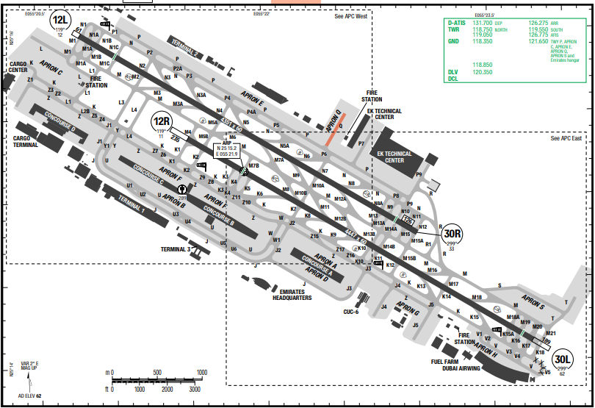
Dubai International Airport (IATA: DXB, ICAO: OMDB) is the primary international airport serving Dubai, United Arab Emirates, and is the world's busiest airport by international passenger traffic.
Dubai features a tropical desert, hot arid climate. Dubai has two seasons – winter and summer. Rainfall has been increasing over the past few decades in the city accumulating to more than 130 mm (5.12 in) per year. Summers are extremely hot and humid with an average high around 41.8 °C and overnight lows around 29.7 °C. Most days are sunny throughout the year. Winters are warm and short with an average high of 23 °C and overnight lows of 14 °C.
Departure |  |  | - RNAV SIDs available  - Remain on TWR FREQ until instructed otherwise. On initial call to DEP, pass the following information: Call-sign / passing level / departure speed, if unable to comply with SID minimum speed restrictions.  - During LVP pilots are required to use the CAT II / III holding points and TKOF from TWYs:  • RWY 30L: K17 / M20  • RWY 30R: N10 / M14A  • RWY 12L: N1A / M1A  • RWY 12R: M4 / K1  - SID with high climb gradient, Pilots need to briefing carefully before T/ O
Arrival and Approach |  |  | - RNAV STARs  - RWY 12R & RWY 12L: Right hand traffic circuit.  - Due capacity constraints from 0000-0259 and 1800-2200, flights shall be arranged to arrive at their coordinated slot time (STA). This time should be planned using a nominal holding time of 8min
Taxi |  |  | Code letter F ACFT: Restricted wingspan
Parking information |  |  | - Stands C51L/ C51/ C51R, C53L/ C53/ C53R, C54L/ C54/ C54R, C55L/ C55/ C55R, E44L/ E44/ E44R and E45L/ E45/ E45R are Multi Aircraft Ramp System (MARS).  - Use the correct CL when arriving on assigned stand.
- TAKE-OFF AND LANDING DISTANCES AVAILABLE
RWY | LENGTH  (m) |  |  | WIDTH  (m) |  | TORA  (m) |  | LDA  (m) | TODA  (m) |  | ASDA  (m)
12L | 4351 |  |  | 60 |  | 4050 |  | 3600 | 4100 |  | 4175
12R | 4447 |  |  | 60 |  | 4106 |  | 4106 | 4375 |  | 4426
30L | 4447 |  |  | 60 |  | 4106 |  | 4106 | 4507 |  | 4504
30R | 4351 |  |  | 60 |  | 4100 |  | 4100 | 4055 |  | 4668
6. ELEVATION: 62ft | 7. EOSID: NO
8. IAP: ILS (CAT I, II, III), LOC, RNP
9. COMPANY NOTE | - Transponder shall remain switches on until parked on stand.  - Birds in the vicinity of the airport.  - Start-up, push-back and taxi procedures.
10. REMARK | NIL

OOMS/ MCT – MUSCAT INTL AIRPORT – MUSCAT – OMAN
- AIRPORT CATEGORY |  |  |  |  |  |  | - RFFS CATEGORY: 10
- AIRPORT CLASSIFICATION
ATR |  | A320 |  |  | A321 |  | A350 |  |  | B787
ADQ |  | ADQ |  |  | ADQ |  | ADQ |  |  | ADQ
- GENERAL STANDARDS
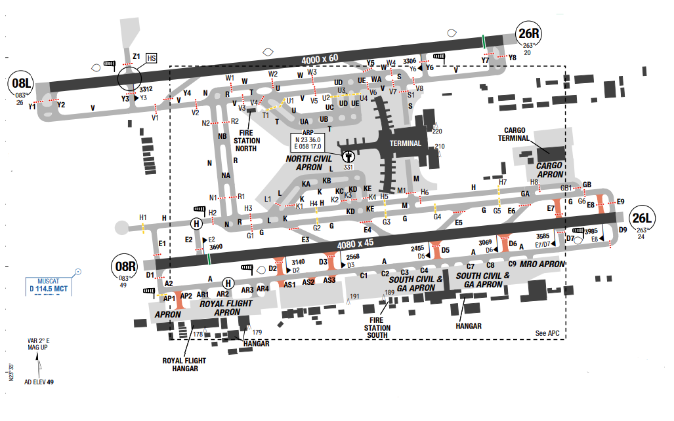
Muscat International Airport (IATA: MCT, ICAO: OOMS), formerly Seeb International Airport, is the main international airport in Oman and is located in Seeb, 32 km from the old city and capital Muscat within the Muscat metropolitan area. Muscat is the capital and most populated city in Oman. Muscat is in northeast Oman and the Tropic of Cancer passes south of the area. Muscat features a hot, arid climate with long and very hot summers and warm "winters". The climate generally is very hot and very humid in the summer, with temperatures frequently reaching as high as 40°C in the summer.

Departure |  |  | - RNAV SIDs available  - Noise abatement procedure: (NADP 1).  - SID with high climb gradient
Arrival and Approach |  |  | - RNAV STARs  - For ILS approach: Maintain assigned altitude until GS intercept, do not fly below GS thereafter.  - For visual approach: Minimum 7nm from the RWY  - RWYs 26R right-hand circuit  - Unless otherwise notified by ATC, pilots should only land on the RWY in use that is indicated by the flashing white REIL.
Taxi |  |  | TWY Y1 not AVBL for ACFT exit from the RWY 08L/ 26R.  TWY AP2, D2, D3, D5, D6 and E7 AVBL for ACFT up to code letter E.  TWY AS1, AS2, AS3 and E8 AVBL for ACFT up to code letter D.
Parking information |  |  | No
- TAKE-OFF AND LANDING DISTANCES AVAILABLE
RWY | LENGTH  (m) |  |  | WIDTH  (m) |  | TORA  (m) |  | LDA  (m) | TODA  (m) |  | ASDA  (m)
08L | 4000 |  |  | 60 |  | 4000 |  | 4000 | 4000 |  | 4000
26R | 4000 |  |  | 60 |  | 4000 |  | 3840 | 4000 |  | 4000
08R | 4080 |  |  | 45 |  | 4080 |  | 3600 | 4080 |  | 4080
26L | 4080 |  |  | 45 |  | 4080 |  | 4080 | 4080 |  | 4080
- ELEVATION: 25ft | - EOSID: NO
- IAP: ILS, LOC, RNP, VOR
- COMPANY NOTE | - Large solitary predatory birds.  - Departures to NW are required to avoid overflying OO(R) -7. Approach/ Radar will issue headings to help avoid this area.
- REMARK | NIL

OPKC/ KHI – JINNAH INTL AIRPORT – KARACHI, PAKISTAN
- AIRPORT CATEGORY |  |  |  |  |  |  | - RFFS CATEGORY: 9
- AIRPORT CLASSIFICATION
ATR |  | A320 |  |  | A321 |  | A350 |  |  | B787
ADQ |  | ADQ |  |  | ADQ |  | ADQ |  |  | ADQ
- GENERAL STANDARDS
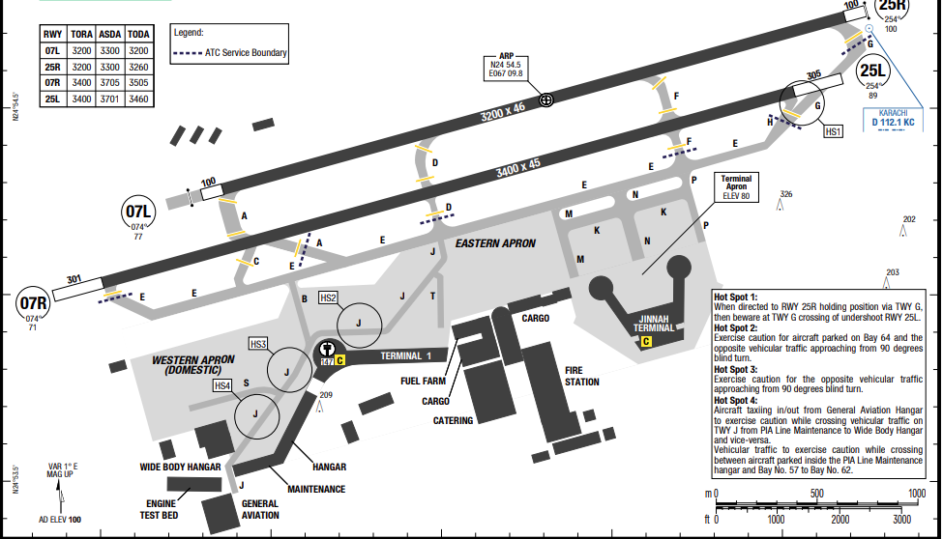
Karachi is located on the coastline of Sindh province in southern Pakistan, which is the largest city in Pakistan, Jinnah International Airport is the busiest airport in Pakistan.
Karachi has a hot desert climate dominated by a long "Summer Season" while moderated by oceanic influence from the Arabian Sea. Summers are hot and humid, and Karachi is prone to deadly heatwaves. the winter climate is dry and lasts between December and February
.

Departure |  |  | - RNAV SIDs  - Require minimum climb gradients.
Arrival and Approach |  |  | - RNAV STARs
Taxi |  |  | - Follow me car maybe provided.
Parking information |  |  | No
- TAKE-OFF AND LANDING DISTANCES AVAILABLE
RWY | LENGTH  (m) |  |  | WIDTH  (m) |  | TORA  (m) |  | LDA  (m) | TODA  (m) |  | ASDA  (m)
07L | 3200 |  |  | 46 |  | 3200 |  | 3200 | 3200 |  | 3300
07R | 3400 |  |  | 45 |  | 3400 |  | 3400 | 3504 |  | 3705
25L | 3400 |  |  | 45 |  | 3400 |  | 3400 | 3460 |  | 3700
25R | 3200 |  |  | 46 |  | 3200 |  | 3200 | 3260 |  | 3300
- ELEVATION: 100ft | - EOSID: NO
- IAP: ILS, LOC, RNP, VOR
- COMPANY NOTE | - Bird in the vicinity of the airport.  - Start-up, Push-back and taxi procedures for turbo-jet aircraft
- REMARK | NIL

OPLA/ LHE – ALLAMA IQBAL INTL AIRPORT - LAHORE, PAKISTAN
- AIRPORT CATEGORY |  |  |  |  |  |  | - RFFS CATEGORY: 9
- AIRPORT CLASSIFICATION
ATR |  | A320 |  |  | A321 |  | A350 |  | B787
ADQ |  | ADQ |  |  | ADQ |  | ADQ |  | ADQ
- GENERAL STANDARDS
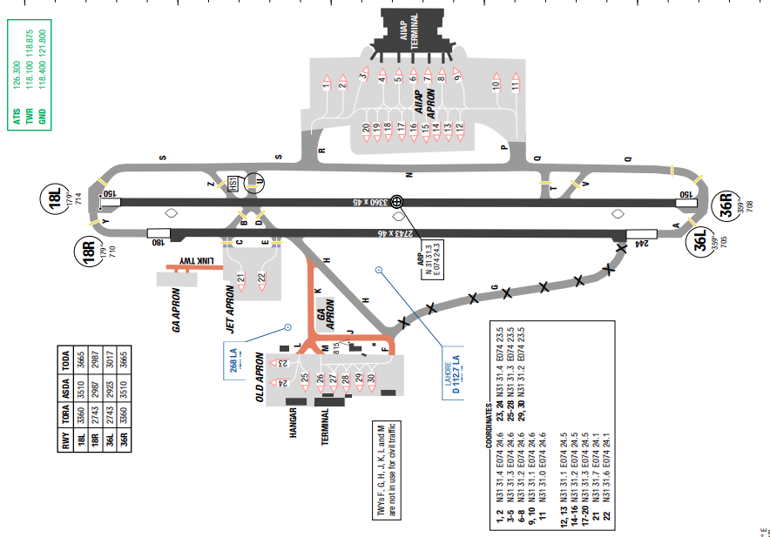
Allama Iqbal International airport is the second largest civilian airport by traffic in Pakistan, serving Lahore, capital of Punjab and second-largest city of Pakistan. The airport has three terminals: the Allama Iqbal terminal, the Hajj terminal, and a cargo terminal. The airport is about 15 km from the centre of the city.
In Lahore, the summers are short, sweltering, humid, and clear and the winters are short, cool, dry, and mostly clear. Over the course of the year, the temperature typically varies from 8°C to 39°C and is rarely below 05°C or above 43°C
Departure |  |  | - RNAV SIDs are available.
Arrival and Approach |  |  | - RNAV STARs are available.  - RWY 36R approved for CAT II/ III operations.
Taxi |  |  | - TWYs F, G, H, J, K, L and M are not in use for civil traffic.
Parking information |  |  | - Stand 22 is an isolated bay.  - Stands 23 through 30 are not in use for civil traffic.
- TAKE-OFF AND LANDING DISTANCES AVAILABLE
RWY | LENGTH  (m) |  |  | WIDTH  (m) |  | TORA  (m) |  | LDA  (m) | TODA  (m) | ASDA  (m)
18L/ 36R | 3360 |  |  | 46 |  | 3360 |  | 3360 | 3365 | 3482
18R/ 36L | 2743 |  |  | 46 |  | 2743 |  | 2743 | 2987 | 2987
- ELEVATION: 712ft | - EOSID: NO
- IAP: ILS (CAT I, II, III), LOC, RNP, VOR
- COMPANY NOTE | - Birds in the vicinity of the airport.  - Operation transponders for ASMGCS (SMR and MLAT)  - Standard pushback procedure. Clearance limit in 5mins.  - Notify POB when contact for start-up.  - All a/ c parked on jet apron shall keep navigation lights and anti-hazard lights beacon during NIGHT and DAY when VIS less than 5km.
- REMARK | NIL

PACD/ CDB – COLD BAY AIRPORT – ALASKA, USA (SPECIAL AUTHORISATION)
- AIRPORT CATEGORY |  |  |  |  |  |  | - RFFS CATEGORY: 6
- AIRPORT CLASSIFICATION
ATR |  | A320 |  |  | A321 |  | A350 |  |  | B787
ADQ |  | ADQ |  |  | ADQ |  | ADQ |  |  | ADQ
- GENERAL STANDARDS
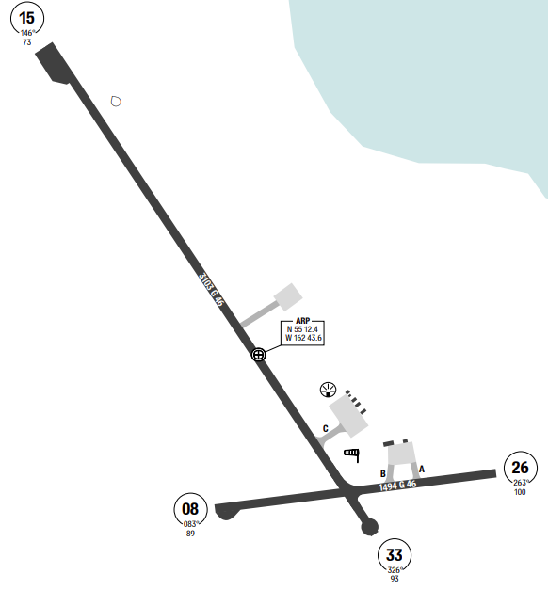
Cold Bay Airport is a state owned, public use airport located in Cold Bay, a city in the Aleutians East Borough of the U.S. state of Alaska. High terrain is to the south of the airport. Heavily glaciated, volcanic mountains run in a northeast to southwest direction down the center of the Alaskan Peninsula. To the east-southeast, Mt. Dutton rises to 4909’ MSL within 16NM. At Cold Bay Airport, the summers are cool, windy, and overcast and the winters are long, freezing, extremely windy, and mostly cloudy. Over the course of the year, the temperature typically varies from -4°C to 14°C and is rarely below -12°C or above 17°C. The warm season lasts for 3 months from June to September with an average daily high temperature above 11°C, while the cold season lasts from November to April. The snowy period of the year lasts for approximately 6 months from November to April.
Departure |  |  | - Conventional SIDs  - Flight crews are required to study the Takeoff Obstacle Notes on the departure charts.
Arrival and Approach |  |  | - No STARs  - Circling not authorized for CAT A Southwest of RWY 15-33 at night.  - DME values will decrease then increase prior to reaching the MAP
Taxi |  |  | - Brake-lock turns are not allowed on runways
Parking information |  |  | No
- TAKE-OFF AND LANDING DISTANCES AVAILABLE
RWY | LENGTH  (m) |  |  | WIDTH  (m) |  | TORA  (m) |  | LDA  (m) | TODA  (m) |  | ASDA  (m)
08/ 26 | 1494 |  |  | 46 |  | 1494 |  | 1494 | 1494 |  | 1494
15/ 33 | 3103 |  |  | 46 |  | 3103 |  | 3103 | 3103 |  | 3103
- ELEVATION: 100ft | - EOSID: YES
- IAP: ILS, LOC, LPV, VOR
- COMPANY NOTE | - Birds in vicinity of all runway approach ends.
- REMARK | - Snow, ice removal & ARPT haz RPRTG DURG duty hr unless prior ARNGMT in writing - AMGR.  - Birds INVOF all RWY APCH ends.  - BRAKELOCK turns NA.  - CFR index B; may be reduced for ACFT less than 90 FT.  - No customs AVBL; 24-48 hr written PPR for foreign ARR RFLG stops - fax 907-271-2684 or 907-271-2686.  - UNLGTD TWR 0.4 NM N; UNLGTD TWR 0.9 NM S; UNLGTD TWR 4.8 NM NW.  - Personnel & EQUIP on RWY.  - ARPT sand LRGR grade than FAA RCMDD/see AC150/5200-30.  - WX camera AVBL - HTTPS://WEATHERCAMS.FAA.GOV  - ROTG BCN UNMON when FSS UNMANNED.  - NWS balloon launch FAC LCTD on ARPT; see inside back cover for details.  - DEICING & fuel M-F 0800-1700 - 907-532-2467; AFT HR PPR & fee - 907-532-7055.

PAFA/ FAI – FAIRBANKS AIRPORT – ALASKA, USA
- AIRPORT CATEGORY |  |  |  |  |  |  | - RFFS CATEGORY: 7
- AIRPORT CLASSIFICATION
ATR |  | A320 |  |  | A321 |  | A350 |  |  | B787
ADQ |  | ADQ |  |  | ADQ |  | ADQ |  |  | ADQ
- GENERAL STANDARDS
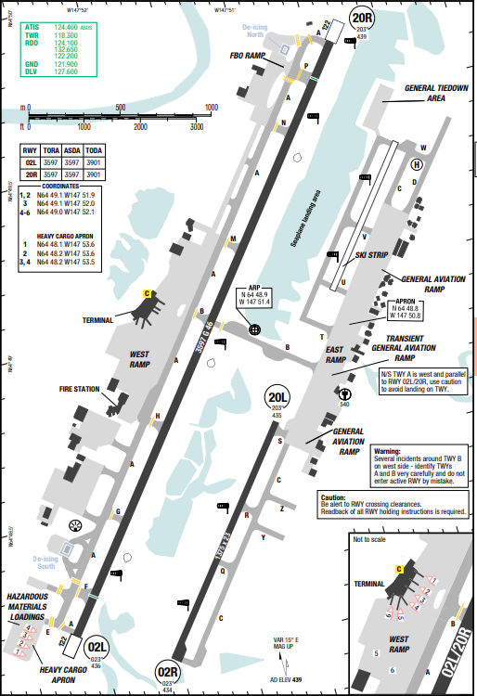
Fairbanks International Airport (IATA: FAI, ICAO: PAFA) is a state-owned public-use airport located three miles (5 km) southwest of the central business district of Fairbanks a city in the Fairbanks North Star Borough of the United States state of Alaska. Fairbanks is the smallest city in the United States with regularly scheduled non-stop international flights, as Condor offers weekly flights to Frankfurt during the summer tourist season. The airport placed in flat area with MSA 4500ft in all sectors. In Fairbanks, the summers are long, comfortable, and mostly cloudy and the winters are frigid, snowy, and partly cloudy. Over the course of the year, the temperature typically varies from -25°C to 22°C and is rarely below -39°C or above 29°C.
Departure |  |  | - RNAV SIDs are available.
Arrival and Approach |  |  | - RNAV STARs are available.
Taxi |  |  | No
Parking information |  |  | No
- TAKE-OFF AND LANDING DISTANCES AVAILABLE
RWY | LENGTH  (m) |  |  | WIDTH  (m) |  | TORA  (m) |  | LDA  (m) | TODA  (m) |  | ASDA  (m)
02/ 20 | 884 |  |  | 23 |  | 884 |  | 884 | 884 |  | 884
02L/ 20R | 3597 |  |  | 46 |  | 3597 |  | 3368 | 3597 |  | 3597
02R/ 20L | 1375 |  |  | 23 |  | 1375 |  | 1375 | 1375 |  | 1375
- ELEVATION: 439ft | - EOSID: YES
- IAP: ILS (CAT I, II, III), LOC, RNP, LPV
- COMPANY NOTE | - Special Engine Out Turn Procedure runway 02L/ R  - Refer to chart EOSID for more information.
- REMARK | - ATCT located at 64-48-39.438N 147-50-55.722W, elevation 538 ft MSL.  - Waterlane is controlled; CTC ATCT on freq 118.3 for approval. Waterlane threshold buoys are 500 ft from N and S shores and mark waterlane. Step taxi prohibited outside of waterlane. East of waterlane is uncontrolled; aircraft may taxi in this area at pilot discretion. Recommend CTC CLNC DEL as soon as practical after ENG start. SFC frozen in winter, not monitored. Limited transient float plane parking AVBL CTC 907-455-4571.  - Migratory birds in the vicinity of ARPT during spring thru fall.  - Military contract fuel AVBL.  - For flights in MOAS east of Fairbanks recommend contacting Eielson RANGR control on 125.3/126.3 or call 1-800-758-8723 for information on military activities.  - Noise abatement procedures in effect FM 2200-0800. All large ACFT, turbine engine, and heavy ACFT utilize RWY 02L for ARRS and RWY 20R for DEPS when wind is not an operational factor. CTC ARPT OPNS for engine run-up locations.  - For AVBLTY of summer gravel strip RWY 02/20 and winter ski strip RWY 02/20 consult local NOTAMS and CTC TWR prior to arrival/departure.  - N/S taxiway (TWY A) is west and parallel to RWY 02L/20R. Be alert to avoid landing on taxiway.  - All RWY hold lines obscured October 1 thru April 1.  - For transient helicopter parking call ARPT OPS 907-451-2300.  - NWS weather balloon launch site 2000 feet west of midfield RWY 02L/20R. Launches are twice daily at 1100 and 2300 hours UTC.  - RWY 02R/20L is limited for use by ACFT design group B II, ACFT or smaller.  - TWY B security gate between RWY 02L/20R and TWY Charlie. Key 121.75 five times to activate.  - Compass rose not calibrated.  - RWY 02R/20L & RWY GRVL/SKI 02/20 not AVBL for scheduled or unscheduled ACR OPNS with more than 30 PSGR seats.  - PPR for MIL ACFT utilizing heavy cargo or TRML APN, CTC ARPT OPS.

PAKN/ AKN – KINGSALMON INTL AIRPORT – ALASKA, USA
- AIRPORT CATEGORY |  |  |  |  |  | - RFFS CATEGORY: 6
- AIRPORT CLASSIFICATION
ATR |  | A320 |  |  | A321 | A350 |  |  |  | B787
ADQ |  | ADQ |  |  | ADQ | N/ A |  |  |  | N/ A
- GENERAL STANDARDS
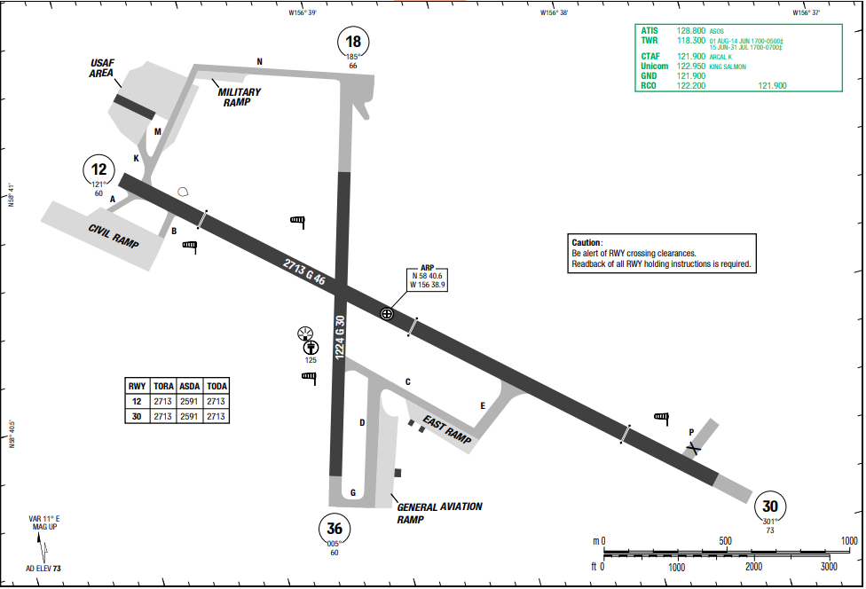
King Salmon Airport (IATA: AKN, ICAO: PAKN) is a state-owned public-use airport located just southeast of King Salmon, in the Bristol Bay Borough of the U.S. state of Alaska. It was formerly the Naknek Air Force Base, named for its location near the Naknek River. King Salmon has a subarctic climate even though it is at 58° North. Temperatures, especially extreme ones, are much less moderate than in the subpolar oceanic climate of the Pacific Ocean side of the Alaska Peninsula

.
Departure |  |  | No
Arrival and Approach |  |  | No
Taxi |  |  | No
Parking information |  |  | No
- TAKE-OFF AND LANDING DISTANCES AVAILABLE
RWY | LENGTH  (m) |  |  | WIDTH  (m) |  |  | TORA  (m) | LDA  (m) | TODA  (m) |  | ASDA  (m)
12/ 30 | 2713 |  |  | 46 |  |  | 2713 | 2591 | 2713 |  | 2713
18/ 36 | 1224 |  |  | 30 |  |  | 1224 | 1224 | 1224 |  | 1224
- ELEVATION: 73ft | - EOSID: YES
- IAP: ILS, LOC, LPV, VOR
- COMPANY NOTE | - Flocks of large migratory birds in vicinity during season.  - Snow, ice removal and airport hazardous conditions performed & reported during attendance schedule from 1700-0300Z.
- REMARK | - Flocks of LRG birds INVOF DURG season.  - Off pavement OPS by ACFT & HEL NA at ACR apron. LNDG, TKOF or PRKG FM dirt or grass NA.  - CIV TSNT PRKG on SE ramp only; OTR PRKG GTR than 48 HR RQRS permit.  - Fighter ARR EXP RDCD SEPN; similar APCH CHARCS & DALGT 3000 FT; dissimilar APCH CHARCS & NGT 6000 FT; AHD/BHND FRMN LNDG 6000 FT.  - 600 FT safety area AER 12.  - RCR DURG 11TH AF fighter flying window; COORD RCR with KING SALMON OPS 907-439-3001/907-439-6000. OPS RSTRD to low APCH/FSL only.  - Flight ORIG outside AK refer to USAF FCG; CSTMS not AVBL.  - Snow/ice removal & ARPT HAZ COND RPRTD DURG ATND HR.  - USAF FAC CIV OPRD with LTD support; call 24 HR prior to ARR for OPS HR; MIL confirm fuel RQMTS 24-48 HR prior.  - MIL fighter/EMERG DVRSON CTC WARRIOR/ELMENDORF SOF 395.15; non fighter/EMERG CTC KING SALMON OPS. 24 HR point MNTS CTAF DURG OPS HR.  - PVT jet PRKG SE section of E ramp - AMGR for info.  - GA apron pavement crumbling; PSBL FOD HAZ. Jet ACFT be alert DURG run up to avoid jet wash DMG.  - WX camera AVBL on internet at https://weathercams.faa.gov  - TWY P CLSD. Apron spots 4 - 7 N of MIL hangar CLSD EXC PROP ACFT.  - ARFF AVBL for PART 121 ACR involved in ETOPS with 30 MIN notice.  - NWS BLN launch FAC on ARPT; see inside back cover for OPS detail.  - Locked wheel turn NA all SFCS.  - TSA REG ARPT; see 49 CFR 1542. All gates & doors RMN secure all times. TSNT or unfamiliar pilots - AMGR for info.  - Business jet PRKG GTR than 1 HR 48 HR PPR

PANC/ ANC - STEVENS ACHORAGE INTL AIRPORT - ALASKA, USA
- AIRPORT CATEGORY |  |  |  |  |  | - RFFS CATEGORY: 9
- AIRPORT CLASSIFICATION
ATR |  | A320 |  |  | A321 | A350 |  |  |  | B787
ADQ |  | ADQ |  |  | ADQ | ADQ |  |  |  | ADQ
- GENERAL STANDARDS
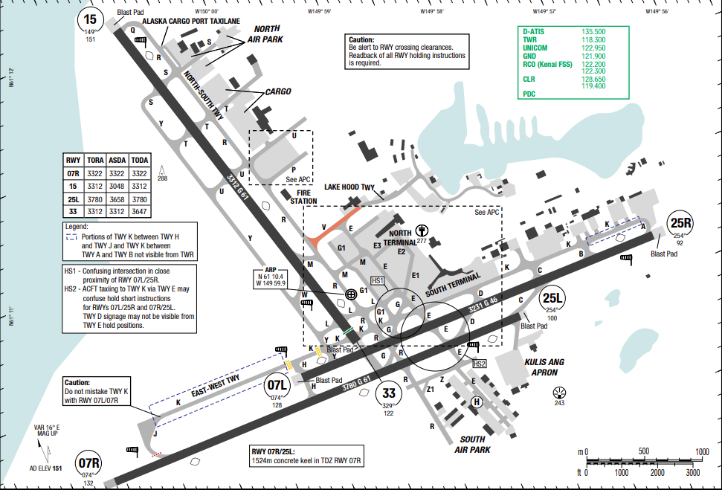
Stevens Anchorage Intl is located in South central Alaska. The airport is at the head of Cook Inlet near the base of the Kenai Peninsula. Obstruction to visibility (mostly due to fog) highest incidences are reported from November to February, averaging between 9 and 12 days per month.
Significant turbulence from the surface up to 15,000ft MSL may occur following cold front passage withing strong low-level winds from the S to SW. Most likely occurs during winter and spring. Turbulence and windshear may be encountered when easterly winds between 10,000ft and 20,000ft MSL are more than 70kts.
Departure |  |  | - Due to terrain surround the airport, high climb gradients required  - All turbojet aircraft departing RWY07R/ 07L during a RWY 15/ 33 closure will employ the FAA close-in NADP or ICAO procedure B NADP
Arrival and Approach |  |  | - Due to terrain surround the airport, crew expected to have late descend clearance. Careful flight planning is required to avoid being too high.  - VSGI and ILS/ RNAV glidepath descend angle not coincident.  - For uncompensated Baro-VNAV system, LNAV/ VNAV not authorized
Taxi |  |  | - Operate XPD with altitude reporting mode and ADS-B enabled on all airport surfaces
Parking information |  |  | No
- TAKE-OFF AND LANDING DISTANCES AVAILABLE
RWY | LENGTH  (m) |  |  | WIDTH  (m) |  |  | TORA  (m) | LDA  (m) | TODA  (m) |  | ASDA  (m)
07L | 3231 |  |  | 46 |  |  | 3231 | 3231 | 3231 |  | 3231
07R | 3780 |  |  | 61 |  |  | 3322 | 3780 | 3780 |  | 3780
15 | 3312 |  |  | 61 |  |  | 3312 | 3048 | 3312 |  | 3312
25L | 3780 |  |  | 61 |  |  | 3780 | 3658 | 3780 |  | 3780
25R | 3231 |  |  | 46 |  |  | 3231 | 3231 | 3231 |  | 3231
33 | 3312 |  |  | 61 |  |  | 3312 | 3170 | 3312 |  | 3312
- ELEVATION: 151ft | - EOSID: YES
- IAP: ILS (CAT I, II, III), LOC, LPV, RNP
- COMPANY NOTE | - Migratory birds in vicinity of airport from spring thru autumn.
- REMARK | - Birds invof arpt spring - fall.  - Non-radio night ops na; non-parrot ops 1 hr ppr; non-radio ops ppr; must prvd eta & remain wi 15 min - ATCT 907-271-2700 wkdays 0730-1600; aft hr & hol - FAA 907-271-5936.  - WSO - 907-266-5105.  - 489 ft unlgted twr 2.5 mi ne.  - Ptns of TWY K btn TWY H & J not vis fm ATCT.  - Compass clbr pad n/a.  - R turn out of ramp prkg R-2 thru R-4 na.  - Flt planning in Anchorage Bowl area - RCO 122.55.  - FAA ramp ppr with ANC FIFO mon-fri 0600-1430 - 135.85 or 907-271-2414 or AVN 405-954-9780.  - Anchorage wx camera avbl on internet at https://weathercams.faa.gov.  - TWY V rstrd to 12500 lb or less; subject to jet blast w of TWY E.  - Tsnt mil ppr.  - Noise sensitive area s & e; RWY 07R, 07L, 15 TBJT/turbofan dep employ FAA close in NADP or ICAO proc B NADP when safety permits; info - amgr.  - TWY V, scty gate e of TWY E - PCL 121.75 5 times; TWY H-2, Lakeshore TWY gates - PCL 121.75 3 times; if inop allow 30 sec reset & notify LHD ops - 907-266-2600.  - PPR for gnd time gtr than 4 hr at arpt ctl spots; apvl req 48 hr prior to dep for ANC - gate mgmt 907 266-2633 or email: dot.aia.ops.gatemanagement@alaska.gov.  - P ramp prkg spots P1/2/3 jet blast haz; exit using min thrust req.  - Cold temperature airport. Altitude correction required at or below -21C.

PASY/ SYA – SHEMYA AIRPORT – ALASKA, USA
- AIRPORT CATEGORY |  |  |  |  |  |  | - RFFS CATEGORY: 7
- AIRPORT CLASSIFICATION
ATR |  | A320 |  |  | A321 |  | A350 |  |  | B787
ADQ |  | ADQ |  |  | ADQ |  | ADQ |  |  | ADQ
- GENERAL STANDARDS
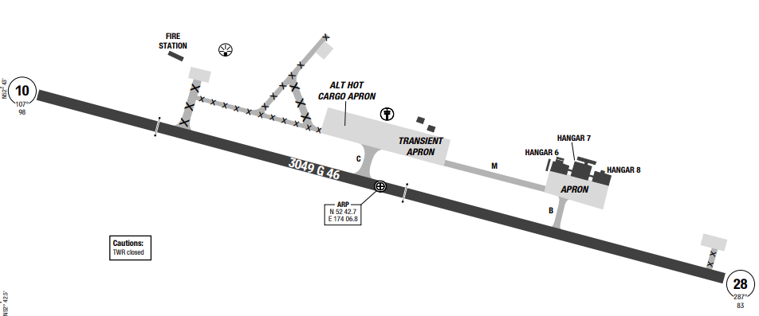
Eareckson Air Station, formerly Shemya Air Force Base, is a United States Air Force military airport located on the island of Shemya, on the western tip of Alaska's Aleutian Islands near the larger island of Attu, and is located approximately 1500 miles southwest of Anchorage. The air base is located in an area with little to no significant terrain, with the highest MSA of 3100’ to the West-Southwest of SYA VOR. The weather on Shemya is very drastic, though the temperatures only vary between single digits to the mid fifties. The island weather is most likely to be cloudy with a mist and the wind is often in the mid 30 to 40 miles per hour.
Departure |  |  | - No SID.  - Departure clearances will be provided by ATC.
Arrival and Approach |  |  | - No STAR  - VGSI and ILS glidepath do not coincide.
Taxi |  |  | - Uncomplicated taxiways to and from the ramp
Parking information |  |  | No
- TAKE-OFF AND LANDING DISTANCES AVAILABLE
RWY | LENGTH  (m) |  |  | WIDTH  (m) |  | TORA  (m) |  | LDA  (m) | TODA  (m) |  | ASDA  (m)
10/ 28 | 3049 |  |  | 46 |  | 3049 |  | 3049 | 3049 |  | 3049
- ELEVATION: 98ft | - EOSID: NO
- IAP: ILS, LOC, VOR
- COMPANY NOTE | - Numerous obstructions in area north of RWY 10-28  - Runway condition is not monitored; recommend visual inspection prior to landing.  - Bird in vicinity of the AP
- REMARK | - Hills 8 NM W 662 FT MSL.  - Ctn: illusion of hgt & usbl RWY wid psbl lndg durg low vsby & at night. Non std VFR pat RWY 10.  - Ctn: see GENOT/radiation areas: 52 44-N/174 05-E bearing 250-028T.  - Flts originating outside the United States refer to AK section of USAF-foreign CLNC guide. 30 min PN for barrier SVC.  - Hvy goose actvt Apr-Jun & Aug-Oct; gulls & ravens invof ARPT. Rpt bird/wildlife strikes on or invof Eareckson - EAS AFLD OPS/TWR D317-392-3505/C907-392-3505 & 11AF/SE D317-552-4730/C907-552-4730.  - Shemya 52 44-N 174 05-E bearing 250-028T; info only.  - PMSV METRO remote WX briefings avbl H24 - 15 OWS D312-576-9755/C618-256-9755; 2 HR PN.  - TWY A, D, & PRI HCP clsd. ALT HCP 72 HR PPR.  - ARPT has RGLR & LED OBSTN LGT; LED LGT may not be vsb to ngt vision devices.  - SVC fee rqrd. TSNT SVC Mon-Fri 1800Z-0300Z++; clsd wkend & hol. Aft HR may incur O/T & SVC fee.  - CTAF advsy 352.05 unavbl 0300-1100Z++ Mon-Sat, Sun & hol. Aft sked ARR CTAF advsy 352.05 avbl one HR prior.  - Airborne ACFT declaring emerg into Eareckson Air STN - Eareckson METRO 127.2 or 352.05 durg ops HR; if no answer - Eareckson radio on CTAF & call 907-392-3505/3606; ensure Anchorage ATC is aware of emerg. As backup Anchorage ATC durg non ops HR shall notify Eareckson radio on 907-392-3505/3606 of all ACFT emerg. Durg non ops HR Eareckson Air STN rqr 30 min PN when psbl.  - USAF installation; clsd to CIV ops. MIL/CIV declared emerg & in distress will be honored.  - WX/AFLD OPS - D317-392-4005/C907-392-4005.  - Coord ETOP or AFLD criteria - D317-392-3362/C907-392-3362.  - Unctld ARPT; prac apch, fleet SVC, customs & ACFT maint NA. Deicer SAE AMS 1424P Type 1 avbl with 1 HR PN.  - Civil ACFT lndg permit req 30 days bfr ldg - D317-552-5282/C907-552-5282.  - Manned OBS supplemented by ASOS 1000-0200Z, Mon-Sat, no Sun or hol.  - RCR/RSC same as ATNDD HR. FICON & RWY cond code not rprtd.  - Mandatory & info signs not installed.

PGUM/ GUM – GUAM INTL AIRPORT – GUAM, GUAM
- AIRPORT CATEGORY |  |  |  |  |  | - RFFS CATEGORY: 9
- AIRPORT CLASSIFICATION
ATR |  | A320 |  |  | A321 | A350 |  |  | B787
ADQ |  | ADQ |  |  | ADQ | ADQ |  |  | ADQ
- GENERAL STANDARDS
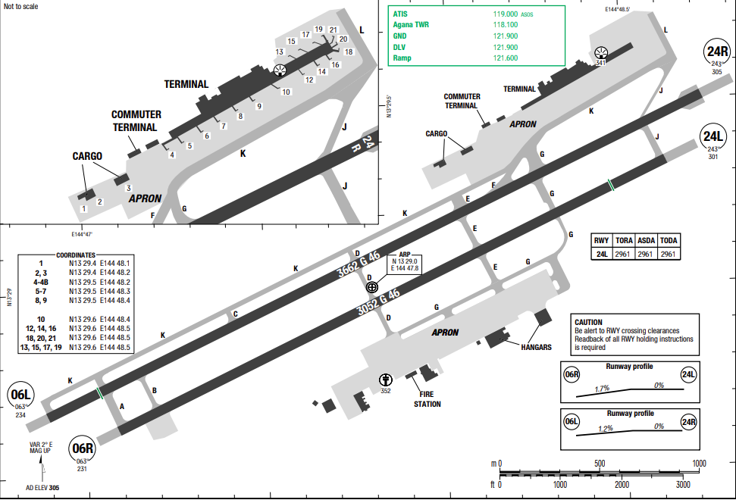
In Guam, the wet season is overcast; the dry season is partly cloudy; and it is hot, oppressive, and windy year-round. Over the course of the year, the temperature typically varies from 76°F to 88°F and is rarely below 74°F or above 90°F. The windier part of the year lasts from October to May, with average wind speeds of more than 13.8 miles per hour. The windiest month of the year in Guam is December, with an average hourly wind speed of 17.1 miles per hour.
Departure |  |  |  | - No SID.  - Expect radar vector.
Arrival and Approach |  |  |  | - No STAR.  - Circle to land not authorized Southeast of RWY 06R, 24L.
Taxi |  |  |  | All Acft contact ramp control.
Parking information |  |  |  | No
- TAKE-OFF AND LANDING DISTANCES AVAILABLE
RWY | LENGTH  (m) |  | WIDTH  (m) |  |  |  | TORA  (m) | LDA  (m) |  | TODA  (m) | ASDA  (m)
06L | 3662 |  | 46 |  |  |  | 3662 | 3357 |  | 3662 | 3662
06R | 3052 |  | 46 |  |  |  | 3052 | 3052 |  | 3052 | 3052
24L | 3052 |  | 46 |  |  |  | 3052 | 2747 |  | 3052 | 3052
24R | 3663 |  | 46 |  |  |  | 3662 | 3662 |  | 3662 | 3662
- ELEVATION: 305ft | - EOSID: NO
- IAP: ILS, LOC, RNP, NDB, VOR
- COMPANY NOTE | - REQ startup when ready for departure.  - Wildlife are present in the vicinity of the airport.  - Military activity is conducted from the surface to FL 190 northeast of the airport.
- REMARK | NIL

PHNL/ HNL – HONOLULU AIRPORT – HAWAII, USA
- AIRPORT CATEGORY |  |  |  |  | - RFFS CATEGORY: 10
- AIRPORT CLASSIFICATION
ATR | A320 |  |  | A321 | A350 |  |  | B787
ADQ | ADQ |  |  | ADQ | ADQ |  |  | ADQ
- GENERAL STANDARDS
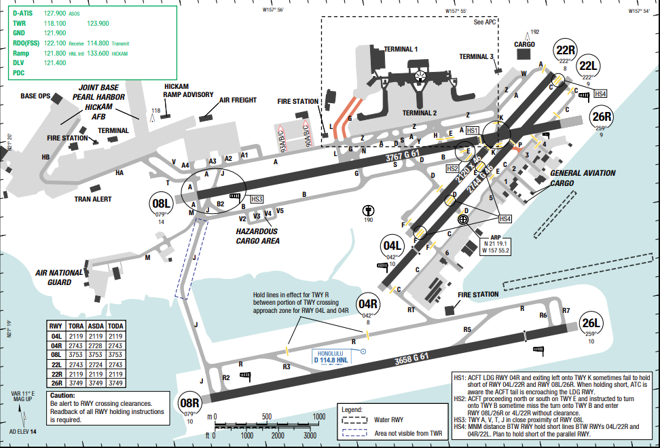
The airport is located in the Honolulu census-designated place three miles (5 km) northwest of Honolulu's central business district. The climate of an area is a composite or frequency distribution of various kinds of weather. The outstanding features of Hawaii's climate include mild temperatures throughout the year, moderate humidity, persistence of northeasterly trade winds, significant differences in rainfall within short distances, and infrequent severe storms. For most of Hawaii, there are only two seasons: "summer and winter" between May and October.
Departure |  | - RNAV SIDs.
Arrival and Approach |  | - Arrival Rwy 08L, fly ILS approach procedure or a close-in base leg remaining over center of Pearl Habor chanel.  - Arrival 26L/ R remain at traffic pattern altitude as long as possible before beginning descent for landing.
Taxi |  | - Wide body landing on RWY 04R roll to end of Rwy.  - No left turn at Twy K without approval
Parking information |  | No
Other information |  | - All jet Aft contact ramp control prior engine start at gate.
- TAKE-OFF AND LANDING DISTANCES AVAILABLE
RWY | LENGTH  (m) |  | WIDTH  (m) |  |  | TORA  (m) | LDA  (m) |  | TODA  (m) | ASDA  (m)
04L/ 22R | 2120 |  | 46 |  |  | 2119 | 2119 |  | 2119 | 2119
04R | 2744 |  | 46 |  |  | 2743 | 2728 |  | 2743 | 2743
08L | 3753 |  | 46 |  |  | 3753 | 3753 |  | 3753 | 3753
08R/ 26L | 3658 |  | 61 |  |  | 3658 | 3658 |  | 3658 | 3658
22L | 2744 |  | 46 |  |  | 2743 | 2724 |  | 2743 | 2743
26R | 3753 |  | 46 |  |  | 3749 | 3749 |  | 3749 | 3749
- ELEVATION: 13ft | - EOSID: NO
- IAP: ILS, LDA, LOC, VOR
- COMPANY NOTE | - All jet Aft contact ramp control prior to engine start at gate or hard stand.
- REMARK | NIL

PWAK/ AWK – WAKE ISLAND AIRFIELD, WAKE ISLAND, U.S.A
1. AIRPORT CATEGORY: A |  |  |  |  |  |  | 2. RFFS CATEGORY: 7
3. AIRPORT CLASSIFICATION
ATR |  | A320 |  |  |  | A321 |  | A350 |  | B787
ADQ |  | ADQ |  |  |  | ADQ |  | ADQ |  | ADQ
4. GENERAL STANDARDS
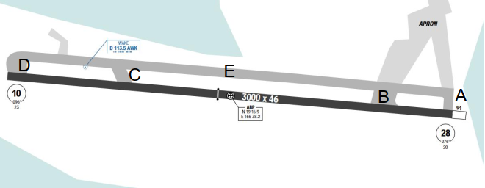
(Airport map for Reference)
Wake Island Airfield is a military air base located on Wake Island, which is known for the Battle of Wake Island during World War II. It is owned by the U.S. Air Force and operated by the 611th Air Support Group. The runway can be used for emergency landings by commercial jetliners flying transpacific routes and has been used in the past by airlines operating jet, turboprop, and prop aircraft on scheduled flights.
Wake Island has a tropical savanna climate, characterized by hot, humid, and windy conditions year-round 24°C with temperatures typically ranging between (Rainfall is relatively light (under 40 inches/year), with a wet season from July to October, and the island is occasionally hit by typhoons
Departure |  |  | - No SID  - Make all DEP report via HF  - Contact Wake island airport operations on 128.0 MHz and 349.4 MHz  - If takeoff and landing data permits, recommend conducting all flight operations to/from the east side of the RWY
Arrival and Approach |  |  | - No STAR  - RWY 10 right-hand circuit  - Expect descent and approach CLR fom Oakland ATC thru San Francisco ARINC.  - Contact PWAK OPS at 100NM before AD and advise requested service requirements.  - Caution: RWY markings worn/faded. RWY is non–precision instrument RWY but is painted to precision instrument standards.
Taxi |  |  | - TWY line restriction located at intersection of TWY E and TWY D  - Restriction continues west onto the warm–up pad, does not provide wingtip clearance to acft with wingspan greater than 60ft
Parking information |  |  | NIL
5. TAKE-OFF AND LANDING DISTANCES AVAILABLE
RWY | LENGTH  (m) |  |  | WIDTH  (m) |  |  | TORA  (m) |  | LDA  (m) | TODA  (m) | ASDA  (m)
10/ 28 | 3000 |  |  | 46 |  |  | 3000 |  | 3000 | 3000 | 3000
6. ELEVATION: 23ft |  |  |  |  | 7. EOSID: NO
8. IAP: GPS, VOR
9. COMPANY NOTE |  |  |  |  | - Wake Island Airfield is uncontrolled airport.  - Advisory Airspace Service and ATC clearance are available through Wake Operations. Wake Operations monitors 121.5 MHz and 243.0 MHz.  - Emergency divert aircraft outside operating hours, contact FAA controller at Oakland Air Route Traffic Control Center (ARTCC) to arrange Base ops/ ATC specialist personnel recall via Wake fire dispatch at phone 808-424-2911 primary or 808-424-2232 secondary.  - Obstacle Departure Chart available  - RWY marking worn/faded. RWY is a non-precision RWY.  - Ocean vessels with mast APRX 30m / 125ft periodically located 3600ft west of THR RWY 10.  - Light pole 31m / 101ft AGL approximately 518m / 1700ft south of RWY 28 THR.  - Caution of gradual pavement rise (hump) located 701m / 2300ft of APCH end RWY 10, 12m / 40ft right of centerline.  - Be alert to ocean vessels with mast approximately 125ft periodically located at mooring buoys 3600ft west of thld RWY 10.  - No aircraft maintenance is available  - Birds in vicinity of AD, especially on APCH to RWY 10 or on DEP from RWY 28. FLT OPS to/from the east recommended if possible.  - Space AVBL passengers are not allowed to remain overnight. RWY 10-28 with 900’ coral overrun  - Afld has mixture of regular and LED obstruction lgts. LED  - obstruction lgts may not be visible to some NVD.
10. REMARK |  |  |  |  | NIL

RCKH/ KHH - KAOHSIUNG (KAOHSIUNG INTL) –TAIWAN
1. AIRPORT CATEGORY: A |  |  |  |  |  |  | 2. RFFS CATEGORY: 9
3. AIRPORT CLASSIFICATION
ATR |  | A320 |  |  |  | A321 |  | A350 |  | B787
ADQ |  | ADQ |  |  |  | ADQ |  | ADQ |  | ADQ
4. GENERAL STANDARDS
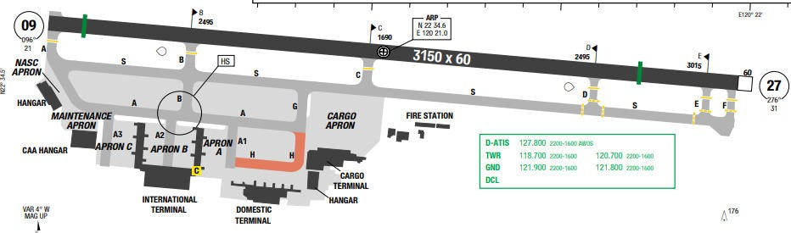
Kaohsiung International Airport is a medium- sized civil airport in Siaogang District, Kaohsiung, Taiwan, also known as Siaogang Airport. The weather is subtropical with local storm and heavy shower rain during summer.
Departure |  |  | - RNAV SIDs  - Speed restriction on departure.  - NADP available at this airport
Arrival and Approach |  |  | - RNAV Arrivals are available.  - Speed restriction on arrivals and miss approaches.  - The preferential runway is RWY 09.  - Usually, strong tailwind is experienced during descent.
Taxi |  |  | - Straight forward taxi with a “follow me” car to lead you into the parking bay.
Parking information |  |  | - Expect gate 24 to 26.
5. TAKE-OFF AND LANDING DISTANCES AVAILABLE
RWY | LENGTH  (m) |  |  | WIDTH  (m) |  |  | TORA  (m) |  | LDA  (m) | TODA  (m) | ASDA  (m)
09 | 3150 |  |  | 60 |  |  | 3150 |  | 2990 | 3209 | 3209
27 | 3150 |  |  | 60 |  |  | 3150 |  | 2705 | 3209 | 3209
6. ELEVATION: 32ft |  |  |  |  | 7. EOSID: YES
8. IAP: ILS, LOC, NDB, RNP
9. COMPANY NOTE |  |  |  |  | - Using power to start other engines on stands is prohibited.  - Follow pushback, start up and cross bleed start procedures.  - Except emergency, takeoff and landing are prohibited between 16h01-22h30 UTC due to noise abatement.  - Ground power unit is available. APU is not required.  - To be filed as an alternate, KHH requires higher planning minimums  - STARs are generally issued but tracking directly to KIZIN could be expected after established contact with Kaohsiung APPR. If not required, holding over KIZIN should be cleared for profile calculation.
10. REMARK |  |  |  |  | Ground Handling Frequency: 131.65 MHz

RCSS/ TSA - SONGSHAN–TAIWAN
1. AIRPORT CATEGORY: A |  |  |  |  |  |  | 2. RFFS CATEGORY: 9
3. AIRPORT CLASSIFICATION
ATR |  | A320 |  |  |  | A321 |  |  | A350 |  |  | B787
ADQ |  | ADQ |  |  |  | ADQ |  |  | ADQ |  |  | ADQ
4. GENERAL STANDARDS
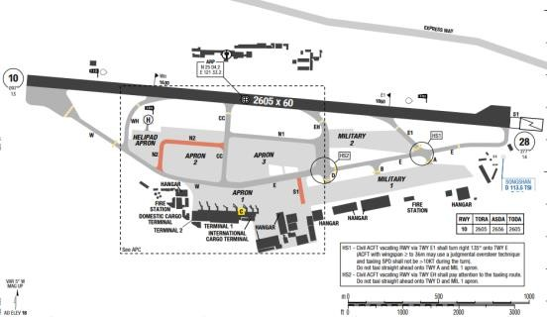
Taipei Songshan Airport (IATA: TSA, ICAO: RCSS) is a city airport and military airbase located in Songshan District, Taipei, Taiwan. The weather is subtropical with local storm and heavy shower rain during summer
Departure |  |  | - INT TKOF from TWY CC to active RWY are prohibited.  - RNAV SID available
Arrival and Approach |  |  | - RWY 10 right-hand circuit
Taxi |  |  | - TWY A, B and D for MIL use only.  - Taxilane N2 and S1 MAX wingspan below 36m / 118ft
Parking information |  |  | - 180 degree turn not permitted if ACFT deviate or taxi over assigned parking bay.  - High PWR on running ENG to start other ENGs not permitted on APN.
5. TAKE-OFF AND LANDING DISTANCES AVAILABLE
RWY | LENGTH  (m) |  |  |  | WIDTH  (m) |  |  | TORA  (m) |  | LDA  (m) | TODA  (m) |  | ASDA  (m)
10/ 28 | 2605 |  |  |  | 60 |  |  | 2605 |  | 2605 | 2605 |  | 2656
6. ELEVATION: 13ft |  |  |  | 7. EOSID: YES
8. IAP: ILS, LDA, LOC, RNP, VOR
9. COMPANY NOTE |  |  |  | - RWY 10/ 28 CLSD daily 0200-0210  - Birds in vicinity of AD
10. REMARK |  |  |  | NIL

RCTP/ TPE - TAIPEI (TAOYUAN INTL)–TAIWAN
1. AIRPORT CATEGORY: A |  |  |  |  |  |  | 2. RFFS CATEGORY: 10
3. AIRPORT CLASSIFICATION
ATR |  | A320 |  |  |  | A321 |  |  | A350 |  |  | B787
ADQ |  | ADQ |  |  |  | ADQ |  |  | ADQ |  |  | ADQ
4. GENERAL STANDARDS
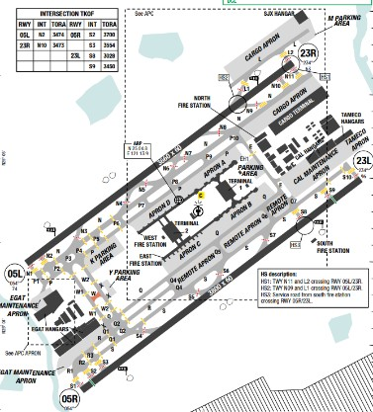
Taipei is located on the coast line lying in the North of Taiwan. There are a lot of mountains on the East and South of the airport. The highest obstacle is a 3675’ high mountain, located on bearing 070º at about 17 NM from the airport. The MSA is 2200ft to the North and West, 6200ft to the East and 8500ft to the South.
Departure |  |  | - Both conventional and RNAV SIDs are available.  - ATC are very accommodating with weather deviations and dependent on traffic volume, requests such as “direct to….” will be approved.  - Noise abatement procedure is applied for all departures.  - NADP available at this airport
Arrival and Approach |  |  | - Both conventional and RNAV STARs are available.  - During periods of heavy traffic, radar vectors will be given, occasionally until interception of the final approach course.  - Very often a/ c is requested to descend and slow down early due to traffic.
Taxi |  |  | - Taxiing in RCTP is fairly straight forward.  - Low Vis Taxi Routes are available.  - Hot Spot locations are available for mitigating runway incursions.  - Flight crews may request tower for FOLLOW ME guidance if necessary.
Parking information |  |  | - Normally VNA a/ c uses parking stands A1 and A2 or A4.
5. TAKE-OFF AND LANDING DISTANCES AVAILABLE
RWY | LENGTH  (m) |  |  | WIDTH  (m) |  |  |  | TORA  (m) |  | LDA  (m) | TODA  (m) |  | ASDA  (m)
05L | 3660 |  |  | 60 |  |  |  | 3474 |  | 3660 | 3660 |  | 3660
23R | 3660 |  |  | 60 |  |  |  | 3473 |  | 3660 | 3660 |  | 3660
05R | 3800 |  |  | 60 |  |  |  | 3700 |  | 3800 | 3800 |  | 3800
23L | 3800 |  |  | 60 |  |  |  | 3450 |  | 3800 | 3800 |  | 3800
6. ELEVATION: 108ft |  |  |  |  | 7. EOSID: NO
8. IAP: ILS (CAT I, II), LOC, RNP
9. COMPANY NOTE |  |  |  |  | - To be filled as an alternate, TPE requires higher planning minimum  - During flight preparation, pilots also are requested to contact Dynasty Operation to provide fuel figures.  - Visas not required for crew on General Declaration Form.  - Ground power is available on arrival to the gate.
10. REMARK |  |  |  |  | - Ground Handling Frequency: 131.3 MHz

RJAA/ NRT–NARITA INTERNATIONAL AIRPORT–TOKYO, JAPAN
1. AIRPORT CATEGORY: A |  |  |  |  |  |  | 2. RFFS CATEGORY: 10
3. AIRPORT CLASSIFICATION
ATR |  | A320 |  |  | A321 |  |  | A350 |  |  | B787
ADQ |  | ADQ |  |  | ADQ |  |  | ADQ |  |  | ADQ
4. GENERAL STANDARDS
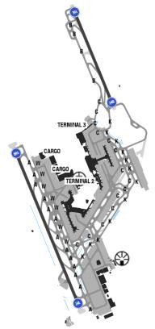
NARITA is an international airport serving the Greater Tokyo Area of Japan. It is located57.5 km east of Tokyo Station and 7 km east-southeast of Narita Station in the city of Narita, with some portions extending into the adjacent town of Shiba Yama. There is no high terrain surround the airport. Weather normally has strong cross wind with thunderstorm and rainy during summertime. During winter, the weather is cold and misty.
Departure |  |  | - RNAV SIDs  - Departing aircrafts shall be ready to accept take- off from the runway assigned by ATC. However, in the event where the assigned runway cannot be accepted due to unavoidable circumstances such as weather conditions, departing aircraft must notify ATC when requesting ATC clearance.  - Aircraft deviating from the flight corridor may be asked the reason for the deviation, including flight numbers, may be made public, except for those made in the interests of safety.  - NADP available at this airport
Arrival and Approach |  |  | - RNAV STARs.  - Normally runway 16L and 34R are used for landing.  - Delayed Flap and reduce flap setting.  - Gear down operation during approach 34L/ R  - Aircrafts are usually cleared by ATC to reach10000ft by BINKS waypoint.
 |  |  | - Be aware that usable runway lengths of RWY16L/ 34R are limited with occasional strong and gusting winds, so Captain should be PF and LDG with MED A/ BRK is recommended.
Taxi |  |  | - Taxi limitations.  - Long taxi time is normally expected.  - Standard Taxi routes.
Parking information |  |  | - Normally from 11 to 18,25-26.  - If parking position is gate 18 or 21, a/ c shall stop before entering (by mashaller) and be towed to the gate.
5. TAKE-OFF AND LANDING DISTANCES AVAILABLE
RWY | LENGTH  (m) |  |  | WIDTH  (m) |  | TORA  (m) |  |  | LDA  (m) | TODA  (m) |  | ASDA  (m)
16L | 2131 |  |  | 60 |  | 2500 |  |  | 2500 | 2500 |  | 25000
16R | 3660 |  |  | 60 |  | 4000 |  |  | 4000 | 4000 |  | 4000
34L | 3662 |  |  | 60 |  | 4000 |  |  | 4000 | 4000 |  | 4000
34R | 2155 |  |  | 60 |  | 2500 |  |  | 2500 | 2500 |  | 2500
6. ELEVATION: 135ft |  |  |  | 7. EOSID: NO
8. IAP: ILS (CAT I, II, III), LOC, RNP, VOR
9. COMPANY NOTE |  |  |  | - Restrictions on the use of APU (should be started 15minutes before ETD)  *Efficient Use of 16L/ 34R:  - In order to maximize the operational efficiency of the airport, it is strongly encouraged for pilots to comply with the use of runway instructed by ATC, For this reason, arriving aircraft shall be ready to accept landing on16L/ 34R(2,500m) if ATC assigns the shorter runway. However, in the event where the assigned runway cannot be accepted due to unavoidable circumstances such as weather conditions, performance, arriving aircrafts must notify ATC of their intentions 30 minutes prior to the estimated time of arrival (ETA).  - If the crew fails to advise ATC before being transferred to NRT Approach, A-RWY landing request will not be possible. And in any other emergency and heavy weather condition, arrival aircraft should land at B (16L/ 34R). Be reminded that any reasons related to taxi time shortening is not accepted.
10. REMARK |  |  |  | Ground Handling Frequency: 131.7 MHz

RJBB/ KIX – KANSAI INTERNATIONAL AIRPORT – OSAKA KANSAI, JAPAN

1. AIRPORT CATEGORY: A |  |  |  |  |  |  |  | 2. RFFS CATEGORY: 10
3. AIRPORT CLASSIFICATION
ATR |  | A320 |  |  |  | A321 |  |  | A350 |  | B787
ADQ |  | ADQ |  |  |  | ADQ |  |  | ADQ |  | ADQ
4. GENERAL STANDARDS
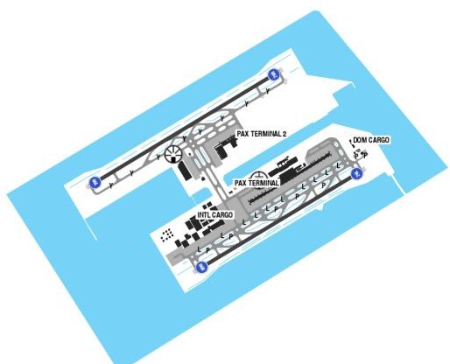
OSAKA (KANSAI INTL) airport is located on an artificial island at exorbitant coast, 50 km from OSAKA center, and 6km offshore into OSAKA bay. There is no high terrain around the airport, with the highest MSA being 6600 ft from KNE VOR, on the South-East. OSAKA has a relatively mild climate, with 4 distinct seasons. Average precipitation (1,138mm) peaks during the rainy season, usually between June till late of July, and in September during typhoon season. In the winter, the weather is cold and misty
Departure |  |  | - RNAV SIDs  - Noise abatement procedures
Arrival and Approach |  |  | - RNAV STARs  - Normally runway for LDG is 06R/ 24L.  - Noise abatement procedures (delayed flap and extend landing gear
Taxi |  |  | - Standard taxi route available  - Due to an upslope on taxiway J3/J4, single-engine taxi is not permitted when departing from runway 06L/24R.
Parking information |  |  | - Normally, Park at stands 28 – 32.  - ATC should request 5 min prior to start engine.
5. TAKE-OFF AND LANDING DISTANCES AVAILABLE
RWY | LENGTH  (m) |  |  |  | WIDTH  (m) |  | TORA  (m) |  |  | LDA  (m) |  | TODA  (m) | ASDA  (m)
06L | 3703 |  |  |  | 60 |  | 4000 |  |  | 4000 |  | 4000 | 4000
06R | 3185 |  |  |  | 60 |  | 3500 |  |  | 3500 |  | 3500 | 3500
24L | 3144 |  |  |  | 60 |  | 3500 |  |  | 3500 |  | 3500 | 3500
24R | 3684 |  |  |  | 60 |  | 4000 |  |  | 4000 |  | 4000 | 4000
6. ELEVATION: 37ft |  |  |  | 7. EOSID: NO
8. PBN AVAILABLE: Y |  |  |  | 9. LVO: Y
9. COMPANY NOTE |  |  |  | - Restrictions on the use of APU  - RJBB Airport RWY 06 Approach.  *Crew situation Awareness:  + From April to July, pilots may encounter strong tailwinds above 1000 feet, which can make it difficult to reduce the aircraft’s speed during the approach. This should be taken into account.  *Recommended Crews’ actions:  + Enhance flight management during the approach phase.  + Extend landing flaps early to ensure a stabilized approach by 1000 feet AGL
10. REMARK |  |  |  | Ground Handling Frequency: 130.95 MHz

RJCC/ CTS – NEW CHITOSE AIRPORT – CHITOSE HOKKAIDO, JAPAN
- AIRPORT CATEGORY |  |  |  |  |  |  | - RFFS CATEGORY: 9
- AIRPORT CLASSIFICATION
ATR |  | A320 |  |  | A321 |  | A350 |  |  | B787
ADQ |  | ADQ |  |  | ADQ |  | ADQ |  |  | ADQ
- GENERAL STANDARDS
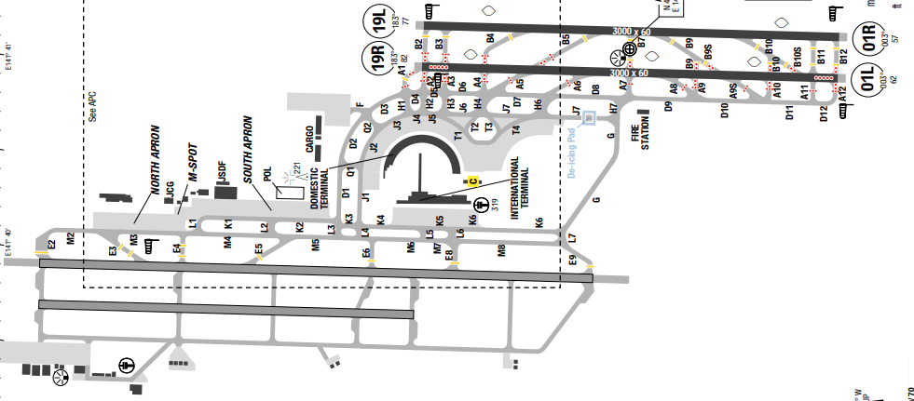
New Chitose Airport is located in the southwestern portion of Hokkaido Island. Hokkaido is the northernmost of the four main Japanese islands and is mostly mountainous. The Pacific Ocean is to the east, the Tsugaru Strait is to the south-southwest, and the Sea of Japan is to the west. New Chitose Airport is 9 NM north of the Pacific coastline on a low-lying land bridge about 17 NM wide and 35 NM long.

Departure |  |  | - RNAV SID.  - RWY 01L/ 19R is primary.  - SID with high climb gradient, Pilots need to briefing carefully before T/ O
Arrival and Approach |  |  | - RNAV STAR  - RWY 01R/ 19L is primary.  - Circling to land: not authorized west of the runways.
Taxi |  |  | - Taxiing limitations
Parking information |  |  | No
- TAKE-OFF AND LANDING DISTANCES AVAILABLE
RWY | LENGTH  (m) |  |  | WIDTH  (m) |  | TORA  (m) |  | LDA  (m) | TODA  (m) |  | ASDA  (m)
01R/ 19L | 3000 |  |  | 60 |  | 3000 |  | 3000 | 3000 |  | 3000
01L/ 19R | 3000 |  |  | 60 |  | 3000 |  | 3000 | 3000 |  | 3000
- ELEVATION: 70ft | - EOSID: NO
- IAP: ILS, LOC, VOR
- COMPANY NOTE | - Restrictions about the use of APU.
- REMARK | NIL

RJFF/ FUK – FUKUOKA INTERNATIONAL AIRPORT – FUKUOKA, JAPAN
1. AIRPORT CATEGORY: A |  |  |  |  |  |  |  | 2. RFFS CATEGORY: 9
3. AIRPORT CLASSIFICATION
ATR |  | A320 |  |  |  | A321 |  |  | A350 |  |  | B787
ADQ |  | ADQ |  |  |  | ADQ |  |  | ADQ |  |  | ADQ
4. GENERAL STANDARDS
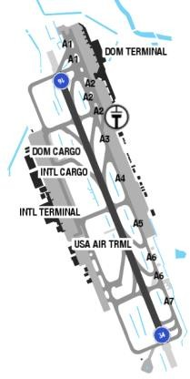
FUKUOKA is located on the North-West coastline of Japan. It is mountainous to the South, West and East of the airport and the MSA is from 2300 to 5500 ft. A small 474ft hill is located just to the right of short final to RWY 34. Also, a radio mast (NHK) is located just below the circling minima on downwind rising to 570ft AMSL.
The summers are tropical with considerable heavy rain during the rainy season and during the typhoon months of September through October. In winter time, it is quite cold. Wind direction is normally SENW
Departure |  |  | - RNAV SIDs  - NADP available at this airport  - DEP ACFT from East APN will use RWY 16L/34R unless otherwise required by ATC.  - DEP ACFT from West APN will use RWY 16R/34L unless otherwise required by ATC.  - Notify DLV in case DEP from RWY 16L/34R is required for performance reasons.
Arrival and Approach |  |  | - Normally ATC provide radar vectors for final and minimum flaps setting for landing is expected.  - ARR ACFT will use RWY 16L/34R unless otherwise required by ATC. In this situation, to avoid misunderstanding of LDG RWY:  + PALS for RWY 16L/34R will be turned on even HJ and in VMC;  + RTIL and PAPI for RWY 16R/34L will normally be turned off. Circling is NOT authorized on East of RWY  - Miss approach for RWY 16 requires minimum climb gradients 5%  - Primarily applied approaches:  + RNP or LOC for RWY 16L/R;  + visual APCH for RWY 34L/R, unless when not applicable, then RNP or LOC.  - NAP available  - ILS RWY 16R, 34L, 16L and 34R radiate simultaneously, pilots shall confirm type of APCH and RWY.
Taxi |  |  | - Numerous TWY with limitations (Refer AOI for details)
Parking information |  |  | - Visual Docking Guidance System (VDGS) is AVBL on stands 1, 2-5, 6, 7-10, 11, 12.
5. TAKE-OFF AND LANDING DISTANCES AVAILABLE
RWY | LENGTH  (m) |  |  | WIDTH  (m) |  |  | TORA  (m) |  |  | LDA  (m) | TODA  (m) |  | ASDA  (m)
16L/ 34R | 2800 |  |  | 60 |  |  | 2800 |  |  | 2800 | 2800 |  | 2800
16R/ 34L | 2500 |  |  | 60 |  |  | 2500 |  |  | 2500 | 2500 |  | 2500
6. ELEVATION: 30ft |  |  |  |  | 7. EOSID: YES
8. IAP: ILS, LOC, RNP, VOR
9. COMPANY NOTE |  |  |  |  | - Birds in vicinity of AD in spring (April-May) and autumn (September - October).  - Restrictions about the use of APU  - Low Level Wind Shear Alert System (LLWAS) in operation.  - AD PPR during MAINT work at AD facilities  - No TKOF/LDG shall be permitted 1300-2200, unless EMERG, WX reasons, TFC congestion or with PPR.  - Use of APU restricted to MNM time required for maintenance purposes.
10. REMARK |  |  |  |  | NIL

RJFK/ KOJ – KAGOSHIMA AIRPORT – KAGOSHIMA, JAPAN
1. AIRPORT CATEGORY: A |  |  |  |  |  |  |  | 2. RFFS CATEGORY: 10
3. AIRPORT CLASSIFICATION
ATR |  | A320 |  |  |  | A321 |  |  | A350 |  |  | B787
ADQ |  | ADQ |  |  |  | ADQ |  |  | ADQ |  |  | ADQ
4. GENERAL STANDARDS
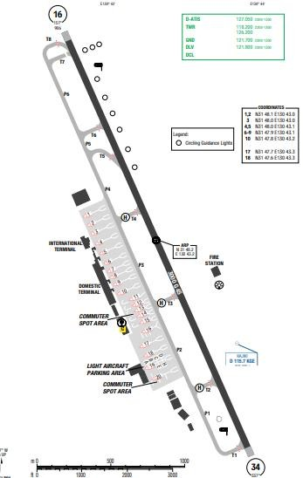
Kagoshima Airport is located at the southern end of Kyushu Island in Japan. Kyushu is the most southern of the four main Japanese islands and its terrain is mountainous. Several interior peaks range from 5000 to about 6000 feet MSL. The airport is located on a coastal plateau 4 NM north of Kagoshima Bay. Except for the bay to the south, the airport is surrounded by high terrain. To the northwest, terrain rises to 2231 feet MSL within 5 NM. To the northeast, terrain rises to 5577 feet MSL within 11 NM.
Departure |  |  | - Noise abatement procedures (steepest climb procedure)  - Requires minimum climb gradients
Arrival and Approach |  |  | - Continuous Descent Operation (CDO) with routes and procedural instructions are available.  - Noise abatement procedures (delayed flap approach and reduced flap setting procedures)  - Approach and circling guidance lights are used at this airport.
Taxi |  |  | - Taxiing wing-tip limitation
Parking information |  |  | No
5. TAKE-OFF AND LANDING DISTANCES AVAILABLE
RWY | LENGTH  (m) |  |  | WIDTH  (m) |  |  | TORA  (m) |  |  | LDA  (m) | TODA  (m) |  | ASDA  (m)
16/ 34 | 2688 |  |  | 45 |  |  | 3000 |  |  | 3000 | 3000 |  | 3000
6. ELEVATION: 891ft |  |  |  |  | 7. EOSID: NO
8. IAP: ILS, LOC, RNP, VOR
9. COMPANY NOTE |  |  |  |  | - Call delivery 5 min before starting engines to obtaining clearance.  - Volcano SAKURAJIMA being active.  - Japanese accent is quite strong. If in doubt, do not hesitate to confirm again.  - This airport is an alternate for FUK. Contact FUK representative or OCC if support needed
10. REMARK |  |  |  |  | NIL

RJFT/ KMJ – KUMAMOTO AIRPORT – KUMAMOTO, JAPAN
1. AIRPORT CATEGORY: A |  |  |  |  |  |  |  | 2. RFFS CATEGORY: 9
3. AIRPORT CLASSIFICATION
ATR | A320 |  |  |  | A321 |  |  |  | A350 |  | B787
ADQ | ADQ |  |  |  | ADQ |  |  |  | ADQ |  | ADQ
4. GENERAL STANDARDS
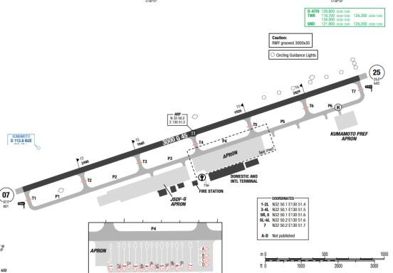
Kumamoto Airport, also known as Aso Kumamoto Airport is an airport in Mashiki, Kumamoto. It is located on the island of Kyushu, the southmost of the four major Japanese islands. Mount Aso (5,223 ft), an extensive active volcano, is in the east of Kumamoto Prefecture.
Departure |  |  | - RNAV SIDs  Noise abatement procedures (steepest climb procedure)
Arrival and Approach |  |  | - RNAV STARs  - Lead in lights and circling lights for RWY25
Taxi |  |  | - Taxiing width limitation
Parking information |  |  | No
5. TAKE-OFF AND LANDING DISTANCES AVAILABLE
RWY |  | LENGTH  (m) |  | WIDTH  (m) |  |  | TORA  (m) |  |  | LDA  (m) |  | TODA  (m) | ASDA  (m)
07/ 25 |  | 2731 |  | 45 |  |  | 3000 |  |  | 3000 |  | 3000 | 3000
6. ELEVATION: 632ft |  |  |  |  |  | 7. EOSID: NO
8. IAP: ILS (CAT I, II, III), LOC, VOR
9. COMPANY NOTE |  |  |  |  |  | - This airport is an alternate for FUK. Contact FUK representative or OCC if support needed.
10. REMARK |  |  |  |  |  | NIL

RJFU/ NGS – NAGASAKI AIRPORT – NAGASAKI, JAPAN
1. AIRPORT CATEGORY: A |  |  |  |  |  |  |  | 2. RFFS CATEGORY: 9
3. AIRPORT CLASSIFICATION
ATR |  | A320 |  |  |  | A321 |  |  | A350 |  |  | B787
ADQ |  | ADQ |  |  |  | ADQ |  |  | ADQ |  |  | ADQ
4. GENERAL STANDARDS
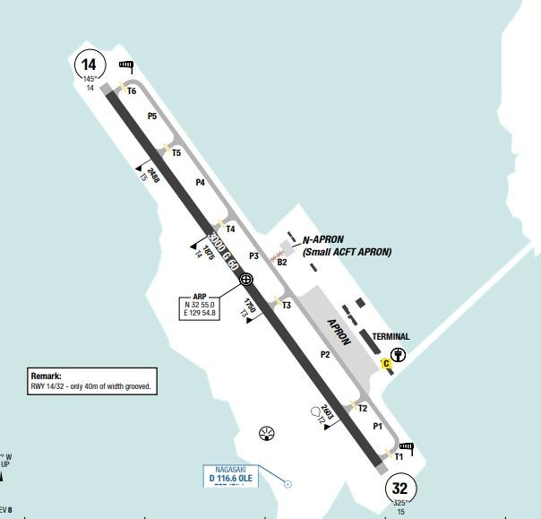
The airport is on an island in Omura Bay, west of Omura City. Nagasaki is located on the island of Kyushu. Broken to overcast ceilings are the predominant sky conditions throughout the year. Fog averages4days from May thought August. Overall, reduced visibility is reported for less than 5 days per month. Annual precipitation totals 224 cm (88.1 in). Winds are from the northwest in March and southeast in august.
Departure |  |  | - RNAV SIDs are available.  - Noise abatement procedures shall be adhered to.
Arrival and Approach |  |  | - RNAV arrivals are available for both runways from multiple directions.  - Continuous Descent Operation (CDO) with routes and procedural instructions are available. Approach and circling guidance lights are used at this airport.
Taxi |  |  | - Taxiing width limitation
Parking information |  |  | - PRKG stand 2A: The power-out PROC is a LT from the PRKG position. - Caution that the next PRKG 3 turns right. PRKG 2A and 3 cannot be taxi in and out at the same time.
5. TAKE-OFF AND LANDING DISTANCES AVAILABLE
RWY | LENGTH  (m) |  |  | WIDTH  (m) |  |  | TORA  (m) |  |  | LDA  (m) | TODA  (m) |  | ASDA  (m)
14/ 32 | 3000 |  |  | 60 |  |  | 3000 |  |  | 3000 | 3000 |  | 3000
6. ELEVATION: 8ft |  |  |  |  | 7. EOSID: NO
8. IAP: ILS, LOC, RNP, VOR
9. COMPANY NOTE |  |  |  |  | - This airport is an alternate for FUK.
10. REMARK |  |  |  |  | NIL

RJGG/ NGO - NAGOYA (CHUBU CENTRAIR INTL)–JAPAN
1. AIRPORT CATEGORY: A |  |  |  |  |  |  | 2. RFFS CATEGORY: 9
3. AIRPORT CLASSIFICATION
ATR |  | A320 |  |  |  | A321 |  |  | A350 |  |  | B787
ADQ |  | ADQ |  |  |  | ADQ |  |  | ADQ |  |  | ADQ
4. GENERAL STANDARDS
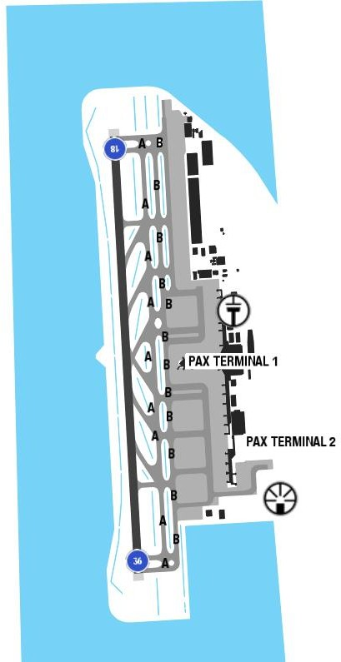
The airport is in the isolated area as a small island. There is no high terrain around the airport. But there is high range of mountain on arrival STAR with highest peak approximately 6500 feet.
The climate is humid temperate, with quite cold winters and hot, humid and rainy summers. Like the rest of Japan, the city is affected by the monsoon circulation: in winter, the northwest cold currents will prevail, while in summer, they will be replaced by hot and humid currents of tropical
Departure |  |  | - RNAV SIDs are available.
Arrival and Approach |  |  | - RNAV STARs  - Noise abatement procedures (delayed flap approach procedure and extended gear)
Taxi |  |  | - Taxi routes, wingtip clearance for aircrafts with different wingspan length.
Parking information |  |  | - Expect to parking at Apron 22-26
5. TAKE-OFF AND LANDING DISTANCES AVAILABLE
RWY | LENGTH  (m) |  |  |  | WIDTH  (m) |  |  | TORA  (m) |  | LDA  (m) | TODA  (m) |  | ASDA  (m)
18/ 36 | 3188 |  |  |  | 60 |  |  | 3500 |  | 3189 | 3500 |  | 3500
6. ELEVATION: 12ft |  |  |  | 7. EOSID: NO
8. IAP: ILS (CAT I, II, III), LOC, RNP, VOR
9. COMPANY NOTE |  |  |  | - Restrictions about the use of APU
10. REMARK |  |  |  | - Ground Handling Frequency: 132.05 MHz

RJNA/ NKM - NAGOYA (NAGOYA)–JAPAN
1. AIRPORT CATEGORY: A |  |  |  |  |  |  |  | 2. RFFS CATEGORY: 6
3. AIRPORT CLASSIFICATION
ATR |  | A320 |  |  | A321 |  |  |  | A350 |  |  | B787
ADQ |  | ADQ |  |  | ADQ |  |  |  | N/ A |  |  | N/ A
4. GENERAL STANDARDS
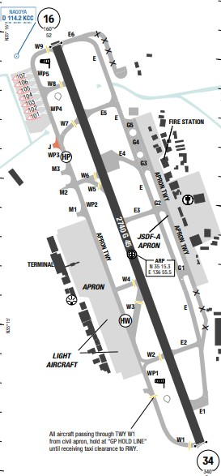
Nagoya Airport is located along the southern coast of Honshu Island. The airport area is part of a river basin that drains into Ise Bay that is 10 NM to the south. Mountains, rising above 2000ft MSL, are in the eastern quadrants and begin within 5NM. To the northeast, terrain rises to 1434ft MSL within 7 NM. To the east, terrain rises to 2300ft MSL within 13NM. Beyond 25NM, there are mountains rising from 2000ft MSL to above 4000ft MSL in the west, north, and east quadrants.
Reduced visibility averages 22 days per month. Snowfall is reported from November through April with peak activity occurring in January and February, averaging 11 days per month. Annual precipitation totals 1587mm (62.5 in). Winds from the north-northwest in December and from the west-northwest in May
Departure |  |  | - Conventional SIDs are available.  - Noise abatement procedure (steepest climb PRO)  - Require minimum climb gradients.
Arrival and Approach |  |  | - RNAV STARs  - Noise abatement procedure (delayed flap approach and reduce flap setting PRO)
Taxi |  |  | - Taxi routes, wingtip clearance for aircrafts with different wingspan length.
Parking information |  |  | - North APN: Strength MAX 5700kg / 12566lbs.
5. TAKE-OFF AND LANDING DISTANCES AVAILABLE
RWY | LENGTH  (m) |  |  | WIDTH  (m) |  |  | TORA  (m) |  |  | LDA  (m) | TODA  (m) |  | ASDA  (m)
16/ 34 | 2399 |  |  | 45 |  |  | 2740 |  |  | 2740 | 2740 |  | 2740
6. ELEVATION: 46ft |  |  |  |  |  | 7. EOSID: NO
8. IAP: ILS, LOC, VOR
9. COMPANY NOTE |  |  |  |  |  | - Radar PAR/ ASR available for RWY 16, 34.  - Contact NGO representative or OCC if support needed.
10. REMARK |  |  |  |  |  | NIL

RJOB/ OKJ - OKAYAMA INTL – JAPAN (SPECIAL AUTHORISATION)
- AIRPORT CATEGORY: A |  |  |  |  |  |  | - RFFS CATEGORY: 9
- AIRPORT CLASSIFICATION
ATR |  | A320 |  | A321 |  |  | A350 |  | B787
ADQ |  | ADQ |  | ADQ |  |  | ADQ |  | ADQ
4. GENERAL STANDARDS
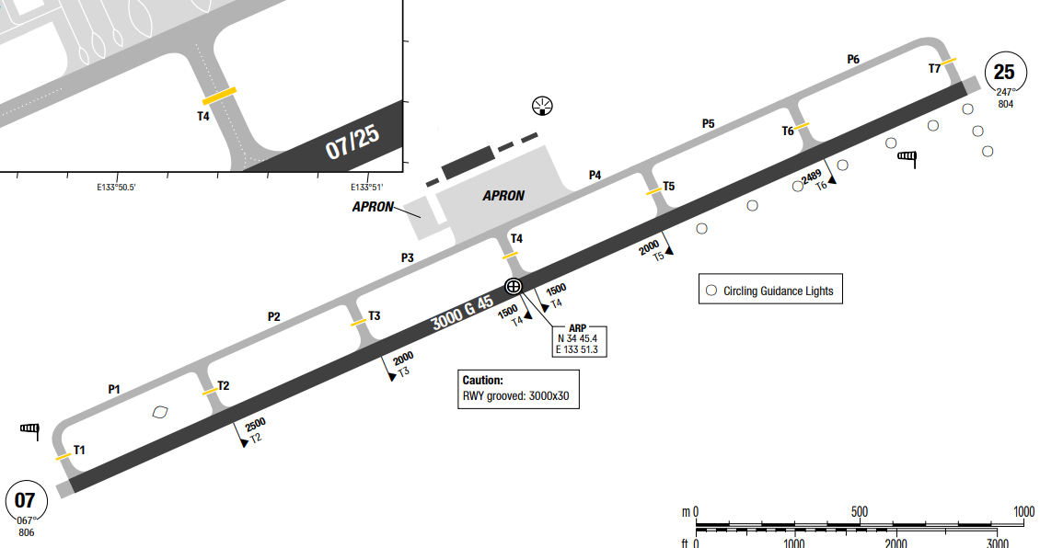
Okayama Airport is an airport in Okayama Prefecture, Japan. It is also known as Okayama Momotaro Airport. It is located 18 km northwest of central Okayama City and 11.5 km northwest or 30 minutes by bus from Okayama Station. It is about 10 minutes from the Okayama interchange.
Okayama enjoys a mild, humid subtropical climate with four distinct seasons. Nicknamed the "Land of Sunshine," it is one of the sunniest and driest cities in Japan, featuring an average annual rainfall of around 1,100 millimeters and significantly more rain-free days than the rest of the country.
Departure |  |  | - RNAV SIDs available and require high cliimb gradient (5.4% to 1400ft)  - De-icing not available
Arrival and Approach |  |  | - No STAR  - COMM FAIL Procedure available
Taxi |  |  | NIL
Parking information |  |  | NIL
5. TAKE-OFF AND LANDING DISTANCES AVAILABLE
RWY | LENGTH  (m) |  |  | WIDTH  (m) |  | TORA  (m) |  | LDA  (m) |  | TODA  (m) | ASDA  (m)
07/25 | 3000 |  |  | 45 |  | 3000 |  | 3000 |  | 3000 | 3000
6. ELEVATION: 785ft |  |  |  |  | 7. EOSID: YES
8. IAP: ILS, LOC, RNP, VOR
9. COMPANY NOTE |  |  |  |  | - A filed flight plan is not accepted at Okayama AD branch, but relayed and accepted at Osaka ATC.
10. REMARK |  |  |  |  | NIL

RJOC/ IZO – IZUMO – SHIMANE, JAPAN (SPECIAL AUTHORISATION)
1. AIRPORT CATEGORY: A |  |  |  |  |  |  | 2. RFFS CATEGORY: 7
3. AIRPORT CLASSIFICATION
ATR | A320 |  |  |  |  | A321 |  | A350 |  |  | B787
ADQ | ADQ |  |  |  |  | ADQ |  | N/ A |  |  | N/ A
4. GENERAL STANDARDS
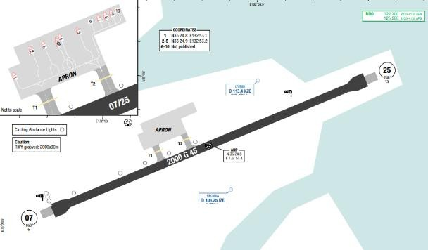
Izumo Airport is an airport in the Hikawa area of Izumo, Shimane Prefecture, Japan, about 20–30 minutes by car from central Izumo or Matsue city centre. This airport is also known as Izumo En- Musubi Airport meaning Izumo Airport of Romantic Fate. The airport terminal has three jet bridge gates, and is equipped with customs and immigration facilities for international charter flights. The Shimane Prefectural Police also has an air base on site. In Izumo, the summers are short, warm, oppressive, and mostly cloudy; the winters are very cold, windy, and partly cloudy; and it is wet year round. The hottest season takes place in June, July, August and September. Most rainfall (rainy season) in Izumo is seen in June, July and September. August has an average maximum temperature of 30°C and is the warmest month of the year while the coldest month is January with an average maximum temperature of 9°C.
Departure |  |  | - RNAV SIDs. Require minimum climb gradient. (RWY 07: 4.6% up to 1300ft, RWY 25: 4.7% up to 2200ft)  - Standard Departure Instrument Chart available. Ask ATC for clearance from Izumo REDIO as normal  - KYOKA SID, CARPS transition, climb 9000ft.  - EO SID available for both RWY  - While departure, change Coms to MIHO app 120.1 for identify and departure as normal.
Arrival and Approach |  |  | - LOC Z RWY 25 with missed climb gradient MNM5%  - RWY 07 slightly upslope.  - Standard Arrival Instrument Chart available.  + Instrument Approach Chart (LOC Y, Z RWY25)  + Instrument Approach Chart (VOR RWY25)  + Instrument Approach Chart (RNP RWY07/ 25)  - After landing, backtrack at the end of RWY and Izumo will give information with parking slot.  - Communicate with Miho App 125.4 for weather forecast.  - Landing RWY 07 via SUSAR, NO STAR.  - 30 miles from KYOKA will be instructed by Miho app vector to the right, then left and direct to SUSAR and clear decent 4300ft with clear RNP 07. High terrain between KYOKA and SUSAR.
Taxi |  |  | - When tow-ing at Izumo airport, REDIO will give instruction as normal.
Parking information |  |  | No
5. TAKE-OFF AND LANDING DISTANCES AVAILABLE
RWY |  | LENGTH  (m) |  |  | WIDTH  (m) |  | TORA  (m) |  | LDA  (m) | TODA  (m) |  | ASDA  (m)
07/ 25 |  | 2000 |  |  | 45 |  | 2000 |  | 2000 | 2000 |  | 2000
6. ELEVATION: 6ft |  |  |  |  |  |  | 7. EOSID: Y
8. IAP: LOC, RNP, VOR
10. COMPANY NOTE |  |  |  | - Birds in vicinity of AD.  - Operation Hour: 2230-1130
11. REMARK |  |  |  | - Izumo airport is an uncontrolled airport.  - There is an air traffic control zone and approach control area around Izumo Airport conducted by The Air Self-Defense Force's Miho Control Unit. Izumo airport is located within the Miho Approach Control Area. Therefore, ATC approvals for aircraft departing from and arriving at Izumo Airport, as well as the exchange of information regarding VFR aircraft in the area will be guaranteed.  - Close coordination between Izumo REDIO and Miho ATC is required.  - Class E airspace is designated around Izumo Airport (within 5 miles and below 3000 ft). IFR operations are permitted for takeoff, landing, or missed approaches; however, only one IFR flight (excluding aircraft on the ground) is allowed in Class E airspace at a time.  - The Izumo Air traffic Control & Operation Information Office (REDIO) at Izumo Airport will:  + Provides information necessary for aircraft operation in the air traffic information zone.  + Transmits ATC reports.  + Provides information and report (REDIO ADVISES) in the air traffic information zone.  - Aircraft flying within the information and control zones:  + will not be allowed to fly within the information zone  + are required to make their own decisions.

RJOO/ ITM – OSAKA INTL AIRPORT – OSAKA, JAPAN
1. AIRPORT CATEGORY: A |  |  |  |  |  |  |  | 2. RFFS CATEGORY: 9
3. AIRPORT CLASSIFICATION
ATR |  | A320 |  |  | A321 |  |  |  | A350 |  |  | B787
ADQ |  | ADQ |  |  | ADQ |  |  |  | ADQ |  |  | ADQ
4. GENERAL STANDARDS
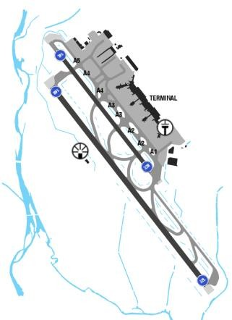
OSAKA (KANSAI INTL) AIRPORT is located on an artificial island at exorbitant coast, 50 km from OSAKA center, 6km offshore into OSAKA bay. There is no high terrain around the airport.
OSAKA has a relatively mild climate with 4 distinct seasons, the amount of precipitation peaks during the rainy season, usually from between June till late of July, and during September which is the typhoon season. During winter, the weather is cold and misty.
Departure |  |  | - Conventional SIDs are available.  - Noise abatement procedure (steepest climb PRO)  - Require minimum climb gradients.
Arrival and Approach |  |  | - RNAV STARs  - Noise abatement procedure (delayed flap approach and reduce flap setting PRO)  - Noise abatement routes (except for safety reasons)
Taxi |  |  | - TWY Restrictions wingspan
Parking information |  |  | No
5. TAKE-OFF AND LANDING DISTANCES AVAILABLE
RWY | LENGTH  (m) |  |  | WIDTH  (m) |  |  | TORA  (m) |  |  | LDA  (m) | TODA  (m) |  | ASDA  (m)
14L | 1828 |  |  | 45 |  |  | 1828 |  |  | 1828 | 1828 |  | 1828
14R | 2667 |  |  | 60 |  |  | 3000 |  |  | 3000 | 3000 |  | 3000
32L | 2667 |  |  | 60 |  |  | 3000 |  |  | 3000 | 3000 |  | 3000
32R | 1828 |  |  | 45 |  |  | 1828 |  |  | 1828 | 1828 |  | 1828
6. ELEVATION: 39ft |  |  |  |  |  | 7. EOSID: YES
8. IAP: ILS, RNP, VOR
9. COMPANY NOTE |  |  |  |  |  | - ATC clearance can be request by voice or DCL  - Restrictions about the use of APU  - This airport is an alternate for KIX.  - Contact KIX representative or OCC if support required
10. REMARK |  |  |  |  |  | NIL

RJOT/ TAK – TAKAMATSU AIRPORT, KAGAWA, JAPAN
1. AIRPORT CATEGOR: A |  |  |  |  |  |  |  |  | 2. RFFS CATEGORY: 9
3. AIRPORT CLASSIFICATION
ATR |  | A320 |  |  |  | A321 |  | A350 |  |  |  | B787
ADQ |  | ADQ |  |  |  | ADQ |  | ADQ |  |  |  | ADQ
4. GENERAL STANDARDS
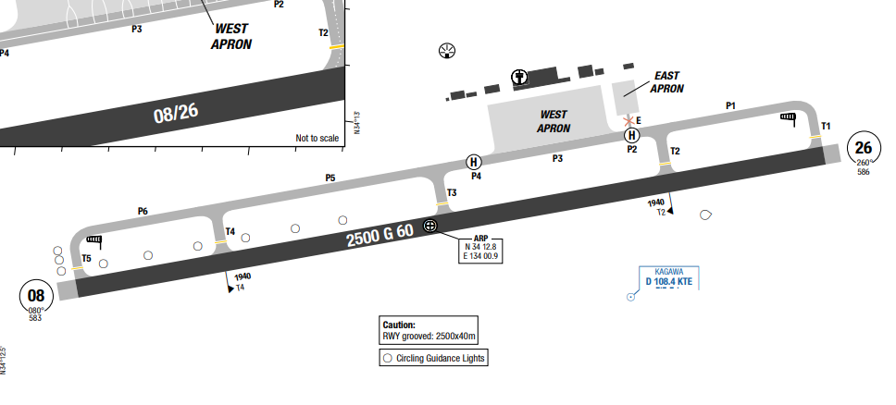
Takamatsu Airport is an airport located 8 NM south-southwest of Takamatsu, Kagawa, Japan. The airport primarily handles domestic flights, with a small number of international flights mainly to South Korea and Taiwan.
Takamatsu features a humid subtropical climate with four distinct seasons, characterized by hot, humid summers and mild, dry winters. The annual average temperature is 16.7°C with highs reaching 38.6°C in August and lows dropping to -7.7°C in January.
Departure |  |  | - RNAV SIDs available and require climb gradient and require high climb gradient (highest 6.6% to 2200ft)  - Critical DME for DME/DME/IRU navigation on RNAV SIDs (refer to AOI)
Arrival and Approach |  |  | - RNAV STAR  - APCH RWY 08: Circle to land from RWY 26 is recommended  - COMM FAIL Procedure available  - LOC 26 coverage restricted to 15° Left of CL up to 17NM  - VOR A available and does not require special training. However, Navigation data is unavailable for this procedure
Taxi |  |  | - TWY E width 9m / 30ft
Parking information |  |  | - Short push-back is AVBL at stands 2, 3, 5, 6 and 7.
5. TAKE-OFF AND LANDING DISTANCES AVAILABLE
RWY | LENGTH  (m) |  |  | WIDTH  (m) |  |  | TORA  (m) |  |  | LDA  (m) | TODA  (m) |  | ASDA  (m)
08/ 26 | 2500 |  |  | 60 |  |  | 2500 |  |  | 2500 | 2500 |  | 2500
6. ELEVATION: 607ft |  |  |  |  | 7. EOSID: YES
8. IAP: ILS, LOC, VOR
9. COMPANY NOTE |  |  |  |  | - For critical DME, DME gap, and inappropriate NAVAIDs  applicable to DME/DME/IRU navigation see eRM – AOI charts  - RWY surface grooved  - Circling Guidance Lights available  - Be aware of RWY width (60m) could cause aircraft actual height illusion
10. REMARK |  |  |  |  | NIL

RJSF/FKS – FUKUSHIMA – JAPAN (SPECIAL AUTHORISATION)
1. AIRPORT CATEGORY: A |  |  |  |  |  |  |  | 2. RFFS CATEGORY: 9
3. AIRPORT CLASSIFICATION
ATR |  | A320 |  |  |  | A321 |  |  | A350 |  |  | B787
ADQ |  | ADQ |  |  |  | ADQ |  |  | NIL |  |  | NIL
4. GENERAL STANDARDS
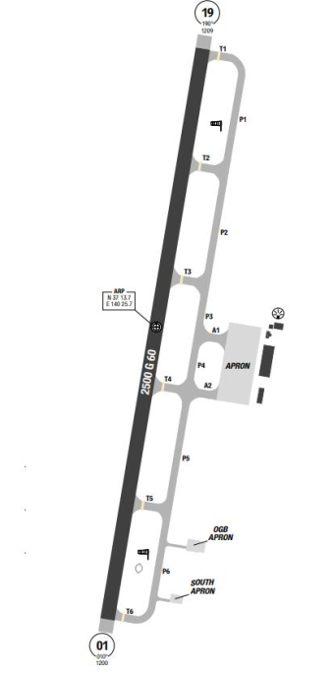
Fukushima Airport is an airport in Sukagawa, Fukushima Prefecture, Japan. The airport is located 19.4 km southeast of Koriyama Station.
In Fukushima, the summers are warm, muggy, wet, and mostly cloudy and the winters are very cold, snowy, windy, and partly cloudy.
When descending, you may encounter strong tailwinds, and as you approach the final, gusty winds combined with the surrounding hilly terrain around the airport can create a mountain wave environment, potentially causing significant turbulence. Be cautious with vertical speed. During takeoff, you will also encounter a mountain wave, so be careful of the aileron speed and large vertical speed at low altitudes to avoid overspeed and TCAS conflicts with some traffic in the airport vicinity.

Departure |  |  |  | - For take-off, Fukushima Radio will provide takeoff clearance.  - RNAV SIDs and require minimum climb gradient. (3.9% up to 2800 ft).  - When it is necessary to separate departures from other IFR traffic/ restrict or regulate IFR traffic flow, Fukushima Radio may deliver clearance from ATC as follow:  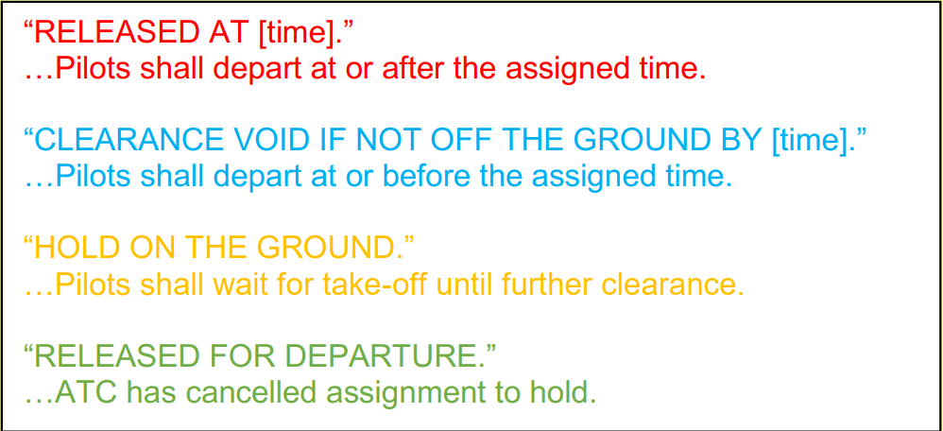
Arrival and Approach |  |  |  | - RNAV STARs available  - ILS/ LOC Z & Y RWY 01 approach with missed approach climb gradient MIN 4%.  - Circle- to land to West side only for each RWY.  - Fukushima Radio will provide information for landing and landing clearance.  - Contact Tokyo Control for approach clearance  - Some required altitudes when passing through Tokyo Control airspace: CBE should be at FL330, and DAIGO at 110.  - Tokyo Control on 118.9 will provide weather information to the crew and ask which approach method they wish to use.  - As the aircraft nears DAIGO, the crew will be cleared for the approach and instructed to switch to Fukushima Radio.  - Fukushima only requires a report 4 nm from SOUMA to confirm that the runway is clear and provide information to the crew.  - The crew will descend according to the chart and monitor traffic.
Taxi |  |  |  | - Small airport with 2 simple TWYs.  - Fukushima Radio will give advice for Taxing clearance, pushback clearance. The crew will monitor traffic and taxi to the stand independently.  - Fukushima Radio will coordinate with the pushback vehicle to ensure safe pushback and start. The crew will inform Fukushima Radio during taxi and taxi out independently.  - No instruction for start-up clearance.  - Fukushima Airport (RJSF) provides marshaller guidance for aircraft parking.  - Ground handling services are managed by an ANA group company.
Parking information |  |  |  | - Normally stands 143-146
5. TAKE-OFF AND LANDING DISTANCES AVAILABLE
RWY | LENGTH  (m) |  |  |  | WIDTH  (m) |  | TORA  (m) |  |  | LDA  (m) | TODA  (m) |  | ASDA  (m)
01/19 | 2500 |  |  |  | 60 |  | 2500 |  |  | 2500 | 2500 |  | 2500
6. ELEVATION: 21ft |  |  | 7. EOSID: YES
8. IAP: ILS, LDA, LOC, RNP, VOR
9. COMPANY NOTE |  |  | - Birds in vicinity of AD.  - Operation Hour: 2300-1200
10. REMARK |  |  | - Fukushima airport is an uncontrolled airport.  - Class E airspace is designated around Fukushima Airport (within 5 miles and below 4000 ft). IFR operations are permitted for takeoff, landing, or missed approaches.  - At Fukushima Airport, Aerodrome Flight Information Service is provided. (Call Sign: Fukushima Radio). Fukushima Radio with primary frequency 118.05 MHz and Backup frequency of 126.2 MHz.  - No surveillance facilities.  - Fukushima Radio provides information and advice for safety of operation but it does not issue instruction as ATC:  + Information and advice in maneuvering area.  + Taxing information  + Advice for pushback  - For approach clearance, intention of Tokyo Control ATC messages. Main frequency is 118.9 Mhz, Secondary frequency is 127.65 MHz.  - Fukushima Radio automatically provide "runway is clear”, when the aircraft could takeoff and landing. Pilots must confirm "runway is clear” before the aircraft takeoff and landing.  - Ground services at Fukushima airport take considerable time. The flight lands on schedule, but the cleaning crew requires additional time to prepare for the next flight. The ground time for the flight on 26/03 at Fukushima, from the chock-in to chock-out, was 1 hour and 20 minutes, despite the return being a ferry flight.  - It is possible to catch Tokyo Control's VHF signal while parked at Fukushima airport, though they may not identify the position. The crew can request long-range clearance via VHF if Fukushima Radio is busy or does not respond.  - The crew is advised to contact Tokyo Control via 121.5 or 243.0 if necessary.  - The route passes through the Nagoya area, heading northeast, with high mountainous terrain. In the event of an emergency descent, the crew should pay attention to the Minimum Off-Route Altitude (MORA).

RJTT/ HND - TOKYO (HANEDA TOKYO INTL)–JAPAN
1. AIRPORT CATEGORY: A |  |  |  |  |  |  |  | 2. RFFS CATEGORY: 10
3. AIRPORT CLASSIFICATION
ATR |  | A320 |  |  |  | A321 |  |  | A350 |  |  | B787
ADQ |  | ADQ |  |  |  | ADQ |  |  | ADQ |  |  | ADQ
4. GENERAL STANDARDS
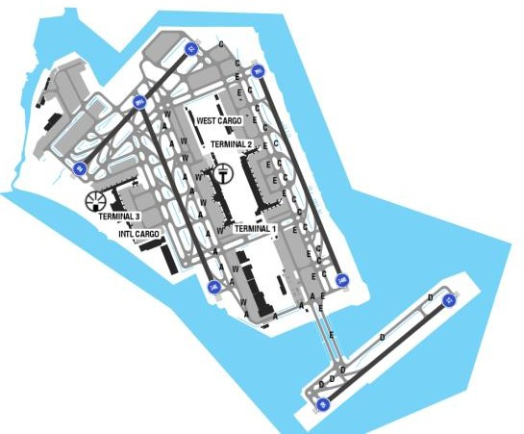
Haneda Airport is located in the Tokyo Bay. There are high terrains on the South West and North of theairport. The highest MSA is 6300ft to the West side.
At Haneda Airport, prevailing winds are northerly about 60 per cent of the year, and the prevailing winds are southerly for the remainder of the year. Fog is rare. In Summer, the climate in Tokyo is noticeably humid at times with slightly raised levels of precipitation in June. Autumns are usually fairly warm and wet, with occasional strong breezes. The winter climate is noticeably cooler, remaining mild during the daytime, aLENGTHough at night time, frost can usually be experienced.
Departure |  |  | - Conventional SIDs are available.  - Noise abatement procedure (steepest climb PRO)  - NADP available at this airport
Arrival and Approach |  |  | - Crew should contact Haneda operation Freq  132.075 Mhz for parking number in advance as you will be asked by ATC.  - From 29 March 2020, during Southerly wind conditions at the airport:  + If the arrival time is before 1500 LT, the STAR OSHIMA 1N/ 2N/ 1B/ 2B for RW22 will be instructed.  + If the arrival time is between 15:00 LT and 19:00 LT, the STAR OSHIMA L, OSHIMA R for RNAV (GNSS) RWY 16L/ R will be instructed. Neither ILS nor LOC will be allowed for RWY 16L/ R approach during this period; only RNAV (GNSS) is allowed.  - When performing RNAV (GNSS) approach RWY 16L/ R, the flight crew is required to pay attention to the following details:  - The descent angle is 3.45 degrees which is steeper than the usual 3.0. The PAPI and Descent Angle are of different values (PAPI still maintained an angle of 3.0 degrees).  - Because of the steep descent angle, Early stabilized approach strategy is recommended. Flight crews should perform NAV/ FPA approach with LNAV minimum plus 50 ft. With VAPP at Final Descent point, maintain rate of descent between 800 to 900 fpm to stay on profile.  - During daytime and periods of Northerly wind, the procedure normally is ILS 34L. In Southerly wind conditions, the procedure will be LDA (Localizer-type directional Aid) runway 22 (good weather) or ILS22 (adverse weather). Active procedure is stated in the ATIS or advised by ATC (see also Noise abatement procedures charts for approach procedure, ILS X RWY 34Land LDA W RWY 22 are primary).  - Captain will be PF to perform LDA APP as the runway on the left hand side (Identify runway clearly and caution in case of strong crosswind).  - In order to avoid wrong LOC capture while performing ILS X 34L approach at HND/ RJTT via KAIHOSTAR, all crew are required to strictly follow the operational recommendations as below:  - Crosscheck the terminal procedure from the published charts with the FMS navigation database on the F-PLN page (waypoint sequences, tracks, distance, and altitude or speed constraints)before entering RNAV airspace.  - Do not capture LOC before reaching to20NMto the RWY.  - LOC button should be armed when A/ C is within20NM.  - Better to capture LOC right after reaching to KAIHO(advised by ATC office).  This case is to be applied when only STAR (KAIHO) is appointed.  *Crew situation awareness:  - Speed constraints and mandatory altitudes are required on final, example RWY 22: (180ktsat D8 IKL, 160kts at D3 IKL, 5000ftat BONDO).  - Rate of descent between BONDO and BEAST maximum is 1500ft/ min.  - For visual prescribed track and using ground visual fix(Tokyo gate bridge, wind power plant and RWY22 approach light)and DME of IKL to turn into final of RWY 22:  *Aircraft configuration:  - 2NM before IKL D1.1: Complete config for landing and Check list1NM before IKL D1.1L select TRK 277, level off, set GA ALT: 4000.  - At IKL D1.1: if the runway is clearly in sight: AP/ FD off, set RWY TRK 222,manualmaneuver to the RWY (initial bank angle is ~ 10 degrees)  - In order to reduce workload, AP disconnection may delay shortly (not more than30")  - PF: select FPA ~2.0 degrees, TRK ~252 degrees, then try to fly manually afterward, follow PAPI-L  Note: At MAPt, if the runway is not in sight, follow published GA procedure  *Common mistake:  - Turn too early, before IKL D1.1.  - After IKL D1.1, banked left too much, which led to RWY 22 center line undershoot. It is difficult to identify the runway before IKL D1.1, due to the afternoon shining sun.  - For LDA APPR RWY 23: perform similar steps to set up
Taxi |  |  | - Normally VNA aircrafts are assigned from stands 144 - 146 in international terminal.  - A long taxi can be expected when taxi for departure runway 05.  - Crew has to maintain vigilance during taxi as some cases of taxi incursion have been reported.  - Crews are required to study the charts carefully as this is a highly complex airport with operations of many guidance and assistive systems in place  - There are standard taxi routes RWY05/ 23  - Restricted TWY and stands  - TWY restrictions for A350 and B787  - ACFT should hold at “GP HOLD LINE”
Parking information |  |  | - Normally stands 143-146
5. TAKE-OFF AND LANDING DISTANCES AVAILABLE
RWY | LENGTH  (m) |  |  | WIDTH  (m) |  |  | TORA  (m) |  |  | LDA  (m) | TODA  (m) |  | ASDA  (m)
04 | 2500 |  |  | 60 |  |  | 2500 |  |  | 2500 | 2500 |  | 2500
05 | 2500 |  |  | 60 |  |  | 2500 |  |  | 2500 | 2500 |  | 2500
16L | 3360 |  |  | 60 |  |  | 3360 |  |  | 3360 | 3360 |  | 3360
16R | 3000 |  |  | 60 |  |  | 3000 |  |  | 3000 | 3000 |  | 3000
22 | 2500 |  |  | 60 |  |  | 2500 |  |  | 2500 | 2500 |  | 2500
23 | 2500 |  |  | 60 |  |  | 2500 |  |  | 2500 | 2500 |  | 2500
34L | 3000 |  |  | 60 |  |  | 3000 |  |  | 3000 | 3000 |  | 3000
34R | 3360 |  |  | 60 |  |  | 3360 |  |  | 3000 | 3360 |  | 3360
6. ELEVATION: 21ft |  |  |  |  | 7. EOSID: YES
8. IAP: ILS, LDA, LOC, RNP, VOR
9. COMPANY NOTE |  |  |  |  | - Restrictions about the use of APU
10. REMARK |  |  |  |  | Ground Handling Frequency: 132.075 MHz

RKJB/ MWX – MUAN AIRPORT – MUAN, KOREA
- AIRPORT CATEGORY |  |  |  |  |  | - RFFS CATEGORY: 9
- AIRPORT CLASSIFICATION
ATR |  | A320 |  | A321 |  | A350 |  |  | B787
ADQ |  | ADQ |  | ADQ |  | ADQ |  |  | ADQ
- GENERAL STANDARDS
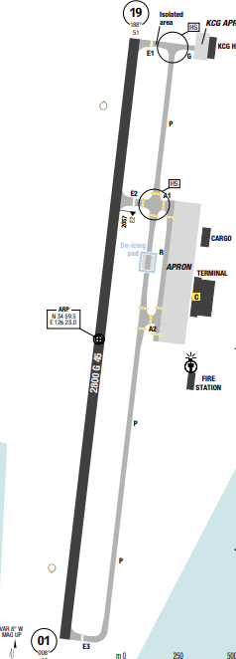
Muan has a warm humid temperate climate with hot summers and no dry season. Over the course of a year, the temperature typically varies from -3°C to 30°C.
The warm season lasts from June to September with an average daily high temperature above 25°C.The cold season lasts from December to February with an average daily high temperature below 9°C. The average cloud cover ranges from 51% to 82%. Over the entire year, the most common forms of precipitation are light rain, moderate rain, and light snow.
Departure |  |  | - SID with high climb gradient, Pilots need to briefing carefully before T/ O
Arrival and Approach |  |  | - CAUTION: On final RWY 01 and Miss APPR or DEP RWY 19 due to obstacle located east of extended RWY at apprx 2.1Nm from RWY 01 threshold
Taxi |  |  | No
Parking information |  |  | No
- TAKE-OFF AND LANDING DISTANCES AVAILABLE
RWY | LENGTH  (m) |  |  | WIDTH  (m) | TORA  (m) |  | LDA  (m) | TODA  (m) |  | ASDA  (m)
01/ 19 | 2800 |  |  | 45 | 3000 |  | 3000 | 3000 |  | 3000
- ELEVATION: 51ft | - EOSID: NO
- IAP: ILS, RNP, VOR
- COMPANY NOTE | - Bird concentrations in the vicinity of the airport.  - Military traffic in vicinity of the airport.
- REMARK | NIL

RKNY/ YNY – YANGYANG INTL AIRPORT – KOREA
- AIRPORT CATEGORY |  |  |  |  |  |  | - RFFS CATEGORY: 7
- AIRPORT CLASSIFICATION
ATR |  | A320 |  |  | A321 |  | A350 |  |  | B787
ADQ |  | ADQ |  |  | ADQ |  | ADQ |  |  | ADQ
- GENERAL STANDARDS
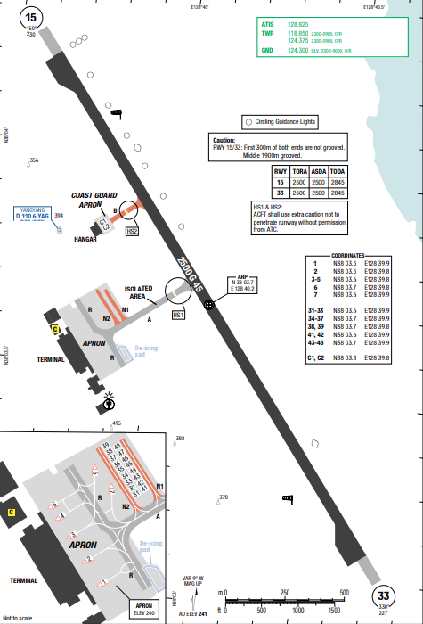
Yangyang International Airport, the summers are warm, humid, wet, and partly cloudy and the winters are short, very cold, windy, and mostly clear. Over the course of the year, the temperature typically varies from -6°C to 28°C and is rarely below -13°C or above 33°C.The average cloud cover ranges from 75% to 90% The probability that precipitation will be observed at this location varies throughout the year. Over the entire year, the most common forms of precipitation are moderate rain or light rain. Precipitation is most likely around the end of July. Over the course of the year, the typical wind speeds vary from 0 m/ s to 8 m/ s.

Departure |  |  | - RNAV SIDs  - Thrust reduction at 1000ft or 1500ft above elevation is recommended.  - SID with high climb gradient.
Arrival and Approach |  |  | - RNAV STARs  - RWY 33 is mainly used for landing  - CAUTION: during approach because the pre-threshold terrain underthe approach path for both RWY 33 and 15 is markedly lower than threshold.
Taxi |  |  | - Taxiway A restricted to ACFT up to code E
Parking information |  |  | No
- TAKE-OFF AND LANDING DISTANCES AVAILABLE
RWY | LENGTH  (m) |  |  | WIDTH  (m) |  | TORA  (m) |  | LDA  (m) | TODA  (m) |  | ASDA  (m)
15 | 2500 |  |  | 45 |  | 2845 |  | 2845 | 2845 |  | 2845
33 | 2500 |  |  | 45 |  | 2845 |  | 2845 | 2845 |  | 2845
- ELEVATION: 241ft | - EOSID: YES
- IAP: ILS, LOC, RNP, VOR
- COMPANY NOTE | - Taxiway A restricted to ACFT up to code E
- REMARK | NIL

RKPC/ CJU – JEJU INTL AIRPORT – JEJU, KOREA
1. AIRPORT CATEGORY: A |  |  |  |  |  |  |  | 2. RFFS CATEGORY: 9
3. AIRPORT CLASSIFICATION
ATR |  | A320 |  |  |  | A321 |  |  | A350 |  |  | B787
ADQ |  | ADQ |  |  |  | ADQ |  |  | ADQ |  |  | ADQ
4. GENERAL STANDARDS
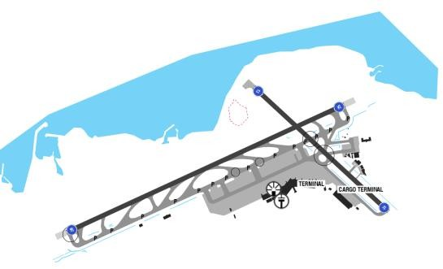
Over the course of a year, the temperature typically varies from 2°C to 30°C and is rarely below -1°C or above 33°C. The average cloud cover ranges from 75% (partly cloudy) to 90% (mostly cloudy). The sky is cloudiest early January and is often clear in late September.
The probability that precipitation will be observed at this location varies throughout the year. Precipitation is most likely around late JAN. Precipitation is least likely around the end of OCT. Over the entire year, the most common forms of precipitation are moderate rain or light rain.
Departure |  |  | - RNAV SIDs  - Require minimum climb gradients.  - Noise abatement procedure (NADP1)
Arrival and Approach |  |  | - RNAV STARs  - Speed restrictions
Taxi |  |  | - Pre-plan the RWY exit strategy that will minimize occupancy time  - Arrival routes  Low VIS taxi routes
Parking information |  |  | - Expected to park at Terminal 2
5. TAKE-OFF AND LANDING DISTANCES AVAILABLE
RWY | LENGTH  (m) |  |  |  | WIDTH  (m) |  | TORA  (m) |  |  | LDA  (m) | TODA  (m) |  |  | ASDA  (m)
07/ 25 | 3180 |  |  |  | 45 |  | 3180 |  |  | 3180 | 3480 |  |  | 3480
13 | 1900 |  |  |  | 45 |  | 1900 |  |  | 1900 | 1900 |  |  | 1960
31 | 1900 |  |  |  | 45 |  | 1900 |  |  | 1489 | 2030 |  |  | 2030
6. ELEVATION: 119ft |  |  |  | 7. EOSID: NO
8. IAP: ILS, LOC, RNP, VOR
9. COMPANY NOTE |  |  |  | - High intensity RWY operation  - Start-up and Pushback procedures  - Speed restrictions in JEJU Terminal control  - Do not turn off the transponder and maintain Mode A code until the aircraft is stationary at parking stand.  - Birds in the vicinity of the airport.  - This airport is an enroute alternate or charter destination. Contact to OCC if support needed.  - As required by Authority, all flights inbound or transit, Advanced Passenger Process (APP) procedure  - Passport checked is done by company’s staff for all crew members.
10. REMARK |  |  |  | NIL

RKPK/ PUS – GIMHAE INTL AIRPORT – BUSAN, KOREA
1. AIRPORT CATEGORY: B |  |  |  |  |  |  |  | 2. RFFS CATEGORY: 9
3. AIRPORT CLASSIFICATION
ATR |  | A320 |  |  | A321 |  |  |  | A350 |  |  | B787
ADQ |  | ADQ |  |  | ADQ |  |  |  | ADQ |  |  | ADQ
4. GENERAL STANDARDS
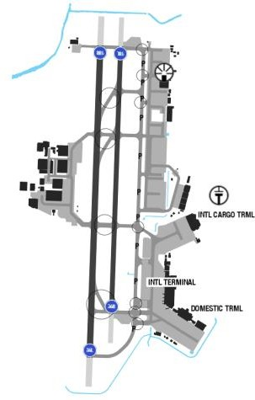
BUSAN airport is located in a very mountainous area. High mountains are located on the East, North and West of the airport. Mountains range1000ft rising to 2105ft starting at about 2.5nm fromRWY18 threshold. The weather in Busan is usually suitable for using RWY 36. There are occasions of strong Southerly wind, leading to RWY 18 being used for approach and landing. During the winter, it is often very cold. Continuous flight in low temperature along with a transit stop at the airport leads to high probability of icing on the aircraft surfaces. External walk around checks must be done very carefully. De-icing may be required before departure.
Departure |  |  | - There are SIDs with high climb gradients. If these SIDs are used in operation, ensure that the all engine climb gradient of aircraft meets the required minimum climb gradient  - NADP available at this airport
Arrival and Approach |  |  | - RNAV STARs  - Speed restrictions  - Noise abatement procedure(delayed/ reduce flap)
Taxi |  |  | - ACFT shall vacate RWY via the designated taxiways  - Follow-me car is available upon apron entrance.  - The procedures of using taxiways.
Parking information |  |  | - While taxiing code letter E ACFT shall:  - Set engines 1 and 4 to idle.  - Maintain ground speed at or below 10KT during taxi.
5. TAKE-OFF AND LANDING DISTANCES AVAILABLE
RWY | LENGTH  (m) |  |  | WIDTH  (m) |  |  | TORA  (m) |  |  | LDA  (m) | TODA  (m) |  | ASDA  (m)
18L/ 36R | 2743 |  |  | 45 |  |  | 2743 |  |  | 2743 | 3043 |  | 3043
18R/ 36L | 3200 |  |  | 60 |  |  | 3200 |  |  | 2600 | 3500 |  | 3500
6. ELEVATION: 13ft |  |  |  |  |  | 7. EOSID: YES
8. IAP: ILS (CAT I, II), LOC, RNP, VOR
9. COMPANY NOTE |  |  |  |  |  | - RWY 36L is recommend for T/ O and LDG  - ATC clearance shall be obtained at least 5 mins prior to pushback.  - Start-up and pushback procedures  - Birds in vicinity of the airport.  - Speed restriction within Korea airspace.  - To be filled as an alternate, PUS requires higher planning minimum.  - Captain must be PF for take-off and landing at this airport.
10. REMARK |  |  |  |  |  | NIL

RKSI/ ICN–INCHEON INTL AIRPORT–SEOUL, KOREA
1. AIRPORT CATEGORY: A |  |  |  |  |  |  |  | 2. RFFS CATEGORY: 9
3. AIRPORT CLASSIFICATION
ATR |  | A320 |  |  |  | A321 |  |  | A350 |  | B787
ADQ |  | ADQ |  |  |  | ADQ |  |  | ADQ |  | ADQ
4. GENERAL STANDARDS
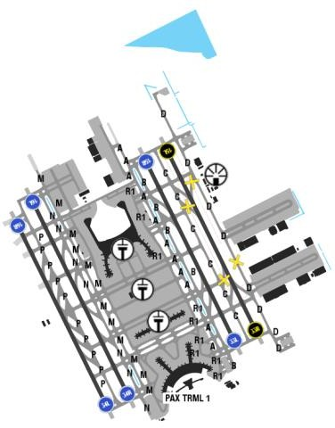
INCHEON airport is located at a flat area, west of Incheon on Yeongjong - Yongyu islands on the west coast about 60 km from the Seoul centre. There are no high terrain surround airport. Incheon features a continental climate with 4clearly defined seasons. It offers hot summers and freezing winters. Summer, which lasts from July till the end of August is the hottest and wettest time of the year with heavy shower rain at times, but they often clear quickly. The winter is much colder in December with temperature drop to 0º by day and frosty spells at night, in early mornings, poor visibility and low cloud ceilings are regular..
Departure |  |  | - There are SIDs with high climb gradients. If these SIDs are used in operation, ensure that the all engine climb gradient of aircraft meets the required minimum climb gradient  - Take- offs of most passenger flights are done on the new runway 16/ 34 and the existing runway 15R/ 33Lwhile runway 15L/ 33R is mostly used for cargo flights for its proximity with the cargo terminals.  - NADP available at this airport
Arrival and Approach |  |  | - Continuous descent operation for arrival  - False course captures may occur when approaching Incheon AP ILS RWY 34R  - GP signals’ fluctuation or interference caused by aircraft taxiing in the vicinity of the GP aerial (RWY15L and 33R)  - ACFT should vacate the RWY via the designated exit TWY  - Follow miss approach procedure for ILS or LOC approach when VOR/ DME is unserviceable
Taxi |  |  | -Follow The Greens Procedure (follow taxiway lighting and guidance system)  -Taxi speed more than 10kts on TWYs A, B, C, D, M,N, P  -Taxi routes and low VIS taxi routes for ARR and DEP
Parking information |  |  | - Gate 10x and 11x are expected for parking
5. TAKE-OFF AND LANDING DISTANCES AVAILABLE
RWY | LENGTH  (m) |  |  |  | WIDTH  (m) |  | TORA  (m) |  |  | LDA  (m) |  | TODA  (m) | ASDA  (m)
15L/ 33R | 3750 |  |  |  | 60 |  | 3750 |  |  | 3750 |  | 4050 | 3870
15R/ 33L | 3750 |  |  |  | 60 |  | 3750 |  |  | 3750 |  | 4050 | 3870
16L/ 34R | 4000 |  |  |  | 60 |  | 4000 |  |  | 4000 |  | 4300 | 4120
16R/ 34L | 3750 |  |  |  | 60 |  | 3750 |  |  | 3750 |  | 4050 | 3870
6. ELEVATION: 59ft |  |  |  | 7. EOSID: YES
8. IAP: ILS (CAT I, II, III), LOC, RNP, VOR
9. COMPANY NOTE |  |  |  | - Bird concentration in vicinity of airport.  - Use of mode S transponder on ground.  - A-CDM operation  - ATC clearance, start-up and pushback procedures  - The RWY 33L/ R or 34L/ R is recommended to be in use to the extent of 8kts tailwind  - This airport is an alternate for ICN. Contact to ICN representative or OCC if support needed.  - As required by Authority, all flights inbound or transit, crew members are requested to complete Advanced Passenger Process procedure– Passport checked-at check-in counter before flight
10. REMARK |  |  |  | Ground Handling Frequency: 131.00 MHz

RKSS/ GMP–SEOUL GIMPO INTL AIRPORT–SEOUL, KOREA
1. AIRPORT CATEGORY: A |  |  |  |  |  |  |  | 2. RFFS CATEGORY: 10
3. AIRPORT CLASSIFICATION
ATR |  | A320 |  |  |  | A321 |  |  | A350 |  |  | B787
ADQ |  | ADQ |  |  |  | ADQ |  |  | ADQ |  |  | ADQ
4. GENERAL STANDARDS
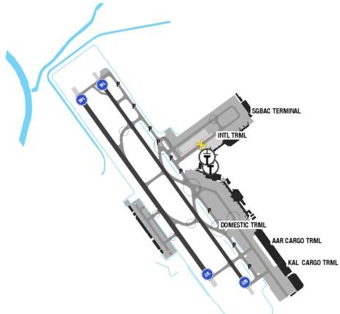
Gimpo International Airport is located in the far western end of Seoul. High terrains are on the east sector with MSA is up to 4000ft.Over the course of a year, the temperature typically varies from-9°C to 30°C.The warm season lasts from late May through September with an average daily high temperature above 24°C.Cloud cover ranges from 62% to 90%.Over the entire year, the most common form of precipitation is light to moderate rain. The season in which it is relatively likely for snow to fall spans from the end of November to the end of March. Over the course of the year typical wind speeds vary from 0 m/ s to 6 m/ s, rarely exceeding 9 m/ s.
Departure |  |  | - RNAV SID.  - Require minimum climb gradients.  - Noise abatement procedures (NADP1)
Arrival and Approach |  |  | - RNAVSTARs  - Speed restrictions.  - Noise abatement procedures (delay flap setting)  - Landing to RWY 14R/ 32L is recommendation.
Taxi |  |  | - Recommend using rapid exit taxiways and within 60s, speed at or above 30kts  - Taxi speed on P should more than 10kts.  - Standard taxi route for arrival and departure  - Low visibility taxi routes.
Parking information |  |  | - Pilots shall pay extra caution to the vehicles and other ACFT taxiing in APN area, ensuring enough wing-tip CLR.  - Pilots shall perform judgemental oversteering when entering TXL RD for code letter E ACFT and above.
5. TAKE-OFF AND LANDING DISTANCES AVAILABLE
RWY | LENGTH  (m) |  |  | WIDTH  (m) |  |  | TORA  (m) |  |  | LDA  (m) | TODA  (m) |  | ASDA  (m)
14L/ 32R | 3600 |  |  | 45 |  |  | 3600 |  |  | 3600 | 3900 |  | 3900
14R/ 32L | 3200 |  |  | 60 |  |  | 3200 |  |  | 3200 | 3500 |  | 3500
6. ELEVATION: 23ft |  |  |  |  | 7. EOSID: YES
8. IAP: ILS, LOC, RNP, VOR
9. COMPANY NOTE |  |  |  |  | - Birds in vicinity of the airport.  - A-CDM  - Speed restrictions within Korea airspace.  - RECAT wake turbulence separation minima. When a pilot encountered wake turbulence, should submit a Report.  - For Radar minimum altitudes see Seoul/ Incheon Intl,  - Avoid flying toward RK(P)- 73 without permission.  - Call delivery or ground 5 minutes before startup to request start- up or ATC clearance.
10. REMARK |  |  |  |  | NIL

RKTN/ TAE - DAEGU (DAEGU INTL) – KOREA
1. AIRPORT CATEGORY: A |  |  |  |  |  |  |  | 2. RFFS CATEGORY: 7
3. AIRPORT CLASSIFICATION
ATR |  | A320 |  |  |  | A321 |  |  | A350 |  |  | B787
ADQ |  | ADQ |  |  |  | ADQ |  |  | N/ A |  |  | N/ A
4. GENERAL STANDARDS
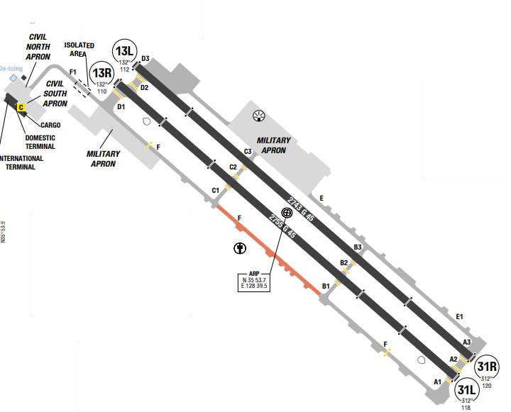
Daegu International Airport is the international airport serving the city of Daegu and the surrounding area in the southeast of South Korea. The airport is also a military base for the ROKAF's 11th Fighter Wing, whose three squadrons fly theF-15K. The airport chiefly serves domestic routes with a small number of international flights. The mountains that comprise the basin trap hot and humid air. Similarly, in winter, cold air lies in the basin. The area receives little precipitation except during the rainy season of summer and is sunny throughout much of the year.
Departure |  |  | -ACFT shall normally enter RWY via the designated TWY. Intersection departures may be initiated by ATC to expedite traffic flow  -RNAV SIDs.  -Require minimum climb gradients.  -Take-offs of most passenger flights are done on the new runway 16/ 34 and the existing runway 15R/ 33Lwhile runway 15L/ 33R is mostly used for cargo flights for its proximity with the cargo terminals.  -Noise abatement procedure
Arrival and Approach |  |  | - PAPI-RWY 13 restricted to 3NM.  - Cirling not authorized NE of RWY 31/ 13, Circling Radius Applied.  - Missed Approach climb gradient: 250ft/ nm to 6000 ft VOR/ DME unserviceable on some Radial
Taxi |  |  | - TWY F between C1 and B1 MAX wingspan 36m/ 118ft.
Parking information |  |  | No
5. TAKE-OFF AND LANDING DISTANCES AVAILABLE
RWY | LENGTH  (m) |  |  | WIDTH  (m) |  |  | TORA  (m) |  |  | LDA  (m) | TODA  (m) |  | ASDA  (m)
13L/ 31R | 2743 |  |  | 45 |  |  | 2743 |  |  | 2743 | 2743 |  | 2743
13R/ 31L | 2755 |  |  | 45 |  |  | 2755 |  |  | 2755 | 2755 |  | 2755
6. ELEVATION: 120ft |  |  |  |  | 7. EOSID: NO
8. IAP: ILS, LOC, RNP, VOR
9. COMPANY NOTE |  |  |  |  | - Bird concentration in the vicinity of airport: wild ducks, cattle egrets and swallows  - All civil aircraft takeoff and landing are restricted from 1500-2000Z except for emergency condition.  - Unable to divert at these HR(2000-2300, 1200- 1500),except EMERG and prior permission ACFT.  - During the Quiet HR, unsurpassed ENG runs and non essential ACFT OPS are prohibited, except civil airlines authorized by ROKAF  - This airport is an alternate for ICN. Contact to ICN representative or OCC if support needed.  - As required by Authority, all flights inbound or transit, crew members are requested to complete Advanced Passenger Process (APP) procedure– Passport checked-at check-in counter before flight
10. REMARK |  |  |  |  | NIL

RKTU/ CJJ–CHEONGJU INTL AIRPORT–CHEONGJU, KOREA
1. AIRPORT CATEGORY: A |  |  |  | 2. RFFS CATEGORY: 8
3. AIRPORT CLASSIFICATION
ATR | A320 |  | A321 |  | A350 | B787
ADQ | ADQ |  | ADQ |  | N/ A | N/ A
4. GENERAL STANDARDS
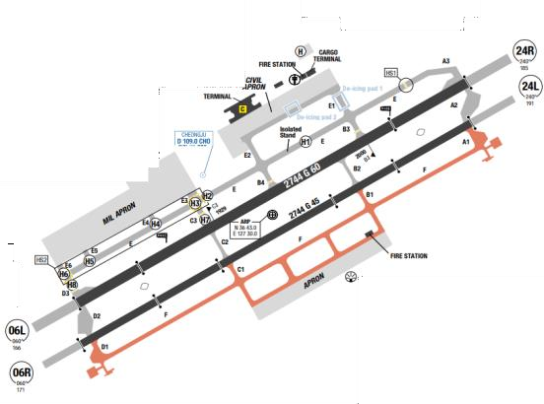
Cheongju International Airport is an international airport in Cheongju city, South Korea. Geum River goes through right center of Cheongju city. Additionally, the tributaries of Musim and Miho flow together in northern part of city. To east and west, there are mountains of Wuam and Bumo. Musimcheon River goes through the middle of Cheongju city. The airport is located in a valley and surrounded by hills, with highest MSA is 4800ft to the south sector. Over the course of a year, the temperature typically varies from-8°C to 31°C and israrelybelow-13°Cor above 34°C. The warm season lasts from the end of May to the end of September with an average daily high temperature above25°C. The hottest time of the year is in early August with an average high of 31°C and low of23°C. The winter lasts from the end of November through to the end of February with an average daily temperature below 8°C. The coldest time of the year is late January with an average low of-8°C and high of 3°C.
Departure |  | - ACFT shall normally enter RWY via the designated TWY. Intersection departures may be initiated by ATC to expedite traffic flow  - RNAV SIDs.  - Require minimum climb gradients.  - Take-offs of most passenger flights are done on the new runway 16/ 34 and the existing runway 15R/ 33Lwhile runway 15L/ 33R is mostly used for cargo flights for its proximity with the cargo terminals.  - Noise abatement procedure
Arrival and Approach |  | - Circling is not authorized Southeast of RWY 06- 24,RWY 24-06

Taxi |  | - Code letter F aircraft shall enter the apron via TWYB3, E1 and shall not move via TWY B4, E2  - Unless otherwise cleared by ATC, all airliners shall taxi at speed of less than 20 kts.  - Standard taxi routes for arrival and departure.
Parking information |  | No
5. TAKE-OFF AND LANDING DISTANCES AVAILABLE
RWY | LENGTH  (m) |  | WIDTH  (m) |  | TORA  (m) | LDA  (m) | TODA  (m) | ASDA  (m)
06L/ 24R | 2744 |  | 60 |  | 2744 | 2744 | 2744 | 2744
06R/ 24L | 2744 |  | 45 |  | 2744 | 2744 | 2744 | 2744
6. ELEVATION: 192ft |  |  |  | 7. EOSID: YES
8. IAP: ILS, LOC, RNP, VOR
9. COMPANY NOTE |  |  |  | - Birds in the vicinity of airport (0-500 ft)  - Mandatory for all airlines to use RWY 24R/ 06Lexcept for emergency but does not exceed PCN34.  - Take-off and landing can be delayed due to military flight and operations  - This airport is an alternate for ICN. Contact to ICN representative or OCC if support needed.  - As required by Authority, all flights inbound or transit, crew members are requested to complete Advanced Passenger Process (APP) procedure
10. REMARK |  |  |  | NIL

ROAH/ OKA – NAHA AIRPORT – NAHA, JAPAN
- AIRPORT CATEGORY |  |  |  |  |  |  | - RFFS CATEGORY: 9
- AIRPORT CLASSIFICATION
ATR |  | A320 |  |  | A321 |  | A350 |  |  | B787
ADQ |  | ADQ |  |  | ADQ |  | ADQ |  |  | ADQ
- GENERAL STANDARDS
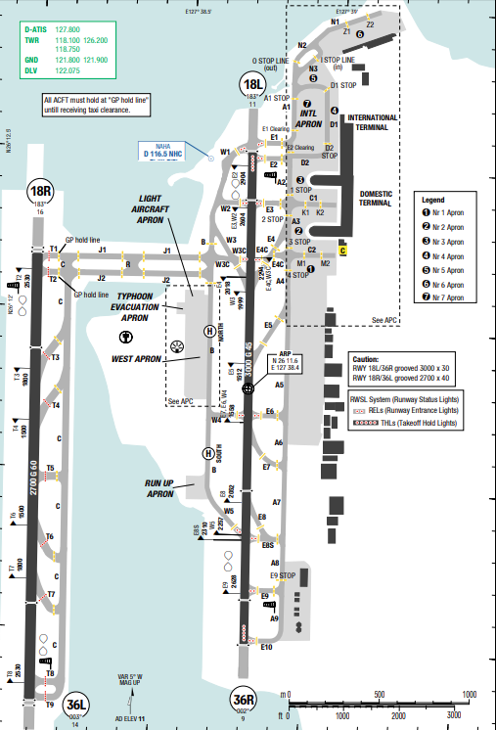
Naha Airport is located along the south-western shoreline of Okinawa Island. Okinawa is the largest of the Ryukyu Islands, which are southwest of Japan's mainland. The Philippines Sea is to the east, while the East China Sea is to the west. This island measures about 60NM from southwest to the northeast, and its irregular width varies between 2 and 16NM. The northern two thirds of Okinawa is heavily forested with low mountains, while the southern third is rolling terrain that is heavily developed. Both runway ends are bordered by water, with urban development immediately east of the airport.
Broken ceilings are the predominant sky conditions throughout the year. As much as 12% of the late morning hours report IMC in May and June. Annual precipitation totals 213 cm (83.9 in). Winds are from the northeast in December, north in March; southwest in July and east in August; north-northeast in October.

Departure |  |  | - RNAV SIDs  - SID with high climb gradient, Pilots need to briefing carefully before T/ O
Arrival and Approach |  |  | - RNAV STARs  - Continuous descent operation (CDO).
Taxi |  |  | - Reduce RWY occupancy time by exiting RWY without delay at the first available TWY
Parking information |  |  | No
- TAKE-OFF AND LANDING DISTANCES AVAILABLE
RWY | LENGTH  (m) |  |  | WIDTH  (m) |  | TORA  (m) |  | LDA  (m) | TODA  (m) |  | ASDA  (m)
18L/ 36R | 2672 |  |  | 45 |  | 3000 |  | 3000 | 3000 |  | 3000
18R/ 36L | 2377 |  |  | 60 |  | 2700 |  | 2700 | 2700 |  | 2700
- ELEVATION: 11ft | - EOSID: NO
- IAP: ILS, LOC, RNP, VOR
- COMPANY NOTE | - Restriction about the use of APU  - Contact Naha Delivery 5 mins prior to starting engines
- REMARK | NIL

RPLC/ CRK–DIOSDADO MACAPAGAL INTL AIRPORT–PAMPANGA, PHILIPPINES
1. AIRPORT CATEGORY: A |  |  |  |  |  |  |  | 2. RFFS CATEGORY: 9
3. AIRPORT CLASSIFICATION
ATR |  | A320 |  |  |  | A321 |  |  | A350 |  |  | B787
ADQ |  | ADQ |  |  |  | ADQ |  |  | ADQ |  |  | ADQ
4. GENERAL STANDARDS
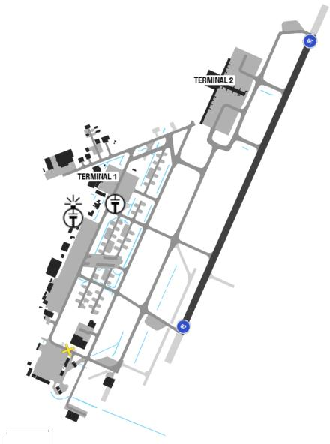
Diosdado Macapagal International Airport is located in the central part of Luzon Island. This island's coastline is mostly mountainous while most of the interior is a broad plain. The airport is on the edge of this plain and immediately to the west, a coastal mountain range runs from Lingayen Gulf in the north, to the entrance of Manila Bay 46 NM to the south. The rainy season begins in late May and lasts until October. Tropical storms and typhoons are possible from June to February. Obstruction to visibility peaks in March and April, averaging 11days per month due to fog, blowing dust/ sand, or smoke/ haze. Thunderstorms average 1 day per month in March and 11 days per month in September. Winds are from the west-southwest in SEP.
Departure |  |  | -RNAV SIDs.  -Require minimum climb gradients.
Arrival and Approach |  |  | -RNAV STARs.  -PAPI for RWY 02 is 3.5  -Circling to land is not authorized west of runway
Taxi |  |  | - Follow me car can be requested through the Clark tower.
Parking information |  |  | - TWY B and C only AVBL for tow-in and tow-out OPS during the day.  - ACFT entering the remote parking at J RAMP and N RAMP shall be by tow-in and tow-out OPS only.
5. TAKE-OFF AND LANDING DISTANCES AVAILABLE
RWY | LENGTH  (m) |  |  | WIDTH  (m) |  |  | TORA  (m) |  |  | LDA  (m) | TODA  (m) |  | ASDA  (m)
02/ 20 | 3200 |  |  | 60 |  |  | 3200 |  |  | 3200 | 3500 |  | 3200
6. ELEVATION: 484ft |  |  |  |  | 7. EOSID: YES
8. IAP: ILS, LOC, RNP
9. COMPANY NOTE |  |  |  |  | - Birds are in the vicinity of the airport.
10. REMARK |  |  |  |  | NIL

RPLL/ MNL–NINOY AQUINO INTL AIRPORT–MANILA, PHILIPPINES
1. AIRPORT CATEGORY/ RFFS CATEGORY |  |  |  |  |  |  |  | 2. RFFS CATEGORY: 9
3. AIRPORT CLASSIFICATION
ATR |  | A320 |  |  |  | A321 |  |  | A350 |  |  | B787
ADQ |  | ADQ |  |  |  | ADQ |  |  | ADQ |  |  | ADQ
4. GENERAL STANDARDS
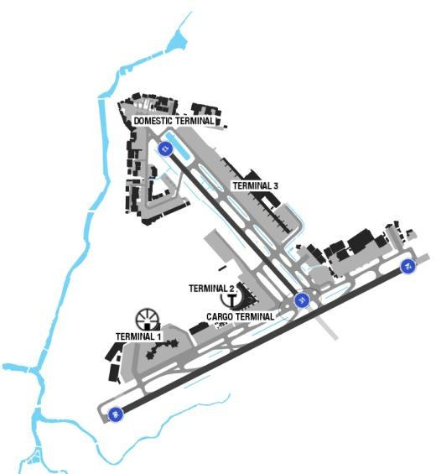
Ninoy Aquino International Airport is located near Manila Bay, on western Luzon Island. Luzon's coastal areas consist of mountainous terrain while the central interior is a large plain. The airport is along Manila Bay's eastern shoreline on an isthmus that separates it from Laguna de Bay.
Terrain surrounding the airport is flat and heavily developed. To the northeast, the Sierra Madre Mountains rise above 4800 feet MSL within 25 NM. To the west across the bay, Mariveles Mountain rises above 4500 feet MSL within 30 NM. Obstruction to visibility due to haze/ smoke and dust/ sand averages 29 days per month through- out the year. Broken to overcast ceilings are the predominant sky conditions from May through January.
Departure |  |  | - RNAV SIDs available with high climb gradient (Highest 7.5% to 500ft at RWY 31)  - NADP available at this airport (TKOF PROC A)  - RWY 31: TKOF from F1, F2 and F3 INT not allowed.
Arrival and Approach |  |  | - RNAV STARs  - COMM FAIL Procedure available  - During ARR via radar vectors, do not cancel IFR within 20NM of AD. RWY 13 touchdown shall be made beyond threshold marker (MNM ALT 15m / 49ft).  - RWY 13 and RWY 06 right-hand circuit:  + TFC circuit: 1500ft, 201-250KT.  + TFC circuit: 1000ft, 106-200KT.  - NAP available: IFR TFC radar vectored to RWY 06/24 shall maintain 3500ft prior entering IFR climb/ descent area. IFR ACFT from north and LDG on RWY 24 shall be RAD vectored to right base leg at 2000ft or higher.
Taxi |  |  | - Should use rapid taxi way to exit.  - Crossing RWY 13/31 from F1 to F1B is prohibited  - TWY G10, F1B, Z, H4, GA1-5 with width restriction
Parking information |  |  | - ACFT with security EMERG shall park and will be cleared by authorities.
5. TAKE-OFF AND LANDING DISTANCES AVAILABLE
RWY | LENGTH  (m) |  |  | WIDTH  (m) |  |  | TORA  (m) |  |  | LDA  (m) | TODA  (m) |  | ASDA  (m)
06 | 3510 |  |  | 60 |  |  | 3510 |  |  | 3510 | 3664 |  | 3510
13 | 2249 |  |  | 45 |  |  | 2249 |  |  | 2105 | 1971 |  | 1971
24 | 3510 |  |  | 60 |  |  | 3409 |  |  | 3510 | 3629 |  | 3510
31 | 2249 |  |  | 45 |  |  | 2105 |  |  | 1800 | 2250 |  | 2105
6. ELEVATION: 75ft |  |  |  |  | 7. EOSID: NO
8. IAP: ILS, LOC, RNP, VOR
9. COMPANY NOTE |  |  |  |  | - Exercise caution for helicopter OPS on W side of RWY 13/31.  - Simultaneous operation of RWY 06/24 and RWY 13/31 possible.  - Birds in vicinity of AD.  - Grass cutting conducted daily 0000-0900 and 1730-1930. Exercise caution when passing  - RWY 06/24, RWY 13/31, TWY C, TWY D and GA areas.
10. REMARK |  |  |  |  | NIL

RPMD/ DVO – FRANCISCO BANGOY INTL, DAVAO, PHILIPPINES
1. AIRPORT CATEGORY: A |  |  |  |  |  |  |  | 2. RFFS CATEGORY: 9
3. AIRPORT CLASSIFICATION
ATR |  | A320 |  |  |  | A321 |  |  | A350 |  |  | B787
ADQ |  | ADQ |  |  |  | ADQ |  |  | ADQ |  |  | ADQ
4. GENERAL STANDARDS
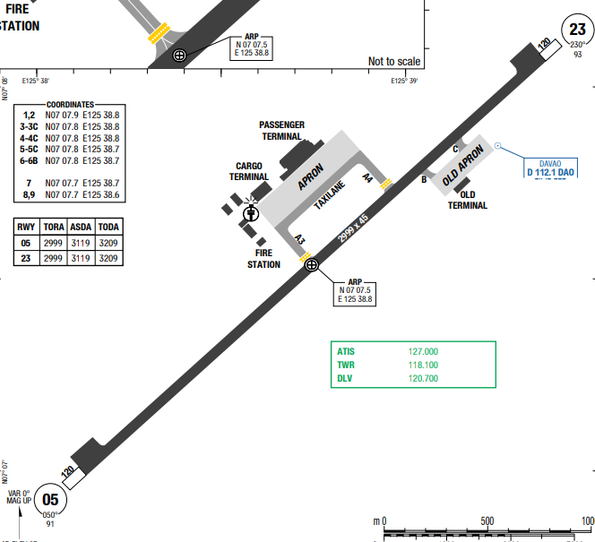
Francisco Bangoy International Airport (IATA: DVO, ICAO: RPMD), also known as Davao International Airport, is the main airport serving Davao City and Davao Region in the Philippines.
Davao has a tropical rainforest climate with year-round high temperatures, high humidity, and consistent rainfall, meaning there is no distinct dry season. While it rains throughout the year, the wettest month is typically June and the driest is March
Departure |  |  | - RNP SIDs available  - RWY 05: Push-back compulsory, start-up parallel to RWY at PSN S1, S2 or as instructed by ATC.  - RWY 23: Push-back compulsory, start-up parallel to RWY at PSN S2, S3 or as instructed by ATC.
Arrival and Approach |  |  | - RNAV STARs  - RWY 21 right-hand circuit, ALT 1000ft AGL PROP, 1500ft AGL JET.
Taxi |  |  | - Standard Taxi Routes for LDG:  + RWY 05 - TWY A4  + RWY 23 - TWY A3
Parking information |  |  | - Taxi with own PWR into parking bay, use marshaller assistance.  - Push-back and tow-out with marshaller only.
5. TAKE-OFF AND LANDING DISTANCES AVAILABLE
RWY | LENGTH  (m) |  |  | WIDTH  (m) |  |  | TORA  (m) |  |  | LDA  (m) | TODA  (m) |  | ASDA  (m)
23 | 2999 |  |  | 45 |  |  | 2999 |  |  | 2999 | 2999 |  | 3119
05 | 2999 |  |  | 45 |  |  | 2999 |  |  | 2999 | 2999 |  | 3119
6. ELEVATION: 35ft |  |  |  |  | 7. EOSID: YES
8. IAP: ILS, RNP, VOR
9. COMPANY NOTE |  |  |  |  | - Only ACFT with MAX weight below 64.8t / 143000lbs are allowed to make 180° turns on RWY.
10. REMARK |  |  |  |  | NIL

RPMZ/ ZAM – ZAMBOANGA, PHILIPPINES
1. AIRPORT CATEGOR: A |  |  |  |  |  |  |  |  | 2. RFFS CATEGORY: 7
3. AIRPORT CLASSIFICATION
ATR |  | A320 |  |  |  | A321 |  | A350 |  |  |  | B787
ADQ |  | ADQ |  |  |  | ADQ |  | ADQ |  |  |  | ADQ
4. GENERAL STANDARDS
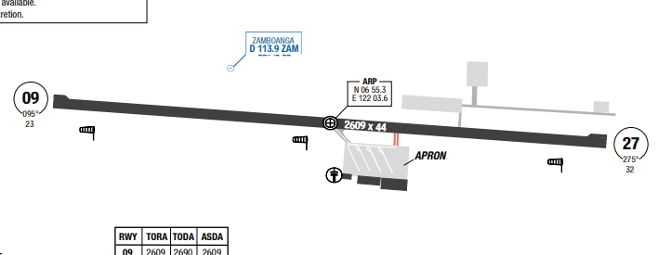
Zamboanga International Airport (IATA: ZAM, ICAO: RPMZ) is the main airport serving Zamboanga City in the Philippines. Located on a 270-hectare (670-acre) site in Barangay Canelar, Zamboanga City.
Zamboanga features a tropical, hot, and often oppressive climate with temperatures ranging from 24°C to 33°C year-round. It is generally humid and overcast, with a drier season from December to May, making it an ideal time for visitation. The region is generally outside the main typhoon belt but faces high cyclone risks in northern parts.
Departure |  |  | - RNAV SIDs available and require climb gradien  - Specific routing for high performance aircrafts  - BURCO 2B, PARAL 2B, MASUN 2B, TINDO 2B: During daytime, climb under VMC authorized by ATC depending upon traffic conditions.
Arrival and Approach |  |  | - RNAV STAR  - RWY 09 right-hand circuit.
Taxi |  |  | - TWY E width 18m / 59FT.
Parking information |  |  | NIL
5. TAKE-OFF AND LANDING DISTANCES AVAILABLE
RWY | LENGTH  (m) |  |  | WIDTH  (m) |  |  | TORA  (m) |  |  | LDA  (m) | TODA  (m) |  | ASDA  (m)
09 | 2609 |  |  | 44 |  |  | 2609 |  |  | 2609 | 2690 |  | 2609
27 | 2609 |  |  | 44 |  |  | 2609 |  |  | 2609 | 2685 |  | 2609
6. ELEVATION: 84ft |  |  |  |  | 7. EOSID: NO
8. IAP: RNP, VOR
9. COMPANY NOTE |  |  |  |  | - 180°-tuns on RWY turn pads only.
10. REMARK |  |  |  |  | NIL

RPVB/ BCD – BACOLOD SILAY INTL AIRPORT, PHILIPPINES
1. AIRPORT CATEGORY: A |  |  |  |  |  |  |  | 2. RFFS CATEGORY: 7
3. AIRPORT CLASSIFICATION
ATR |  | A320 |  |  |  | A321 |  |  | A350 |  |  | B787
ADQ |  | ADQ |  |  |  | ADQ |  |  | N/A |  |  | N/A
4. GENERAL STANDARDS
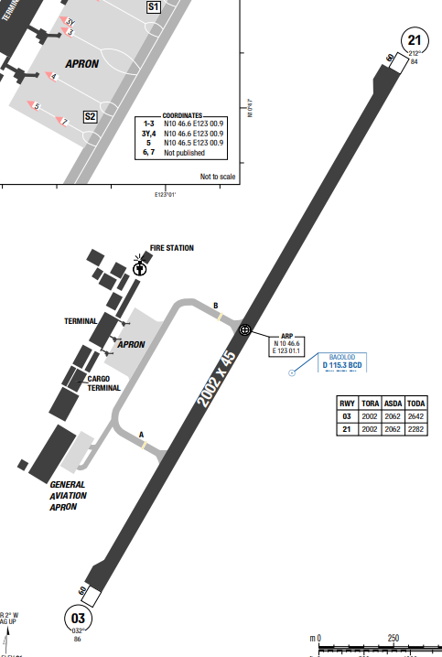
Bacolod–Silay International Airport, is an airport serving the general area of Metro Bacolod, located in the Negros Island Region of the Philippines. The airport is located 15 kilometers northeast of Bacolod on a 181-hectare site in Barangay Bagtic, Silay, Negros Occidental.
Bacolod has a tropical monsoon climate with two seasons: a wet season from May to December and a dry season from January to April. The city experiences high temperatures, high humidity, and abundant rainfall, especially during August and September. Flooding can occur during heavy rains, which are frequent in the wet and monsoon seasons.
Departure |  |  | - RNP SIDs and require high climb gradient (Highest 10.4% - TADAG 2F)  - Transponder with a Mode C capability required to operate within TCA
Arrival and Approach |  |  | - RNAV STARs  - RWY 21 right-hand circuit, ALT 1000ft AGL PROP, 1500ft AGL JET.
Taxi |  |  | NIL
Parking information |  |  | - While taxiing flight crew must contact TWR for parking bay assignment.  - Solid yellow nose guidelines shall be used for all ARR ACFT.  - ACFT may taxi with own PWR via TWY A or B into bay but wing marshaller compulsory.
5. TAKE-OFF AND LANDING DISTANCES AVAILABLE
RWY | LENGTH  (m) |  |  | WIDTH  (m) |  |  | TORA  (m) |  |  | LDA  (m) | TODA  (m) |  | ASDA  (m)
03 | 2002 |  |  | 45 |  |  | 2002 |  |  | 2002 | 2642 |  | 2062
21 | 2002 |  |  | 45 |  |  | 2002 |  |  | 2002 | 2282 |  | 2062
6. ELEVATION: 35ft |  |  |  |  | 7. EOSID: NO
8. IAP: ILS, RNP, VOR
9. COMPANY NOTE |  |  |  |  | NIL
10. REMARK |  |  |  |  | NIL

RPVE/ MPH – CATICLAN AIRPORT, AKLAN, PHILIPPINES
1. AIRPORT CATEGORY: A |  |  |  |  |  |  |  | 2. RFFS CATEGORY: 7
3. AIRPORT CLASSIFICATION
ATR |  | A320 |  |  |  | A321 |  |  | A350 |  |  | B787
ADQ |  | ADQ |  |  |  | ADQ |  |  | N/A |  |  | N/A
4. GENERAL STANDARDS
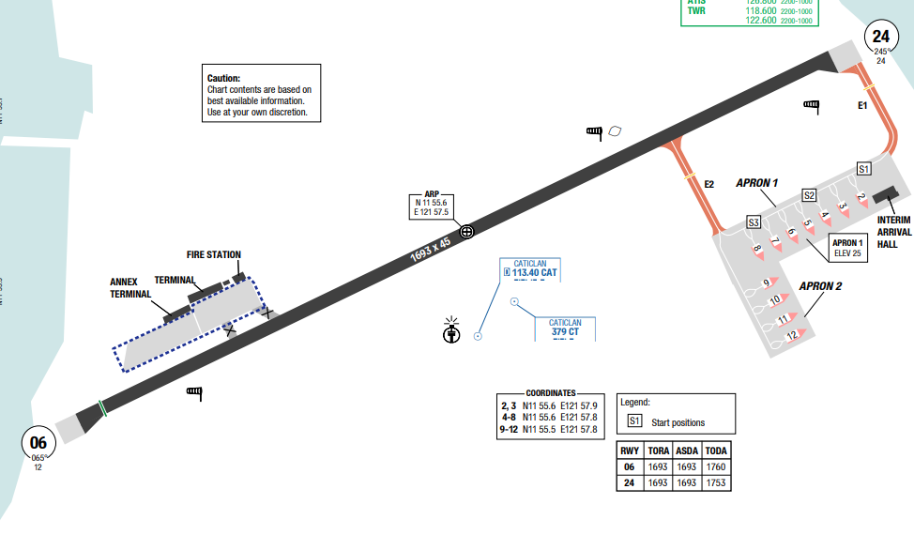
Godofredo P. Ramos Airport, also known as Caticlan Airport and Boracay Airport, is an international airport serving the general area of the municipality of Malay, located in the province of Aklan in the Philippines. It is one of the two gateways to Boracay, the other being Kalibo International Airport in Kalibo.
Aklan has a tropical climate characterized by high temperatures year-round, high humidity, and abundant rainfall. Temperatures typically range from 26°C to 32°C, with the hottest months being April and May. Aklan's climate is similar to the rest of the Philippines, which experiences high temperature, high humidity, and plenty of rainfall.
Departure |  |  | - RNAV SIDs  - Require minimum climb gradients (7.9% to 1000)
Arrival and Approach |  |  | - RNAV STARs  - RWY 06 turbulence on short final may occur  - RWY 24 right-hand circuit.
Taxi |  |  | - TWY E1, E2 width 18m / 59ft.  - Taxiing ACFT should follow GND marshaller.
Parking information |  |  | - Marshaller mandatory.
5. TAKE-OFF AND LANDING DISTANCES AVAILABLE
RWY | LENGTH  (m) |  |  | WIDTH  (m) |  |  | TORA  (m) |  |  | LDA  (m) | TODA  (m) |  | ASDA  (m)
24 | 1693 |  |  | 45 |  |  | 1693 |  |  | 1693 | 1760 |  | 1693
06 | 1693 |  |  | 45 |  |  | 1693 |  |  | 1693 | 1753 |  | 1639
6. ELEVATION: 7ft |  |  |  |  | 7. EOSID: NO
8. IAP: RNP
9. COMPANY NOTE |  |  |  |  | - All ACFT shall use the RWY turn-around pad or follow nose wheel markings on RWY 06/24 when making 180° turn after LDG roll (excluding AT72 and smaller ACFT).  - No re-land at the AD in case of technical problem AFT TKOF.  - Birds in the vicinity of AD.
10. REMARK |  |  |  |  | NIL

RPVI/ ILO – ILOILO INTL AIRPORT, PHILIPPINES
1. AIRPORT CATEGORY: A |  |  |  |  |  |  |  | 2. RFFS CATEGORY: 9
3. AIRPORT CLASSIFICATION
ATR |  | A320 |  |  |  | A321 |  |  | A350 |  |  | B787
ADQ |  | ADQ |  |  |  | ADQ |  |  | N/A |  |  | N/A
4. GENERAL STANDARDS
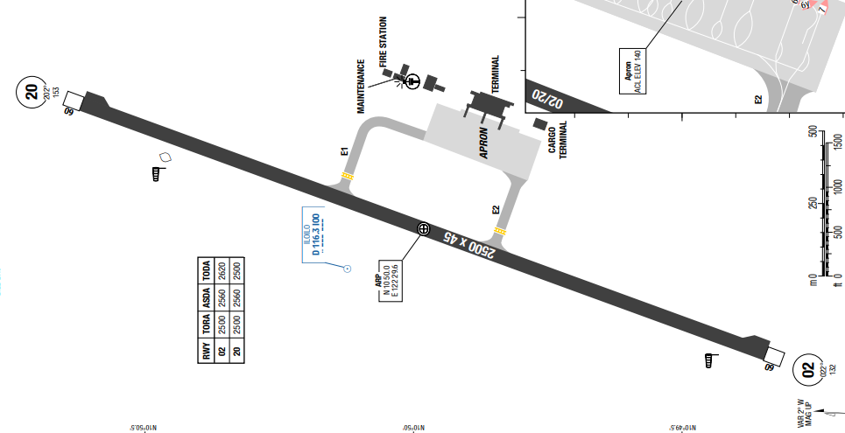
Iloilo International Airport is the main international airport serving Iloilo City and its metropolitan area, as well as the rest of Iloilo province in the Western Visayas region of the Philippines. It is the fifth-busiest airport in the Philippines and is located in the municipality of Cabatuan, Iloilo, approximately 24 kilometers northwest of Iloilo City proper.
Iloilo has a tropical wet and dry climate, with a wet season from June to November and a dry season from November to May. The area experiences high rainfall, with the wettest month being August and the driest being February. It is also a high-hazard area for cyclones (typhoons) and urban flooding.
Departure |  |  | - RNAV SIDs  - Require minimum climb gradients (highest 6.8% - BUSOG1N)
Arrival and Approach |  |  | -RNAV STARs
Taxi |  |  | - While taxiing contact TWR for parking bay assignment.  - All ACFT may taxi in with PWR using TWY E1 or E2 to respective bay assignments must be assisted by marshaller
Parking information |  |  | NIL
5. TAKE-OFF AND LANDING DISTANCES AVAILABLE
RWY | LENGTH  (m) |  |  | WIDTH  (m) |  |  | TORA  (m) |  |  | LDA  (m) | TODA  (m) |  | ASDA  (m)
20 | 2500 |  |  | 45 |  |  | 2500 |  |  | 2500 | 2620 |  | 2560
02 | 2500 |  |  | 45 |  |  | 2500 |  |  | 2500 | 2500 |  | 2560
6. ELEVATION: 153ft |  |  |  |  | 7. EOSID: NO
8. IAP: ILS, RNP, VOR
9. COMPANY NOTE |  |  |  |  | NIL
10. REMARK |  |  |  |  | NIL

RPVM/ CEB–MACTAN-CEBU INTL AIRPORT, LAPU-LAPU, PHILIPPINES
1. AIRPORT CATEGORY: A |  |  |  |  |  |  |  | 2. RFFS CATEGORY: 9
3. AIRPORT CLASSIFICATION
ATR |  | A320 |  |  |  | A321 |  |  | A350 |  |  | B787
ADQ |  | ADQ |  |  |  | ADQ |  |  | ADQ |  |  | ADQ
4. GENERAL STANDARDS
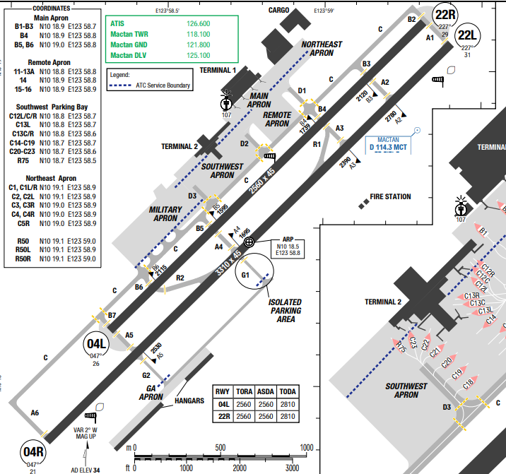
Mactan–Cebu International Airport is an international airport serving Metro Cebuand serves as the main gateway to the Central Visayas region, it is the second busiest airport in the Philippines. The climate of Cebu is tropical. There are 2 seasons in Cebu − the dry and wet season. It is dry and sunny most of the year with some occasional rains during the months of June to December. The province of Cebu normally gets typhoons once a year.
Departure |  |  | - RNAV SIDs  - Require minimum climb gradients.  - Noise abatement procedure.
Arrival and Approach |  |  | - RNAV STARs  - RWY 04L/R right-hand circuit.  - RWY 22L/R left-hand circuit  - Noise abatement procedure.
Taxi |  |  | - All widebody, four engined aircraft are advise to use the inboard engines when taxiing to avoid foreign object damage.  - All rotary wing operating to and from Mactan International Heliport shall contact Mactan Air Traffic Control for clearance/ traffic advisory/ information service prior to start-up, lift-off and taxi operations from their respective hangar or parking bay.
Parking information |  |  | - 4 ENG ACFT are advised to use inner ENGs while taxiing to avoid jet blast.  - Visual docking guidance system AVBL.
5. TAKE-OFF AND LANDING DISTANCES AVAILABLE
RWY | LENGTH  (m) |  |  | WIDTH  (m) |  |  | TORA  (m) |  |  | LDA  (m) | TODA  (m) |  | ASDA  (m)
04R/22L | 3310 |  |  | 45 |  |  | 3310 |  |  | 3310 | 3310 |  | 3310
04L/22R | 2560 |  |  | 45 |  |  | 2560 |  |  | 2560 | 2810 |  | 2560
6. ELEVATION: 35ft |  |  |  |  | 7. EOSID: NO
8. IAP: RNP, VOR
9. COMPANY NOTE |  |  |  |  | - Birds in vicinity of the airport.
10. REMARK |  |  |  |  | NIL

RPSP/ TAG – BOHOL-PANGLAO INTL, PANGLAO, PHILIPPINES
1. AIRPORT CATEGOR: A |  |  |  |  |  |  |  |  | 2. RFFS CATEGORY: 7
3. AIRPORT CLASSIFICATION
ATR |  | A320 |  |  |  | A321 |  | A350 |  |  |  | B787
ADQ |  | ADQ |  |  |  | ADQ |  | N/A |  |  |  | N/A
4. GENERAL STANDARDS
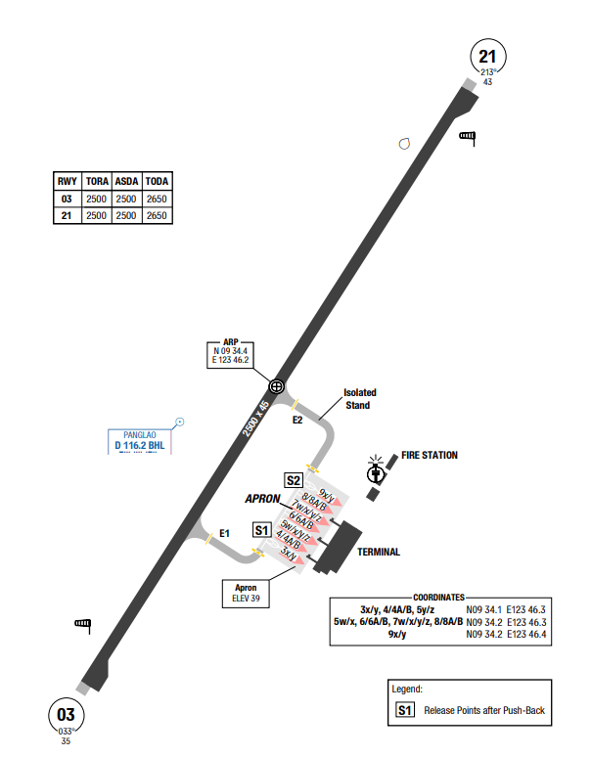
Bohol–Panglao International Airport (IATA: TAG, ICAO: RPSP), also known as New Bohol International Airport or Panglao Island Airport, is an international airport on Panglao Island in the province of Bohol, Philippines.
Panglao, Philippines, features a tropical climate with high temperatures 24-33°C and high humidity year-round. It belongs to a Type IV climate (distributed rainfall), with a dry season from November to May and a wetter, rainier season from June to October. The best time to visit is December to April, which offers sunny days and minimal ra
Departure |  |  | - RNAV SIDs available and require climb gradient and require high climb gradient (highest 6.5% to 11000ft). Presence of trees near DER  - COMM FAIL Procedure available
Arrival and Approach |  |  | - RNAV STAR  - ILS 27: GP unusable from D2 IPKT (MM) to RWY 27 THR.  - COMM FAIL Procedure available
Taxi |  |  | - PIC shall taxi following the TWY guide lines and GND controller/ marshaller.
Parking information |  |  | - All ACFT shall be assisted with wing marshals/walkers.  - All ACFT LDG RWY 03 shall taxi-in via TWY E2, unless otherwise instructed by ATC.  - All ACFT LDG RWY 21 shall taxi-in via TWY E1, unless otherwise instructed by ATC.
5. TAKE-OFF AND LANDING DISTANCES AVAILABLE
RWY | LENGTH  (m) |  |  | WIDTH  (m) |  |  | TORA  (m) |  |  | LDA  (m) | TODA  (m) |  | ASDA  (m)
12/ 30 | 3050 |  |  | 45 |  |  | 3050 |  |  | 3050 | 3050 |  | 3050
6. ELEVATION: 84ft |  |  |  |  | 7. EOSID: NO
8. IAP: ILS, LOC, RNP, VOR
9. COMPANY NOTE |  |  |  |  | - 180° turns for A319 and above ACFT on turn pads only and must follow the nose wheel guide
10. REMARK |  |  |  |  | NIL

UACC/NQZ – ASTANA (NURSULTAN NAZARBYEV INTL) – KAZAKHSTAN
- AIRPORT CATEGORY: A |  |  |  |  |  | - RFFS CATEGORY: 9
- AIRPORT CLASSIFICATION
ATR |  | A320 |  |  | A321 | A350 |  |  |  | B787
ADQ |  | ADQ |  |  | ADQ | ADQ |  |  |  | ADQ
- GENERAL STANDARDS
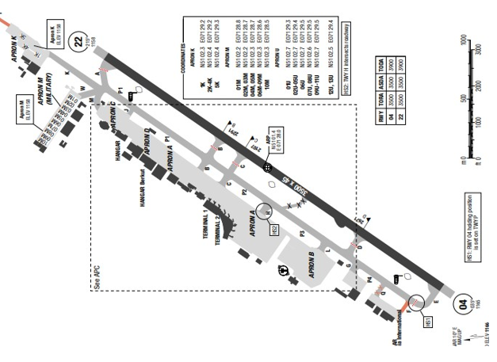
Nursultan Nazarbayev International Airport is located in the upland of north central Kazakhstan. Terrain in this area is fairly level and land immediately surrounding the airport consists mostly of cultivated fields.
The Ishim River passes the airport 4 NM to the north, while Lake Maybalyk is 1 NM to the southeast. The highest obstacle in the area is a man-made structure at 1803 feet MSL, 7 NM to the north. Icing conditions are prevalent from November through March, reported an average of 25 days per month. Annual precipitation totals 33 cm (12.8 in). Winds are from the south-southwest in December. Winds are from the southeast in April. Winds are from the west in June
Departure |  |  | - RNAV SIDs are available.  - SIDs require minimum climb gradient.
Arrival and Approach |  |  | - RNAV STARs are available.  - Circle to land minimum is not published for this airport.  - There are airspeed restrictions and continuous descent operations for all RNAV approach procedures
Taxi |  |  | - TWY with width <23m: Q, F, Y
Parking information |  |  | - Entry to stands 17-19, 24-50, 70-75, 101C-104C by towing.  - Exit from stands 1-11, 20-23 by towing.
- TAKE-OFF AND LANDING DISTANCES AVAILABLE
RWY | LENGTH  (m) |  |  | WIDTH  (m) |  |  | TORA  (m) | LDA  (m) | TODA  (m) |  | ASDA  (m)
04/ 22 | 3500 |  |  | 45 |  |  | 3500 | 3500 | 3900 |  | 3500
- ELEVATION: 685ft | - EOSID: NO
- IAP: ILS, LOC, RNP, VOR
- COMPANY NOTE | - ATC uses Russian for local, and English for international traffic. This intermix, in addition to the different broadcasting techniques, may produce confusion.  - Birds are in the vicinity of the airport and may fly across the runway and approach area especially 1-2 hours before and after sunset  - Low visibility procedures for ground operations exist at this airport.  - Numerous prohibited and restricted areas are within the airport vicinity.  - Noise abatement procedures are in effect for this airport. Refer to LIDO Route Manual - AOI Charts for details.
- REMARK | NIL

UAAA/ ALA – ALMATY AIRPORT – ALMATY, KAZAKHSTAN
- AIRPORT CATEGORY: A |  |  |  |  |  | - RFFS CATEGORY: 9
- AIRPORT CLASSIFICATION
ATR |  | A320 |  |  | A321 | A350 |  |  |  | B787
ADQ |  | ADQ |  |  | ADQ | ADQ |  |  |  | ADQ
- GENERAL STANDARDS
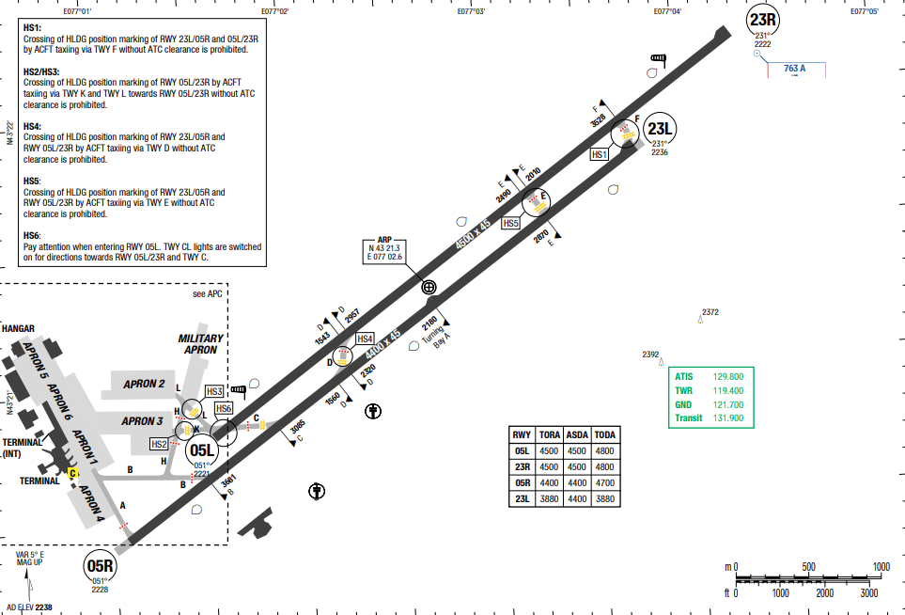
Almaty International Airport is an international airport in Almaty, Kazakhstan. It is larger than Nursultan Nazarbayev International Airport (NQZ) in Astana and is the main international gateway into the country. At Almaty International Airport, the summers are warm, dry, and mostly clear and the winters are freezing, snowy, and partly cloudy. Over the course of the year, the temperature typically varies from - 9°C to 31°C and is rarely below -17°C or above 36°C
Departure |  |  | - RNAV SIDs  - Immediate T/O after receiving clearance. Inform ATC if unable  - SID with high climb gradient
Arrival and Approach |  |  | - RNAV STARs
Taxi |  |  | - Speed limitations.
Parking information |  |  | No
- TAKE-OFF AND LANDING DISTANCES AVAILABLE
RWY | LENGTH  (m) |  |  | WIDTH  (m) |  |  | TORA  (m) | LDA  (m) | TODA  (m) |  | ASDA  (m)
05L/ 23R | 4500 |  |  | 45 |  |  | 4500 | 4500 | 4800 |  | 4500
05R | 4400 |  |  | 45 |  |  | 4400 | 4400 | 4800 |  | 4400
23L | 4400 |  |  | 45 |  |  | 4400 | 4400 | 4700 |  | 4400
- ELEVATION: 2238ft | - EOSID: YES
- IAP: ILS, LOC, RNP, VOR
- COMPANY NOTE | - Birds are in the vicinity of the airport.  - RWY may be slippery when wet.  - Do not mistake Boralday Airport (7NM West) for this airport.  - Numerous restricted and prohibited area surround the airport.
- REMARK | NIL

UAKK/KGF – KARAGANDA (KARAGANDA) - KAZAKHSTAN
- AIRPORT CATEGORY: A |  |  |  |  |  |  | - RFFS CATEGORY: 8
- AIRPORT CLASSIFICATION
ATR |  | A320 |  |  | A321 |  | A350 |  |  | B787
ADQ |  | ADQ |  |  | ADQ |  | ADQ |  |  | ADQ
- GENERAL STANDARDS
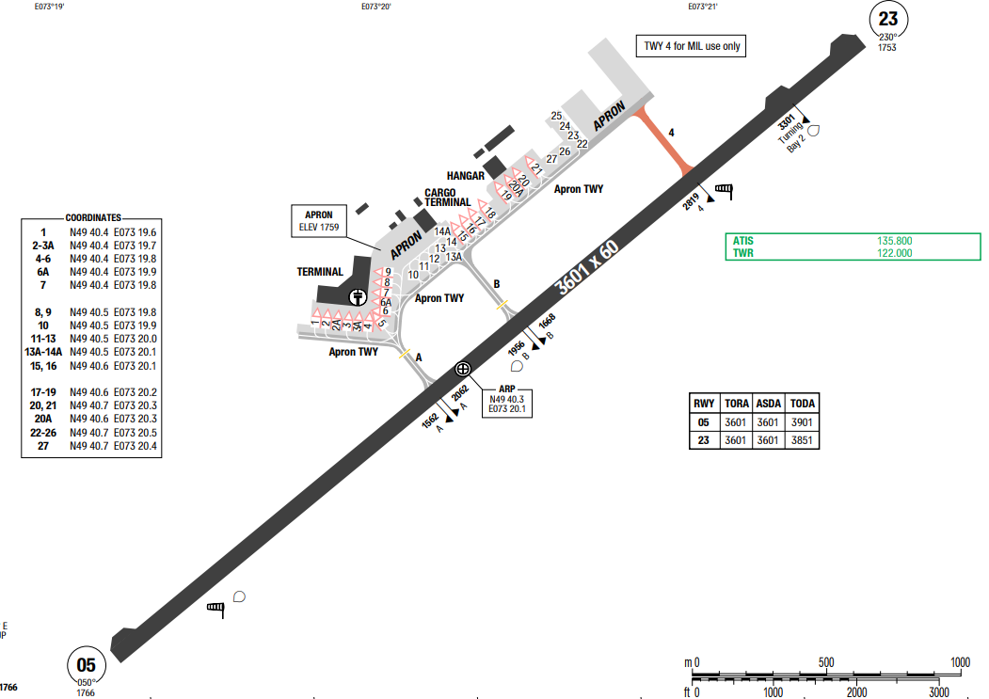
Karaganda Airport is located in north central Kazakhstan near the eastern edge of an extensive semiarid grass-covered plain. Undeveloped land mixed with cultivated fields surround the airport.
The terrain is flat, gradually becoming more hilly to the east and south. A small creek passes the airport 2 NM to the north. The highest obstacle is a man-made structure at 2575 feet MSL, located within 11 NM to the south-southwest. Karaganda has a Continental climate with warm summers and very cold winters. Precipitation is moderately low throughout the year, although slightly heavier from May to July. Snow is frequent, though light, in winter.

Departure |  |  | NIL
Arrival and Approach |  |  | - Circle to land minimums are not published for this airport.
Taxi |  |  | - TWY 4 width 18m / 59ft. TWY 4 MIL use only.
Parking information |  |  | - Taxiing into/out of stands 10-18 under own ENG PWR is allowed for the ACFT with length < 37m; wingspan < 29m
- TAKE-OFF AND LANDING DISTANCES AVAILABLE
RWY | LENGTH  (m) |  |  | WIDTH  (m) |  | TORA  (m) |  | LDA  (m) | TODA  (m) |  | ASDA  (m)
05 | 3600 |  |  | 60 |  | 3600 |  | 3600 | 3900 |  | 3600
23 | 3600 |  |  | 60 |  | 3600 |  | 3600 | 3850 |  | 3600
- ELEVATION: 1766ft | - EOSID: NO
- IAP: ILS, VOR
- COMPANY NOTE | - ATC uses Russian for local, and English for international traffic. This intermix, in addition to the different broadcasting techniques, may produce confusion.  - Low visibility procedures for ground operations exist at this airport.  - The airport is equipped with a terminal Doppler RADAR to monitor low-level windshear
- REMARK | NIL

UATT/AKX – AKTOBE (AKTOBE) - KAZAKHSTAN
- AIRPORT CATEGORY: A |  |  |  |  |  |  | - RFFS CATEGORY: 8
- AIRPORT CLASSIFICATION
ATR |  | A320 |  |  | A321 |  | A350 |  |  | B787
ADQ |  | ADQ |  |  | ADQ |  | ADQ |  |  | ADQ
- GENERAL STANDARDS
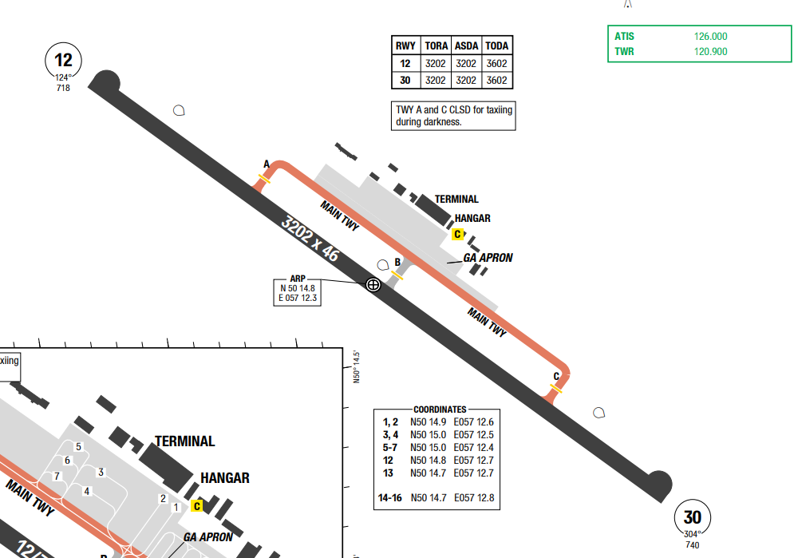
Aktobe International Airport is an airport in Kazakhstan located 1.5 km south-west of Aktobe. It has a small terminal with five airliner parking spots. The MSA is 2500ft. Aktobe has a humid continental climate, with wide seasonal variations in temperature. In winter, temperatures can reach a low of -48 °C, with a daily average minimum of -16 °C. Summer temperatures can reach a high of 43 °C , with an average maximum temperature of 30 °C . The weather can change rapidly, especially during spring and autumn (the especially windy days in March). Precipitation usually occurs in early spring and late autumn/early winter and is otherwise sporadic throughout the year.

Departure |  |  | - Conventional SIDs are available.  - SIDs require minimum climb gradient
Arrival and Approach |  |  | - Conventional STARs are available.
Taxi |  |  | - TWY A, C, MAIN TWY width 20m / 66ft.  - TWY A and C CLSD during darkness.
Parking information |  |  | - Taxiing onto APN after RWY vacation shall be carried out only after follow-me.  - Taxi guide lines may be invisible because of snow. Follow-me AVBL O/R via GND
- TAKE-OFF AND LANDING DISTANCES AVAILABLE
RWY | LENGTH  (m) |  |  | WIDTH  (m) |  | TORA  (m) |  | LDA  (m) | TODA  (m) |  | ASDA  (m)
12/30 | 3200 |  |  | 45 |  | 3200 |  | 3200 | 3600 |  | 3200
- ELEVATION: 741ft | - EOSID: NO
- IAP: ILS, VOR, NDB
- COMPANY NOTE | NIL
- REMARK | NIL

UBBB/ GYD – HEYDAR ALIYEV INTL AIRPORT – BAKU, AZERBAIJAN
- AIRPORT CATEGORY: A |  |  |  |  |  |  | - RFFS CATEGORY: 9
- AIRPORT CLASSIFICATION
ATR |  | A320 |  |  | A321 |  | A350 |  |  | B787
ADQ |  | ADQ |  |  | ADQ |  | ADQ |  |  | ADQ
- GENERAL STANDARDS
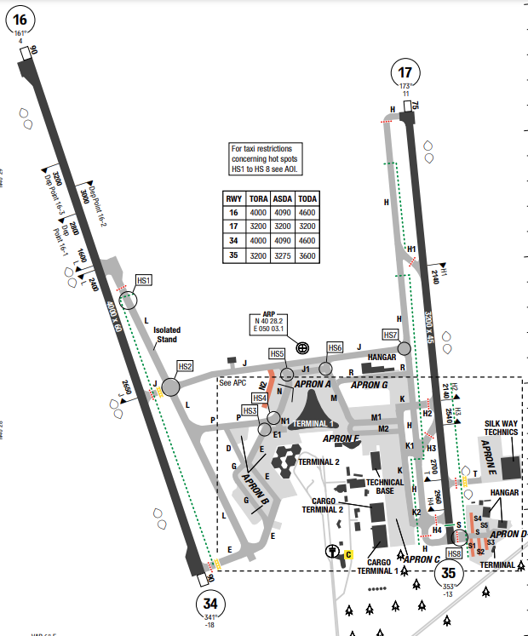
Baku Heydar Aliyev International Airport is one of the six international airports serving Azerbaijan.
Formerly, it was called Bina International Airport by the name of a suburb in Baku.
Departure |  |  | - RNAV SIDs  - Contact BAKU departure as soon as practical after take-off
Arrival and Approach |  |  | - RNAV STARs  - Radar vector is applicable for sequencing and on request by crew  - Noise abtement procedure (using reverse thrust)
Taxi |  |  | - Taxi to stand with follow me car only
Parking information |  |  | No
- TAKE-OFF AND LANDING DISTANCES AVAILABLE
RWY | LENGTH  (m) |  |  | WIDTH  (m) |  | TORA  (m) |  | LDA  (m) | TODA  (m) |  | ASDA  (m)
16 | 4000 |  |  | 60 |  | 4000 |  | 4000 | 4600 |  | 4090
17 | 3200 |  |  | 45 |  | 3200 |  | 3200 | 3200 |  | 3200
34 | 4000 |  |  | 60 |  | 4000 |  | 4000 | 4090 |  | 4090
35 | 3200 |  |  | 45 |  | 3200 |  | 3065 | 3600 |  | 3275
- ELEVATION: 10ft | - EOSID: NO
- IAP: ILS (CAT I, II, III), RNP, VOR
- COMPANY NOTE | - When parked, set Squawk 2000 before selecting OFF or STBY.
- REMARK | NIL

UBBG/ GNJ – GANJA AIRPORT – GANJA, AZERBAIJAN
- AIRPORT CATEGORY: A |  |  |  |  |  |  | - RFFS CATEGORY: 8
- AIRPORT CLASSIFICATION
ATR |  | A320 |  |  | A321 |  | A350 |  | B787
ADQ |  | ADQ |  |  | ADQ |  | ADQ |  | ADQ
- GENERAL STANDARDS
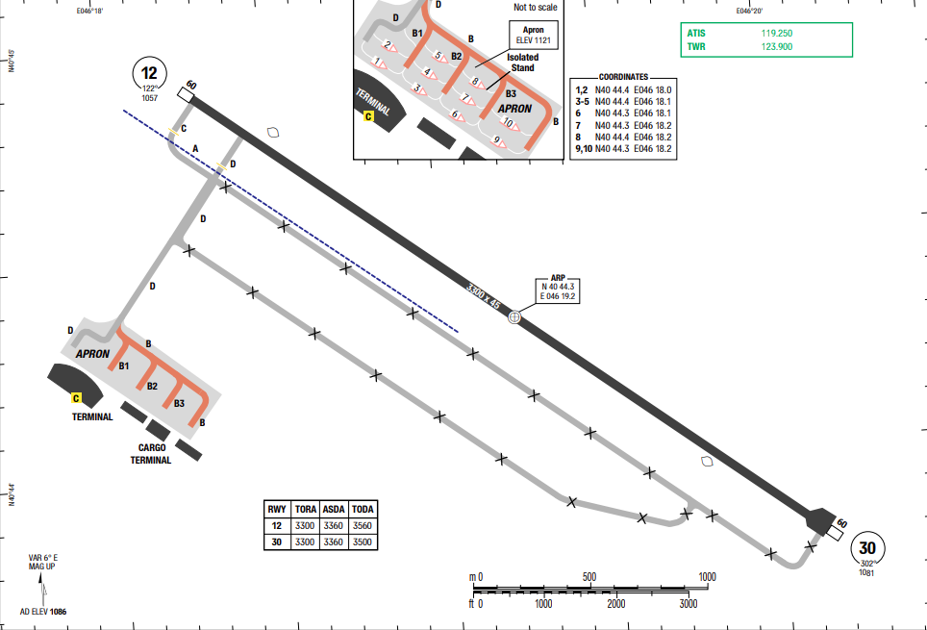
Ganja located 400–450 meters (1312 to 1476 ft) above the sea level, lies on the Ganja-Dashkasan plain in the Kur-Araz lowland in the west of Azerbaijan, 375 km (33 mi) away from Baku. It is situated at the north-eastern foothills of the Lesser Caucasus Mountain ranges on the Ganjachay river. Located at an elevation of 1086ft above sea level, Ganja has a Humid subtropical, no dry season climate.

Departure |  |  | - Conventional SIDs  - Requires minimum climb gradients.
Arrival and Approach |  |  | - Conventional STARs
Taxi |  |  | - TWY B, B1, B2 and B3 width 18m/ 59ft.  - TWYs in APN area are not equipped with lights indicating median strip.  - Taxilines may be invisible due to snow, request follow-me via TWR.
Parking information |  |  | No
- TAKE-OFF AND LANDING DISTANCES AVAILABLE
RWY | LENGTH  (m) |  |  | WIDTH  (m) |  | TORA  (m) |  | LDA  (m) |  | TODA  (m) | ASDA  (m)
12/ 30 | 3300 |  |  | 45 |  | 3300 |  | 3300 |  | 3560 | 3360
- ELEVATION: 1086ft | - EOSID: NO
- IAP: ILS, VOR
- COMPANY NOTE | NIL
- REMARK | NIL

UEEE/ YKS – YAKUTSK AIRPORT – YAKUTSK, RUSSIA
- AIRPORT CATEGORY: A |  |  |  |  |  | - RFFS CATEGORY: 8, 9 O/ R
- AIRPORT CLASSIFICATION
ATR |  | A320 |  |  | A321 | A350 |  | B787
ADQ |  | ADQ |  |  | ADQ | ADQ |  | ADQ
- GENERAL STANDARDS
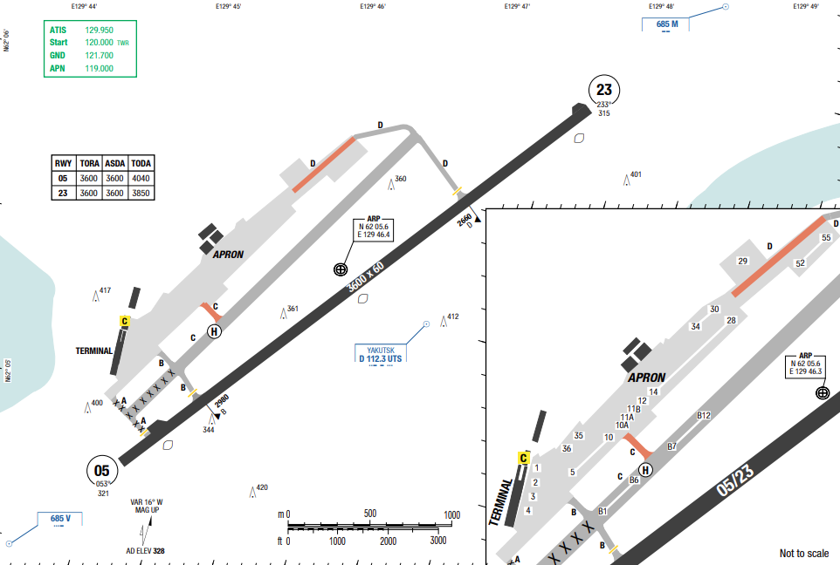
Yakutsk Airport is located in the Central Yakut Lowland of Eastern Siberia near the western bank of the Lena River. This river is immediately east of the airport and is approximately 3 NM wide. During periods of seasonal flooding, the Lena is often 8 NM wide and can encompass the airport area. Terrain immediately east of Lena's riverbank consists mostly of marsh land. Low hills, rising above 1000 feet are 35 NM to the west-southwest. A man-made structure at 1270 feetMSL, 4 NM west-southwest of the airport.
Departure |  |  | - RNAV SIDs.  - Noise abatement procedure.
Arrival and Approach |  |  | - RNAV STARs
Taxi |  |  | - Closed RWY 05/ 23 for ACFT taxiing only.
Parking information |  |  | No
- TAKE-OFF AND LANDING DISTANCES AVAILABLE
RWY | LENGTH  (m) |  |  | WIDTH  (m) |  | TORA  (m) | LDA  (m) |  | TODA  (m) | ASDA  (m)
05 | 3400 |  |  | 60 |  | 3400 | 3400 |  | 3690 | 3400
23 | 3400 |  |  | 60 |  | 3400 | 3400 |  | 3400 | 3400
- ELEVATION: 10ft | - EOSID: NO
- IAP: ILS, VOR
- COMPANY NOTE | - Birds are in the vicinity of the airport.  - The metric system is used in this airspace. Wind speed is given in meters per second and heights are given in meters.
- REMARK | NIL

UHHH/ KHV - NOVY AIRPORT - KHABAROVSK, RUSSIA
- AIRPORT CATEGORY: A |  |  |  |  |  |  | - RFFS CATEGORY: 9
- AIRPORT CLASSIFICATION
ATR | A320 |  |  |  | A321 |  | A350 |  |  | B787
ADQ | ADQ |  |  |  | ADQ |  | ADQ |  |  | ADQ
- GENERAL STANDARDS
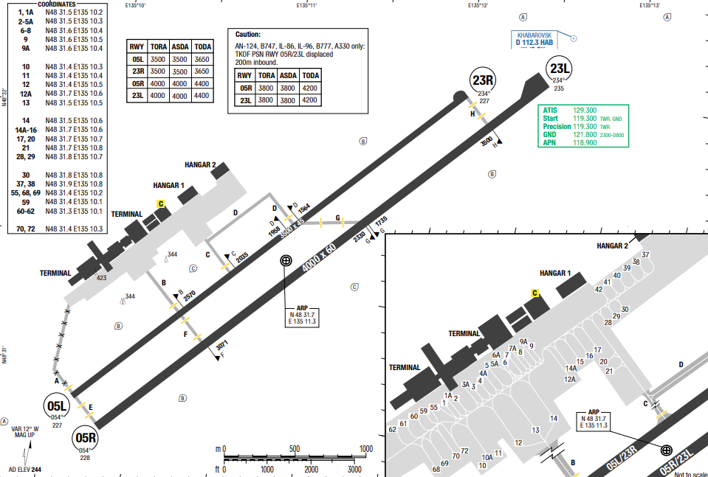
Khabarovsk Novy Airport is an airport located at the eastern part of Khabarovsk, Khabarovsk Krai, Russia.In this area, the valley is more than 60NM wide and spreads from southwest to northeast.
The Amur River flows northwestward, passing the airport 6NM to the west. Within 3NM to the southwest, there is an 856ft high man-made structure. Khabarovsk area has a severely continental climate with its northern areas being subarctic with stronger maritime summer moderation in the north.
In summer, the weather is hot, wet and humid which rapidly transforms into severely cold and long winters, where temperatures hardly ever go above freezing.
Departure |  |  | - RNAV SIDs.  - Noise abatement procedure (Specific SIDs or NADP1)  - RWY occupation time is less than 1 min, if unable, pilot must request new take-off clearance.  - RWY 05L/ R if preference for take-off.  - Unless otherwise instructed climb to 2220 (1977), at 900 (657) establish radio contact with Radar or Approach controller and report take-off execution, assigned SID and altitude/ FL to be reached.  - EXPECT 'direct to' procedure and/ or RADAR vectoring.
Arrival and Approach |  |  | - RNAV STARs  - RWY 23L/ R if preference for landing.  - EXPECT 'direct to' procedure and/ or RADAR vectoring.
Taxi |  |  | - RWY vacate procedure.
Parking information |  |  | No
- TAKE-OFF AND LANDING DISTANCES AVAILABLE
RWY |  | LENGTH  (m) |  | WIDTH  (m) |  | TORA  (m) |  | LDA  (m) | TODA  (m) |  | ASDA  (m)
05L/ 23R |  | 3500 |  | 45 |  | 3500 |  | 3500 | 3500 |  | 3500
05R/ 23L |  | 4000 |  | 60 |  | 4000 |  | 4000 | 4000 |  | 4000
- ELEVATION: 243ft | - EOSID: NO
- IAP: ILS (CAT I, II), LOC, NDB, RNP, VOR
- COMPANY NOTE | - Birds are in the vicinity of the airport.  - ATC uses Russian for local, and English for international traffic. This intermix, in addition to the different broadcasting techniques, may produce confusion.  - The metric system is used in this airspace. per second and heights are given in meters speed is given in meters  - Class C airspace overlies the airport.  - Circle to land minimums are not published for this airport.
- REMARK | NIL

UHMA/ DYR - UGOLNY AIRPORT- ANADYR, RUSSIA
- AIRPORT CATEGORY: A |  |  |  |  |  | - RFFS CATEGORY: 8
- AIRPORT CLASSIFICATION
ATR |  | A320 |  |  | A321 | A350 |  |  | B787
ADQ |  | ADQ |  |  | ADQ | ADQ |  |  | ADQ
- GENERAL STANDARDS
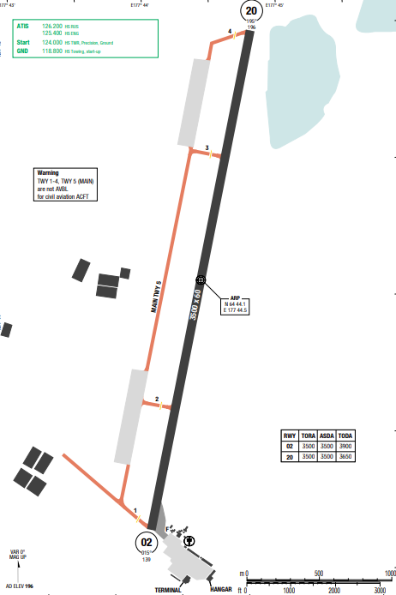
The airport is located on the eastern Pacific coastline of Russia, 2NM inland from the main portion of Anadyr Bay’s northwestern shoreline. Land surrounding the airport is mostly tundra. West side of the airport is relatively flat with many small lakes. Northeast corner has terrain which rises from 1135MSL within 3NM, up to 3320MSL within 12NM.Most of the year, waterways are covered in ice packs, which changes the appearance of the surrounding areas. Visibility is reduced due to the obstruction of blowing snow about 7-14days per month from November to April. Broken ceiling is the predominant sky condition from April to November.
Departure |  |  | - Conventional SIDs.  - WARNING: Heavy turbulence with downflows may be expected during climbing.
Arrival and Approach |  |  | - Conventional STARs  - WARNING: Heavy turbulence with downflows may be expected on final.
Taxi |  |  | - LVO is applied ONLY FOR GROUND MOVEMENTS AND OPERATIONS when RVR is less than 550m
Parking information |  |  | No
- TAKE-OFF AND LANDING DISTANCES AVAILABLE
RWY | LENGTH  (m) |  |  | WIDTH  (m) |  |  | TORA  (m) | LDA  (m) |  | TODA  (m) | ASDA  (m)
01/ 19 | 3501 |  |  | 60 |  |  | 3501 | 3501 |  | 3501 | 3501
- ELEVATION: 194ft | - EOSID: NO
- IAP: ILS, LOC, NDB, RNP
- COMPANY NOTE | - Metric unit is used for the airspace.  - NO circle to land is published.  - Birds are in the vicinity.
- REMARK | NIL

UHMM/ GDX – SOKOL AIRPORT – MAGADAN, RUSSIA
- AIRPORT CATEGORY: A |  |  |  |  |  | - RFFS CATEGORY: 8
- AIRPORT CLASSIFICATION
ATR |  | A320 |  |  | A321 | A350 |  |  |  | B787
ADQ |  | ADQ |  |  | ADQ | ADQ |  |  |  | ADQ
- GENERAL STANDARDS
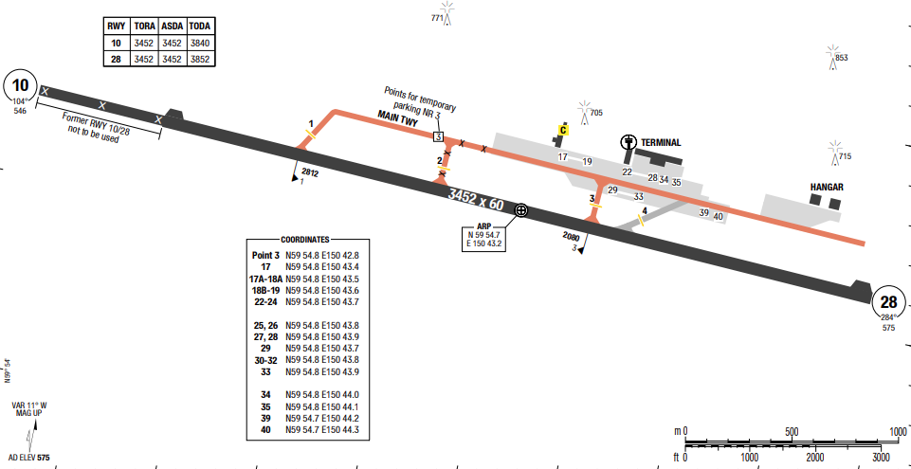
Sokol Airport is located near the Sea of Okhotsk coastline in far eastern Russia. In this area the coastline is oriented east to west, and the airport is located 20 M inland from Tai Bay's northern shore. Sokol is in a valley and is surrounded by an extensive mountain system. Obstruction to visibility, due to fog, peaks from May through August, averaging 10-14 days per month. Obstruction to visibility due to blowing snow is highest from October through February, averaging 8-10 days per month. Broken to overcast ceilings are the predominant sky conditions throughout the whole year.
Departure |  |  | - RNAV SIDs  - SID with high climb gradient
Arrival and Approach |  |  | - RNAV STARs.  - Warning: Turbulence may occur during missed approach due to terain relief.  - Circling to land is not authorized north of the airport.
Taxi |  |  | - Exercise extra caution during taxi at the aerodrome.  - Follow me car is required for taxi during:  • Night time  • Day time, when VIS is les than 2000m  • Day time, when markings or signs are not visible
Parking information |  |  | No
- TAKE-OFF AND LANDING DISTANCES AVAILABLE
RWY | LENGTH  (m) |  |  | WIDTH  (m) |  |  | TORA  (m) | LDA  (m) | TODA  (m) |  | ASDA  (m)
10/ 28 | 3452 |  |  | 60 |  |  | 3452 | 3156 | 3452 |  | 3452
- ELEVATION: 571ft | - EOSID: NO
- IAP: ILS, NDB, RNP
- COMPANY NOTE | - Metric unit is used for the airspace.  - Birds are in the vicinity.
- REMARK | NIL

UHPP/ PKC - YELIZOVO AIRPORT, PETROPAVLOVSK-KAMCHATSKY, RUSSIA
- AIRPORT CATEGORY: A |  |  |  |  |  | - RFFS CATEGORY: 8
- AIRPORT CLASSIFICATION
ATR |  | A320 |  |  | A321 | A350 |  |  |  | B787
ADQ |  | ADQ |  |  | ADQ | ADQ |  |  |  | ADQ
- GENERAL STANDARDS
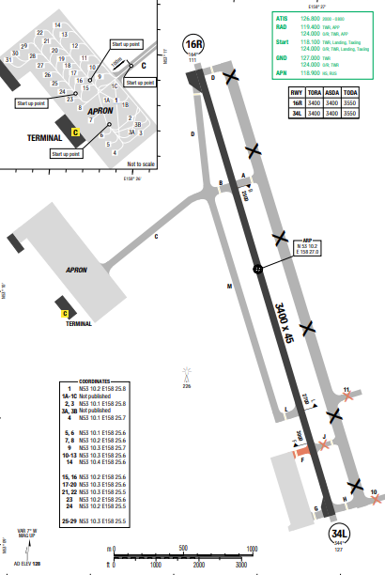
Yelizovo airport is located in the southeastern portion of the Kamchatka Peninsula. This peninsula separates the Sea of Okhotsk from the Pacific Ocean and contains many volcanic peaks.
The airport in in a valley. Avachinsky Bay is 7NM southeast of the airport. Visibility is reduced due to fog, about 11-16 days per month from June to August. Broken to Overcast ceiling are the predominant sky conditions throughout the year
Departure |  |  | - RNAV SIDs.  - EXPECT radar vectoring  - SID with high climb gradient
Arrival and Approach |  |  | - RNAV STARs  - EXPECT radar vectoring
Taxi |  |  | - 180 turn is permitted on RWY 16/ 34 turn-pad and on RWY by pilot request.  - Must report RWY vacation.
Parking information |  |  | No
- TAKE-OFF AND LANDING DISTANCES AVAILABLE
RWY | LENGTH  (m) |  |  | WIDTH  (m) |  |  | TORA  (m) | LDA  (m) | TODA  (m) |  | ASDA  (m)
16R/ 34L | 3400 |  |  | 45 |  |  | 3400 | 3400 | 3550 |  | 3400
- ELEVATION: 128ft | - EOSID: NO
- IAP: ILS (CAT I, II), NDB, VOR
- COMPANY NOTE | - Birds are in the vicinity of the airport.  - ATC uses Russian for local, and English for international traffic. This intermix, in addition to the different broadcasting techniques, may produce confusion.  - The metric system is used in this airspace. Wind speed is given in meters per second and heights are given in meters.  - Caution: Some Russian transponders may not be detected by TCAS.  - The RWY characteristics may cause it to become slipper when wet.
- REMARK | NIL

UHSS/ UUS – KHOMUTOVO AIRPORT – YUZHNO-SAKHALINSK, RUSSIA
- AIRPORT CATEGORY: A |  |  |  |  |  | - RFFS CATEGORY: 8
- AIRPORT CLASSIFICATION
ATR |  | A320 |  |  | A321 | A350 |  |  | B787
ADQ |  | ADQ |  |  | ADQ | ADQ |  |  | ADQ
- GENERAL STANDARDS
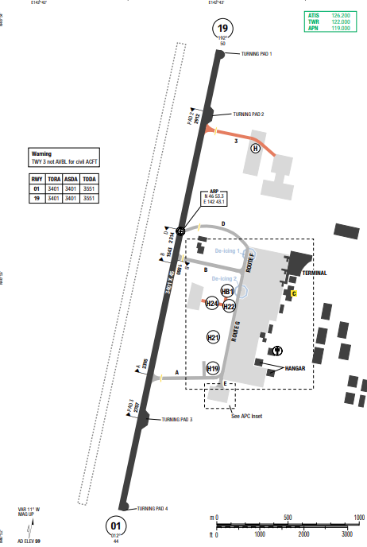
Yuzhno-Sakhalinsk Airport; also called Khomutovo, is an airport in Yuzhno-Sakhalinsk, on the Russia Island of Sakhalin. The airport was established in 1945 as a military airfield. With currently one 3.400m concrete runway, one passenger terminal, two cargo terminals and 16 aircraft stand. Yuzhno-Sakhalinsk Airport is the largest airport in Sakhalin Oblast. Yuzhno-Sakhalinsk (Khomutovo Airport) is located at the southern end of Sakhalin Island. This island is across the Tatar Strait, 122NM E of the Russian mainland. The Sea of Okhotsk is to the E while Hokkaido Island Is to the south. Sakhalin Island is 513 NM long from N to S, and varies in width from 7 to 86NM.
Departure |  |  | - Conventional SIDs  - Noise abatement procedure.
Arrival and Approach |  |  | - Conventional STARs  - RWY 01 is preferential RWY for landing.
Taxi |  |  | - Taxiing of index 1 thru 6 ACFT with a wingspan of MAX 213’/ 65m shall be permitted via TWYs A thru D to route F and G.  - Taxiing of index 1 thru 7 ACFT with a wingspan of MAX 262’/ 80m shall be permitted via TWY A or B to route G
Parking information |  |  | No
- TAKE-OFF AND LANDING DISTANCES AVAILABLE
RWY | LENGTH  (m) |  |  | WIDTH  (m) |  |  | TORA  (m) | LDA  (m) |  | TODA  (m) | ASDA  (m)
01/ 19 | 3401 |  |  | 45 |  |  | 3401 | 3401 |  | 3551 | 3401
- ELEVATION: 59ft | - EOSID: NO
- IAP: ILS, LOC, NDB
- COMPANY NOTE | - Birds are in the vicinity of the airport.  - Restricted areas are surrounded the airport.
- REMARK | NIL

UIII/ IKT – IRKUTSK AIRPORT – IRKUTSK, RUSSIA
- AIRPORT CATEGORY: A |  |  |  |  |  | - RFFS CATEGORY: 8
- AIRPORT CLASSIFICATION
ATR |  | A320 |  |  | A321 | A350 |  |  |  | B787
ADQ |  | ADQ |  |  | ADQ | ADQ |  |  |  | ADQ
- GENERAL STANDARDS
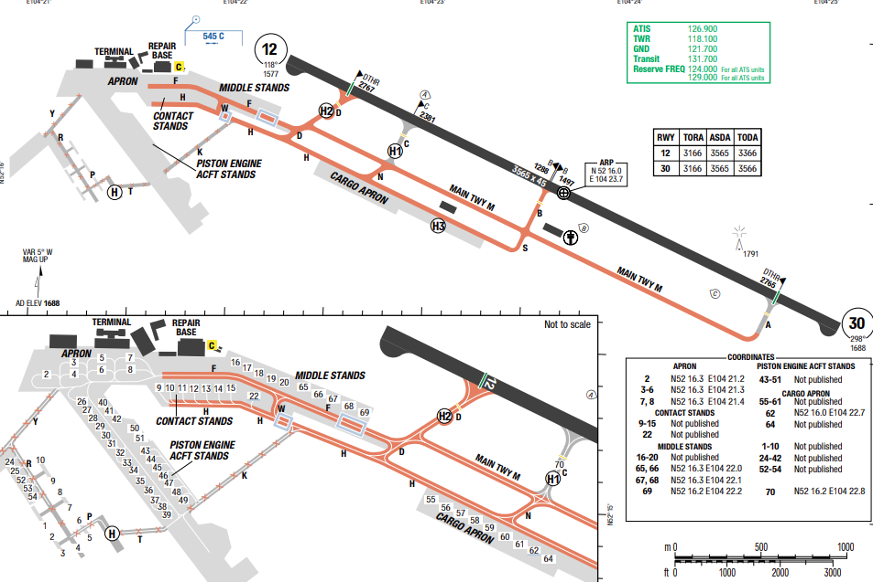
Irkutsk is an international airport on the outskirts of Irkutsk, Russia, at a distance of 60 kilometers (37 miles) from Lake Baikal. Irkutsk is characterized by an extreme variation of temperatures between seasons. It can be very warm in the summer, and very cold in the winter. However, Lake Baikal has a tempering effect, giving Irkutsk temperatures that are less extreme than elsewhere in Siberia.
Departure |  |  | - Conventional and RNAV SIDs  - SID with high climb gradient
Arrival and Approach |  |  | - Conventional and RNAV STARs  - Excessive descent speeds should be avoided, if possible, immediately prior to final approach
Taxi |  |  | WY 05L/ 23R for ACFT taxiing only.
Parking information |  |  | No
- TAKE-OFF AND LANDING DISTANCES AVAILABLE
RWY | LENGTH  (m) |  |  | WIDTH  (m) |  |  | TORA  (m) | LDA  (m) | TODA  (m) |  | ASDA  (m)
12/ 30 | 3565 |  |  | 45 |  |  | 3166 | 3166 | 3366 |  | 3565
- ELEVATION: 59ft | - EOSID: NO
- IAP: ILS, RNP, NDB, VOR
- COMPANY NOTE | - Birds are in the vicinity of the airport.
- REMARK | NIL

ULLI/ LED - PULKOVO AIRPORT - ST PETERSBURG, RUSSIA
- AIRPORT CATEGORY: A |  |  |  |  |  | - RFFS CATEGORY: 9
- AIRPORT CLASSIFICATION
ATR |  | A320 |  |  | A321 | A350 |  |  |  | B787
ADQ |  | ADQ |  |  | ADQ | ADQ |  |  |  | ADQ
- GENERAL STANDARDS
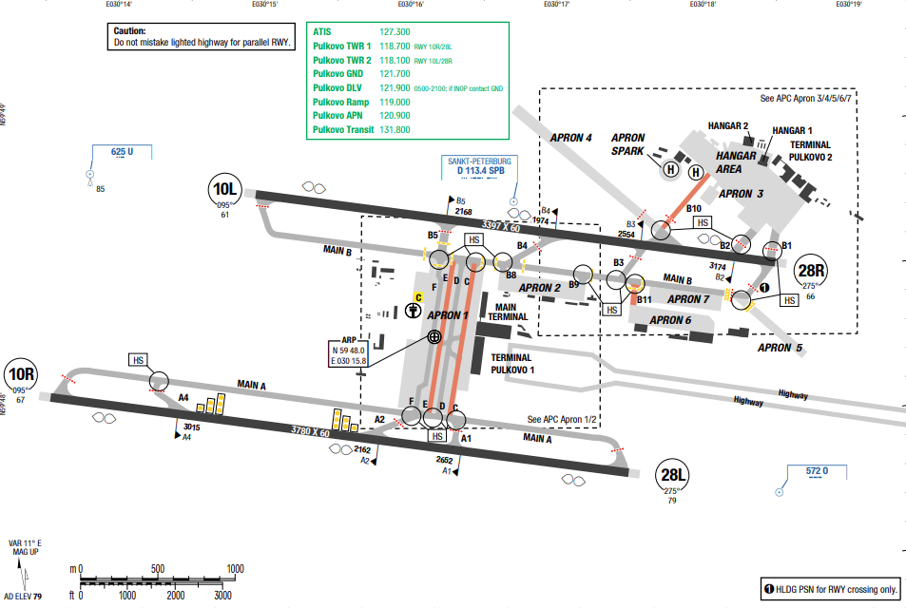
Pulkovo is an international airport serving St. Petersburg, Russia. It is the twelfth-busiest airport in Europe. The airport is located 23 km (14 mi) south of the city centre. Saint Petersburg has a humid continental climate. The distinct moderating influence of Baltic Sea cyclones results in warm, humid and short summers and long, moderately cold wet winters. The average maximum temperature in July is 23 °C, and the average minimum temperature in February is −8.5 °C
Departure |  |  | - RNAV SIDs.  - SID with high climb gradient
Arrival and Approach |  |  | - RNAV STARs  - EXPECT “direct to” procedure and/ or vectoring.
Taxi |  |  | - Standard taxi routes
Parking information |  |  | No
- TAKE-OFF AND LANDING DISTANCES AVAILABLE
RWY | LENGTH  (m) |  |  | WIDTH  (m) |  |  | TORA  (m) | LDA  (m) | TODA  (m) |  | ASDA  (m)
10L | 3397 |  |  | 60 |  |  | 3780 | 3484 | 3780 |  | 3780
28R | 3397 |  |  | 60 |  |  | 3397 | 3082 | 3397 |  | 3397
10R | 3780 |  |  | 60 |  |  | 3780 | 3484 | 3780 |  | 3780
28L | 3780 |  |  | 60 |  |  | 3780 | 3428 | 3780 |  | 3780
- ELEVATION: 79ft | - EOSID: NO
- IAP: ILS (CAT I, II, III), NDB, RNP, VOR
- COMPANY NOTE | - Operation of mode S when ACFT is on ground
- REMARK | NIL

UNBB/BAX – MIKHAYLOVKA – BARNAUL – RUSSIA
1. AIRPORT CATEGORY: A |  |  |  |  |  |  |  | 2. RFFS CATEGORY: 8
3. AIRPORT CLASSIFICATION
ATR |  | A320 |  |  |  | A321 |  |  | A350 |  |  | B787
ADQ |  | ADQ |  |  |  | ADQ |  |  | ADQ |  |  | ADQ
4. GENERAL STANDARDS
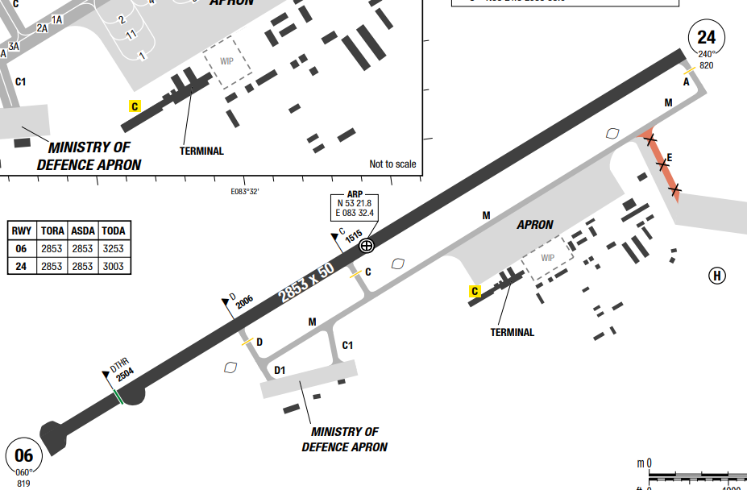
Barnaul Gherman Titov International Airport (IATA: BAX, ICAO: UNBB)
(sometimes referred to as Barnaul West or Mikhaylovka) is a major airport in Altai Krai, Russia located 17 km west of Barnaul.
The continental climate of Barnaul is defined by its geographical position: it is subject to long, frigid winters, with an average of -17.5 °C in January, but also enjoys a short warm season in the summer with an average high of 19.8 °C in July.
Departure |  |  | - Engines start-up shall be carried out on stands. Taxiing of ACFT out of stands shall be carried out usually under own engines power. Taxiing (towing) of ACFT out of the stand shall be carried out after obtaining TWR controller’s clearance and by the signals of a specialist of  the aerodrome engineering service, responsible for ACFT departure  - Take-off not from RWY 06/24 beginning is PROHIBITED during LVP  - Take-off without stop at the line-up position after taxiing onto the runway is PROHIBITED during LVP  - Responsibility for RWY incursion and nonadherence to the assigned taxi routes on the manoeuvring area shall be placed on the flight crew.
Arrival and Approach |  |  | - Arriving aircraft shall be parked onto designated stands taxiing into these stands under own engines power or by towing.  The aircraft shall be met at stands by responsible marshaller of the AD Ground Handling Service, on whose signals the aircraft parking onto stand is carried out.
Taxi |  |  | - Taxiing at night and in the day-time when visibility is less than 2000 m shall be carried out with navigation and taxi lights switched on.  - Towing shall be executed when ACFT aeronautical lights and flashing lights are turned on. Towing safety shall be provided by a person in charge of towing.  - ACFT can cross ILS critical areas by TWR controller’s clearance. Crossing ILS critical areas is PROHIBITED during ACFT approach from the moment of turn onto final approach track till landing.  - Taxiing of ACFT via TWY E when visibility is 2000 m or less shall be carried out after “Follow-me” vehicle, taxiing and towing of ACFT via TWY E are PROHIBITED when  visibility is less than 800 m.
Parking information |  |  | - A380 shall use inboard ENG only on TWY A and D.  - ACFT type B747 shall taxi into RWY via TWY C only.  - For taxiing into/out of stands, marshaller compulsory.  - Power-back into/out of stands prohibited.  - De-icing fluid applied
5. TAKE-OFF AND LANDING DISTANCES AVAILABLE
RWY | LENGTH  (m) |  |  | WIDTH  (m) |  |  | TORA  (m) |  |  | LDA  (m) | TODA  (m) |  | ASDA  (m)
06/ 24 | 2850 |  |  | 50 |  |  | 2850 |  |  | 2850 | 3250 |  | 2850
6. ELEVATION: 838ft |  |  |  |  | 7. EOSID: NO
8. IAP: ILS, LOC, RNP, VOR, NDB
9. COMPANY NOTE |  |  |  |  | - TWR controller assigns SSR code for the departing ACFT using codes 5250- 5253 and 5260-5264, allocated for Barnaul/Mikhaylovka AD.  - In order to obtain instructions: NDB/MKR BU (399 kHz) or LOM AR (428 kHz);  - TWR controller by phone - 8 (3852) 66-83-79;  - Flight Control Officer by phone - 8 (3852) 24-36-59
10. REMARK |  |  |  |  | NIL

UNKL/ KJA – KRASNOYARSK INTL, KRASNOYARSK, RUSSIA
- AIRPORT CATEGORY: A |  |  |  |  |  |  | - RFFS CATEGORY: 8
- AIRPORT CLASSIFICATION
ATR |  | A320 |  | A321 |  |  | A350 |  | B787
ADQ |  | ADQ |  | ADQ |  |  | ADQ |  | ADQ
4. GENERAL STANDARDS
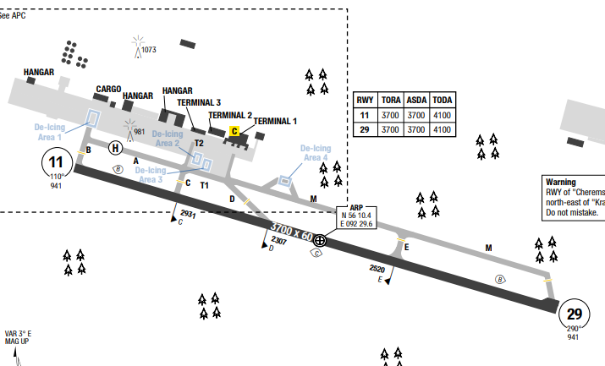
Krasnoyarsk International Airport (IATA: KJA, ICAO: UNKL), is a major airport in Krasnoyarsk Krai, Russia, 27 kilometres northwest of Krasnoyarsk.
Krasnoyarsk features an extreme humid continental climate characterized by short, pleasant summers and long, bitterly cold, snowy winters. Extreme temperature variations define the year, with average daytime highs ranging from -11°C in January to 25°C in July.
Departure |  |  | - RNAV SIDs available and require minimum climb gradient  - De-icing available  - LVP take-off apply
Arrival and Approach |  |  | - RNAV STARs  - LVP available  - COMM FAIL Procedure available
Taxi |  |  | - ACFT with wingspan above 65m / 213ft and OMGWS above 14m / 46ft when LDG on RWY 11 shall vacate the RWY via TWYs B or C, after carrying out a turn at the RWY 29 turn pad.  - ACFT with wingspan above 65m / 213ft and OMGWS above 14m / 46ft taxi via TWY M and E prohibited.  - Taxiing from TWY D to M and vice versa permitted only for ACFT with MAX OMGWS 8.9m /29ft.  - Use of TWY D to vacate/enter RWY 11 permitted only to ACFT with wingspan up to 24m /79ft and OMGWS up to 4m / 13ft.  - ACFT with wingspan BTN 32m / 105ft - 65m / 213ft and OMGWS BTN 9m / 30ft - 14m / 46ft use of TWY M to vacate/enter RWY permitted strictly along the CL and at MNM speed.
Parking information |  |  | - A-VDGS Safedock AVBL on stands 1, 1A, 1B, 1C, 2-4, 4A, 4B and 4C.  - Numerous Stands with aircraft size limitation
5. TAKE-OFF AND LANDING DISTANCES AVAILABLE
RWY | LENGTH  (m) |  |  | WIDTH  (m) |  | TORA  (m) |  | LDA  (m) |  | TODA  (m) | ASDA  (m)
11/ 29 | 3700 |  |  | 60 |  | 3700 |  | 3700 |  | 4100 | 3700
6. ELEVATION: 941ft |  |  |  |  | 7. EOSID: NO
8. IAP: ILS (CAT I/II), LOC, GLS, RNP, VOR
9. COMPANY NOTE |  |  |  |  | - Birds in vicinity of AD.  - Beware of RWY width illusion
10. REMARK |  |  |  |  | NIL

UNNT/OVB – TOLMACHEVO – NOVOSIBIRSK – RUSSIA
1. AIRPORT CATEGORY: A |  |  |  |  |  |  |  | 2. RFFS CATEGORY: 8
3. AIRPORT CLASSIFICATION
ATR |  | A320 |  |  |  | A321 |  |  | A350 |  |  | B787
ADQ |  | ADQ |  |  |  | ADQ |  |  | ADQ |  |  | ADQ
4. GENERAL STANDARDS
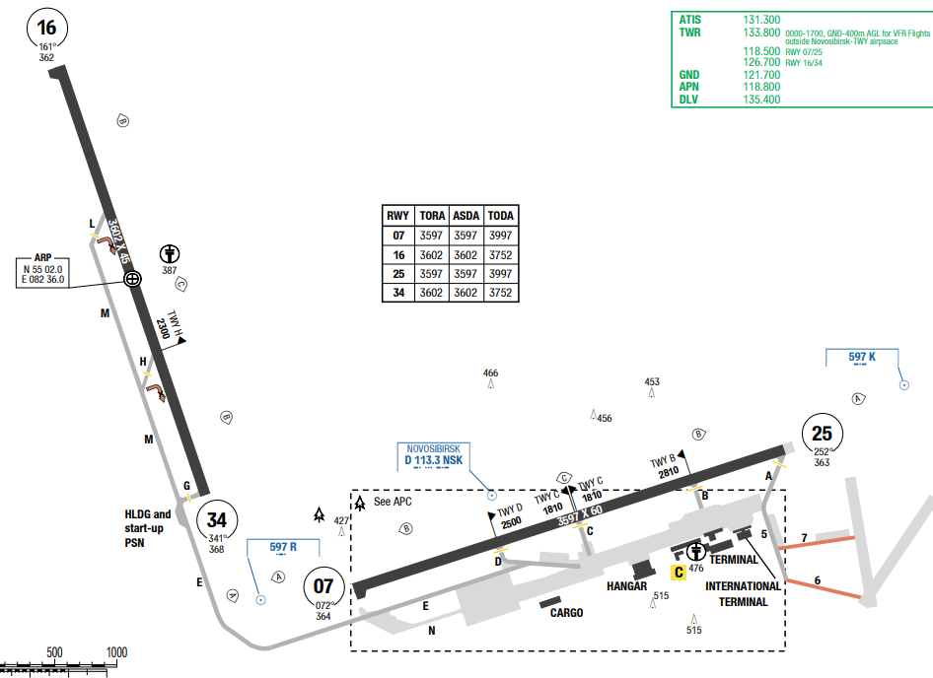
Novosibirsk Tolmachevo Airport (IATA: OVB, ICAO: UNNT) is situated in the town of Ob, 16 kilometres west of the center of Novosibirsk, an industrial and scientific center in Siberia and Russia's third-largest city.
In Novosibirsk, the summers are comfortable and partly cloudy and the winters are frigid, snowy, windy, and overcast.
Departure |  |  | - Prefer RWY for TKOF: RWY 07, RWY 16/34  - If unable to TKOF without delay on the RWY, flight crew shall notify TWR with time required to prepare for TKOF prior to occupying the RWY.  - TKOF without stop at the line-up position must be carried out within 1min after obtaining ATC CLR.  - It is permitted for the flight crew of the ACFT executing take-off to climb to ALT 4000 ft based upon AD QNH pressure (1110 m based upon AD QFE pressure), unless initial altitude of climb was assigned by the ATS unit
Arrival and Approach |  |  | - Prefer RWY for LDG: RWY 25, RWY 16/34  - Visual APCH AVBL if VIS is 5000m or above and CEIL is 1000m or above  - If intended to land on RWY 07 - ILS Y RWY 07;  - If intended to land on RWY 25 - ILS Y RWY 25;  - If intended to land on RWY 16 - ILS Y RWY 16;  - If intended to land on RWY 34 - ILS Y RWY 34.
Taxi |  |  | - Taxiing from TWY L or H to right onto RWY 16/34 is prohibited.  - Taxiing via TWY E shall be carried out with increased caution and at MNM speed.  - When markings are invisible (due to snow- or ice- covered grounds) ACFT shall be escorted by follow-me. Stopping of ACFT with wingspan above 42m / 138ft at HLDG position 2 is prohibited.  - Taxiing of ACFT with wingspan above 42m / 138ft via TWY E is permitted only, when start-up position 2 at TWY E HLDG bay is vacant.  - Taxiing of ACFT with wingspan above 48m / 157ft via APN taxi route from abeam TWY B to abeam TWY C prohibited.  - Taxiing of ACFT with wingspan BTN 48m / 138ft and 65m / 213ft via APN taxi route from TWY C to D BTN stands 41 and 31-33 is allowed only, when stand 33 is vacant.  - Stopping of ACFT with wingspan above 42m / 138ft at HLDG position 2 is prohibited
Parking information |  |  | - A380 shall use inboard ENG only on TWY A and D.  - ACFT type B747 shall taxi into RWY via TWY C only.  - For taxiing into/out of stands, marshaller compulsory.
5. TAKE-OFF AND LANDING DISTANCES AVAILABLE
RWY | LENGTH  (m) |  |  | WIDTH  (m) |  |  | TORA  (m) |  |  | LDA  (m) | TODA  (m) |  | ASDA  (m)
07/25 | 3600 |  |  | 60 |  |  | 3600 |  |  | 3600 | 3900 |  | 3600
16/34 | 3600 |  |  | 45 |  |  | 3600 |  |  | 3600 | 3750 |  | 3600
6. ELEVATION: 368ft |  |  |  |  | 7. EOSID: NO
8. IAP: ILS, LOC, RNP, VOR, NDB
9. COMPANY NOTE |  |  |  |  | - Birds in vicinity of AD.  - In all cases flight crew can contact Flight Control Officer via phone: +7 964 095 42 47, +7383 359 90 25.
10. REMARK |  |  |  |  | NIL

USSS/SVX – KOLTSOVO – YEKATERINBURG – RUSSIA
1. AIRPORT CATEGORY: A |  |  |  |  |  |  |  | 2. RFFS CATEGORY: 9
3. AIRPORT CLASSIFICATION
ATR |  | A320 |  |  |  | A321 |  |  | A350 |  |  | B787
ADQ |  | ADQ |  |  |  | ADQ |  |  | ADQ |  |  | ADQ
4. GENERAL STANDARDS
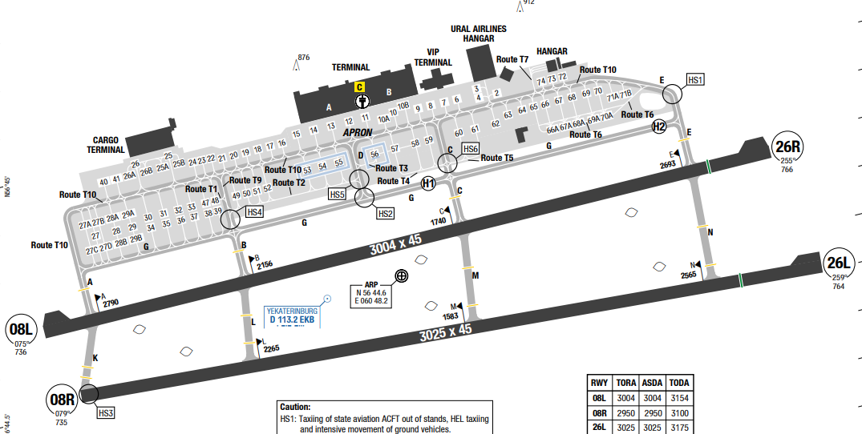
Koltsovo International Airport (IATA: SVX, ICAO: USSS) is the international airport serving Yekaterinburg, Russia, located 16 km (10 mi) southeast of the city.
In Yekaterinburg, the summers are comfortable and partly cloudy and the winters are frigid, snowy, and overcast. July is the hottest month in Yekaterinburg with an average temperature of 19°C and the coldest is January at -14°C.
Departure |  |  | - Clearance for rolling TKOF from RWY 08R/26L can be requested by the flight crew not earlier than the ACFT occupies RWY 08R/26L holding position. If the flight crew requests line-up from a certain position on the runway, it means, that the flight crew is ready to execute take-off not from the RWY beginning. PIC must start ACFT movement within 10s after obtaining TKOF clearance.  - Two-way communication via intercom shall be maintained between the flight crew and the tow crew. Frequency 118.900 MHz (call sign − “Koltsovo-Ground Handling”) shall be used, when communication via intercom is not available.  - In case of using RWY 08L/26R for landing, it is necessary to take into account the peculiarity of TWY G location, the pavement of which can be seen better than RWY 08L/26R under certain weather conditions. This TWY is located parallel to RWY 08L/26R, at 200 m north of the runway, 22.5 m wide.  - Before departure the flight crew shall set transponder to code (squawk) assigned by ATS unit and activate Mode S when requesting clearance for towing or taxiing, whichever is earlier.  - When a decision to return to the aerodrome of departure has been made, the flight crew shall:  + proceed to SID termination point, and then to the point of commencement of the nearest basic RNAV STAR  of the aerodrome of departure;  + maintain flight route and profile of STAR procedure;  + execute approach-to-land according to the established procedure, if possible basic ILS W approach and carry out landing.
Arrival and Approach |  |  | - After landing the flight crew shall keep Mode S transponder activated until ACFT is parked on the stand.  - After landing the flight crew shall plan vacation of the runway along the nearest TWY (or along the TWY recommended by the controller).  - In arrival phase – CDO (continuous descent operations) procedure. In the course of the flight arriving ACFT shall descend to FAF/FAP at a maximum possible permanent rate, at minimum engines power, ideally in the least drag configuration. CDO procedure has been realized by using altitude boxes at STAR fixes
Taxi |  |  | - Transfer of control limit between GND controller and TWR controller during taxiing for TKOF is the moment of vacation (crossing) of TWY G, when turning (crossing) to the south segments of TWY A, B, C, E  - A330, A359, A35K, B744, B77L, B77W, B788, B789, B78X may taxi into stand 7 along special marking when A321, B732, B739, B38M, B39M, B734, B745, B736, B737, 738 occupy stands 6 and 8.  - A359, A35K, B744, B77W, B788, B789, B78X may taxi into stand 12 when stand 13 is vacant.  - Parking on Route T7 to/from APT hangar along special marking is AVBL for ACFT with MAX wingspan 32m / 105ft.  - AN124, A359, A35K, B744, B748, B77W prohibited to taxi under own ENG PWR through stands 28 and 29.
Parking information |  |  | - Taxiing via TWY E shall be carried out under MNM ENG PWR.  - Taxiing of B748 via all TWYs shall be carried out under MNM ENG PWR.  - Taxi into/out of stand 64 shall be carried out by towing, facing north.
5. TAKE-OFF AND LANDING DISTANCES AVAILABLE
RWY | LENGTH  (m) |  |  | WIDTH  (m) |  |  | TORA  (m) |  |  | LDA  (m) | TODA  (m) |  | ASDA  (m)
08L/26R | 3000 |  |  | 45 |  |  | 3000 |  |  | 3000 | 3150 |  | 3000
08R/26L | 2950 |  |  | 45 |  |  | 2950 |  |  | 2950 | 3100 |  | 2950
6. ELEVATION: 766ft |  |  |  |  | 7. EOSID: NO
8. IAP: ILS, LOC, RNP, VOR, NDB
9. COMPANY NOTE |  |  |  |  | - Stands 53-56 AVBL for de-icing. De-icing with running ENG is prohibited for turboprop ACFT and ACFT with wingspan above 36m / 118ft.
10. REMARK |  |  |  |  | NIL

UTAA/ ASB - ASHGABAT, TURKMENISTAN
- AIRPORT CATEGORY: A |  |  |  |  |  | - RFFS CATEGORY: 9
- AIRPORT CLASSIFICATION
ATR |  | A320 |  |  | A321 | A350 |  |  | B787
ADQ |  | ADQ |  |  | ADQ | ADQ |  |  | ADQ
- GENERAL STANDARDS
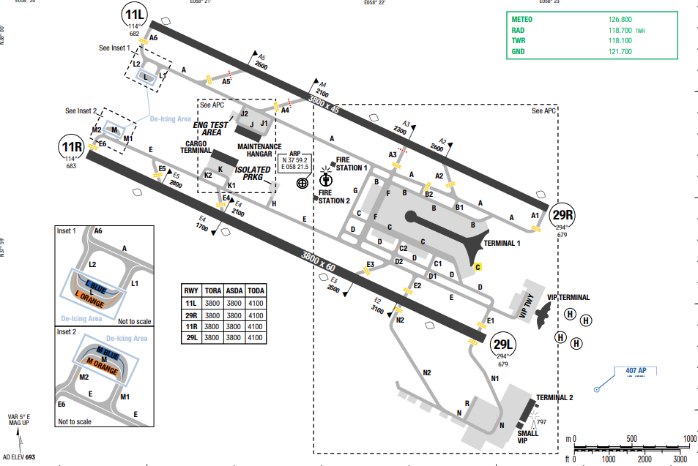
Ashgabat International Airport (IATA: ASB, ICAO: UTAA) is one of five international airports in Turkmenistan. It is located within the city limits of Ashgabat (Ashkhabad). Highest MSA 11800 ft is to the south-west and south-east of the airport. In Turkmenistan, a country of Central Asia, the climate is arid continental, with cold winters and scorchingly hot, sunny summers.
Departure |  |  | - SIDs are available.
Arrival and Approach |  |  | - STARs are available.
Taxi |  |  | - Taxiing out of Terminal 1, C-check and Cargo aprons by Follow-me car until aircraft reaches TWYs A or E. Further taxiing shall be executed by self-maneuvering to RWY  - Arriving aircraft shall be met and escorted by follow-me car to designated stand.
Parking information |  |  | No
- TAKE-OFF AND LANDING DISTANCES AVAILABLE
RWY | LENGTH  (m) |  |  | WIDTH  (m) |  |  | TORA  (m) | LDA  (m) | TODA  (m) | ASDA  (m)
11L/ 29R | 3800 |  |  | 45 |  |  | 3800 | 3800 | 3800 | 3800
11R/ 20L | 3800 |  |  | 60 |  |  | 3800 | 3800 | 3800 | 3800
- ELEVATION: 692ft | - EOSID: NO
- IAP: ILS (CAT I, II, III), NDB, VOR
- COMPANY NOTE | - Birds in vicinity of airport.
- REMARK | NIL

UTAM/ MYP - MARY INTERNATIONAL AIRPORT, MARY, TURKMENISTAN
- AIRPORT CATEGORY: A |  |  |  |  |  | - RFFS CATEGORY: 8
- AIRPORT CLASSIFICATION
ATR |  | A320 |  |  | A321 | A350 |  |  |  | B787
ADQ |  | ADQ |  |  | ADQ | ADQ |  |  |  | ADQ
- GENERAL STANDARDS
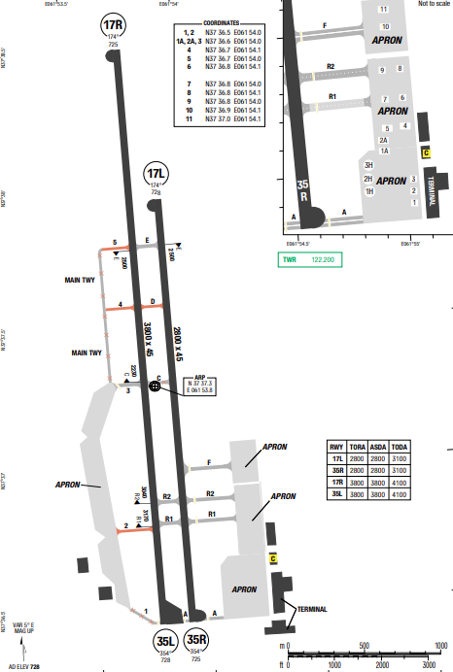
Mary International Airport is the third largest international airport in Turkmenistan. The airport is located 6 km. north-east of the centre of Mary. There are no terrain surrounding the airport
At Mary Airport, the summers are sweltering, arid, and clear and the winters are very cold, snowy, and partly cloudy. Over the course of the year, the temperature typically varies from 32°F to 101°F and is rarely below 23°F or above 108°F.
Departure |  |  | - SIDs are available.
Arrival and Approach |  |  | - STARs are available.
Taxi |  |  | - This a small airport with one runway and simple taxi ways
Parking information |  |  | No
- TAKE-OFF AND LANDING DISTANCES AVAILABLE
RWY | LENGTH  (m) |  |  | WIDTH  (m) |  |  | TORA  (m) | LDA  (m) | TODA  (m) |  | ASDA  (m)
17L/ 35R | 2800 |  |  | 45 |  |  | 3100 | 3100 | 3100 |  | 3100
17R/ 35L | 3800 |  |  | 45 |  |  | 3800 | 3800 | 4100 |  | 3800
- ELEVATION: 728ft | - EOSID: NO
- IAP: ILS, NDB
- COMPANY NOTE | - Birds in vicinity of airport.
- REMARK | NIL

UTDD/ DYU – DUSHANBE (DUSHANBE) - TAJIKISTAN
- AIRPORT CATEGORY: A |  |  |  |  |  | - RFFS CATEGORY: 7
- AIRPORT CLASSIFICATION
ATR |  | A320 |  |  | A321 | A350 |  |  |  | B787
ADQ |  | ADQ |  |  | ADQ | ADQ |  |  |  | ADQ
- GENERAL STANDARDS
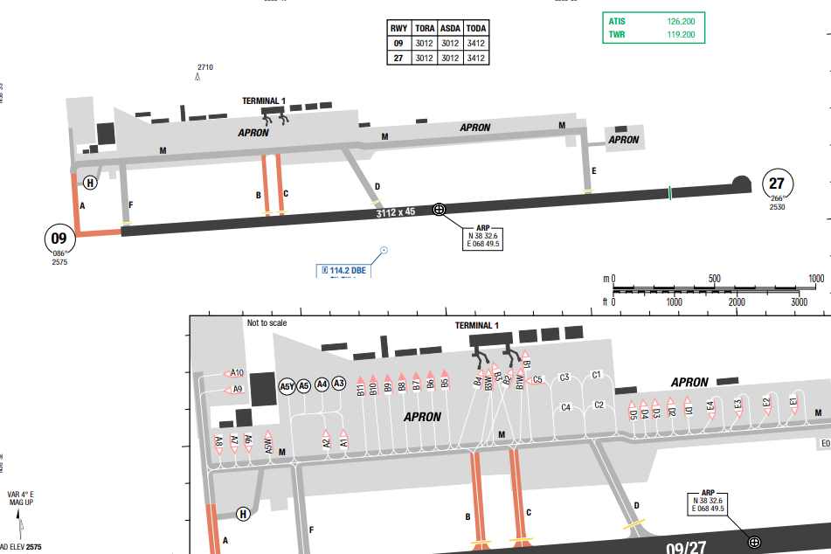
Dushanbe International Airport is an international airport in Dushanbe, the capital of Tajikistan.
The highest MSA is 15.600ft to the North of the airport. Dushanbe features a Mediterranean climate with some humid continental climate influences. The city features hot summers and chilly winters.
Departure |  |  | - Conventional SIDs are available.  - SID with high climb gradient
Arrival and Approach |  |  | - Conventional STARs are available.  - QNH on request.
Taxi |  |  | No
Parking information |  |  | No
- TAKE-OFF AND LANDING DISTANCES AVAILABLE
RWY | LENGTH  (m) |  |  | WIDTH  (m) |  |  | TORA  (m) | LDA  (m) | TODA  (m) |  | ASDA  (m)
09/ 27 | 3112 |  |  | 45 |  |  | 3012 | 3012 | 3412 |  | 3012
- ELEVATION: 2569ft | - EOSID: NO
- IAP: ILS, NDB
- COMPANY NOTE | - LVP is applied when RVR is less than 600m
- REMARK | NIL

UTDK/ TJU – KULOB INTL AIRPORT, KHATLON, TAJIKISTAN
- AIRPORT CATEGORY: A |  |  |  |  |  | - RFFS CATEGORY: 6
- AIRPORT CLASSIFICATION
ATR |  | A320 |  |  | A321 | A350 |  |  |  | B787
ADQ |  | ADQ |  |  | ADQ | N/ A |  |  |  | N/ A
- GENERAL STANDARDS
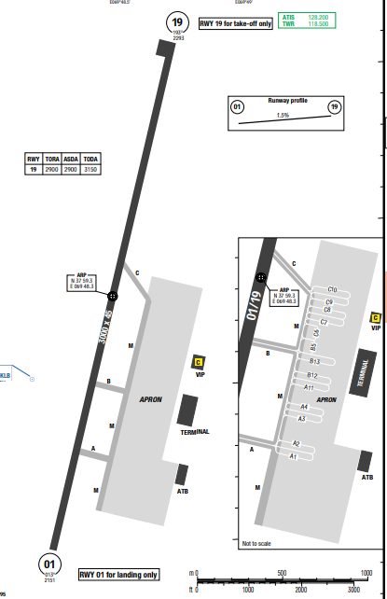
High terrain to the West and East of the runway, up to 9440ft. Located at an elevation of 621.61 meters (2039.4 feet) above sea level, Kulob has a Mediterranean, hot summer climate. The district’s yearly temperature is 18.81oC (65.86oF) and it is 10.95% higher than Tajikistan’s averages. Kulob typically receives about 78.67 millimeters (3.1 inches) of precipitation and has 113.74 rainy days (31.16% of the time) annually. In Kulob, the summers are hot, arid, and clear and the winters are very cold, snowy, and partly cloudy
Departure |  |  | - Using QFE. QNH on request. Min climb gradient 5.2% up to 4590ft.  - SID with high climb gradient
Arrival and Approach |  |  | - Using QFE. QNH on request. Approach ILS Rwy 01 or NDB DME Rwy 01. - Rwy 19 landing is not allowed.
Taxi |  |  | No
Parking information |  |  | No
- TAKE-OFF AND LANDING DISTANCES AVAILABLE
RWY | LENGTH  (m) |  |  | WIDTH  (m) |  |  | TORA  (m) | LDA  (m) | TODA  (m) |  | ASDA  (m)
01/ 19 | 3000 |  |  | 45 |  |  | 3000 | 3000 | 3150 |  | 3000
- ELEVATION: 2295ft | - EOSID: NO
- IAP: ILS, NDB
- COMPANY NOTE | NIL
- REMARK | NIL

UTDL/ LBD – KHUJAND INTL AIRPORT, TAJIKISTAN
- AIRPORT CATEGORY: A |  |  |  |  |  | - RFFS CATEGORY: 7
- AIRPORT CLASSIFICATION
ATR |  | A320 |  |  | A321 | A350 |  |  |  | B787
ADQ |  | ADQ |  |  | ADQ | ADQ |  |  |  | ADQ
- GENERAL STANDARDS
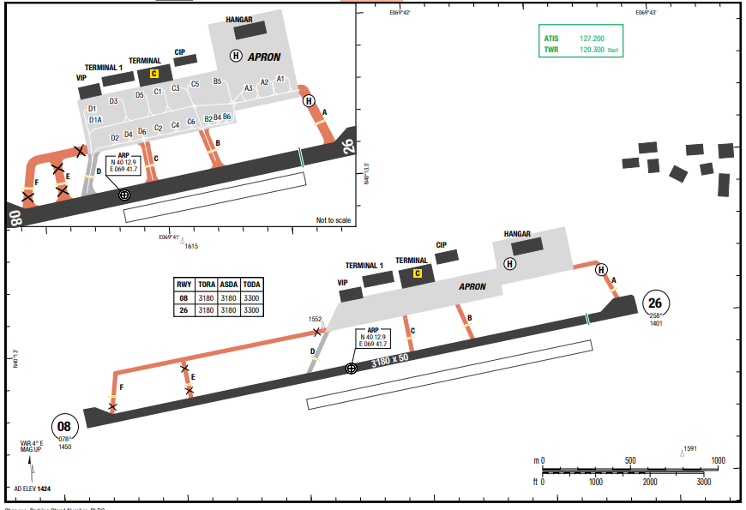
High terrain to the North and South of runways. Highest terrain up to 4984ft.
In Khŭjand, the summers are hot, arid, and clear and the winters are very cold, snowy, and partly cloudy. Over the course of the year, the temperature typically varies from -2°C to 36°C and is rarely below -8°C or above 40°C
Departure |  |  | - Using QFE. QNH on request. Lost comms procedure is available.
Arrival and Approach |  |  | - Using QFE. QNH on request. Lost comms procedure is available. ILS rwy 26 have a GS angle 2.67°
Taxi |  |  | No
Parking information |  |  | No
- TAKE-OFF AND LANDING DISTANCES AVAILABLE
RWY | LENGTH  (m) |  |  | WIDTH  (m) |  |  | TORA  (m) | LDA  (m) | TODA  (m) |  | ASDA  (m)
08/ 26 | 3180 |  |  | 50 |  |  | 3180 | 3180 | 3300 |  | 3180
- ELEVATION: 1424ft | - EOSID: NO
- IAP: ILS, NDB
- COMPANY NOTE | - Operation in 24hrs.  - Airport operator: (834) 224-28-22
- REMARK | NIL

UZSA/ NVI – NAVOI INTL AIRPORT, NAVOI, UZBEKISTAN
- AIRPORT CATEGORY: A |  |  |  |  |  | - RFFS CATEGORY: 9
- AIRPORT CLASSIFICATION
ATR |  | A320 |  |  | A321 | A350 |  |  |  | B787
ADQ |  | ADQ |  |  | ADQ | ADQ |  |  |  | ADQ
- GENERAL STANDARDS
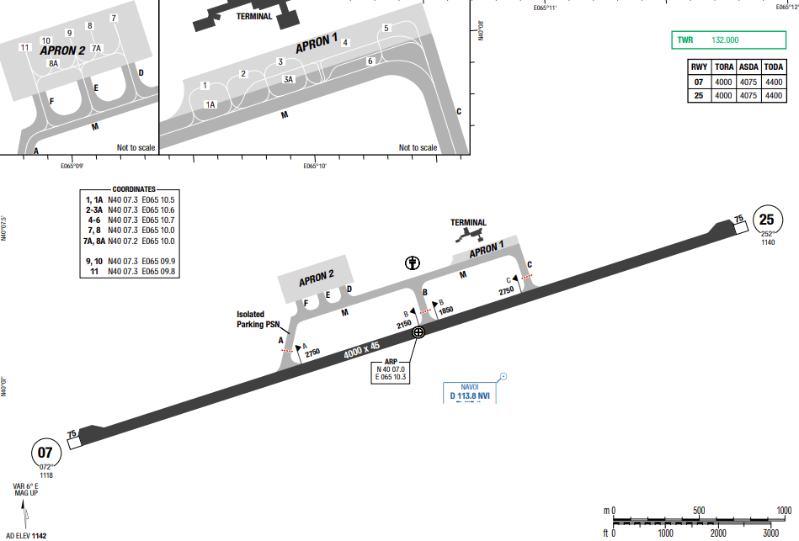
NAVOI INTL AIRPORT is an airport of entry in Navoi, Uzbekistan. Navoi Airport now serves 3 airlines flying to 9 cities in 8 countries including passenger flights and the work is underway to create business links with new airlines and set up new routes. MSA of the airport is 4900ft.
Departure |  |  | - Conventional SIDs.  - Initial climb clearance FL080 or by ATC
Arrival and Approach |  |  | - Conventional STARs.
Taxi |  |  | No
Parking information |  |  | No
- TAKE-OFF AND LANDING DISTANCES AVAILABLE
RWY | LENGTH  (m) |  |  | WIDTH  (m) |  |  | TORA  (m) | LDA  (m) | TODA  (m) |  | ASDA  (m)
07/ / 25 | 4000 |  |  | 45 |  |  | 4075 | 4075 | 4400 |  | 4075
- ELEVATION: 1142ft | - EOSID: NO
- IAP: ILS (CAT I, II), VOR
- COMPANY NOTE | NIL
- REMARK | NIL

UZSB/ BHK – BUKHARA INTL AIRPORT, BUKHARA, UZBEKISTAN
- AIRPORT CATEGORY: A |  |  |  |  |  | - RFFS CATEGORY: 8
- AIRPORT CLASSIFICATION
ATR |  | A320 |  |  | A321 | A350 |  |  |  | B787
ADQ |  | ADQ |  |  | ADQ | ADQ |  |  |  | ADQ
- GENERAL STANDARDS
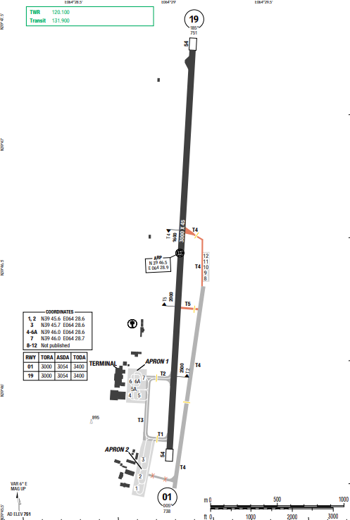
MSA of the airport is 2500ft. Hot, semi-arid climate hot, sometimes extremely hot summers and mild to warm winters, with low annual precipitation, most of which occurs during the monsoon season (Jul-Sep).
Departure |  |  | - Initial climb clearance FL080 or by ATC
Arrival and Approach |  |  | - Circle to land not authorized at night
Taxi |  |  | No
Parking information |  |  | No
Other information |  |  | No
- TAKE-OFF AND LANDING DISTANCES AVAILABLE
RWY | LENGTH  (m) |  |  | WIDTH  (m) |  |  | TORA  (m) | LDA  (m) | TODA  (m) |  | ASDA  (m)
01/ 19 | 3000 |  |  | 45 |  |  | 3000 | 3000 | 3400 |  | 3054
- ELEVATION: 751ft | - EOSID: NO
- IAP: ILS, NDB
- COMPANY NOTE | NIL
- REMARK | NIL

UZSS/ SKD – SAMARKAND INTL AIRPORT, SAMARKAND, UZBEKISTAN
- AIRPORT CATEGORY: A |  |  |  |  |  | - RFFS CATEGORY: 9
- AIRPORT CLASSIFICATION
ATR |  | A320 |  |  | A321 | A350 |  |  |  | B787
ADQ |  | ADQ |  |  | ADQ | ADQ |  |  |  | ADQ
- GENERAL STANDARDS
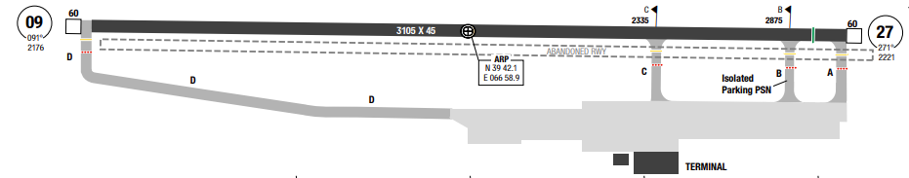
Samarkand International Airport is an airport of entry in Samarkand, Uzbekistan, 6 km from the city center. It is located in southeastern Uzbekistan, in the Zarefshan River valley.Highest MSA sector is to the south, 10100ft. Mountainous area is to the northeast with MSA 6700ft.
Samarkand has a Mediterranean climate that closely borders on a semi-arid climate (BSk) with hot, dry summers and relatively wet, variable winters that ENR ALT periods of warm weather with periods of cold weather.
Departure |  |  | - SID are available.  - SID with high climb gradient
Arrival and Approach |  |  | - STAR starts from the enroute fix with radar required, following by approach IAF  - Visual approach for both runways is only permitted in daytime only
Taxi |  |  | - Samarkand airport has simple taxi routes.
Parking information |  |  | No
Other information |  |  | - Low visibility procedure available.  - Circle to land only permitted in daytime only, with altitude about 1250’ above airport level
- TAKE-OFF AND LANDING DISTANCES AVAILABLE
RWY | LENGTH  (m) |  |  | WIDTH  (m) |  |  | TORA  (m) | LDA  (m) | TODA  (m) |  | ASDA  (m)
09 | 3105 |  |  | 45 |  |  | 3105 | 3105 | 3255 |  | 3165
27 | 3105 |  |  | 45 |  |  | 3105 | 2985 | 3255 |  | 3165
- ELEVATION: 2223ft | - EOSID: NO
- IAP: ILS (CAT I, II), VOR
- COMPANY NOTE | - Low visibility procedure available.
- REMARK | NIL

UZTT/ TAS – TASHKENT (ISLAM KARIMOV) - UZBEKISTAN
- AIRPORT CATEGORY: A |  |  |  |  |  | - RFFS CATEGORY: 9
3. AIRPORT CLASSIFICATION
ATR |  | A320 |  | A321 |  | A350 |  |  | B787
ADQ |  | ADQ |  | ADQ |  | ADQ |  |  | ADQ
4. GENERAL STANDARDS
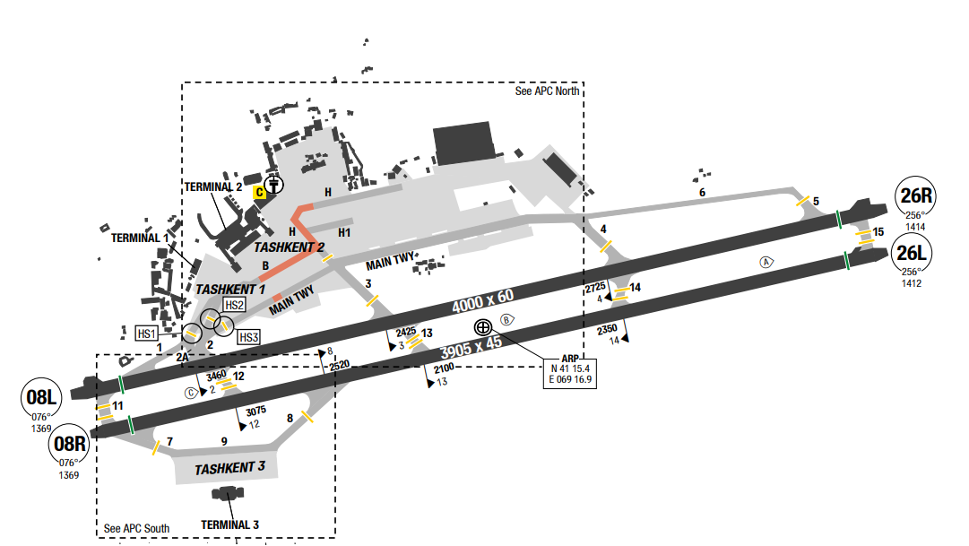
Islam Karimov Airport is located in eastern Uzbekistan. The airport is near the western edge of the Tian Shan Mountain Range, in a desert oasis next to the Chirchik River. In the eastern quadrants, mountains rise from 3000 feet MSL within 20 NM, to over 9000 feet MSL within 30 NM. Land surrounding the immediate airport area is fairly level. Shardara Reservoir is located 40 NM to the west-southwest. To the north, a man-made structure is at 2764 feet MSL within 5 NM.
Obstruction to visibility, most commonly due to low ceiling, averages 5 days per month from October through April. Broken to overcast ceilings are the predominant sky conditions from December through March.
Departure |  |  | - Conventional SIDs are available.  - SIDs require minimum climb gradient.
Arrival and Approach |  |  | - Conventional STARs are available.  - A minimum ceiling is required for all circle-to-land manoeuvres to this airport.  - Circling to land is not authorized at night.
Taxi |  |  | - MAX wingspan 48m / 157ft:  • TWY B between stands B11 and B17  • Main TWY behind stands B11 and B12  • TWY H between stands B17 and H43
Parking information |  |  | - VIS docking guidance system (AGNIS) AVBL  - Use of reverse thrust or variable pitch PROP not permitted  - During taxiing on TWY 13 outer ENGs of four ENG ACFT must be used on idle power only.
- TAKE-OFF AND LANDING DISTANCES AVAILABLE
RWY | LENGTH  (m) |  |  | WIDTH  (m) | TORA  (m) |  | LDA  (m) | TODA  (m) |  | ASDA  (m)
08L | 4000 |  |  | 60 | 4000 |  | 4000 | 4150 |  | 4000
08R | 3905 |  |  | 45 | 3755 |  | 3755 | 3905 |  | 3755
26L | 3905 |  |  | 45 | 3905 |  | 3905 | 4055 |  | 3905
26R | 4000 |  |  | 60 | 4000 |  | 4000 | 4150 |  | 4000
6. ELEVATION: 1417ft |  |  |  | 7. EOSID: NO
8. IAP: ILS (CAT I, II), VOR
9. COMPANY NOTE |  |  |  | NIL
10. REMARK |  |  |  | NIL

UUDD/DME – DOMODEDOVO - MOSCOW - RUSSIA
1. AIRPORT CATEGORY: A |  |  |  |  |  |  |  | 2. RFFS CATEGORY: 9
3. AIRPORT CLASSIFICATION
ATR |  | A320 |  |  |  | A321 |  |  | A350 |  |  | B787
ADQ |  | ADQ |  |  |  | ADQ |  |  | ADQ |  |  | ADQ
4. GENERAL STANDARDS
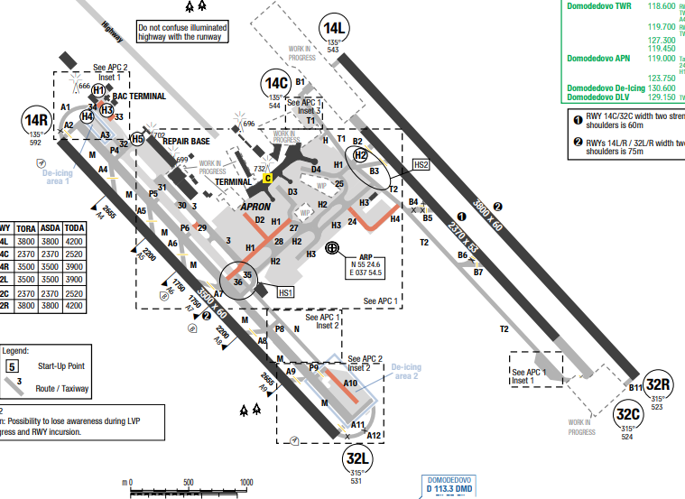
Moscow Domodedovo International Airport (IATA: DME, ICAO: UUDD), formally Domodedovo Mikhail Lomonosov International Airport, is an international airport serving Moscow, the capital of Russia. It is located in Domodedovo, Moscow Oblast, 42 kilometres south-southeast from the city centre of Moscow.
Moscow has a warm-summer humid continental climate with warm to hot summers and long, cold, winters. Weather can fluctuate widely, with temperatures ranging from −25 °C in the city.
Departure |  |  | - Transfer of CTL Points between TWR and APN when DEP  - Change of ACFT flight direction (course) after takeoff is permitted only after reaching flight altitude of 400 ft AAL
Arrival and Approach |  |  | - On initial radio contact with TWR, flight crew shall report ACFT call sign only and the WTC HEAVY when applicable.  - Transfer of CTL Points between TWR and APN when ARR  - Flying below the ILS glide path angle is not allowed.
Taxi |  |  | - Taxiing via TWY M is permitted, if LDG minima are:  • RWY 14R - CEIL 60m, RVR 800m;  • RWY 32L - CEIL 75m, RVR 900m.  - Taxiing under own ENG PWR and towing prohibited for ACFT with wingspan  - While RWY 32R in use for TKOF and LDG, vacate RWY via TWY B7 and B5 after recommendation by TWR during final APCH only.  - In case unable to vacate RWY on nearest TWY, report to TWR on first contact accordingly.  - When ACFT are holding at RWY 14R/32L RWY HLDG PSN on TWY A4-A9, taxiing via TWY M behind these ACFT is prohibited.
Parking information |  |  | - Taxiing of ACFT via Routes A10, H2, H3 between stands 65 and 66 and between stands 66 and 67A shall be carried out strictly along the taxi guide lines.  - During taxiing along the APN and into/out of stands do not stop during turns. In case of the ACFT stop at turning the flight crew must request for permission to continue taxiing from APN controller.  - Simultaneous tail to tail parking of code letter E and D ACFT at start-up positions 3A-4 prohibited.  - ACFT taxiing and towing behind the ACFT parked at start-up position 22 prohibited.  - Stand 57, 58 shall be vacated by towing towards Route H2.
5. TAKE-OFF AND LANDING DISTANCES AVAILABLE
RWY | LENGTH  (m) |  |  | WIDTH  (m) |  |  | TORA  (m) |  |  | LDA  (m) | TODA  (m) |  | ASDA  (m)
14L/32R | 3800 |  |  | 60 |  |  | 3800 |  |  | 3800 | 4200 |  | 3800
14C/32C | 2370 |  |  | 45 |  |  | 2370 |  |  | 2370 | 2520 |  | 2370
14R/32L | 3500 |  |  | 60 |  |  | 3500 |  |  | 3500 | 3900 |  | 3500
6. ELEVATION: 592ft |  |  |  |  | 7. EOSID: YES
8. IAP: ILS, LOC, RNP, VOR, NDB
9. COMPANY NOTE |  |  |  |  | - Preferential Runways  + TKOF: RWY 14L/R  + LDG: RWY 32L/R  - B747 must exercise extreme caution while taxiing in loop area of Route T1.  - Birds in vicinity of AD.
10. REMARK |  |  |  |  | NIL

UUEE/ SVO–SHEREMETYEVO AIRPORT-MOSCOW, RUSSIA
1. AIRPORT CATEGORY: A |  |  |  |  |  |  |  | 2. RFFS CATEGORY: 9
3. AIRPORT CLASSIFICATION
ATR |  | A320 |  |  |  | A321 |  |  | A350 |  | B787
ADQ |  | ADQ |  |  |  | ADQ |  |  | ADQ |  | ADQ
4. GENERAL STANDARDS
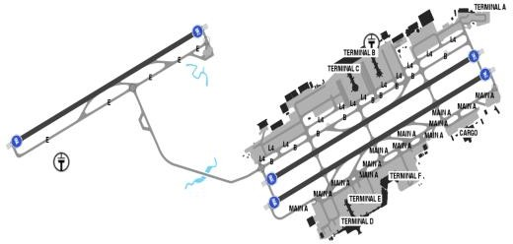
Sheremetyevo Alexander S. Pushkin ITNL Airport is one of four international airports that serves Sheremetyevo Alexander S. Pushkin International Airport is one of four international airports that serves the city of Moscow and is the busiest airport in Russia. It is located in 29 km (18mi) northwest of central Moscow, in the city of Khimki, Moscow Oblast. Moscow has a humid continental climate with long, cold (aLENGTHough average by Russian standards) winters usually lasting from mid-NOV to the end of MAR, and warm summers.
Departure |  |  | - RNAV SIDs  - NADP available at this airport
Arrival and Approach |  |  | - RNAV STARs.
Taxi |  |  | - Minimum RWY occupation time.
Parking information |  |  | - Expect parking at Terminal C
5. TAKE-OFF AND LANDING DISTANCES AVAILABLE
RWY | LENGTH  (m) |  |  | WIDTH  (m) |  |  | TORA  (m) |  |  | LDA  (m) |  | TODA  (m) | ASDA  (m)
06L/ 24R | 3200 |  |  | 60 |  |  | 3200 |  |  | 3200 |  | 3200 | 3200
06R/ 24L | 3700 |  |  | 60 |  |  | 3700 |  |  | 3700 |  | 3700 | 3700
06C/ 24C | 3552 |  |  | 60 |  |  | 3552 |  |  | 3552 |  | 3552 | 3552
6. ELEVATION: 630ft |  |  |  |  | 7. EOSID: NO
8. IAP: ILS (CAT I, II, III), LOC, RNP, NDB, VOR
9. COMPANY NOTE |  |  |  |  | - Birds are in the vicinity of the airport.  - This intermix, in addition to the different broadcasting techniques, may produce confusion.  - Class C airspace overlies the airport.
10. REMARK |  |  |  |  | NIL

UUWW/VKO – VNUKOVO – MOSCOW – RUSSIA
1. AIRPORT CATEGORY: A |  |  |  |  |  |  |  | 2. RFFS CATEGORY: 9
3. AIRPORT CLASSIFICATION
ATR |  | A320 |  |  |  | A321 |  |  | A350 |  |  | B787
ADQ |  | ADQ |  |  |  | ADQ |  |  | ADQ |  |  | ADQ
4. GENERAL STANDARDS
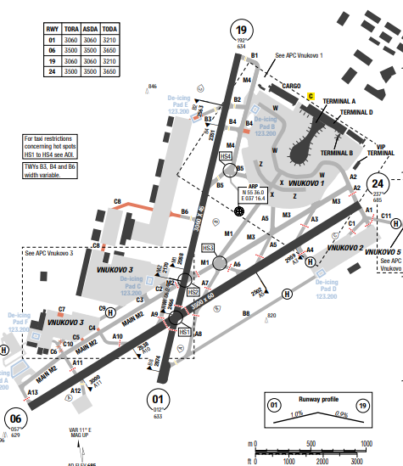
Vnukovo, formally Vnukovo Andrei Tupolev International Airport (IATA: VKO, ICAO: UUWW), is a dual-runway international airport located in Vnukovo District, 28 km (17 mi) southwest of the centre of Moscow, Russia.
In Moscow, the summers are comfortable and partly cloudy and the winters are long, freezing, snowy, windy, and overcast. July is the hottest month in Moscow with an average temperature of 19°C and the coldest is January at -8°C.
Departure |  |  | - Aircraft turn from (150) m/(500) ft to (300) m/(1000) ft AAL shall be carried out with a 15° bank, from (300) m/(1000) ft to (900) m/(2960) ft – with a 20° bank, from (900) m/(2960) ft – with a 25° bank or at angular speed of 3°/sec.  - Noise abatement procedure during climb NADP 1 shall be employed by ACFT departing from RWY 01 and RWY 06.  - Noise abatement procedure during climb NADP 2 shall be employed by ACFT departing from RWY 19 and RWY 24.  - RWY 01 should not be used as preferential runway for take-off operations in night time.
Arrival and Approach |  |  | - RWY 19 and RWY 06 should not be used as preferential runway for landing operations in night time.  - When RVR values are from 2000 to 600 m (inclusive) “Vnukovo-Precision” controller shall advise RVR value at the touchdown zone to the flight crew before ACFT reaches glide path interception point (FAP). RVR values in the middle and at the end of the runway are transmitted, if at least one of the values is below 600 m or these values have been requested by the flight crew. After passing FAP, “Vnukovo-Precision” controller transmits any changes of the above parameters.  Great rates of descent should be avoided (if possible) immediately prior to the final approach segment
Taxi |  |  | - TWY restriction  +TWY B4 (from M4 to APN), C4, C5 width 21m / 69ft.  + TWY B3 (on segment 135m / 443ft long from APN), C7, C8 (on segment 631m / 2070ft long from APN 4, rest 152m / 499ft) width 18m / 59ft.  + TWY C6, C10 width 14m / 46ft.  + TWY A12 is not AVBL for taxiing or towing.  + Taxi route RWY 24 - RWY 01 AVBL in daylight hours when VIS is more than 2000m.
Parking information |  |  | - ACFT must stop at the intermediate holding position marking on TWY C2, C3, when taxiing from start-up positions located on Vnukovo 3 apron 4 to MAIN TWY M2.  - Follow-me AVBL O/R
5. TAKE-OFF AND LANDING DISTANCES AVAILABLE
RWY | LENGTH  (m) |  |  | WIDTH  (m) |  |  | TORA  (m) |  |  | LDA  (m) | TODA  (m) |  | ASDA  (m)
01/19 | 3060 |  |  | 45 |  |  | 3060 |  |  | 3060 | 3210 |  | 3060
06/24 | 3500 |  |  | 45 |  |  | 3500 |  |  | 3500 | 3650 |  | 3500
6. ELEVATION: 685ft |  |  |  |  | 7. EOSID: YES
8. IAP: ILS, LOC, RNP, VOR, NDB
9. COMPANY NOTE |  |  |  |  | - Flight crew of ACFT parked on Vnukovo 1 apron must request ATC clearance from “Vnukovo-Delivery- 1” controller on FREQ 131.800 MHz, flight crews of ACFT parked on other aprons - from “Vnukovo- Delivery-3” controller on FREQ 129.700 MHz, not earlier than 15 minutes before time of departure indicated in the flight plan, reporting flight number, destination aerodrome, stand number, ATIS code letter.  - Before crossing RWY 01/19, stop on TWY M1 or MAIN TWY M2 and REQ further CLR from TWR.  - Before crossing RWY 06/24, stop on TWYs A1, A3, A4, A6, A7, A8, A10, A11 and REQ further CLR from TWR.  At RWY 06 extremity only right turn must be carried out at reduced speed.
10. REMARK |  |  |  |  | Flight Control Officer (Moscow ACC):  • +7 495 956 87 34  • +7 495 436 26 62  • +7 916 043 36 16

UWGG/ GOJ – STRIGINO INTL – NIZHNY NOVGOROD, RUSSIA
- AIRPORT CATEGORY: A |  |  |  |  |  |  | - RFFS CATEGORY: 8
- AIRPORT CLASSIFICATION
ATR |  | A320 |  | A321 |  |  | A350 |  | B787
ADQ |  | ADQ |  | ADQ |  |  | ADQ |  | ADQ
4. GENERAL STANDARDS
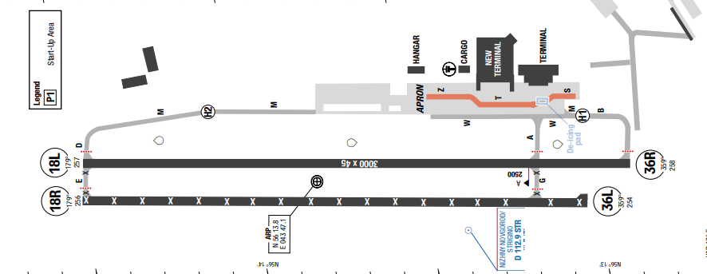
Strigino Airport (IATA: GOJ, ICAO: UWGG) also referred to as Nizhny Novgorod International Airport is the international airport serving the city of Nizhny Novgorod, Russia. It is located on the outskirts of the city's Avtozavodsky District, 14 km southwest of city centre.
Nizhny Novgorod features a humid continental climate with four distinct seasons. Winters are cold and snowy, lasting from late November to mid-March, with average January lows dropping to -12°C. Summers are warm and mild, with average July highs reaching 24°C to 26°C.
Departure |  |  | - RNAV SIDs available and require minimum climb gradient  - De-icing not available  - NADP1 and NADP2 apply at the airrport  - LVP available
Arrival and Approach |  |  | - RNAV STAR  - COMM FAIL Procedure available  - Visual manoeuvring east of AD prohibited.
Taxi |  |  | - TWY T and segment of TWY S to Stand 1-3 not available for ACFT code D and above.
Parking information |  |  | - Taxiing of B739 ACFT shall be carried out on segment along route Z from stand 10 to stand 19.  - Taxiing of B744 ACFT shall be carried out on segment along route W from abeam stand 22 to TWY M.
5. TAKE-OFF AND LANDING DISTANCES AVAILABLE
RWY | LENGTH  (m) |  |  | WIDTH  (m) |  | TORA  (m) |  | LDA  (m) |  | TODA  (m) | ASDA  (m)
18L/ 36R | 3000 |  |  | 45 |  | 3000 |  | 3000 |  | 3000 | 3000
6. ELEVATION: 258ft |  |  |  |  | 7. EOSID: NO
8. IAP: ILS, LOC, GLS, RNP, VOR, NDB
9. COMPANY NOTE |  |  |  |  | - RWY 18R/36L CLSD
10. REMARK |  |  |  |  | NIL

UWKD/KZN – KAZAN – KAZAN – RUSSIA
1. AIRPORT CATEGORY: A |  |  |  |  |  |  |  | 2. RFFS CATEGORY: 8
3. AIRPORT CLASSIFICATION
ATR |  | A320 |  |  |  | A321 |  |  | A350 |  |  | B787
ADQ |  | ADQ |  |  |  | ADQ |  |  | ADQ |  |  | ADQ
4. GENERAL STANDARDS
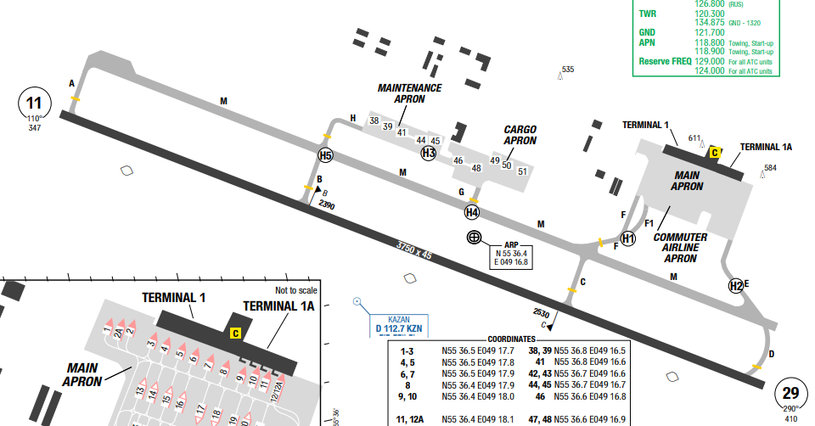
Kazan International Airport is an international airport in Russia, around 25 km southeast of Kazan.
Kazan city experiences a continental climate with four distinct seasons. Summers are warm and humid, with temperatures averaging between 18°C and 25°C. The months of June to August are the warmest.
Departure |  |  | - RNAV SIDs  - LVP is in force when RVR is 550m or below. ACFT TKOF shall be executed only from RWY beginning, stop at line-up position in mandatory.  - Special take-off procedures for RWY 11/29:  - During TKOF and climb to 1900ft:  + TKOF thrust;  + TKOF flaps;  + climb at V2 + 10 to 20KT;  + after reaching 1100ft turn with a bank 25 degree.  - At 1900ft:  + reduce ENG PWR to rated PWR while maintaining a positive rate of climb  - From 1900 ft up to 3400ft:  + climb at V2 + 10 to 20KT.  - At 3400ft:  + accelerate to speed of wing flaps retraction;  + retract flaps;
Arrival and Approach |  |  | - RNAV STARs  - When executing GLS, RNAV APCH flight crew must inform TWR about alternate APCH PROC. Report last communicated ATIS information code letter on initial contact with APP  - Descent and approach to Kazan AD shall be carried out:  + along the established STAR and approach procedures, applying “Direct to” instruction;  + by vectoring  Altitude and speed restrictions can be cancelled by TWR controller (“Kazan-Radar”);  - Direct routing on STAR track shall be carried out only after obtaining the instruction from the ATC unit to proceed directly to the assigned point.
Taxi |  |  | - Taxiing from the main TWY to TWY F and vice versa towards THR RWY 29 shall be carried  out strictly along taxi guide line at MNM speed and with caution.  - Taxiing when VIS below 2000m and during HN, shall be carried out with navigation and  taxi lights switched on.  Crossing of ILS critical areas by TWR clearance only.
Parking information |  |  | - Taxiing BTN stands 13-18, 23-27 permitted for ACFT with MAX wingspan 34.5m / 113ft.
5. TAKE-OFF AND LANDING DISTANCES AVAILABLE
RWY | LENGTH  (m) |  |  | WIDTH  (m) |  |  | TORA  (m) |  |  | LDA  (m) | TODA  (m) |  | ASDA  (m)
11/29 | 3750 |  |  | 45 |  |  | 3750 |  |  | 3750 | 3900 |  | 3750
6. ELEVATION: 410ft |  |  |  |  | 7. EOSID: NO
8. IAP: ILS, LOC, RNP, VOR, NDB
9. COMPANY NOTE |  |  |  |  | - SRE radar serves as APCH for TKOF up to FL90 and for LDG from FL100.  - Exit from RWY 29 and entry onto RWY 29 along TWY F shall be carried out strictly along taxi guide line, at MNM speed.  - Birds in vicinity of AD
10. REMARK |  |  |  |  | NIL

UWUU/UFA – UFA - RUSSIA
1. AIRPORT CATEGORY: A |  |  |  |  |  |  |  | 2. RFFS CATEGORY: 8
3. AIRPORT CLASSIFICATION
ATR |  | A320 |  |  |  | A321 |  |  | A350 |  |  | B787
ADQ |  | ADQ |  |  |  | ADQ |  |  | ADQ |  |  | ADQ
4. GENERAL STANDARDS
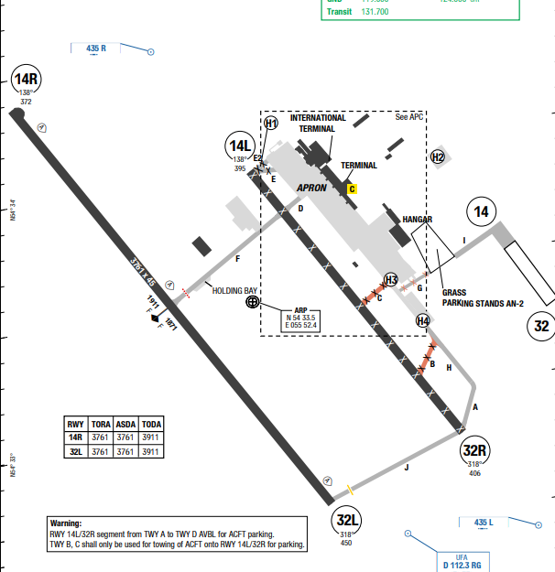
Ufa International Airport (IATA: UFA, ICAO: UWUU) is the primary airport serving Ufa, the capital of Bashkortostan, Russia.
In Ufa, the summers are comfortable and partly cloudy and the winters are long, frigid, snowy, and overcast. The month of July boasts the highest average temperature, with a recorded maximum of 20.8 °C. At -
11.9 °C on average, January is the coldest month of the year.

Departure |  |  | - During departure from the aerodrome the flight crews shall strictly adhere to the established departure procedures.  - Clearance for towing or engines start-up operations, and taxi instructions are issued by GND controller.  Engines can be started, when ACFT is under tow, if this  procedure is prescribed by the Aeroplane Flight Manual and approved by ground handling specialists.
Arrival and Approach |  |  | - When executing instrument approach or visual approach, proceeding below ILS glide path is PROHIBITED.  - The required noise abatement procedures are not observed over the overflown areas in the following cases:  - if there are ice, slush, water or mud, rubber, oil and etc. on RWY and friction coefficient is 0.4 or less;  - under meteorological conditions when ceiling is less than 150 m or horizontal visibility is less than 1800 m;  - when cross-wind component on RWY (including gusts) exceeds 7 m/s;  - when tail-wind component on RWY exceeds 2.5 m/s;  - when wind shear is forecasted or reported, or it is expected that adverse weather conditions (for example, thunderstorms) may influence aircraft approach and landing.  - Missed approach tracks should exclude crossing the RWY 14R/32L extended centre line.
Taxi |  |  | - TWY B width 17m / 56ft.  - TWY C width 16m / 52ft.  - TWY G width 9m / 30ft.  - APN route K3 from stand 1A to 1C width 9.5m / 31ft.  - Taxiing of ACFT with wingspan 65m / 213ft and above and OMGWS 14m / 46ft and above via TWY F and D is prohibited.  - If HLDG Bay on TWY F is occupied by ACFT with wingspan 32m / 105ft and above and OMGWS 9m / 30ft and above then taxiing of ACFT with wingspan 42m / 138ft and above and OMGWS 10.5m / 34ft and above via TWY F is prohibited.  - Standard Taxi Routes available
Parking information |  |  | - Taxiing via TWY E shall be carried out under MNM ENG PWR.  - Taxiing of B748 via all TWYs shall be carried out under MNM ENG PWR.  - Taxi into/out of stand 64 shall be carried out by towing, facing north.
5. TAKE-OFF AND LANDING DISTANCES AVAILABLE
RWY | LENGTH  (m) |  |  | WIDTH  (m) |  |  | TORA  (m) |  |  | LDA  (m) | TODA  (m) |  | ASDA  (m)
14L/32R | 2515 |  |  | 45 |  |  | 2515 |  |  | 2515 | 2515 |  | 2515
14R/32L | 3760 |  |  | 45 |  |  | 3760 |  |  | 3760 | 3911 |  | 3760
6. ELEVATION: 450ft |  |  |  |  | 7. EOSID: NO
8. IAP: ILS, LOC, RNP, VOR, NDB
9. COMPANY NOTE |  |  |  |  | - During night time (1800-0200):  - ENG run-up prohibited.  - Flight OPS of T134, T154 and IL86 ACFT prohibited, except for medical, emergency, SAR and state aviation flights.  - Run-up of ACFT APU between 1800-0200 is prohibited  Birds in vicinity of AD.
10. REMARK |  |  |  |  | NIL

UWWW/KUF – KURUMOCH - SAMARA - RUSSIA
1. AIRPORT CATEGORY: A |  |  |  |  |  |  |  | 2. RFFS CATEGORY: 8
3. AIRPORT CLASSIFICATION
ATR |  | A320 |  |  |  | A321 |  |  | A350 |  |  | B787
ADQ |  | ADQ |  |  |  | ADQ |  |  | ADQ |  |  | ADQ
4. GENERAL STANDARDS
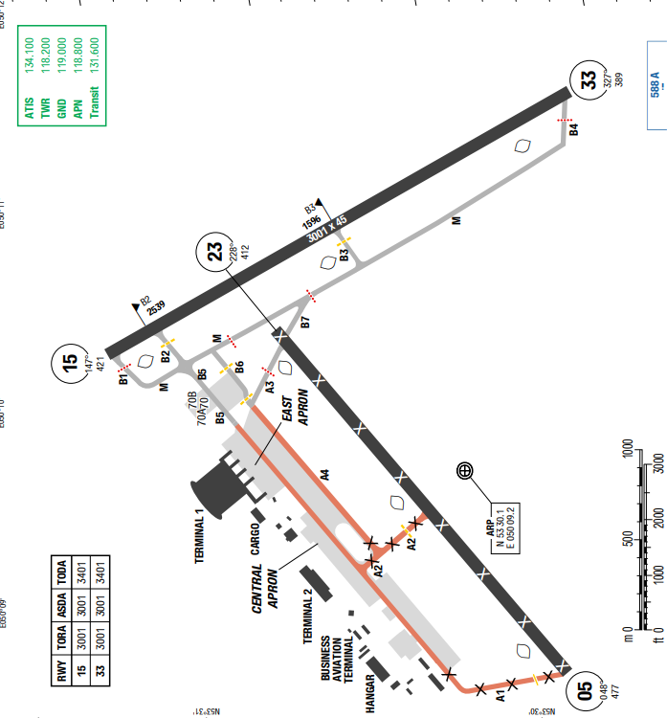
Kurumoch International Airport is the international airport serving the city of Samara, Russia, located 35 km north of the city. Besides Samara, the airport serves Tolyatti – the second largest city in the region. The name of the airport originated from the closest village of Kurumoch 7 km southwest.
At Kurumoch International Airport, the summers are warm and partly cloudy and the winters are long, freezing, snowy, windy, and overcast.
Departure |  |  | - If RWY occupation of more than 1min required after line-up and before TKOF, advise ATC before.  - When cleared for immediate TKOF, rolling TKOF no later than 60s after CLR required.  - TKOF not from RWY beginning shall be carried out upon request of the flight crew or at the initiative of the ATS unit. PIC is responsible for making the decision to carry out such TKOF.
Arrival and Approach |  |  | - Downwind LDG is permitted upon request of the flight crew or at the initiative of the respective ATS unit  • Exit TWY: TO, T5 and the parallel TWY.
Taxi |  |  | - TWY A1, A4 width 18m / 59ft.  - TWY A2 width 16m / 52ft.  - Wingspan Limitations: Taxi via TWY A3, B6, B7 AVBL for ACFT with wingspan up to 65m / 213ft and OMGWS up to 14m / 46ft.  - Towing of ACFT with started ENG is prohibited on the APN covered with snow, ice, except for ACFT with unserviceable APU.
Parking information |  |  | - Follow-me / Marshaller  - Follow-me is AVBL O/R.  - Taxiing into stands shall be executed with marshaller assistance.  - If marshaller's service is not provided, the flight crew shall stop the aircraft and report GND controller.  - ACFT with wingspan up to 42m / 138ft and OMGWS up to 12.5m / 41ft taxi under own ENG PWR into stands 21-23.  - ACFT with wingspan up to 32m / 105ft and OMGWS up to 9m / 30ft taxi into stands 10-16 through adjacent stands.  - ACFT with wingspan up to 32m / 105ft and OMGWS up to 6m / 20ft taxi into stands 8, 9, 35, 36, 40-47 through adjacent stands.  - ACFT with wingspan up to 65m /213ft and OMGWS up to 14m / 46ft permitted to taxi on the APN from abeam stand 34 to stand 24  - De-icing shall be carried out on stands 71-72
5. TAKE-OFF AND LANDING DISTANCES AVAILABLE
RWY | LENGTH  (m) |  |  | WIDTH  (m) |  |  | TORA  (m) |  |  | LDA  (m) | TODA  (m) |  | ASDA  (m)
05/ 23 | 2555 |  |  | 45 |  |  | 2555 |  |  | 2555 | 2555 |  | 2555
15/ 33 | 3000 |  |  | 45 |  |  | 3000 |  |  | 3000 | 3400 |  | 3000
6. ELEVATION: 477ft |  |  |  |  | 7. EOSID: NO
8. IAP: ILS, LOC, RNP, VOR
9. COMPANY NOTE |  |  |  |  | - In winter conditions, APNs and TWYs can be covered by packed snow, ice, marking signs can be unseen.  - Birds in vicinity of AD.
10. REMARK |  |  |  |  | NIL

VAAH/ AMD–SARDAR VALLABH BHAI PATEL INTL AIRPORT–AHMEDABAD, INDIA
1. AIRPORT CATEGORY: A |  |  |  |  |  |  |  | 2. RFFS CATEGORY: 9
3. AIRPORT CLASSIFICATION
ATR |  | A320 |  |  |  | A321 |  |  | A350 |  |  | B787
ADQ |  | ADQ |  |  |  | ADQ |  |  | ADQ |  |  | ADQ
4. GENERAL STANDARDS
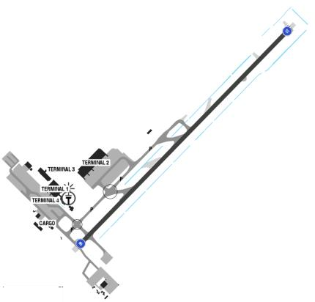
The airport is in Hansol, 9km (5.6mi) north of central Ahmedabad. Ahmedabad has a hot semi- arid climate, with marginally less rain than required for a tropical savanna climate. There are three main seasons: summer, monsoon and winter. Aside from the monsoon season, the climate is extremely dry. The weather is hot from March to June; the average summer24°C-43°C. From November to February, the average maximum temperature is13°C-30°C. Cold winds from the north are responsible for a mild chill in January.
Departure |  |  | - RNAV SIDs.  - Contact Approach when passing 1000ft unless otherwise specified by ATC
Arrival and Approach |  |  | - RNAV STARs  - Expect radar vector for final.  - Speed restrictions on ARR  - RWY 05/ 23 not available due to maintenance on every 0530-0930. RWY shall be restored 30mins in case of emergency.
Taxi |  |  | - Taxi way width restriction
Parking information |  |  | - All ACFT to park under the guidance of marshaller on APN 3  - All ACFT to taxiing on APN 1 to use MNM PWR in order to avoid jet blast.
5. TAKE-OFF AND LANDING DISTANCES AVAILABLE
RWY | LENGTH  (m) |  |  | WIDTH  (m) |  |  | TORA  (m) |  |  | LDA  (m) | TODA  (m) |  | ASDA  (m)
05/ 23 | 3505 |  |  | 45 |  |  | 3505 |  |  | 3505 | 3505 |  | 3505
6. ELEVATION: 189ft |  |  |  |  | 7. EOSID: NO
8. IAP: ILS, LOC, RNP, VOR
9. COMPANY NOTE |  |  |  |  | - Birds in the vicinity of the airport.
10. REMARK |  |  |  |  | NIL

VABB/ BOM–CHHATRAPATI SHIVAJI MAHARAJ INTL AIRPORT–MUMBAI, INDIA
1. AIRPORT CATEGORY: A |  |  |  |  |  |  |  | 2. RFFS CATEGORY: 10
3. AIRPORT CLASSIFICATION
ATR |  | A320 |  |  | A321 |  |  |  | A350 |  |  | B787
ADQ |  | ADQ |  |  | ADQ |  |  |  | ADQ |  |  | ADQ
4. GENERAL STANDARDS
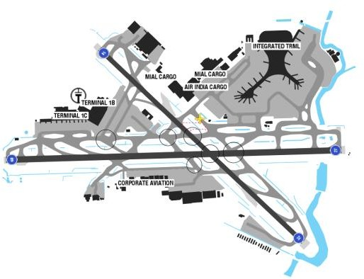
CHHATRAPATI SHIVAJI MAHARAJ INTL Airport is the airport serving Mumbai, India. The highest MSA is to the West sector of BBB VOR at 3800ft. The Climate of Mumbai is a tropical, wet, and dry climate. Mumbai's climate can be best described as moderately hot with high level of humidity. Its coastal nature and tropical location ensure temperatures do not fluctuate much throughout the year. Mumbai experiences three distinct seasons: Winter (October to February) winter temperature15to 20°C Peak Winter Months–Dec to Mid Feb with temperature range 12–19°C.Summer (March to May) Avg temperature 30 to 27°C; Peak Summer Months (Mid-March to 1June week), temperature up to 30– 40°C with humidity being 70–80%.
Departure |  |  | - A-CDM procedure.  - RNAV SIDs  - Expect SID ANOLI 2A  - Unless instructed otherwise, contact Mumbai approach after pass 800ft  - SID with high climb gradient
Arrival and Approach |  |  | - Landing clearance based on anticipated separation.  - Wake turbulence separation minima will still be applied.  - Lost com procedure is avail.  - When on RWY, keep TCAS selected  - For ARR expect ILS 27 Via EMRAK 2A
Taxi |  |  | - Use designated rapid exit taxi way depend on type of aircraft.  - Taxi limitations  - For Landing RWY 27 expect vacate via N7 then follow me car
Parking information |  |  | - Standard push-back and start-up procedures.
5. TAKE-OFF AND LANDING DISTANCES AVAILABLE
RWY | LENGTH  (m) |  |  | WIDTH  (m) |  |  | TORA  (m) |  |  | LDA  (m) | TODA  (m) |  | ASDA  (m)
09 | 3448 |  |  | 60 |  |  | 3188 |  |  | 3048 | 3188 |  | 3188
14 | 2871 |  |  | 45 |  |  | 2871 |  |  | 2471 | 2871 |  | 2871
27 | 3448 |  |  | 60 |  |  | 3448 |  |  | 2965 | 3448 |  | 3448
32 | 2871 |  |  | 45 |  |  | 2871 |  |  | 2673 | 2871 |  | 2871
6. ELEVATION: 40ft |  |  |  |  |  | 7. EOSID: YES
8. IAP: ILS, LOC, RNP, VOR
9. COMPANY NOTE |  |  |  |  |  | - Birds in the vicinity of the airport.  - Push-back procedures.  - Pilot shall not request for direct belowFL140  - RWY 09/ 27 and RWY 14/ 32 closed DLY except Fri between 2150-2230 for LDG and T/ O. In case of emergency runway restoration period is 10 minutes  - The airport has two terminals for scheduled commercial passenger services: Terminal 1 for domestic flights and Terminal 2 at Sahar for both international and domestic flights
10. REMARK |  |  |  |  |  | NIL

VABO/ BBQ – VADODARA AIRPORT– VADODARA, INDIA
1. AIRPORT CATEGORY: A |  |  |  |  |  |  |  | 2. RFFS CATEGORY: 7
3. AIRPORT CLASSIFICATION
ATR |  | A320 |  |  | A321 |  |  |  | A350 |  |  | B787
ADQ |  | ADQ |  |  | ADQ |  |  |  | N/A |  |  | N/A
4. GENERAL STANDARDS
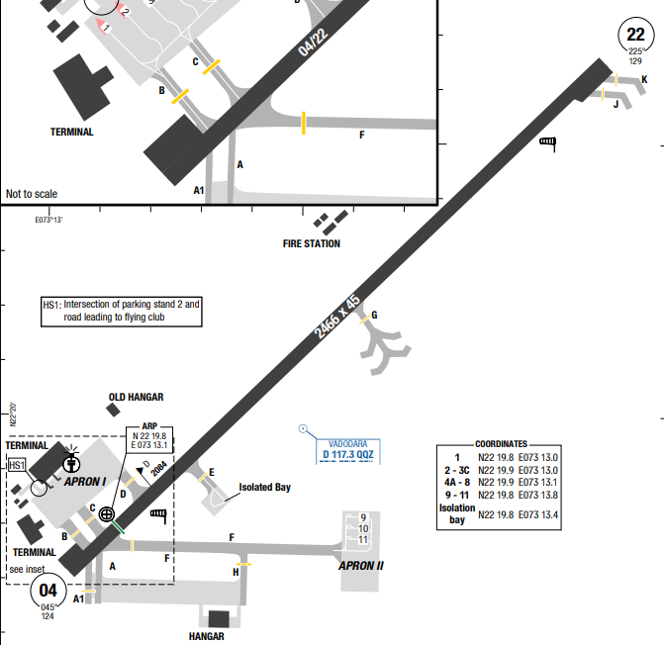
Vadodara Airport is a customs airport and Indian Air Force base serving the city of Vadodara in Gujarat, India. It is located in the suburb of Harni, northeast of Vadodara. It is the third-busiest airport in Gujarat, after Ahmedabad and Surat airports.
Vadodara has a tropical savanna and borderline semi-arid climate featuring three distinct seasons: summer, monsoon, and winter.
Summer (March to June): Hot and dry weather dominates, with average maximum temperatures reaching around 39°C to 40°C (102°F to 104°F). May is typically the hottest month.
Monsoon (July to September): The southwest monsoon brings high humidity and heavy rainfall, averaging about 950 mm (37 inches) annually. July is usually the wettest and cloudiest month.
Winter (October to February): Conditions turn cool, dry, and pleasant, with average daytime highs around 30°C and chilly night minimums dropping to about 15°C in January
Departure |  |  | - No SID
Arrival and Approach |  |  | - No STAR  - Speed control for each flight phase
Taxi |  |  | - TWY G MIL use only.  - APN 1: Vacate RWY via TWY B and C, enter RWY via TWY D
Parking information |  |  | NIL
5. TAKE-OFF AND LANDING DISTANCES AVAILABLE
RWY | LENGTH  (m) |  |  | WIDTH  (m) |  |  | TORA  (m) |  |  | LDA  (m) | TODA  (m) |  | ASDA  (m)
22/ 04 | 2466 |  |  | 45 |  |  | 2466 |  |  | 2466 | 2466 |  | 2466
6. ELEVATION: 131ft |  |  |  |  |  | 7. EOSID: NO
8. IAP: ILS, LOC, RNP, VOR
9. COMPANY NOTE |  |  |  |  |  | - ACFT shall not lock turn / pivotal turn on RWY to avoid damage.
10. REMARK |  |  |  |  |  | NIL

VAID/ IDR – DEVI AHILYA BAI HOLKAR – INDORE, INDIA
1. AIRPORT CATEGORY: A |  |  |  |  |  |  |  | 2. RFFS CATEGORY: 7
3. AIRPORT CLASSIFICATION
ATR |  | A320 |  |  | A321 |  |  |  | A350 |  |  | B787
ADQ |  | ADQ |  |  | ADQ |  |  |  | N/A |  |  | N/A
4. GENERAL STANDARDS
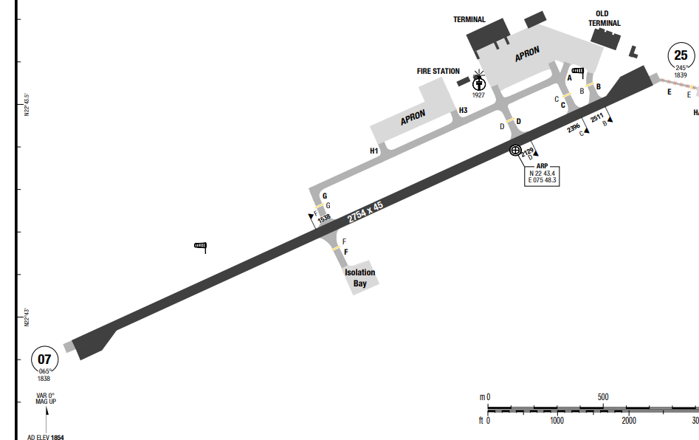
Devi Ahilya Bai Holkar Airport (IATA: IDR, ICAO: VAID) is a customs airport serving the city of Indore, the financial capital of the state of Madhya Pradesh. It is the busiest airport in Central India and is located at Bijasen Tekri, 8 km west of Indore.
Indore has a transitional climate that borders between a tropical savanna and a humid subtropical climate, made milder by its high elevation.
Departure |  |  | - No SID  - COMM FAIL procedure available  - LVP: DEPs may only be conducted from the beginning of RWY 07
Arrival and Approach |  |  | - No STAR  - Speed control for each flight phase  - COMM FAIL procedure available
Taxi |  |  | - TWY E width 6.7m / 22ft.
Parking information |  |  | - Visual Docking guidance system (VDGS) AVBL for parking stands 1-5.
5. TAKE-OFF AND LANDING DISTANCES AVAILABLE
RWY | LENGTH  (m) |  |  | WIDTH  (m) |  |  | TORA  (m) |  |  | LDA  (m) | TODA  (m) |  | ASDA  (m)
07/ 25 | 2754 |  |  | 45 |  |  | 2754 |  |  | 2754 | 2754 |  | 2754
6. ELEVATION: 1854ft |  |  |  |  |  | 7. EOSID: NO
8. IAP: ILS, LOC, RNP, VOR
9. COMPANY NOTE |  |  |  |  |  | - Jackals on the movement area.  - Seasonal bird activity in AD and APCH path
10. REMARK |  |  |  |  |  | NIL

VANP/ NAG – DR. BABASAHEB AMBEDKAR INTL – NAGPUR – INDIA
- AIRPORT CATEGORY: A |  |  |  |  |  | - RFFS CATEGORY: 8
- AIRPORT CLASSIFICATION
ATR |  | A320 |  | A321 |  | A350 |  |  | B787
ADQ |  | ADQ |  | ADQ |  | ADQ |  |  | ADQ
4. GENERAL STANDARDS
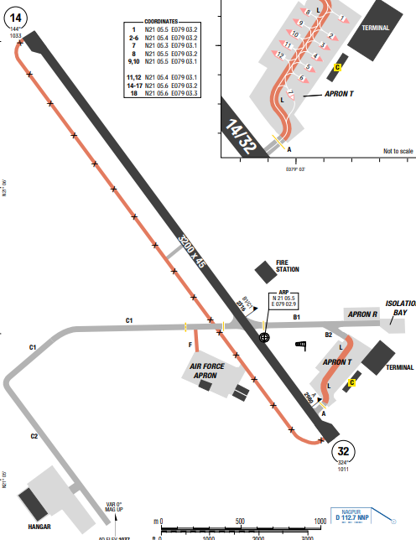
Dr. Babasaheb Ambedkar International Airport (IATA: NAG, ICAO: VANP) is an international airport serving the city of Nagpur, Maharashtra, India. The airport is located at Sonegaon, 8 km (5 mi) southwest of Nagpur. The climate of Nagpur is tropical, with a rainy season from June to mid-October, due to the monsoon, and a dry season from mid-October to May. The rains usually end in early or mid-October. The city is located in central India, in the state of Maharashtra, at 21 degrees north latitude and 300 meters (985 feet) above sea level.
Departure |  |  | - No SID available
Arrival and Approach |  |  | - No STAR available
Taxi |  |  | - TWY F width 15m / 49ft.  - Taxilane L from B2 to A restricted for ACFT up to code letter C.  - TWY C1 is lighted up to TWY F intersection, rest portion of C1 in not lighted.
Parking information |  |  | - Apron T restricted to code C type ACFT. All stands are push-back
5. TAKE-OFF AND LANDING DISTANCES AVAILABLE
RWY | LENGTH  (m) |  |  | WIDTH  (m) |  |  | TORA  (m) | LDA  (m) |  | TODA  (m) | ASDA  (m)
14/ 32 | 3200 |  |  | 45 |  |  | 3200 | 3200 |  | 3200 | 3200
6. ELEVATION: 1033ft |  |  |  |  | 7. EOSID: NO
8. IAP: ILS, LOC, RNP, VOR
9. COMPANY NOTE |  |  |  |  | NIL
10. REMARK |  |  |  |  | NIL

VCBI/CMB – COLOMBO INTL AIRPORT – KATUNAYAKE, SRI LANKA
- AIRPORT CATEGORY: A |  |  |  |  |  | - RFFS CATEGORY: 9
- AIRPORT CLASSIFICATION
ATR |  | A320 |  |  | A321 | A350 |  |  |  | B787
ADQ |  | ADQ |  |  | ADQ | ADQ |  |  |  | ADQ
- GENERAL STANDARDS
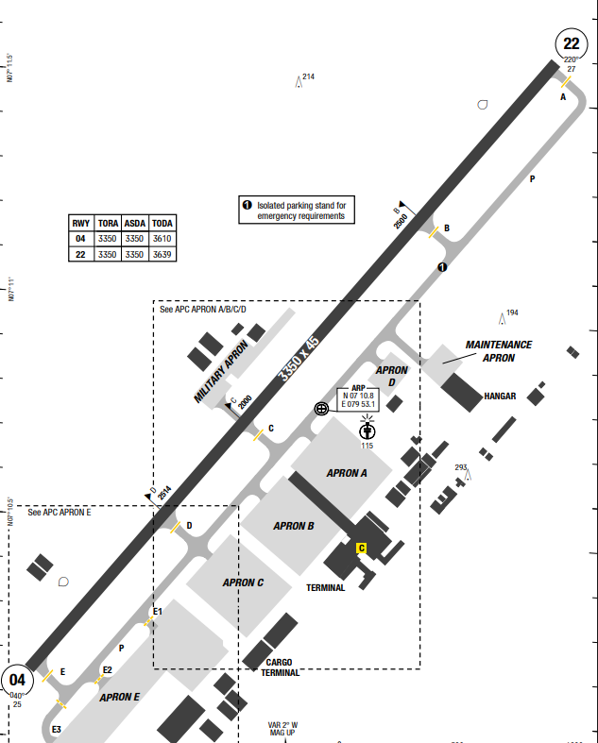
Bandaranaike International Airport (commonly known as Colombo International Airport, and locally as Katunayake Airport) is the main international airport serving Sri Lanka. It is named after former Prime Minister S.W.R.D. Bandaranaike and is located in a suburb of Negombo, 32.5 kilometres (20 1⁄4 miles) north of the nation's longstanding capital and commercial center, Colombo. The airfield is 13 NM North of the city of Colombo. It is almost on the coast with a large lagoon on its seaward side. The land is flat in the vicinity of the airfield but starts to rise 15 NM East, slowly at first, but at 40 NM more rapidly to form a mountain range with peaks to nearly 7359 feet ASL The airfield is surrounded by trees up tp 80 feet AGL.
The temperature varies little throughout the year staying mainly between 24°C and 30°C. Poor flying conditions come mainly from thunderstorms and heavy rain.

Departure |  |  | - RNAV SIDs are available with high climb gradient (highest 6.5% to 6000ft at RWY 22)  - SIDs RADAR: Maintain assigned HDG climb to MSA or at last assigned LVL (if higher). Maintain MSA or assigned LVL as appropriate for 2min. Then climb to flight plan LVL and intercept flight plan track (as amended by ATC if applicable  - RTB (return to base) available, refer to AOI Chart for detail
Arrival and Approach |  |  | - RNAV STARs are available.  - COMM FAIL procedure  - RWY 04 and 22 both left-hand and right-hand 1500ft ALT circuit AVBL
Taxi |  |  | - Follow-me car available
Parking information |  |  | - Marshaller compulsory.  - Nose-in parking permitted only.  - Isolated stand AVBL on parallel TWY P, 231m / 758ft from TWY B towards TWY C to serve EMERG requirements.  - Stands A6-A9, B10-B12, B14 equipped with SAFEDOCK.  - For special flight, expect Stand A1-A2 for parking and Stand E48-E49 for overnight parking
- TAKE-OFF AND LANDING DISTANCES AVAILABLE
RWY | LENGTH  (m) |  |  | WIDTH  (m) |  |  | TORA  (m) | LDA  (m) | TODA  (m) |  | ASDA  (m)
04 | 3350 |  |  | 45 |  |  | 3350 | 3350 | 3610 |  | 3350
22 | 3350 |  |  | 45 |  |  | 3350 | 3350 | 3639 |  | 3350
6. ELEVATION: 30ft | 7. EOSID: NO
8. IAP: ILS, LOC, RNP, VOR
9. COMPANY NOTE | - RWY 04/22 CLSD every WED 0900-1130 due to MAINT  - Birds in vicinity of AD
10. REMARK | NIL

VCRI/ HRI – MATTALA INTL AIRRPORT – RAJAPAKSA, SRI LANKA
- AIRPORT CATEGORY: A |  |  |  |  |  |  | - RFFS CATEGORY: 10
- AIRPORT CLASSIFICATION
ATR |  | A320 |  |  | A321 |  | A350 |  |  | B787
ADQ |  | ADQ |  |  | ADQ |  | ADQ |  |  | ADQ
- GENERAL STANDARDS
Mattala Rajapaksa International Airport (IATA: HRI, ICAO: VCRI) is an international airport serving southeast Sri Lanka. It is located in the town of Mattala, 18 km from Hambantota.
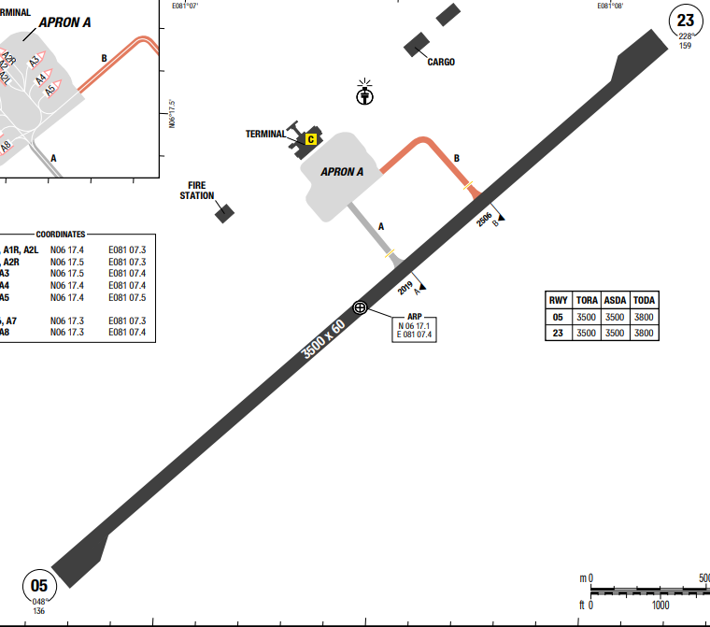
Mattala, located in Sri Lanka's southern Hambantota District, features a hot, tropical climate with significant year-round warmth, high humidity, and distinct wet/dry seasons influenced by monsoons. Temperatures often exceed 30°C, with recent highs reaching 33.9°C, while nights typically hover around 23-25°C
Departure |  |  | - Conventional SIDs are available
Arrival and Approach |  |  | - Conventional STARs available
Taxi |  |  | - TWY B width 15m / 49ft.
Parking information |  |  | - Marshaller mandatory.  - Nose-in parking permitted only.
- TAKE-OFF AND LANDING DISTANCES AVAILABLE
RWY | LENGTH  (m) |  |  | WIDTH  (m) |  | TORA  (m) |  | LDA  (m) | TODA  (m) |  | ASDA  (m)
05/23 | 3500 |  |  | 60 |  | 3500 |  | 3500 | 3800 |  | 3500
6. ELEVATION: 157ft | 7. EOSID: YES
8. IAP: ILS, LOC, NDB, VOR
9. COMPANY NOTE | - Non-SKED FLTs PPR only
10. REMARK | NIL

VDPP/ PNH–PHNOMPENH INTL AIRPORT-PHNOMPENH, CAMBODIA
1. AIRPORT CATEGORY: A |  |  |  |  |  |  |  | 2. RFFS CATEGORY: 9
3. AIRPORT CLASSIFICATION
ATR |  | A320 |  |  |  | A321 |  |  | A350 |  |  | B787
ADQ |  | ADQ |  |  |  | ADQ |  |  | ADQ |  |  | ADQ
4. GENERAL STANDARDS
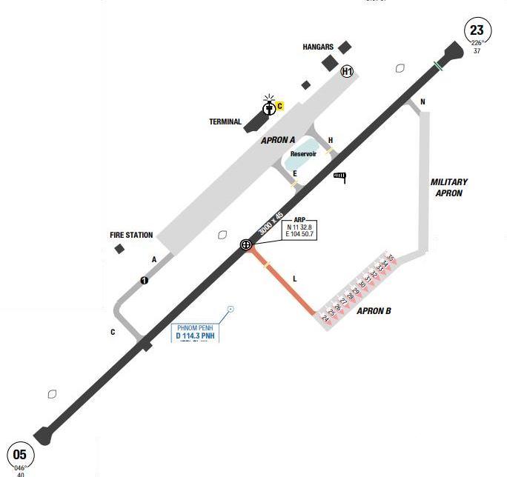
The airport is situated in the Mekong Delta with little terrain or obstructions surrounding it. However, the MSA to the West is 3600 Ft.
PNH has a tropical monsoon climate, over the course of a year, the temperature typically varies from 23°C to 35°C. The average cloud cover ranges from 34% (mostly clear) to 62% (partly cloudy). The sky is cloudiest around the end of August and clearest early February. The probability that precipitation will be observed at this location varies throughout the year.Precipitation is most likely around early September. Precipitation is least likely around late January.
Departure |  |  | - RNAV SIDs  - Radar vectors on departure are about 10NMs south of the airfield before a left turn on course is permitted.
Arrival and Approach |  |  | - RNAV STARs are available.  - Radar Vectors can be given to intercept the final approach course for the ILS.
Taxi |  |  | - 180 degree turnaround on the runway is allowed only in 3 areas: beginning of RWY 23 and RWY 05, and at 630m from RWY 05 threshold.
Parking information |  |  | - Expect: Apron 10-13
5. TAKE-OFF AND LANDING DISTANCES AVAILABLE
RWY | LENGTH  (m) |  |  | WIDTH  (m) |  |  | TORA  (m) |  |  | LDA  (m) | TODA  (m) |  | ASDA  (m)
05 | 3000 |  |  | 45 |  |  | 3000 |  |  | 3000 | 3000 |  | 3000
23 | 3000 |  |  | 45 |  |  | 3000 |  |  | 2850 | 3000 |  | 3000
6. ELEVATION: 40ft |  |  |  |  | 7. EOSID: YES
8. IAP: ILS, LOC, RNP, VOR
9. COMPANY NOTE |  |  |  |  | - Pushback procedures
10. REMARK |  |  |  |  | NIL

VDSA/ SAI - SIEM REAP-ANGKOR INTL – CAMBODIA
1. AIRPORT CATEGORY: A |  |  |  |  |  |  |  | 2. RFFS CATEGORY: 9
3. AIRPORT CLASSIFICATION
ATR |  | A320 |  |  | A321 |  |  |  | A350 |  |  | B787
ADQ |  | ADQ |  |  | ADQ |  |  |  | N/ A |  |  | N/ A
4. GENERAL STANDARDS
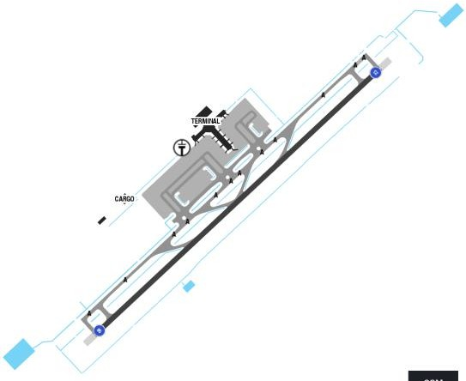
Siem Reap–Angkor International Airport (IATA: SAI, ICAO: VDSA), is an international airport located in Soutr Nikom District, Siem Reap province which serves the city of Siem Reap.
In Siem Reap, the wet season is oppressive and overcast, the dry season is muggy and partly cloudy, with high humidity and thunderstorms in the rainy season and it is hot year round. Heavy thunderstorms can often be expected in the area in the afternoon. Sometimes tailwind can be out of limits for landing or take off.
Departure |  |  | - When flight formalities have been completed and aircraft is ready for departure (all doors are closed), all aircraft are to call Angkor Tower for ATC clearance on frequency 121.90 MHz.  - Departure shall normally be cleared in the order in which they are ready for take-off, except that deviations may be made from this order of priority to facilitate the maximum number of departures with the least average delay
Arrival and Approach |  |  | - RNAV STARs are available.  - Radar Vectors can be given to intercept the final approach course for the ILS.  - Visual approach is normally approved in good weather
Taxi |  |  | - There are two main taxiways to the apron.  - Rapid exit taxiway A4 & A5 available for aircraft up to code C only.
Parking information |  |  | No
5. TAKE-OFF AND LANDING DISTANCES AVAILABLE
RWY | LENGTH  (m) |  |  | WIDTH  (m) |  |  | TORA  (m) |  |  | LDA  (m) | TODA  (m) |  | ASDA  (m)
05 | 3000 |  |  | 45 |  |  | 3000 |  |  | 3000 | 3000 |  | 3000
23 | 3000 |  |  | 45 |  |  | 3000 |  |  | 2850 | 3000 |  | 3000
6. ELEVATION: 191ft |  |  |  |  |  | 7. EOSID: NO
8. IAP: ILS, LOC, RNP, VOR
9. COMPANY NOTE |  |  |  |  |  | - SAI airport operation hours is 23h00 – 2000 UTC (0600 - 0300 LT).  - Delays may be expected for the second aircraft to pushback and to taxi when two or more aircraft are parked either adjacent to one another or close together
10. REMARK |  |  |  |  |  | NIL

VDTI/KTI – TECHO INTERNATIONAL AIRPORT
1. AIRPORT CATEGORY: A |  |  |  |  |  |  |  | 2. RFFS CATEGORY: 7
3. AIRPORT CLASSIFICATION
ATR |  | A320 |  |  |  | A321 |  |  | A350 |  |  | B787
ADQ |  | ADQ |  |  |  | ADQ |  |  | ADQ |  |  | ADQ
4. GENERAL STANDARDS
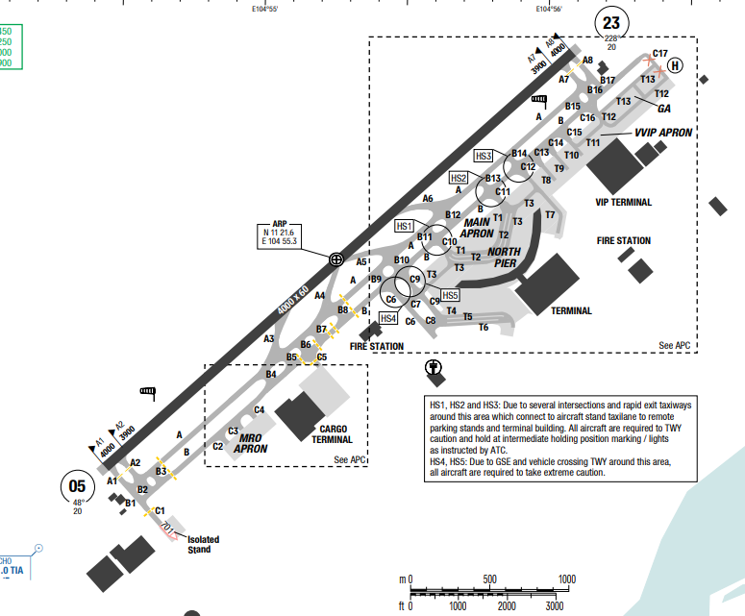
Techo International Airport (IATA: KTI, ICAO: VDTI) is an international airport currently under construction in Kandal Province of Cambodia. Located about 30–40 kilometres (16–22 NM; 19–25 mi) south of Phnom Penh, the first phase is expected to be operational by 2025[7] and will replace the existing Phnom Penh International Airport as the city's main aviation hub.
Phnom Penh has a tropical monsoon climate, over the course of a year, the temperature typically varies from 23°C to 35°C. The average cloud cover ranges from 34% (mostly clear) to 62% (partly cloudy). The sky is cloudiest around the end of August and clearest early February. The probability that precipitation will be observed at this location varies throughout the year.
Departure |  |  |  | - Pushback/start-up: Must be requested when fully ready.  - Start-up with one engine allowed on request, limited to right engine unless approved  - Noise Abatement: Not published; idle power suggested in apron/taxi areas  - RNAV SIDs available
Arrival and Approach |  |  |  | - Standard taxi route issued by ATC.  - Multiple taxiways depending on gate location.  - LVP (Low Visibility Procedure): Stop bars installed at key taxiways; ground guidance mandatory.  - RNAV STARs available
Taxi |  |  |  | - VDGS: Not specified; marshaller or follow-me used  - Pushback Procedures: Defined per stand and aircraft code. Example: Stand 123 (Code F): Push back facing WEST to Taxi Lane T5, then tow to "T" mark  - Engine Start: Normally after pushback; one-engine start during pushback permitted under ATC/GRU approval
Parking information |  |  |  | - Start-up Procedure  - VDGS installed on parking stand 8 is not aligned with the markings. Crew is advised to disregard the VDGS and follow the guidelines.
5. TAKE-OFF AND LANDING DISTANCES AVAILABLE
RWY | LENGTH  (m) |  | WIDTH  (m) |  |  |  | TORA  (m) |  |  | LDA  (m) | TODA  (m) |  | ASDA  (m)
05/23 | 4000 |  | 60 |  |  |  | 4000 |  |  | 4000 | 4000 |  | 4000
6. ELEVATION: 22ft |  |  |  |  | 7. EOSID: N
8. IAP: ILS (CAT I/II), RNP, VOR
9. COMPANY NOTE |  |  |  |  | - ATC Frequency:  + TWR: 118.00 MHz  + GND: 121.90 MHz  + ATIS: 128.30 MHz / D-ATIS: 131.45 MHz  - Runway TORA/TODA 4000m on both RWY 05 and 23 allows unrestricted long-haul ops including Code F (B748, A388)  - Due to full-length TORA/TODA on both runways (4000m), intersection takeoff is unnecessary and not encouraged.  - Confirm stand procedures carefully—some stands require special pushback or tow forward to “T” marks.  - Expect significant taxi distance depending on stand allocation; monitor brake temperature accordingly.
10. REMARK |  |  |  |  | NIL

VEBN/ VNS – LAL BAHADUR SHASTRI – VARANASI – INDIA
1. AIRPORT CATEGORY: A |  |  |  |  |  |  |  |  | 2. RFFS CATEGORY: 7
3. AIRPORT CLASSIFICATION
ATR |  | A320 |  |  |  |  | A321 |  |  | A350 |  |  | B787
ADQ |  | ADQ |  |  |  |  | ADQ |  |  | N/ A |  |  | N/ A
4. GENERAL STANDARDS
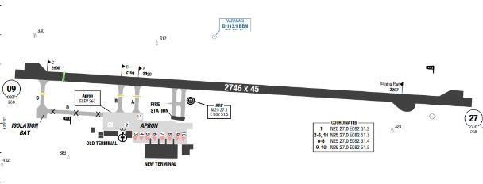
Lal Bahadur Shastri Airport (IATA: VNS, ICAO: VEBN) is an international airport serving Varanasi, Uttar Pradesh, India. It is located at Babatpur, 26 km northwest of Varanasi.
Climate of Varanasi is a humid subtropical climate with large variations between summer and winter temperature. The dry summer starts at April and lasts until June, followed by the monsoon season from July to October. The temperature ranges between 22 and 46°C in the summer.
Winter in Varanasi see very large variations with warm days and downright cold nights. Cold waves from the Himalayan region cause temperatures to dip across the city in the winter from December to February and temperatures below 5°C are not uncommon.
The average annual rainfall is 1,110 mm. Fog is common in the winters, while hot dry winds called loo blow in the summer
Departure |  |  |  | - SIDs not available  - Lost com procedure  - LVP available  - DEPARTURE INTENDING TO LAND BACK AT VARANASI:  Departing aircraft experiencing RCF and intending to land back at VARANASI airport shall  + Continue on Radar heading, climbing to or maintaining the cleared Flight level. However, in case the RCF is experienced below FL150 and the cleared flight level is above FL150, aircraft shall maintain FL150.  + One minute after setting Mode A/C code 7600 or reaching the appropriate level; take a turn to proceed direct to ‘BBN’ VOR maintaining level.  + Descend to 3300 FT in ‘BBN’ hold. Leave ‘BBN’ VOR at 3300 FT to  carry out any of the published instrument approach procedure for assigned runway.
Arrival and Approach |  |  |  | - Arriving aircraft shall enter the traffic circuit on the downwind leg at an angle of 45 degrees and shall maintain aerodrome circuit height
- In case arriving aircraft has not been advised of any runway for landing, Runway 27 shall be considered as assigned runway for
such arrival.
Taxi |  |  | - Pushback procedures available.  - Taxiway “A”, “B”, “C” is 23M wide. TWY “C” is used for entry and exists to /from Isolation bay only.
Parking information |  |  | - Start-up Procedure  - VDGS installed on parking stand 8 is not aligned with the markings. Crew is advised to disregard the VDGS and follow the guidelines.
5. TAKE-OFF AND LANDING DISTANCES AVAILABLE
RWY | LENGTH  (m) |  |  |  | WIDTH  (m) |  |  | TORA  (m) |  |  | LDA  (m) | TODA  (m) |  | ASDA  (m)
09 | 2746 |  |  |  | 45 |  |  | 2746 |  |  | 2514 | 2746 |  | 2746
27 | 2746 |  |  |  | 45 |  |  | 2746 |  |  | 2746 | 2746 |  | 2746
6. ELEVATION: 270ft |  |  |  |  |  | 7. EOSID: NO
8. IAP: ILS, LOC, RNP, VOR
9. COMPANY NOTE |  |  |  |  |  | - LVP available  - No Aircraft shall take lock turn/ pivotal turn on the Runway to avoid pavement damage.  - Varanasi ATC shall ensure approach and runway lights of the assigned runway in ‘SWITCHED ON’ position for RCF aircraft irrespective of day/night/visibility/weather conditions.  - In strong tail wind conditions for assigned Runway, aircraft will carry out a missed approach on assigned runway and after following complete missed approach procedure for such approach, will carry out any of the published instrument approach procedure for the opposite runway.  - Varanasi has En-route RADAR and not the Terminal RADAR. Air traffic controlling above FL060 is under the purview of RADAR control and flights are controlled procedurally at or below FL060. Any Hold at or below FL060 is only over BBN. Standard Radio Communication Failure procedure will apply during RADAR environment even though the flight may be below FL060.  - Crew need to be cautious for road close by on approach of RWY09 and Take -off path of RWY27. The moving traffic on the  road might distract the Crew during approach/landing on RWY09 and during Take-off from RWY27.
10. REMARK |  |  |  |  |  | NIL

VEBS/ BBI – BIJU PATNAIK INTERNATIONAL AIRPORT, BHUBANESWAR, INDIA
- AIRPORT CATEGORY: A |  |  |  |  |  | - RFFS CATEGORY: 7
- AIRPORT CLASSIFICATION
ATR |  | A320 |  | A321 |  | A350 |  |  | B787
ADQ |  | ADQ |  | ADQ |  | ADQ |  |  | ADQ
4. GENERAL STANDARDS
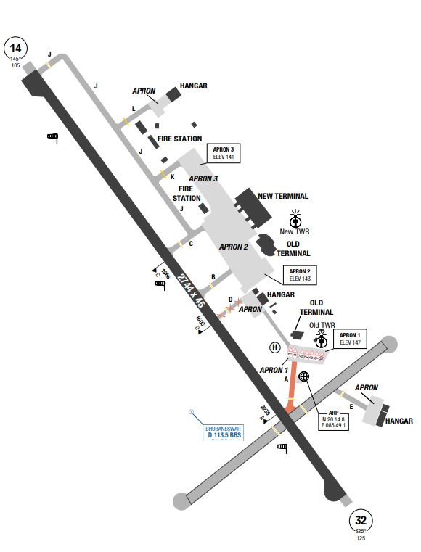
Biju Patnaik International Airport is a domestic airport serving Bhubaneswar, the capital city of the state of Odisha, India. MSA is based on multiple navigation aid stations with highest sector is 3300ft. The climate of Bhubaneswar is tropical, with a rainy due to the monsoon, and a dry season from November to May. The rains usually end in early or mid-October.
Departure |  |  | No
Arrival and Approach |  |  | No
Taxi |  |  | - TWY A width 15m / 49ft.  - TWY D width 11m / 36ft.
Parking information |  |  | No
- TAKE-OFF AND LANDING DISTANCES AVAILABLE
RWY | LENGTH  (m) |  |  | WIDTH  (m) |  |  | TORA  (m) | LDA  (m) |  | TODA  (m) | ASDA  (m)
14/ 32 | 2744 |  |  | 45 |  |  | 2744 | 2744 |  | 2744 | 2744
6. ELEVATION: 141ft |  |  |  |  | 7. EOSID: NO
8. IAP: ILS, LOC, RNP, VOR
9. COMPANY NOTE |  |  |  |  | NIL
10. REMARK |  |  |  |  | NIL

VECC/ CCU – NETAJI SUBASH CHANDRA BOSE INTL AIRPORT, KOLKATA, INDIA
- AIRPORT CATEGORY: A |  |  |  |  |  | - RFFS CATEGORY: 9
- AIRPORT CLASSIFICATION
ATR |  | A320 |  | A321 |  | A350 |  |  | B787
ADQ |  | ADQ |  | ADQ |  | ADQ |  |  | ADQ
4. GENERAL STANDARDS
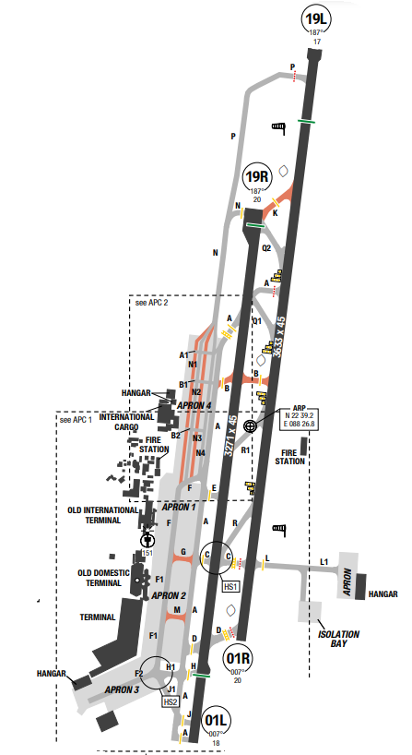
Netaji Subhas Chandra Bose International Airport is a public airport located 17 km north of the central business district of Kolkata (Calcutta), a city in West Bengal, India. MSA of the airport is 2000ft. Tropical Monsoon climate (Köppen climate classification Am) - monthly mean temperatures above 18°C in every month of the year and features wet and dry seasons. A tropical monsoon climate typically features less pronounced dry seasons than a tropical savanna climate and sees less variance in temperatures during the course of the year. The driest month nearly always occurs at or soon after the "winter" solstice.
Departure |  |  | - RNAV SIDs  - SID with high climb gradient
Arrival and Approach |  |  | - RNAV STARs  - Speed restrictions
Taxi |  |  | - Shall vacate RWY via exit TWY as assigned by TWR on final approach or inform inability to ATC.  - Standard taxi routes
Parking information |  |  | - 180° turn not allowed for power-in/ push-back parking.
5. TAKE-OFF AND LANDING DISTANCES AVAILABLE
RWY | LENGTH  (m) |  |  | WIDTH  (m) |  |  | TORA  (m) | LDA  (m) |  | TODA  (m) | ASDA  (m)
01L | 3271 |  |  | 45 |  |  | 3271 | 2833 |  | 3271 | 3271
01R | 3633 |  |  | 45 |  |  | 3633 | 3633 |  | 3633 | 3633
19L | 3633 |  |  | 45 |  |  | 3633 | 3207 |  | 3633 | 3633
19R | 3271 |  |  | 45 |  |  | 3271 | 3183 |  | 3271 | 3271
6. ELEVATION: 20ft |  |  |  |  | 7. EOSID: NO
8. IAP: ILS (CAT I, II, III), LOC, RNP, VOR
9. COMPANY NOTE |  |  |  |  | NIL
10. REMARK |  |  |  |  | NIL

VEGY/ GAY – GAYA – GAYA, INDIA
- AIRPORT CATEGORY: A |  |  |  |  |  |  | - RFFS CATEGORY: 7
- AIRPORT CLASSIFICATION
ATR |  | A320 |  | A321 |  |  | A350 |  | B787
ADQ |  | ADQ |  | ADQ |  |  | ADQ |  | ADQ
4. GENERAL STANDARDS
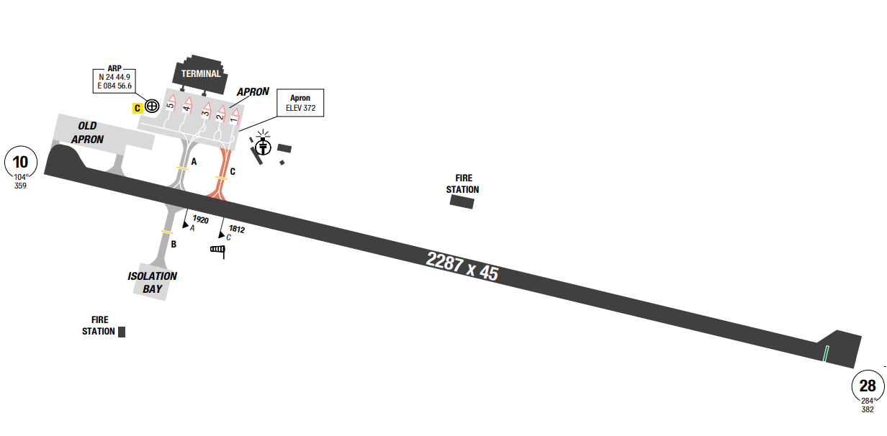
Gaya International Airport is an international airport serving Gaya, Bihar, India. It is located 12 km south-west of Gaya and 5 km from Bodh Gaya, from where Gautama Buddha attained enlightenment. The airport is spread over an area of 3.86 square kilometers. The airport terminal building, spread over 7,500 square meters can handle 250 departure and 250 arrival passengers, two aerobridges and an apron capable. In Gaya, the wet season is oppressive and mostly cloudy, the dry season is mostly clear, and it is hot year round.
Departure |  |  | No
Arrival and Approach |  |  | - ATC may clear within aerodrome control zone an aircraft established on any radial other than the promulgated radial to join 12D ARE procedure at or above 2900 ft  - Miss approach procedure available with restricted IAS and hold or as instructed by ATC.
Taxi |  |  | - From stands 1 and 2 taxi to RWY 10/ 28 via TWY C.
Parking information |  |  | No
5. TAKE-OFF AND LANDING DISTANCES AVAILABLE
RWY | LENGTH  (m) |  |  | WIDTH  (m) |  | TORA  (m) |  | LDA  (m) |  | TODA  (m) | ASDA  (m)
10 | 2287 |  |  | 45 |  | 2287 |  | 2287 |  | 2287 | 2287
28 | 2287 |  |  | 45 |  | 2287 |  | 2210 |  | 2287 | 2287
6. ELEVATION: 383ft |  |  |  |  | 7. EOSID: YES
8. IAP: ILS, LOC, RNP, VOR
9. COMPANY NOTE |  |  |  |  | NIL
10. REMARK |  |  |  |  | NIL

VERC/ IXR – BISRA MUNDA AIRPORT, RANCHI, INDIA
1. AIRPORT CATEGORY: A |  |  |  |  |  |  |  | 2. RFFS CATEGORY: 9
3. AIRPORT CLASSIFICATION
ATR |  | A320 |  |  |  | A321 |  |  | A350 |  |  | B787
ADQ |  | ADQ |  |  |  | ADQ |  |  | ADQ |  |  | ADQ
4. GENERAL STANDARDS
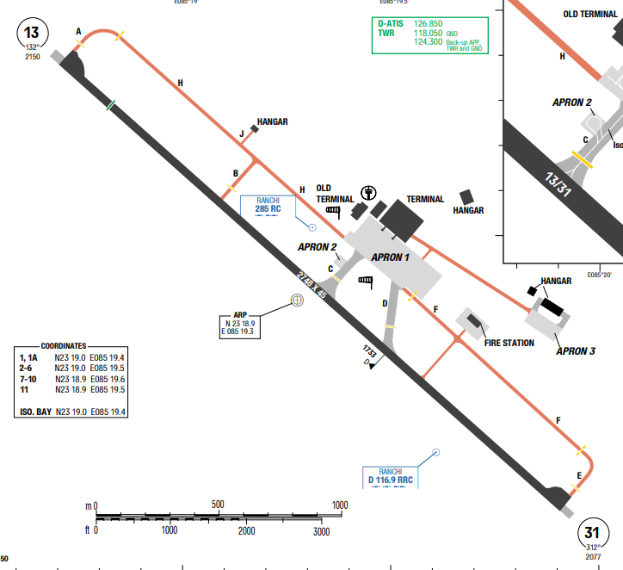
Birsa Munda Airport is a domestic airport serving Ranchi, the capital city of Jharkhand, India. It is named after the famous Indian tribal freedom fighter, Birsa Munda, and is currently managed by the Airports Authority of India. The airport is located in Hinoo, approximately 5 km from the city center and sprawls over an area of 1,568 acres.
Ranchi has a subtropical climate, characterized by hot summers (March–May), a monsoon season with heavy rainfall (June–October), and dry, cool winters (November–February). The highest temperatures occur in May, with an average high of about 36.1°C, while the coolest temperatures are in January, with an average high of around 22.1°C and an average low of 9.5°C. The city receives the most rainfall in July.
Departure |  |  | - No SID
Arrival and Approach |  |  | - No STAR
Taxi |  |  | - TWY A, B, E, F, G, H width 15m / 49ft.
Parking information |  |  | - Visual Docking Guidance System (VDGS) AVBL on stand 3 and 4.  - APN 2 AVBL for ACFT up to code letter B.
5. TAKE-OFF AND LANDING DISTANCES AVAILABLE
RWY | LENGTH  (m) |  |  | WIDTH  (m) |  |  | TORA  (m) |  |  | LDA  (m) | TODA  (m) |  | ASDA  (m)
13/ 31 | 2750 |  |  | 45 |  |  | 2750 |  |  | 2750 | 2750 |  | 2750
6. ELEVATION: 30ft |  |  |  |  | 7. EOSID: YES
8. IAP: ILS, LOC, VOR
9. COMPANY NOTE |  |  |  |  | - ACFT shall not lock / pivotal turn on the RWY to avoid pavement damage.  - RWY turn pad at both ends of RWY 13/31 AVBL for B77W for special OPS with prior permission.  - Caution: Fuel type not identify at the airport
10. REMARK |  |  |  |  | NIL

VGHS/ DAC – HARZAT SHAHJALAL INTL AIRPORT, DHAKA, BANGLADESH
- AIRPORT CATEGORY: A |  |  |  |  |  |  | - RFFS CATEGORY: 9
- AIRPORT CLASSIFICATION
ATR |  | A320 |  | A321 |  |  | A350 |  | B787
ADQ |  | ADQ |  | ADQ |  |  | ADQ |  | ADQ
4. GENERAL STANDARDS
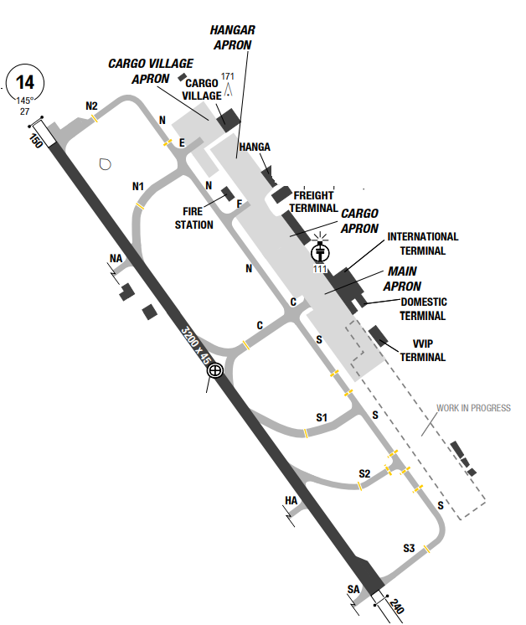
Hazrat Shahjalal international airport is the main international airport serving Dhaka City, the capital city of Bangladesh, and it is the largest airport in Bangladesh. It is located in Kurmitola, 17km from city center, in the northern part of Dhaka. MSA is based on multiple navigation aid stations at 2000ft. Dhaka has a tropical wet and dry climate, influenced by pre-monsoon and post-monsoon circulations and frequently experiences heavy precipitation and tropical cyclones.Dhaka has dry season from November to March and a rainy season from May to October.
Departure |  |  | - Conventional SIDs (also are noise abated)  - NO STAR
Arrival and Approach |  |  | - RWY 32 right-hand circuit.
Taxi |  |  | No
Parking information |  |  | - Nose-in guidance at stands.  - ACFT with wingspan more than 24m / 80ft require tow bar for push-back.
- TAKE-OFF AND LANDING DISTANCES AVAILABLE
RWY | LENGTH  (m) |  |  | WIDTH  (m) |  | TORA  (m) |  | LDA  (m) |  | TODA  (m) | ASDA  (m)
14 | 3200 |  |  | 45 |  | 3200 |  | 3200 |  | 3625 | 3440
32 | 3200 |  |  | 45 |  | 3200 |  | 3200 |  | 3500 | 3350
6. ELEVATION: 27ft |  |  |  |  | 7. EOSID: NO
8. IAP: ILS, LOC, RNP, VOR
9. COMPANY NOTE |  |  |  |  | - Birds
10. REMARK |  |  |  |  | NIL

VHHH/ HKG-HONG KONG INTERNATIONAL AIRPORT–HONGKONG, CHINA
1. AIRPORT CATEGORY: A` |  |  |  |  |  |  |  | 2. RFFS CATEGORY: 10
3. AIRPORT CLASSIFICATION
ATR |  | A320 |  |  |  | A321 |  |  | A350 |  |  | B787
ADQ |  | ADQ |  |  |  | ADQ |  |  | ADQ |  |  | ADQ
4. GENERAL STANDARDS
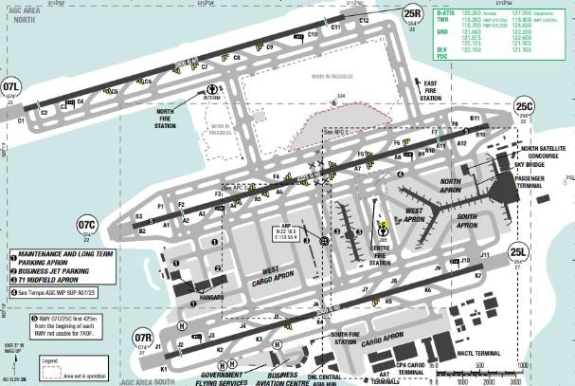
Hong Kong International Airport ( IATA : HKG , ICAO : VHHH ) is an international airport on the island of Chek Lap Kok in western Hong Kong. Late summer and continental from autumn to late winter. Expect heavy rain during thunder storm season. Typhoons are common. Hong Kong's climate is affected by its tropical coastal location in the East Sea. Annual rainfall is on average 2200mm (85in).Most typhoons will approach Hong Kong from the South-East sector in summer and autumn, particularly in August and September. During typhoon occasions, the airport may indicate surface winds of 30-35kts however the 1000ft wind may reach 100kts
Departure |  |  | - Pushback and start can take a while due to heavy traffic. Hong Kong uses color-coded pushback procedures. The crew must ensure that this push back information is correctly relayed to the ground crew.  - RWY 07R/ 25L is used for takeoff.  - RNAV SIDs  - Expect step-climbs from HKG radar after airborne.  - NADP available at this airport
Arrival and Approach |  |  | - RNAV STARs are issued and generally adhered to. However, be ready for a possibility of radar vectors for a much shorter approach if traffic volume is light and the weather is good. HKG ATC is excellent and has the benefit of weather radar so deviations for weather are always accommodated.  - RWY 07L/ 25R is normally used for landing for commercial a/ c.  - Holding sometimes is required due to flow control.  - For SIERAs arrival, expect to descend and maintain FL190 or 210 by SIERA, Crew are requested to contact HKG radar 3 minutes before SIERA.  - If MLDW needs to be increased to ensure carrying the payload, follow missed approach EOSID procedure with below implementation:  *General  Use LANDING CHART provided in: Mobile Ops Plus > Library > 1.10 RTOW A320_321.  *At dispatch  - Use DISPATCH LANDING CHART provided in RTOW folder to determine the Maximum Landing Weight (MLW) at destination (Do nott use Flysmart Landing Module).  *In-flight  - No ECAM ALERT: Determine the MLW using the IN-FLIGHT  - LANDING CHART (Do not use Flysmart Landing Module).  - ECAM ALERT: Anytime during the flight, if an ECAM alert occurs, use both IN-FLIGHT LANDING CHART and FLYSMART on iPad to calculate as follows:  + Step 1: Use In-flight Landing chart (without ECAM ALERT) to determine MLW1.  + Step 2: Use Flysmart In-flight Landing module with:  - The same inputs for In-flight Landing chart;  - ECAM ALERT item;  - GA Gradient %: Min (STD).  Calculate to get MLW2.  + Step 3: MLW is the lower of MLW1 and MLW2.  + For example:  - 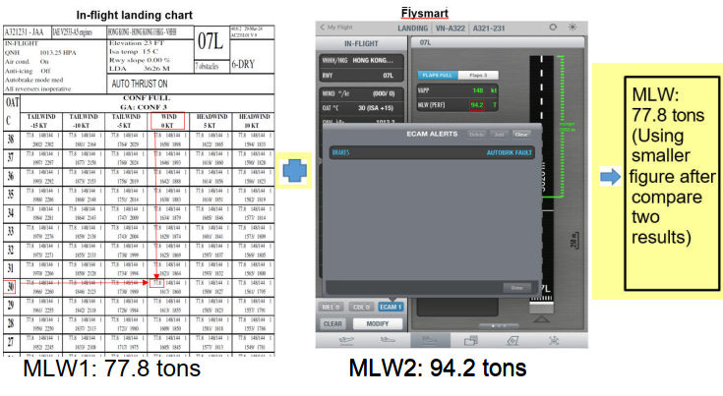
Taxi |  |  | - Normal parking is in the vicinity of B or H.
Parking information |  |  | No
5. TAKE-OFF AND LANDING DISTANCES AVAILABLE
RWY | LENGTH  (m) |  |  | WIDTH  (m) |  |  | TORA  (m) |  |  | LDA  (m) | TODA  (m) |  | ASDA  (m)
07L/ 25R | 3800 |  |  | 60 |  |  | 3800 |  |  | 3626 | 3800 |  | 3800
07C/ 25C | 4225 |  |  | 60 |  |  | 4225 |  |  | 4225 | 4225 |  | 4225
07R | 3800 |  |  | 60 |  |  | 4100 |  |  | 3640 | 3800 |  | 3800
25L | 3800 |  |  | 60 |  |  | 4100 |  |  | 3800 | 3800 |  | 3800
6. ELEVATION: 28ft |  |  |  |  | 7. EOSID: YES
8. IAP: ILS (CAT I, II, III), LOC, RNP
9. COMPANY NOTE |  |  |  |  | - Captain has to do Transit Check Procedures at this Airport.  - Maintenance support is good from the handling agent and they can clear technical log defects, or raise ADDs as applicable.  - For any operational inquiry, pilots can contact HONG KONG operation on frequency 131.6 MHZ
10. REMARK |  |  |  |  | Ground Handling Frequency: 113.1 MHz, 118.2 MHz, 118.4 MHz, 118.7 MHz

VIAR/ ATQ–SRI GURU RAM DASS JEE INTL AIRPORT–AMRITSAR, INDIA
1. AIRPORT CATEGORY: A |  |  |  |  |  |  |  | 2. RFFS CATEGORY: 8
3. AIRPORT CLASSIFICATION
ATR |  | A320 |  |  |  | A321 |  |  | A350 |  | B787
ADQ |  | ADQ |  |  |  | ADQ |  |  | ADQ |  | ADQ
4. GENERAL STANDARDS
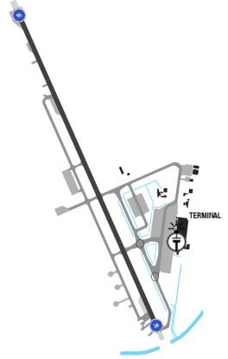
Sri Guru Ram Das Jee International Airport is an international airport located 11 km northwest of the city of Amritsar, in the state of Punjab, India. Hot, semi-arid climate hot, sometimes extremely hot summersand mild to warm winters, with low annual precipitation, most of which occurs during the monsoon season(Jul-Sep).
Departure |  |  | - NO SIDs  - LVP available
Arrival and Approach |  |  | - NO STARs  - LVP available, Lost COM available
Taxi |  |  | - Normal parking is in the vicinity of B or H.  - TWY P and L AVBL up to code letter E ACFT.
Parking information |  |  | No
5. TAKE-OFF AND LANDING DISTANCES AVAILABLE
RWY | LENGTH  (m) |  |  | WIDTH  (m) |  |  | TORA  (m) |  |  | LDA  (m) | TODA  (m) | ASDA  (m)
16/ 34 | 3658 |  |  | 45 |  |  | 3658 |  |  | 3658 | 3658 | 3658
6. ELEVATION: 760 ft |  |  |  |  | 7. EOSID: NO
8. IAP: ILS (CAT I, II, III), LOC, RNP, VOR
9. COMPANY NOTE |  |  |  |  | - RWY 16/ 34 not AVBL MON-FRI 1100-1300 due to  - SKED maintenance. AVBL in EMERG with 20min PN.  - Wheel-lock turns on RWY prohibited. Use turn pads to conduct 180 turns on RWY
10. REMARK |  |  |  |  | NIL

VIDP/ DEL–INDIRA GANDHI INTLAIRPORT–DELHI, INDIA
1. AIRPORT CATEGORY: A |  |  |  |  |  |  |  |  | 2. RFFS CATEGORY: 10
3. AIRPORT CLASSIFICATION
ATR |  | A320 |  |  |  |  | A321 |  |  | A350 |  |  | B787
ADQ |  | ADQ |  |  |  |  | ADQ |  |  | ADQ |  |  | ADQ
4. GENERAL STANDARDS
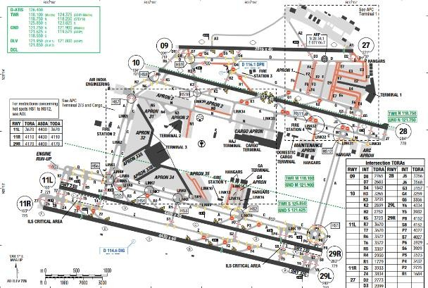
Indira Gandhi International Airport is the primary international airport serving Delhi, the capital of India, and the National Capital Region. The airport is situated in Palam, Delhi, 15 km southwest of the New Delhi Railway Station and 16 km from New Delhi city center. May is the hottest month in New Delhi with an average temperature of 33°C and the coldest is January at 13°C. The wettest month is July with an average of 180mm of rain.
Departure |  |  | - RNAV SIDs (If unable to comply advise ATC and EXPECTE RADAR vector).  - Follow speed/ level restrictions  - SID with high climb gradient
Arrival and Approach |  |  | - RNAV STARs  - Speed restrictions are to be flown as accurately as possible. Aircraft unable to comply with these speeds must inform ATC and state what speeds can be used.  - Pilots should also advise ATC if circumstances necessitate a change of speed due to aircraft performance limitation.  - Expect radar vector at the end of STAR.  Pilot should minimize the use of reverse thrust after landing to reduce disturbance in areas adjacent to the aerodrome
Taxi |  |  | - Shall vacate RWY via preferred RWY exits  - LVP taxi route.  Taxi restriction
Parking information |  |  |  | - Expect: Terminal 3 (apron 31 to 34)
5. TAKE-OFF AND LANDING DISTANCES AVAILABLE
RWY | LENGTH  (m) |  |  |  | WIDTH  (m) |  |  | TORA  (m) |  |  | LDA  (m) | TODA  (m) |  | ASDA  (m)
09 | 2816 |  |  |  | 45 |  |  | 2816 |  |  | 2816 | 2816 |  | 2816
10/ 28 | 3813 |  |  |  | 45 |  |  | 3813 |  |  | 3813 | 3813 |  | 3813
11R | 4430 |  |  |  | 60 |  |  | 4110 |  |  | 3465 | 4110 |  | 4110
11L | 4400 |  |  |  | 45 |  |  | 3670 |  |  | 3000 | 3670 |  | 4400
27 | 2816 |  |  |  | 45 |  |  | 2816 |  |  | 2665 | 2816 |  | 2816
29R | 4400 |  |  |  | 45 |  |  | 4400 |  |  | 3670 | 4400 |  | 4400
29L | 4430 |  |  |  | 60 |  |  | 4430 |  |  | 2970 | 4430 |  | 4430
6. ELEVATION: 778ft |  |  |  |  |  | 7. EOSID: NO
8. IAP: ILS (CAT I, II, III), LOC, NDB, RNP, VOR
9. COMPANY NOTE |  |  |  |  |  | - Standard push-back procedure  - Transponder operating procedures on ground (after landing keep AUTO, TCAS off when vacating RWY,STANDBY when ACFT is parked, mode C on ground)  - Bird in the vicinity of the airport.
10. REMARK |  |  |  |  |  | NIL

VIJP/ JAI–JAIPUR INTL AIRPORT–JAIPUR, INDIA
1. AIRPORT CATEGORY: A |  |  |  |  |  |  |  | 2. RFFS CATEGORY: 9
3. AIRPORT CLASSIFICATION
ATR |  | A320 |  |  |  | A321 |  |  | A350 |  |  | B787
ADQ |  | ADQ |  |  |  | ADQ |  |  | ADQ |  |  | ADQ
4. GENERAL STANDARDS
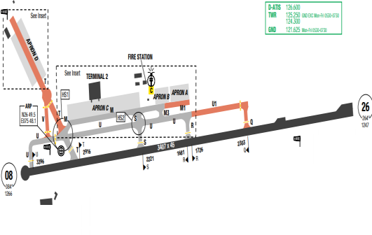
Jaipur International Airport is the primary airport serving Jaipur, the capital of the Indian state of Rajasthan. It is located in the southern suburb of Sanganer, 13 km (8.1 mi) from Jaipur. The highest MSA around the JJP VOR is 3800m to the North sector. In Jaipur, the wet season is oppressive and partly cloudy, the dry season is mostly clear, and it is hot year round, especially from March to July. Over the course of the year, the temperature typically varies from9°C to 40°C and is rarely below 5°C or above 43°C.
Departure |  |  | - RNAV SIDs  - Require minimum climb gradient
Arrival and Approach |  |  | - RNAV STARs  - Follow level/ speed restrictions unless otherwise authorized by ATC  - Expect radar at the end of STAR
Taxi |  |  | - TWY Width restriction
Parking information |  |  | No
5. TAKE-OFF AND LANDING DISTANCES AVAILABLE
RWY | LENGTH  (m) |  |  | WIDTH  (m) |  |  | TORA  (m) |  |  | LDA  (m) | TODA  (m) |  | ASDA  (m)
08/ 26 | 3407 |  |  | 45 |  |  | 3407 |  |  | 3407 | 3407 |  | 3407
6. ELEVATION: 1268ft |  |  |  |  | 7. EOSID: NO
8. IAP: ILS (CAT I, II, III), LOC, RNP, VOR
9. COMPANY NOTE |  |  |  |  | - Bird in vicinity of airport.  - RWY 08/ 26 not AVAIL due to routine maintenance work from MON-SAT 0900-1100Z
10. REMARK |  |  |  |  | NIL

VILK/ LKO – CHAUDHARY CHARAN SINGH INTL – LUCKNOW – INDIA
1. AIRPORT CATEGORY: A |  |  |  |  |  |  | 2. RFFS CATEGORY: 7
3. AIRPORT CLASSIFICATION
ATR |  | A320 |  |  |  | A321 |  |  | A350 |  | B787
ADQ |  | ADQ |  |  |  | ADQ |  |  | ADQ |  | ADQ
4. GENERAL STANDARDS
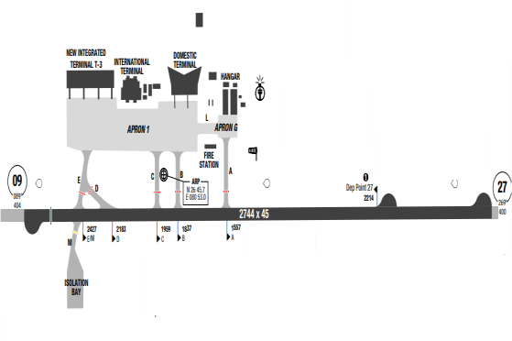
Chaudhary Charan Singh International Airport (IATA: LKO, ICAO: VILK) is an international airport serving Lucknow, the capital of the Indian state of Uttar Pradesh. It is located in Amausi, 14 km from the city centre, and was earlier known as ''Amausi Airport''. In Lucknow, the wet season is oppressive and partly cloudy, the dry season is mostly clear, and it is hot year round
Departure |  |  | - Maximum number of arrival and departure- 12 (The minimum spacing BTN two successive ARR shall be more than 5 min) 17 (09 Arrivals and 08 Departures)  - The departing aircraft must commence take-off run before the arriving aircraft has crossed the FAP.
Arrival and Approach |  |  | - Maximum number of arrival only: 06  - During CAT II/ CAT IIIA and CAT IIIB operations, Approach Control/ Tower shall ensure that subsequent arrival is cleared for CAT II or CAT IIIA or CAT IIIB
Taxi |  |  | - LVP available  - Standard taxi route available
Parking information |  |  | - A-VDGS will be operational, 24X7.  - When a Code E aircraft is parked on stand 104, code C aircraft cannot be parked on Stand 104L and 104R.  - Stand 12 is interdependent with Stand 13, if Code D/ E parked on stand 12 only Code C can be parked on Stand 13 and vice
5. TAKE-OFF AND LANDING DISTANCES AVAILABLE
RWY | LENGTH  (m) |  |  | WIDTH  (m) |  |  |  | TORA  (m) |  | LDA  (m) | TODA  (m) | ASDA  (m)
09 | 2744 |  |  | 45 |  |  |  | 2744 |  | 2578 | 2744 | 2744
27 | 2744 |  |  | 45 |  |  |  | 2744 |  | 2744 | 2744 | 2744
6. ELEVATION: 406ft |  |  |  |  | 7. EOSID: NO
8. IAP: ILS (CAT I, II, III), LOC, RNP, VOR
9. COMPANY NOTE |  |  |  |  | - Two 90FT high steel lattice Mast raised at taxi  - Both lighted and unlighted landing Direction indicator (LDI) available at VILK. Position between TWY ‘B’ and TWY ‘C’  - Pilot to exercise caution while Taxing IN/ OUT with low power from Apron.  - Isolation bay suitable up to A330-200 AVBL at VILK.
10. REMARK |  |  |  |  | NIL

VLLB/ LPQ–LUANGPHABANG INTL AIRPORT–LUANG PHABANG, LAO
1. AIRPORT CATEGORY: B |  |  |  |  |  |  |  | 2. RFFS CATEGORY: 8
3. AIRPORT CLASSIFICATION
ATR |  | A320 |  |  |  | A321 |  |  | A350 |  |  | B787
ADQ |  | ADQ |  |  |  | ADQ |  |  | N/ A |  |  | N/ A
4. GENERAL STANDARDS
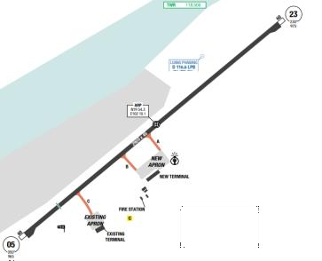
Surrounded by jungle, with the Mekong River flowing through, Luang Phabang has a tropical monsoon climate. There are 2 seasons in this weather. The dry season comes from November to May while the rainy season lasts from May to October. Overall, the annual average temperature is approximately 26 degrees with the highest of 36degrees in ARP an the coldest of 14 degrees in JAN and it is very humid most days, with annual precipitation of approximately 1300 mm. Obstruction to visibility mostly due to smoke or fog.
Departure |  |  | - RNAV SIDs.  - SID with high climb gradient
Arrival and Approach |  |  | - RNAV STARs.  - Adhere to step descent altitude constraints due to terrain.  - Circle to land not authorized Southeast of airport.  - If MLDW needs to be increased to ensure carrying the payload, follow missed approach EOSID procedure with below implementation:  *General  Use LANDING CHART provided in: Mobile Ops Plus > Library > 1.10 RTOW A320_321.  *At dispatch  - Use DISPATCH LANDING CHART provided in RTOW folder to determine the Maximum Landing Weight (MLW) at destination (Do nott use Flysmart Landing Module).  *In-flight  - No ECAM ALERT: Determine the MLW using the IN-FLIGHT  - LANDING CHART (Do not use Flysmart Landing Module).  - ECAM ALERT: Anytime during the flight, if an ECAM alert occurs, use both IN-FLIGHT LANDING CHART and FLYSMART on iPad to calculate as follows:  + Step 1: Use In-flight Landing chart (without ECAM ALERT) to determine MLW1.  + Step 2: Use Flysmart In-flight Landing module with:  - The same inputs for In-flight Landing chart;  - ECAM ALERT item;  - GA Gradient %: Min (STD).  Calculate to get MLW2.  + Step 3: MLW is the lower of MLW1 and MLW2.  + For example:  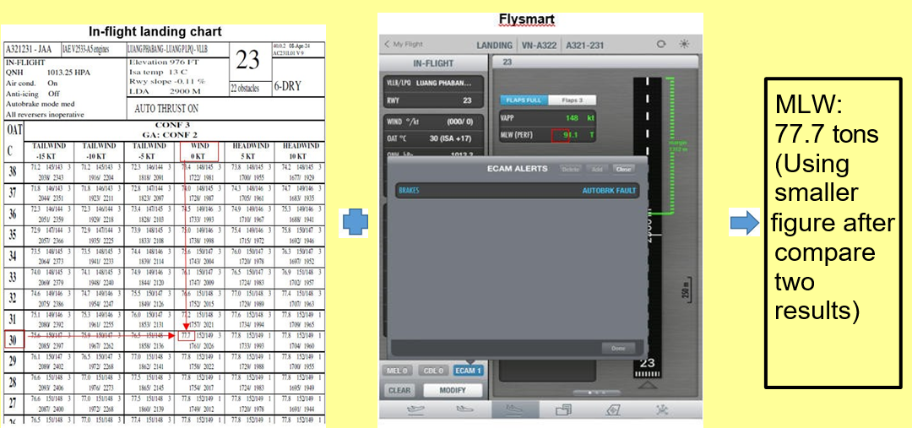  MLW1: 77.7 tons MLW2: 91.1 tons
Taxi |  |  | - Short taxi in-out time, crew should pay attention on minimum engine cooling and warm-up time.  - TWYs A, B, C width 18m / 59ft
Parking information |  |  | - Marshaller AVBL.
5. TAKE-OFF AND LANDING DISTANCES AVAILABLE
RWY | LENGTH  (m) |  |  | WIDTH  (m) |  |  | TORA  (m) |  |  | LDA  (m) | TODA  (m) |  | ASDA  (m)
05 | 2900 |  |  | 45 |  |  | 3200 |  |  | 2500 | 3200 |  | 2960
23 | 2900 |  |  | 45 |  |  | 2550 |  |  | 2550 | 3160 |  | 2960
6. ELEVATION: 975ft |  |  |  |  | 7. EOSID: YES
8. IAP: ILS, RNP, VOR
9. COMPANY NOTE |  |  |  |  | - Fuel Tinkering might be applied for sector: HAN- LPQ  - If there is a failure in LPQ that requires rectification, be mindful that there is no maintenance contract there, MOC will have to arrange technical staff to come from Vietnam.  - There are two air bridges available on the apron and there are no dollies for cargo loading.  - GPU, Air-starter Unit, GCU are available.  - Captain must be PF for landing at this airport.
10. REMARK |  |  |  |  | NIL

VLVT/ VTE–WATTAY INTL AIRPORT–VIENTIANE, LAOS
1. AIRPORT CATEGORY: A |  |  |  |  |  |  |  | 2. RFFS CATEGORY: 9
3. AIRPORT CLASSIFICATION
ATR |  | A320 |  |  |  | A321 |  |  | A350 |  |  | B787
ADQ |  | ADQ |  |  |  | ADQ |  |  | ADQ |  |  | ADQ
4. GENERAL STANDARDS
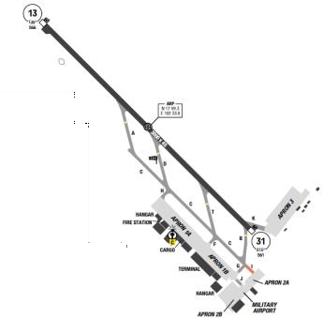
The airport is located on the North bank of Mekong delta, which is the border between Laos and Thailand. The Vientiane city is on the South- East of the airport, very close to RWY 31 threshold. High terrain is rising towards North- West and North of the airport. There are multiple high hills along the final approach path of RWY 13. Vientiane has fairly good weather all year around. During summer, afternoon thunderstorms could be expected. Due to the mountains around, on the West and North of the airport there are frequent CBS. In winter, it is sometimes misty/ foggy during sunrise time.
Departure |  |  | - RNAV SIDs.  - RWY 31 is usually used for takeoff  - Departure RWY 13 requires immediate turn after T/ O to avoid over flying Vientiane city.
Arrival and Approach |  |  | - RNAV STARs  - Adhere to step descent altitude constraints due to terrain.  - Visual approach is normally approved in good weather.  - Flight below 4000’ over the city is prohibited except for landing and take-off only.  - RWY 13 is usually used for landing
Taxi |  |  | - Follow-me car available
Parking information |  |  | - Nose-in guidance at ACFT stands.
5. TAKE-OFF AND LANDING DISTANCES AVAILABLE
RWY | LENGTH  (m) |  |  | WIDTH  (m) |  |  | TORA  (m) |  |  | LDA  (m) | TODA  (m) |  | ASDA  (m)
13/ 31 | 3000 |  |  | 45 |  |  | 3150 |  |  | 3150 | 3150 |  | 3060
6. ELEVATION: 566 ft |  |  |  |  | 7. EOSID: YES
8. IAP: ILS, LOC, RNP, VOR
9. COMPANY NOTE |  |  |  |  | - A flight engineer will accompany the flight into VTE.  - Fuel tankering is applied for sector: HAN-VTE
10. REMARK |  |  |  |  | NIL

VMMC/ MFM–MACAO INTL AIRPORT–MACAO, PR OF CHINA
1. AIRPORT CATEGORY: A |  |  |  |  |  |  |  | 2. RFFS CATEGORY: 9
3. AIRPORT CLASSIFICATION
ATR |  | A320 |  |  |  | A321 |  |  | A350 |  |  | B787
ADQ |  | ADQ |  |  |  | ADQ |  |  | ADQ |  |  | ADQ
4. GENERAL STANDARDS
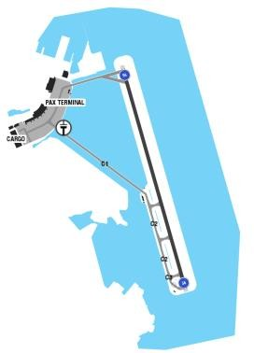
Macau International Airport is situated at eastern end of Taipa Island on the bank of Seashore. In this Airport, there is no significant Obstacles situated on the take-off path and Approach Path of the runway. Runway is situated on the bank of seashore. It is a water front airport so there are no special obstacles on the route. Weather at Macau is influenced alternatively by the cold northeast monsoon from China‘s mainland and the southeast and southwest monsoons from the ocean and therefore its climate has the features of both continent and ocean climates.
Departure |  |  | - RNAV SIDs  - RWY 34 prefer for T/ O
Arrival and Approach |  |  | - RNAV STARs  - Noise abatement for landing RWY 16.  - Speed restrictions
Taxi |  |  | - Nose-wheel guidelines when taxiing on apron and taxiway and enter/ exiting the RWY
Parking information |  |  | - ENG ground running at idle PWR not exceeding 15min on PKG bays.
5. TAKE-OFF AND LANDING DISTANCES AVAILABLE
RWY | LENGTH  (m) |  |  | WIDTH  (m) |  |  | TORA  (m) |  |  | LDA  (m) | TODA  (m) |  | ASDA  (m)
16 | 3360 |  |  | 45 |  |  | 3225 |  |  | 2865 | 3285 |  | 3285
34 | 3360 |  |  | 45 |  |  | 3300 |  |  | 2930 | 3300 |  | 3300
6. ELEVATION: 20ft |  |  |  |  | 7. EOSID: YES
8. IAP: ILS (CAT I, II), LOC, RNP, VOR
9. COMPANY NOTE |  |  |  |  | - Color code for pushback.  - The preferential RWY is also RWY 34, if the tailwind component does not exceed 10 KT. If the tailwind component is higher than 10 KT on RWY 34 and the VIS or ceiling for RWY 16 are below minima for this RWY, no landing will be allowed unless specifically requested by the pilot  - If the landing is conducted by the First Officer, compliance with the requirements specified in FOM-Chapter 8.1.2.5 is mandatory
10. REMARK |  |  |  |  | NIL

VNBW/ BWA – GAUTAM BUDDHA INTL – BHAIRAHAWA, NEPAL
1. AIRPORT CATEGORY: A |  |  |  |  |  |  |  | 2. RFFS CATEGORY: 9
3. AIRPORT CLASSIFICATION
ATR |  | A320 |  |  |  | A321 |  |  | A350 |  |  | B787
ADQ |  | ADQ |  |  |  | ADQ |  |  | N/A |  |  | N/A
4. GENERAL STANDARDS
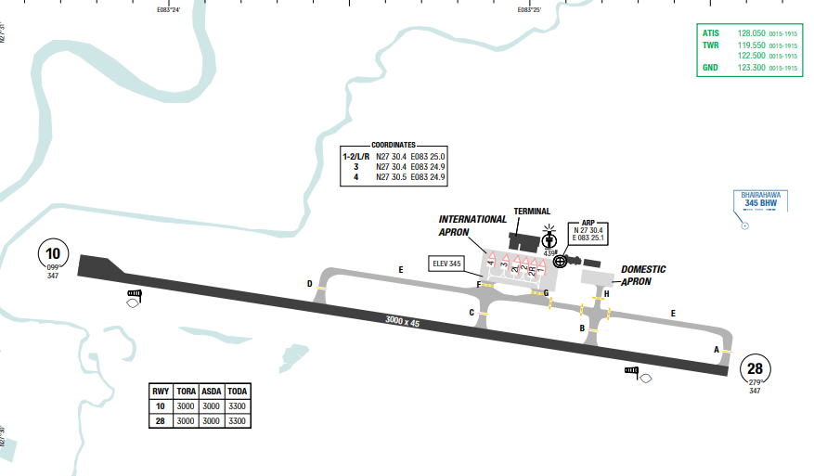
Gautam Buddha International Airport (IATA: BWA, ICAO: VNBW), also known as Bhairahawa Airport, is an international airport located in Siddharthanagar serving Lumbini in Lumbini Province, as well as the Butwal﹣Siddharthanagar urban agglomeration in Nepal. The airport is in close proximity to adjacent Koikata FIR (VECF)
Terrain within the vicinity of the airfield.
Bhairahawa has moderate climate with significant summer rainfall and dry winters.The highest average temperature in Bhairahawa is 39°C in May and the lowest is 23°C in January. There is a lot of rainfall in the summer, and in the winter it is quite dry again. The average annual temperature for Bhairahawa is 32° degrees and there is about 452 mm of rain in a year.
Departure |  |  | - RNAV SIDs are available and require a minimum climb gradient.  - MOPRU 1D with high SID climb gradient. Pilot must briefing carefully before take-off.  - RWY 28 is the preferred RWY for departure
Arrival and Approach |  |  | - RNAV STARs are available.  - Circling to the South of RWY is prohibited.  - Circling at night is not authorized.  - Miss approach procedure available.  - Straight-in landing on RWY 28 not applicable for cat D  - RWY 28 approach is offset 8° from RWY centerline
Taxi |  |  | - Simple taxi to and from the apron. Remark that the PCN of the TWY E between TWY B and TWY C is low (35/F/C/W/T)  - If landing on RWY 10, expect to exit via TWY A, E, B and backtrack via RWY to TWY C  - Engine Out Taxi-In not permitted
Parking information |  |  | NIL
5. TAKE-OFF AND LANDING DISTANCES AVAILABLE
RWY | LENGTH  (m) |  |  | WIDTH  (m) |  |  | TORA  (m) |  |  | LDA  (m) | TODA  (m) |  | ASDA  (m)
10/28 | 3000 |  |  | 45 |  |  | 3000 |  |  | 3000 | 3300 |  | 3000
6. ELEVATION: 347ft |  |  |  |  | 7. EOSID: NO
8. IAP: RNP, VOR
9. COMPANY NOTE |  |  |  |  | - Sometimes cases of bird concentrations in the vicinity of aerodrome may be encountered.  - No Special procedures have been adopted to control these bird concentrations except driving them through guards and security personnel.  - VFR traffic in the vicinity of the airfield.
10. REMARK |  |  |  |  | NIL

VNKT/ KTM - KATHMANDU (TRIBHUVAN INTL) – NEPAL
1. AIRPORT CATEGORY: C |  |  |  |  |  |  | 2. RFFS CATEGORY: 09
3. AIRPORT CLASSIFICATION
ATR |  |  | A320 |  | A321 |  |  | A350 |  |  | B787
ADQ |  |  | ADQ |  | ADQ |  |  | N/A |  |  | N/A
4. GENERAL STANDARDS
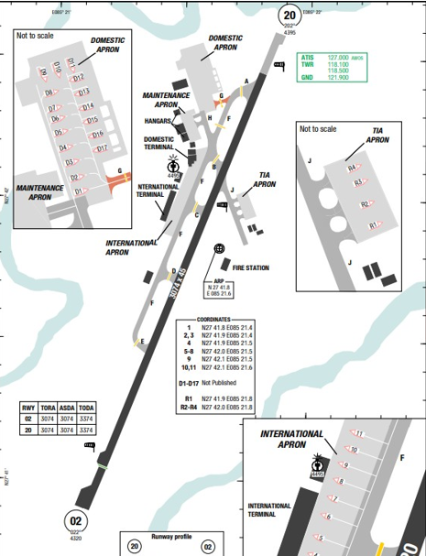
Tribhuvan International Airport is located in the Kathmandu Valley about 5 km (3.1 mi) from the city center of Kathmandu, Nepal and is surrounded by the world’s highest mountains. The higher Himalayan Mountain Range is to the north, while the lower Mahabharat Range is to the south. Land around the immediate airport area is fairly level with some cultivated fields mixed between urban development projects.
Hazards: Mountains in the vicinity up to 9600ft, approach with steep vertical profile and changing descent gradients. Bird activity July - December.
Location/terrain: The AD lies centered in a basin of mountains, about 3 NM E of Kathmandu.
Himalaya peaks and main ridge are situated N of AD, foothills in the S
To the North: A man made structure on high terrain rises to 4794 feet AMSL within 5 NM and terrain up to 8963 feet AMSL within 7 NM.
To the Northeast: A terrain high point rises to 7805feet AMSL within 8 NM. To the East: A terrain high point rises to 5440 feet AMSL within 6 NM, and 7805 feet AMSL within 9 NM.
To the Southeast: A terrain high point rises to 9285feet AMSL within 10 NM. To the Southwest: A terrain high point rises to 8365feet AMSL within 8 NM. To the Northwest: A terrain high point rises to 6890 feet AMSL within 7 NM. The highest MSA is at the North-West sector from KTM VOR at 21100ft.
Kathmandu climate is subtropical and is influenced by the Himalayan Mountains. The mountains act as a barrier separating the continental air mass to the north and the tropical air mass to the south.
Late May to early June is the pre-monsoon period, the weather during this period is generally dry and good but with a few intense thunderstorms and some low clouds. The visibility is occasionally 6 to 8 km with mist. The temperature is hot and can reach 34°C. The winds are easterly, south-easterly and southwesterly.
From mid-June to mid-September is the monsoon period. The weather is stable with heavy rain activity at night with few thunderstorms and some low clouds. Wind is variable from East, Southeast and Southwest, generally between 5 to 10kt with visibility of 8 to 10 km.
Late September to Mid-October is the post monsoon period (autumn). Weather is generally very good and clear with very few thunderstorms in the late afternoons and night time can be
expected with presence of low clouds. Visibility is generally 10 km, but morning mist can be expected with a visibility of 2 to 3 km on a few occasions.
The period from mid-October to end of February is the winter season. Weather is generally good with clear skies most of the time with one or two rainy periods, (moderate rain) for about 12 to 36 hours during the season, with temperature of approximately -2°C in the morning and maximum of 18°C in the afternoons (in December, January and February). The visibility is good during the day but fog is expected at night and morning, clearing by 0930 to 1130 local time. Low clouds can also be expected. Light fog to be expected from 10 October to mid-November and dense fog from mid-November to end of February. Early March to the end of May is the dry season. Weather is dry. Unstable and hot with temperature up to 34°C, thus resulting in a very frequent and intense activity of thunderstorms starting late afternoon or evening for only a few hours with heavy cloud cells moving fast. Low clouds are expected. Surface wind in these conditions can reach 30 to 40kt (Max 55kt).
Departure |  | - As this is a high elevation airport, crew must calculate performance carefully and strictly follow SID/OEI procedure.  - Must delay departure in case of bad weather in the take-off or climb out path.  - There is no way to deviate the weather until above MSA  - Unless otherwise cleared by ATC:  - RWY 20 is in use: DEP TFC is to leave valley via Biratnagar pass for east and Bharatpur pass - for west.  - RWY 02 is in use: DEP TFC is to leave valley via Kakani and Nagarkot pass.  Prior to TKOF pilot should agree to execute VIS DEP by providing a read back of the ATC instructions.
Arrival and Approach |  | - With high terrains surrounding, crew has to pay attention and strictly follow ATC instructions during approach and landing at the airport. PIC needs to have special airport certificate before flying to this airport.  - RWY 02 is preferred runway for arrival.  - Between VOR 2 and VOR B approach procedure, crew must consider doing the VOR 02 APP from GURAS as it is a straight in approach. Crew shall apply the following suggested procedures when performing approach at VNKT  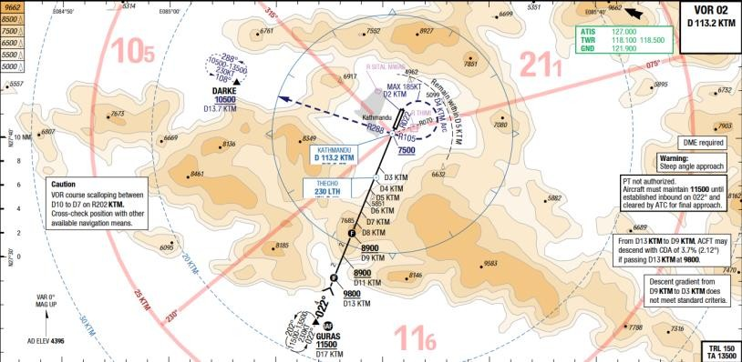  - Landing performance calculations required.  - On PERF GO AROUND page, set THR reduction and Acceleration altitude to 7500/7500.  - Approaches maybe conducted with NAV-FPA if the accuracy is positive. Otherwise selected TRK-FPA. The vertical deviation (VDEV) should closely monitored between 17-10 Nm.  - All approaches must be established with landing configuration before GURAS.  - Between GURAS and KTM D9 DME, select 9800ft. FPA 3.06 Degrees start descending.  - Between KTM 9 DME and KTM 3 DME. Set FPA 5.31 degrees and closely monitor flight path and VAPP. (Do not let speed increase to any more than VAPP + 15kts. ROD of 1700-2200ft/min are to be expected.  - 3.3 Nm reduces to 3 degrees FPA.  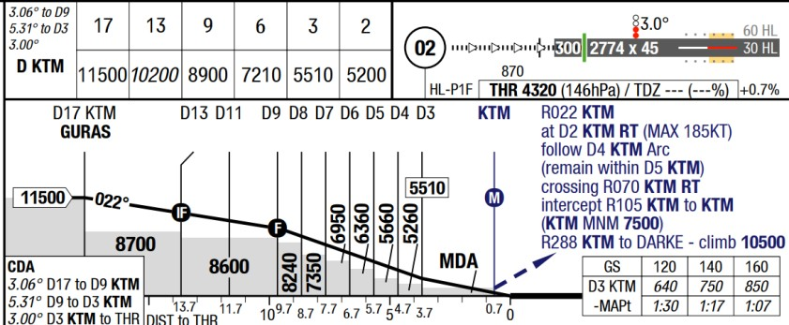  - Take in to consider landing techniques at high airport elevation.  - At an average GS of 175kts inside 3 DME till landing, to maintain 3 degrees path, a ROD of approximately 925 FPM. This needs to be briefed by the crew.  - In case of a single engine missed approach, follow special EOSID procedure.  - Crew should consider shooting this approach only after considering the weather in the final approach and miss approach path because given the topography it would be difficult to find an escape path in case of bad weather.  - APCH sequence is to be established by 10 DVOR/DME and no overtaking is permitted after 10DVOR/DME. Unless otherwise cleared by ATC:  - RWY 20 is in use: Inbound TFC from west is to enter valley via Kakani pass and from east - via Nagarkot pass.  RWY 02 is in use: Inbound TFC from west is to enter valley via Bharatpur pass and from east - via Biratnagar pass.  - Faded runway markings  - Visual illusion of being high on profile due to the up-slope of runway 02  - Runway End Safety Area (RESA) is not available  - Tailwinds and downdrafts may be expected  - Go around acceleration altitude is 10,500ft. Go around flaps to be maintained to reduce the radius of turn (remain within 4nm).  - If MLDW needs to be increased to ensure carrying the payload, follow missed approach EOSID procedure with below implementation:  * General  Use LANDING CHART provided in: Mobile Ops Plus > Library > 1.10 RTOW A320_321.  *At dispatch  - Use DISPATCH LANDING CHART provided in RTOW folder to determine the Maximum Landing Weight (MLW) at destination (Do nott use Flysmart Landing Module).  *In-flight  - No ECAM ALERT: Determine the MLW using the IN-FLIGHT  - LANDING CHART (Do not use Flysmart Landing Module).  - ECAM ALERT: Anytime during the flight, if an ECAM alert occurs, use both IN-FLIGHT LANDING CHART and FLYSMART on iPad to calculate as follows:  + Step 1: Use In-flight Landing chart (without ECAM ALERT) to determine MLW1.  + Step 2: Use Flysmart In-flight Landing module with:  - The same inputs for In-flight Landing chart;  - ECAM ALERT item;  - GA Gradient %: Min (STD).  Calculate to get MLW2.  + Step 3: MLW is the lower of MLW1 and MLW2.  + For example:  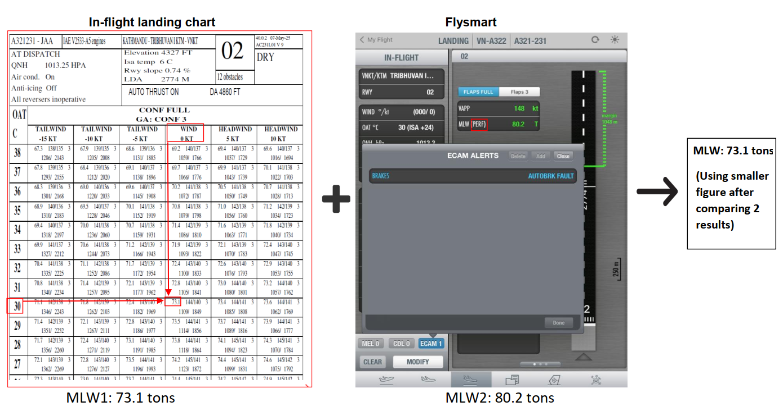
Taxi |  | - TWY G width 18m
Parking information |  | NIL
5. TAKE-OFF AND LANDING DISTANCES AVAILABLE
RWY | LENGTH  (m) |  |  | WIDTH  (m) |  | TORA  (m) |  |  | LDA  (m) | TODA  (m) |  | ASDA  (m)
02/20 | 3074 |  |  | 45 |  | 3074 |  |  | 3074 | 3374 |  | 3074
6. ELEVATION: 4395ft |  |  |  | 7. EOSID: YES
8. IAP: LOC, RNP, VOR
9. COMPANY NOTE |  |  |  | - Visual approaches to Kathmandu are prohibited.  - Circling approaches are prohibited.  - Low level clouds/fogs.  - VOR B approaches are not recommended.  - Extra holding fuel of 45 minutes is recommended due to traffic  - Birds are in the vicinity of the airport.  - Fully managed VOR APP not authorized  - PAPI RWY 20 is restricted to be usable within 3NM from RWY THR with clear visibility.  *RWY 20:  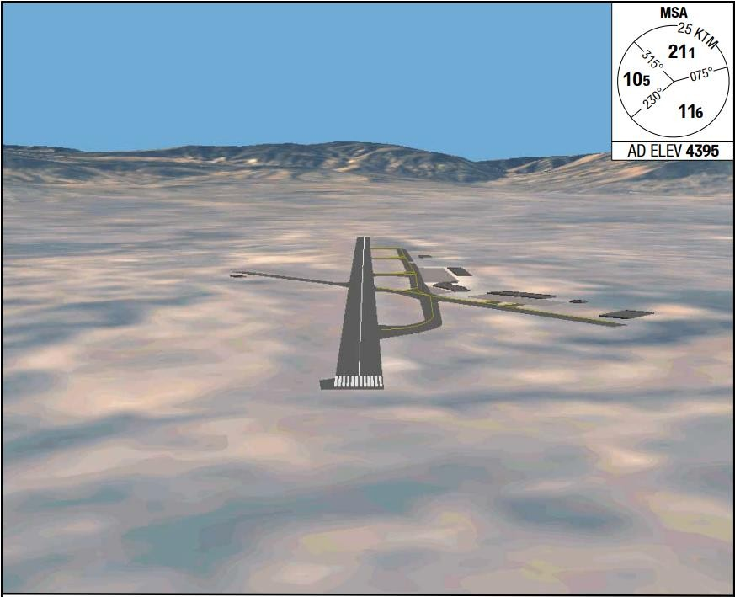  - Pilots to report TFC in sight to release restrictions for climb and descend.
10. REMARK |  |  |  | NIL

VOBL/ BLR – KEMPEGOWDA INTL – BENGALURU – INDA
1. AIRPORT CATEGORY: A |  |  |  |  |  |  |  | 2. RFFS CATEGORY: 10
3. AIRPORT CLASSIFICATION
ATR |  | A320 |  |  |  | A321 |  |  | A350 |  |  | B787
ADQ |  | ADQ |  |  |  | ADQ |  |  | N/A |  |  | N/A
4. GENERAL STANDARDS
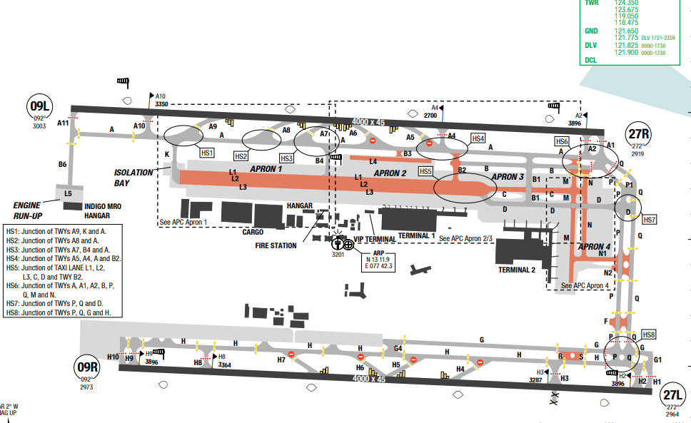
Kempegowda International Airport (IATA: BLR, ICAO: VOBL) is an international airport serving Bengaluru, the capital of the Indian state of Karnataka. Spread over 16 square kilometres (6.2 sq mi), it is located about 35 km (22 mi) north of the city near the suburb of Devanahalli.
Bangalore experiences a relatively mild temperature range throughout the year.
Summers (March to May) are warm, with daytime temperatures ranging from 28 to 34 degrees Celsius (82 to 93 degrees Fahrenheit). Nights are more relaxed, providing relief from the daytime heat. The monsoon season (June to September) brings moderate to heavy rainfall, cooling the temperatures. Rainfall during this season contributes to the city's greenery and lush landscapes. Winters (December to February) They are characterized by cool and dry weather. Daytime temperatures range from 14 to 28 degrees Celsius (57 to 82 degrees Fahrenheit), while nights can be chilly, with temperatures dropping to around 10 degrees Celsius (50 degrees Fahrenheit).Thunderstorms occur frequently in the rainy season, up to 50% of days. May-June: Heavy thunderstorms in afternoon/evening. July-November: Heavy rainfall with strong crosswinds. Rainfall heaviest in September, October & May. Surface winds are light and variable during April-May
Departure |  |  | - RNAV SIDs available  - SIDs with high climb gradients, Pilots need to briefing carefully before T/O  - LVP take-off available, In case of aborted TKOF on north RWY with RVR 350m or less, mandatory follow-me service shall be provided for vacating via RET A5-A9 or TWY A10 till joining TWY A.
Arrival and Approach |  |  | - RNAV STARs available  - Pilots landing at VOBL to exercise caution for VOYK having similar RWY orientation and is 4.3NM south of VOBL RWY 09L/27R and 3.2NM south of VOBL RWY 09R/27L.  - RWY 09L: GP coverage is restricted to +/- 7° at 10NM.  - RWY 27R: GP coverage is restricted to +/- 8° at 1500ft AGL at 8NM from THR and +/- 8° at 2000ft  - AGL at 10NM from THR.
Taxi |  |  | - Landing on RWY09L rapid exit A5 is available at approximately 2550M  - Entry into Taxiway A5 from Taxiway A is prohibited for departing aircraft  - Utmost care needed when taxiing in lanes L1, L2, L3 due to close proximity  - Expect follow-me guidance to change lanes between L1 and L3  - Taxiways P and Q do not have surface movement radar coverage  - Upslope on taxiway Q and H1 requires caution  - Do not enter Taxiway A without prior clearance from tower  - Upslope on most stands (use chocks before releasing parking brakes)  - Standard TWY Route Available
Parking information |  |  | NIL
5. TAKE-OFF AND LANDING DISTANCES AVAILABLE
RWY | LENGTH  (m) |  |  | WIDTH  (m) |  |  | TORA  (m) |  |  | LDA  (m) | TODA  (m) |  | ASDA  (m)
09L/ 27R | 4000 |  |  | 45 |  |  | 4000 |  |  | 4000 | 4000 |  | 4000
09R/ 27L | 4000 |  |  | 45 |  |  | 4000 |  |  | 4000 | 4000 |  | 4000
6. ELEVATION: 2030ft |  |  |  |  | 7. EOSID: NO
8. IAP: ILS, LOC, RNP, VOR
9. COMPANY NOTE |  |  |  |  | - Significant upslope (+0.63%) on runway 09L/27R  Active 24/7 military airfields nearby with similar runway bearings. Military activities may cause delays  - High bird activity  - ATC controllers are very busy and talk fast. Frequent frequency changes between stations. Due to expected R/T congestion, monitor continuously and use "SAY AGAIN" to clear ambiguity  - Multiple restricted, danger, and prohibited areas exist around Bengaluru  - Restricted areas: Multiple VO(R) areas with various altitude restrictions  - Clearance delivery available 15 minutes before departure on 121.825 MHz
10. REMARK |  |  |  |  | NIL

VOBZ/ VGA – VIJAYAWADA, VIJAYAWADA, INDIA
1. AIRPORT CATEGORY: A |  |  |  |  |  |  |  | 2. RFFS CATEGORY: 7
3. AIRPORT CLASSIFICATION
ATR |  | A320 |  |  |  | A321 |  |  | A350 |  |  | B787
AQD |  | AQD |  |  |  | AQD |  |  | N/A |  |  | N/A
4. GENERAL STANDARDS
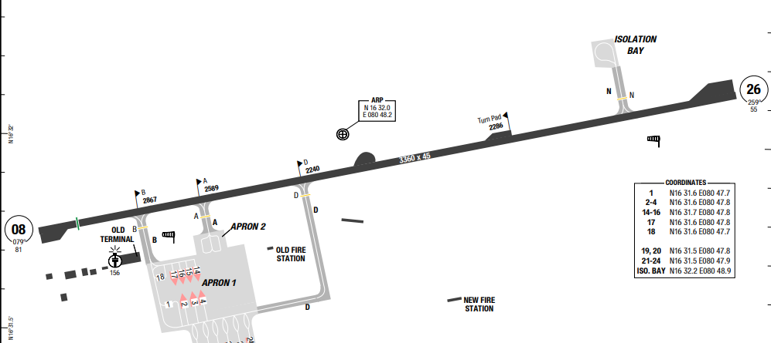
Vijayawada Airport (IATA: VGA, ICAO: VOBZ), officially known as Vijayawada International Airport, is an international airport serving Vijayawada and Andhra Pradesh Capital Region in India.
Vijayawada features a tropical wet and dry climate with three distinct seasons: hot summers, a wet monsoon period, and moderate, pleasant winters. The annual mean temperature ranges between 23°C and 34°C, with extreme highs frequently surpassing 40°C during peak summer.
Departure |  |  | - No SID  - LVP apply
Arrival and Approach |  |  | - No STAR  - Speed control
Taxi |  |  | - TWY B AVBL for up to code letter C ACFT.  - TWY D AVBL up to A321 ACFT.  - Taxiing guidance provided on R/T.  - TWY A not AVBL for OPS.
Parking information |  |  | - Stands 1, 18 and Iso bay are power-in/out.  - Stands 2-4, 14-17, 19-24 are power-in/push-back.  - APN II not AVBL for OPS.
5.TAKE-OFF AND LANDING DISTANCES AVAILABLE
RWY | LENGTH  (m) |  |  | WIDTH  (m) |  |  | TORA  (m) |  |  | LDA  (m) | TODA  (m) |  | ASDA  (m)
08/26 | 3360 |  |  | 45 |  |  | 3360 |  |  | 3360 | 3360 |  | 3360
6. ELEVATION: 83ft |  |  |  |  | 7. EOSID: NO
8. IAP: ILS, LOC, RNP, VOR
9. COMPANY NOTE |  |  |  |  | - ACFT shall not perform lock turn / pivotal turn on RWY.
10. REMARK |  |  |  |  | NIL

VOCI/ COK – NEDUMBASSERY INTL, COCHIN, INDIA
1. AIRPORT CATEGORY: A |  |  |  |  |  |  |  | 2. RFFS CATEGORY: 9
3. AIRPORT CLASSIFICATION
ATR |  | A320 |  |  |  | A321 |  |  | A350 |  |  | B787
AQD |  | AQD |  |  |  | AQD |  |  | AQD |  |  | AQD
4. GENERAL STANDARDS
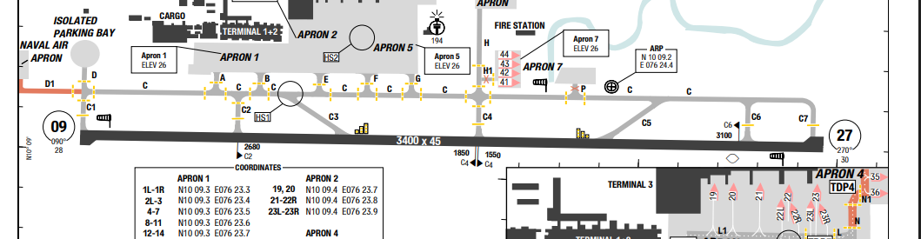
Cochin International Airport (IATA: COK, ICAO: VOCI), also known as Kochi International Airport, is an international airport serving the city of Kochi, Kerala, India. Located at Nedumbassery, about 25 km northeast of the city center, the airport is the first of its kind to be developed under a Public–private partnership (PPP) model in India.
Nedumbassery has a tropical monsoon climate with high humidity and temperatures often ranging from 25°C to 35°C. The area experiences heavy rainfall, primarily from June to September, with significant humidity, and it is generally hot.
Departure |  |  | - RNAV SID available and require minimum climb gradient  - COM FAIL Procedure available  - LVP available
Arrival and Approach |  |  | - RNAV STAR available  - COM FAIL Procedure available  - NAP available with reverse thrust
Taxi |  |  | - TWY D1 width 15m / 49ft.  - TWY H1 width 10.5m / 34ft.  - Aircraft size Limitations
Parking information |  |  | - Advanced Visual Docking Guidance System (A-VDGS) AVBL at stands 1R-6 and 19-23R.  - Marshalling is provided for other stands.  - On entering the stands, ACFT speed shall be maintained as is acceptable for a seamless and error-free ACFT type-sensing followed by azimuth guidance by the A-VDGS, until final STOP point on stand.  - ACFT entering stands 19-21 in APN 2 to exercise caution due to proximity of the equipment parking area.
5.TAKE-OFF AND LANDING DISTANCES AVAILABLE
RWY | LENGTH  (m) |  |  | WIDTH  (m) |  |  | TORA  (m) |  |  | LDA  (m) | TODA  (m) |  | ASDA  (m)
09/27 | 3400 |  |  | 45 |  |  | 3400 |  |  | 3400 | 3400 |  | 3400
6. ELEVATION: 30ft |  |  |  |  | 7. EOSID: NO
8. IAP: ILS, LOC, RNP, VOR
9. COMPANY NOTE |  |  |  |  | - Critical ACFT for AD is B744.
10. REMARK |  |  |  |  | NIL

VOHS/ HYD–RAJIV GANDHI INTLAIRPORT–HYDERABAD, INDIA
1. AIRPORT CATEGORY: A |  |  |  |  |  |  |  | 2. RFFS CATEGORY: 9
3. AIRPORT CLASSIFICATION
ATR |  | A320 |  |  |  | A321 |  |  | A350 |  |  | B787
ADQ |  | ADQ |  |  |  | ADQ |  |  | ADQ |  |  | ADQ
4. GENERAL STANDARDS
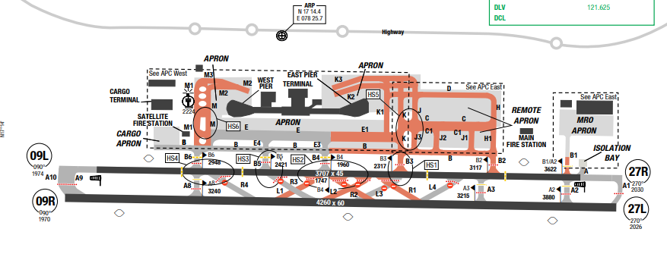
Rajiv Gandhi International Airport is an international airport that serves Hyderabad, the capital of the Indian state of Telangana. It is located in Shamshabad, about 24 kilometres (15 mi) south of Hyderabad and it was opened on 23 March 2008 to replace Begumpet Airport, which was the sole civilian airport serving Hyderabad. Raising terrains are to the Southwest of the airport, with highest terrain is 2559ft. The MSA is 3600ft in a sector of 25nm form HIA VOR
At Rajiv Gandhi International Airport, the wet season is oppressive and overcast, the dry season is mostly clear, and it is hot year-round. Over the course of the year, the temperature typically varies from 16°C to 38°c and is rarely below 12°c or above 41°C. Weather is hazy year-round due to smoke, March to early June is the hottest period Jun-Sep: Southwest Monsoon with Frequent cyclones/depressions from Bay of Bengal with heavy rainfall, thunderstorms, low clouds, and strong winds Oct-Nov: Post-monsoon with north westerly winds, rain and thunderstorms
Caution: Expect low-level clouds during June and September
Departure |  |  | - Trans altitude 7000.  - RNAV 1 required. RADAR required.
Arrival and Approach |  |  | - VOR approaches are available for both RWYs. VOR approaches are offset (2° for 27R, 3° for 09R, 7° for 09L)  - Primary runways: 09R/27L with ILS approaches. Secondary runways: 09L/27R for DAY VFR operations only  - When approaching Hyderabad, route W20S after BUSBO is not available due to air force exercises
Taxi |  |  | - Specific pushback directions based on stand numbers  - Some stands require pulling forward to specific limit lines to avoid jet blast on perimeter walls
Parking information |  |  | - ACFT on stand 11 shall pull forward abeam stand 12 to avoid jet blast  - Visual docking system AVBL
5. TAKE-OFF AND LANDING DISTANCES AVAILABLE
RWY | LENGTH  (m) |  |  | WIDTH  (m) |  |  | TORA  (m) |  |  | LDA  (m) | TODA  (m) |  | ASDA  (m)
09L/ 27R | 3707 |  |  | 45 |  |  | 3707 |  |  | 3707 | 3707 |  | 3707
09R/ 27L | 4260 |  |  | 60 |  |  | 4260 |  |  | 4260 | 4260 |  | 4260
6. ELEVATION: 2030ft |  |  |  |  | 7. EOSID: NO
8. IAP: ILS, LOC, RNP, VOR
9. COMPANY NOTE |  |  |  |  | - Do not mistake Hakimpet Air Base (located 20NM NE of Hyderabad) for Rajiv Gandhi International Airport. Both airports have similar runway alignments which can cause confusion  - Slight upslope/downslope runway (±0.40-0.46%)  - Multiple restricted areas and danger zones around the airport  - Significant bird activity with reported bird strikes
10. REMARK |  |  |  |  | NIL

VOPB/ IXZ – VEER SAVAKAR INTERNATIONAL AIRPORT, PORT BLAIR, INDIA
- AIRPORT CATEGORY: A |  |  |  |  |  |  | - RFFS CATEGORY: 7
- AIRPORT CLASSIFICATION
ATR |  | A320 |  | A321 |  |  | A350 |  | B787
ADQ |  | ADQ |  | ADQ |  |  | N/A |  | N/A
4. GENERAL STANDARDS
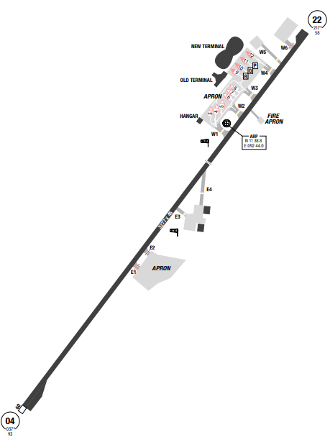
Veer Savarkar Airport is a domestic airport located 2 km south of Port Blair and is the main airport of the Andaman and Nicobar Islands of India MSA is based on multiple navigation aid stations at 2700ft. The climate in the Andaman and Nicobar Islands is a warm tropical climate which is why the weather is pleasant most of the time. Port Blair has humid weather and no winter season, the monsoon lasts up to 120 days and the rainfall varies from medium to heavy.
Departure |  |  | - NO SIDs  - RWY 04 is not allowed for takeoff.
Arrival and Approach |  |  | - NO STARs  - RWY 22 is not allowed for landing.
Taxi |  |  | - TWY W5 width 10.5m / 34ft
Parking information |  |  | No
- TAKE-OFF AND LANDING DISTANCES AVAILABLE
RWY | LENGTH  (m) |  |  | WIDTH  (m) |  | TORA  (m) |  | LDA  (m) |  | TODA  (m) | ASDA  (m)
04/ 22 | 3277 |  |  | 45 |  | 3277 |  | 3277 |  | 3277 | 3277
6. ELEVATION: 93ft |  |  |  |  | 7. EOSID: NO
8. IAP: ILS, LOC, RNP, VOR
9. COMPANY NOTE |  |  |  |  | - Birds
10. REMARK |  |  |  |  | NIL

VOTV/ TRV – THIRUVANTHAPURAM INTL, INDIA
- AIRPORT CATEGORY: A |  |  |  |  |  |  | - RFFS CATEGORY: 9
- AIRPORT CLASSIFICATION
ATR |  | A320 |  |  | A321 |  | A350 |  |  | B787
ADQ |  | ADQ |  |  | ADQ |  | ADQ |  |  | ADQ
- GENERAL STANDARDS
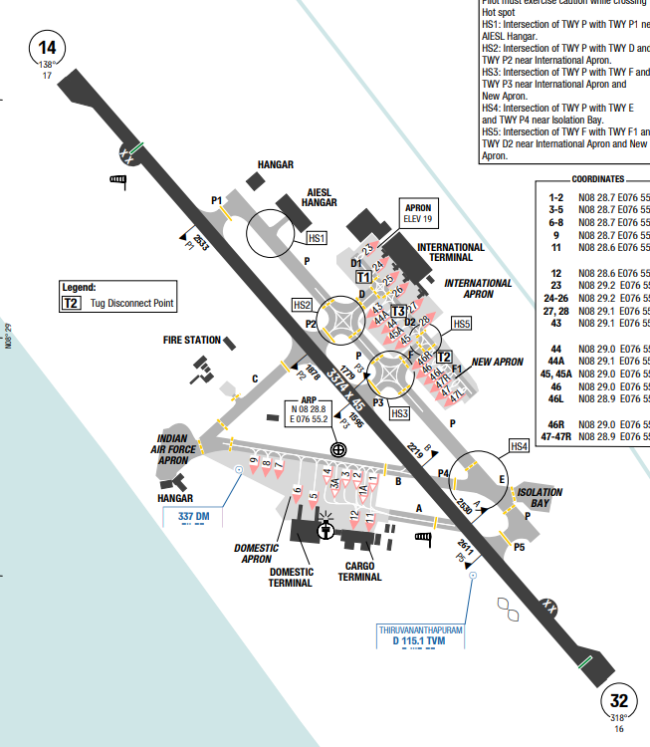
Thiruvananthapuram International Airport an international airport that serves Thiruvananthapuram, the capital city of Kerala, India. Established in 1932, it is the first airport in the state of Kerala and the fifth international airport of India, officially declared in 1991. The airport, spread over an area of 800 acres (320 ha), the airport is approximately 3.7 km due west from the city centre and the Padmanabhaswamy Temple, 16 km from Kovalam beach, 13 km from Technopark and 21 km from Vizhinjam International Seaport.
Thiruvananthapuram has a tropical, hot, and humid climate, generally categorized as a tropical wet and dry climate. Temperatures typically range from 23°C to 32°C, with highs reaching 36°C in summer. The city experiences heavy rainfall (around 1,835 mm annually).
Departure |  |  | - RNAV SID available with high climb gradient (highest 7% to 1000ft)  - COM FAIL Procedure available  - LVP available
Arrival and Approach |  |  | - RNAV STAR available  - COM FAIL Procedure available
Taxi |  |  | - TWY C MAX wingspan 52m / 171ft.  - TWYs D, E, F, P, P1-P5 AVBL up to code letter E ACFT. If ACFT on stand 11, TWY A MAX wingspan 48m / 157ft.
Parking information |  |  | - TWY E is used only for taxiing to isolated parking position.  - VDGS not AVBL for stands 46, 46L, 46R, 47, 47L, 47R.  - Docking of ACFT to the stand 27 while following VGDS shall be done by PIC.  - Stand 1-4 taxi in and out by self maneuvering via TWY A.  - Stand 5-9 taxi-in self maneuvering via TWY B, taxi-out via TWY B after push-back.  - Stand 11, 12 taxi-in self maneuvering via TWY B and stand 1, 2 (if occupied via TWY A), taxi-out via TWY A after push-back.  - Stand 2 and 3 N/A for OPS at night.  - Only idle ENG PWR is permitted on stands.
- TAKE-OFF AND LANDING DISTANCES AVAILABLE
RWY | LENGTH  (m) |  |  | WIDTH  (m) |  | TORA  (m) |  | LDA  (m) | TODA  (m) |  | ASDA  (m)
14/32 | 3374 |  |  | 45 |  | 3374 |  | 3374 | 3374 |  | 3374
6. ELEVATION: 17 ft | 7. EOSID: NO
8. IAP: ILS, LOC, RNP, VOR
9. COMPANY NOTE | - RWY 14/32 CLSD for preventive MAINT every MON, WED, THU and FRI BTN 0830 and 1030 subject to WX and VIS. RWY restoration time is 30min.  - 180° turn on RWY permitted up to code letter C ACFT, code letter D or E ACFT use only RWY turn pad.  - No ACFT permitted to make pivotal turn by locking rear wheels on RWY or RWY turn pad.  - Birds in vicinity of AD
10. REMARK | NIL

VOVZ/ VTZ – VISAKHAPATNAM, VISAKHAPATNAM, INDIA
1. AIRPORT CATEGORY: A |  |  |  |  |  |  |  | 2. RFFS CATEGORY: 7
3. AIRPORT CLASSIFICATION
ATR |  | A320 |  |  |  | A321 |  |  | A350 |  |  | B787
AQD |  | AQD |  |  |  | AQD |  |  | N/A |  |  | N/A
4. GENERAL STANDARDS
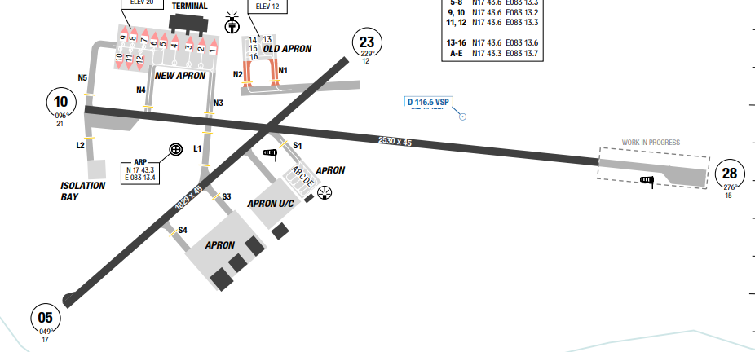
Visakhapatnam Airport (IATA: VTZ, ICAO: VOVZ) is a customs airport[a] serving the city of Visakhapatnam, Andhra Pradesh, India. It operates as a civil enclave alongside the airbase INS Dega, owned and operated by the Indian Navy.
Visakhapatnam (Vizag) features a tropical wet and dry climate characterized by hot, humid summers and mild, pleasant winters. Located on the coast of Andhra Pradesh, the city experiences a heavy monsoon season from July to September. Average annual temperatures range between 17°C and 35°C.
Departure |  |  | - No SID  - RWY 10/28 before DEP.
Arrival and Approach |  |  | - No STAR  - Speed control  - RWY 05 and RWY 10 right-hand circuit
Taxi |  |  | - TWY D1 width 15m / 49ft.
Parking information |  |  | - Visual Docking Guidance System (VDGS) AVBL at stands 2-4.
5.TAKE-OFF AND LANDING DISTANCES AVAILABLE
RWY | LENGTH  (m) |  |  | WIDTH  (m) |  |  | TORA  (m) |  |  | LDA  (m) | TODA  (m) |  | ASDA  (m)
10/28 | 2530 |  |  | 45 |  |  | 2530 |  |  | 2530 | 2530 |  | 2530
05/23 | 1829 |  |  | 45 |  |  | 1829 |  |  | 1829 | 1829 |  | 1829
6. ELEVATION: 21ft |  |  |  |  | 7. EOSID: NO
8. IAP: ILS, LOC, RNP, VOR
9. COMPANY NOTE |  |  |  |  | - High hills around AD.  - Glider flying daily BTN 0030-0230.  - 141cm hydrogen filled balloons released daily BTN 2300-0100, 1100-1300 and  - 1700-1900. Safety height 30000m, horizontal displacement is 120km with rate of ascent  - 300m/min.  - Unmarked link road established BTN middle marker and marker 4 port side of RWY 28.  - Pilot to exercise caution while taxing, LDG and TKOF.  - Flights may be delayed due to extensive MIL OPS.  - Extensive migratory bird activity in vicinity of AD.
10. REMARK |  |  |  |  | NIL

VTBD/ DMK–DON MUEANG INTL AIRPORT–BANGKOK, THAILAND
1. AIRPORT CATEGORY: A |  |  |  |  |  |  |  | 2. RFFS CATEGORY: 9
3. AIRPORT CLASSIFICATION
ATR |  | A320 |  |  |  | A321 |  |  | A350 |  |  | B787
ADQ |  | ADQ |  |  |  | ADQ |  |  | ADQ |  |  | ADQ
4. GENERAL STANDARDS
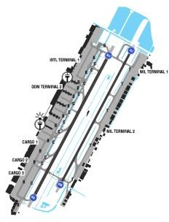
Don Mueang International Airport is one of two international airports serving Bangkok, Thailand, the other one being Suvarnabhumi Airport.
The weather is tropical in nature with a year- round average of 31ºC with high humidity and frequent thunderstorms. Bangkok enjoys a tropical monsoon climate, meaning that it has 3 main seasons: hot season from March to June, rainy season from July to October, and cool season between November and February.
Departure |  |  | - RNAV SIDs.  - Noise abatement procedure.
Arrival and Approach |  |  | - RNAV STARs.  - Speed restriction
Taxi |  |  | - All taxiing aircraft have to reduce to minimum power while taxiing along TWY B(North), taxi lane T between RWY V and TWY S can be used only for aircraft code letter A, B, C, D
Parking information |  |  | - Marshaller mandatory.  - Follow-me and wingman mandatory for code letter F ACFT
5. TAKE-OFF AND LANDING DISTANCES AVAILABLE
RWY | LENGTH  (m) |  |  | WIDTH  (m) |  |  | TORA  (m) |  |  | LDA  (m) | TODA  (m) |  | ASDA  (m)
03L/ 21R | 3700 |  |  | 60 |  |  | 3700 |  |  | 3700 | 3850 |  | 3850
03R/ 21L | 3500 |  |  | 45 |  |  | 3500 |  |  | 3500 | 3650 |  | 3600
6. ELEVATION: 9ft |  |  |  |  | 7. EOSID: NO
8. IAP: ILS (CAT I, II), LOC, RNP, VOR
9. COMPANY NOTE |  |  |  |  | - Upon reaching the parking bay, flight crews are requested to confirm with the ground personnel whether the flaps need to be retracted, to avoid risks of collision with the refueling vehicles.
10. REMARK |  |  |  |  | NIL

VTBS/ BKK–SUVARNABHUMI INTL AIRPORT–BANGKOK, THAILAND
1. AIRPORT CATEGORY: A |  |  |  |  |  |  | 2. RFFS CATEGORY: 10
3. AIRPORT CLASSIFICATION
ATR |  | A320 |  |  | A321 |  |  | A350 |  |  | B787
ADQ |  | ADQ |  |  | ADQ |  |  | ADQ |  |  | ADQ
4. GENERAL STANDARDS
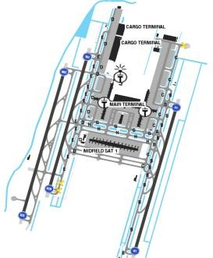
Suvarnabhumi airport is located about 10NMs north of the Gulf of Thailand. The area is flat with no high terrain within 30NM of the airfield. The highest MSA is to the South side from the Airport Reference Point at 3900ft. The hottest time in Bangkok lasts between Marchand May, when the best weather conditions last from December to February, with frequent clear sky and the temperature is at an average of 24 degrees Celcius.
Departure |  |  | - A- CDM procedure.  - Normally RWY 01R/ 19L is used for takeoff, but RWY change could be expected.  - - RNAV SIDs  - - Initial climb clearance 6000’ or as directed by ATC  - Speed and altitude restriction  - - NADP available at this airport
Arrival and Approach |  |  | - RNAV STARs  - Speed and altitude restriction  - Normally RWY 01L/ 19R is used for landing, but RWY change could be expected
Taxi |  |  | - Minimum runway occupancy time  - Mode S transponder on ground.  - Multiple runway incursion hot spots are identified and illustrated in the airport chart.  - Standard taxi route  - Single engine taxi is not PERMITTED due to soft ground condition.
Parking information |  |  | - Concourse E or Concourse F
5. TAKE-OFF AND LANDING DISTANCES AVAILABLE
RWY | LENGTH  (m) |  |  | WIDTH  (m) |  | TORA  (m) |  |  | LDA  (m) | TODA  (m) |  | ASDA  (m)
01 | 4000 |  |  | 60 |  | 4000 |  |  | 4000 | 4000 |  | 4000
19 | 4000 |  |  | 60 |  | 4000 |  |  | 4000 | 4550 |  | 4000
02R | 3700 |  |  | 60 |  | 3700 |  |  | 3700 | 4800 |  | 3700
20L | 3700 |  |  | 60 |  | 3700 |  |  | 3700 | 4400 |  | 3700
02L/ 20R | 4000 |  |  | 60 |  | 4000 |  |  | 4000 | 4000 |  | 4000
6. ELEVATION: 9ft | 7. EOSID: NO
8. IAP: ILS (CAT I, II), LOC, RNP
9. COMPANY NOTE | - Push back procedures.  - To avoid jet blast in the apron, pilots are urgently requested to adhere strictly to the startup and pushback procedures and to use minimum break away power and taxi power when operate in apron and taxiway. Aircraft shall be pushed back and towed forward on the yellow taxi lane centerline marking.  - Bird’s activities in vicinity of the airport. Pilots have to make a report bird strike to the general manager of the airport  - The difference between ILS DME and runway threshold at BKK airport is 2.3 NM. Flight crew should be aware of this difference to avoid miscalculating the distance to the runway threshold.  - The flaps need to be retracted, to avoid risks of collision with the refueling vehicles.  - Captain has to do Transit Check Procedure at this Airport  - Many soft spots are reported on ramp taxiways, crews take extreme caution during taxi in and out.  - As required by Authority, all flights inbound or transit, crew members are requested to complete Advanced Passenger Process (APP) procedure
10. REMARK | Ground Handling Frequency: 131.025 MHz

VTCC/ CNX – CHIANG MAI INTL AIRPORT – CHIANG MAI, THAILAND
1. AIRPORT CATEGORY: A |  |  |  |  |  |  |  | 2. RFFS CATEGORY: 9
3. AIRPORT CLASSIFICATION
ATR |  | A320 |  |  |  | A321 |  |  | A350 |  |  | B787
ADQ |  | ADQ |  |  |  | ADQ |  |  | ADQ |  |  | ADQ
4. GENERAL STANDARDS
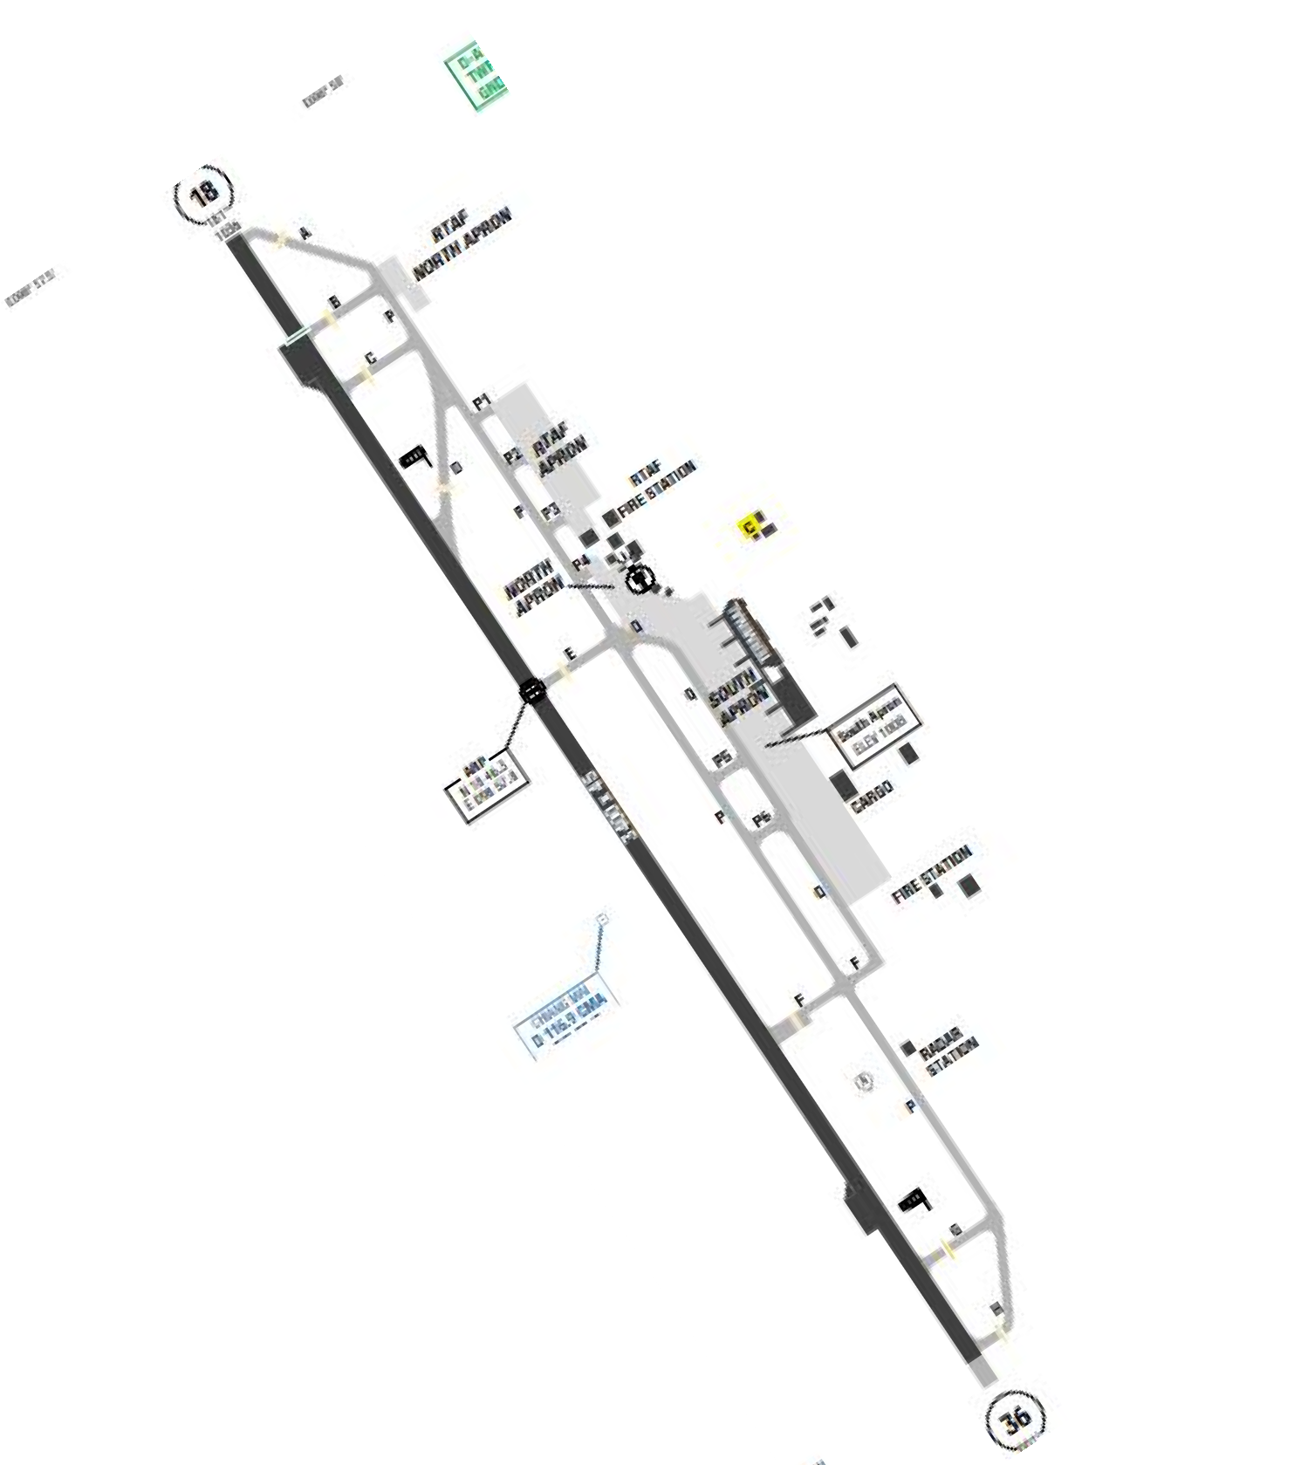
Chiang Mai International Airport is located in the northwestern mountains of Thailand. Mountains in this region are oriented from the north to the south and most mountain tops vary between 3000 and 6500 feet MSL. The climate of Chiang Mai is tropical monsoon and falls into three main seasons. The weather, like in most of Thailand, is typically hot and humid with the temperatures in Chiang Mai are often close to or above to 30°C. From June to late October, you can expect frequent rain and thunder showers.
Departure |  |  | - Contact departure frequency when airborne Expect radar vectors for several points that are not part of the SID  - RNAV SIDs.  - Require minimum climb gradients.  - Initial climb clearance 11000’ or as directed by ATC
Arrival and Approach |  |  | - RNAV STARs.  - Speed restriction
Taxi |  |  | - In order to provide a more flexible ground traffic movement all domestic departures shall on longer be required to be ready to taxi within 5 minutes after clearance received.
Parking information |  |  | - Safegate VDGS AVBL at stands 3-8
5. TAKE-OFF AND LANDING DISTANCES AVAILABLE
RWY | LENGTH  (m) |  |  | WIDTH  (m) |  |  | TORA  (m) |  |  | LDA  (m) | TODA  (m) |  | ASDA  (m)
18 | 3400 |  |  | 45 |  |  | 3400 |  |  | 3100 | 3400 |  | 3400
36 | 3400 |  |  | 45 |  |  | 3100 |  |  | 3100 | 3100 |  | 3100
6. ELEVATION: 1036ft |  |  |  |  | 7. EOSID: YES
8. IAP: ILS, LOC, RNP, VOR
9. COMPANY NOTE |  |  |  |  | Birds are in the vicinity of the airport.  - All IFR aircraft are to call “Ground Control” 5 minutes prior to ATC clearance request.  - Operation of all non-scheduled flights, including flight as alternate aerodrome, shall have a handling agent.  - All non-scheduled a/ c ready to taxi out shall prepare their own tow bar (except for a/ c below code C, must inform ATC before doing so)  Danger Area VT (D)-41 overflies the airport, Danger Area VT (D)-42 is located within 9 NM to the southwest and Restricted Area VT(R)-5 is adjacent to the northwest portion of the runway
10. REMARK |  |  |  |  | NIL

VTCT/ CEI – CHIANG RAI INTL AIRPORT – CHIANGRAI, THAILAND
1. AIRPORT CATEGORY: A |  |  |  | 2. RFFS CATEGORY: 9
3. AIRPORT CLASSIFICATION
ATR | A320 |  | A321 |  | A350 | B787
ADQ | ADQ |  | ADQ |  | ADQ | ADQ
4. GENERAL STANDARDS
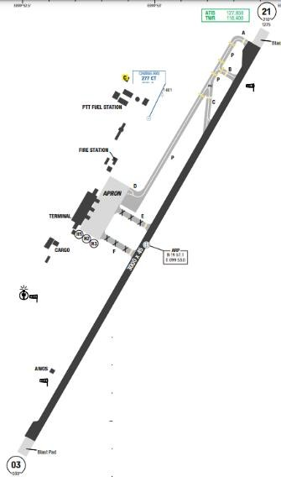
Chiang Rai International Airport is in the city of Chiang Rai in northern Thailand. Chiang Rai lies on the flat alluvial plain of the Mae Kok River, a tributary of the Mekong, between the Daen Lao Range in the north and the Phi Pan Nam Range in the south. The Mae Kok River runs along Chiang Rai's north side, flowing eastwards out of Burma at Tha Ton town, bending north-eastwards and joining the Mekong River about 40 kilometres (25 mi) northeast of the city. Chiang Rai has a tropical wet and dry climate. Winters are fairly dry and warm.
Departure |  | - Between 1500-2259 UTC, departing aircraft shall use runway 03 avoid the residential area, unless it would affect the safety of flight.  - Omnidirectional departures during take-off and initial climb-out are permitted during the day and night  - SID with high climb gradient,
Arrival and Approach |  | - ILS approach available for RWY 03.  - STARs not available.
Taxi |  | No
Parking information |  | - Self-manoeuvring may be permitted and is limited by airport authority.  - Air Operator or Handling Agent shall get permission from airport authority before operate.  - Power back are not permitted at any parking stands.
5. TAKE-OFF AND LANDING DISTANCES AVAILABLE
RWY | LENGTH  (m) | WIDTH  (m) |  | TORA  (m) | LDA  (m) | TODA  (m) | ASDA  (m)
21 | 3400 | 45 |  | 3400 | 3100 | 3400 | 3400
03 | 3400 | 45 |  | 3100 | 3100 | 3100 | 3100
6. ELEVATION: 1036ft |  |  | 7. EOSID: NO
8. IAP: ILS, LOC, RNP, VOR
9. COMPANY NOTE |  |  | - Between 1500-2259, departing aircraft shall use RWY 03 avoid the residential area, unless it would affect the safety of flight.  - Contact OCC or VNA representative at BKK for support.  - This airport could be used as alternate for VLVT.  - Upon reaching the parking bay, flight crews are requested to confirm with the ground personnel whether the flaps need to be retracted, to avoid risks of collision with the refuelling vehicles.  - As required by Authority, all flights inbound or transit, crew members are requested to complete Advanced Passenger Process (APP) procedure – Passport checked - at check-in counter before flight
10. REMARK |  |  | NIL

VTSB/ URT – SURAT THANI AIROPRT, THAILAND
1. AIRPORT CATEGOR: A |  |  |  |  |  |  |  |  | 2. RFFS CATEGORY: 8
3. AIRPORT CLASSIFICATION
ATR |  | A320 |  |  |  | A321 |  | A350 |  |  |  | B787
ADQ |  | ADQ |  |  |  | ADQ |  | ADQ |  |  |  | ADQ
4. GENERAL STANDARDS
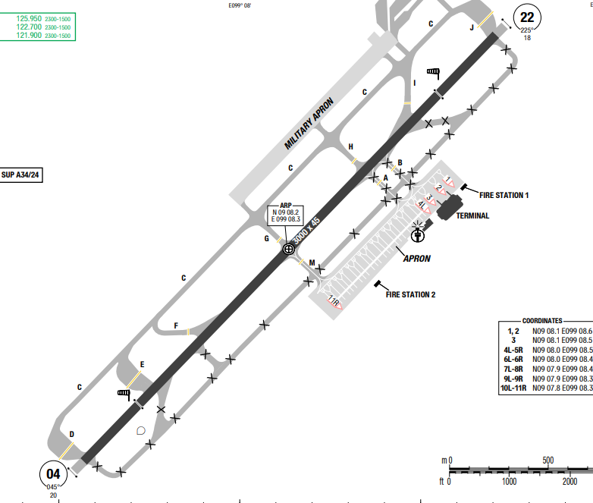
Surat Thani International Airport (IATA: URT, ICAO: VTSB) is an international airport in Tambon Hua Toei, Amphoe Phunphin, Surat Thani province in Southern Thailand. It is located 21 kilometres (13 mi) west of downtown Surat Thani, and is also home to the Royal Thai Air Force (RTAF) squadrons.
Surat Thani has a tropical, hot, and humid climate with temperatures consistently around 30-35°C. It features two main seasons: a rainy, wet season from May to October, and a cooler, drier season from November to February.
Departure |  |  | - RNAV SIDs available and require high climb gradient  - For RNAV SIDs RWY 22: Close-in obstacles. Terrain 71ft HGT, 407m from DER  - Omnidirectional DEP during TKOF and initial climb-out are permitted during the day and night. ATC CLR may be issued upon REQ of the pilot or upon initiative of the ATC and accepted by the pilot. Routing:  + RWY 04: 5.0% to 6100  Climb RWY HDG to MNM 1500 - then comply with ATC clearance issued or as directed by ATC  + RWY 22: 5.0% to 6100  Climb RWY HDG to MNM 1500 - then comply with ATC clearance issued or as directed by ATC
Arrival and Approach |  |  | - RNAV STAR  - RWY 22 right-hand circuit  - R227 STN VOR within 10-13NM DME out of tolerance roughness and scalloping
Taxi |  |  | NIL
Parking information |  |  | - Visual Docking Guidance System (VDGS) AVBL at stands 2, 3.  - A-VDGS AVBL at stand 2.
5. TAKE-OFF AND LANDING DISTANCES AVAILABLE
RWY | LENGTH  (m) |  |  | WIDTH  (m) |  |  | TORA  (m) |  |  | LDA  (m) | TODA  (m) |  | ASDA  (m)
04/ 22 | 3050 |  |  | 45 |  |  | 3000 |  |  | 3000 | 3000 |  | 3000
6. ELEVATION: 20ft |  |  |  |  | 7. EOSID: YES
8. IAP: ILS, LOC, RNP
9. COMPANY NOTE |  |  |  |  | - Low Level Windshear Alert System (LLWAS) in operation.  - 180° turns on RWY prohibited for code C ACFT or higher, use turnpads only.
10. REMARK |  |  |  |  | NIL

VTSG/ KBV – KRABI INTL, NUEA KHLONG, THAILAND
1. AIRPORT CATEGOR: A |  |  |  |  |  |  |  |  | 2. RFFS CATEGORY: 9
3. AIRPORT CLASSIFICATION
ATR |  | A320 |  |  |  | A321 |  | A350 |  |  |  | B787
ADQ |  | ADQ |  |  |  | ADQ |  | ADQ |  |  |  | ADQ
4. GENERAL STANDARDS
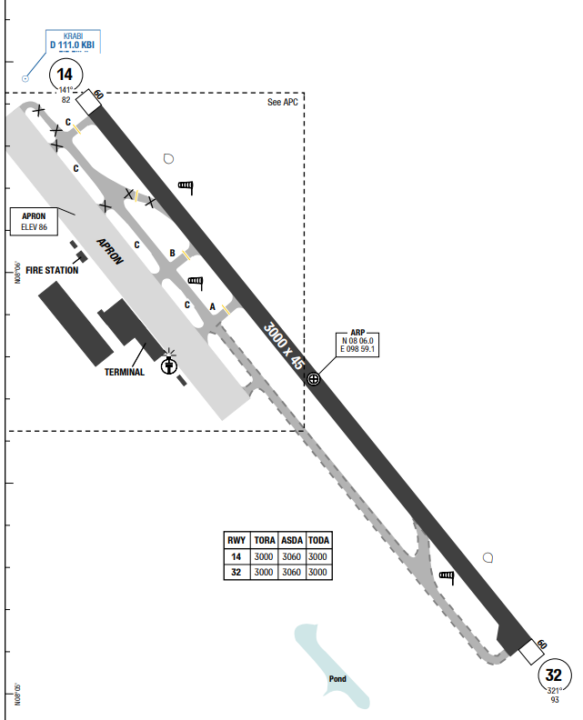
Krabi International Airport (IATA: KBV, ICAO: VTSG) is an international airport in Nuea Khlong subdistrict, Nuea Khlong district, Krabi province in southern Thailand. It is about 7 kilometres east of downtown Krabi.
Krabi has a tropical monsoon climate, featuring high temperatures (24-32°C) and high humidity year-round. The, dry season, ideal for travel, runs from November to March/April. The wet season, dominated by the monsoon, lasts from May to October, with September and October typically being the wettest months
Departure |  |  | - RNAV SIDs available and require climb gradient and require high climb gradient  - COMM FAIL Procedure available
Arrival and Approach |  |  | - RNAV STAR  - COMM FAIL Procedure available
Taxi |  |  | NIL
Parking information |  |  | NIL
5. TAKE-OFF AND LANDING DISTANCES AVAILABLE
RWY | LENGTH  (m) |  |  | WIDTH  (m) |  |  | TORA  (m) |  |  | LDA  (m) | TODA  (m) |  | ASDA  (m)
14/ 32 | 3000 |  |  | 45 |  |  | 3000 |  |  | 3000 | 3000 |  | 3060
6. ELEVATION: 84ft |  |  |  |  | 7. EOSID: YES
8. IAP: ILS, LOC, RNP, VOR
9. COMPANY NOTE |  |  |  |  | - Low Level Windshear Alert System (LLWAS) in operation.  - Birds in vicinity of AD.
10. REMARK |  |  |  |  | NIL

VTSP/ HKT – PHUKET INTL, PHUKET, THAILAND
1. AIRPORT CATEGOR: A |  |  |  |  |  |  |  |  | 2. RFFS CATEGORY: 9
3. AIRPORT CLASSIFICATION
ATR |  | A320 |  |  |  | A321 |  | A350 |  |  |  | B787
ADQ |  | ADQ |  |  |  | ADQ |  | ADQ |  |  |  | ADQ
4. GENERAL STANDARDS
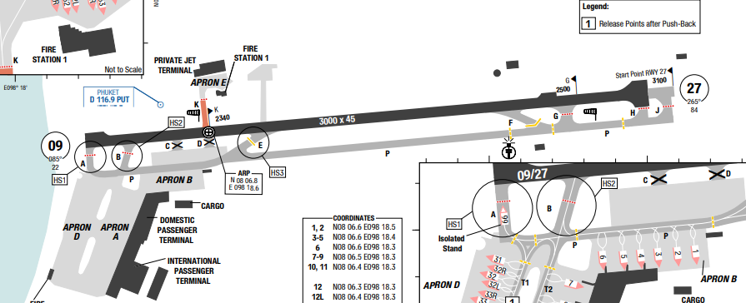
Phuket International Airport (IATA: HKT, ICAO: VTSP) is an international airport serving the island province of Phuket in southern Thailand. It is located 32 km north of the city of Phuket in the Mai Khao subdistrict of Thalang district. The airport plays a major role in Thailand's tourism industry, as Phuket is a popular resort destination.
Departure |  |  | - RNAV SIDs available and require high climb gradient (highest 6.5% to 11000ft)  - COMM FAIL Procedure available
Arrival and Approach |  |  | - RNAV STAR  - ILS 27: GP unusable from D2 IPKT (MM) to RWY 27 THR.  - COMM FAIL Procedure available
Taxi |  |  | - Taxiway Width: TWY K width 20m / 66ft  - Aircraft Size Limitations:  + Due to MNM separation DIST between RWY CL and TWY CL of 150m / 492 ft, in IMC ACFT code letter C, D, E on may be REQ to hold on TWY during LDG or TKOF of ACFT code letter C, D, E.
Parking information |  |  | - Stand 6 increased slope, exercise additional caution when parking on stand
5. TAKE-OFF AND LANDING DISTANCES AVAILABLE
RWY | LENGTH  (m) |  |  | WIDTH  (m) |  |  | TORA  (m) |  |  | LDA  (m) | TODA  (m) |  | ASDA  (m)
09/ 27 | 3050 |  |  | 45 |  |  | 3050 |  |  | 3050 | 3050 |  | 3050
6. ELEVATION: 84ft |  |  |  |  | 7. EOSID: NO
8. IAP: ILS, LOC, RNP, VOR
9. COMPANY NOTE |  |  |  |  | - 180°-turn on RWY prohibited for ACFT with wingspan 24m / 79ft and above. 180°-turn shall be carried out on turn pad near THR of RWY 27  - APN A, D and E are blind spot areas for ATC. Maneuvering at own discretion after ATC instructions are issue  - Birds in vicinity of AD.
10. REMARK |  |  |  |  | NIL

VTSS/ HDY – HAT YAI INTL, SONGKHLA, THAILAND
1. AIRPORT CATEGOR: A |  |  |  |  |  |  |  |  | 2. RFFS CATEGORY: 9
3. AIRPORT CLASSIFICATION
ATR |  | A320 |  |  |  | A321 |  | A350 |  |  |  | B787
ADQ |  | ADQ |  |  |  | ADQ |  | ADQ |  |  |  | ADQ
4. GENERAL STANDARDS
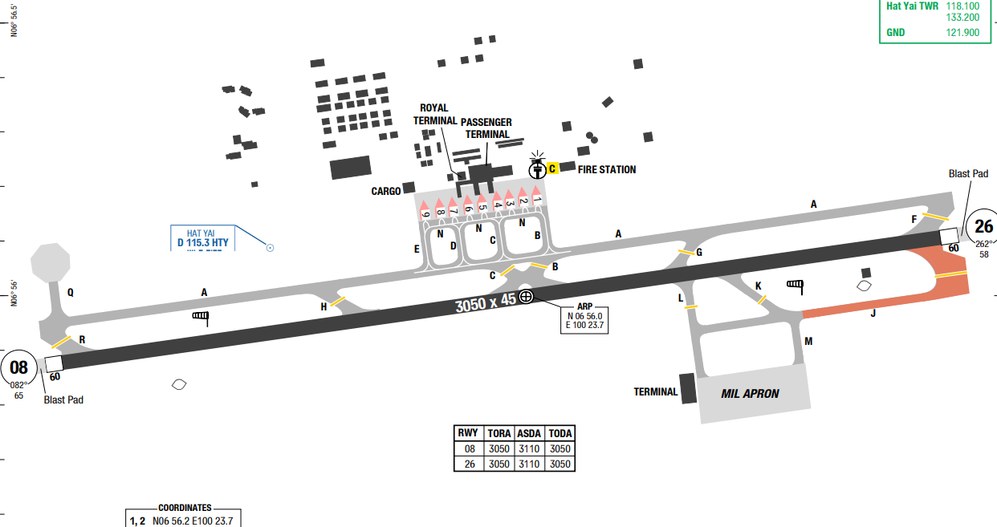
Hat Yai International Airport[a] (IATA: HDY, ICAO: VTSS) is in Khlong La subdistrict, Khlong Hoi Khong district, Songkhla province in southern Thailand, near the city of Hat Yai
Songkhla features a hot and oppressive tropical, monsoon climate (Köppen Am) with high temperatures, high humidity, and little variation year-round. The city has a distinct wet season (roughly July-October) and a drier season, with temperatures usually ranging from 25-32°C, peaking at over 35°C) in April/May.
Departure |  |  | - RNP SIDs available and require climb gradient and require high climb gradient.  - COMM FAIL Procedure available
Arrival and Approach |  |  | - RNP STAR  - RWY 08 right-hand circuit.  - COMM FAIL Procedure available
Taxi |  |  | - Follow strictly taxiing CL to avoid reduced safety DIST to parked ACFT.  - TWY A and J not AVBL when code letter C or higher ACFT TKOF or LDG on the RWY, due to insufficient separation distance.
Parking information |  |  | - Taxi with MNM PWR on APN.  - Marshaller AVBL.  - Visual Docking Guidance System (VDGS) SAFEGATE AVBL at stands 4-6
5. TAKE-OFF AND LANDING DISTANCES AVAILABLE
RWY | LENGTH  (m) |  |  | WIDTH  (m) |  |  | TORA  (m) |  |  | LDA  (m) | TODA  (m) |  | ASDA  (m)
08/26 | 3050 |  |  | 45 |  |  | 3050 |  |  | 3050 | 3050 |  | 3110
6. ELEVATION: 90ft |  |  |  |  | 7. EOSID: YES
8. IAP: ILS, LOC, RNP, VOR
9. COMPANY NOTE |  |  |  |  | - Code letter C ACFT and higher are not allowed to make 180° turn on RWY.  - Birds in vicinity of AD, especially MAR-JUL
10. REMARK |  |  |  |  | NIL

VTUD/ UTH – UDON THANI – UDON THANI – THAILAND
1. AIRPORT CATEGOR: A |  |  |  |  |  |  |  | 2. RFFS CATEGORY: 8
3. AIRPORT CLASSIFICATION
ATR |  | A320 |  |  |  | A321 |  |  | A350 |  |  | B787
ADQ |  | ADQ |  |  |  | ADQ |  |  | N/ A |  |  | N/ A
4. GENERAL STANDARDS
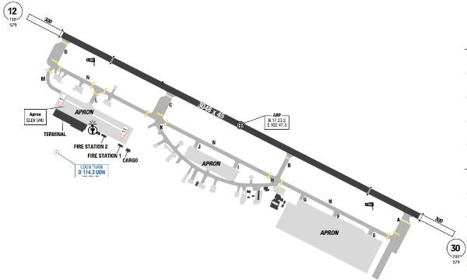
Udon Thani International Airport (IATA: UTH, ICAO: VTUD) is in the Nong Khon Kwang subdistrict, Mueang Udon Thani district, Udon Thani province in northeastern Thailand. It is approximately 450 kilometres (280 mi) northeast of Bangkok. Udon Thani has a tropical savanna climate. The wet season is oppressive and overcast, the dry season is humid and partly cloudy, and it is hot year round. Temperatures rise until April, which is hot with the average daily maximum at 36.2 °C
Departure |  |  | - RNAV SIDs available and require climb gradient
Arrival and Approach |  |  | No
Taxi |  |  | No
Parking information |  |  | No
5. TAKE-OFF AND LANDING DISTANCES AVAILABLE
RWY | LENGTH  (m) |  |  | WIDTH  (m) |  |  | TORA  (m) |  |  | LDA  (m) | TODA  (m) |  | ASDA  (m)
12/ 30 | 3050 |  |  | 45 |  |  | 3050 |  |  | 3050 | 3050 |  | 3050
6. ELEVATION: 579ft |  |  |  |  | 7. EOSID: NO
8. IAP: ILS, LOC, RNP, VOR
9. COMPANY NOTE |  |  |  |  | - Bird concentrations in the vicinity of an aerodrome
10. REMARK |  |  |  |  | NIL

VVBM/ BMV – BUON MA THUOT AIRPORT – BUON MA THUOT, VIETNAM
1. AIRPORT CATEGORY: A |  |  |  |  |  |  |  | 2. RFFS CATEGORY: 6
3. AIRPORT CLASSIFICATION
ATR |  | A320 |  |  |  | A321 |  |  | A350 |  |  | B787
ADQ |  | ADQ |  |  |  | ADQ |  |  | N/ A |  |  | N/ A
4. GENERAL STANDARDS
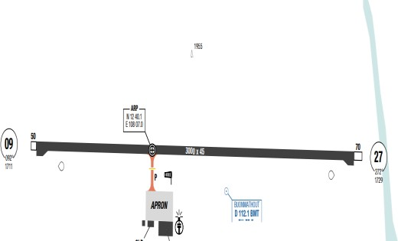
Buon Ma Thuot Airport is a joint civil and military airport located near provincial capital Buon Ma Thuoc, Dak Lak Province. The two distinct wet and dry seasons in this region are easily recognized. Wet season lasts from April to late October with significant downpours. The highest rainfall occurs in August. Thunderstorms are frequent during the wet season especially in the afternoon. Dry season sees less rain and generally fair-weather conditions. Temperature in this southern region is generally about 25ºC. Wind in area is generally around 6 to 10kts. But during wet season, thunderstorm can produce very strong gusting winds.
Departure |  |  | - RNAV SIDs available and require climb gradient
Arrival and Approach |  |  | - RNAV STARs.  - Strict adherence to arrival and approach procedures is required.  - When conducting the approach via DME arcs, flight crews should be aware of their speeds to avoid overshooting the arc.  - Respect mandatory altitude constraint.
Taxi |  |  | - 180-degree turnaround permitted only at the end of the runway.  - Flight crews should pay attention on minimum engine cooling and warm up time due to short taxi durations.  - There is only one taxiway to the apron
Parking information |  |  | No
5. TAKE-OFF AND LANDING DISTANCES AVAILABLE
RWY | LENGTH  (m) |  |  |  | WIDTH  (m) |  | TORA  (m) |  |  | LDA  (m) | TODA  (m) |  | ASDA  (m)
09 | 3000 |  |  |  | 45 |  | 3000 |  |  | 3000 | 3200 |  | 3070
27 | 3050 |  |  |  | 45 |  | 3000 |  |  | 3000 | 3200 |  | 3050
6. ELEVATION: 1736ft |  |  |  | 7. EOSID: YES
8. IAP: ILS, LOC, RNP, VOR
9. COMPANY NOTE |  |  |  | - If the landing is conducted by the First Officer, compliance with the requirements specified in FOM-Chapter 8.1.2.5 is mandatory  - RWY 09 is upslope, flight crew need to pay extra caution during landing.  - There are occurrences of GPWS triggering on short final. Flight crews are requested to monitor profile carefully.
10. REMARK |  |  |  | NIL

VVCA/ VCL – CHU LAI AIRPORT – QUANG NAM, VIETNAM
1. AIRPORT CATEGORY: A |  |  |  |  |  |  |  | 2. RFFS CATEGORY: 7
3. AIRPORT CLASSIFICATION
ATR |  | A320 |  |  |  | A321 |  |  | A350 |  |  | B787
ADQ |  | ADQ |  |  |  | ADQ |  |  | N/A |  |  | N/A
4. GENERAL STANDARDS
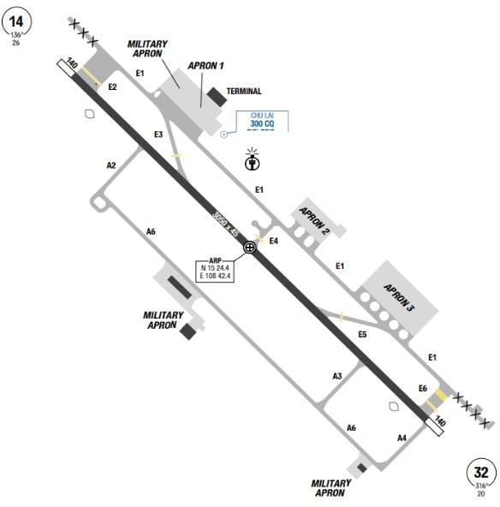
Chu Lai airport is located near Tam Ky city, the largest city in Quang Nam province. The airport is located in the Chu Lai Open Economic Zone, Nui Thanh District. The Truong Son mountain chain is on the West, Dung Quat bay is on the East of the airport. The highest MSA is to the South-west sector from CLA VOR at 7500ft.The seasons in Chu Lai are distinct wet and dry season. The dry season lasts from February to August, with mainly north-easterly wind. Haze or mist may appear, especially in the early morning. Thunderstorms may occur in late afternoon. Temperature is around 28–29-degree C. Wet season lasts from September to December, strong wind is blowing from North and North-west. Heavy rain occurs usually in October, with low cloud base.
Departure |  |  | - SID for RWY14 require minimum climb gradient 5% to FL098 and 5% to 7900ft for RWY32
Arrival and Approach |  |  | - ILS is available for RWY 32. Occasionally, RWY 14 is used for landing.  - As the airport is surrounded by high hills on the West and no radar available at VVCA, crews are requested strictly follow ATC instruction.
Taxi |  |  | - Simple taxi procedures to and from the apron.
Parking information |  |  | - Apron 3 MIL use only  - E-WX, E-NOTAM for all domestic and international flights with block time of 9 hours or less departing from VCL are uploaded to EFF for official use.
5. TAKE-OFF AND LANDING DISTANCES AVAILABLE
RWY | LENGTH  (m) |  |  | WIDTH  (m) |  |  | TORA  (m) |  |  | LDA  (m) | TODA  (m) |  | ASDA  (m)
14 | 3050 |  |  | 45 |  |  | 3050 |  |  | 3050 | 3350 |  | 3190
32 | 3050 |  |  | 45 |  |  | 3050 |  |  | 3050 | 3350 |  | 3190
6. ELEVATION: 26ft |  |  |  |  | 7. EOSID: NO
8. IAP: ILS, LOC, RNP, VOR
9. COMPANY NOTE |  |  |  |  | - In case of ILS approach procedures, CAT C and CAT D can be applied.  - ASU, AGU, GPU status is updated in Flight Document (MO Plus>Briefing>Specific Flight>Flight Document.
10. REMARK |  |  |  |  | NIL

VVCI/ HPH – CAT BI INTL AIRPORT – HAI PHONG, VIETNAM
1. AIRPORT CATEGORY: A |  |  |  |  |  |  |  | 2. RFFS CATEGORY: 8
3. AIRPORT CLASSIFICATION
ATR |  | A320 |  |  |  | A321 |  |  | A350 |  |  | B787
ADQ |  | ADQ |  |  |  | ADQ |  |  | ADQ |  |  | ADQ
4. GENERAL STANDARDS
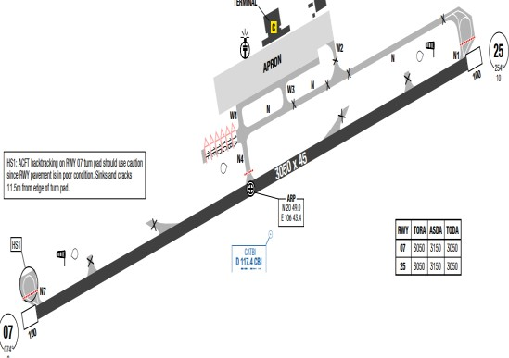
VVCI is located about 50 miles away from Noi Bai airport. The MSA, based on CAB VOR is from 5100ft in the North sector to 1480ft in the South- West sector. There is a 449ft mountain located at about 8Nm West of CBI. Terrain is located to the North and flattens towards the sea. Temperature as well as significant weather is not much different from NB airport. There are four distinct seasons with the lowest temperature reaching 11ºC in January, and highest one can jump up to 40ºC in July. Wind in this region is influenced by North- East monsoon, as well as sea breezes. North and northeasterly wind is quite stable during the winter from October to the New Year.
Departure |  |  | - RNAV SIDs  - SID with high climb gradient
Arrival and Approach |  |  | - RNAV STARs.  - The preferred runway is 07 for arrival  - Visual approach is normally approved in good weather condition.
Taxi |  |  | - Holding point on N1 and N7 only for A321 and equivalent or smaller.  - Single Engine Taxi is permitted.
Parking information |  |  | - Parking stand number is assigned by CAT BI TWR  - For parking 1A: taxi to holding position, shut down engines and ACFT is pushed to the stand
5. TAKE-OFF AND LANDING DISTANCES AVAILABLE
RWY | LENGTH  (m) |  |  | WIDTH  (m) |  |  | TORA  (m) |  |  | LDA  (m) | TODA  (m) |  | ASDA  (m)
07/ 25 | 3050 |  |  | 45 |  |  | 3050 |  |  | 3050 | 3150 |  | 3150
6. ELEVATION: 10ft |  |  |  |  | 7. EOSID: NO
8. IAP: ILS, LOC, RNP, VOR
9. COMPANY NOTE |  |  |  |  | - There is a military airport (Kien An) which lies approximately 5 NM, with similar runway direction and has often been mistaken for Cat Bi. Caution should be exercised for this reason when making visual approaches into Cat Bi.
10. REMARK |  |  |  |  | NIL

VVCM/ CAH – CA MAU AIRPORT – CA MAU, VIETNAM
1. AIRPORT CATEGORY: A |  |  |  |  |  |  |  | 2. RFFS CATEGORY: 6
3. AIRPORT CLASSIFICATION
ATR |  | A320 |  |  |  | A321 |  |  | A350 |  | B787
AQD |  | N/ A |  |  |  | N/ A |  |  | N/ A |  | N/ A
4. GENERAL STANDARDS
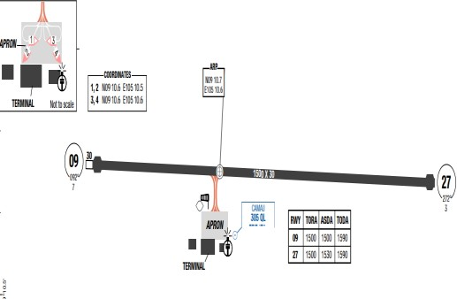
Ca Mau Airport is a small airport in Cà Mau Province, the most southern part of Vietnam. The airport is located 2 kilometers to the east of the city. The terrain around the airport is generally flat, with the MSA around QL NDB at 1900ft.
Ca Mau has a tropical climate. Ca Mau has significant rainfall most months, with a short dry season. The average temperature in Ca Mau is 26.7 °C. In a year, the rainfall is 2465 mm. The driest month is February, with 22 mm of rainfall. In October, the precipitation reaches its peak, with an average of 413 mm. The warmest month of the year is April, with an average temperature of 28.2 °C. At 25.7 °C on average, December is the coldest month of the year
Departure |  |  | - Runway 09 is commonly used for takeoff.  - Conventional SID.  - Require minimum climb gradients.
Arrival and Approach |  |  | - Conventional STAR.  - For NDB approach RWY 09/ 27: Final Approach Course is 2 degrees offset from North of extended centerline.  - If the approach is NDB RWY 09, the aircraft will face directly to the sun (early morning flight) on short final, affect to the visual of pilots
Taxi |  |  | - Single ENG taxi is permitted
Parking information |  |  | No
5. TAKE-OFF AND LANDING DISTANCES AVAILABLE
RWY | LENGTH  (m) |  |  | WIDTH  (m) |  |  | TORA  (m) |  |  | LDA  (m) |  | TODA  (m) | ASDA  (m)
09 | 1500 |  |  | 30 |  |  | 1500 |  |  | 1500 |  | 1590 | 1590
27 | 1500 |  |  | 30 |  |  | 1500 |  |  | 1500 |  | 1590 | 1530
6. ELEVATION: 7ft |  |  |  |  | 7. EOSID: NO
8. IAP: NDB, RNP
9. COMPANY NOTE |  |  |  |  | - If the landing is conducted by the First Officer, compliance with the requirements specified in FOM-Chapter 8.1.2.5 is mandatory  - Visual approach is normally approved in good weather condition.
10. REMARK |  |  |  |  | NIL

VVCR/ CXR – CAM RANH INTL AIRPORT – KHANH HOA, VIETNAM
1. AIRPORT CATEGORY: A |  |  |  |  |  |  |  | 2. RFFS CATEGORY: 9
3. AIRPORT CLASSIFICATION
ATR |  | A320 |  |  |  | A321 |  |  | A350 |  |  | B787
AQD |  | AQD |  |  |  | AQD |  |  | AQD |  |  | AQD
4. GENERAL STANDARDS
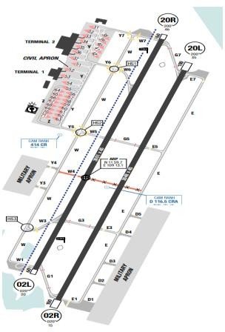
Cam Ranh airport is located close to the sea and is about 40km from Nha Trang city. This region has dry and wet season. The wet season lasts from May to November, while the dry season runs the rest of the year. The average temperature is around 25°C to 30°C but sometimes it can reach 35°C.`
From the beginning of the year till August, rain is not so frequent. This airport is rarely faced with low clouds, CBs cloud that prevents aviation operations. During the Wet season, there are heavy but short-lived downpours. During the Dry season, wind mostly blows South or South-easterly, while its direction changes to North and North-East in the remaining of the year.
Departure |  |  | - There are SIDs with high climb gradients. If these SIDs are used in operation, ensure that the all engine climb gradient of aircraft meets the required minimum climb gradient  - RWY 02L/ 20R is mainly used for take-off.  - If no military activity, CXR ATC is quite flexible and will approve VMC departures in good weather condition.
Arrival and Approach |  |  | - RNAV STARs.  - RWY 02R/ 20L is mainly used for landing.  - For RWY02L/ 02R approaches with slope of ≥ 3.5 degrees. All pilots are requested to pay extra attention to avoid unstable approach and firm or hard landing.  - RWY 20L/ R is down sloped and RWY 02L/ R is up sloped.
Taxi |  |  | - Taxi limitations
Parking information |  |  | - Taxi out of stand 55 possible under own PWR.
5. TAKE-OFF AND LANDING DISTANCES AVAILABLE
RWY | LENGTH  (m) |  |  | WIDTH  (m) |  |  | TORA  (m) |  |  | LDA  (m) | TODA  (m) |  | ASDA  (m)
02L/ 20R | 3051 |  |  | 45 |  |  | 3051 |  |  | 3051 | 3251 |  | 3111
02R/ 20L | 3048 |  |  | 45 |  |  | 3048 |  |  | 3048 | 3048 |  | 3148
6. ELEVATION: 46ft |  |  |  |  | 7. EOSID: YES
8. IAP: ILS, LOC, RNP, VOR
9. COMPANY NOTE |  |  |  |  | - Birds are in the vicinity of the airport.  - Training flight and technical test flights can be made once having obtained the permission from the appropriate authority.  - Military activity is frequent in Cam Ranh, therefore delays and re-routing could be expected.  - Approach can only be established quite late.
10. REMARK |  |  |  |  | NIL

VVCS/ VCS – CON SON AIRPORT – BA RIA VUNG TAU, VIETNAM
1. AIRPORT CATEGORY: A |  |  |  |  |  |  |  | 2. RFFS CATEGORY: 6
3. AIRPORT CLASSIFICATION
ATR |  | A320 |  |  |  | A321 |  |  | A350 |  |  | B787
ADQ |  | N/ A |  |  |  | N/ A |  |  | N/ A |  |  | N/ A
4. GENERAL STANDARDS
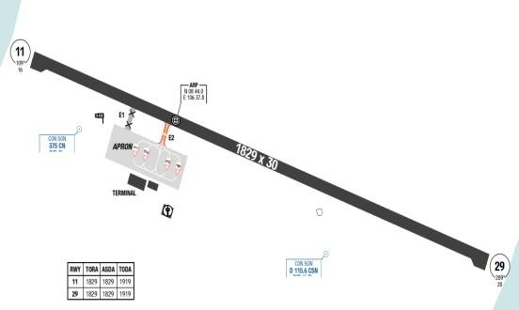
Con Dao Airport or Con Son Airport (IATA: VCS, ICAO: VVCS) is located on Con Son Island, the largest island of Con Dao archipelago off the coast of Ba Ria–Vung Tau province, Vietnam.
Con Dao Island is in the Asian monsoon climate and influenced by ocean climate. By dint of this, Con Dao weather is relatively cool and pleasant all year round; it is also influenced by weather in Southeast Vietnam.
Strong Winds in Con Dao occur in Two Phases:
- Rainy Season: Strong winds accompany cumulonimbus clouds and thunderstorms.
- Dry Season: From November to March each year, the region experiences monsoonal winds, predominantly from the northeast.
Con Dao frequently encounters gusts ranging from 10 to 30 knots throughout the day.
On final approach (1,000–2,000 feet), wind speeds can reach 30–40 knots, maintaining a stable direction but gradually decreasing upon airport approach, though gusts remain frequent. From 500 feet to the runway threshold, gusty winds combined with the surrounding terrain can cause wind direction changes of up to 90 degrees compared to the reported weather conditions. This phenomenon is particularly frequent at the threshold of Runway 11.
Departure |  |  | - RNAV SIDs.
Arrival and Approach |  |  | - RNAV STARs.  - For VOR Approach RWY 29:  - NDB and DME required.  - Final approach course is offset 5 degrees from the right of the RWY centerline.  - Only use CSN VOR/ DME from R-085 and R-125 and from R-260 to R-340 clockwise.  - This procedure is used only when the aircraft is over CN NDB.  - For NDB Approach RWY 29:  - Between aircraft position’s bearing and outbound bearing more than 30 degrees, a procedure turn must be executed. In case a holding is required, speed will be reduced to 170kt).
Taxi |  |  | - Single ENG taxi is permitted
Parking information |  |  | - Pilots must follow ATC instruction strictly and keep outside vigilance, though taxi instructions are normally simple
5. TAKE-OFF AND LANDING DISTANCES AVAILABLE
RWY | LENGTH  (m) |  |  | WIDTH  (m) |  |  | TORA  (m) |  |  | LDA  (m) | TODA  (m) |  | ASDA  (m)
11/ 29 | 1829 |  |  | 30 |  |  | 1829 |  |  | 1829 | 1919 |  | 1919
6. ELEVATION: 20ft |  |  |  |  | 7. EOSID: YES
8. IAP: RNP, NDB
9. COMPANY NOTE |  |  |  |  | - If the landing is conducted by the First Officer, compliance with the requirements specified in FOM-Chapter 8.1.2.5 is mandatory  - There is weight limitation for takeoff.  - GCU is not available.  - No maintenance support. Transit check only.  - Multiple airlines operate flights to Con Dao, however the airport has 4 parking slots, probably causing flight delays due to operating time.  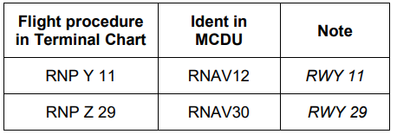  - Due to an FMS limitation on ATR aircraft, the system cannot handle multiple approaches of the same approach type to the same runway (for example: RNP Y 11, RNP Z 11,...). To resolve this, a fictitious runway 12/30 is created and does not affect normal flight operations, the new procedure idents of VVCS airport for ATR aircraft will be updated as follows:
10. REMARK |  |  |  |  | NIL

VVCT/ VCA – CAN THO INTL AIRPORT – CAN THO, VIETNAM
1. AIRPORT CATEGORY: A |  |  |  |  |  |  |  | 2. RFFS CATEGORY: 8
3. AIRPORT CLASSIFICATION
ATR |  | A320 |  |  |  | A321 |  |  | A350 |  |  | B787
AQD |  | AQD |  |  |  | AQD |  |  | AQD |  |  | AQD
4. GENERAL STANDARDS
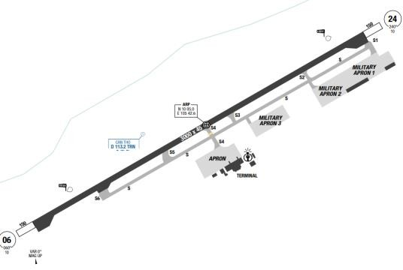
Can Tho airport is a joint military/ civil airport which has two distinct seasons – rainy and dry. The dry season brings reduced visibility in the early morning with haze and easterly winds. The wet season brings frequent thunderstorms with heavy rain showers in the afternoon and strong winds. Large storms can be in the area during the monsoon season.
Departure |  |  | - RNAV SIDs.  - SID with high climb gradient
Arrival and Approach |  |  | - RNAV STARs  - Pilots are responsible for checking the compatibility of flight procedures data.
Taxi |  |  | - Taxi limitations  - 180 degree turn on the runway is forbidden, except on the turning pad. Taxiways S, S1, S2, S3, S5 and S6 are used for military operations only
Parking information |  |  | No
5. TAKE-OFF AND LANDING DISTANCES AVAILABLE
RWY | LENGTH  (m) |  |  | WIDTH  (m) |  |  | TORA  (m) |  |  | LDA  (m) | TODA  (m) |  | ASDA  (m)
06/ 24 | 3000 |  |  | 45 |  |  | 3000 |  |  | 3000 | 3200 |  | 3150
6. ELEVATION: 10ft |  |  |  |  | 7. EOSID: NO
8. IAP: ILS, LOC, RNP, VOR
9. COMPANY NOTE |  |  |  |  | - Bird on Airport  - Visual approaches are normally approved in good weather.  - ASU, AGU, GPU status is updated in Flight Document (MO Plus>Briefing>Specific Flight>Flight Document.
10. REMARK |  |  |  |  | NIL

VVDB/ DIN – DIEN BIEN AIRPORT – VIETNAM
1. AIRPORT CATEGORY: B |  |  |  |  |  |  |  |  | 2. RFFS CATEGORY: 7
3. AIRPORT CLASSIFICATION
ATR |  | A320 |  |  |  |  | A321 |  |  | A350 |  |  | B787
AQD |  | AQD |  |  |  |  | AQD |  |  | N/ A |  |  | N/ A
4. GENERAL STANDARDS
Dien Bien Airport is located in the city of Dien Bien Phu, which is West of Hanoi. The airport is located in the valley surrounding with high mountains. The airport elevation is 1592’. The highest MSA is at the North-East sector of DBN VOR at 9190ft.
In Dien Bien Phu, the wet season is hot, oppressive, and overcast and the dry season is warm and mostly clear. Over the course of the year, the temperature typically varies from 11°C to 33°C and is rarely below 7°C or above 38°C
Departure |  |  | - ATC may request the crew to cancel the SID and follow Radar Vectors northbound, or direct to a relevant waypoint. In these cases, the crew MUST be aware of the MSA for terrain clearance during climb-out. To ensure two-way communication is maintained with relevant agencies, during departure, VVDB ATC will request the flight crew to temporarily communicate with the next frequency to make sure the crew is in contact with ATC, then report back if contact is established. This procedure is performed during either SID or radar vectors. The flight crew should temporarily contact with the next frequency via VHF 2 (VHF 1 is VVDB TWR)  When contact is established via VHF 2, the crew will switch back to VHF 1 to report with VVDB TWR, then change to next frequency on VHF 1. VHF 2 will be returned to 121.5 MHz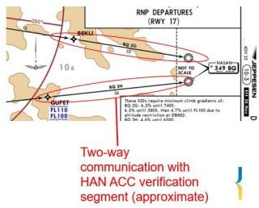  - EOSID available (*)
Arrival and Approach |  |  | - RNAV STARs  - NAP available  - If MLDW needs to be increased to ensure carrying the payload, follow missed approach EOSID procedure with below implementation:  *General  Use LANDING CHART provided in: Mobile Ops Plus > Library > 1.10 RTOW A320_321.  *At dispatch  Use DISPATCH LANDING CHART provided in RTOW folder to determine the Maximum Landing Weight (MLW) at destination (Do nott use Flysmart Landing Module).  *In-flight  - No ECAM ALERT: Determine the MLW using the IN-FLIGHT  - LANDING CHART (Do not use Flysmart Landing Module).  - ECAM ALERT: Anytime during the flight, if an ECAM alert occurs, use both IN-FLIGHT LANDING CHART and FLYSMART on iPad to calculate as follows:  + Step 1: Use In-flight Landing chart (without ECAM ALERT) to determine MLW1.  + Step 2: Use Flysmart In-flight Landing module with:  - The same inputs for In-flight Landing chart;  - ECAM ALERT item;  - GA Gradient %: Min (STD).  Calculate to get MLW2.  + Step 3: MLW is the lower of MLW1 and MLW2.  + For example:  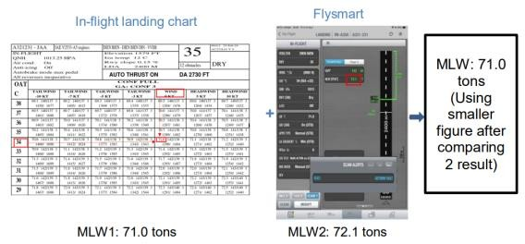
Taxi |  |  | - Single engine taxi out is not permitted.  - Pilots must follow ATC instruction strictly and keep outside vigilance, though taxi instructions are usually simple with just only one taxiway E2 (50ft wide, Cement)
Parking information |  |  | No
5. TAKE-OFF AND LANDING DISTANCES AVAILABLE
RWY | LENGTH  (m) |  |  |  | WIDTH  (m) |  |  | TORA  (m) |  |  | LDA  (m) | TODA  (m) |  | ASDA  (m)
17 | 2400 |  |  |  | 45 |  |  | 2400 |  |  | 2400 | 2700 |  | 2500
35 | 2400 |  |  |  | 45 |  |  | 2400 |  |  | 2400 | 2700 |  | 2400
6. ELEVATION: 1592ft |  |  |  |  |  | 7. EOSID: YES
8. IAP: RNP, VOR
9. COMPANY NOTE |  |  |  | - Captain shall be PF for takeoff and landing.  - When using Fly-smart Takeoff module to calculate takeoff performance Thrust Reduction/ Acceleration heights of A321 should be increased (for example, increase to 2000ft/ 2000ft) to meet a high Minimum All Engine Climb Gradient requirement with a scheduled Take off Weight.  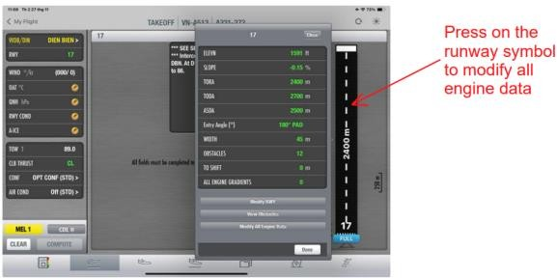  - Fuel is available at VVDB.  - 180° turn is forbidden on the runway, except at the end. There is one backtrack available for RWY17.  - According to the SOP, when a vertical speed of higher than 1000 FPM is required to maintain correct descend profile during approach, a special briefing should be conducted.  - The briefing should include:  + Approach Strategy  + Determination of V/ S on 3.5 degree flight path  - For operation to Dien Bien airport, a thorough TEM briefing should be conducted that required flight crew to identify THREATS that related to such operation.  - For example:  + Strong tailwind on approach;  + High descent angle on final;  + High elevation airport;  + Terrains surrounding airport.  - After identified all possible THREATS, to MANAGE THREATS crew should brief with a contingency plan such as:  + Using early stabilized speed technique;  + Pre-determine ROD required for expected vertical flight path on approach. Crew can use rule of thumb (Ground Speed:60) X Decent Angle 3.5; Landing technique expected for high ROD on final approach; G/ A path at & below MDA (briefed above)  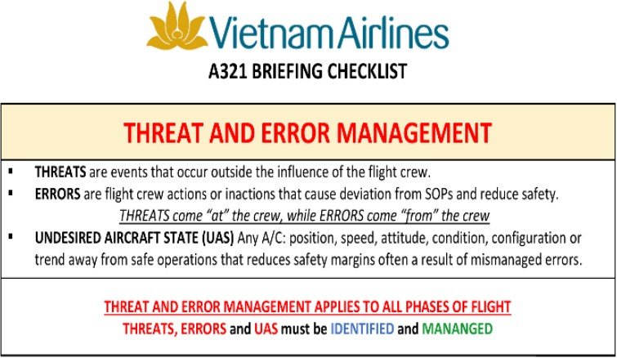  - VNA representative: 0084 23 735366 and 0084 23824948
10. REMARK |  |  |  | NIL

* For airport VVDB, compliance with the special engine-out turn procedure is mandatory. Please follow the EOSID chart in Lido mPilot and the charts below (also available in Lido mPilot – Company Chart – documents login required).

*For Go-around with Engine-out at RWY 17:
Follow EOSID Chart in LIDO mPilot.
*For Go-around with Engine-out at RWY 35 above Engine-out:
Follow EOSID Chart in LIDO mPilot or EOSID Chart below
Note: ACC ALT must be at MAX ACCELERATION HEIGHT in all cases.
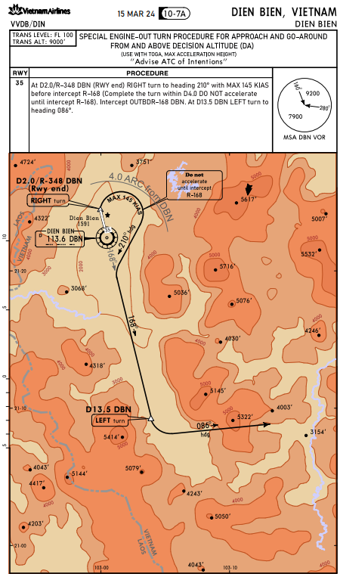
*For Go-around with Engine-out at or below MDA:
Refer to Visual guidance chart below:
Note: ACC ALT must be AT MAX ACCELERATION HEIGHT in all case.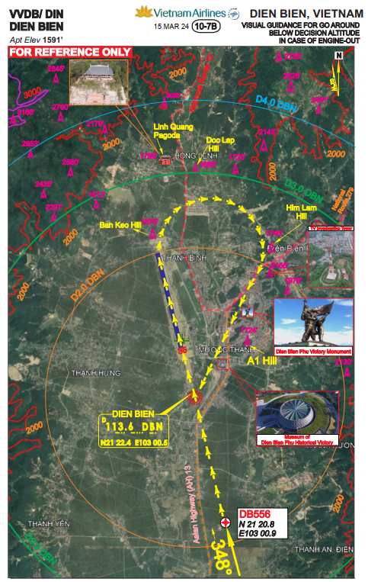

VVDH/ VDH – DONG HOI AIRPORT – QUANG BINH, VIETNAM
1. AIRPORT CATEGORY: A |  |  |  |  |  |  |  | 2. RFFS CATEGORY: 7
3. AIRPORT CLASSIFICATION
ATR |  | A320 |  |  |  | A321 |  |  | A350 |  |  | B787
AQD |  | AQD |  |  |  | AQD |  |  | N/ A |  |  | N/ A
4. GENERAL STANDARDS
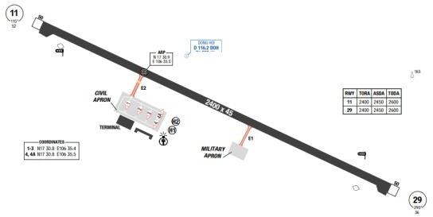
Dong Hoi Airport is located in Loc Ninh commune, 6 km north of Dong Hoi city, which is the capital of Quang Binh province, in North Central Coast, on a sandy area, by the coast of East Sea.Like all provinces in north and north central of Vietnam, there are four distinct seasons in Dong Hoi. In the spring, it is cool, humid and foggy. The city has monsoon climate with three types of wind: south-easterly wind, south-westerly wind and northeast wind.
Departure |  |  | - Conventional and RNAV SIDs.  - Require minimum climb gradients..
Arrival and Approach |  |  | - Conventional and RNAV STARs.  - RWY 29 is mainly used for landing. Radar service is available.  - RWY 29 is up sloped.  - Circling is permitted on the North of the RWY.
Taxi |  |  | - For takeoff from RWY 11 and landing on RWY 29, because of short taxi time, crew should pay attention to observe the minimum engine cooling/ warm up time. After landing, back-track at the end and vacate via E2 to civil apron.
Parking information |  |  | No
5. TAKE-OFF AND LANDING DISTANCES AVAILABLE
RWY | LENGTH  (m) |  |  | WIDTH  (m) |  |  | TORA  (m) |  |  | LDA  (m) | TODA  (m) |  | ASDA  (m)
11/ 29 | 2400 |  |  | 45 |  |  | 2400 |  |  | 2400 | 2600 |  | 2450
6. ELEVATION: 59ft |  |  |  |  | 7. EOSID: YES
8. IAP: ILS, LOC, RNP, VOR
9. COMPANY NOTE |  |  |  |  | - ASU, AGU, GPU status is updated in Flight Document (MO Plus>Briefing>Specific Flight>Flight Document.
10. REMARK |  |  |  |  | NIL

VVDL/ DLI – LIEN KHUONG AIRPORT – LAM DONG, VIETNAM
1. AIRPORT CATEGORY: A |  |  |  |  |  |  |  | 2. RFFS CATEGORY: 7
3. AIRPORT CLASSIFICATION
ATR |  | A320 |  |  |  | A321 |  |  | A350 |  | B787
AQD |  | AQD |  |  |  | AQD |  |  | N/A |  | N/A
4.GENERAL STANDARDS
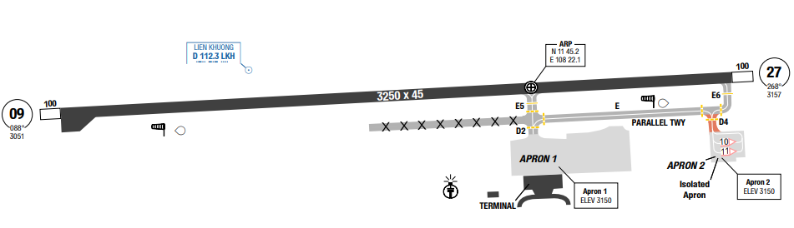
Lien Khuong Airport is located about 30 km south of Da Lat, Lam Dong Province. It is situated in a highly mountainous area, with a lot of surrounding obstacles around, therefore the MSA in all sectors are quite high (from 7900ft to 9500ft) with transition altitude 9000ft.
Due to its location and elevation, Da Lat is often cool for the entire year, with the temperature hardly exceeds 25ºC, and might get down to 10ºC during Night-time. The reference temperature of the airport is 30.9 °C. Weather in this region is also divided into dry and wet season.
Departure |  |  | - Conventional and RNAV SIDs.  - RNAV SID with high require minimum climb gradients (Highest 9.1% on RWY 09)
Arrival and Approach |  |  | - Conventional and RNAV STARs.  - Visual approach is not approved by company.  - The flight and speed profile needs to be closely monitored, taking in account the elevation of this airport and surrounding terrains.  - Respect mandatory altitude constraint.
Taxi |  |  | - When landing on RWY 09 or takeoff from RWY 27, because of short taxi time, crew should pay attention to observe the minimum engine cooling/ warm up time.  - Single engine taxi is not permitted.  - TWY D4 width 18m / 59ft.  - TWY D4 used for ACFT up to code C (MAX wingspan 36m / 118ft) and equivalent
Parking information |  |  | No
5.TAKE-OFF AND LANDING DISTANCES AVAILABLE
RWY | LENGTH  (m) |  |  | WIDTH  (m) |  |  | TORA  (m) |  |  | LDA  (m) |  | TODA  (m) | ASDA  (m)
09 | 3250 |  |  | 45 |  |  | 3250 |  |  | 3250 |  | 3500 | 3350
27 | 3250 |  |  | 45 |  |  | 3250 |  |  | 3250 |  | 3550 | 3350
6. ELEVATION: 3157ft |  |  |  |  | 7. EOSID: YES
8. IAP: ILS, LOC, RNP, VOR
9. COMPANY NOTE |  |  |  |  | - If the landing is conducted by the First Officer, compliance with the requirements specified in FOM-Chapter 8.1.2.5 is mandatory  - RWY 09 is upslope, flight crew need to pay extra caution during landing.  - Airport lighting system is available and operation as follow:  - For night operations: Shall be operated 30 minutes before/ after ETD, 30 minutes before ETA.  - For day operations: Shall be operated when Vis < 4000m or pilot requests.  - Birds in the vicinity of the airport.
10. REMARK |  |  |  |  | NIL

VVDN/ DAD – DA NANG INTL AIRPORT – DA NANG, VIETNAM
1. AIRPORT CATEGORY: A |  |  |  |  |  |  |  | 2. RFFS CATEGORY: 9
3. AIRPORT CLASSIFICATION
ATR |  | A320 |  |  |  | A321 |  |  | A350 |  |  | B787
AQD |  | AQD |  |  |  | AQD |  |  | AQD |  |  | AQD
4. GENERAL STANDARDS
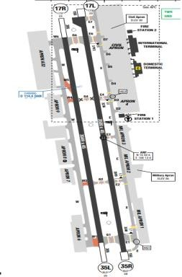
Da Nang airport is located near the coast line, on the South-West side of Da Nang city. There are mountain ranges on the North-West and West of the airport. The SON TRA peninsula is 2283ft-high and at about 5.5 Nm North-East of the ARP. Situating in Central Vietnam, the temperature in Da Nang is high all year around, with the average temperature rarely decreasing below 17ºC. While seasons are divided into almost the country, the exception to this general pattern is the Central area.
Departure |  |  | - Conventional and RNAV SIDs.  - RWY 35R is normally used for departure.  - Intersection departures are approved by CAAV at Da Nang Airport.  - Pilots are required to apply Intersection takeoff as much as possible.  - There are SIDs with high climb gradients. If these SIDs are used in operation, ensure that the all engine climb gradient of aircraft meets the required minimum climb gradient
Arrival and Approach |  |  | - Conventional and RNAV STARs  - RWY 35L is mainly used for landing  - VOR 17L/ R:  - CAAV Approval and simulator training are required for pilots flying the VOR RWY 17L/ R approach.  - This procedure will be used only when there is no military operation at the airport.  - Steep descent gradient on final (3.5 degrees)  - Arrivals from the South are demanding due to the terrain. If the Aircraft is number 1 for approach, flight crew can expect shortcut. In addition to the high terrain, strong tailwinds, normally experienced during the descent, often make the aircraft to be high on profile. Flight crews are required to monitor their flight trajectory very carefully.  - Respect mandatory altitude constraint
Taxi |  |  | - Follow-me car is available O/ R
Parking information |  |  | - Limitation for code D/ E aircraft operating to stand
5.TAKE-OFF AND LANDING DISTANCES AVAILABLE
RWY | LENGTH  (m) |  |  | WIDTH  (m) |  |  | TORA  (m) |  |  | LDA  (m) | TODA  (m) |  | ASDA  (m)
17L | 3500 |  |  | 45 |  |  | 3500 |  |  | 3500 | 3860 |  | 3650
17R | 3049 |  |  | 45 |  |  | 3049 |  |  | 3049 | 3354 |  | 3354
35L | 3049 |  |  | 45 |  |  | 3049 |  |  | 3049 | 3354 |  | 3354
35R | 3500 |  |  | 45 |  |  | 3500 |  |  | 3500 | 3860 |  | 3650
6. ELEVATION: 30ft |  |  |  |  | 7. EOSID: YES
8. IAP: ILS, LOC, RNP, VOR
9. COMPANY NOTE |  |  |  |  | - DA NANG is one of the main bases of VNA.  - DA NANG is joint civil and military use airport, therefore during good weather conditions, there might be military activities.  - When Door L1 on wide-body aircraft (B787 and A350) is not allowed to be used for disembarking, the following solution shall be implemented to avoid inconveniences for Business passenger/ VIP guests. Wide-body aircraft pilots shall ask for parking slots information from ATC or OCCs (via VHF) when preparing to land at DAD. If the aircraft is designated to a parking that do not allow the use of Door L1, pilots shall notify cabin crews of this information. Parking slots that can accommodate wide-body aircraft but do not allow the use of Door L1 for passengers disembarking from all arrival flights at DAD airport are: 14, 16, 18, 20, 21, 22, 23, 25, 27, 28.
10. REMARK |  |  |  |  | Ground Handling Frequency: 129.2 MHz

VVNB/ HAN – NOI BAI INTL AIRPORT – HANOI, VIETNAM
1. AIRPORT CATEGORY: A |  |  |  |  |  | 2. RFFS CATEGORY: 9
3. AIRPORT CLASSIFICATION
ATR | A320 |  |  | A321 |  |  | A350 |  |  | B787
AQD | AQD |  |  | AQD |  |  | AQD |  |  | AQD
4. GENERAL STANDARDS
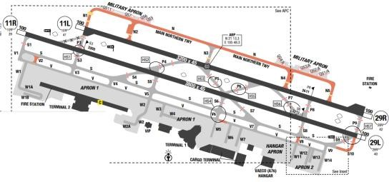
Noi Bai International Airport is located in Hanoi, the capital city of Vietnam. There are mountain ranges situating to the North, North-West, West and South-West of the airport. The highest MSA is in the North-West sector of NOB VOR at 6400ft. Noi Bai airport is in the Northern part of Vietnam, which can be characterized by the presence of four distinct seasons (spring, summer, autumn and winter). During summer months, temperature can reach 41ºC with very high humidity (up to 92%) that makes the climate uncomfortable. An extremely high rate of rainfall can be experienced during this period.
July and August are the two hottest months when typhoons can be often expected. It is also the time of the year when the most adverse thunderstorm activities are present. Unlike the South, thunderstorms in Northern Vietnam can last up to 60 minutes. The winter lasts from around November to April. The temperature during this period may occasionally drop to around 10ºC. February and March are marked with persistent drizzling rain. During this season, the presence of fog is regular, especially in the mornings. The wind in this airport is observed to be stable. From March to August, South-easterly wind is more frequent, while from September to February, the wind blows from North East. Wind speed is normally variable between 2 - 8kt only. Wind speed can gust up to 20kt during rain or thunderstorms.
During the monsoon season, strong crosswinds are common, with the possibility of sudden changes (gusts). Low visibility conditions may also affect operations. This period typically lasts from October to March, with peak intensity from December to February.
Departure |  |  | - A- CDM procedure.  - Conventional and RNAV SIDs.  - There are SIDs with high climb gradients. If these SIDs are used in operation, ensure that the all engine climb gradient of aircraft meets the required minimum climb gradient
Arrival and Approach |  |  | - Conventional and RNAV STARs  - Occasionally, radar vectors are issued.  - During low traffic hours, shortcuts are usually issued. Flight crews are requested to monitor the flight profile closely.  - Speed restriction within Noi Bai TMA
Taxi |  |  | - TWY V2, V8, V10 used for Act up to A321 and equivalent (wingspan up to but not including 118' (36 m)  - TWY S4, S5, S7 one-way use via vacating RWY 11R/ 29L  - Extreme caution must be exercised when applying single-engine taxi-in procedures at VVNB. Single taxi-in is not allowed for parking:  1. A350, B787: 48  2. A321: 48, 71, 72, 73, 74, 79, 80, 81  - To keep appropriate wing tip clearance from the aircraft passing behind, the aircraft should move forward to a position where the stop marking is just invisible in front of the nose from the normal flight deck seating position when the aircraft stop at the stop marking on the TWY.  - Aircraft landing on RWY 11L/29R and vacating via the TWYs (with particular attention to TWY P7) shall hold short of RWY 11R/29L until clearance to cross RWY 11R/29L has been issued by ATC.  - For TWY P3  • When an aircraft is holding at the holding position on TWY P3 for RWY 11L/29R, RWY 11R/29L shall not be used for take-off or landing operations.  • When an aircraft is holding at the holding position on TWY P3 for RWY 11R/29L, RWY 11L/29R shall not be used for take-off or landing operations.  – For TWYs P4, P5, P6, P7, P8 and P9:  • When a Code D aircraft (wingspan less than 52 m) or smaller is holding at the holding position on TWYs P4, P5, P6, P7, P8 or P9 for RWY 11L/29R, RWY 11R/29L may be used for take-off and landing operations.  • When a Code D aircraft (wingspan less than 52 m) or smaller is holding at the holding position on TWYs P4, P5, P6, P7, P8 or P9 for RWY 11R/29L, RWY 11L/29R may be used for take-off and landing operations.  - Two RWY Operation available with 4 option:  + RWY 11L is used for landing, RWY 11R is used for take-off  + RWY 11L is used for take-off, RWY 11R is used for landing.  + RWY 29R is used for landing, RWY 29L is used for take-off.  + RWY 29R is used for take-off, RWY 29L is used for landing.
Parking information |  |  | - Speed restriction when on apron area
5. TAKE-OFF AND LANDING DISTANCES AVAILABLE
RWY | LENGTH  (m) |  |  | WIDTH  (m) | TORA  (m) |  |  | LDA  (m) | TODA  (m) |  | ASDA  (m)
11L | 3200 |  |  | 45 | 3200 |  |  | 3200 | 3600 |  | 3300
11R | 3800 |  |  | 45 | 3800 |  |  | 3800 | 4140 |  | 3900
29L | 3800 |  |  | 45 | 3800 |  |  | 3800 | 4120 |  | 3900
29R | 3200 |  |  | 45 | 3200 |  |  | 3200 | 3600 |  | 3300
6. ELEVATION: 43ft |  | 7. EOSID: NO
8. IAP: ILS (CAT I, II), LOC, VOR
9. COMPANY NOTE |  | - Birds in the vicinity of the airport.  - Intersection departures have been approved by the CAAV. Data for performances are updated on Fly-smart.  - For Arrival: Shut down Left Engine; wait for Ground Power supplied, then Shut down Right Engine.  - For Departure: Start Right Engine First.  - NB airport is used by both civil and military aircraft. Approach and departure may be delayed due to military activities.  - The city is to the South of the airport and must not be overflown.  - When Door L1 on wide-body aircraft (B787 and A350) is not allowed to be used for disembarking, the following solution shall be implemented to avoid inconveniences for Business passenger/ VIP guests.  - Wide-body aircraft pilots shall ask for parking slots information from ATC or OCCs (via VHF) when preparing to land at HAN. If the aircraft is designated to a parking that do not allow the use of Door L1, pilots shall notify cabin crews of this information. Parking slots that can accommodate wide-body aircrafts but do not allow the use of Door L1 for passenger disembarking at HAN airport are:  - Domestic arrival flight: Parking slots from 36 to 52.  - International arrival flight: Parking slots 17A, 18A, 18B.  - Two RWY Operation instruction:  + When an aircraft lined up on the RWY receives a take-off clearance, the flight crew shall acknowledge the clearance promptly and commence the take-off roll within 10 seconds for Code C aircraft (e.g. A320, A321) and within 15 seconds for Code D aircraft and above (e.g. A350, B787), measured from the time the take-off clearance is acknowledged. If unable to comply, the flight crew shall immediately inform Noi Bai TWR.  + Flight crews shall complete the applicable Standard Operating Procedures (SOPs) while taxiing to the RWY holding position to ensure the aircraft is ready to accept a take-off clearance without delay.  + At the RWY holding position, after receiving a line-up instruction or an immediate take-off clearance, the flight crew shall complete any remaining SOP items so as to minimise actions required after entering the RWY.  + Unless instructed to line up and wait or issued a conditional line-up clearance, the flight crew shall be prepared to commence take-off without stopping after entering the RWY. Upon receipt of a take-off clearance, the take-off roll shall be initiated without delay.  + When an immediate take-off clearance is issued, the flight crew shall:  • If holding at the RWY holding position, line up and commence the take-off roll without stopping;  • If already lined up on the RWY, commence the take-off roll without delay;  • If unable to comply, immediately advise ATC.
10. REMARK |  | Ground Handling Frequency: 129.7 MHz

VVPB/ HUI – PHU BAI INTL AIRPORT – THUA THIEN HUE, VIETNAM
1. AIRPORT CATEGORY: A |  |  |  |  |  |  |  | 2. RFFS CATEGORY: 7
3. AIRPORT CLASSIFICATION
ATR |  | A320 |  |  |  | A321 |  |  | A350 |  |  | B787
AQD |  | AQD |  |  |  | AQD |  |  | AQD |  |  | AQD
4. GENERAL STANDARDS
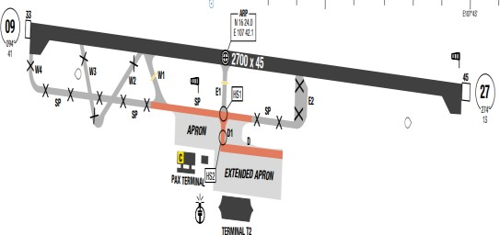
The airport is located near the coastline with surrounding mountains to the West, South-West and South. Noi Bai can be characterized by the presence of four distinct seasons. During summer months, temperature can reach 41ºC and 92% humidity that makes the climate uncomfortable. An extremely high rate of rainfall can be experienced during this period July and August are the two hottest months when typhoon or adverse thunderstorm activities can be often unexpected.
Departure |  |  | - Conventional and RNAV SIDs.SID with high climb gradient  - SID are issued and adhered to. Preferential runway for departure is RWY 09 but a request can be made for RWY 27 if conditions permit  - Strictly adhere to departure procedures, do not turn South early due to high terrain.
Arrival and Approach |  |  | - Conventional and RNAV STARs  - RWY 27 is up-sloped.  - Visual approach is normally approved during daytime in good weather.  - Arrivals from the South are subjected to higher altitudes due to the terrain South and West of the airport. Descent below 8000Ft will not be granted unless you are within 15DME from HUE VOR. Even then, clearance will only be given to 7000Ft until you are overhead the VOR/ NDB and commencing the approach.
Taxi |  |  | - When landing on runway 27, it is not recommended to vacate via the E1 taxiway right away, as the brake and tyre wear increases while the engines still need time to cool down
Parking information |  |  | No
5. TAKE-OFF AND LANDING DISTANCES AVAILABLE
RWY | LENGTH  (m) |  |  | WIDTH  (m) |  |  | TORA  (m) |  |  | LDA  (m) | TODA  (m) |  | ASDA  (m)
09 | 2700 |  |  | 45 |  |  | 2700 |  |  | 2700 | 2840 |  | 2745
27 | 2700 |  |  | 45 |  |  | 2700 |  |  | 2700 | 2870 |  | 2733
6. ELEVATION: 49ft |  |  |  |  | 7. EOSID: YES
8. IAP: ILS, LOC, RNP, VOR
9. COMPANY NOTE |  |  |  |  | - If the landing is conducted by the First Officer, compliance with the requirements specified in FOM-Chapter 8.1.2.5 is mandatory
10. REMARK |  |  |  |  | NIL

VVPC/ UIH–PHU CAT AIRPORT–BINH DINH, VIETNAM
1. AIRPORT CATEGORY: A |  |  |  |  |  |  |  | 2. RFFS CATEGORY: 6
3. AIRPORT CLASSIFICATION
ATR |  | A320 |  |  |  | A321 |  |  | A350 |  |  | B787
AQD |  | AQD |  |  |  | AQD |  |  | N/ A |  |  | N/ A
4. GENERAL STANDARDS
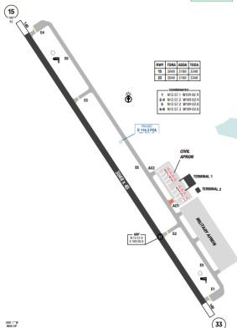
Phu Cat Airport is the airport serving Quy Nhon, Vietnam. It is in Phu Cat District, around 30kilometersnorthest of Quy Nhon within Binh Dinh province, along the South-Central Coast of Vietnam. Raising terrains are to the West and to the South of the airport. The highest MSA is to the South sector of PCA VOR at 6100ft.Weather conditions in VVPC are generally good during the year. Highest temperature was recorded during summer was 42ºC. Average precipitation days annually are 90 days, mostly from SEP to NOV.
Departure |  |  | - Conventional and RNAV SIDs.  - In good WX, flight crews are often cleared for visual departure. If visual departure is issued, be vigilant of terrain before turning.  - SID with high climb gradient
Arrival and Approach |  |  | - Conventional and RNAV STARs  - RNP approaches for RWY15 include steep descent gradient on final (3.5 degree), early stabilized approach technique is recommended.
Taxi |  |  | - Single engine taxi NOT permitted
Parking information |  |  | No
5. TAKE-OFF AND LANDING DISTANCES AVAILABLE
RWY | LENGTH  (m) |  |  | WIDTH  (m) |  |  | TORA  (m) |  |  | LDA  (m) | TODA  (m) |  | ASDA  (m)
15/ 33 | 3048 |  |  | 45 |  |  | 3048 |  |  | 3048 | 3348 |  | 3188
6. ELEVATION: 98ft |  |  |  |  | 7. EOSID: YES
8. IAP: ILS, LOC, RNP, VOR
9. COMPANY NOTE |  |  |  |  | ASU, AGU, GPU status is updated in Flight Document (MO Plus>Briefing>Specific Flight>Flight Document.
10. REMARK |  |  |  |  | NIL

VVPK/ PXU – PLEIKU AIRPORT – GIA LAI, VIETNAM
1. AIRPORT CATEGORY: A |  |  |  |  |  |  |  | 2. RFFS CATEGORY: 7
3. AIRPORT CLASSIFICATION
ATR | A320 |  |  |  |  | A321 |  |  | A350 |  | B787
AQD | AQD |  |  |  |  | AQD |  |  | N/ A |  | N/ A
4. GENERAL STANDARDS
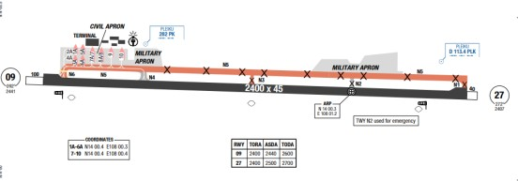
Pleiku Airport is located near the city of Pleiku within Gia Lai Province in Southern Vietnam.
This airport belongs to the Central Highlands region of Vietnam. There are multiple areas of high terrain surrounding the airport, with the highest MSA being 8100’ to the North sector of PLK VOR.
There are two distinct wet and dry seasons in Pleiku. Wet season lasts from April to late October, thunderstorm appears frequently with heavy raining as well as CB clouds. During the dry season from November to March, strong gusting winds are frequently encountered
Departure |  |  | - Conventional and RNAV SIDs. SID with high climb gradient
Arrival and Approach |  |  | - Conventional and RNAV STARs  - Runway 27 upslope  - Due to high airport elevation, flight crew should be aware of stabilized altitude.
Taxi |  |  | - Due to short taxi in and out time, flight crews shall pay attention to the minimum engine cooling and warm-up time.  - When taxiing to line up for departure, flight crew must follow strictly yellow line depicted on the RWY.
Parking information |  |  | - N4, N6 are available for aircrafts up to A321 and equivalent.
5. TAKE-OFF AND LANDING DISTANCES AVAILABLE
RWY |  | LENGTH  (m) |  | WIDTH  (m) |  |  | TORA  (m) |  |  | LDA  (m) | TODA  (m) | ASDA  (m)
15 |  | 3048 |  | 45 |  |  | 2600 |  |  | 2400 | 2600 | 2440
33 |  | 3048 |  | 45 |  |  | 2700 |  |  | 2400 | 2700 | 2500
6. ELEVATION: 2441ft |  |  |  |  | 7. EOSID: YES
8. IAP: ILS, LOC, RNP, VOR
9. COMPANY NOTE |  |  |  |  | - Birds on the airport.
10. REMARK |  |  |  |  | NIL

VVPQ/ PQC – PHU QUOC INTL AIRPORT – KIEN GIANG, VIETNAM
1. AIRPORT CATEGORY: A |  |  |  |  |  |  |  | 2.RFFS CATEGORY: 9
3. AIRPORT CLASSIFICATION
ATR |  | A320 |  |  |  | A321 |  |  | A350 |  |  | B787
AQD |  | AQD |  |  |  | AQD |  |  | AQD |  |  | AQD
4. GENERAL STANDARDS
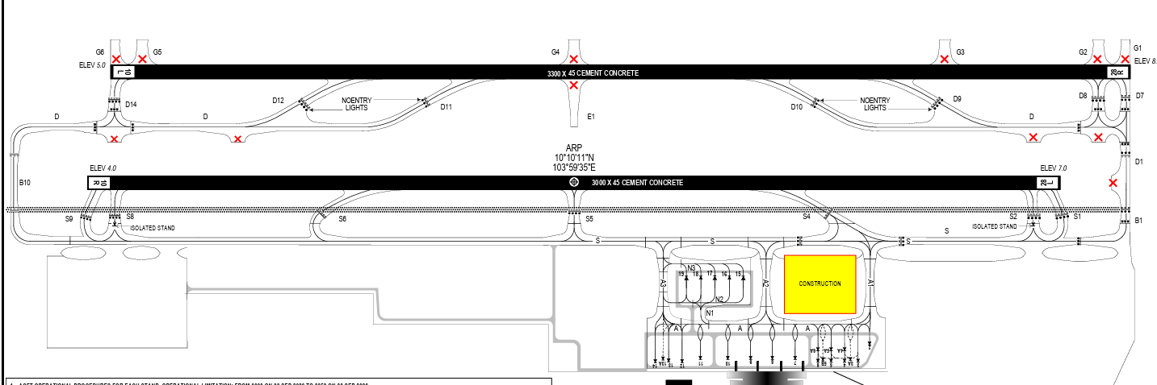
Phu Quoc airport is located south of the Phu Quoc Island which is largest island in Viet Nam
The island's monsoonal sub-equatorial climate is characterized by distinct rainy (June to November) and dry seasons (December to May). The annual rainfall is high, averaging 2,879 millimetres. In the northern mountains, up to 4,000 millimetres of precipitation has been recorded. April and May are the hottest months, with temperature exceeding 35 °C.
Departure |  |  | - Conventional and RNAV SIDs.
Arrival and Approach |  |  | - Conventional and RNAV STARs
Taxi |  |  | - Single Engine Taxi is not permitted.  - TWY A2 only used for ACFT up to code C (A320/ 1) and equivalent.
Parking information |  |  | No
5. TAKE-OFF AND LANDING DISTANCES AVAILABLE
RWY | LENGTH  (m) |  |  | WIDTH  (m) |  |  | TORA  (m) |  |  | LDA  (m) | TODA  (m) |  | ASDA  (m)
10R | 3000 |  |  | 45 |  |  | 3000 |  |  | 3000 | 3140 |  | 3000
28L | 3000 |  |  | 45 |  |  | 3000 |  |  | 3000 | 3230 |  | 3000
10L/ 28R | 3300 |  |  | 45 |  |  | 3300 |  |  | 3300 | 3700 |  | 3300
6. ELEVATION: 23ft |  |  |  |  | 7. EOSID: YES
8. IAP: ILS, LOC, RNP, VOR
9. COMPANY NOTE |  |  |  |  | - Visual approach is normally approved in good weather condition.  - Flight crew should be aware of the soft spots on the surface of the airport. High power might be required.  - ASU, AGU, GPU status is updated in Flight Document (MO Plus>Briefing>Specific Flight>Flight Document.  - RWY 10R/28L shall be available for take-off operations only and used as an alternative RWY of 10L/28R.
10. REMARK |  |  |  |  | NIL

VVRG/ VKG – RACH GIA AIRPORT – KIEN GIANG, VIETNAM
1. AIRPORT CATEGORY: A |  |  |  |  |  |  |  | 2. RFFS CATEGORY: 5
3. AIRPORT CLASSIFICATION
ATR |  | A320 |  |  |  | A321 |  |  | A350 |  | B787
AQD |  | N/ A |  |  |  | N/ A |  |  | N/ A |  | N/ A
4. GENERAL STANDARDS
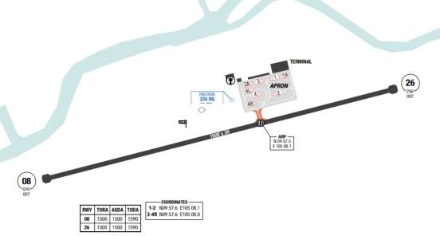
Rach Gia Airport is located in Rach Gia, Vietnam, to the north-east of Rach Gia city. The terrain around the airport is generally flat, with the highest MSA at the North sector from RG NDB at 3200ft.
Rach Gia has a tropical climate with significant rainfall most months and a short dry season. The temperature here averages 27.0 °C. Precipitation in Rach Gia is about 2296 mm on average. The least amount of rainfall occurs in February. The average in this month is 14 mm. In September, the precipitation reaches its peak, with an average of 360 mm.
Departure |  |  | - Conventional and RNAV SIDs.
Arrival and Approach |  |  | - Conventional and RNAV STARs.  - When approach is RWY 08, the aircraft will face directly to the sun (early morning flight) on short final, affect to the visual of pilots.  - For NDB RWY 08 and 26: Final approach track is 2 degrees offset from extended runway centerline.
Taxi |  |  | - Single engine taxi is not permitted  - 180o turn is forbidden on the runway, except at the end.
Parking information |  |  | No
5. TAKE-OFF AND LANDING DISTANCES AVAILABLE
RWY | LENGTH  (m) |  |  | WIDTH  (m) |  |  | TORA  (m) |  |  | LDA  (m) |  | TODA  (m) | ASDA  (m)
08/ 26 | 1500 |  |  | 30 |  |  | 1590 |  |  | 1500 |  | 1590 | 1590
6. ELEVATION: 7ft |  |  |  |  | 7. EOSID: NO
8. IAP: NDB, RNP, VOR
9. COMPANY NOTE |  |  |  |  | - Shortcuts are occasionally provided by ATC during low traffic periods which may leave the aircraft high on profile. Crews are requested to take extra caution when radar vectored.  - Delays can be expected during peak hours due to apron congestion.  - Prohibited area to the south of airport VV (P) – 4  - When Door L1 on wide-body aircrafts (B787 and A350) is not allowed to be used for disembarking, the following solution shall be implemented to avoid inconveniences for Business passenger/ VIP guests.  - Wide-body aircraft pilots shall ask for parking slots information from ATC or OCCs (via VHF) when preparing to land at SGN. If the aircraft is designated to a parking slot that do not allow the use of Door  - If the landing is conducted by the First Officer, compliance with the requirements specified in FOM-Chapter 8.1.2.5 is mandatory
10. REMARK |  |  |  |  | NIL

VVTH/ TBB – TUY HOA AIRPORT – PHU YEN, VIETNAM
1. AIRPORT CATEGORY: A |  |  |  |  |  |  |  | 2. RFFS CATEGORY: 6
3. AIRPORT CLASSIFICATION
ATR |  | A320 |  |  |  | A321 |  |  | A350 |  |  | B787
AQD |  | AQD |  |  |  | AQD |  |  | N/ A |  |  | N/ A
4. GENERAL STANDARDS
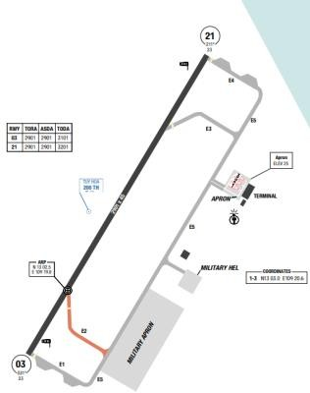
The airport is located on the seashore, about 5km to the south of Tuy Hoa city, along the central coast of southern Vietnam. There are high elevating mountains on the North, Northwest and Southwest of the airport. Strong crosswind is usually encountered during landing. With local thunderstorms, the low clouds base and visibility can be expected. From May to October, the airport will have fog and mist in the early morning
Departure |  |  | - If there is no wind limitation, RWY 03 is preferential for takeoff  - SID with high climb gradient.
Arrival and Approach |  |  | - Conventional and RNAV STARs.  - RWY21 is preferential.  - RNP approaches for RWY03 include steep descent gradient on final (3.5 degree), with final course is offset 15 degrees from extended runway center line
Taxi |  |  | - Single-engine taxiing is not permitted.  - Simple taxi procedures to and from the apron
Parking information |  |  | No
5. TAKE-OFF AND LANDING DISTANCES AVAILABLE
RWY | LENGTH  (m) |  |  | WIDTH  (m) |  |  | TORA  (m) |  |  | LDA  (m) | TODA  (m) |  | ASDA  (m)
03/ 21 | 2901 |  |  | 45 |  |  | 3101 |  |  | 2901 | 3101 |  | 3101
6. ELEVATION: 26ft |  |  |  |  | 7. EOSID: YES
8. IAP: ILS, LOC, RNP, VOR
9. COMPANY NOTE |  |  |  |  | - ASU, AGU, GPU status is updated in Flight Document (MO Plus>Briefing>Specific Flight>Flight Document.
10. REMARK |  |  |  |  | NIL

VVTS/ SGN - HO CHI MINH (TAN SON NHAT ITNL) – VIETNAM
1. AIRPORT CATEGORY: A |  |  |  |  |  |  |  |  | 2. RFFS CATEGORY: 9
3. AIRPORT CLASSIFICATION
ATR |  | A320 |  |  |  | A321 |  |  |  | A350 |  |  | B787
AQD |  | AQD |  |  |  | AQD |  |  |  | AQD |  |  | AQD
4. GENERAL STANDARDS
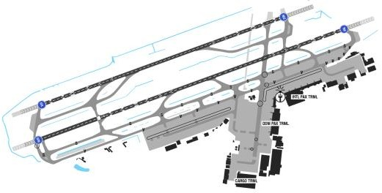
Tan Son Nhat International Airport (IATA: SGN, ICAO: VVTS), is the largest airport in Vietnam. It is located 4 mi (6 km) north of the center (District 1) of Ho Chi Minh City.
Ho Chi Minh City has a distinct dry season and rainy season. The rainy season extends from May to November, often accompanied by thunderstorms (CB), strong gusts, and wind shear (WS), particularly during the onset of convective activity. The dry season runs from November to March, with strong crosswinds and frequent variations in wind direction and speed. Additionally, year-round high temperatures contribute to increased convective activity, resulting in higher atmospheric instability, especially in terminal areas, which may lead to less stable approach conditions.

Departure |  |  | - There are SIDs with high climb gradients. If these SIDs are used in operation, ensure that the all engine climb gradient of aircraft meets the required minimum climb gradient  - RWY 25L/ 07L is normally used for take-off ACFT.  - Intersection take-offs are approved by the CAAV. Data for performance are updated.
Arrival and Approach |  |  | - RNAV STARs  - RWY 25R/ 07R is normally used for landing ACFT.  - Speed restrictions on arrival.
Taxi |  |  | - Maximum time to vacate RWY is 60s  - If unable to vacate P4/ 5 (25R) and S5/ 6 (07R), must be notified to ATC when A/ C on final.
Parking information |  |  | - Extreme caution must be exercised when applying single-engine taxi-in procedures at VVTS. The list of parking/ gates which flight crews are not allowed to perform single-engine taxi-in consists of: Parking 23, 24, 25, 44, 45, 46, 52, 53, 54.  - Caution: Stand 97 sometimes are unable to align with IRS
5. TAKE-OFF AND LANDING DISTANCES AVAILABLE
RWY | LENGTH  (m) |  |  | WIDTH  (m) |  |  |  | TORA  (m) |  |  | LDA  (m) | TODA  (m) |  | ASDA  (m)
07L | 3050 |  |  | 45 |  |  |  | 3050 |  |  | 3050 | 3360 |  | 3360
07R | 3828 |  |  | 45 |  |  |  | 3828 |  |  | 3059 | 4128 |  | 3978
25L | 3828 |  |  | 45 |  |  |  | 3828 |  |  | 3828 | 4128 |  | 3948
25R | 3050 |  |  | 45 |  |  |  | 3050 |  |  | 3050 | 3360 |  | 3253
6. ELEVATION: 33ft |  |  |  |  |  |  | 7. EOSID: YES
8. IAP: ILS, LOC, RNP, VOR
9. COMPANY NOTE |  |  |  |  | - Shortcuts are occasionally provided by ATC during low traffic periods which may leave the aircraft high  on profile. Crews are requested to take extra caution when radar vectored.  - Delays can be expected during peak hours due to apron congestion.  - Prohibited area to the south of airport VV (P) – 4  - When Door L1 on wide-body aircrafts (B787 and A350) is not allowed to be used for disembarking, the following solution shall be implemented to avoid inconveniences for Business passenger/ VIP guests. Wide-body aircraft pilots shall ask for parking slots information from ATC or OCCs (via VHF) when preparing to land at SGN. If the aircraft is designated to a parking slot that do not allow the use of Door L1, pilots shall notify cabin crews of this information. Parking slots that can accommodate wide body aircrafts but do not allow the use of Door L1 for passenger disembarking at SGN airport are as below:  Domestic arrival flight: Parking slots 9, 15, 16, 17, 18, 19, 20, 21, 22. For B787-9, B787-10, parking slots 4, 5, 6, 7 also do not allow the use of Door L1.  - International arrival flight: Parking slots 4, 5, 6, 7.
10. REMARK |  |  |  |  | Ground Handling Frequency: 129.7 MHz

VVTX/ THD – THO XUAN AIRPORT – THANH HOA, VIETNAM
1. AIRPORT CATEGORY: A |  |  |  |  |  |  |  |  | 2. RFFS CATEGORY: 7
3. AIRPORT CLASSIFICATION
ATR | A320 |  |  |  |  | A321 |  |  |  | A350 |  |  | B787
AQD | AQD |  |  |  |  | AQD |  |  |  | N/A |  |  | N/A
4. GENERAL STANDARDS
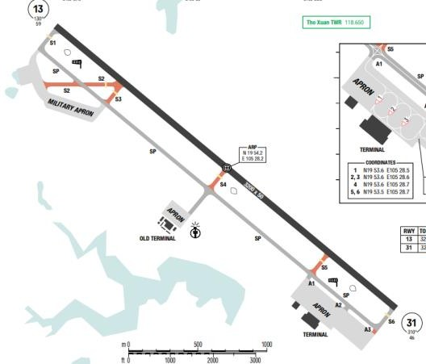
Tho Xuan Airport is an airport located in Sao Vang town in Tho Xuan District, Thanh Hoa Province, 45 km northwest of the provincial capital Thanh Hoa. The airport is currently operated by Vietnam People's Air Force (VPAF).
The airport is surrounded by high hills with the highest MSA is 7300ft to the NW-SW sector.
Possessing a marginal humid subtropical climate, bordering on a tropical savanna climate (Aw), Thanh Hoa city has four seasons with two distinctive hot and cold atmospheres in a year.
Departure |  |  | - Conventional and RNAV SIDs.  - SID with high climb gradient
Arrival and Approach |  |  | - Conventional and RNAV STARs.  - Expect ILS W approach RW 31.  - Respect mandatory altitude constraint.
Taxi |  |  | - Taxiways S1, S2, S3 and SP (a portion from taxiway S1 to taxiway S3) available for both civil and military flight ops.
Parking information |  |  | No
5. TAKE-OFF AND LANDING DISTANCES AVAILABLE
RWY |  | LENGTH  (m) |  | WIDTH  (m) |  |  | TORA  (m) |  |  |  | LDA  (m) | TODA  (m) |  | ASDA  (m)
13/ 31 |  | 3200 |  | 50 |  |  | 3500 |  |  |  | 3200 | 3500 |  | 3500
6. ELEVATION: 59ft |  |  |  |  |  |  |  | 7. EOSID: YES
8. IAP: ILS, LOC, RNP, VOR
9. COMPANY NOTE |  |  |  |  | - Night operation subject to DEP/ ARR plan in accordance with granted flight permission.  - ASU, AGU, GPU status is updated in Flight Document (MO Plus>Briefing>Specific Flight>Flight Document.
10. REMARK |  |  |  |  | NIL

VVVD/ VDO - QUANG NINH (VAN DON) – VIETNAM
1. AIRPORT CATEGORY: A |  |  |  |  |  |  |  | 2. RFFS CATEGORY: 9
3. AIRPORT CLASSIFICATION
ATR |  | A320 |  |  |  | A321 |  |  | A350 |  | B787
AQD |  | AQD |  |  |  | AQD |  |  | AQD |  | AQD
4. GENERAL STANDARDS
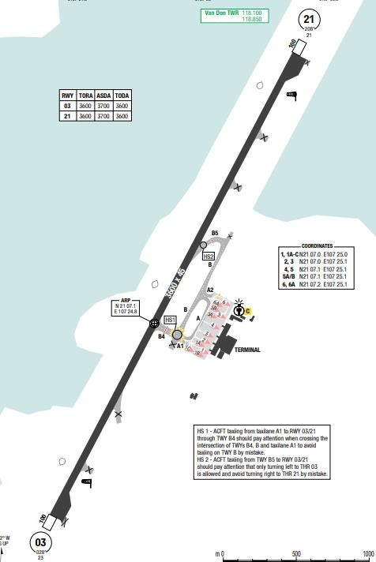
Van Don International Airport is an airport in Van Don District, Quang Ninh Province, Vietnam, the home to World Heritage Ha Long Bay. It is located about 50 km away from Ha Long and 20 km from Cam Pha. The wet season is warm, oppressive and overcast, the dry season is comfortable, humid, windy and mostly clear. Over the course of the year, the temperature typically varies from 14°C to 30°C. The area experiences extreme seasonal variation in monthly rainfall. The heaviest rainfalls are during August. The least rainfalls are during February. The windier part of the year lasts for almost 6 months, from September to March. The calmer time of year lasts for 6 months, from March to September.

Departure |  |  | - Conventional and RNAV SIDs.  - Require minimum climb gradients.
Arrival and Approach |  |  | - Conventional and RNAV STARs.
Taxi |  |  | - Turn pad on RWY is used for A/ c code E or equivalent.  - Arriving aircraft will be allocated a stand NBR by Van Don TWR.
Parking information |  |  | - Visual Docking Guidance System (VDGS) at VDO is available at stands NR 02 and NR 03 (limited speed must be complied to avoid overshoot)
5. TAKE-OFF AND LANDING DISTANCES AVAILABLE
RWY | LENGTH  (m) |  |  | WIDTH  (m) |  |  | TORA  (m) |  |  | LDA  (m) |  | TODA  (m) | ASDA  (m)
03/ 21 | 3600 |  |  | 45 |  |  | 3600 |  |  | 3600 |  | 3600 | 3600
6. ELEVATION: 26ft |  |  |  |  | 7. EOSID: YES
8. IAP: ILS, LOC, RNP, VOR
9. COMPANY NOTE |  |  |  |  | NIL
10. REMARK |  |  |  |  | NIL

VVVH/ VII – VINH AIRPORT – NGHE AN, VIETNAM
1. AIRPORT CATEGORY: A |  |  |  |  |  |  |  | 2. RFFS CATEGORY: 7
3. AIRPORT CLASSIFICATION
ATR |  | A320 |  |  |  | A321 |  |  | A350 |  |  | B787
AQD |  | AQD |  |  |  | AQD |  |  | N/A |  |  | N/A
4. GENERAL STANDARDS
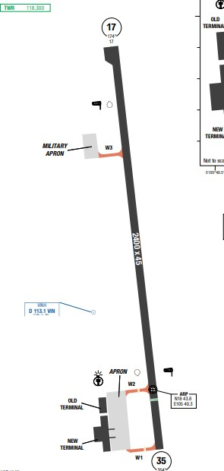
VVVH is in the Northern Central part of Vietnam. There is significant difference in weather at Vinh.
The summer and winter weather are quite distinct. From April to October, summertime, the temperature and humidity are high making the climate uncomfortable. Temperatures can reach 40ºC in October. During wintertime, temperature can drop to 13ºC. The wind during summertime is from the West. Sometimes, wind can blow South-West or North- West. Low temperature with light wind in the morning makes Fog is common during the winter quite often closing the airport all day. VINH is located on the coastline with some high ground to the North, South and West. High terrain is on the South-West of the airport. There is a hill located on final approach to RWY 17
Departure |  |  | - Conventional and RNAV SIDs.  - SID with high climb gradient
Arrival and Approach |  |  | - Conventional and RNAV STARs  - Runway 17 is preferential for landing.  - Caution should be exercised as there are a lot of high terrains on the final approach course which can trigger GPWS warning.  - Respect mandatory altitude constraint
Taxi |  |  | - Single engine taxi is not permitted  - In case of landing RWY17 or takeoff RWY35, because of short taxi time, crew should pay attention to observe the minimum engine cooling/ warm up time.
Parking information |  |  | No
5. TAKE-OFF AND LANDING DISTANCES AVAILABLE
RWY | LENGTH  (m) |  |  | WIDTH  (m) |  |  | TORA  (m) |  |  | LDA  (m) | TODA  (m) |  | ASDA  (m)
17 | 2400 |  |  | 45 |  |  | 2550 |  |  | 2400 | 2550 |  | 2550
35 | 2400 |  |  | 45 |  |  | 2700 |  |  | 2100 | 2700 |  | 2700
6. ELEVATION: 20ft |  |  |  |  | 7. EOSID: YES
8. IAP: ILS, LOC, RNP, VOR
9. COMPANY NOTE |  |  |  |  | - Visual approach is normally approved in good weather.
10. REMARK |  |  |  |  | NIL

VYMD/ MDL – MANDALAY INTL AIRPORT – MANDALAY, MYANMAR
1. AIRPORT CATEGORY: A |  |  |  |  |  |  |  |  | 2. RFFS CATEGORY: 9
3. AIRPORT CLASSIFICATION
ATR |  | A320 |  |  |  | A321 |  | A350 |  |  |  | B787
AQD |  | AQD |  |  |  | AQD |  | AQD |  |  |  | AQD
4. GENERAL STANDARDS
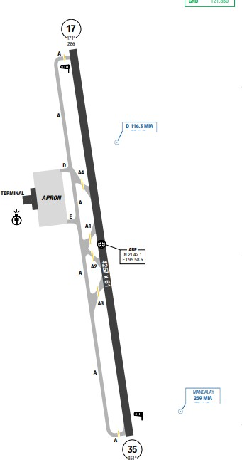
Mandalay International Airport located 35 km south of Mandalay in Tada-U, is one of only three international airports in Myanmar. Mandalay features noticeably warmer and cooler periods of the year. Average temperatures in January, the mildest month, hovers around 21 °C while the hottest month, April, averages 31 °C. Mandalay is very hot in the months of April and May, with average high temperatures easily exceeding 35 °C. It is not uncommon to see high temperatures surpass 40 °C during these two months in the city.
Departure |  |  | - RNAV SIDs.  - Requires minimum climb gradients.
Arrival and Approach |  |  | - RNAV STARs.  - Speed restrictions.
Taxi |  |  | - This a small airport with one runway and simple taxi ways.
Parking information |  |  | No
5. TAKE-OFF AND LANDING DISTANCES AVAILABLE
RWY | LENGTH  (m) |  |  | WIDTH  (m) |  |  | TORA  (m) |  |  | LDA  (m) | TODA  (m) |  | ASDA  (m)
17/ 35 | 4267 |  |  | 61 |  |  | 4267 |  |  | 4267 | 4267 |  | 4267
6. ELEVATION: 301ft |  |  |  |  | 7. EOSID: NO
8. PBN : ILS, LOC, NDB, RNP,VOR
9. COMPANY NOTE |  |  |  |  | NIL
10. REMARK |  |  |  |  | NIL

VYYY/ RGN – YANGON INTAL AIRPORT – YANGON, MYANMAR
1. AIRPORT CATEGORY: A |  |  |  |  |  |  |  | 2. RFFS CATEGORY: 9
3. AIRPORT CLASSIFICATION
ATR |  | A320 |  |  |  | A321 |  |  | A350 |  |  | B787
AQD |  | AQD |  |  |  | AQD |  |  | AQD |  |  | AQD
4. GENERAL STANDARDS
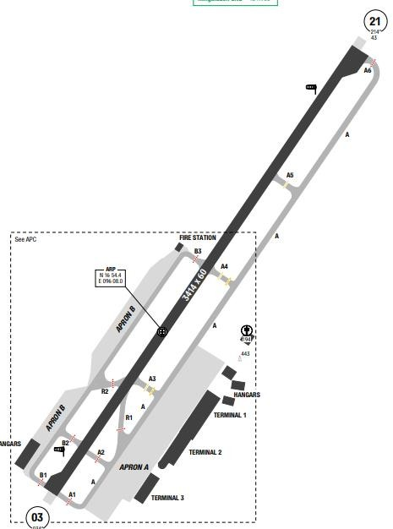
Kota Kinabalu Airport is an international airport in Kota Kinabalu, the state capital of Sabah, Malaysia. It is located approximately 8 km southwest of the city centre. Two distinct seasons (rainy and dry) exist in Yangon. From April to October is the frequent presence of showering rainfalls. In July is when the precipitation is the heaviest, sometimes lasting throughout the month. During the period of November until March of the following year, thunderstorms and rains rarely happen. During the dry season, rain can come together with thunderstorm, especially in the afternoon, that results in very gusty wind, sometimes 45kt gusting and risk of windshear
Departure |  |  | - RNAV SIDs.  - Requires minimum climb gradients.
Arrival and Approach |  |  | - RNAV STARs.  - All landing traffic keep rolling to the end of Rwy for entering TWY A.  - When landing and taking-off from the RWY 21: Threshold of RWY 03 cannot be seen until a/ c approaches within a distance of 492’-820’ from it.
Taxi |  |  | - Taxi here is very simple with parallel taxiway A which can lead to main apron from both RWY ends.  - All non-shedule flight shall be guided by follow me car upon apron A or B  - Single Engine Taxi is not permitted.
Parking information |  |  | - Parking periods exceeding 3h, only upon approval by AOCC
5. TAKE-OFF AND LANDING DISTANCES AVAILABLE
RWY | LENGTH  (m) |  |  | WIDTH  (m) |  |  | TORA  (m) |  |  | LDA  (m) | TODA  (m) |  | ASDA  (m)
03/ 21 | 3414 |  |  | 60 |  |  | 3414 |  |  | 3414 | 3414 |  | 3414
6. ELEVATION: 110ft |  |  |  |  | 7. EOSID: NO
8. IAP: ILS, LOC, RNP, VOR
9. COMPANY NOTE |  |  |  |  | - Meteorological information: refer to Yangon airport for infor.  - Contact OCC or VNA representative at Yangon for support.
10. REMARK |  |  |  |  | NIL

WAAA/ UPG - MAKASSAR (SULTAN HASANUDDIN) – INDONESIA
- AIRPORT CATEGORY: A |  |  |  |  |  |  | - RFFS CATEGORY: 9
- AIRPORT CLASSIFICATION
ATR |  | A320 |  | A321 |  |  | A350 |  | B787
AQD |  | AQD |  | AQD |  |  | AQD |  | AQD
4. GENERAL STANDARDS
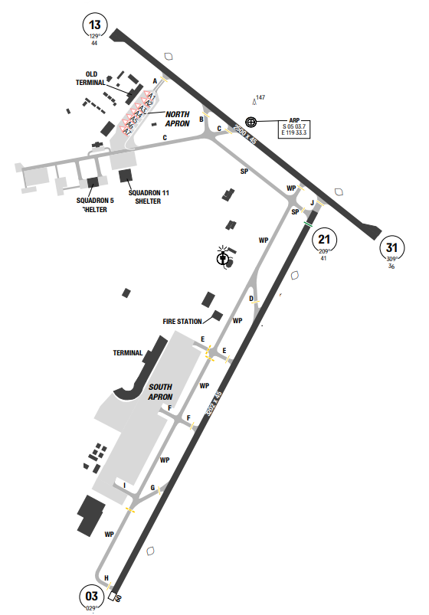
Sultan Hasanuddin International Airport is located on the border of Makassar and Maros, a suburb in South Sulawesi, approximately 15 minutes 20 km from Makassar city via freeway/ tollway or 20 minutes 23 km via highway. There is high terrain to the East of the Airport. The highest MSA is at the SouthEast sector of MAK VOR, with one portion reaching up to 11800ft. In Makassar, overcast cloud is common during the wet season, the dry season is partly cloudy, and it is hot and oppressive year round. Over the course of the year, the temperature typically varies from 22°C to 33°C and is rarely below 21°C or above 35°C.
Departure |  |  | - Conventional and RNAV SIDs.
Arrival and Approach |  |  | - Conventional and RNAV STARs.  - EXPECTED: ILS RWY 03/ 21
Taxi |  |  | .- Standard Taxiing Routes
Parking information |  |  | No
5. TAKE-OFF AND LANDING DISTANCES AVAILABLE
RWY | LENGTH  (m) |  |  | WIDTH  (m) |  | TORA  (m) |  | LDA  (m) |  | TODA  (m) | ASDA  (m)
03 | 3100 |  |  | 45 |  | 3202 |  | 3202 |  | 3500 | 3202
21 | 3100 |  |  | 45 |  | 3160 |  | 4000 |  | 3390 | 3160
13/ 31 | 2500 |  |  | 45 |  | 2560 |  | 2560 |  | 2650 | 2560
6. ELEVATION: 44ft |  |  |  |  | 7. EOSID: NO
8. IAP: ILS, LOC, RNP, VOR
9. COMPANY NOTE |  |  |  |  | NIL
10. REMARK |  |  |  |  | NIL

WADD/DPS – BALI (I GUSTI NGURAH RAI INTL) – INDONESIA
1. AIRPORT CATEGORY: A |  |  |  |  |  |  |  | 2. RFFS CATEGORY: 9
3. AIRPORT CLASSIFICATION
ATR |  | A320 |  |  |  | A321 |  |  | A350 |  |  | B787
ADQ |  | ADQ |  |  |  | ADQ |  |  | ADQ |  |  | ADQ
4. GENERAL STANDARDS
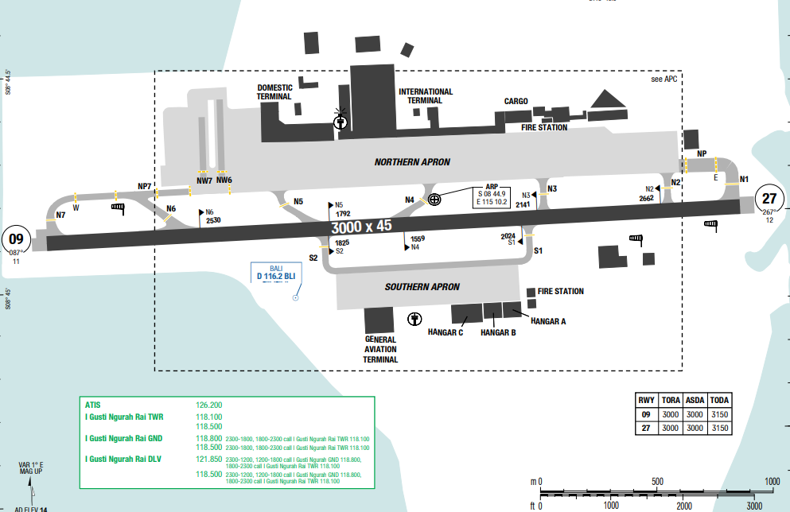
I Gusti Ngurah Rai International Airport is located near the southern tip of Bali Island, located 13 km south of Denpasar. Ngurah Rai is the second busiest airport in Indonesia after Soekarno–Hatta International Airport. The island measures 80 NM from the West to the East and 45 NM from the North to the South. A series of volcanoes form a mountain range that extends the length of the island. The southern slope is gentler, descending to form an alluvial plain at the island’s southern end. The airport’s runway crosses a narrow isthmus. The volcano, Mt. Agung, rises to 9827 feet MSL 31 NM northeast of the airport.
Caution: kites may be present in the airport vicinity up to 2500 feet AGL. Wildlife and birds are present in the airport vicinity.
The highest MSA is at the North sector of the ARP, at 9700ft.
Departure |  |  | - Pilot shall request ATC Clearance to Ngurah Ground Control on initial contact at least 20 minutes before estimated off-block time.  - Aircraft shall request the clearance for pushback within 15 minutes before and after estimated off-block time.  - RNAV SIDs are available.  - Special Engine-Out turn procedures available for runway 09.
Arrival and Approach |  |  | - RNAV STARs.  - Comply with speed restrictions during arrival.
Taxi |  |  | - Taxi instructions are straightforward. Simple taxi routes to and from the apron
Parking information |  |  | - Parking 16 - 27 are usually used for VNA aircrafts
5. TAKE-OFF AND LANDING DISTANCES AVAILABLE
RWY | LENGTH  (m) |  |  | WIDTH  (m) |  |  | TORA  (m) |  |  | LDA  (m) | TODA  (m) |  | ASDA  (m)
09/27 | 3000 |  |  | 45 |  |  | 3000 |  |  | 3000 | 3150 |  | 3000
6. ELEVATION: 11ft |  |  |  |  | 7. EOSID: YES
8. IAP: ILS, RNP, VOR
9. COMPANY NOTE |  |  |  |  | - RWY CLSD daily 2100-2130 and every TUE 1800-2300.  - Expect delays BTN 0900-0915 due RWY inspection.
10. REMARK |  |  |  |  | NIL

WADL/LOP – ZAINUDDIN ABDUL MADJID INTL AIRPORT – PRAYA, INDONESIA
1. AIRPORT CATEGORY: A |  |  |  |  |  |  |  | 2. RFFS CATEGORY: 7
3. AIRPORT CLASSIFICATION
ATR |  | A320 |  |  |  | A321 |  |  | A350 |  |  | B787
ADQ |  | ADQ |  |  |  | ADQ |  |  | N/A |  |  | N/A
4. GENERAL STANDARDS
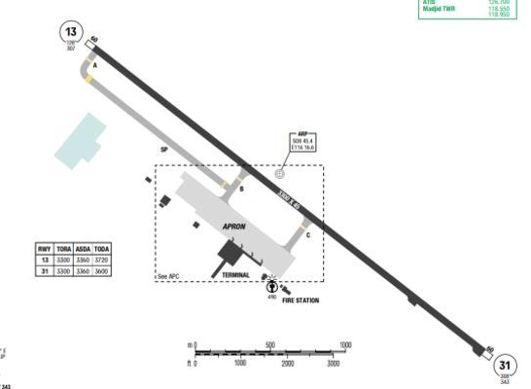
Juanda Airport is located along the Madura Strait on Java’s northern coast. This island is in Southern Indonesia. The Java Sea is to the North while the Indian Ocean is to the South. Java Island measures 574NM from east to west with a maximum width of 110NM. A series of volcanoes, commonly rising between 8000 and 12000ft MSL, form a belt that extends the full length of the island. And surrounding the immediate airport area is flat with extensive fishponds along the shoreline and rice paddies further inland.
Departure |  |  | - RNAV SIDs.  - Taking off without delay, if unable to comply must report to ATC
Arrival and Approach |  |  | - RNAV STARs.  - Speed restriction on ARR
Taxi |  |  | - ACFT shall taxi in/ out of RWY via TWY A, B and SP.  - Follow guidelines until holding point B.)
Parking information |  |  | No
5. TAKE-OFF AND LANDING DISTANCES AVAILABLE
RWY | LENGTH  (m) |  |  | WIDTH  (m) |  |  | TORA  (m) |  |  | LDA  (m) | TODA  (m) |  | ASDA  (m)
13 | 3300 |  |  | 45 |  |  | 3300 |  |  | 3300 | 3720 |  | 3360
31 | 3300 |  |  | 45 |  |  | 3300 |  |  | 3300 | 3620 |  | 3360
6. ELEVATION: 343ft |  |  |  |  | 7. EOSID: NO
8. IAP:
9. COMPANY NOTE |  |  |  |  | - RWY inspection daily from 2100-2120 and 0750-0810.  - Birds and dogs on and in vicinity of AD.  - RWY 13/31 right- and left-hand circuit or by ATC.
10. REMARK |  |  |  |  | NIL

WARR/ SUB – JUANDA AIRPORT – SURABAYA, INDONESIA
1. AIRPORT CATEGORY: A |  |  |  |  |  |  |  | 2. RFFS CATEGORY: 8
3. AIRPORT CLASSIFICATION
ATR |  | A320 |  |  |  | A321 |  |  | A350 |  |  | B787
ADQ |  | ADQ |  |  |  | ADQ |  |  | ADQ |  |  | ADQ
4. GENERAL STANDARDS
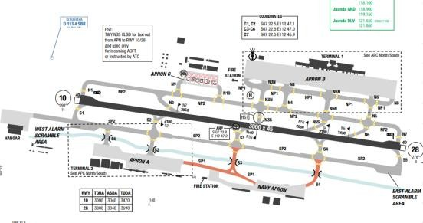
Juanda Airport is located along the Madura Strait on Java’s northern coast. This island is in Southern Indonesia. The Java Sea is to the North while the Indian Ocean is to the South. Java Island measures 574NM from east to west with a maximum width of 110NM. A series of volcanoes, commonly rising between 8000 and 12000ft MSL, form a belt that extends the full length of the island. And surrounding the immediate airport area is flat with extensive fishponds along the shoreline and rice paddies further inland.
Departure |  |  | - RNAV SIDs.  - Taking off without delay, if unable to comply must report to ATC
Arrival and Approach |  |  | - RNAV STARs.  - Speed restriction on ARR
Taxi |  |  | - Minimum runway occupation time (Use rapid exit taxi way)
Parking information |  |  | No
5. TAKE-OFF AND LANDING DISTANCES AVAILABLE
RWY | LENGTH  (m) |  |  | WIDTH  (m) |  |  | TORA  (m) |  |  | LDA  (m) | TODA  (m) |  | ASDA  (m)
10 | 3000 |  |  | 45 |  |  | 3000 |  |  | 3000 | 3470 |  | 3040
28 | 3000 |  |  | 45 |  |  | 3000 |  |  | 3000 | 3690 |  | 3040
6. ELEVATION: 11ft |  |  |  |  | 7. EOSID: NO
8. IAP:
9. COMPANY NOTE |  |  |  |  | - Runway upslope results in short runway feeling. Perform landing and roll-out with care.  - No Ground Air-conditioning unit.  - GPU, Air-starter are available.  - Strictly follow Glide slope, if not, it is very easy to trigger EGPWS Caution/ Warning due to terrain below.
10. REMARK |  |  |  |  | NIL

WBGG/ KCH - KUCHING INTERNATIONAL AIRPORT, KUCHING, MALAYSIA
- AIRPORT CATEGORY: A |  |  |  |  |  |  | - RFFS CATEGORY: 9
- AIRPORT CLASSIFICATION
ATR |  | A320 |  | A321 |  |  | A350 |  | B787
ADQ |  | ADQ |  | ADQ |  |  | ADQ |  | ADQ
4. GENERAL STANDARDS
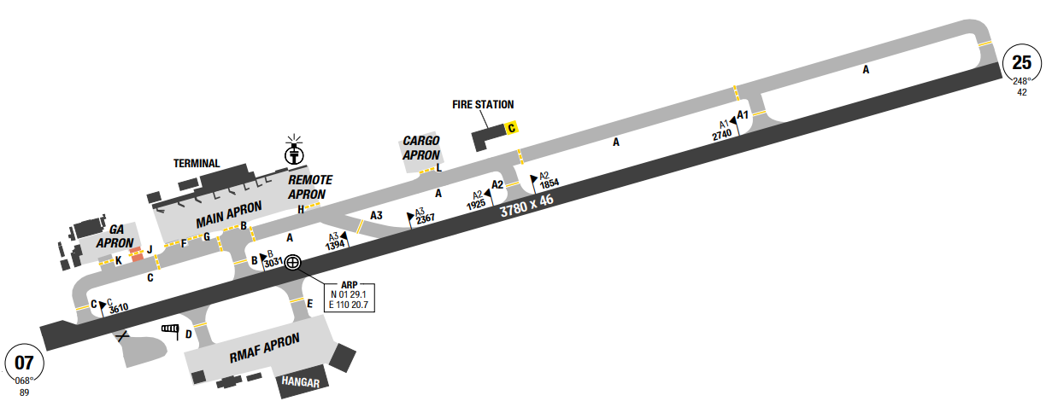
Kuching has a tropical rainforest climate moderately hot but very humid at times and receives substantial rainfall. The average annual rainfall is approximately 4,200 mm.
The wettest times are during the North-East Monsoon months of November to February and the city's driest months are June through August. The temperature in Kuching ranges from 19 °C to 36 °C but the average temperature is around 23 °C in the early hours of the morning and rises to around 33 °C during mid-afternoon.
This temperature stays almost constant throughout the year if it is not affected by the heavy rain and strong winds during the early hours of the morning which can bring the temperature down to 19 °C but this is very rare
Departure |  |  | - Request ATC clearance 5 mins before start-up  - RNAV SIDs.  - Contact Kuching radar 120.2 immediately before  2000’ unless instructed otherwise.  - Standard Initial altitude 6000’  - Require minimum climb gradients.
Arrival and Approach |  |  | - RNAV STAR available
Taxi |  |  | - Aircraft upon landing Rwy 25 and vacating via Twy A3 shall NOT make right turn onto A.  - For full code C aircraft movements at bay 2 or bay 3 with either parking bay 2 or bay 3 already occupied with code C aircraft, a wingman shall be present to guide aircraft to ensure wingtip clearance during aircraft operation on ground.  - No wide body aircraft is allowed to park at bay 8 and 9 when bay 8L is occupied. Follow marshaller.
Parking information |  |  | - When bays 5, 7, 8, 10 and 11 are occupied, no aircraft is allowed to be parked at bays SR, 7R, 8L, 8R, 10A, 10B, 11A and 11B.
5. TAKE-OFF AND LANDING DISTANCES AVAILABLE
RWY | LENGTH  (m) |  |  | WIDTH  (m) |  | TORA  (m) |  | LDA  (m) |  | TODA  (m) | ASDA  (m)
07 | 3780 |  |  | 46 |  | 3780 |  | 3780 |  | 3780 | 3780
25 | 3780 |  |  | 46 |  | 3780 |  | 3780 |  | 3840 | 3780
6. ELEVATION: 89ft |  |  |  |  | 7. EOSID: NO
8. IAP: ILS, LOC, RNP, VOR
9. COMPANY NOTE |  |  |  |  | - Birds in the vicinity of the airport.
10. REMARK |  |  |  |  | NIL

WBKK/ BKI – KOTA KINABALU AIRPORT, KOTA KINABALU, MALAYSIA
- AIRPORT CATEGORY: A |  |  |  |  |  |  | - RFFS CATEGORY: 9
- AIRPORT CLASSIFICATION
ATR |  | A320 |  | A321 |  |  | A350 |  | B787
ADQ |  | ADQ |  | ADQ |  |  | ADQ |  | ADQ
4. GENERAL STANDARDS
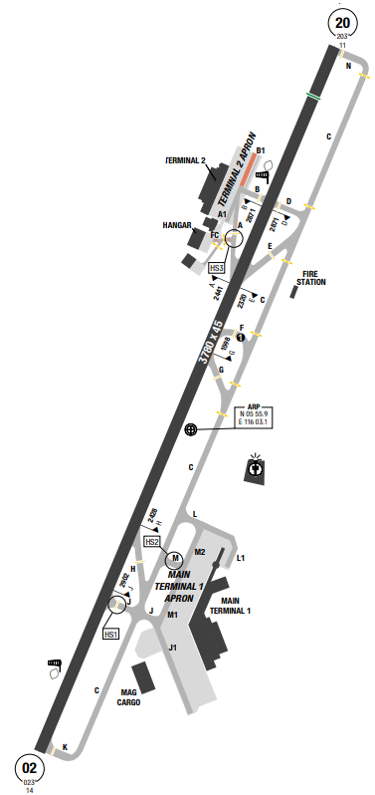
Kota Kinabalu features a tropical monsoon climate (Am) with constant high temperatures, and a considerable amount of rain and high humidity throughout the course of the year. Two prevailing monsoons characterize the climate of this part of Sabah are the Northeast Monsoon and the Southwest Monsoon. The Northeast Monsoon occurs between November and March, while the Southwest Monsoon occurs between May and September. There are also two successive inter-monsoons from April to May and from September to October.
The climate in Kota Kinabalu is hot, oppressive, and overcast. Over the course of the year, the temperature typically varies from 24°C to 32°C and is rarely below 22°C or above 34°C
Departure |  |  | - RNAV SIDs are available.  - SID with high climb gradient
Arrival and Approach |  |  | - RNAV STARs are available.
Taxi |  |  | - TWY F available day operations only.  - For aircraft parking at Bay No 6,6A and 6B, aircraft to taxi in via Taxiway J only.
Parking information |  |  | - Apron at terminal 02 will be used only for cargo and general aviation.
5. TAKE-OFF AND LANDING DISTANCES AVAILABLE
RWY | LENGTH  (m) |  |  | WIDTH  (m) |  | TORA  (m) |  | LDA  (m) |  | TODA  (m) | ASDA  (m)
02/ 20 | 3780 |  |  | 45 |  | 3780 |  | 3780 |  | 3780 | 3780
6. ELEVATION: 14ft |  |  |  |  | 7. EOSID: NO
8. IAP: ILS, LOC, RNP, VOR
9. COMPANY NOTE |  |  |  |  | - Birds in the vicinity of the airport.  - RWY 02/ 20 closed every Tue between 1845-2115.  - Pilots landing RWY 20 or departing RWY 02 must not overfly the city of Kota Kinabalu.
10. REMARK |  |  |  |  | NIL

WBSB/ BWN – BRUNEI INTERNATIONAL, BANDAR SERI BEGAWAN, BRUNEI
- AIRPORT CATEGORY: A |  |  |  |  |  |  | - RFFS CATEGORY: 9
- AIRPORT CLASSIFICATION
ATR |  | A320 |  | A321 |  |  | A350 |  | B787
ADQ |  | ADQ |  | ADQ |  |  | ADQ |  | ADQ
4. GENERAL STANDARDS
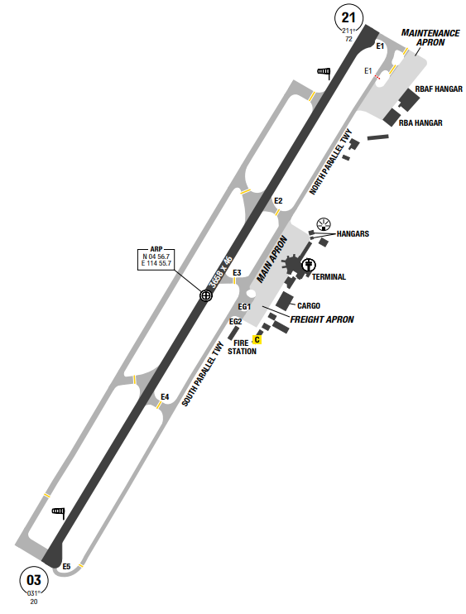
Brunei International airport is the primary airport in the nation of Brunei. It serves as the home base for Royal Brunei Airlines. The Royal Brunei Air Force is also based at the Rimba Air Base, which is located within the airport's area.
MSA of the airport is from 3000ft to the highest 3500ft (at the souhthern quadrants of the airport)
The climate in Bandar Seri Begawan is hot, oppressive, and overcast. Over the course of the year, the temperature typically varies from 23°C to 32°C and is rarely below 21°C or above 34°C
Departure |  |  | - No SID available.
Arrival and Approach |  |  | - No STAR available  - Pilots are advised to exercise caution during APPR to RWY 03 and departure from RWY 21 due to turbulence and the formation of low stratus type of cloud caused by a turbine-power plant situated 1.2 NM on RWY 03 final approach..
Taxi |  |  | - This a small airport with one runway and simple taxi ways
Parking information |  |  | No
5. TAKE-OFF AND LANDING DISTANCES AVAILABLE
RWY | LENGTH  (m) |  |  | WIDTH  (m) |  | TORA  (m) |  | LDA  (m) |  | TODA  (m) | ASDA  (m)
03/ 21 | 3658 |  |  | 46 |  | 3658 |  | 3658 |  | 3993 | 3658
6. ELEVATION: 73ft |  |  |  |  | 7. EOSID: NO
8. IAP: ILS, LOC, NDB, VOR
9. COMPANY NOTE |  |  |  |  | - Birds in the vicinity of the airport.
10. REMARK |  |  |  |  | NIL

WIDD/ BTH – HANG NADIM AIRPORT – BATAM, INDONESIA
1. AIRPORT CATEGORY: A |  |  |  |  |  |  |  | 2. RFFS CATEGORY: 9
3. AIRPORT CLASSIFICATION
ATR |  | A320 |  |  |  | A321 |  |  | A350 |  |  | B787
ADQ |  | ADQ |  |  |  | ADQ |  |  | ADQ |  |  | ADQ
4. GENERAL STANDARDS
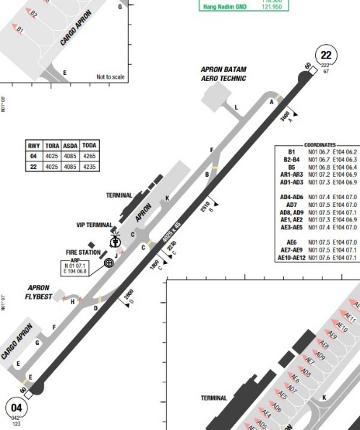
Hang Nadim International Airport, also known as Bandara International Hang Nadim, is located in Batam, Riau Islands, Indonesia. Named after the famous Laksamana Hang Nadim, it is the only airport on the island. Surrounding terrains are quite flat with the highest MSA at only 2200ft to the east side. Batam has a tropical climate with average temperatures between 26-32 °C. Humidity in the region ranges from 73% to 96%.The region has a wet season from November to April and a dry season from May to October. Average annual rainfall is around 2,600 mm.
Departure |  |  | - Request ATC clearance 20 mins before start.  - Conventional SIDs.
Arrival and Approach |  |  | - Conventional STARs.
Taxi |  |  | - Taxi routes for departure and arrival are available.
Parking information |  |  | No
5. TAKE-OFF AND LANDING DISTANCES AVAILABLE
RWY | LENGTH  (m) |  |  | WIDTH  (m) |  |  | TORA  (m) |  |  | LDA  (m) | TODA  (m) |  | ASDA  (m)
04/ 22 | 4025 |  |  | 45 |  |  | 4025 |  |  | 4025 | 4265 |  | 4085
6. ELEVATION: 123ft |  |  |  |  | 7. EOSID: NO
8. IAP: ILS, LOC, RNP, VOR
9. COMPANY NOTE |  |  |  |  | NIL
10. REMARK |  |  |  |  | NIL

WIHH/ HLP – HALIM PERDANAKUSUMA – JAKARTA, INDONESIA
1. AIRPORT CATEGORY: A |  |  |  |  |  |  |  | 2. RFFS CATEGORY: 9
3. AIRPORT CLASSIFICATION
ATR |  | A320 |  |  |  | A321 |  |  | A350 |  |  | B787
ADQ |  | ADQ |  |  |  | ADQ |  |  | ADQ |  |  | ADQ
4. GENERAL STANDARDS
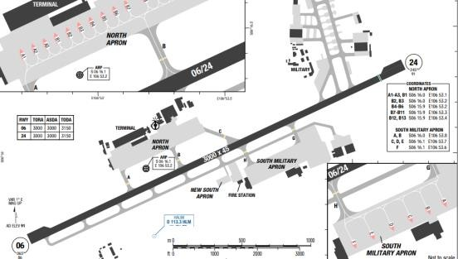
Halim Perdanakusuma Airport is located in East Jakarta in the Indonesian capital Jakarta. Java Sea is north of the airport, highest MSA is to the south with 6900ft.
Departure |  |  | - RNAV SIDs  - Expect radar vector for departure.
Arrival and Approach |  |  | - RNAV STARs
Taxi |  |  | - Wide body aircraft shall make 180° turn on RWY turning area only when taxiing back track.  - All ACFT are not allowed make one wheel lock- turn on RWY
Parking information |  |  | No
5. TAKE-OFF AND LANDING DISTANCES AVAILABLE
RWY | LENGTH  (m) |  |  | WIDTH  (m) |  |  | TORA  (m) |  |  | LDA  (m) | TODA  (m) |  | ASDA  (m)
06/ 24 | 3000 |  |  | 45 |  |  | 3000 |  |  | 3000 | 3150 |  | 3000
6. ELEVATION: 84ft |  |  |  |  | 7. EOSID: NO
8. IAP: ILS, LOC, NDB, RNP, VOR
9. COMPANY NOTE |  |  |  |  | - This airport is used as alternate for CGK airport.
10. REMARK |  |  |  |  | NIL

WIII/ CGK – SOEKARNO-HATTA INTL AIRPORT – JAKARTA, INDONESIA
1. AIRPORT CATEGORY: A |  |  |  |  |  |  |  | 2. RFFS CATEGORY: 9
3. AIRPORT CLASSIFICATION
ATR |  | A320 |  |  |  | A321 |  |  | A350 |  |  | B787
ADQ |  | ADQ |  |  |  | ADQ |  |  | ADQ |  |  | ADQ
4. GENERAL STANDARDS
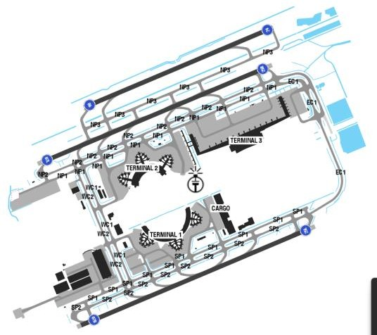
Soekarno-Hatta International Airport is located in southern Indonesia near the northwestern coast of Java Island. Java is part of the Greater Sunda Islands in southern Indonesia and is 570 NM long from east to west, by 110 NM wide. A chain of active volcanic mountains, with many peaks rising between 5000 and 12,000 feet MSL, traverse the island's length. Bali Island is directly to the east while Sunda Strait is to the west, and the Indian Ocean is to the south. The airport is in a low alluvial plain about 25 NM wide. This plain is prone to flooding during periods of heavy rainfall. Jakarta Bay is 5 NM to the northeast. To the south, Salak Mountain rises to 7277 feet MSL within 35 NM.
Obstruction to visibility, mostly due to smoke/ haze, averages 23 days per month throughout the year. Broken ceilings are the predominant sky condition throughout the year
Departure |  |  | - RNAV SIDs  - Clearance delivery will give a specific SID for departure, however radar vector normally given by tower for all departure traffic.  - For DEP, must contact Delivery 25 minutes before push back.  - Initial level is given by Delivery and Final level is informed by Jakarta ACC  - Pilot shall contact Approach control unit immediately after airborne.
Arrival and Approach |  |  | - Speed restrictions
Taxi |  |  | - Minimum runway occupation time.  - The airport has a published standard taxi route.
Parking information |  |  | - G15-G18 in terminal 3 area
5. TAKE-OFF AND LANDING DISTANCES AVAILABLE
RWY | LENGTH  (m) |  |  | WIDTH  (m) |  |  | TORA  (m) |  |  | LDA  (m) | TODA  (m) |  | ASDA  (m)
06 | 3000 |  |  | 60 |  |  | 3000 |  |  | 3000 | 3400 |  | 3000
07L | 3600 |  |  | 60 |  |  | 3600 |  |  | 3600 | 4000 |  | 3660
07R/ 25L | 3660 |  |  | 60 |  |  | 3660 |  |  | 3660 | 4060 |  | 3720
24 | 3000 |  |  | 60 |  |  | 3000 |  |  | 3000 | 3060 |  | 3000
25R | 3600 |  |  | 60 |  |  | 3000 |  |  | 3000 | 3960 |  | 3660
6. ELEVATION: 34ft |  |  |  |  | 7. EOSID: NO
8. IAP: ILS, LOC, RNP
9. COMPANY NOTE |  |  |  |  | - Bird activity in vicinity of AD, pilots are requested to be vigilant and file a bird strike report form to  AIS/ BO  - Prior permission from apt authorities required for non-scheduled aircraft due to limited aircraft  parking.  - Captain has to do transit check procedure.  - The PAPI for RWY 25R/ 07L is hard to see and were reported to be giving varying indications.  - High volume of traffic should be expected on the radio frequency (ATC tend to speak very fast, be  prepared for encounter an overlapping radio COM)
10. REMARK |  |  |  |  | Ground Handling Frequency: 131.95 MHz

WIPP/ PLM – SULTAN MAHMUD BADARUDDIN II AIRPORT – PALEMBANG, INDONESIA
1. AIRPORT CATEGORY: A |  |  |  |  |  |  |  | 2. RFFS CATEGORY: 8
3. AIRPORT CLASSIFICATION
ATR |  | A320 |  |  |  | A321 |  |  | A350 |  |  | B787
ADQ |  | ADQ |  |  |  | ADQ |  |  | ADQ |  |  | ADQ
4. GENERAL STANDARDS
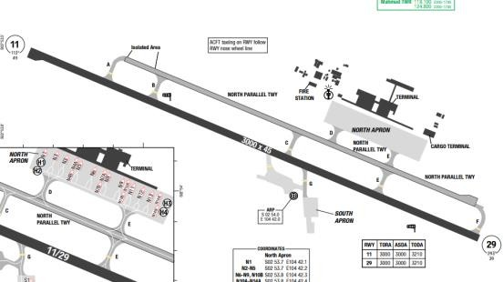
Sultan Mahmud Badaruddin II Airport is an international airport serving the city of Palembang, South Sumatra and surrounding areas. Palembang is generally flat, with the MSA from PLB VOR reaching 1500’. Only a small portion of the land area of the city sees significant elevation, namely in the northern part of town.
Palembang has a tropical rainforest climate with relatively high humidity and occasional strong winds. The temperature ranges from 23.4 to 31.7 degrees Celsius. Annual rainfall ranges from 2000 mm to 3000 mm. During the months when the humidity is at its peak, the city's marshlands are routinely inundated. The temperature stays at a constant value throughout the city.
Departure |  |  | - RNAV SIDs.
Arrival and Approach |  |  | - RNAV STARs.
Taxi |  |  | No
Parking information |  |  | No
5. TAKE-OFF AND LANDING DISTANCES AVAILABLE
RWY | LENGTH  (m) |  |  | WIDTH  (m) |  |  | TORA  (m) |  |  | LDA  (m) | TODA  (m) |  | ASDA  (m)
11/ 29 | 3000 |  |  | 45 |  |  | 3210 |  |  | 3210 | 3210 |  | 3210
6. ELEVATION: 49ft |  |  |  |  | 7. EOSID: NO
8. IAP: ILS, LOC, RNP, VOR
9. COMPANY NOTE |  |  |  |  | - Contact OCC or VNA representative at CGK for support.  - This airport is alternate for CGK and SIN.
10. REMARK |  |  |  |  | NIL

WMKA/ AOR – SULTAN ABDUL HALIM AIRPORT – ALOR SETAR, MALAYSIA
1. AIRPORT CATEGORY: A |  |  |  |  |  |  |  | 2. RFFS CATEGORY: 7
3. AIRPORT CLASSIFICATION
ATR |  | A320 |  |  |  | A321 |  |  | A350 |  |  | B787
ADQ |  | ADQ |  |  |  | ADQ |  |  | N/ A |  |  | N/ A
4. GENERAL STANDARDS
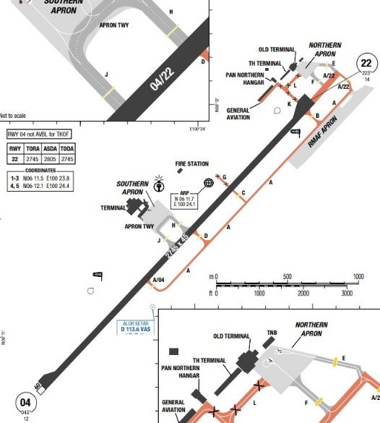
Sultan Abdul Halim Airport is an airport that serves Alor Setar, a city in the state of Kedah in Malaysia. The airport is adjacent to the sea on the South-West to North-West sector. The surrounding terrains are hilly with highest MSA at 5500ft to the South.
Alor Setar features a tropical rainforest climate, which brings a very lengthy wet season. As is common in several regions with this climate, precipitation is seen even during the short dry season. Temperatures are relatively consistent throughout the course of the year, with average high temperature around 32 degrees Celsius and average low temperature around 23 degrees Celsius. Alor Setar sees on average roughly 2300 mm of precipitation per year
Departure |  |  | - Conventional and RNAV SIDs for RWY22  - ONLY RWY 22 is available for takeoff.
Arrival and Approach |  |  | - Conventional and RNAV SIDs for RWY04  - ONLY RWY 04 is available for landing.
Taxi |  |  | - All ACFT are not allowed to make locked-wheel turn on runway.
Parking information |  |  | - There are only 3 parking bays for civil aircraft.  - Apron is limited to code E and below
5. TAKE-OFF AND LANDING DISTANCES AVAILABLE
RWY | LENGTH  (m) |  |  | WIDTH  (m) |  |  | TORA  (m) |  |  | LDA  (m) | TODA  (m) |  | ASDA  (m)
04 | 2745 |  |  | 45 |  |  | 2745 |  |  | 2745 | 2745 |  | 2745
22 | 2745 |  |  | 45 |  |  | 2745 |  |  | 2745 | 2805 |  | 2805
6. ELEVATION: 15ft |  |  |  |  | 7. EOSID: NO
8. IAP: ILS, LOC, RNP, VOR
9. COMPANY NOTE |  |  |  |  | - Contact OCC or VNA representative at KUL for support.  - Upon reaching the parking bay, flight crews are requested to confirm with the ground personnel whether the flaps need to be retracted, to avoid risks of collision with the refueling vehicles.
10. REMARK |  |  |  |  | NIL

WMKJ/ JHB – SENAI INTL AIRPORT – JOHOR BAHRU, MALAYSIA
1. AIRPORT CATEGORY: A |  |  |  |  |  |  |  | 2. RFFS CATEGORY: 8
3. AIRPORT CLASSIFICATION
ATR |  | A320 |  |  |  | A321 |  |  | A350 |  |  | B787
ADQ |  | ADQ |  |  |  | ADQ |  |  | N/ A |  |  | N/ A
4. GENERAL STANDARDS
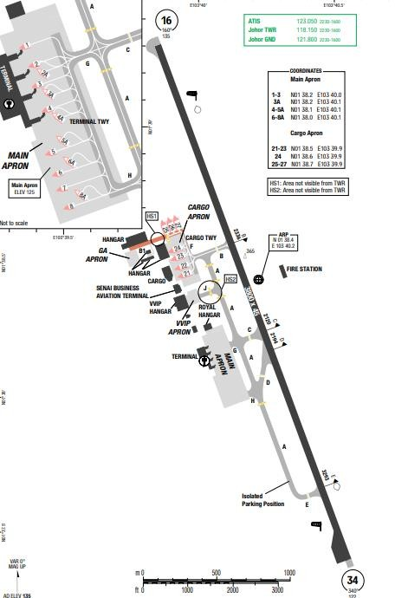
The airport is located approximately 32 km north-west of the Johor Bahru city centre.
The city has an equatorial climate with consistent temperatures, a considerable amount of rain, and high humidity throughout the course of the year. Daily average temperatures range from 26.4 °C in January to 27.8 °C in April with an average annual rainfall of around 2,350 mm. ALENGTHough the climate is relatively uniform, it does show some seasonal variation because of monsoons, with noticeable changes in wind speed and direction, cloud cover and amount of rainfall. There are two monsoon periods each year, the first one between mid- October and January, which is the north-east Monsoon. This period is characterised by heavier rainfall and wind from the north-east. The second one is the south-west Monsoon, which hardly affects the rainfall in Johor Bahru, where winds are from the south and south-west. This occurs between June and September.
Departure |  |  | - RNAV SIDs.  - Require minimum climb gradient.
Arrival and Approach |  |  | - RNAV STARs.  - RWY 34 Right-hand circuit
Taxi |  |  | - Lock-wheel turn not allowed
Parking information |  |  | No
5. TAKE-OFF AND LANDING DISTANCES AVAILABLE
RWY | LENGTH  (m) |  |  | WIDTH  (m) |  |  | TORA  (m) |  |  | LDA  (m) | TODA  (m) |  | ASDA  (m)
16/ 34 | 3800 |  |  | 45 |  |  | 3800 |  |  | 3800 | 3800 |  | 3800
6. ELEVATION: 135ft |  |  |  |  | 7. EOSID: YES
8. IAP: ILS, LOC, RNP, VOR
9. COMPANY NOTE |  |  |  |  | NIL
10. REMARK |  |  |  |  | NIL

WMKK/ KUL – KUALA LUMPUR INTL AIRPORT – KUALA LUMPUR, MALAYSIA
1. AIRPORT CATEGORY: A |  |  |  |  |  |  |  | 2. RFFS CATEGORY: 10
3. AIRPORT CLASSIFICATION
ATR |  | A320 |  |  |  | A321 |  |  | A350 |  |  | B787
ADQ |  | ADQ |  |  |  | ADQ |  |  | ADQ |  |  | ADQ
4. GENERAL STANDARDS
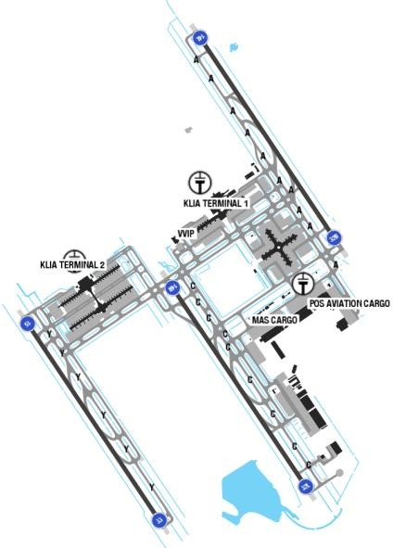
Kuala Lumpur International Airport is Malaysia's main international airport and one of the biggest airports in Southeast Asia and worldwide. It is located in Sepang District of Selangor, approximately 45 kilometers (28 mi) south of Kuala Lumpur city center and serves the Greater Klang Valley conurbation. Terrain is to the North of the airport and the MSA is 5300ft on the North-East and 2200ft on the South-West.
Titiwangsa Mountains in the East and Indonesia's Sumatra Island in the West, Kualalumpur has a annually equatorial climate, which is warm and sunny, along with a plenty amount of rainfall, especially during the Southwest monsoon from September to April. Dust particles from forest fires on nearby Sumatra Island sometimes create a phenomenon known as haze. This usually lasts for 1 to 2 weeks.
Departure |  |  | - Request ATC clearance 5 mins before start-up.  - Usually during taxi Lumpur Ground asks for registration number and POB figure  - RNAV SIDs.  - Contact “Lumpur radar” after airborne as soon as practicable before passing 2000ft on 135.25
Arrival and Approach |  |  | - RNAV STARs.  - Shortcuts are available during occasions when the traffic load is low.  - Speed restrictions are available.
Taxi |  |  | - Standard Taxi Routes are issued and normally adhered to.  - Crossing runway on single engine taxi is not permitted.
Parking information |  |  | - Satellite A, ESN or ESE.
5. TAKE-OFF AND LANDING DISTANCES AVAILABLE
RWY | LENGTH  (m) |  |  | WIDTH  (m) |  |  | TORA  (m) |  |  | LDA  (m) | TODA  (m) |  | ASDA  (m)
14L/ 32R | 4019 |  |  | 60 |  |  | 4019 |  |  | 4019 | 4019 |  | 4019
14R/ 32L | 4000 |  |  | 60 |  |  | 4000 |  |  | 4000 | 4000 |  | 4000
15/ 33 | 3960 |  |  | 60 |  |  | 3960 |  |  | 3960 | 3960 |  | 3960
6. ELEVATION: 69ft |  |  |  |  | 7. EOSID: NO
8. IAP: ILS, LOC, RNP, VOR
9. COMPANY NOTE |  |  |  |  | - Lumpur controlling agencies can provide great assistance to pilots in approach and weather deviations thanks to their advanced weather radar and monitoring systems.  - Upon reaching the parking bay, flight crews are requested to confirm with the ground personnel whether the flaps need to be retracted for refueling.  - Ground handling provides maintenance support.  - All flight documents are brought to the aircraft by the ground handling agents.
10. REMARK |  |  |  |  | NIL

WMKL/ LGK – LANGKAWI INTL AIRPORT – LANGKAWI I, MALAYSIA
1. AIRPORT CATEGORY: A |  |  |  |  |  |  |  | 2. RFFS CATEGORY: 9
3. AIRPORT CLASSIFICATION
ATR |  | A320 |  |  |  | A321 |  |  | A350 |  |  | B787
ADQ |  | ADQ |  |  |  | ADQ |  |  | ADQ |  |  | ADQ
4. GENERAL STANDARDS
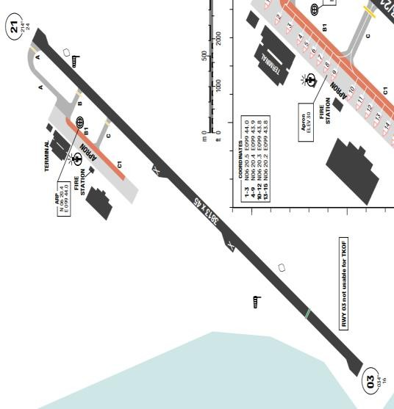
Langkawi International Airport is an airport in Padang Matsirat, Langkawi, Kedah, Malaysia. Langkawi receives more than 2,400 mm (94 in) of rain annually. Langkawi features a tropical monsoon climate. Langkawi has a short dry season from December until February. March to November is a long rainy season. September is the wettest month when it can receive more than 500 mm (20 in).
Departure |  |  | - Conventional and RNAV SIDs.  - RWY 03 take-off not allowed.  - Require minimum climb gradients.
Arrival and Approach |  |  | - Conventional and RNAV STARs.  - RWY 21 landing not allowed.
Taxi |  |  | - Apron TWY B1 and aircraft stand taxilane C1 is restricted to code C aircraft or smaller.  - RWY 21 turnpad and marking to accommodate ACFT with max wingspan 36m and max outer main gear span 9m.
Parking information |  |  | No
5. TAKE-OFF AND LANDING DISTANCES AVAILABLE
RWY | LENGTH  (m) |  |  | WIDTH  (m) |  |  | TORA  (m) |  |  | LDA  (m) | TODA  (m) |  | ASDA  (m)
03/ 21 | 3813 |  |  | 45 |  |  | 3813 |  |  | 3203 | 3813 |  | 3813
6. ELEVATION: 23ft |  |  |  |  | 7. EOSID: NO
8. IAP: ILS, RNP, VOR
9. COMPANY NOTE |  |  |  |  | NIL
10. REMARK |  |  |  |  | NIL

WMKP/ PEN – PENANG INTL AIRPORT – PENANG, MALAYSIA
1. AIRPORT CATEGORY: A |  |  |  |  |  |  |  | 2. RFFS CATEGORY: 9
3. AIRPORT CLASSIFICATION
ATR |  | A320 |  |  |  | A321 |  |  | A350 |  |  | B787
AQD |  | AQD |  |  |  | AQD |  |  | AQD |  |  | AQD
4. GENERAL STANDARDS
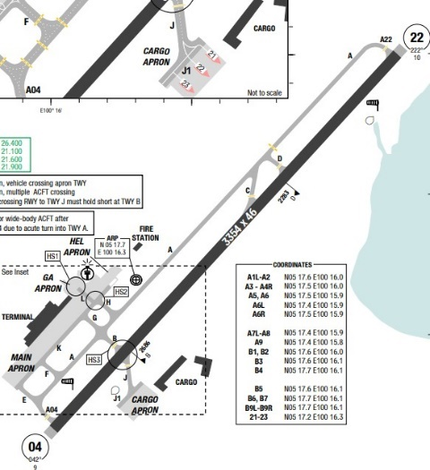
Penang is a Malaysian state located on the northwest coast of Peninsular Malaysia, by the Malacca Strait. As in the rest of Malaysia, Penang has a tropical rainforest climate bordering on a tropical monsoon climate, a lengthough the state does experience slightly drier conditions from December to February of the following year. The climate is very much dictated by the surrounding sea and the prevailing wind system with average temperature around 30-32 degree Celsius.
Penang's proximity with the island of Sumatra makes it susceptible to dust particles carried by wind from perennial but transient forest fires, creating a phenomenon known as the Southeast Asian haze.
Departure |  |  | - Conventional and RNAV SIDs.  - Require minimum climb gradients.
Arrival and Approach |  |  | - Conventional and RNAV STARs.  - Circling prohibited in sector 250o-20o due to high terrain
Taxi |  |  | - TWY C not available for wide-bodied Acft after landing RWY 04 due acute turn into TWY A.
Parking information |  |  | No
5. TAKE-OFF AND LANDING DISTANCES AVAILABLE
RWY | LENGTH  (m) |  |  | WIDTH  (m) |  |  | TORA  (m) |  |  | LDA  (m) | TODA  (m) |  | ASDA  (m)
04/ 22 | 3354 |  |  | 46 |  |  | 3354 |  |  | 3354 | 3354 |  | 3354
6. ELEVATION: 10ft |  |  |  |  | 7. EOSID: NO
8. IAP: ILS, LOC, RNP, VOR
9. COMPANY NOTE |  |  |  |  | - Upon reaching the parking bay, flight crews are requested to confirm with the ground personnel whether the flaps need to be retracted for refueling.
10. REMARK |  |  |  |  | NIL

WSSS/ SIN – CHANGI AIRPORT – SINGAPORE, SINGAPORE
1. AIRPORT CATEGORY: A |  |  |  |  |  |  |  | 2. RFFS CATEGORY: 10
3. AIRPORT CLASSIFICATION
ATR |  | A320 |  |  |  | A321 |  |  | A350 |  |  | B787
ADQ |  | ADQ |  |  |  | ADQ |  |  | ADQ |  |  | ADQ
4. GENERAL STANDARDS
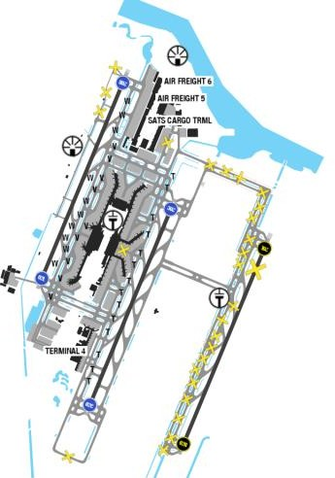
Changi International airport is located in a quite flat area. The airport is located in Changi, at the eastern end of Singapore, approximately 20 km from Marina Bay (Singapore's Downtown Core), on a 13-square-kilometre (5.0 sq mi) site. Singapore's climate is characterized by uniform temperature and pressure, high humidity and abundant rainfall. The climate of Singapore can be divided into two main seasons, the Northeast Monsoon and the Southwest Monsoon season. North-East Monsoon Season starts from December to early March. North Easterly winds prevail during this period, sometimes reaching 10kts.
Departure |  |  | - RNAV SIDs  - NADP available at this airport: DEP RWY 20R: NAP applicable between 1600-2200, except when RWY 20C/02C is not AVBL  - A-CDM availalbe  - COMM FAIL available  - Vessel Movement Departure Procedures available  - DEP flights from Singapore requesting FL280 or FL320 on L759, M770, N571, N571/N877 or P628 will be cleared (REFER AOI)
Arrival and Approach |  |  | - RNAV STARs  - Speed restrictions.  - Minimum runway occupation time. Max speed to vacate is 50kts on designated exit taxiway.  - Simultaneous independent parallel approaches.  - ILS DME RWY 20R unusable beyond 15° west of CL below 2500ft.  - Between 0830-1030 expected delays about 15min.  - NAP available: RWY 02L/20R: 1600-2200 except for operational and safety reasons, avoid using more than idle reverse thrust.
Taxi |  |  | - Taxi speed limitations, use of minimum thrust and wingspan limited on specific TWY. (Speed limit is 20kts when taxiing along TWY R/ S)  - Pilot are reminded to always use minimum power when starting engines, when manoeuvring within apron or taxiway to other part of airport, especially critical when commencing to taxi that break-away thrusts are kept to an absolute minimum and then be reduced to idle asap.  - When issuing taxi CLR, ATC will use "Follow the Greens" with a verbal CLR limit. "Follow the Greens" procedure is not AVBL on RWYs and rapid exit TWYs.
Parking information |  |  | - In terminal 3,4.
5. TAKE-OFF AND LANDING DISTANCES AVAILABLE
RWY | LENGTH  (m) |  |  | WIDTH  (m) |  |  | TORA  (m) |  |  | LDA  (m) | TODA  (m) |  | ASDA  (m)
03L/21R | 4000 |  |  | 60 |  |  | 4000 |  |  | 4000 | 4060 |  | 4000
03R/21L | 4000 |  |  | 60 |  |  | 4000 |  |  | 4000 | 4060 |  | 4000
03C/21C | 4000 |  |  | 60 |  |  | 4000 |  |  | 4000 | 4060 |  | 4000
6. ELEVATION: 22ft |  |  |  |  | 7. EOSID: NO
8. IAP: ILS (CAT I, II), LOC, RNP, VOR
9. COMPANY NOTE |  |  |  |  | - Captain does Transit Check Procedure at this airport.  - Upon reaching the parking bay, flight crews are requested to confirm with the ground personnel  whether the flaps need to be retracted, to avoid risks of collision with the refueling vehicles.  - In accordance with Flight Level Assignment Scheme for South China Sea area, all flight departing from SIN via airway L642, joining M753 will be assigned FL260, 300, 380. When obtaining ATC clearance, pilot should request the appropriate flight level.  - Maritime vessels of variable heights in water north and south of RWYs  - Reduced Runway Separation Minima Between Aircraft Using the Same Runway available  - Do not mistake Paya Lebar AD for Changi AD located 4NM W.  - Do not mistake Changi East (MIL use only) for RWY 02C/20C.
10. REMARK |  |  |  |  | Ground Handling Frequency: 131.225 MHz

YBAS/ ASP - ALICE SPRINGS AIRPORT – AUSTRALIA
- AIRPORT CATEGORY: A |  |  |  |  |  |  | - RFFS CATEGORY: 6
- AIRPORT CLASSIFICATION
ATR |  | A320 |  | A321 |  |  | A350 |  | B787
ADQ |  | ADQ |  | ADQ |  |  | N/A |  | N/A
4. GENERAL STANDARDS
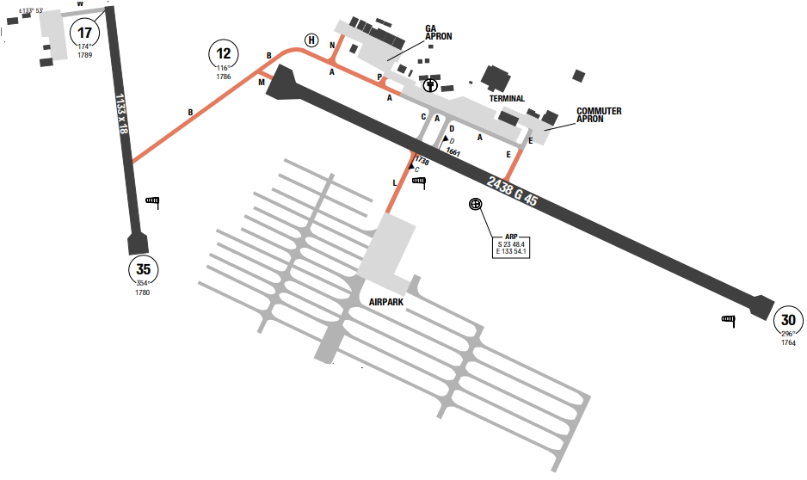
Alice Springs Airport (IATA: ASP, ICAO: YBAS) is an Australian regional airport 7 nautical miles (13 km; 8.1 mi) south of Alice Springs, Northern Territory. The airport has two runways, the larger of which can accommodate the Airbus A380, Boeing 747 and 777 landing (but not a fully laden takeoff due to high temperatures and the runway length). The only scheduled flights using the airport are domestic, a lengthough international charters do use the airport on occasions. The MSA around ARP is 5200ft. In Alice Springs, the summers are long, hot, and partly cloudy and the winters are short, cold, dry, and mostly clear.
Departure |  |  | - Conventional and RNAV SIDs.  - Require minimum climb gradients.
Arrival and Approach |  |  | - DME or GNSS arrival.  - No circling North of rwy 12/ 30 beyond 3nm
Taxi |  |  | - Taxi limitations  - Aircraft 80.000kg and above must use rwy 12/ 30 threshold turning nodes, turn 180 starboard
Parking information |  |  | - Jet ACFT shall use MNM PWR when taxiing out of stands in APN.
5. TAKE-OFF AND LANDING DISTANCES AVAILABLE
RWY | LENGTH  (m) |  |  | WIDTH  (m) |  | TORA  (m) |  | LDA  (m) |  | TODA  (m) | ASDA  (m)
12/ 30 | 2438 |  |  | 45 |  | 2438 |  | 2438 |  | 2438 | 2438
17/ 35 | 1133 |  |  | 18 |  | 1133 |  | 1133 |  | 1133 | 1133
6. ELEVATION: 1789ft |  |  |  |  | 7. EOSID: YES
8. IAP: ILS, LOC, RNP, VOR
9. COMPANY NOTE |  |  |  |  | - Manned balloon activity in the vicinity of circuit area at sunrise and early morning  - Sealed drag strip 0.5nm west of airport, aligned parallel RWY 17/ 35 may be mistaken for rwy..
10. REMARK |  |  |  |  | NIL

YBBN/ BNE - BRISBANE INTL, BRISBANE, QLD, AUSTRALIA
- AIRPORT CATEGORY: A |  |  |  |  |  |  | - RFFS CATEGORY: 9
- AIRPORT CLASSIFICATION
ATR |  | A320 |  | A321 |  |  | A350 |  | B787
ADQ |  | ADQ |  | ADQ |  |  | ADQ |  | ADQ
4. GENERAL STANDARDS
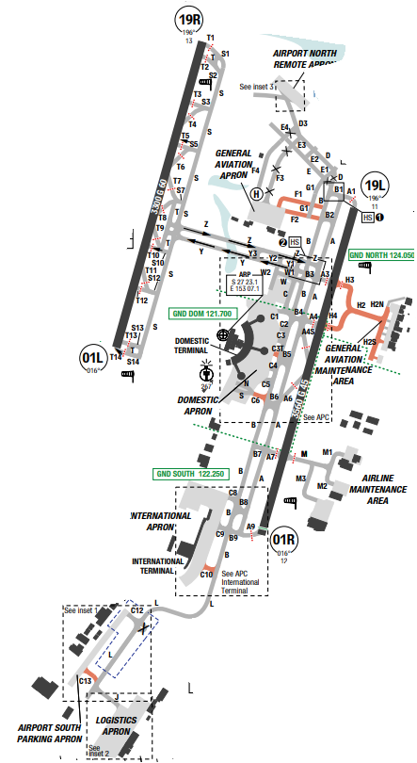
Brisbane Airport is the primary international airport serving Brisbane and South East Queensland. MSA of the surrounding area is 2500ft within the 10NM circle around the airport.
Brisbane has a humid subtropical climate with hot, wet summers and moderately dry, moderately warm winters. Brisbane experiences an annual mean minimum of 16.6 °C and mean maximum of 26.6 °C, making it Australia's second-hottest capital city after Darwin.
Annual precipitation is ample. From November to March, thunderstorms are common over Brisbane, with the more severe events accompanied by large damaging hail stones, torrential rain and destructive winds.
Departure |  |  | - RNAV SIDs available  - Noise abatement procedure (NADP1 for RWY19L/ R)  - SID with high climb gradient
Arrival and Approach |  |  | - RNAV STARs.  - Circling Approach at night 01L/ 19R not permitted
Taxi |  |  | - Taxi restrictions  - Single-engine taxi should not be exercised
Parking information |  |  | - ACFT to use MNM power when entering, exiting and operating on all APN.  - Aerobridge Lighting Configuration
5. TAKE-OFF AND LANDING DISTANCES AVAILABLE
RWY | LENGTH  (m) |  |  | WIDTH  (m) |  | TORA  (m) |  | LDA  (m) |  | TODA  (m) | ASDA  (m)
01L/ 19R | 3300 |  |  | 60 |  | 3300 |  | 3300 |  | 3300 | 3300
01R | 3560 |  |  | 45 |  | 3500 |  | 3500 |  | 3500 | 3500
19L | 3560 |  |  | 45 |  | 3560 |  | 3500 |  | 3560 | 3560
6. ELEVATION: 15ft |  |  |  |  | 7. EOSID: NO
8. IAP: ILS, LOC, RNP
9. COMPANY NOTE |  |  |  |  | - Parallel Operations Runway Assignment  - Airport Efficiency Procedures  - Significant Bird hazard exist.
10. REMARK |  |  |  |  | NIL

YBCS/ CNS – CAIRNS INTL AIRPORT – CAIRNS, QLD, AUSTRALIA
- AIRPORT CATEGORY: A |  |  |  |  |  |  | - RFFS CATEGORY: 8
- AIRPORT CLASSIFICATION
ATR |  | A320 |  | A321 |  |  | A350 |  | B787
ADQ |  | ADQ |  | ADQ |  |  | ADQ |  | ADQ
4. GENERAL STANDARDS
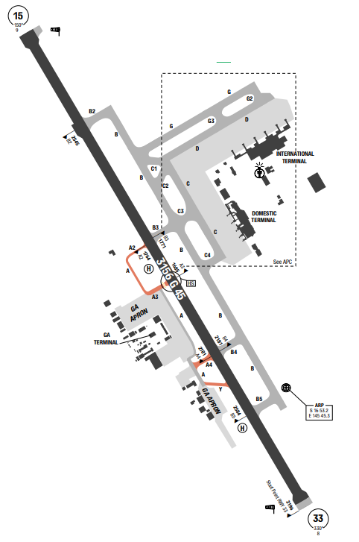
CAIRNS airport is an international airport in Cairns, Queensland, Australia. It is the seventh busiest airport in Australia. The airport is located 2.3 nautical miles (4.3 km; 2.6 mi) north northwest of Cairns or 7 kilometres north of the Cairns central business district, in the suburb of Aeroglen. The airport lies between Mount Whitfield to the west and Trinity Bay to the east. There is mountainous area to the southwest side of the airport with the highest MSA is 6500ft.
In Cairns, the wet season is hot, oppressive, and overcast and the dry season is warm, humid, and partly cloudy.
Departure |  |  | - Conventional SIDs. Require minimum climb gradients.  - Prefer RWY 15 for departure with noise abatement climb procedure apply.
Arrival and Approach |  |  | - RNAV and GNSS STARs.  - Prefer RWY 15 for landing..
Taxi |  |  | - All wide-body require use minimum thrust.
Parking information |  |  | - Marshaller mandatory. Service to be provided by Fixed Base OPR or GND handler.
5. TAKE-OFF AND LANDING DISTANCES AVAILABLE
RWY | LENGTH  (m) |  |  | WIDTH  (m) |  | TORA  (m) |  | LDA  (m) |  | TODA  (m) | ASDA  (m)
15 | 3196 |  |  | 45 |  | 3156 |  | 3156 |  | 3256 | 3156
33 | 3196 |  |  | 45 |  | 3196 |  | 3156 |  | 3256 | 3196
6. ELEVATION: 10ft |  |  |  |  | 7. EOSID: NO
8. IAP: ILS, LOC, NDB, RNP, VOR
9. COMPANY NOTE |  |  |  |  | - Birds in vicinity of the airport.
10. REMARK |  |  |  |  | NIL

YBRK/ ROK–ROCKHAMPTON – QUEENSLAND, AUSTRALIA
- AIRPORT CATEGORY: A |  |  |  |  |  |  | - RFFS CATEGORY: 6
- AIRPORT CLASSIFICATION
ATR |  | A320 |  | A321 |  |  | A350 |  | B787
ADQ |  | ADQ |  | ADQ |  |  | ADQ |  | ADQ
4. GENERAL STANDARDS
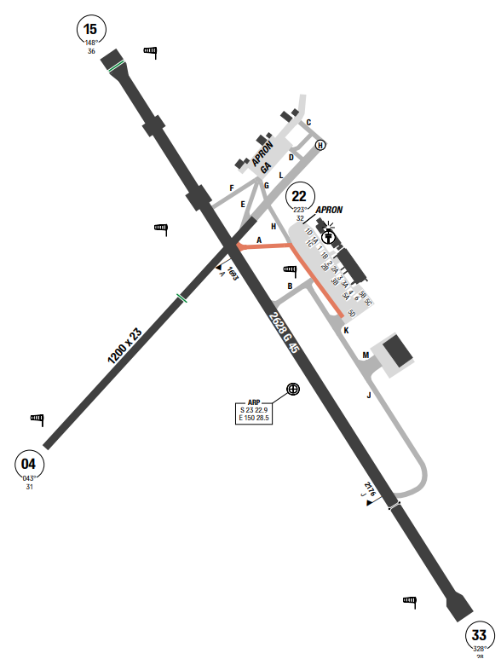
Rockhampton Airport is a major Australian regional airport in West Rockhampton, Queensland that services the city of Rockhampton, with direct flights to various major centers in Queensland, as well as Melbourne in Victoria. Terrain around the airport is mostly flat, despite obstructions to the West of the Rockhampton airport, with the highest obstacle is 340ft.
At Rockhampton Airport, the summers are long, hot, muggy, wet, windy, and partly cloudy and the winters are short, cool, and mostly clear. Over the course of the year, the temperature typically varies from 10°C to 31°C and is rarely below 5°C or above 35°C.
Departure |  |  | - Conventional and RNAV SIDs. Require minimum climb gradients.  - Preferred RWY for takeoff: 15
Arrival and Approach |  |  | - RNAV STARs  - Preferred RWY for landing: 33
Taxi |  |  | - Taxi restrictions
Parking information |  |  | - 48HR PN required for ACFT above 5700kg for parking approval.
5. TAKE-OFF AND LANDING DISTANCES AVAILABLE
RWY | LENGTH  (m) |  |  | WIDTH  (m) |  | TORA  (m) |  | LDA  (m) |  | TODA  (m) | ASDA  (m)
04 | 1200 |  |  | 23 |  | 1140 |  | 1140 |  | 1140 | 1140
15 | 2628 |  |  | 45 |  | 2628 |  | 2628 |  | 2930 | 2628
22 | 1200 |  |  | 23 |  | 1200 |  | 800 |  | 1263 | 1200
33 | 2628 |  |  | 45 |  | 2568 |  | 2568 |  | 2688 | 2568
6. ELEVATION: 36ft |  |  |  |  | 7. EOSID: NO
8. IAP: NDB, RNP, VOR
9. COMPANY NOTE |  |  |  |  | - Birds in vicinity of the airport.
10. REMARK |  |  |  |  | NIL

YBTL/ TSV – TOWNSVILLE – QUEENSLAND, AUSTRALIA
- AIRPORT CATEGORY: A |  |  |  |  |  |  | - RFFS CATEGORY: 7
- AIRPORT CLASSIFICATION
ATR |  | A320 |  | A321 |  |  | A350 |  | B787
ADQ |  | ADQ |  | ADQ |  |  | ADQ |  | ADQ
4. GENERAL STANDARDS
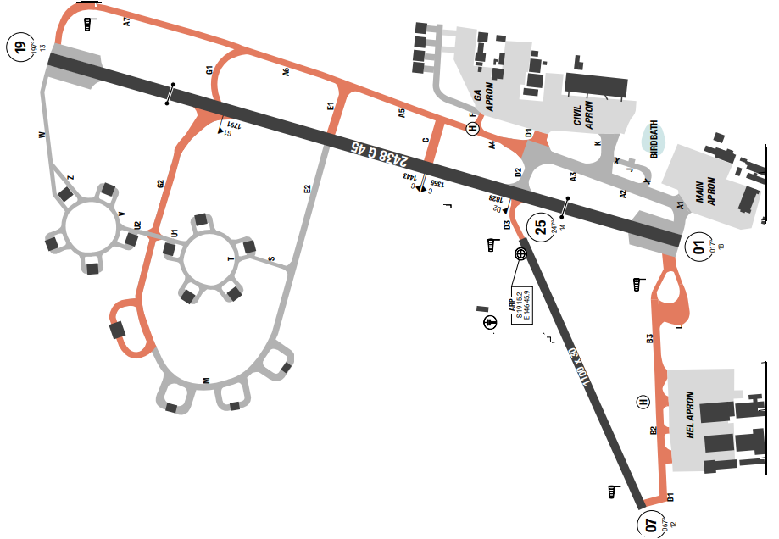
Townsville Airport is a major Australian regional airport that services the city of Townsville, Queensland. The airport is also known as Townsville International Airport, and Garbutt Airport, a reference to its location in the Townsville suburb of Garbutt. Terrain around the airport is mostly flat, despite obstructions to the West of the Townsville airport, with the highest obstacle is 167ft. In Townsville, the wet season is hot, oppressive, and mostly cloudy and the dry season is warm, humid, windy, and mostly clear. Over the course of the year, the temperature typically varies from 14°C to 31°C and is rarely below 9°C or above 33°C. The predominant average hourly wind direction in Townsville is from the east throughout the year.
Departure |  |  | - RNAV SIDs.  - SID with high climb gradient
Arrival and Approach |  |  | - RNAV and GNSS STARs.
Taxi |  |  | - Taxi restrictions
Parking information |  |  | No
5. TAKE-OFF AND LANDING DISTANCES AVAILABLE
RWY | LENGTH  (m) |  |  | WIDTH  (m) |  | TORA  (m) |  | LDA  (m) |  | TODA  (m) | ASDA  (m)
01/ 19 | 2438 |  |  | 45 |  | 2438 |  | 2438 |  | 2438 | 2438
07/ 25 | 1100 |  |  | 30 |  | 1100 |  | 1100 |  | 1100 | 1100
6. ELEVATION: 18ft |  |  |  |  | 7. EOSID: NO
8. IAP: ILS, LOC, NDB, RNP, VOR
9. COMPANY NOTE |  |  |  |  | - Birds in vicinity of the airport.
10. REMARK |  |  |  |  | NIL

YGEL/ GET – GERALDTON – AUSTRALIA (SPECIAL AUTHORISATIONS)
1. AIRPORT CATEGORY: A |  |  |  |  |  |  |  | 2. RFFS CATEGORY: 7
3. AIRPORT CLASSIFICATION
ATR |  | A320 |  |  |  | A321 |  |  | A350 |  |  | B787
ADQ |  | ADQ |  |  |  | ADQ |  |  | ADQ |  |  | ADQ
4. GENERAL STANDARDS
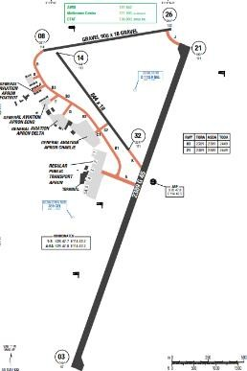
Geraldton Airport is an airport located 6 nautical miles east of Geraldton, Western Australia, in Moonyoonooka along the Geraldton – Mount Magnet Road. The highest MSA is at the North West of the airport at 2300’. Winters are short but mild and wet with cool nights. In the winter the temperature is mild with daily highs averaging around 20 °C (68 °F). Most of the yearly rainfall falls in this period. In the summer months, Geraldton averages 32–33 °C, with some days over 40 °C.
Departure |  |  | - A clearance into CTA is required for departures. This will be provided by MEL Centre when taxiing or airborne after a departure call to MEL Centre.  - Aircrafts parked in a power-in/ power-out position (aircraft can depart under their own power without needing pushback. The crew is required to notify MEL Centre of their start-up intentions and movement plans.
Arrival and Approach |  |  | - LNAV/ VNAV arrivals are available.  - Local QNH and temperature REQUIRED.  - For LNAV/ VNAV: Procedure temperature range 0°C to 60°C.  - Pilot may operate an aircraft with unserviceable VHF radio if a radio failure occurs during the flight. In this case, the pilot continues to land and activates the aircraft’s anti-collision lights, landing lights and transponder (if any).  - When landing, crew will be in contact with Melbourne Centre with VHF#1 and on the Geraldton CTAF with VHF#2. On VHF#2, the crew will broadcast their intentions advising Geraldton traffic what procedure they are flying (monitored by the Airport Reservation Office- ARO) and similarly advise Melbourne Centre so they can be updated with traffic information
Taxi |  |  | - Rwy 14/ 32 available for Code B taxiing aircraft 18,739 lbs (8,500 kg) max.  - Twy B2, C2, D, K, Apron Delta Code B aircraft 18,739 lbs (8,500 kg) max.  - Twy B1, C1, Apron Charlie Code B aircraft 48,502 lbs (22,000 kg) max  - Twy A Code E (B787/ A330) aircraft  - All other taxiways and aprons are Code A aircraft 12,566 lbs (5,700 kg) max.
Parking information |  |  | - Parking prior permission required from Aerodrome Manager on RPT Apron, Apron Charlie Bays 20 and 21 and Apron Delta (Shine).  - Bay 5A Code E (B787/ A330) aircraft. Main Apron Bays 1 to 5 Code C aircraft.  - Geraldton airport provides Fixed Base Operator (FBO) and marshalling services for runway vacating and taxiing to/ from the YGEL bays.  - These services guide the aircraft during taxiing in and out from the gate to the runway.
5. TAKE-OFF AND LANDING DISTANCES AVAILABLE
RWY | LENGTH  (m) |  |  |  | WIDTH  (m) |  | TORA  (m) |  |  | LDA  (m) | TODA  (m) |  | ASDA  (m)
03/ 21 | 2390 |  |  |  | 45 |  | 2389 |  |  | 2390 | 2449 |  | 2389
6. ELEVATION: 122ft |  |  |  | 7. EOSID: NO
8. IAP: NDB, RNP, VOR
9. COMPANY NOTE |  |  |  | - Weather balloon launch 2315 UTC TUE-FRI FM 1.3KM SSW ARP. Additional launch may occur in severe weather.  - For OPS west of Geraldton, refer to ERC L8 for the lateral bounds of the Abrolhos Islands CTAF. All OPS on the Abrolhos Island CTAF on 127.1.  - All ACFT ABV 50,000KG to use turning nodes, MAX RAD turns at MNM speed.  - ACFT to use MNM power when entering, exiting and operating on all APN.  - RFFS category for YGEL airport temporary down to 7. According to CAAV:  - If an airport serves more than one purpose, the highest RFFS category corresponding to that purpose applies at the expected time of usage.  - Reduced RFFS category for an aircraft shall be approved by CAAV provided that:  - Aircraft with MEL on doors/ slides shall not be released for flight with destination alternates of reduced RFFS category.  - During disembarkation/ embarkation or passenger onboard, refueling/ defueling is not allowed at airport with reduced RFFS category.  When 02 alternates are selected, the alternate with reduced RFFS category shall not be used in case of any fire-fighting equipment have been used inflight.
10. REMARK |  |  |  | - Genaldton is a non-towered airport  - No take-off or landing clearance is required at YGEL.  - Operation at Geraldton airport under CTAF (Common Traffic Advisory Frequency) procedures with frequency 126.8 (VHF#2). Pilots use CTAF 126.8 to communicate directly with each other also inform other aircraft of their intentions.  - Melbourne Center with frequency 121.2 (VHF#1) oversees the operations at YGEL and provide traffic information services to crew.  - MEL Centre will provide a SSR code and provide traffic information services to the aircraft when in ADSB/ Radar Contact. MEL Centre will provide a traffic information service for all other identified aircraft to the crew. Likewise, MEL Centre will advise other IFR aircraft.  - It is mandatory to carry a serviceable VHF radio, and being qualified to use it. MEL Centre provides a clearance into CTA (Controlled Traffic Area) for departure either during taxiing or once the aircraft is airborne after making a departure call to MEL Centre.  - Marshallers: assist in preventing collisions between aircrafts and between aircraft and obstructions within the maneuvering area.  - YGEL operates under CTAF (Common Traffic Advisory Frequency) procedures. The crew should use the CTAF radio to inform other aircraft of their intentions. YGEL Safety personnel are available to assist with these procedures.

YMAV/ AMV - AVALON AIRPORT – VICTORIA, AUSTRALIA
1. AIRPORT CATEGORY: A |  |  |  |  |  |  |  | 2. RFFS CATEGORY: 7
3. AIRPORT CLASSIFICATION
ATR |  | A320 |  |  |  | A321 |  |  | A350 |  |  | B787
ADQ |  | ADQ |  |  |  | ADQ |  |  | ADQ |  |  | ADQ
4. GENERAL STANDARDS
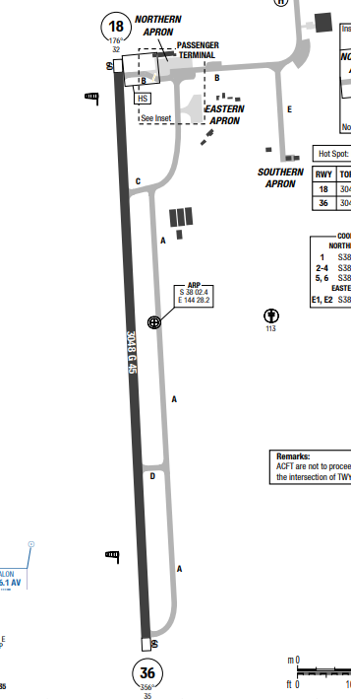
Avalon Airport is an international airport, located in Avalon in the City of Greater Geelong in Victoria, Australia. While located outside the Melbourne metropolitan area, it is the second busiest of the four airports serving the state capital in passenger traffic. It is located 15 km north-east of the Geelong CBD and 50 kilometres south-west of the Melbourne.
Avalon Airport in Victoria, Australia, experiences a temperate maritime climate with warm summers and cool, windy winters. Temperatures typically range from 6°C to 26°C throughout the year, with low humidity and moderate, consistent rainfall. It is often partly cloudy, with February being the warmest month and July the coldest.
Departure |  |  | - A clearance into CTA is required for departures. This will be provided by MEL Centre when taxiing or airborne after a departure call to MEL Centre.  - COMM FAIL Procedure available  - RNP SIDs
Arrival and Approach |  |  | - RNP STARs  + x`RWY 18: Intercept LOC RWY 18  + RWY 36: Expect radar vectors for final  - COMM FAIL Procedure available  - RWY 18 right-hand circuit.
Taxi |  |  | - Widebody ACFT are required to taxi with MNM PWR.  - TWY A past TWY D not AVBL to code letter C ACFT (or larger) when a code letter C ACFT (or larger) is HLDG on TWY D  - Code letter E and F ACFT must be towed from INT of TWY A and B when accessing the hangar precint. H24 PN required.  - Code letter F ACFT are not permitted to taxi on their own on TWY B past the passenger terminal when code letter C, D or E ACFT are parked at the terminal.  - Code letter F ACFT are permitted to move under tow only due to wingtip CLR.  - CFT are not to proceed beyond stop sign located at the intersection of TWY A and B unless escorted.
Parking information |  |  | - Outside TWR HR, ACFT parked on Northern APN bay 1 must push-back east only.  - For B747 (all types), access to main APN via TWY A.
5. TAKE-OFF AND LANDING DISTANCES AVAILABLE
RWY | LENGTH  (m) |  |  |  | WIDTH  (m) |  | TORA  (m) |  |  | LDA  (m) | TODA  (m) |  | ASDA  (m)
18 | 3048 |  |  |  | 45 |  | 3048 |  |  | 3048 | 3353 |  | 3108
36 | 3048 |  |  |  | 45 |  | 3048 |  |  | 3048 | 3291 |  | 3108
6. ELEVATION: 35ft |  |  |  | 7. EOSID: NO
8. IAP: ILS, RNP, VOR
9. COMPANY NOTE |  |  |  | - 180°-turn on RWY prohibited to code letter C ACFT and above  - Pilot activated lighting - If PAL activation fails, call 03 5227 9150 for manual activation.  - Birds in vicinity of AD.  - Whenever possible, avoid the noise sensitive areas of Lara, Little River and Geelong Grammar School (R233 AV VOR, 3NM, or 229° MAG 3.5NM from YMAV ARP).
10. REMARK |  |  |  | NIL

YMML/ MEL - MELBOURNE (MELBOURNE INTL) - AUSTRALIA
1. AIRPORT CATEGORY: A |  |  |  |  |  |  |  | 2. RFFS CATEGORY: 9
3. AIRPORT CLASSIFICATION
ATR |  | A320 |  |  |  | A321 |  |  | A350 |  |  | B787
ADQ |  | ADQ |  |  |  | ADQ |  |  | ADQ |  |  | ADQ
4. GENERAL STANDARDS
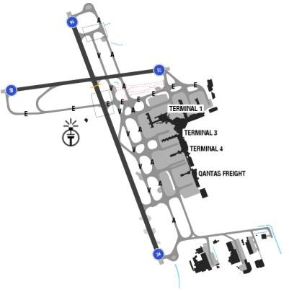
Melbourne is subject to variable and rapidly changing weather conditions. The weather is primarily influenced by the cold fronts that move from the SSW, and their associated winds.
General Weather: The presence of a low- pressure system in the Melbourne area will almost certainly be associated with moderate to strong winds, whereas a high will bring light winds and frequent occurrences of low level stratiform cloud with associated drizzle. Snow rarely reaches the ground, and the runway should never be worse than wet. Reduced visibility and low cloud occur predominately with a wind in the southwest quadrant.
Departure |  |  | - There are SIDs with high climb gradients. If these SIDs are used in operation, ensure that the all engine climb gradient of aircraft meets the required minimum climb gradient  - EXPECT SID: KEPPA or BISON  - Noise Abatement Procedures for Preferred RWY and Flight Paths in Charts.  - NADP available at this airport
Arrival and Approach |  |  | - RNAV STARs.  - EXPECT STAR: ARBEY  - Speed restrictions  - Normal runway for arrival is 16, with a northerly wind expect to fly the full procedure approach for the RNAV or radar vectors for approach RWY 34.  - Note:  - The Australian authority advises crew NOT to use IAN approach mode for RNAV Z RWY 34 since it is not as appropriate for VNAV procedure, as the IAN Glide Path commences at the FAF (BOSGI), and therefore, the altitude constraint may not be assured by IAN prior to BOSGI.  - Crews need to pay close attention for airport elevation of nearly 500ft for better planning on configuration and stabilizing approach.  - False LOC capture may occur 35 degrees either side of LLZ.
Taxi |  |  | - Taxi restrictions  - Single engine taxi not permitted in Melbourne.  - If you have to stop and need more than idle power to move the aircraft, you must shut down both engines and request a tow track.  - To ensure minimum RWY occupancy time and support optimum spacing on final, whenever operational condition permits, expect to vacate the RWY via the designed exit TWY:
Parking information |  |  | - Standard push-back procedures.
5. TAKE-OFF AND LANDING DISTANCES AVAILABLE
RWY | LENGTH  (m) |  |  | WIDTH  (m) |  |  | TORA  (m) |  |  | LDA  (m) | TODA  (m) |  | ASDA  (m)
09/ 27 | 2286 |  |  | 45 |  |  | 2286 |  |  | 2286 | 2286 |  | 2286
16/ 34 | 3657 |  |  | 60 |  |  | 3657 |  |  | 3657 | 3657 |  | 3657
6. ELEVATION: 434ft |  |  |  |  | 7. EOSID: YES
8. IAP: ILS (CAT I, II, III), LOC, RNP, VOR
9. COMPANY NOTE |  |  |  |  | - Be advised the expected traffic holding fuel advisory for Melbourne can be found in CFP. International Class 1 NOTAM containing a “Traffic Holding Advisory” applies.  - Taxiway lighting is poor around threshold RWY27.  - There is a general absence of taxiway edge lighting  - Handling/ Refueling: Melbourne ground staff is not permitted to Load or Pushback A/ C during lightning/ thunderstorm activity.  - Secondary airport Essendon 5nm Southeast  - Birds and animals in vicinity of airport.  - To avoid ground frequency congestion and improve airport efficiency, pilots must check if pushback truck is ready and connected to the aircraft prior to requesting pushback clearance.  - Due to persistent upper wing ice in the wing root region, extra fuel may need to be loaded to assist in melting the ice during the turn around. Please take advice from Melbourne Engineering as to the amount of extra fuel to be loaded. Flight Dispatch may be contacted to produce a CFP with the revised fuel load, if required. Crew are advised that in air temperatures of at least plus 5 degrees Celsius, the use of hot water to de-ice aircraft is  allowed in Melbourne. If fuel is cold soaked ensure that all frost or ice is fully removed and that residual water on top of wing does not re-freeze.  - Immigration: Fill out the form en-route which will be stamped by the Immigration Officer and again at the Customs and then taken by Customs prior to baggage screening/ exit. On departure, only passport needs to be submitted for Immigration Clearance.  - GPU and ground air-conditioning unit are available at the gate.  - The airport authority is very strict in food quarantine especially with meat products and vegetables.  - Valid Residual Disinsection Certificate should be present onboard as approval that the a/ c has been disinsected.  - All flight documents are brought to the aircraft by the ground handling agents.  - Australia is very strict on Biosecurity requirements. Aircrew and passengers are required to comply with legislative requirement under the Bio Security act 2015. Prior to arrival, at the earlier of top of descent or 30 minutes before the ACFT is estimated to come to a standstill, pilots shall advise ATC the followings:  - Details of any person on board who has or had signs or symptoms of a listed human disease during the fight.  - Details of any person on board the aircraft who died during the flight.  - If there are animal or plants (or both) in the cabin of the aircraft  - If any animal in the cabin of the aircraft died during the flight  - After landing, biosecurity officer will meet at the  ACFT. Follow the officer’s instruction carefully and closely.
10. REMARK |  |  |  |  | Ground Handling Frequency: 131.8 MHz

YPAD/ ADL – ADELAIDE INTERNATIONAL AIRPORT, SOUTH AUSTRLIA, AUSTRALIA
- AIRPORT CATEGORY: A |  |  |  |  |  |  | - RFFS CATEGORY: 9
- AIRPORT CLASSIFICATION
ATR |  | A320 |  | A321 |  |  | A350 |  | B787
ADQ |  | ADQ |  | ADQ |  |  | ADQ |  | ADQ
4. GENERAL STANDARDS
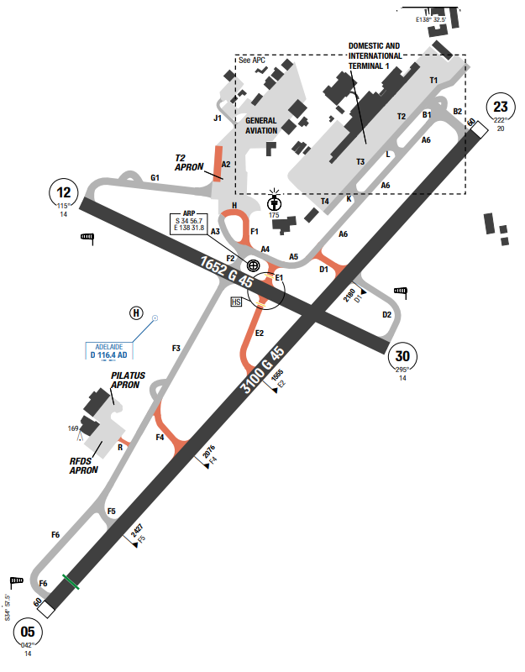
Adelaide Airport (IATA: ADL, ICAO: YPAD), also known as Adelaide International Airport, is the principal airport of Adelaide, South Australia and the fifth-busiest airport in Australia, servicing 8.5 million passengers in the financial year ending 30 June 2019. Located adjacent to West Beach, it is approximately 6 km (3.7 mi) west of the city centre.
In Adelaide, the summers are warm and dry, the winters are cold, and it is windy and mostly clear year round. Over the course of the year, the temperature typically varies from 7°C to 28°C and is rarely below 3°C or above 36°C
Departure |  |  | - RNAV SIDs.  - SID with high climb gradient
Arrival and Approach |  |  | - RNAV STARs.  - Speed Restrictions.
Taxi |  |  | - Taxi restrictions
Parking information |  |  | - Aerobridge Lighting Configuration: Flight crew must stop and wait for a green light before proceeding into the bay.
5. TAKE-OFF AND LANDING DISTANCES AVAILABLE
RWY | LENGTH  (m) |  |  | WIDTH  (m) |  | TORA  (m) |  | LDA  (m) |  | TODA  (m) | ASDA  (m)
05 | 3100 |  |  | 45 |  | 3100 |  | 2950 |  | 3100 | 3100
12 | 1652 |  |  | 45 |  | 1652 |  | 1652 |  | 1832 | 1652
23 | 3100 |  |  | 45 |  | 3100 |  | 3100 |  | 3100 | 3100
30 | 1652 |  |  | 45 |  | 1652 |  | 1652 |  | 1832 | 1100
6. ELEVATION: 20ft |  |  |  |  | 7. EOSID: YES
8. IAP: ILS, LOC, RNP, VOR
9. COMPANY NOTE |  |  |  |  | - Birds in vicinity of the airport.
10. REMARK |  |  |  |  | NIL

YPDN/ DRW – DARWIN INTERNATIONAL, NORTHERN TERRITORY, AUSTRALIA
- AIRPORT CATEGORY: A |  |  |  |  |  |  | - RFFS CATEGORY: 8
- AIRPORT CLASSIFICATION
ATR |  | A320 |  | A321 |  |  | A350 |  | B787
ADQ |  | ADQ |  | ADQ |  |  | ADQ |  | ADQ
4. GENERAL STANDARDS
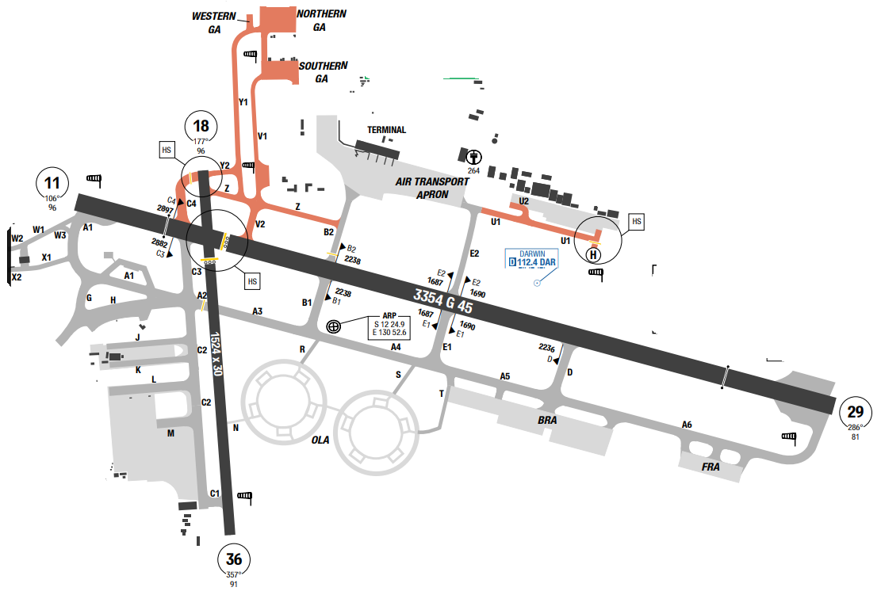
Darwin International Airport (IATA: DRW, ICAO: YPDN) is the busiest airport serving the Northern Territory and the tenth busiest airport in Australia. It is the only airport serving Darwin. The airport is located in Darwin's northern suburbs, 8 km (5.0 mi) from Darwin city centre, in the suburb of Eaton. It shares runways with the Royal Australian Air Force's RAAF Base Darwin. MSA of the airport is from 1700ft to the highest of 3000ft. In Darwin, the wet season is oppressive and overcast, the dry season is muggy and partly cloudy, and it is hot year round. Over the course of the year, the temperature typically varies from 20°C to 32°C and is rarely below 16°C or above 34°C.
Departure |  |  | - RNAV SIDs.  - Prefered RWY for takeoff:  • RWY 11 for departure tracks within 021° through S to 199°  • RWY 29 for departure tracks within 200° through N to 020°
Arrival and Approach |  |  | - RNAV STARs.  - Prefered RWY for landing:  • RWY 11 for departure tracks within 200° through N to 020°  • RWY 29 for departure tracks within 021° through S to 199°
Taxi |  |  | - Taxi restrictions
Parking information |  |  | No
5. TAKE-OFF AND LANDING DISTANCES AVAILABLE
RWY | LENGTH  (m) |  |  | WIDTH  (m) |  | TORA  (m) |  | LDA  (m) |  | TODA  (m) | ASDA  (m)
11/ 29 | 3354 |  |  | 60 |  | 3354 |  | 3354 |  | 3354 | 3354
18/ 36 | 1524 |  |  | 30 |  | 1524 |  | 1524 |  | 1524 | 1524
6. ELEVATION: 103ft |  |  |  |  | 7. EOSID: NO
8. IAP: ILS, LOC, NDB, RNP, VOR
9. COMPANY NOTE |  |  |  |  | NIL
10. REMARK |  |  |  |  | NIL

YPKA/ KTA – KARRATHA – AUSTRALIA
- AIRPORT CATEGORY: A |  |  |  |  |  |  | - RFFS CATEGORY: 6
- AIRPORT CLASSIFICATION
ATR |  | A320 |  | A321 |  |  | A350 |  | B787
ADQ |  | ADQ |  | ADQ |  |  | ADQ |  | ADQ
4. GENERAL STANDARDS
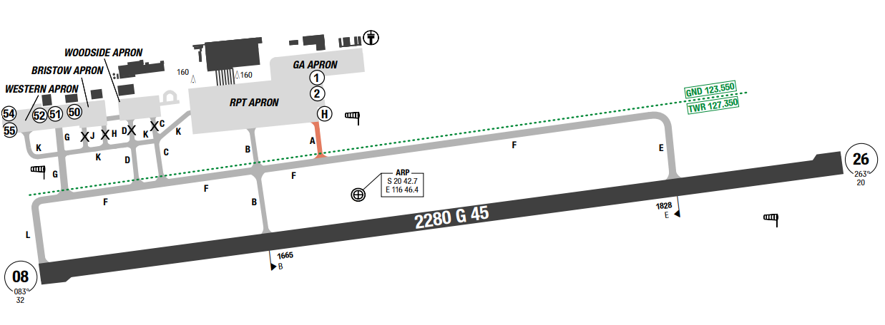
Karratha Airport (IATA: KTA, ICAO: YPKA) is an airport in Karratha, in the Pilbara region of Western Australia. The airport is 14 km from Karratha and 5 nautical miles (9.3 km) south of Dampier. In Karratha, the summers are long, hot, muggy, and partly cloudy; the winters are short, comfortable, dry, and mostly clear; and it is windy year round. The hot season lasts for 5.4 months, from October 28 to April 11, with an average daily high temperature above 93°F.
Departure |  |  | - Extensive Helicopter OPS conducted to N of AD.
Arrival and Approach |  |  | - Landing aircraft to remain on TWR Freq until vacated TWY F and then monitor ground unless instructed otherwise.  - Low visibility operations not available.
Taxi |  |  | - Taxi restrictions
Parking information |  |  | - GA Apron tie-downs rated to MAX 5,700KG.  - GA Apron active tie-downs designated by white markings with a red stripe.
5. TAKE-OFF AND LANDING DISTANCES AVAILABLE
RWY | LENGTH  (m) |  |  | WIDTH  (m) |  | TORA  (m) |  | LDA  (m) |  | TODA  (m) | ASDA  (m)
08/ 26 | 2280 |  |  | 45 |  | 2280 |  | 2280 |  | 2340 | 2280
6. ELEVATION: 33ft |  |  |  |  | 7. EOSID: NO
8. IAP: NDB, RNP, VOR
9. COMPANY NOTE |  |  |  |  | - Bird and animal hazard exists.
10. REMARK |  |  |  |  | NIL

YPPD/ PHE – PORT HEDLAND INTL – PORT HEDLAND – AUSTRALIA
- AIRPORT CATEGORY: A |  |  |  |  |  |  | - RFFS CATEGORY: 6
- AIRPORT CLASSIFICATION
ATR |  | A320 |  | A321 |  |  | A350 |  | B787
ADQ |  | ADQ |  | ADQ |  |  | ADQ |  | ADQ
4. GENERAL STANDARDS
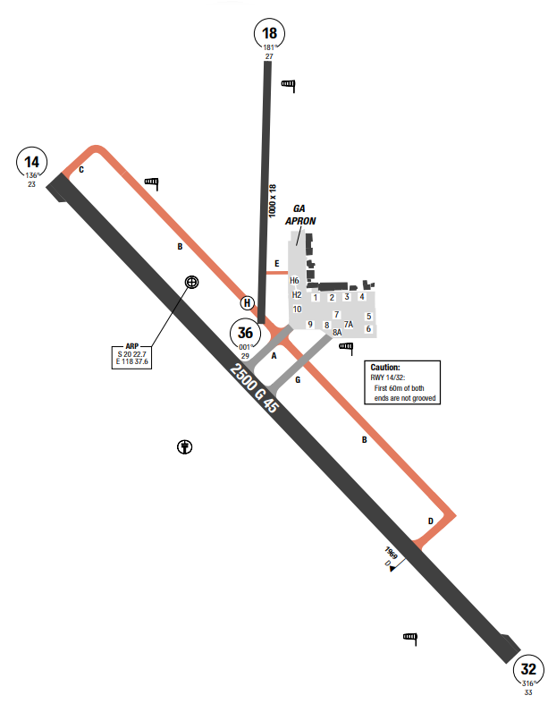
Port Hedland International Airport (IATA: PHE, ICAO: YPPD) is an international airport serving Port Hedland, Western Australia. The airport is 5 nautical miles (9.3 km) south-east of Port Hedland and 11 km from South Hedland and is owned by the Town of Port Hedland Council. It is an important airport for passengers who work in the mining industry.nThe climate of Port Hedland is tropical arid, with a very hot, humid period from December to March and a relatively cool period from May to August. The rains are scarce, and the only period with moderate rains is from January to March. This area of Western Australia can be affected by tropical cyclones. Cyclones typically form from mid-November to mid-May, but are more likely from late December to late March. In 2023, category 5 cyclone Ilsa hit the city in mid-April.
Departure |  |  | No
Arrival and Approach |  |  | - No direct Apch Lading or Departure from Apron.  - All Ops to be conducted from TWY or RWY.
Taxi |  |  | - TWY C, B Between TWY A and D, B Between C and RWY 18/ 36, TWY D, E are suitable for daylight OPS only.  - Wide body aircraft to use yellow dash lines when taxiing from RWY 14/ 32 onto Twy G.
Parking information |  |  | - DEP ACFT from bays 1-8 must use turn out lines.  - Pilots are REQ to minimize ground running of turboprop ACFT in the vicinity of parking bays 1-5 to reduce noise levels in terminal.
5. TAKE-OFF AND LANDING DISTANCES AVAILABLE
RWY | LENGTH  (m) |  |  | WIDTH  (m) |  | TORA  (m) |  | LDA  (m) |  | TODA  (m) | ASDA  (m)
14/ 32 | 2500 |  |  | 45 |  | 2500 |  | 2500 |  | 2560 | 2500
6. ELEVATION: 33ft |  |  |  |  | 7. EOSID: NO
8. IAP: NDB, RNP, VOR
9. COMPANY NOTE |  |  |  |  | - Significant bird and animal hazard exist.
10. REMARK |  |  |  |  | NIL

YPPH/ PER – PERTH INTL – PERTH – AUSTRALIA
1. AIRPORT CATEGORY: A |  |  |  |  |  |  |  | 2. RFFS CATEGORY: 9
3. AIRPORT CLASSIFICATION
ATR |  | A320 |  |  |  | A321 |  |  | A350 |  |  | B787
ADQ |  | ADQ |  |  |  | ADQ |  |  | ADQ |  |  | ADQ
4. GENERAL STANDARDS
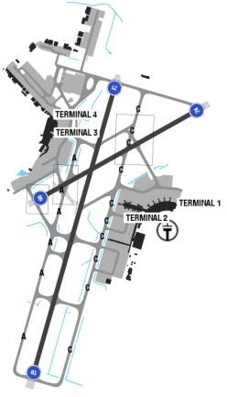
Perth Airport is an international, domestic and general aviation airport serving Perth, the capital city of Western Australia. It is the fourth busiest airport in Australia measured by passenger movements and falls within the boundaries of the City of Belmont, City of Kalamunda and the City of Swan.
Perth enjoys hot, dry summers and mild winters. During summer rain is unusual, but winter can bring downpours of rain and thunderstorms. Plan a trip to Perth with our information on temperature and rainfall. Summer in Perth is hot and dry with very little rainfall.
Departure |  |  | - There are SIDs with high climb gradients. If these SIDs are used in operation, ensure that the all engine climb gradient of aircraft meets the required minimum climb gradient  - Runway 21, Runway 03 and Runway 06 are equally preferred.  - By day, ATC may use 7874' (2400m) runway separation between aircraft arriving to Runway 03/ 21.  - NADP available at this airport
Arrival and Approach |  |  | - Noise abatement procedure  - RNAV STARs
Taxi |  |  | - Numerous taxiing restrictions apply.  - Aircraft to use minimum power when entering, exiting and operating on all aprons.
Parking information |  |  | - Standard push-back procedures.
5. TAKE-OFF AND LANDING DISTANCES AVAILABLE
RWY | LENGTH  (m) |  |  | WIDTH  (m) |  |  | TORA  (m) |  |  | LDA  (m) | TODA  (m) |  | ASDA  (m)
21 | 3444 |  |  | 45 |  |  | 3444 |  |  | 3444 | 3504 |  | 3444
03 | 3444 |  |  | 45 |  |  | 3444 |  |  | 3444 | 3644 |  | 3444
24/ 06 | 2163 |  |  | 45 |  |  | 2163 |  |  | 2163 | 2224 |  | 2163
6. ELEVATION: 67ft |  |  |  |  | 7. EOSID: YES
8. IAP: ILS (CAT I, II, III), LOC, RNP, VOR
9. COMPANY NOTE |  |  |  |  | - A slot allocation system and a ground delay program (GDP) applies at Perth airport. The arrival GDP applies to all fixed wing, non-priority flights departing from all Australian domestic airports and arriving at Perth between 0030-1400 UTC MON-FRI.  - Operators may request to swap start sequence numbers of own company aircraft by contacting Perth Tower.
10. REMARK |  |  |  |  | Ground Handling Frequency: 120.8 MHz

YSCB/ CBR – CANBERRA AIRPORT – CANBERRA, AUSTRALIA
1. AIRPORT CATEGORY: A |  |  |  |  |  |  |  | 2. RFFS CATEGORY: 7
3. AIRPORT CLASSIFICATION
ATR |  | A320 |  |  |  | A321 |  |  | A350 |  |  | B787
ADQ |  | ADQ |  |  |  | ADQ |  |  | ADQ |  |  | ADQ
4. GENERAL STANDARDS
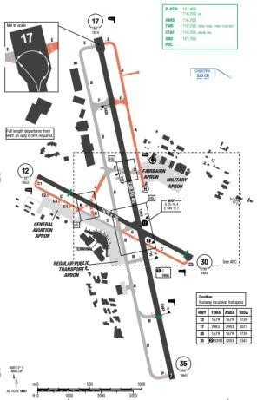
Canberra International Airport is an international airport situated in the District of Majura, Australian Capital Territory serving Australia's capital city, Canberra, as well as the nearby city of Queanbeyan and regional areas of the Australian Capital Territory, and southeastern New South Wales. High terrain in the vicinity of the airport. Highest MSA sector is 7500ft on the southern side.
Canberra has an oceanic climate. In January, the warmest month, the average high is approximately 29°C; in July, the coldest month, the average high drops to approximately 12°C
Departure |  |  | - RNAV SIDs.  - Require minimum climb gradient.  - Noise abatement procedures (prefered RWY and flight paths)  - Departures on RWY 35 are normally conducted from taxiway N, however the full length is available if operationally required
Arrival and Approach |  |  | - RNAV STARs.  - ILS 35 has 2 DA(H) depend on required minimum miss approach climb gradients.  - RWY 35 has a permanently displaced threshold. The Glideslope and T-VASIS are aligned with this displaced threshold  - RWY 17 approach area crosses a ridge line with high terrain (Mt. Majura) in proximity on the western side. Mt. Majura has obstacle lighting installed.
Taxi |  |  | - Taxi restrictions
Parking information |  |  | No
5. TAKE-OFF AND LANDING DISTANCES AVAILABLE
RWY | LENGTH  (m) |  |  | WIDTH  (m) |  |  | TORA  (m) |  |  | LDA  (m) | TODA  (m) |  | ASDA  (m)
12/ 30 | 1679 |  |  | 30 |  |  | 1679 |  |  | 1613 | 1739 |  | 1739
17 | 3283 |  |  | 45 |  |  | 2983 |  |  | 2983 | 3072 |  | 2983
35 | 3283 |  |  | 45 |  |  | 3283 |  |  | 2683 | 3343 |  | 3283
6. ELEVATION: 1886ft |  |  |  |  | 7. EOSID: YES
8. IAP: ILS (CAT I, II), LOC, NDB, RNP, VOR
9. COMPANY NOTE |  |  |  |  | - Due to strong westerly winds down stream of buildings, severe turbulence may be experienced at touchdown RWY 35.  - Aircraft operating between Black Mountain and airport may experience radio interference.  - Bird hazard  - Special Engine Failure procedure available for runway 17.  - According to NOTAM F3627/ 22, issue date 10/ 11/ 2022, RFFS category for YSCB airport temporary down to 7.  - According to CAAV:  - If an airport serves more than one purpose, the highest RFFS category corresponding to that purpose applies at the expected time of usage.  - Reduced RFFS category for an aircraft shall be approved by CAAV provided that:  - Aircraft with MEL on doors/ slides shall not be released for flight with destination alternates of reduced RFFS category.  - During disembarkation/ embarkation or passenger onboard, refueling/ defueling is not allowed at airport with reduced RFFS category.  - When 02 alternates are selected, the alternate with reduced RFFS category shall not be used in case of any fire-fighting equipment have been used inflight.
10. REMARK |  |  |  |  | NIL

YSSY/ SYD - KINGSFORD SMITH INTL AIRPORT – SYDNEY, AUSTRALIA
1. AIRPORT CATEGORY: A |  |  |  |  |  |  |  | 2. RFFS CATEGORY: 10
3. AIRPORT CLASSIFICATION
ATR |  | A320 |  |  |  | A321 |  |  | A350 |  |  | B787
ADQ |  | ADQ |  |  |  | ADQ |  |  | ADQ |  |  | ADQ
4. GENERAL STANDARDS
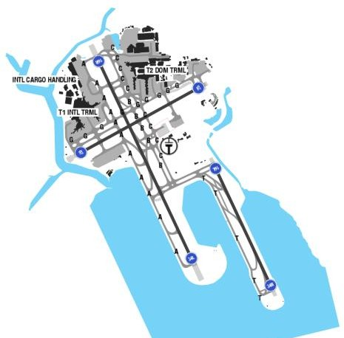
Sydney Airport (IATA: SYD, ICAO: YSSY), officially Sydney Kingsford Smith Airport and occasionally known as Mascot Airport, is an international airport located in Mascot, New South Wales, Australia, 9 kilometres south of the Sydney central business district.
Sydney has a temperate to humid subtropical climate featuring warm summers, mild winters, and no dry season.
Summer (December – February): Average temperatures range from 18.6°C to 25.8°C with high humidity peaking around 65%. Autumn (March – May): Milder conditions with falling humidity and average temperatures between 14.6°C and 22.2°C.Winter (June – August): Cool and mild, with temperatures dropping between 8.8°C and 17°C; June is often the wettest month.Spring (September – November): Pleasantly warm days with lower humidity than summer, averaging 11°C to 23°C

Departure |  |  | - RNAV SIDs  - EXPECT SIDs: DEENNA or RICMOND.  - Readback of the SID (including any transition) is required.  - NADP available at this airport
Arrival and Approach |  |  | - Crews shall advise inability to accept the duty runway as soon as possible. Pilots must state the word “REQUIRE. ”  - ATC may advise that Independent Visual Approaches are in use with notification as “EXPECT ILS APPROACH THEN INDEPENDENT VISUAL  APPROACH WHEN VISUAL”. Pilots are requested to call “Visual” and/ or “Runway (Number L/ R) in  Sight” as applicable, as soon as possible after initial contact with Approach/ Director. The “Rwy (number) LEFT/ RIGHT IN SIGHT” report indicates that the pilot can maintain the runway in sight throughout the approach. ATC will continue to vector the aircraft for final intercept. The “VISUAL” report is the only report required when established on the localizer.  - Localizer and G/ S guidance shall be maintained. This allows the application of the reduction in separation associated with Independent Visual Approaches chart.  - Independent Visual Approach instructions and advisory information.
Taxi |  |  | - Preferred exit taxiway procedures (do not apply during curfew hours)  - Single engine taxi is prohibited in YSSY, and taxi should be performed at idle power. If you stop the aircraft and need more than idle power to move, you must shut down the engines and call for tug.  - U-turn is not allowed for specific taxi way depend on type of aircraft.
Parking information |  |  | No
5. TAKE-OFF AND LANDING DISTANCES AVAILABLE
RWY | LENGTH  (m) |  |  | WIDTH  (m) |  |  | TORA  (m) |  |  | LDA  (m) | TODA  (m) |  | ASDA  (m)
07 | 2530 |  |  | 45 |  |  | 2530 |  |  | 2530 | 2530 |  | 2530
16L | 2438 |  |  | 45 |  |  | 2438 |  |  | 2207 | 2438 |  | 2438
16R | 3962 |  |  | 45 |  |  | 3962 |  |  | 3877 | 3962 |  | 3962
25 | 2530 |  |  | 45 |  |  | 2530 |  |  | 2429 | 2530 |  | 2530
34L | 3962 |  |  | 45 |  |  | 3962 |  |  | 3962 | 3962 |  | 3962
34R | 2438 |  |  | 45 |  |  | 2438 |  |  | 2400 | 2438 |  | 2438
6. ELEVATION: 21ft |  |  |  |  | 7. EOSID: NO
8. IAP: ILS (CAT I, II), LOC, RNP
9. COMPANY NOTE |  |  |  |  | - SYD Curfew Restrictions: (In Local time and mention in ATIS)  - Handling/ Refueling: Sydney ground staff are not permitted to Load or Pushback aircraft during lightning/ thunderstorm activity (due to many injuries and occasional fatalities in the past).
10. REMARK |  |  |  |  | Ground Handling Frequency: 131.7 MHz

ZBAA/ PEK – BEIJING CAPITAL AIRPORT – BEIJING, PR OF CHINA
1. AIRPORT CATEGORY: A |  |  |  |  |  |  |  | 2. RFFS CATEGORY: 10
3. AIRPORT CLASSIFICATION
ATR |  | A320 |  |  |  | A321 |  |  | A350 |  |  | B787
ADQ |  | ADQ |  |  |  | ADQ |  |  | ADQ |  |  | ADQ
4. GENERAL STANDARDS
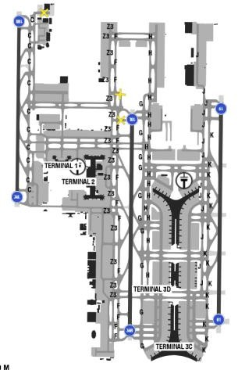
Beijing Capital International Airport is located 32 km (20 mi) northeast of Beijing's city center, in anenclave of Chaoyang District and the surroundings of that enclave in suburban Shunyi District.
There are variable surrounding high terrains near the airport. During summertime, the weather is quite good and usually hazy. Summer, which last from June to September is very hot and humid with frequent rain. Winter lasts from December to February and is dry and cold. Sandstorms are observed at times
Departure |  |  | - Shall not apply for ATC delivery clearance 30mins earlier than ETD, for push-back not earlier than 10mins.  - RNAV SIDs  - RWY 18L/ 36R is mainly used for departure.  - NADP available at this airport
Arrival and Approach |  |  | - RNAV STARs.  - RWY 18R/ 36L and 01/ 19 is used for arrival.  - ATIS is only available within 120 nm from the AP.  - Speed restrictions.  - ACFT shall vacate RWY within 50s (70s if heavy or above). If unable, crew have report to ATC.  - ATC usually requires to an early speed reduction, early and step-descent at due to high volume of  traffic.  - Sometimes during approach, ATC requires pilot to maintain visual separation with traffic ahead.  Therefore, the crew should actively adjust speed during approach to avoid unwanted go around due traffic still on runway  - RWY change is also expected at last moment during approach.
Taxi |  |  | - Taxi routes.  - Taxi routes for LVO  - ATC may give individual taxi routes depending on traffics.  - Long taxi time normally is expected for departure runway 18 (around 30-40 minutes or more) due to high volume of traffic.  - When wind reach 10.8m/ s, single engine taxi is prohibited.  - There are several locations that require special attention of the crew in the actual operation so as to  avoid taxing into the runway by mistake in Beijing Capital Airport:  - The intersection area of taxiway S4 and taxiway F.  - The intersection area of taxiway Z2 and taxiway F.  - The intersection area of taxiway W2 and taxiway F.  - Multiple runway incursion hot spots are identified and illustrated on the chart
Parking information |  |  | - Parking bays 205-215 at S apron
5. TAKE-OFF AND LANDING DISTANCES AVAILABLE
RWY | LENGTH  (m) |  |  | WIDTH  (m) |  |  | TORA  (m) |  |  | LDA  (m) | TODA  (m) |  | ASDA  (m)
01 | 3800 |  |  | 60 |  |  | 3800 |  |  | 3800 | 4300 |  | 3800
18L/ 36R | 3800 |  |  | 60 |  |  | 3800 |  |  | 3800 | 4000 |  | 3800
18R/ 36L | 3200 |  |  | 50 |  |  | 3200 |  |  | 3200 | 3200 |  | 3200
19 | 3800 |  |  | 60 |  |  | 3800 |  |  | 3800 | 3800 |  | 3800
6. ELEVATION: 116ft |  |  |  |  | 7. EOSID: YES
8. IAP: ILS (CAT I, II, III), LOC
9. COMPANY NOTE |  |  |  |  | - Set transponder on mode S while taxiing.  - Pilots are requested to carefully study the airport charts and strictly follow the ATC instructions. When the flight crew has any doubts, they should immediately stop the aircraft and request to clarify. As stated by Beijing Airport authorities, for all airlines operating to and from PEK, any failures to comply with taxi instructions will be fined. Subsequent flights to PEK by violated operators will be moved to parking areas at a significant distance from the terminal, leading to expensive additional airport fees.  - Due to high volume of traffic and departure priority being given to Chinese aircrafts, it is pertinent to carry extra fuel for your departure, especially if there is any inclement weather.  - Empty disinfection spray bottles should be presented to Beijing airport authority at arrival as proof that the aircraft has been disinfected.  - Flight documents are brought to the aircraft by the ground handling agents.
10. REMARK |  |  |  |  | NIL

ZBAD/ PKX – BEIJING DAXING AIRPORT – BEIJING, PR OF CHINA
1. AIRPORT CATEGORY: A |  |  |  |  |  |  |  | 2. RFFS CATEGORY: 10
3. AIRPORT CLASSIFICATION
ATR |  | A320 |  |  |  | A321 |  |  | A350 |  |  | B787
ADQ |  | ADQ |  |  |  | ADQ |  |  | ADQ |  |  | ADQ
4. GENERAL STANDARDS
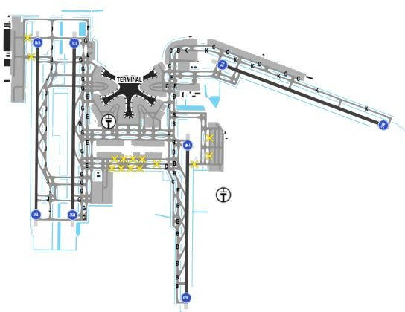
Beijing Daxing International Airport, is one of two international airports serving Beijing. Beijing is just about affected by monsoon circulation, giving it a typical semi-humid continental monsoon climate with humid summers and cold, dry winters.
The hottest month is July, and January is the coldest. The rainy summer season is June, July, and August. Beijing has four well-defined typical seasons. In general, Beijing's spring temperatures are very changeable day-to-day and month-to-month. Summer is hot, humid, and rainy with moderate to heavy thundery showers. Autumn is sunny and less rainy with comfortable and pleasant weather. Winter is cold and dry, windy but with little snow. At the same latitude as New York, Beijing has similar weather but is colder in the winter.
Departure |  |  | - Shall not apply for ATC delivery clearance 30 mins earlier than ETD, using DCL or voice  - RWY 11L and 17L/ 35R are mainly used for departure.  - RNAV SIDs  - NADP available at this airport
Arrival and Approach |  |  | - RNAV STARs  - RWY 01L/ 19R and 17R/ 35L are mainly used for arrival.
Taxi |  |  | - After landing, crew shall use and vacate rapid taxiway as soon as possible  - For departure, ACFT shall finish RWY alignment within 60s, takeoff run 10s  - Once flight crew crossed RWY, report to TWR “RWY vacated”  - When the wind speed is 21kts or greater, taxiing with single engine is strictly forbidden.  - ACFT taxiing speed limits: less than 30kts on straights TWYs, less than 40kts on rapid exit TWYs.  - While taxiing on TWYs parallel and next to RWY, pilots shall pay attention to other ACFT vacating RWY, keep safety separation and avoid ground conflict.  - When red stop bars are illuminated, any crossing is strictly forbidden
Parking information |  |  | No
5. TAKE-OFF AND LANDING DISTANCES AVAILABLE
RWY | LENGTH  (m) |  |  | WIDTH  (m) |  |  | TORA  (m) |  |  | LDA  (m) | TODA  (m) |  | ASDA  (m)
01L/ 19R | 3400 |  |  | 60 |  |  | 3400 |  |  | 3400 | 3400 |  | 3400
11L | 3800 |  |  | 60 |  |  | 3800 |  |  | 3800 | 3800 |  | 3800
17L/ 35R | 3800 |  |  | 60 |  |  | 3800 |  |  | 3800 | 3800 |  | 3800
17R/ 35L | 3800 |  |  | 60 |  |  | 3800 |  |  | 3800 | 3800 |  | 3800
29R | 3800 |  |  | 60 |  |  | 3800 |  |  | 3800 | 3800 |  | 3800
6. ELEVATION: 83ft |  |  |  |  | 7. EOSID: YES
8. IAP: ILS (CAT I, II, III), LOC
9. COMPANY NOTE |  |  |  |  | - Birds.  - Coloring push back procedures.
10. REMARK |  |  |  |  | NIL

ZBDS/ DSN - ORDOS EJIN HORO INTL AIRPORT, CHINA
1. AIRPORT CATEGORY: A |  |  |  |  |  |  |  | 2. RFFS CATEGORY: 9
3. AIRPORT CLASSIFICATION
ATR |  | A320 |  |  |  | A321 |  |  | A350 |  |  | B787
ADQ |  | ADQ |  |  |  | ADQ |  |  | ADQ |  |  | ADQ
4. GENERAL STANDARDS
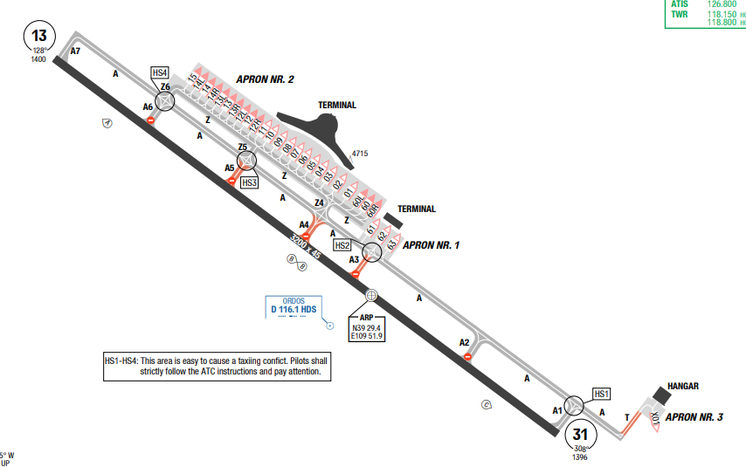
Ordos Ejin Horo International Airport is an airport serving Ordos City in China's Inner Mongolia Autonomous Region. It is located in Ejin Horo Banner. First built in 1959 and called Dongsheng Airport, the airport ceased operation in 1983.
Ejin Horo has a dry, arid climate common to desert regions, characterized by large daily and seasonal temperature fluctuations. The annual average temperature is below 18°C, with temperatures frequently dropping below freezing in the winter. It experiences dry conditions, with low annual precipitation and significant temperature swings between day and night.
Departure |  |  | - RNAV SIDs  - COMM failure procedure available  - Pilot shall start ENG within 5min after receipt of start-up CLR.
Arrival and Approach |  |  | - RNAV STARs  - COMM failure procedure available
Taxi |  |  | - TWY A, A1, A2, A6, A7, Z, Z4-Z6 AVBL for ACFT with MAX wingspan below 65m / 213ft.  - TWY A3-A5, T AVBL for ACFT with MAX wingspan 36m/ 118ft.  - Forbidden enter TWY A after vacating RWY via TWY A4, A5, follow ATC instructions strictly.  - TWY T width 18m / 59ft.
Parking information |  |  | NIL
5. TAKE-OFF AND LANDING DISTANCES AVAILABLE
RWY | LENGTH  (m) |  |  | WIDTH  (m) |  |  | TORA  (m) |  |  | LDA  (m) | TODA  (m) |  | ASDA  (m)
13/ 31 | 3200 |  |  | 45 |  |  | 3200 |  |  | 3200 | 3200 |  | 3200
6. ELEVATION: 4593ft |  |  |  |  | 7. EOSID: YES
8. IAP: ILS, LOC, RNP, VOR
9. COMPANY NOTE |  |  |  |  | - Birds in vicinity of AD.
10. REMARK |  |  |  |  | NIL

ZBHH/ HET- HOHHOT BAITA – CHINA
- AIRPORT CATEGORY: A |  |  |  |  |  |  | - RFFS CATEGORY: 8
- AIRPORT CLASSIFICATION
ATR |  | A320 |  | A321 |  |  | A350 |  | B787
ADQ |  | ADQ |  | ADQ |  |  | ADQ |  | ADQ
4. GENERAL STANDARDS
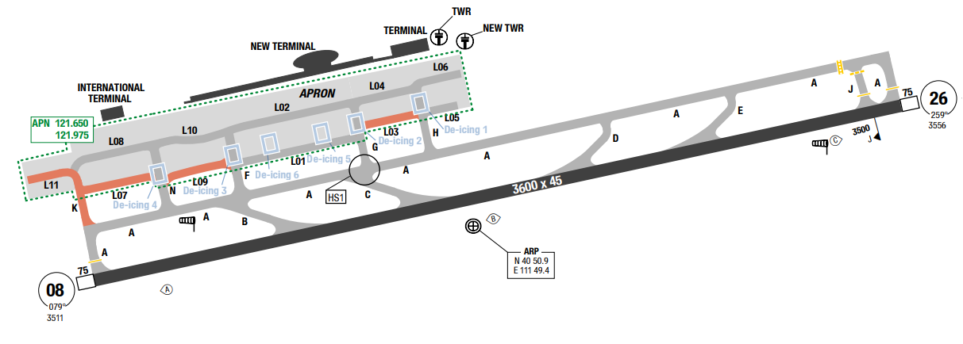
Baita Airport is located in the Inner Mongolian Autonomous Region of north central China. The highest MSA is to the north sector of KJ NDB at 9700’. Annual precipitation totals 40 cm (15.9 in). Winds are from the northwest in March. Winds are from the south in August. Winds are from the northwest in November. Expect very low temperature and snow in winter.
Departure |  |  | - Conventional and RNAV SIDs  - SID with high climb gradient
Arrival and Approach |  |  | - Conventional and RNAV STARs  - Speed restrictions. IF unable, report available speed before IAF  - Require minimum climb gradient for missed approach  - Circling to land is not authorized north of the airport.
Taxi |  |  | - ACFT shall vacate RWY within 50s (medium) or 70s (heavy ACFT); align RWY within 50s  - During winter, taxi lines can be difficult to see due to snow. Flight crew can request follow me car for taxi.
Parking information |  |  | - EXPECT: Parking 12 to 14.
5. TAKE-OFF AND LANDING DISTANCES AVAILABLE
RWY | LENGTH  (m) |  |  | WIDTH  (m) |  | TORA  (m) |  | LDA  (m) |  | TODA  (m) | ASDA  (m)
08 | 3600 |  |  | 45 |  | 4000 |  | 4000 |  | 4000 | 3675
26 | 3600 |  |  | 45 |  | 3800 |  | 3800 |  | 3800 | 3675
6. ELEVATION: 3556ft |  |  |  |  | 7. EOSID: YES
8. IAP: ILS, LOC
9. COMPANY NOTE |  |  |  |  | - Expect rapid changes in altitudes, headings and frequencies during arrivals and departures  - All altitudes are given in meters.  - ATC communications can be easily misunderstood, especially numbers.  - Close attention is required. Use standard phraseology as accurately as possible.  - Birds are in the vicinity of the airport.
10. REMARK |  |  |  |  | NIL

ZBSJ/ SJW – SHIJIAZHUANG (ZHENGDING INTL) – CHINA
- AIRPORT CATEGORY: A |  |  |  |  |  |  | - RFFS CATEGORY: 8
- AIRPORT CLASSIFICATION
ATR |  | A320 |  | A321 |  |  | A350 |  | B787
ADQ |  | ADQ |  | ADQ |  |  | ADQ |  | ADQ
4. GENERAL STANDARDS
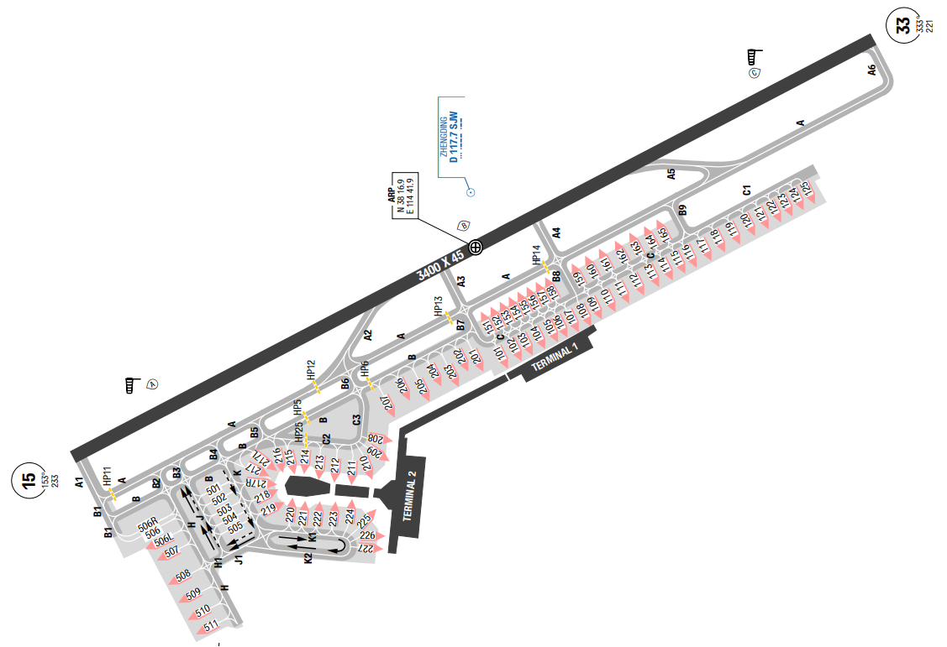
The airport serves Shijiazhuang, the capital of Hebei province, China. The terrain surrounding Shijiazhuang is generally flat, with the highest MSA of 3800ft to the West of SJW VOR. In Shijiazhuang, the summers are long, hot, humid, and partly cloudy and the winters are freezing, dry, and mostly clear. During the night winter, the ceiling can become very low.
Departure |  |  | - RNAV SIDs.
Arrival and Approach |  |  | - RNAV STARs.
Taxi |  |  | - Standard taxi routes and parking informations.  - TWY B2, B4 and B6 are used for arrival Aircrafts entering apron.  - TWYs B1, B3 and B5 are used for departure Aircrafts exiting apron.
Parking information |  |  | - EXPECT: Parking from 103 to 107.
5. TAKE-OFF AND LANDING DISTANCES AVAILABLE
RWY | LENGTH  (m) |  |  | WIDTH  (m) |  | TORA  (m) |  | LDA  (m) |  | TODA  (m) | ASDA  (m)
15 | 3400 |  |  | 45 |  | 3400 |  | 3400 |  | 3640 | 3400
33 | 3400 |  |  | 45 |  | 3400 |  | 3400 |  | 3640 | 3400
6. ELEVATION: 2336ft |  |  |  |  | 7. EOSID: YES
8. IAP: ILS, LOC, NDB, VOR
9. COMPANY NOTE |  |  |  |  | - RWY 33 right-hand circuit.
10. REMARK |  |  |  |  | NIL

ZBTJ/ TSN – BINHAI AIRPORT – TIANJIN, PR OF CHINA
1. AIRPORT CATEGORY: A |  |  |  |  |  |  |  | 2. RFFS CATEGORY: 9
3. AIRPORT CLASSIFICATION
ATR |  | A320 |  |  |  | A321 |  |  | A350 |  |  | B787
ADQ |  | ADQ |  |  |  | ADQ |  |  | ADQ |  |  | ADQ
4. GENERAL STANDARDS
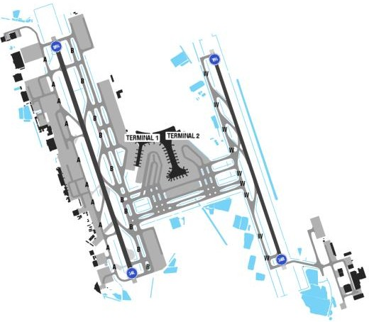
Tianjin Binhai International Airport is an airport located in Dongli District, Tianjin. It is one of the major air cargo centers in the People's Republicof China. The terrains surrounding the airport are flat with the MSA of 3800ft. Tianjin is located on the east shore of the European-Asian continent, which is affected by monsoons.
Tianjin has a temperate monsoon climate, making the area windy and dry in the spring, hot and rainy in the summer (June to August), cool in the autumn, and cold and snowy in the winter (December to February). The annual rainfall in Tianjin is 600 mm, and the annual average temperature is 12 degrees Celsius
Departure |  |  | - RNAV SIDs  - RWY 16R/ 34L is used for takeoff.  - Departing ACFT shall report ALT and departure mode on initial contact.
Arrival and Approach |  |  | - RNAV STARs.  - RWY 16L/ 34R is used for landing.
Taxi |  |  | - ACFT shall fully vacate 50s after touching ground; finish RWY alignment within 60s after receiving clearance.
Parking information |  |  | - EXPECT: Parking 10x
5. TAKE-OFF AND LANDING DISTANCES AVAILABLE
RWY | LENGTH  (m) |  |  | WIDTH  (m) |  |  | TORA  (m) |  |  | LDA  (m) | TODA  (m) |  | ASDA  (m)
16L/ 34R | 3200 |  |  | 45 |  |  | 3200 |  |  | 3200 | 3640 |  | 3400
16R | 3600 |  |  | 60 |  |  | 3600 |  |  | 3200 | 3600 |  | 3600
34L | 3600 |  |  | 60 |  |  | 3600 |  |  | 3600 | 3600 |  | 3600
6. ELEVATION: 6ft |  |  |  |  | 7. EOSID: NO
8. IAP: ILS (CAT I, II*), LOC, VOR
9. COMPANY NOTE |  |  |  |  | - Birds  - RWY 34L/ R right-hand circuit.
10. REMARK |  |  |  |  | NIL
*Note: CAT II/ III available, approval require

ZBYN/ TYN – WUSU – TAIYUAN – CHINA
- AIRPORT CATEGORY: A |  |  |  |  |  |  | - RFFS CATEGORY: 9
- AIRPORT CLASSIFICATION
ATR |  | A320 |  | A321 |  |  | A350 |  | B787
ADQ |  | ADQ |  | ADQ |  |  | ADQ |  | ADQ
4. GENERAL STANDARDS
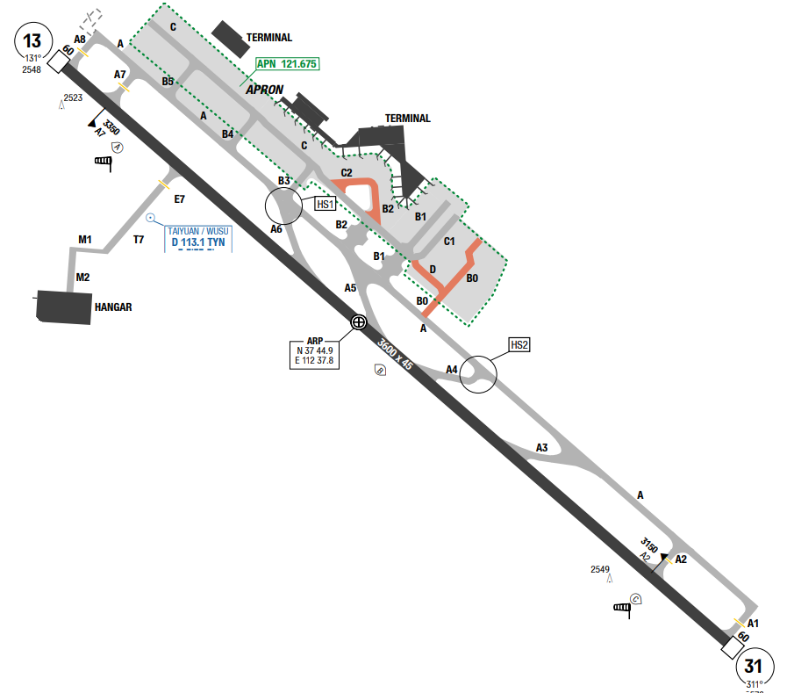
Taiyuan Wusu International Airport is an airport serving Taiyuan, the capital of Shanxi province,
China. It is is located about 15 kilometres (about 9.3 miles) southeast of downtown Taiyuan. The
airport is surrounded by mountains. Taiyuan experiences a semi-arid climate. Spring is dry, with frequent dust storms, followed by early summer heat waves. Summer tends to be warm to hot with most of the year's rainfall concentrated in July and August. Winter is long and cold, but dry and sunny. Because of the aridity, there tends to be considerable diurnal variation in temperature, except during the summer.
Departure |  |  | - RNAV SIDs.  - Flight crew shall pay attention to the mountain NE of AD and the chimneys between 360° and 040°of AD, altitude above 3940
Arrival and Approach |  |  | - RNAV STARs.  - Radar vector for final.  - For miss approach, ACFT will be requested to maintain RWY HDG
Taxi |  |  | - ACFT should be vacated RWY within 50s (70s for heavy ACFT)  - Runway incursion hot spots are identified and illustrated
Parking information |  |  | - Follow-me mandatory for arriving ACFT
5. TAKE-OFF AND LANDING DISTANCES AVAILABLE
RWY | LENGTH  (m) |  |  | WIDTH  (m) |  | TORA  (m) |  | LDA  (m) |  | TODA  (m) | ASDA  (m)
13/ 31 | 3600 |  |  | 45 |  | 3600 |  | 3600 |  | 3600 | 3660
6. ELEVATION: 2579ft |  |  |  |  | 7. EOSID: YES
8. IAP: ILS, LOC, VOR
9. COMPANY NOTE |  |  |  |  | - Birds.
10. REMARK |  |  |  |  | NIL

ZGGG/ CAN – BAIYUN AIRPORT – GUANGZHOU, PR OF CHINA
1. AIRPORT CATEGORY: A |  |  |  |  |  |  |  | 2. RFFS CATEGORY: 10
3. AIRPORT CLASSIFICATION
ATR |  | A320 |  |  | A321 |  |  |  | A350 |  | B787
ADQ |  | ADQ |  |  | ADQ |  |  |  | ADQ |  | ADQ
4. GENERAL STANDARDS
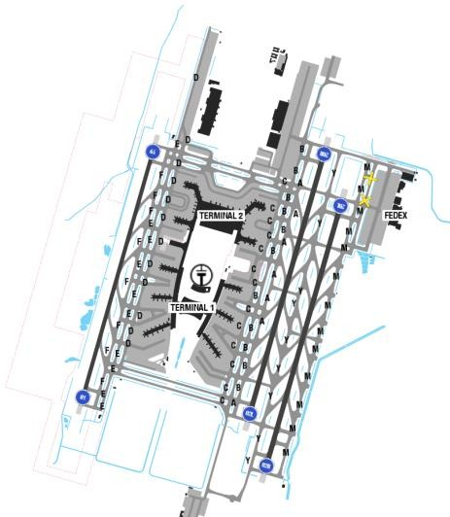
Guangzhou leans against Jiulian mountain in the North, Luofu in the West, Qingyun in the East and the Jiulian-Nankun mountain ranges in the middle. In the South of the airport is the Zhuzhiang River Delta.
Guangzhou has a subtropical humid monsoon climate, which is hot and rainy. In wintertime, which lasts from October to March, the climate is drier with an average temperature of 22°C. In contrast, in summer, from April to September, it is quite hot with an average temperature of 32°C and humid with often heavy rainfall. Very often, it is quite hazy due to industrial zones around the airport.
Departure |  |  | - RNAV SIDs  - EXPECT 01/ 20R for departure.  - ATC always gives step-climbs. Expect low level flying within Guangzhou Fir.  - Report RWY in use to APP02 on first contact.  - Leave Tower without instruction as soon as airborne, contact Approach immediately on the frequency assigned by ATC clearance.  - NADP available at this airport
Arrival and Approach |  |  | - RNAV STARs.  - RWY 02R/ 20L is mainly used for arrival.  - Speed restrictions.
Taxi |  |  | - ACFT should finish alignment within 60s.  - Taxi routes for arrival.  - Taxi routes for departure.  - Multiple Runway Incursion Hot Spots are identified and illustrated.  - 180° turnaround on the runway is forbidden.  - EPXECT: Route Yellow 11, long taxi time due to congestion.  - Extreme vigilance is required when crossing runways.  - Runway incursion occurred at Baiyun Airport after landing and expect taxi via P4-P3, which exposed  the risk that flight crew would invade East Runway (02L/ 20R) by mistaking warning light as runway  holding point especially at night.  - Pilots are requested to pay attention during taxi via P4-P3 taxiway to avoid RWY incursion.  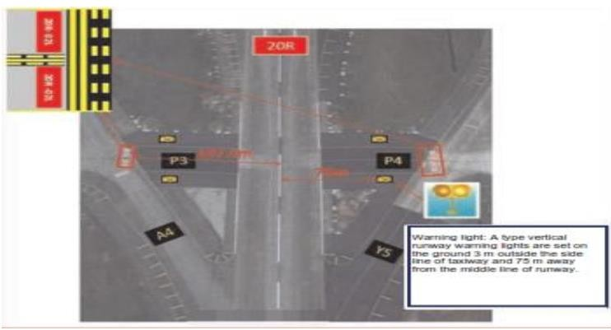
Parking information |  |  | - Normally on the East apron (stand 145 to 150).
5. TAKE-OFF AND LANDING DISTANCES AVAILABLE
RWY | LENGTH  (m) |  |  |  |  | WIDTH  (m) | TORA  (m) |  |  | LDA  (m) |  | TODA  (m) | ASDA  (m)
01L/ 19R | 3600 |  |  |  |  | 45 | 3600 |  |  | 3600 |  | 3600 | 3600
02L/ 20R | 3800 |  |  |  |  | 60 | 3800 |  |  | 3800 |  | 3800 | 3800
02R/ 20L | 3800 |  |  |  |  | 60 | 3800 |  |  | 3800 |  | 3800 | 3800
01R/ 19L | 3600 |  |  |  |  | 45 | 3600 |  |  | 3600 |  | 3600 | 3600
6. ELEVATION: 50ft |  |  |  | 7. EOSID: YES
8. IAP: ILS, LOC
9. COMPANY NOTE |  |  |  | - WARNING: several airports near ZGGG. ACT shall strictly adhere to flight track and altitude and follow ATC instructions.  - Metric unit is used in China airspace.  - It is a requirement of BAIYUN airport, not to start the APU after landing. Electrical power and air conditioning are available at the gate. APU could be started 10 minutes before estimated chock off time.  - Most of the radio chatter is in Chinese, so extra vigilance on the radio is essential.
10. REMARK |  |  |  | Ground Handling Frequency: 121.75 MHz (east RWY), 121.85 MHz (west RWY)

ZGHA/ CXS - CHANGSHA (HUANGHUA) – CHINA
- AIRPORT CATEGORY: A |  |  |  |  |  |  | - RFFS CATEGORY: 9
- AIRPORT CLASSIFICATION
ATR |  | A320 |  | A321 |  |  | A350 |  | B787
ADQ |  | ADQ |  | ADQ |  |  | ADQ |  | ADQ
4. GENERAL STANDARDS
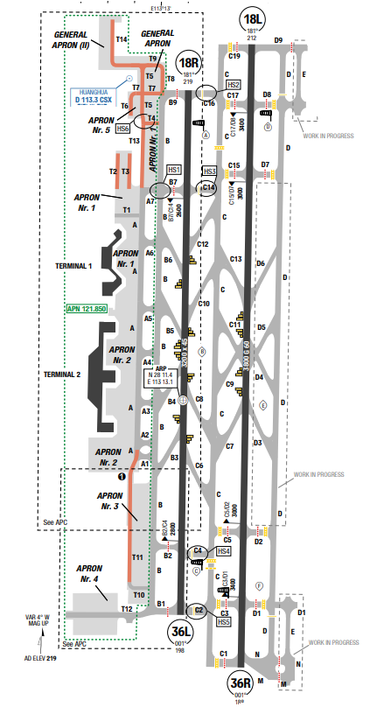
Changsha Huanghua International Airport is the airport serving Changsha, Hunan province, People's Republic of China. Located about 25 kilometres from downtown Changsha in the town of Huanghua in Changsha County. Changsha experiences a humid subtropical climate, with annual average temperature being 17.03 °C, with a mean of 4.6 °C in January and 29.0 °C in July. Average annual precipitation is 1,331mm. The four seasons are distinct. The summers are long and very hot, with heavy rainfalls, and autumn is comfortable and is the driest season.
Departure |  |  | - Conventional and RNAV SIDs.  - Noise abatement procedure.  - In order to avoid frequency congestion, pilot shall leave HUANGHUA TWR frequency without instruction from controller after tanging off and contact APP immediately on the frequency assigned by ATC clearance.  - SID with high climb gradient
Arrival and Approach |  |  | - Conventional and RNAV STARs.
Taxi |  |  | - ACFT shall fully vacate within 50s after touching down; finish alignment within 60s.  - Multiple Runway Incursion Hot Spots are identified and illustrated.
Parking information |  |  | - Taxiing into APN by follow-me only.
5. TAKE-OFF AND LANDING DISTANCES AVAILABLE
RWY | LENGTH  (m) |  |  | WIDTH  (m) |  | TORA  (m) |  | LDA  (m) |  | TODA  (m) | ASDA  (m)
18L/ 36R | 3800 |  |  | 60 |  | 3800 |  | 3800 |  | 3800 | 3800
18R/ 36L | 3200 |  |  | 45 |  | 3200 |  | 3200 |  | 3200 | 3200
6. ELEVATION: 219ft |  |  |  |  | 7. EOSID: NO
8. IAP: ILS (CAT I, II*), LOC
9. COMPANY NOTE |  |  |  |  | - Birds are in the vicinity of the airport.  - Expect rapid changes in altitudes, headings and  frequencies during arrivals and departures
10. REMARK |  |  |  |  | NIL
*Note: CAT II, approval require

ZGNN/ NNG–WUXUAIRPORT–NANNING, PR OF CHINA
1. AIRPORT CATEGORY: A |  |  |  |  |  |  |  | 2. RFFS CATEGORY: 8
3. AIRPORT CLASSIFICATION
ATR |  | A320 |  |  |  | A321 |  |  | A350 |  | B787
ADQ |  | ADQ |  |  |  | ADQ |  |  | ADQ |  | ADQ
4. GENERAL STANDARDS
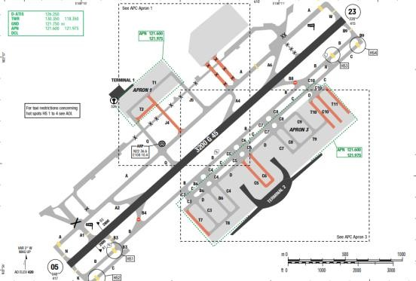
Nanning Wuxu Intl is an airport serving Nanning, the capital of Guangxi Autonomous Region, China. It is located 32km south-west of the center of the city. The climate in Nanning is warm and temperate. Nanning is a city with a significant rainfall. Even in the driest months, there are frequent heavy rainfalls. The average annual temperature is 22.5°C in Nanning. There is an average amount 1363 mm of annual precipitation. July is the warmest month of the year. The temperature in July averages to about 29 °C. January is the coldest month, with temperatures averaging 13 °C.
Departure |  |  | - Conventional and RNAV SID  - Noise abatement procedure
Arrival and Approach |  |  | - Conventional and RNAV STARs.
Taxi |  |  | - 180 turnaround on TWY is forbidden.  - ACFT should finish entering RWY less than 90s,
Parking information |  |  | - EXPECT 10x
5. TAKE-OFF AND LANDING DISTANCES AVAILABLE
RWY | LENGTH  (m) |  |  | WIDTH  (m) |  |  | TORA  (m) |  |  | LDA  (m) |  | TODA  (m) | ASDA  (m)
05/ 23 | 3200 |  |  | 45 |  |  | 3200 |  |  | 3200 |  | 3200 | 3200
6. ELEVATION: 420ft |  |  |  |  | 7. EOSID: NO
8. IAP: ILS (CAT I, II*), LOC, VOR
9. COMPANY NOTE |  |  |  |  | NIL
10. REMARK |  |  |  |  | NIL
*Note: CAT II, approval require

ZGSZ/ SZX – BAOAN AIRPORT – SHENZHEN, PR OF CHINA
1. AIRPORT CATEGORY: A |  |  |  |  |  |  |  | 2. RFFS CATEGORY: 9
3. AIRPORT CLASSIFICATION
ATR |  | A320 |  |  |  | A321 |  |  | A350 |  |  | B787
ADQ |  | ADQ |  |  |  | ADQ |  |  | ADQ |  |  | ADQ
4. GENERAL STANDARDS
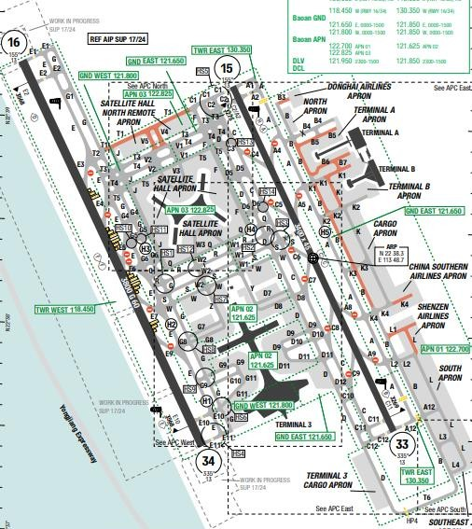
Shenzhen Bao'an International Airport is the airport serving Shenzhen, Guangdong Province. It is located on the east bank of the Pearl River near Huangtian and Fuyong villages in Bao'an District and is 32 km (20 mi) northwest of the city center.
In Shenzhen, the wet season is hot, oppressive, and overcast and the dry season is comfortable, windy, and mostly clear. The wet season lasts from April to September. The dry season lasts from September to April.
Departure |  |  | - Conventional and RNAV SID  - Noise abatement procedure
Arrival and Approach |  |  | - Conventional and RNAV STARs.  - Speed restrictions  - Miss approaches require minimum climb gradient (3%). Crew inform TWR on initial contact if unable
Taxi |  |  | - Vacating RWY via rapid exit TWYs (within 50s, forbidden to stop).  - Shall turn on mode S after landing until entering parking stands.  - Follow-me is not available for arrival, except special flight. If required, landing aircraft shall file for follow me service to Airport Operation control centre in 30 minutes advance.
Parking information |  |  | - EXPECT Parking from 301-308
5. TAKE-OFF AND LANDING DISTANCES AVAILABLE
RWY | LENGTH  (m) |  |  | WIDTH  (m) |  |  | TORA  (m) |  |  | LDA  (m) | TODA  (m) |  | ASDA  (m)
15/ 33 | 3400 |  |  | 45 |  |  | 3400 |  |  | 3400 | 3400 |  | 3400
16/ 34 | 3800 |  |  | 60 |  |  | 3800 |  |  | 3800 | 3800 |  | 3800
6. ELEVATION: 13ft |  |  |  |  | 7. EOSID: NO
8. IAP: ILS, LOC
9. COMPANY NOTE |  |  |  |  | - Using APU.  - RWY 15/ 33 is closed on Monday, Wednesday, Friday, and Saturday between 1800-2200UTC, but it is still available for taxing during closure period.  - RWY 16/ 34 is closed on Tuesday, Thursday, and Sunday between 1800-2200UTC.
10. REMARK |  |  |  |  | NIL

ZHCC/ CGO - ZHENGZHOU (XINZHENG INTL) – CHINA
- AIRPORT CATEGORY: A |  |  |  |  |  |  |  | - RFFS CATEGORY: 9
- AIRPORT CLASSIFICATION
ATR | A320 |  |  | A321 |  |  |  | A350 |  | B787
ADQ | ADQ |  |  | ADQ |  |  |  | ADQ |  | ADQ
4. GENERAL STANDARDS
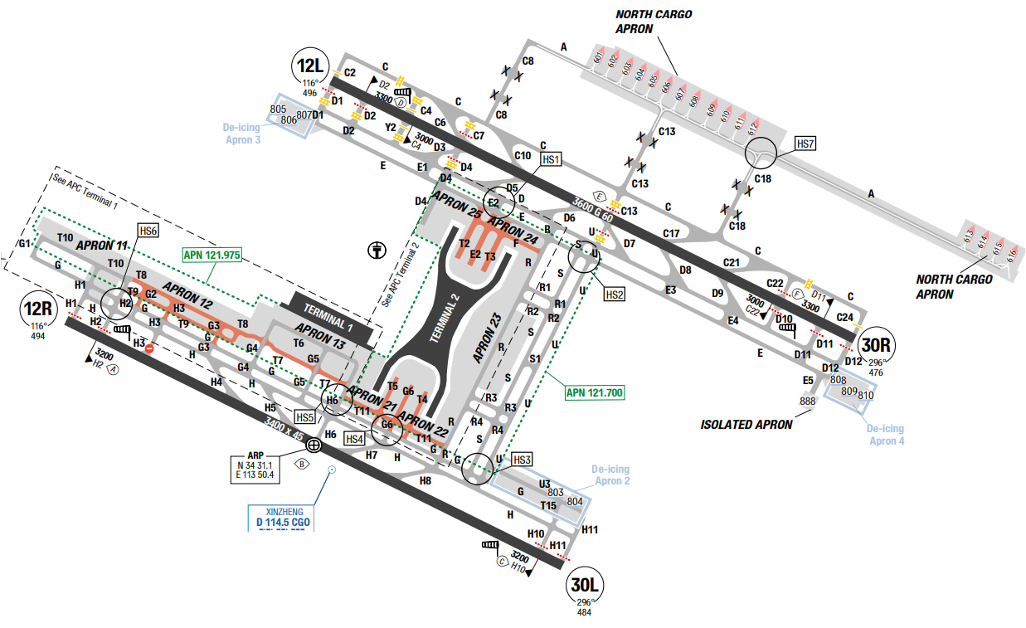
Xinzheng International Airport is in Xinzheng, 37 kilometres (23 mi) southeast of downtown Zhengzhou. With a warm temperate continental climate, the annual average temperature of Zhengzhou is about 14 degrees Celsius. The weather is comfortable, with bright sunshine and a clear distinction among the four seasons. The climate in July is the hottest with an average temperature of about 27 degrees Celsius, while the coldest month is January, with an average temperature around minus 0 degrees Celsius.
Departure |  |  | - Conventional and RNAV SIDs.  - RWY 30L/ 12R is mainly used for departure.  - Noise abatement procedure
Arrival and Approach |  |  | - Conventional and RNAV STARs.  - RWY30R/ 12L is mainly used for landing.  - Speed restrictions  - Circle to land restrictions exist at this airport.
Taxi |  |  | - ACFT shall enter and get ready for takeoff within 60s  - Multiple Runway Incursion Hot Spots are identified and illustrated on the chart.  - ACFT shall switch on transponder when taxiing.  - 180 turnaround on RWY is strictly forbidden without ATC permission
Parking information |  |  | - EXPECT: parking 26x
5. TAKE-OFF AND LANDING DISTANCES AVAILABLE
RWY |  | LENGTH  (m) |  |  |  | WIDTH  (m) | TORA  (m) |  | LDA  (m) |  | TODA  (m) | ASDA  (m)
12L/ 30R |  | 3600 |  |  |  | 60 | 3600 |  | 3600 |  | 3600 | 3600
12R/ 30L |  | 3400 |  |  |  | 45 | 3400 |  | 3400 |  | 3400 | 3400
6. ELEVATION: 496ft |  |  |  |  | 7. EOSID: YES
8. IAP: ILS (CAT I, II), LOC
9. COMPANY NOTE |  |  |  |  | - Wake turbulence re-categorization (RECAT-CN)  - RWY closing time
10. REMARK |  |  |  |  | NIL

ZHHH/ WUH - WUHAN (TIANHE) – CHINA
- AIRPORT CATEGORY: A |  |  |  |  |  |  | - RFFS CATEGORY: 9
- AIRPORT CLASSIFICATION
ATR |  | A320 |  | A321 |  |  | A350 |  | B787
ADQ |  | ADQ |  | ADQ |  |  | ADQ |  | ADQ
4. GENERAL STANDARDS
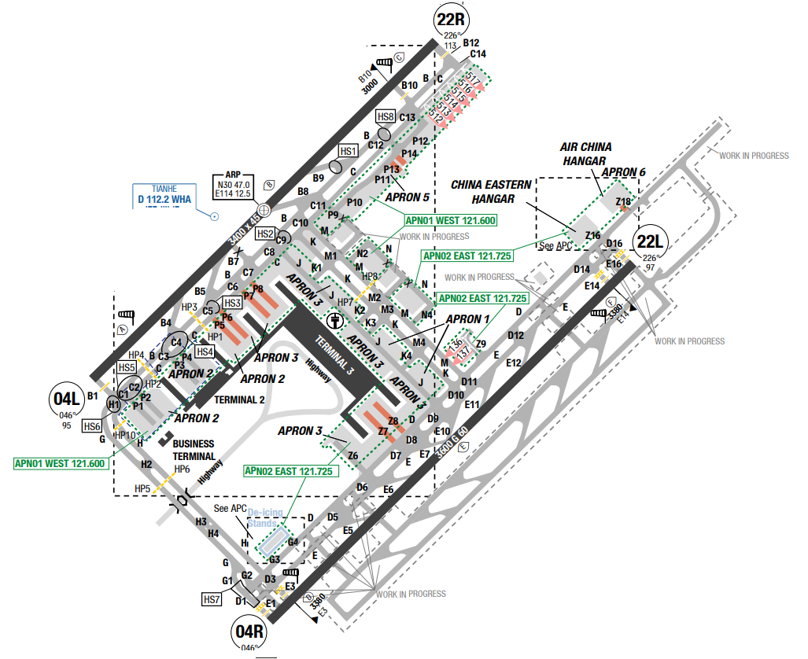
Wuhan Tianhe International Airport serves Wuhan, the capital of the Hubei province, People's Republic of China. The surrounding terrains are generally low and flat in the middle and hilly in the south, with the Yangtze and Han rivers winding through the city.
Wuhan's climate is humid subtropical with abundant rainfall and four distinctive seasons. Wuhan is known for its oppressively humid summers, when dew points can often reach 26 °C or more. Because of its hot summer weather. Spring and autumn are generally mild, while winter is cool with occasional snow. Annual precipitation totals 1,269 mm, mainly from May to July; the annual mean temperature is 16.63 °C, the frost-free period lasts 211 to 272 days. Extreme temperatures have ranged from −18.1 to 42.0 °C
Departure |  |  | - Conventional and RNAV SIDs.  - Noise abatement procedure
Arrival and Approach |  |  | - Conventional and RNAV STARs.  - Speed restrictions
Taxi |  |  | - ACFT shall finish RWY alignment within 60s
Parking information |  |  | - Follow-me available
5. TAKE-OFF AND LANDING DISTANCES AVAILABLE
RWY | LENGTH  (m) |  |  | WIDTH  (m) |  | TORA  (m) |  | LDA  (m) |  | TODA  (m) | ASDA  (m)
04L | 3400 |  |  | 45 |  | 3400 |  | 3400 |  | 3470 | 3400
04R/ 22L | 3600 |  |  | 60 |  | 3600 |  | 3600 |  | 3600 | 3600
22R | 3400 |  |  | 45 |  | 3400 |  | 3400 |  | 3510 | 3400
6. ELEVATION: 113ft |  |  |  |  | 7. EOSID: NO
8. IAP: ILS (CAT I, II), LOC
9. COMPANY NOTE |  |  |  |  | - Birds in vicinity of the airport  - Wake turbulence re-categorization (RECAT-CN)
10. REMARK |  |  |  |  | NIL

ZLDH/DNH – DONHUANG – MOGAO – CHINA
- AIRPORT CATEGORY: A |  |  |  |  |  |  | - RFFS CATEGORY: 9
- AIRPORT CLASSIFICATION
ATR |  | A320 |  | A321 |  |  | A350 |  | B787
ADQ |  | ADQ |  | ADQ |  |  | ADQ |  | ADQ
4. GENERAL STANDARDS
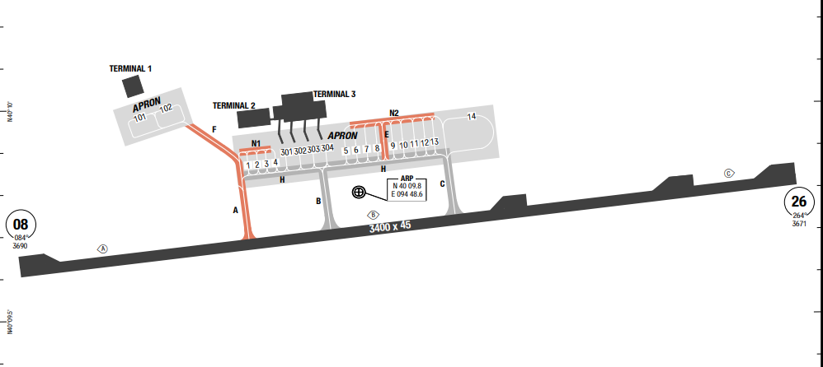
Dunhuang Mogao International Airport is an airport serving the city of Dunhuang in Gansu Province, China. Airport is located 12.7 kilometers from downtown Dunhuang.
Mogao, Gansu Province, China, has a harsh continental desert climate with high summer temperatures and very cold winters, and low rainfall. Large temperature differences between day and night, abundant sunshine, and low rainfall are the main characteristics of this area.
Departure |  |  | - RNAV SID available
Arrival and Approach |  |  | - RNAV STAR available  - Circuits shall be made to the North of RWY. With ATC clearance, circuit shall be made to the South of RWY
Taxi |  |  | - TWY A, F with width restriction  - TWY A, B, C, E, F, N1, N2 with max wingspan restriction
Parking information |  |  | - ACFT taxiing out from stand 4 shall turn left only.  - ACFT taxiing out from stand 5 shall turn right only.  - Follow-me is mandatory for ACFT parking on APN.  - Visual Docking Guidance System (VDGS) AVBL at stands 301-304
5. TAKE-OFF AND LANDING DISTANCES AVAILABLE
RWY | LENGTH  (m) |  |  | WIDTH  (m) |  | TORA  (m) |  | LDA  (m) |  | TODA  (m) | ASDA  (m)
038/ 26 | 3400 |  |  | 45 |  | 3400 |  | 3400 |  | 3400 | 3400
6. ELEVATION: 3744ft |  |  |  |  | 7. EOSID: YES
8. IAP: ILS (CAT I), LOC, VOR
9. COMPANY NOTE |  |  |  |  | - The route from ZLJQ to ZLDH via P27 is close to Diwopu shooting range, pilots shall keep the flight track strictly.  - Birds in vicinity of AD.
10. REMARK |  |  |  |  | NIL

ZLIC/ INC – HEDONG – YINCHUAN – CHINA
- AIRPORT CATEGORY: A |  |  |  |  |  |  | - RFFS CATEGORY: 9
- AIRPORT CLASSIFICATION
ATR |  | A320 |  | A321 |  |  | A350 |  | B787
ADQ |  | ADQ |  | ADQ |  |  | ADQ |  | ADQ
4. GENERAL STANDARDS
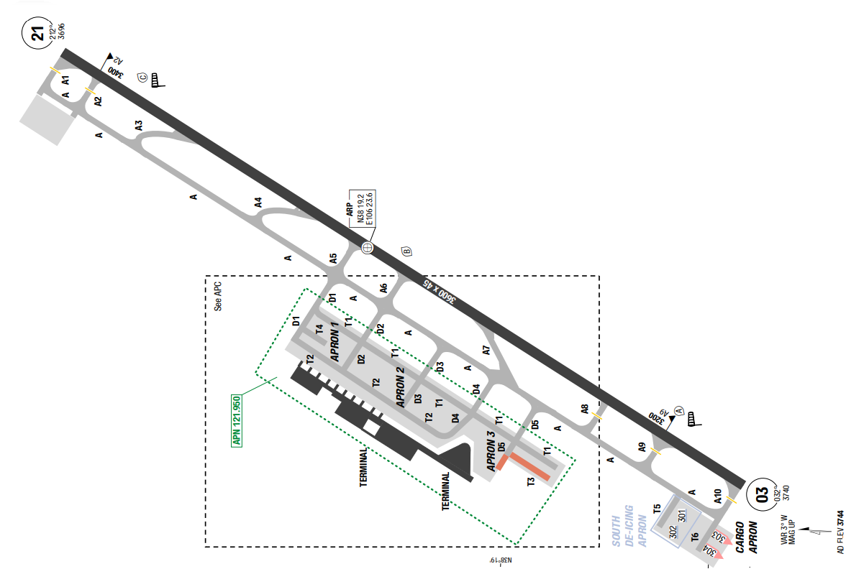
Yinchuan Hedong International Airport (IATA: INC, ICAO: ZLIC) is the primary airport serving Yinchuan, the capital of Ningxia Hui Autonomous Region, People's Republic of China. It is located 25 kilometres (16 mi) southeast of downtown Yinchuan in the town of Linghe of Lingwu City
Yinchuan has distinct seasons, with dry, cold winters, late springs and short summers. The monthly 24-hour average temperature ranges from -6.8 °C (19.8 °F) in January to 24.4 °C in July, with the annual mean at 10.1 °C .The climate in Yinchuan is desert continental, with very cold winters and hot summers. The rains are not abundant and are concentrated from May to September, with a maximum in July and August.
Departure |  |  | - Low Visibility Operation Procedure  - Departure aircraft shall contact Yinchuan TWR for delivery clearance 10 minutes prior to pushback and start-up.  - Partial runway take-off regulations:  • After flight crew apply for partial runway to take off, ATC can approve and provide air traffic control service according to the situation.  • The tower controller can command aircraft to enter RWY03/ 21 via TWY A9/ A2 by using partial runway for take-off. Inform ATC if flight crew cannot accept it.  • Flight crew shall vacate RWY as soon as possible via rapid exit TWY.
Arrival and Approach |  |  | - RWY 03/ 21 right- and left-hand circuit:  • CAT A/ B at ALT 1550m / 5085ft,  • CAT C/ D at ALT 1750m / 5741ft  - LDG RWY 21: Lights of AD expressway are strong. Do not mistake with RWY lights.  - Arriving aircraft shall be guided by follow-me vehicle to park on stands (except stands Nr.301-304). If necessary, flight crew could apply for follow-me vehicle service or towing service via corresponding Control frequency for all departing aircraft and arriving aircraft parking on stands Nr.201,301-304.
Taxi |  |  | - TWY T1, T5, T6, D1 (between T1 and T2) MAX wingspan below 65m / 213ft.  - TWY T4 wingspan 52m / 171ft till below 65m / 213ft.  - TWY T2, D2-D4 (between T1 and T2), D5 (between T1 and T3) MAX wingspan below 52m/ 171ft.  - TWY T3, D5 (west of T3) MAX wingspan below 36m / 118ft.  - TWY A shoulder width 11.4m / 37ft.
Parking information |  |  | - Follow-me available
5. TAKE-OFF AND LANDING DISTANCES AVAILABLE
RWY | LENGTH  (m) |  |  | WIDTH  (m) |  | TORA  (m) |  | LDA  (m) |  | TODA  (m) | ASDA  (m)
03/ 21 | 3600 |  |  | 45 |  | 3600 |  | 3600 |  | 3600 | 3600
6. ELEVATION: 3744ft |  |  |  |  | 7. EOSID: NO
8. IAP: ILS (CAT I, II*), LOC, NDB, VOR
9. COMPANY NOTE |  |  |  |  | - Birds in vicinity of the airport
10. REMARK |  |  |  |  | NIL
*Note: CAT II, approval require

ZLLL/ LHW - ZHONGCHUAN (LANZHOU ZHONGCHUAN INTL) – CHINA
- AIRPORT CATEGORY: A |  |  |  |  |  |  | - RFFS CATEGORY: 9
- AIRPORT CLASSIFICATION
ATR |  | A320 |  | A321 |  |  | A350 |  |  | B787
ADQ |  | ADQ |  | ADQ |  |  | ADQ |  |  | ADQ
4. GENERAL STANDARDS
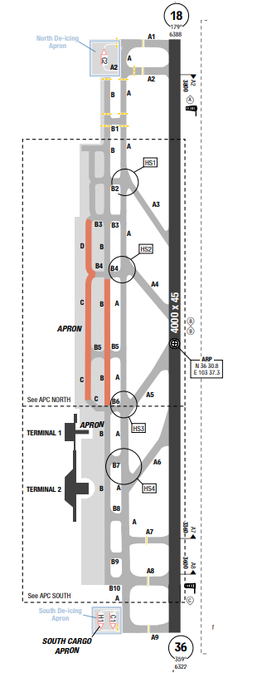
The Airport is in Lanzhou, the capital of Gansu Province, China. It is located 67 kilometers north of downtown Lanzhou. There are areas of very high terrain adjacent to the airport (in the North and South of the airport) The warm season is from May to September, with an average daily high temperature above 23°C. The cold season is from November to February, with an average daily high temperature below 7°C. In Lanzhou, the average percentage of the sky covered by clouds experiences significant seasonal variation over the course of the year. The clearer part of the year in Lanzhou begins around September and lasts for 4 months, ending around February. The cloudier part of the year begins around February and lasts for 7 months, ending around September.
Departure |  |  | - Conventional and RNAV SIDs  - SID with high climb gradient, Pilots need to briefing carefully before T/ O
Arrival and Approach |  |  | - Conventional and RNAV STARs.  - There are airspeed restrictions for all instrument  approach procedures.  - Initial approach speed max 205kts  - Require minimum Miss APCH climb gradients
Taxi |  |  | - Shall vacate RWY within 50s after touchdown; finish RWY alignment within 60s, if unable inform to ATC.  - Taxi routes for arrival and departure.  - Taxi speed shall not exceed 27kts ( in apron 8kts)  - Multiple Runway Incursion Hot Spots are identified and illustrated on the chart.
Parking information |  |  | - Expected parking 10x
5. TAKE-OFF AND LANDING DISTANCES AVAILABLE
RWY | LENGTH  (m) |  |  | WIDTH  (m) |  | TORA  (m) |  | LDA  (m) | TODA  (m) |  | ASDA  (m)
18/ 36 | 4000 |  |  | 45 |  | 4000 |  | 4000 | 4000 |  | 4000
6. ELEVATION: 6388ft |  |  |  |  | 7. EOSID: YES
8. IAP: ILS, LOC, VOR
9. COMPANY NOTE |  |  |  |  | - WARNING: do not mistake the airport road light and RWY lights.  - Birds in the vicinity of the airport.
10. REMARK |  |  |  |  | NIL

ZLXN/ XNN – XINING CAOJIAPU INTL AIRPORT
- AIRPORT CATEGORY: A |  |  |  |  |  |  | - RFFS CATEGORY: 9
- AIRPORT CLASSIFICATION
ATR |  | A320 |  | A321 |  |  | A350 |  | B787
ADQ |  | ADQ |  | ADQ |  |  | ADQ |  | ADQ
4. GENERAL STANDARDS
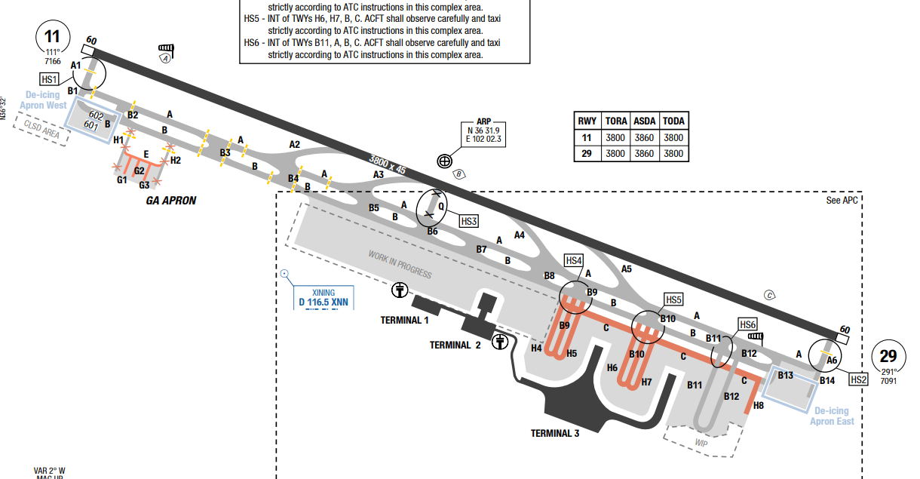
Xining Caojiapu International Airport, is an airport serving Xining, the capital of Qinghai Province, China. It is located in Huzhu County, Haidong, on the Tibetan Plateau about 30 kilometres east of downtown Xining.
Xining has a high-altitude, semi-arid climate with a large temperature difference between day and night and between seasons. It experiences cold winters with snow, and warm summers that are considered pleasant, with daytime highs typically around 15°C-25°C Spring and autumn are mild, with pleasant daytime temperatures but chilly nights.
Departure |  |  | - RNAV SIDs.  - Report "HEAVY" before taxiing.  - De-icing AVBL  - DEP ACFT shall align with RWY centerline and be ready to TKOF within 60s after receiving TKOF CLR, otherwise inform TWR before entering RWY.
Arrival and Approach |  |  | - RNAV STARs.  - RWY 11/29 right/left-hand circuit (S of the RWY) at 3150m/ 10340ft.  - Report RWY vacated, TWY used and current position, especially in LVP.
Taxi |  |  | - TWY with wingspan restriction
Parking information |  |  | - Marshaller mandatory when taxiing on APN to stand.  - Follow-me and towing AVBL O/R.  - Towing mandatory for:  • ACFT with wingspan 36m / 118ft and above parked at stand 603R;  • ACFT parked at stands 211, 301-330.  - Taxi Speed Limitations  • MAX taxi speed 27KT.  • MAX taxi speed 8KT near OBST.
5. TAKE-OFF AND LANDING DISTANCES AVAILABLE
RWY | LENGTH  (m) |  |  | WIDTH  (m) |  | TORA  (m) |  | LDA  (m) |  | TODA  (m) | ASDA  (m)
11/ 29 | 3800 |  |  | 45 |  | 3800 |  | 3800 |  | 3800 | 3860
6. ELEVATION: 7119ft |  |  |  |  | 7. EOSID: NO
8. IAP: ILS (CAT I, II), LOC, VOR
9. COMPANY NOTE |  |  |  |  | - Expect rapid changes in altitudes, headings and frequencies during arrivals and departures.
10. REMARK |  |  |  |  | NIL

ZLXY/ XIY - XI’AN (XIANYANG) – CHINA
- AIRPORT CATEGORY: A |  |  |  |  |  |  | - RFFS CATEGORY: 9
- AIRPORT CLASSIFICATION
ATR |  | A320 |  | A321 |  |  | A350 |  | B787
ADQ |  | ADQ |  | ADQ |  |  | ADQ |  | ADQ
4. GENERAL STANDARDS
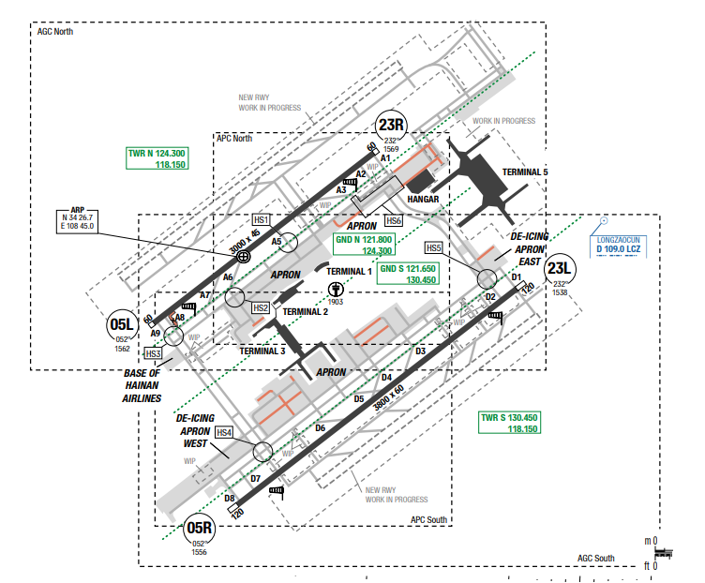
Xianyang airport is located in the central area of northwest China. The Airport is in the Wei River Valley. In this area the valley runs west to east. Mountains to the north begin within 15NM, while to the south, they begin within 25NM. The mountains to the north are part of the Huangtu Plateau and terrain commonly rises between 4000 and 6000ft MSL. Mountains to south rise between 7000 and 12000ft MSL. To the north, the Jing River passes the airport within 4NM and the Wei River passes the airport 5NM to the south. To the northwest, terrain rises to 4019ft MSL within 17NM.
Departure |  |  | - RNAV SIDs.  - SID with high climb gradient
Arrival and Approach |  |  | - RNAV STARs.
Taxi |  |  | - Multiple Runway Incursion Hot Spots are identified and illustrated on the chart.
Parking information |  |  | - Follow-me available
5. TAKE-OFF AND LANDING DISTANCES AVAILABLE
RWY | LENGTH  (m) |  |  | WIDTH  (m) |  | TORA  (m) |  | LDA  (m) |  | TODA  (m) | ASDA  (m)
05L | 3000 |  |  | 45 |  | 3000 |  | 3000 |  | 2160 | 3060
05R | 3800 |  |  | 60 |  | 3800 |  | 3800 |  | 2250 | 3920
23L | 3800 |  |  | 60 |  | 3800 |  | 3800 |  | 3800 | 3920
23R | 3000 |  |  | 45 |  | 3000 |  | 3000 |  | 3000 | 3060
6. ELEVATION: 1572ft |  |  |  |  | 7. EOSID: YES
8. IAP: ILS (CAT I, II), LOC, VOR
9. COMPANY NOTE |  |  |  |  | - Expect rapid changes in altitudes, headings and frequencies during arrivals and departures.
10. REMARK |  |  |  |  | NIL

ZMCK/ UBN – ULAANBAATAR (CHINGGIS KHAAN INTL) – MONGOLIA
- AIRPORT CATEGORY: A |  |  |  |  |  |  | - RFFS CATEGORY: 9
- AIRPORT CLASSIFICATION
ATR |  | A320 |  | A321 |  |  | A350 |  | B787
ADQ |  | ADQ |  | ADQ |  |  | ADQ |  | ADQ
4. GENERAL STANDARDS
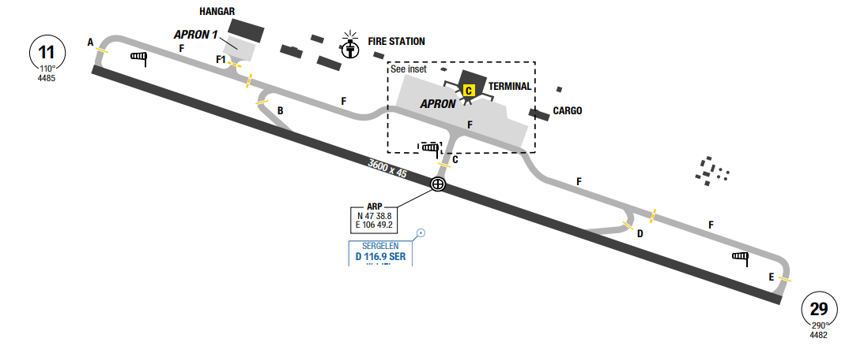
The weather in Ulaanbaatar is changeable with four main seasons including Spring, Summer, Autumn, and Winter. The city is located at 1,305m above sea level, hence the Ulaanbaatar climate is the featured steppe climate. The annual average Ulaanbaatar temperature is -0.7 °C / 30.7 °F, and annual rainfall is 256 mm/ 10.1 inches. January is the coldest month of the year and July is the hottest month in Ulaanbaatar.
Departure |  |  | - Conventional and RNAV SIDs.  - Require minimum climb gradients.
Arrival and Approach |  |  | - Conventional and RNAV STARs.  - Require minimum miss APCH gradients.
Taxi |  |  | - Simple taxi to and from the apron.  - Follow-me service will be provided on request.
Parking information |  |  | No
5. TAKE-OFF AND LANDING DISTANCES AVAILABLE
RWY | LENGTH  (m) |  |  | WIDTH  (m) |  | TORA  (m) |  | LDA  (m) |  | TODA  (m) | ASDA  (m)
11/ 29 | 3600 |  |  | 45 |  | 3600 |  | 3600 |  | 3600 | 3600
6. ELEVATION: 4485ft |  |  |  |  | 7. EOSID: YES
8. IAP: ILS, LOC, RNP, VOR
9. COMPANY NOTE |  |  |  |  | - Expect rapid changes in altitudes, headings and frequencies during arrivals and departures.
10. REMARK |  |  |  |  | NIL

ZMUB/ ULN – ULAANBAATAR (BUYANT-UKHAA INTL) – MONGOLIA
- AIRPORT CATEGORY: A |  |  |  |  |  |  | - RFFS CATEGORY: 8
- AIRPORT CLASSIFICATION
ATR |  | A320 |  | A321 |  |  | A350 |  | B787
ADQ |  | ADQ |  | ADQ |  |  | ADQ |  | ADQ
4. GENERAL STANDARDS
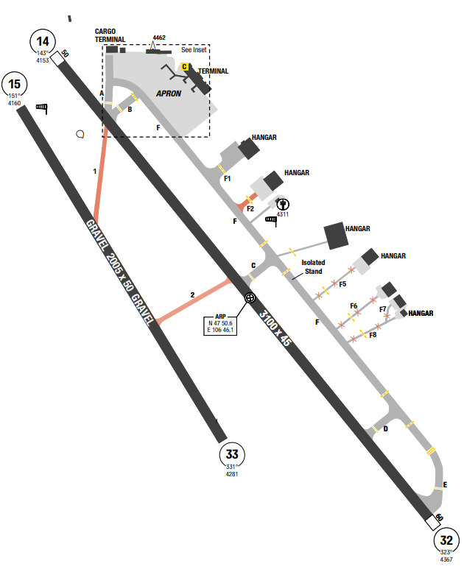
Buyant-Ukhaa International Airport is a semi-operational international airport serving Ulaanbaatar, Mongolia, situated 18 km (11 mi) southwest of the capital. The weather in Ulaanbaatar is changeable with four main seasons including Spring, Summer, Autumn, and Winter. The city is located at 1,305m above sea level, hence the Ulaanbaatar climate is the featured steppe climate. The annual average Ulaanbaatar temperature is -0.7 °C / 30.7 °F, and annual rainfall is 256 mm/ 10.1 inches. January is the coldest month of the year and July is the hottest month in Ulaanbaatar. Summer is the perfect time to visit Ulaanbaatar, because it has longer days, and warm climate which are beneficial to explore different destinations in Ulaanbaatar.
Departure |  |  | - Conventional SIDs.  - Require minimum climb gradients.
Arrival and Approach |  |  | - CAUTION: Deviation in GP and LOC signal at a distance of 4.85-5.63, 7.46-8.4 and 9.02-10.11 NM from THR RWY 14. Fly over this area carefully.
Taxi |  |  | No
Parking information |  |  | No
5. TAKE-OFF AND LANDING DISTANCES AVAILABLE
RWY | LENGTH  (m) |  |  | WIDTH  (m) |  | TORA  (m) |  | LDA  (m) |  | TODA  (m) | ASDA  (m)
14 | 3100 |  |  | 45 |  | 3100 |  | 3100 |  | 3100 | 3100
15 | 2005 |  |  | 50 |  | 2005 |  | 2005 |  | 2005 | 2005
32 | 3100 |  |  | 45 |  | 3450 |  | 3100 |  | 3450 | 3150
33 | 2005 |  |  | 50 |  | 2005 |  | 2005 |  | 2455 | 2455
6. ELEVATION: 4364ft |  |  |  |  | 7. EOSID: YES
8. IAP: ILS, NDB, RNP, VOR
9. COMPANY NOTE |  |  |  |  | - Birds in vicinity of apt.
10. REMARK |  |  |  |  | NIL

ZPPP/ KMG - KUNMING (KUNMING CHANGSHUI INTL)–CHINA
- AIRPORT CATEGORY: A |  |  |  |  |  |  | - RFFS CATEGORY: 9
- AIRPORT CLASSIFICATION
ATR |  | A320 |  | A321 |  |  | A350 |  | B787
ADQ |  | ADQ |  | ADQ |  |  | ADQ |  | ADQ
4. GENERAL STANDARDS
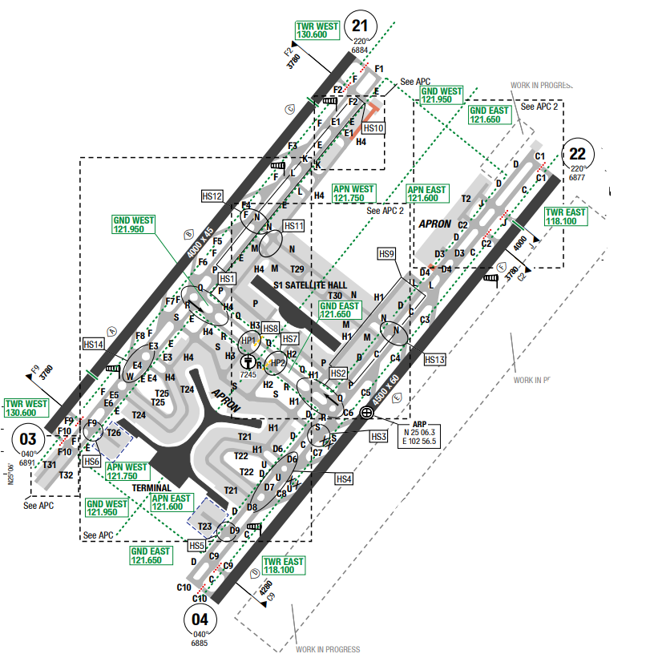
The average yearly temperature is about 15 degrees Celsius. January is the coldest month with average temperature at 8 degrees Celsius, while July is the hottest month with average temperature at 18 degrees Celsius. Kunming has abundant rainfall, with annual precipitation at 1101 mm (43 inches). The rainy season lasts from May to October.
The average yearly temperature is about 15 degrees Celsius. January is the coldest month with average temperature at 8 degrees Celsius, while July is the hottest month with average temperature at 18 degrees Celsius. Kunming has abundant rainfall, with annual precipitation at 1101 mm (43 inches). The rainy season lasts from May to October
Departure |  |  | - Require minimum climb gradients.  - Conventional and RNAV SIDs.  - RNAV LXI 9Z for departure RWY 22.  - In case of departure on another RWY, crew can expect RNAV departure via LXI.
Arrival and Approach |  |  | - Conventional and RNAV STARs.  - Speed restrictions  - EXPECTED: LXI 1Z for RNAV ILS Z RWY 22.  - In case of approach on another RWY, crew can expect RNAV approach via LXI.
Taxi |  |  | - Shall use rapid taxiway within 50s after touchdown; finish alignment within 60s.  - Multiple Runway Incursion Hot Spots are identified and illustrated on the chart.
Parking information |  |  | - EXPECTED parking 10x
5. TAKE-OFF AND LANDING DISTANCES AVAILABLE
RWY | LENGTH  (m) |  |  | WIDTH  (m) |  | TORA  (m) |  | LDA  (m) |  | TODA  (m) | ASDA  (m)
03 | 4000 |  |  | 45 |  | 4000 |  | 3460 |  | 4000 | 4000
04/ 22 | 4500 |  |  | 60 |  | 4500 |  | 4500 |  | 4500 | 4500
21 | 4000 |  |  | 45 |  | 4000 |  | 4000 |  | 4000 | 4000
6. ELEVATION: 6901ft |  |  |  |  | 7. EOSID: NO
8. IAP: ILS (CAT I, II), LOC
9. COMPANY NOTE |  |  |  |  | - Birds, laser bird.
10. REMARK |  |  |  |  | NIL

ZSCG/ CZX – BENNIU INTL AIRPORT – CHANGZHOU, CHINA
1. AIRPORT CATEGORY: A |  |  |  |  |  |  |  | 2. RFFS CATEGORY: 8
3. AIRPORT CLASSIFICATION
ATR |  | A320 |  |  |  | A321 |  |  | A350 |  |  | B787
ADQ |  | ADQ |  |  |  | ADQ |  |  | ADQ |  |  | ADQ
4. GENERAL STANDARDS
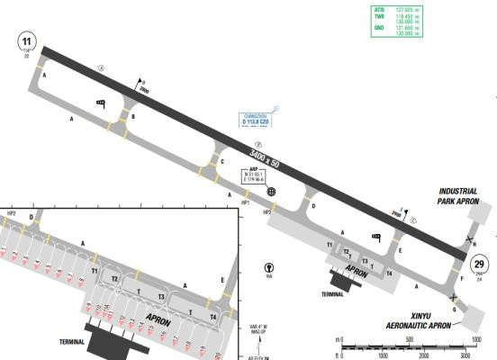
The average annual temperature is 15 degrees Celsius in Changzhou. About 1064 mm of precipitation falls annually. The driest month is December, with 35 mm of rain. Most of the precipitation here falls in July, averaging 176 mm. July is the warmest month of the year. The temperature in July averages 28 degrees Celsius. January is the coldest month, with temperatures averaging 3 degrees Celsius. In Changzhou, the average percentage of the sky covered by clouds experiences significant seasonal variation over the course of the year. The clearer part of the year begins around August and lasts for 6 months, ending around March.
Departure |  |  | - Request ATC clearance 10mins before cabin door closed; conduct pushback within 5 min.  - Conventional and RNAV SIDs.  - Require minimum climb gradients.
Arrival and Approach |  |  | - Conventional STARs  - Report the estimated time of reaching OLRIS or XUTGU, estimated landing time and SSR transponder before arriving at CZO 20 minutes in advance.
Taxi |  |  | - 180° turnaround on TWY is strictly forbidden
Parking information |  |  | - EXPECTED: parking 9 to 15
5. TAKE-OFF AND LANDING DISTANCES AVAILABLE
RWY | LENGTH  (m) |  |  | WIDTH  (m) |  |  | TORA  (m) |  |  | LDA  (m) | TODA  (m) |  | ASDA  (m)
11/ 29 | 3400 |  |  | 50 |  |  | 3400 |  |  | 3400 | 3400 |  | 3400
6. ELEVATION: 24ft |  |  |  |  | 7. EOSID: NO
8. IAP: ILS, LOC, VOR
9. COMPANY NOTE |  |  |  |  | - ATIS connectivity is from approximately 200NM from the airport
10. REMARK |  |  |  |  | NIL

ZSHC/ HGH – XIAOSHAN INTL AIRPORT - HANGZHOU, CHINA
1. AIRPORT CATEGORY: A |  |  |  |  |  |  |  | 2. RFFS CATEGORY: 9
3. AIRPORT CLASSIFICATION
ATR |  | A320 |  |  |  | A321 |  |  | A350 |  | B787
ADQ |  | ADQ |  |  |  | ADQ |  |  | ADQ |  | ADQ
4. GENERAL STANDARDS
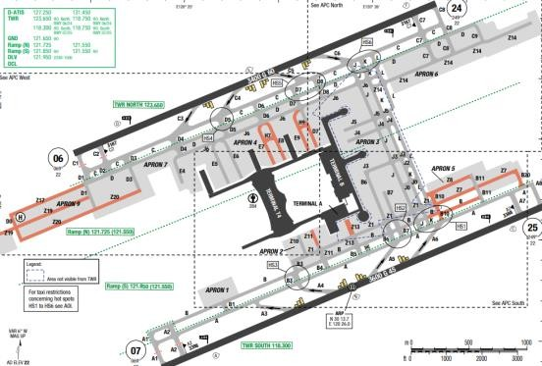
Hangzhou Xiaoshan International Airport is the principal airport serving Hangzhou, a major city in the Yangtze River Delta region and the capital of Zhejiang Province, China. The airport is located on the southern shore of Qiantang River in Xiaoshan District and is 27 km (17 mi) east of downtown Hangzhou.The climate is humid subtropical with four distinctive seasons, characterized by long, very hot, humid summers and chilly, cloudy and drier winters (with occasional snow). The mean annual temperature is 16°C. The city receives an average annual rainfall of 1,450 mm and is affected by the plum rains of the Asian monsoon in June.
Departure |  |  | - Conventional and RNAV SIDs.  - Require minimum climb gradients.  - Noise abatement procedures.  - Expect RWY 24 or RWY 07 for departure  - Initial contact after takeoff, report RWY designation
Arrival and Approach |  |  | - Conventional and RWY STARs.  - Expect RWY 25 or RWY 06 for landing.  - Require minimum miss approach climb gradients.
Taxi |  |  | - Shall vacate designated exit taxiway, within 50s after touchdown; finish RWY alignment within 60s.  - 180o turnaround on TWY is strictly forbidden.  - Taxi routes for normal and LVP operations  - Multiple Runway Incursion Hot Spots are identified and illustrated on the chart.
Parking information |  |  | - Expect parking stand at Terminal A, bay no. 215- 218
5. TAKE-OFF AND LANDING DISTANCES AVAILABLE
RWY | LENGTH  (m) |  |  | WIDTH  (m) |  |  | TORA  (m) |  |  | LDA  (m) |  | TODA  (m) | ASDA  (m)
06 | 3400 |  |  | 60 |  |  | 3400 |  |  | 3500 |  | 3400 | 3400
24 | 3400 |  |  | 60 |  |  | 3400 |  |  | 3400 |  | 3400 | 3400
07/ 25 | 3600 |  |  | 45 |  |  | 3600 |  |  | 3600 |  | 3600 | 3600
6. ELEVATION: 22ft |  |  |  |  | 7. EOSID: YES
8. IAP: ILS (CAT I, II), LOC, VOR
9. COMPANY NOTE |  |  |  |  | - Birds in vicinity of APT  - RWYs 07 and 24 Right-hand circuit
10. REMARK |  |  |  |  | NIL

ZSNB/ NGB – LISHE AIRPORT – NINGBO, CHINA
1. AIRPORT CATEGORY: A |  |  |  |  |  |  |  | 2. RFFS CATEGORY: 8
3. AIRPORT CLASSIFICATION
ATR |  | A320 |  |  |  | A321 |  |  | A350 |  |  | B787
ADQ |  | ADQ |  |  |  | ADQ |  |  | ADQ |  |  | ADQ
4. GENERAL STANDARDS
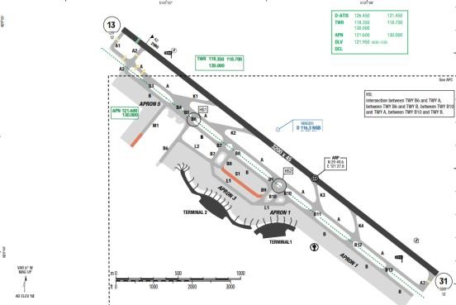
Ningbo Lishe International Airport is the principal airport serving Ningbo, a major city in the Yangtze River Delta region and the second largest city in Zhejiang Province, China. The highest MSA is at the south sector of BK NDB, at 5500ft. The annual mean temperature is 16 degrees Celsius. The highest month mean temperature is 29 degrees Celsius in July; the lowest month temperature is 5 degrees Celsius. The annual average rainfall is 1400 mm and mainly concentrates in June and September.
Departure |  |  | - Conventional and RNAV SIDs.
Arrival and Approach |  |  | - Conventional and RWY STARs.  - Expect RNAV ILS DME Z RW 13/ 31
Taxi |  |  | - Shall vacate RWY within 60s after touchdown; finish RWY alignment within 60s, if unable inform to ATC.  - 180° turnaround on TWY is strictly forbidden.  - Multiple Runway Incursion Hot Spots are identified and illustrated on the chart
Parking information |  |  | - Expect Parking 2 to 7
5. TAKE-OFF AND LANDING DISTANCES AVAILABLE
RWY | LENGTH  (m) |  |  | WIDTH  (m) |  |  | TORA  (m) |  |  | LDA  (m) | TODA  (m) |  | ASDA  (m)
13 | 3200 |  |  | 45 |  |  | 3200 |  |  | 3050 | 3200 |  | 3200
31 | 3200 |  |  | 45 |  |  | 3200 |  |  | 3200 | 3200 |  | 3200
6. ELEVATION: 12ft |  |  |  |  | 7. EOSID: YES
8. IAP: ILS, LOC, VOR
9. COMPANY NOTE |  |  |  |  | - Birds.  - RWY 13 right-hand circuit
10. REMARK |  |  |  |  | NIL

ZSJN/ TNA - JINAN (YAOQIANG) – CHINA
- AIRPORT CATEGORY: A |  |  |  |  |  |  | - RFFS CATEGORY: 9
- AIRPORT CLASSIFICATION
ATR |  | A320 |  | A321 |  |  | A350 |  | B787
ADQ |  | ADQ |  | ADQ |  |  | ADQ |  | ADQ
4. GENERAL STANDARDS
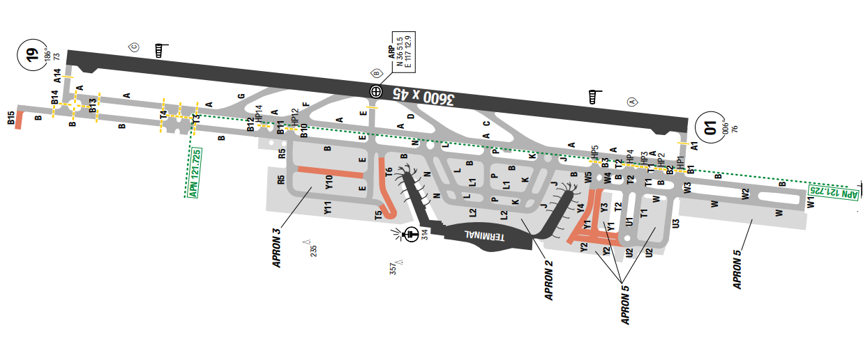
Jinan Yaoqiang International Airport is the airport serving Jinan, the capital of Shandong Province, China. The airport is located approximately 33 kilometres (21 mi) northeast of the city centre and immediately to the north of the town of Yaoqiang. Highest MSA is 5300ft on the south of airport.
Jinan has four well-defined seasons. The city is dry and nearly without rain in spring, hot and rainy in summer, crisp in autumn and dry and cold (with little snow) in winter. The average annual temperature is 14.70 °C, and the annual precipitation is around slightly above 670 mm, with a strong summer maximum, and high variability from year to year. January is the coldest and driest month, with a mean temperature of −0.4 °C and 5.7 mm of equivalent rainfall. July is the hottest and wettest month.
Departure |  |  | - Conventional and RNAV SIDs.  - Noise abatement procedure (obstacle clearance and climb gradients)
Arrival and Approach |  |  | - Conventional and RNAV STARs
Taxi |  |  | - Taxi restrictions  - 180 degree turnaround on TWY is strictly forbidden
Parking information |  |  | No
5. TAKE-OFF AND LANDING DISTANCES AVAILABLE
RWY | LENGTH  (m) |  |  | WIDTH  (m) |  | TORA  (m) |  | LDA  (m) |  | TODA  (m) | ASDA  (m)
01/ 19 | 3600 |  |  | 45 |  | 3600 |  | 3600 |  | 3600 | 3600
6. ELEVATION: 76ft |  |  |  |  | 7. EOSID: YES
8. IAP: ILS, LOC, VOR
9. COMPANY NOTE |  |  |  |  | - Birds in vicinity of APT
10. REMARK |  |  |  |  | NIL

ZSNJ/ NKG – LUKOU AIRPORT – NANJING, CHINA
1. AIRPORT CATEGORY: A |  |  |  |  |  |  |  | 2. RFFS CATEGORY: 9
3. AIRPORT CLASSIFICATION
ATR |  | A320 |  |  |  | A321 |  |  | A350 |  |  | B787
ADQ |  | ADQ |  |  |  | ADQ |  |  | ADQ |  |  | ADQ
4. GENERAL STANDARDS
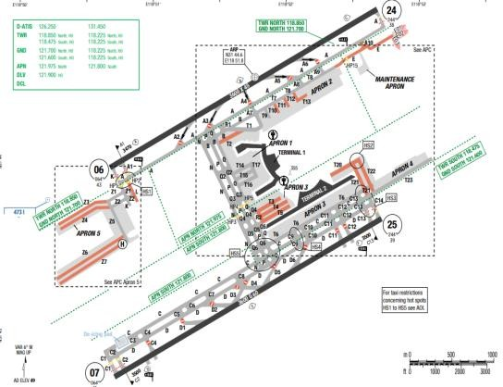
Lukou Airport is located in a coastal region of eastern China, at the southern edge of the North
China Plain. The area contains many large lakes, canals, and extensive areas of rice paddies along major rivers. Terrain surrounding the airport is mostly flat. Scattered hills are south and outh west of the airport within 5 NM. Shijiu Lake is 12 NM to the south. To the south-southwest, terrain rises to 1506 feet MSL within 8 NM. The Tianmu Mountains, with terrain up to 4000 feet MSL, start about 80 NM to the south-southeast. Annual precipitation totals 100 cm.
Departure |  |  | - Conventional and RNAV SIDs.  - Noise abatement procedure (NADP1 in safe condition)
Arrival and Approach |  |  | - Conventional and RNAV STARs.  - The latest time to issue landing clearance can be before ACFT flying over RWY threshold.
Taxi |  |  | - Shall fully vacate the RWY within 50s after touchdown via designated taxi ways.  - Shall finish RWY alignment within 60s from holding point, if unable inform TWR before entering RWY  - Follow me cars normally guides arriving aircrafts to their parking stands  - Taxi restrictions  - Taxi route for LVO.  - Multiple Runway Incursion Hot Spots are identified and illustrated on the chart.
Parking information |  |  | No
5. TAKE-OFF AND LANDING DISTANCES AVAILABLE
RWY | LENGTH  (m) |  |  | WIDTH  (m) |  |  | TORA  (m) |  |  | LDA  (m) | TODA  (m) |  | ASDA  (m)
06/ 24 | 3600 |  |  | 45 |  |  | 3600 |  |  | 3600 | 3600 |  | 3600
07/ 25 | 3600 |  |  | 60 |  |  | 3600 |  |  | 3600 | 3600 |  | 3600
6. ELEVATION: 12ft |  |  |  |  | 7. EOSID: NO
8. IAP: ILS (CAT I, II*), LOC, VOR
9. COMPANY NOTE |  |  |  |  | - From 0700-2359LT daily, RNP flight procedures are primary and conventional procedures are secondary procedures  - RWYs 07 and 24 are right-hand circuit  - Birds  - ATC communications can be easily misunderstood, especially numbers. Close attention is required. Use standard phraseology as accurately as possible.  - Expect rapid changes in altitudes, headings and frequencies during arrivals and departures. All altitudes are given in meters  - Circling to land is only authorized southeast of the runway.
10. REMARK |  |  |  |  | NIL
*Note: CAT II, approval require

ZSPD/ PVG – PUDONG INTL AIRPORT – SHANGHAI, CHINA
1. AIRPORT CATEGORY: A |  |  |  |  |  |  |  | 2. RFFS CATEGORY: 10
3. AIRPORT CLASSIFICATION
ATR |  | A320 |  |  |  | A321 |  |  | A350 |  |  | B787
ADQ |  | ADQ |  |  |  | ADQ |  |  | ADQ |  |  | ADQ
4. GENERAL STANDARDS
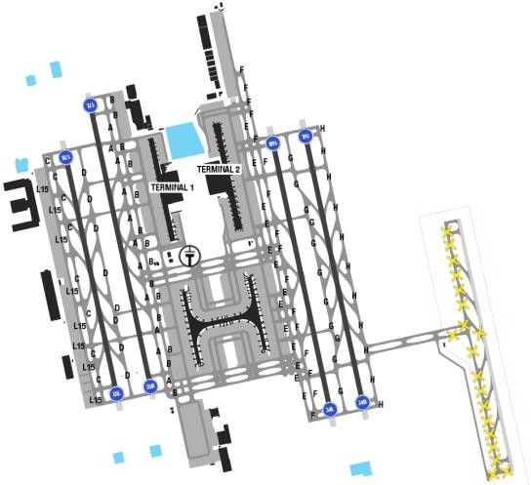
PUDONG airport is located at flat area about 30 km from the city centre, adjacent to the coastline in the Eastern edge of PUDONG district, 40 km East of HONGQIAO airport.
Shanghai has a subtropical maritime monsoon climate with 4 distinct seasons. Overall, Shanghai
WX is mild and moist with low level of clouds year around. August and September typhoon can bring heavy rain in their wake.
Departure |  |  | - RWY 16R/ 34L and 17L/ 35R are mainly for departure  - Conventional and RNAV SIDs.  - NADP available at this airport  - RNAV SIDs available
Arrival and Approach |  |  | - RWY 16L/ 34R and 17R/ 35L are mainly for arrival.  - Conventional and RNAV STARs.  - ATC usually requires to an early speed reduction and early descent due to high volume of traffic.  - Expect: Runway for LDG is 16L or 34R and 17R/ 35L. Stars are issued and adhered to but Radar vector to intercept final course is normally expected.
Taxi |  |  | - Shall vacate RWY via rapid taxiway within 50s and report RWY vacated after taxiing to parallel TXY.  - Shall turn off taxi light when follow-me car in sight  - LVOP taxi routes  - 180° turnaround on TWY is strictly forbidden  - There are predetermined taxi routes. But ATC may give individual taxi routes depending on traffics.  - Long taxi time is normally expected for departure (around 20-30 minutes or more) due to high volume of traffic.
Parking information |  |  | - Expect: Terminal 2, gate 60-64 or 80-84
5. TAKE-OFF AND LANDING DISTANCES AVAILABLE
RWY | LENGTH  (m) |  |  | WIDTH  (m) |  |  | TORA  (m) |  |  | LDA  (m) | TODA  (m) |  | ASDA  (m)
16L/ 34R | 3800 |  |  | 60 |  |  | 3800 |  |  | 3800 | 3800 |  | 3800
16R/ 34L | 3800 |  |  | 60 |  |  | 3800 |  |  | 3800 | 3800 |  | 3800
17L/ 35R | 4000 |  |  | 60 |  |  | 4000 |  |  | 4000 | 4000 |  | 4000
17R/ 35L | 3400 |  |  | 60 |  |  | 3400 |  |  | 3400 | 3400 |  | 3400
6. ELEVATION: 12ft |  |  |  |  | 7. EOSID: NO
8. IAP: ILS (CAT I, II, III), LOC, VOR
9. COMPANY NOTE |  |  |  |  | - ACFT parking on boarding bridge stands shall turn off APU and use of bridge equipment.  - Fast engine run-ups near boarding bridges or on apron are strictly forbidden.  - Multiple Runway Incursion Hot Spots are identified. Extreme caution must be exercised due to the high traffic load at Shanghai. Flight crews are requested to carefully study Taxi Routes and Hot Spots instructions.  - There is a lot of chatter in Chinese on the frequency. Extra vigilance is required in ATC frequency monitoring.  - Metric unit is used in Chinese airspace. Be very careful to use the Meter-Foot conversion table.
10. REMARK |  |  |  |  | NIL

ZSSS/ SHA – HONGQIAO INTL AIRPORT – SHANGHAI, CHINA
1. AIRPORT CATEGORY: A |  |  |  |  |  |  |  | 2. RFFS CATEGORY: 9
3. AIRPORT CLASSIFICATION
ATR |  | A320 |  |  |  | A321 |  |  | A350 |  |  | B787
ADQ |  | ADQ |  |  |  | ADQ |  |  | ADQ |  |  | ADQ
4. GENERAL STANDARDS
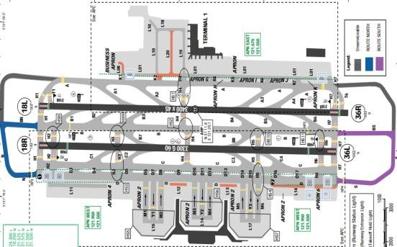
The airport is located near the town of Hongqiao in Changning District and Minhang District, 13 kilometres (8.1 mi) west of downtown, and is closer to the city center than the area's primary international airport, Shanghai Pudong. The surrounding terrain is quite flat. Shanghai has a subtropical maritime monsoon climate with 4 distinct seasons. Overall, Shanghai WX is mild and moist with low level of clouds year round. August and September typhoon can bring heavy rain in their wake.
Departure |  |  | - RWY 18R/ 36L are mainly for departure.  - RWY 18L/ 36R could be used for departure by ATC clearance.  - Conventional and RNAV SIDs.  - Require minimum climb gradients.  - Noise abatement procedure.
Arrival and Approach |  |  | - Conventional and RNAV STARs.  - HUD special CAT II is available for RWY 36R
Taxi |  |  | - Shall fully vacate RWY within 50s after touchdown via first or second rapid exit taxiway, if unable inform ATC  - Taxi routes for arrival RWY 18L/ 36R  - LVP taxi routes  - Turns of more than 90° on RWY or TWY are forbidden
Parking information |  |  | No
5. TAKE-OFF AND LANDING DISTANCES AVAILABLE
RWY | LENGTH  (m) |  |  | WIDTH  (m) |  |  | TORA  (m) |  |  | LDA  (m) | TODA  (m) |  | ASDA  (m)
18L/ 36R | 3400 |  |  | 58 |  |  | 3300 |  |  | 3200 | 3300 |  | 3300
18R/ 36L | 3300 |  |  | 60 |  |  | 3150 |  |  | 2850 | 3210 |  | 3210
6. ELEVATION: 10ft |  |  |  |  | 7. EOSID: NO
8. IAP: ILS (CAT I, II*), LOC, VOR
9. COMPANY NOTE |  |  |  |  | - Birds  - ACFT parking on boarding bridge stands shall turn off APU and use of bridge equipment.  - This airport is alternate for PVG.  - Contact to PVG representative or OCC if support required.  - All altitudes are given in meters.  - Expect rapid changes in altitudes, headings and frequencies during arrivals and departures.  - ATC communications can be easily misunderstood, especially numbers. Extra vigilance in monitoring radio frequencies is required. Use standard phraseology as accurately as possible.
10. REMARK |  |  |  |  | NIL
*Note: CAT II, approval require

ZSWX/ WUX – SUNAN SHUOFANG INTL AIRPORT – WUXI, CHINA
1. AIRPORT CATEGORY: A |  |  |  |  |  |  |  | 2. RFFS CATEGORY: 8
3. AIRPORT CLASSIFICATION
ATR |  | A320 |  |  |  | A321 |  |  | A350 |  |  | B787
ADQ |  | ADQ |  |  |  | ADQ |  |  | ADQ |  |  | ADQ
4. GENERAL STANDARDS
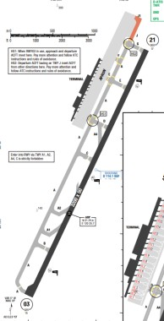
Sunan Shuofang International Airport is an airport serving the cities of Wuxi and Suzhou in southern Jiangsu Province, China. It is located in Shuofang Subdistrict, 12 kilometres (7.5 mi) southeast of Wuxi and 22 km (14 mi) northwest of Suzhou. The climate here is mild, and generally warm and temperate. There is significant rainfall throughout the year in Suzhou. Even the driest month still has a lot of rainfall. The climate here is classified as Cfa by the Köppen-Geiger system. The average annual temperature is 16.8 °C | 62.2 °F in Suzhou. Precipitation here is about 1461 mm |57.5 inch per year.
Departure |  |  | - Conventional and RNAV SIDs.  - Require minimum climb gradients.
Arrival and Approach |  |  | - Conventional and RNAV STARs.  - Due to no radar, all arrival aircraft from SASAN, EKIMU shall report to TOWER at least 30 min before flying across SASAN, EKIMU. If the difference between actual time and the first reported time is more than 1 min (including 1min), pilot shall report TWR again. If the transponder code is changed after the first location reporting, pilot shall report TWR controller.
Taxi |  |  | - Enter RWY via TWY C is strictly forbidden.  - Taxiing with braking is strictly forbidden.  - 1800 turns are strictly forbidden except on RWY turnpads.  - ACFT shall close cabin sun visor all the time while taxiing.
Parking information |  |  | No
5. TAKE-OFF AND LANDING DISTANCES AVAILABLE
RWY | LENGTH  (m) |  |  | WIDTH  (m) |  |  | TORA  (m) |  |  | LDA  (m) | TODA  (m) |  | ASDA  (m)
03/ 21 | 3200 |  |  | 50 |  |  | 3200 |  |  | 3200 | 3200 |  | 3200
6. ELEVATION: 17ft |  |  |  |  | 7. EOSID: YES
8. IAP: ILS, LOC, VOR
9. COMPANY NOTE |  |  |  |  | - AD not available for overnight business FLT except emergency  - Activities of bird flocks are found all the year in the vicinity of aerodrome
10. REMARK |  |  |  |  | NIL

ZUCK/ CKG - CHONGQING (JIANGBEI) – CHINA
- AIRPORT CATEGORY: A |  |  |  |  |  |  | - RFFS CATEGORY: 9
- AIRPORT CLASSIFICATION
ATR |  | A320 |  | A321 |  |  | A350 |  | B787
ADQ |  | ADQ |  | ADQ |  |  | ADQ |  | ADQ
4. GENERAL STANDARDS
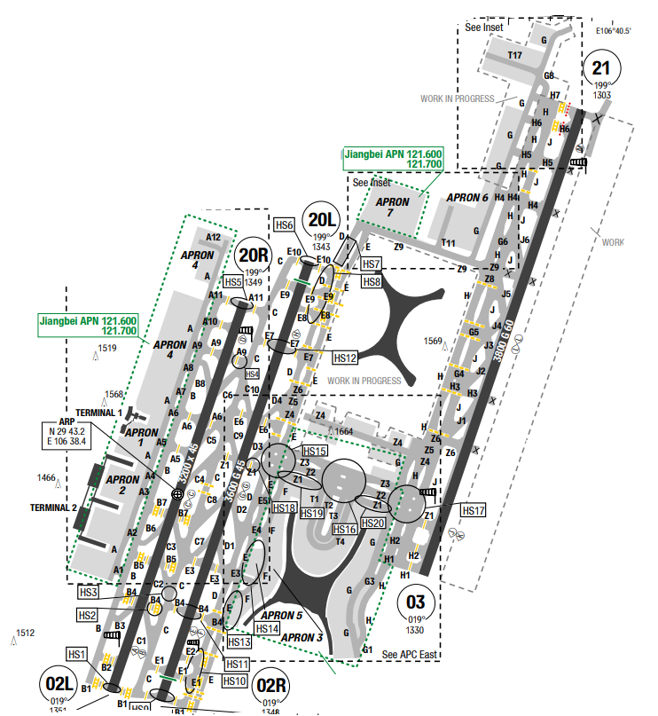
Chongqing Jiangbei International Airport is an airport located in the Yubei District of Chongqing, China. Located 21 km north of the city-centre of Chongqing. Chongqing has a monsoon-influenced humid subtropical climate, and for most of the year experiences very humid conditions. Known as one of the "Three Furnaces" of the Yangtze River, along with Wuhan and Nanjing, its summers are long and among the hottest and most humid in China, with highs of 33 to 34 °C in July and August in the urban area. Winters are short and somewhat mild, but damp and overcast.
Departure |  |  | - Conventional and RNAV SIDs.  - Noise abatement procedure  - Departure shall report RWY designator at first contact with ATC
Arrival and Approach |  |  | - Conventional and RNAV STARs
Taxi |  |  | - Shall fully vacte within 50s after touchdown; cross 42s after clearance; finish alignment within 60s.  - Taxi procedures  - Multiple runway incursion hot spots are identified  and illustrated on the chart
Parking information |  |  | - Follow-me mandatory on APN except parking on stands
5. TAKE-OFF AND LANDING DISTANCES AVAILABLE
RWY | LENGTH  (m) |  |  | WIDTH  (m) |  | TORA  (m) |  | LDA  (m) |  | TODA  (m) | ASDA  (m)
02L/ 20R | 3200 |  |  | 45 |  | 3200 |  | 3200 |  | 3200 | 3200
02R/ 20L | 3600 |  |  | 45 |  | 3600 |  | 3400 |  | 3600 | 3600
03/ 21 | 3800 |  |  | 60 |  | 3800 |  | 3800 |  | 3800 | 3800
6. ELEVATION: 1364ft |  |  |  |  | 7. EOSID: NO
8. IAP: ILS (CAT I, II), LOC, VOR
9. COMPANY NOTE |  |  |  |  | - Birds
10. REMARK |  |  |  |  | NIL

ZUGY/ KWE – LONGDONGBAO – GUIYANGI – CHINA
- AIRPORT CATEGORY: A |  |  |  |  |  |  | - RFFS CATEGORY: 9
- AIRPORT CLASSIFICATION
ATR |  | A320 |  | A321 |  |  | A350 |  | B787
ADQ |  | ADQ |  | ADQ |  |  | ADQ |  | ADQ
4. GENERAL STANDARDS
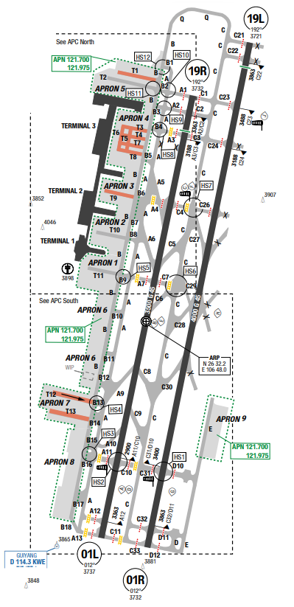
Guiyang Longdongbao International Airport (IATA: KWE, ICAO: ZUGY) is an international airport serving Guiyang, the capital of Southwest China’s Guizhou province. Guiyang Longdongbao Airport was opened on 28 May 1997 and adopted its current name on 19 January 2006. It is located 11 km (6.8 mi) southeast from Guiyang's city center. Sharing the subtropics moist temperate climate, Guiyang has pleasant weather with no intense heat in summer or much cold in winter. It has the annual temperature of 15.3°C. July is the hottest month of the year with a temperature of 24°C averagely, while January is the coldest month with average temperature is 4.6°C.
Departure |  |  | - CAT II precision approcah and landing: 300m≤RVR＜550m, 30m≤Ceiling or vertical VIS＜60m.  - Low visibility take-off:  + Aircraft CAT A/ B/ C: 200m≤Touchdown RVR＜400m, + Aircraft CAT D: 250m≤Touchdown RVR＜400m.  - Low visibility take-off available for all RWYs, HUD low visibility take-off only available for RWY19R.
Arrival and Approach |  |  | - Circuit at 1650-1750m / 5413-5741ft for CAT C/ D ACFT, 1450-1550m / 4757-5085ft for CAT A/ B ACFT.
Taxi |  |  | - Leaving RWY 01R via TWY C29 prohibited.  - TWY T12 is only AVBL for ACFT taxiing from west to east.  - Wingspan limitation.
Parking information |  |  | - Forbid to use adjacent stand to make 180° turn or taxi back to TWY B by own PWR.  - Marshaller AVBL.
5. TAKE-OFF AND LANDING DISTANCES AVAILABLE
RWY | LENGTH  (m) |  |  | WIDTH  (m) |  | TORA  (m) |  | LDA  (m) |  | TODA  (m) | ASDA  (m)
01L | 3500 |  |  | 45 |  | 3500 |  | 3500 |  | 3500 | 3500
19R | 3500 |  |  | 45 |  | 3500 |  | 3200 |  | 3720 | 3500
01R | 4000 |  |  | 45 |  | 4000 |  | 4000 |  | 4000 | 4000
19L | 4000 |  |  | 45 |  | 4000 |  | 3800 |  | 4000 | 4000
6. ELEVATION: 3737ft |  |  |  |  | 7. EOSID: NO
8. IAP: ILS (CAT I, II), LOC, VOR
9. COMPANY NOTE |  |  |  |  | - Birds in vicinity of AD.
10. REMARK |  |  |  |  | NIL

ZUTF/ TFU –CHENGDU (CHENGDU TIANFU) – CHINA
- AIRPORT CATEGORY: A |  |  |  |  |  |  | - RFFS CATEGORY: 9
- AIRPORT CLASSIFICATION
ATR |  | A320 |  | A321 |  |  | A350 |  | B787
ADQ |  | ADQ |  | ADQ |  |  | ADQ |  | ADQ
4. GENERAL STANDARDS
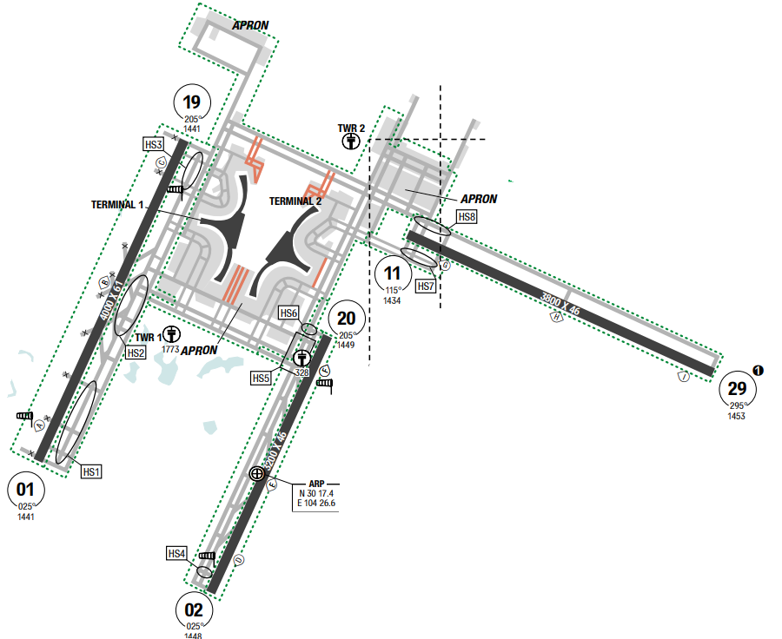
Chengdu Tianfu International Airport is one of the two international airports serving Chengdu, the capital of China's Sichuan province, the other one being Chengdu Shuangliu International Airport (CTU). Chengdu has a monsoon-influenced humid subtropical climate and is largely mild and humid. It has four distinct seasons, with moderate rainfall concentrated mainly in the warmer months, and relieved from both sweltering summers and freezing winters. The 24-hour daily mean temperature in January is 5.6 °C (42.1 °F), and snow is rare but there are a few periods of frost each winter. The summer is hot and humid. The 24-hour daily mean temperature in July and August is around 25 °C. Rainfall is common year-round but is the greatest in July and August, with very little of it in the cooler months.
Departure |  |  | - RWY 11 only used for take-off from West to East  - Conventional and RNAV SIDs.
Arrival and Approach |  |  | - Conventional and RNAV STARs.  - Speed restrictions (strictly follow)
Taxi |  |  | - Shall begin take-off run within 10s after aligning with RWY centerline and receiving take-off clearance.  - Listen carefully and repeat the taxiing instructions of ATC, verify any questions in time  - Taxi routes for departure and arrival.  - During conducting LVP, aerodrome can provide  Follow-me vehicle guidance according to the  agreement with airlines; otherwise, paid guidance  shall be provided for ACFTs on demand.
Parking information |  |  | - The stands nearby the terminal are equipped with VDGS. Marshaller guidance is available for remote stands.  - Follow-me available
5. TAKE-OFF AND LANDING DISTANCES AVAILABLE
RWY | LENGTH  (m) |  |  | WIDTH  (m) |  | TORA  (m) |  | LDA  (m) |  | TODA  (m) | ASDA  (m)
01/ 19 | 4000 |  |  | 60 |  | 4000 |  | 4000 |  | 4000 | 4000
02/ 20 | 3200 |  |  | 45 |  | 3200 |  | 3200 |  | 3200 | 3200
11 | 3800 |  |  | 45 |  | 3800 |  | 3800 |  | 3800 | 3800
29 | 3800 |  |  | 45 |  | 3800 |  | 3800 |  | 3800 | 3800
6. ELEVATION: 1452ft |  |  |  |  | 7. EOSID: NO
8. IAP: ILS (CAT I, II, III), LOC
9. COMPANY NOTE |  |  |  |  | - Birds in vicinity of AD.  - Birds
10. REMARK |  |  |  |  | NIL

ZUUU/ CTU – CHENGDU (SHUANGLIU) – CHINA
- AIRPORT CATEGORY: A |  |  |  |  |  |  | - RFFS CATEGORY: 9
- AIRPORT CLASSIFICATION
ATR |  | A320 |  | A321 |  |  | A350 |  | B787
ADQ |  | ADQ |  | ADQ |  |  | ADQ |  | ADQ
4. GENERAL STANDARDS
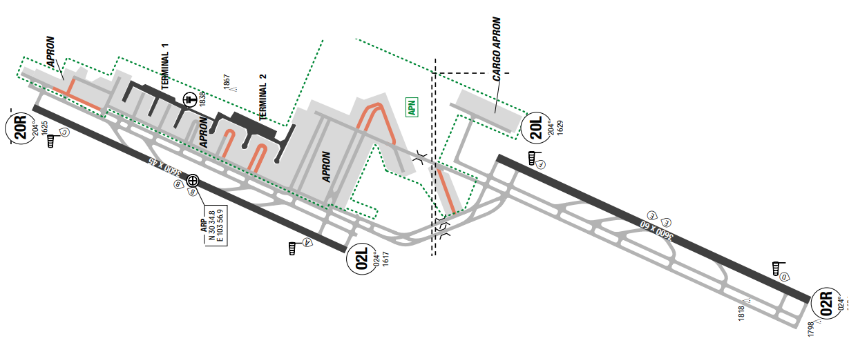
Chengdu Shuangliu International Airport is the major international airport serving Chengdu, China. Located about 16 kilometres (10 mi) southwest of downtown Chengdu to the north of Shuangliu County. Chengdu has a monsoon-influenced humid subtropical climate and is largely mild and humid. It has four distinct seasons, with moderate rainfall concentrated mainly in the warmer months, and relieved from both sweltering summers and freezing winters. The 24-hour daily mean temperature in January is 5.6 °C (42.1 °F), and snow is rare but there are a few periods of frost each winter. The summer is hot and humid. The 24-hour daily mean temperature in July and August is around 25 °C. Rainfall is common year-round but is the greatest in July and August, with very little of it in the cooler months.
Departure |  |  | - Conventional and RNAV SIDs.  - Noise abatement procedure (NADP1)  - When departing from RWY 02L, deviation to the  West of the upwind course is forbidden without ATC permission.
Arrival and Approach |  |  | - Conventional and RNAV STARs.  - Expect RWY02R/ 20R.  - Radar vector for approach can also be expected after FJC.  - When approach RWY 02L/ 20R, deviation to West of final APCH course is forbidden without ATC permission.
Taxi |  |  | - Standard taxi routes  - Taxi restrictions  - Long taxi route to the apron (around 10km)  - Multiple Runway Incursion Hot Spots are identified and illustrated on the chart.
Parking information |  |  | - Expect parking 31x (sometimes 10x)
5. TAKE-OFF AND LANDING DISTANCES AVAILABLE
RWY | LENGTH  (m) |  |  | WIDTH  (m) |  | TORA  (m) |  | LDA  (m) |  | TODA  (m) | ASDA  (m)
02L | 3600 |  |  | 45 |  | 3600 |  | 3600 |  | 3200 | 3200
02R | 3600 |  |  | 60 |  | 3600 |  | 3600 |  | 3600 | 3600
20L | 3600 |  |  | 60 |  | 3600 |  | 3600 |  | 3800 | 3800
20R | 3600 |  |  | 45 |  | 3600 |  | 3600 |  | 3600 | 3600
6. ELEVATION: 1681ft |  |  |  |  | 7. EOSID: NO
8. IAP: ILS (CAT I, II), LOC, VOR
9. COMPANY NOTE |  |  |  |  | - Standard push back directions  - Wake turbulence Re-Categorization (RECAT-CN)  - Laser bird dispersal equipment available transmitting green light, exercise caution during takeoff and landing
10. REMARK |  |  |  |  | NIL

ZWWW/ URC – URUMQI (DIWOPU) – CHINA
- AIRPORT CATEGORY: A |  |  |  |  |  |  | - RFFS CATEGORY: 9
- AIRPORT CLASSIFICATION
ATR |  | A320 |  | A321 |  |  | A350 |  | B787
ADQ |  | ADQ |  | ADQ |  |  | ADQ |  | ADQ
4. GENERAL STANDARDS
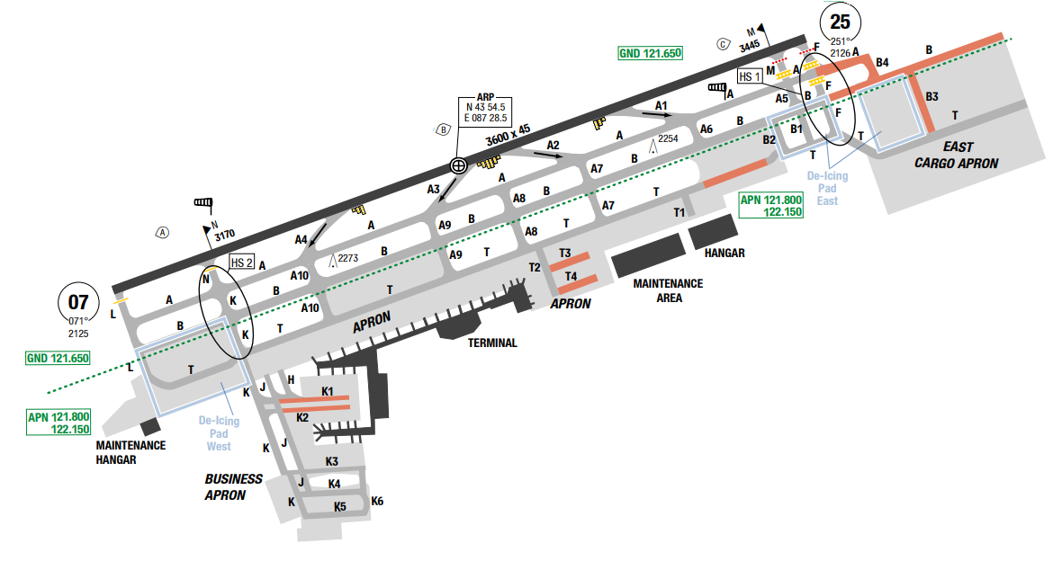
Diwopu Airport is located on the southern edge of Dzungarian Basin. The airport is at the foot of Tian Shan's northern slopes. High steep mountains, beginning within 7 NM, are in the southern quadrants. To the southeast, terrain rises from 4000 feet MSL within 13 NM, to above 12,000 feet MS within 27 NM. To the southwest, terrain rises to 4000 feet MS within 10 NM. To the west, mountains rise to more than 17,000 feet within 38 NM. A man-made structure at 2638 feet MSL is located east of the airport within 4 NM.
Departure |  |  | - There are speed restrictions for departure.  - SID with high climb gradient, Pilots need to briefing carefully before T/ O
Arrival and Approach |  |  | - RNAV STARs are available.  - There are airspeed restrictions for all instrument approach procedures.  - Circling to land is not authorized south of the runway.
Taxi |  |  | - Taxiway Restriction
Parking information |  |  | - Follow-me and towing AVBL via GND.  - Marshaller AVBL.
5. TAKE-OFF AND LANDING DISTANCES AVAILABLE
RWY | LENGTH  (m) |  |  | WIDTH  (m) |  | TORA  (m) |  | LDA  (m) |  | TODA  (m) | ASDA  (m)
07/ 25 | 3600 |  |  | 45 |  | 3600 |  | 3600 |  | 3800 | 3600
6. ELEVATION: 2126ft |  |  |  |  | 7. EOSID: YES
8. IAP: ILS (CAT I, II, III), LOC, VOR
9. COMPANY NOTE |  |  |  |  | - Moderate to severe turbulence caused by the chimneys located in vicinity of the airport may occur in this area.  - Birds are in the vicinity of the airport.
10. REMARK |  |  |  |  | NIL

ZYCC/ CGQ – LONGJIA (CHANGCHUN) – CHINA
- AIRPORT CATEGORY: A |  |  |  |  |  |  | - RFFS CATEGORY: 9
- AIRPORT CLASSIFICATION
ATR |  | A320 |  | A321 |  |  | A350 |  | B787
ADQ |  | ADQ |  | ADQ |  |  | ADQ |  | ADQ
4. GENERAL STANDARDS
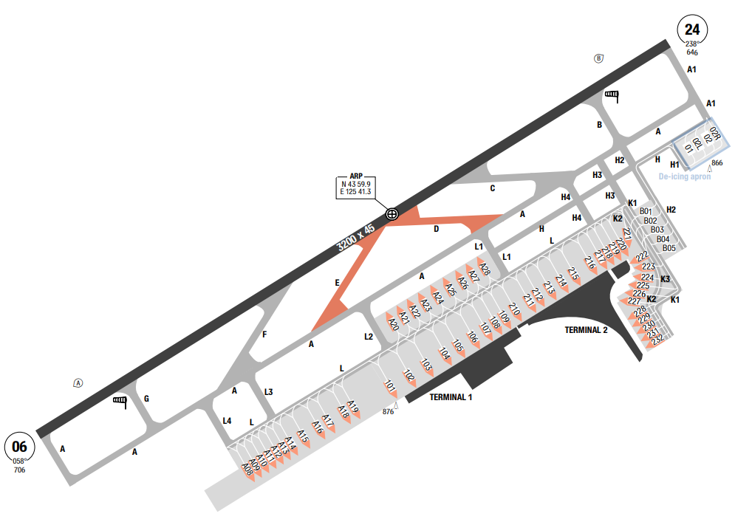
Longjia airport is located in the northeasern China, in the middle of the Manchurian Plain. A ridge of hills running SW to NE is about 5NM SE of the airport and rise between 1200~1800ft MSL. The Shitou Koumen Reservoir splits this ridge of hills, 4NM to the SE. Kalunhu a smaller reservoir rectangular in shape, is 6NM to the SW. The land surrounding the airport area is fairly level and consists mostly of cultivated fields. To the E – SE, terrain rises to 1631 feet MSL within 9NM.
Departure |  |  | - Conventional and RNAV SIDs.  - Require min climb gradients.
Arrival and Approach |  |  | - Conventional and RNAV STARs.  - ATC permission required for CDO. CDO time between 2200-0600LCT and is terminated once ATC gives heading instruction.
Taxi |  |  | - Twy C and F restricted to aircraft with wingspan up to 54.94m  - Twy D and E restricted to aircraft with wingspan less than 36m
Parking information |  |  | No
5. TAKE-OFF AND LANDING DISTANCES AVAILABLE
RWY | LENGTH  (m) |  |  | WIDTH  (m) |  | TORA  (m) |  | LDA  (m) |  | TODA  (m) | ASDA  (m)
06/ 24 | 3200 |  |  | 45 |  | 3200 |  | 3200 |  | 3200 | 3200
6. ELEVATION: 706ft |  |  |  |  | 7. EOSID: NO
8. IAP: ILS, LOC, NDB
9. COMPANY NOTE |  |  |  |  | - Birds are in the vicinity of the airport.
10. REMARK |  |  |  |  | NIL

ZYTL/ DLC - DALIAN (ZHOUSHUIZI) – CHINA
- AIRPORT CATEGORY: A |  |  |  |  |  |  | - RFFS CATEGORY: 9
- AIRPORT CLASSIFICATION
ATR |  | A320 |  | A321 |  |  | A350 |  | B787
ADQ |  | ADQ |  | ADQ |  |  | ADQ |  | ADQ
4. GENERAL STANDARDS
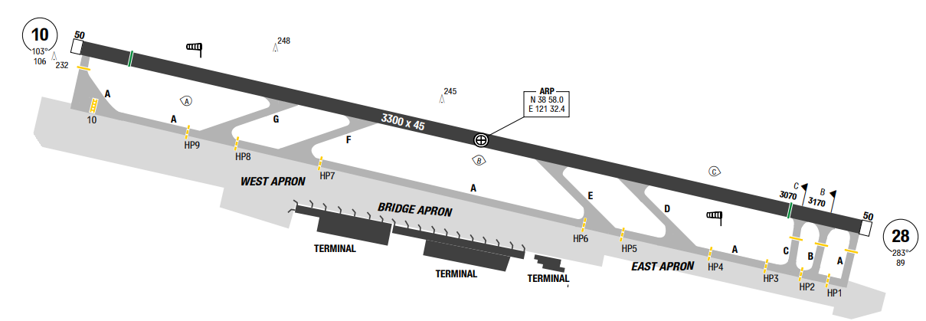
Dalian Zhoushuizi International Airport is located in Ganjingzi District, about 10 km (6 mi) northwest of the city centre.
Dalian has a monsoon-influenced humid continental climate, characterised by humid summers due to the East Asian monsoon, and cold, windy, dry winters that reflect the influence of the vast Siberian anticyclone. The monthly 24-hour average temperature ranges from −3.9 °C in January to 24.1 °C in August. Annual precipitation averages 602mm but is heavily concentrated in the summer months and can vary greatly from year to year.
Departure |  |  | - Conventional and RNAV SIDs.
Arrival and Approach |  |  | - Conventional and RNAV STARs.  - Papi RWY 10 is 3.3°  - Circuits can be made both side of the RWY
Taxi |  |  | - MAX speed for taxiing is 16KT.
Parking information |  |  | No
5. TAKE-OFF AND LANDING DISTANCES AVAILABLE
RWY | LENGTH  (m) |  |  | WIDTH  (m) |  | TORA  (m) |  | LDA  (m) |  | TODA  (m) | ASDA  (m)
10 | 3300 |  |  | 45 |  | 3300 |  | 3100 |  | 3300 | 3350
28 | 3300 |  |  | 45 |  | 3300 |  | 3000 |  | 3300 | 3350
6. ELEVATION: 107ft |  |  |  |  | 7. EOSID: NO
8. IAP: ILS, LOC, RNP, VOR
9. COMPANY NOTE |  |  |  |  | - Birds are in the vicinity of the airport.
10. REMARK |  |  |  |  | NIL

ZYTX/ SHE - SHENYANG (TAOXIAN INTL) – CHINA
- AIRPORT CATEGORY: A |  |  |  |  |  |  | - RFFS CATEGORY: 9
- AIRPORT CLASSIFICATION
ATR |  | A320 |  | A321 |  |  | A350 |  | B787
ADQ |  | ADQ |  | ADQ |  |  | ADQ |  | ADQ
4. GENERAL STANDARDS
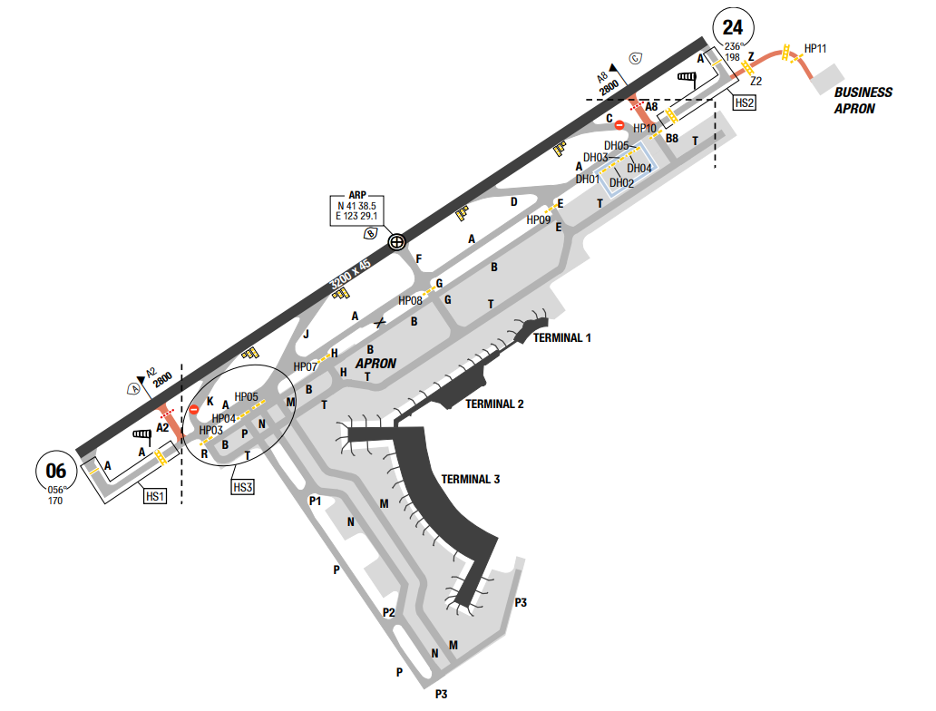
Taoxian Airport is located in northeastern China. This area is at the southern end of the Manchurian Plain, about 85 NM northeast of Liaodong Bay. The Qian Mountains, which are oriented southwest to northeast and contain peaks varying between 2500 and 4000 feet MSL, begin about 10 NM east of the airport.
Annual precipitation totals 72 cm. Winds are from the south-southwest in September.
Obstruction to visibility averages 12 days per month. Fog averages 9 days per month throughout the year, while the highest incidences of blowing dust and sand are reported from March through May, averaging 4 days per month. Broken ceiling is the predominant sky condition from May through August.
Departure |  |  | - Shall inform ATC before crossing holding position if occupying the RWY more than 1 min.  - Conventional and RNAV SIDs.  - Leave TWR without instruction, state SID designator
Arrival and Approach |  |  | - Conventional and RNAV STARs.  - Airspeed restrictions for all instrument approach procedures
Taxi |  |  | - RWY 24 in use: ACFT cannot vacate TWY A via TWY M and N.  - RWY 06 in use: Landing ACFT shall taxi into apron of Terminal 1, 2 and 3 via TWY E and G.  - Taxi restrictions  - 180° turns on asphalt surfaces prohibited.
Parking information |  |  | - HLDG points (HP03, HP05-HP11, DH01-DH05 are compulsory report points, flight crew shall report position when approach to these points.
5. TAKE-OFF AND LANDING DISTANCES AVAILABLE
RWY | LENGTH  (m) |  |  | WIDTH  (m) |  | TORA  (m) |  | LDA  (m) |  | TODA  (m) | ASDA  (m)
06 | 3200 |  |  | 45 |  | 3200 |  | 3200 |  | 3200 | 3200
24 | 3200 |  |  | 45 |  | 3200 |  | 3200 |  | 3200 | 3200
6. ELEVATION: 198ft |  |  |  |  | 7. EOSID: NO
8. IAP: ILS, LOC, VOR
9. COMPANY NOTE |  |  |  |  | - Birds are in the vicinity of the airport.
10. REMARK |  |  |  |  | NIL

AIRPORT FACILITIES
For each airport’s facilities, please refer to LIDO Route Manual related AFC (Airport facilities chart)

WEATHER MINIMA
4.2.3.1. General concept
Please refer to FOM 8.1.3
4.2.3.1. Weather minima for take-off and landing
- T/ O: Please refer to LIDO AOI Chart for each related airport, Weather minima section.
- Landing: Refer to LIDO IAC Chart

LOW VISIBILITY OPERATION
4.2.4.1 General Concept
- Please refer to FOM 8.4.5
4.2.4.2 Low visibility procedure (LVP)
- For low visibility procedure (LVP), please refer to LIDO AOI Chart for each related airport, LVP section.
4.2.4.3. CAT II/ III Approval Airport List
- All data below are approved by Civil Aviation Authority (CAA).
- Crew must compare AOC OPSPEC Minima with approach chart minima and the higher value must be used.

Country | Available Airport
Austria, Belgium, Bulgaria, Croatia, Cyprus, Czechia, Denmark, Estonia, Finland, France, Germany, Greece, Hungary, Iceland, Ireland, Italy, Latvia, Liechtenstein, Lithuania, Luxembourg, Malta, Netherlands, Norway, Poland, Portugal, Romania, Slovakia, Slovenia, Spain, Sweden, Switzerland | All (TCO  members)
Armenia | UDYZ
Australia | YMML, YSSY, YPPH, YSCB
Azerbaijan | UBBB
Bahrain | OBBI
Belarus | All
China | ZBTJ, ZGHA, ZGNN, ZHCC, ZHHH, ZPPP, ZSHC, ZSNJ, ZSSS, ZUCK, ZUGY, ZUUU, ZLXY, ZUTF,  ZBAA, ZWWW, ZBAD, ZSPD, ZLIC
Canada | CYVR
Cambodia | VDTI
Egypt | All
Hongkong | VHHH
India | All
Iran | All
Japan | All
Kazakhstan | UAAA, UACC
Korea | All
Kyrgyzstan | All
Macau | VMMC
Pakistan | All
Qatar | OTHH
Russia | All
Saudi Arab | All
Serbia | LYBE
Singapore | WSSS
Taiwan | RCTP
Thailand | All
Turkey | All
Turkmenistan | All
UAE | All
United Kingdom | All
Uzbekistan | All
Vietnam | VVNB

- All data below are approved by Civil Aviation Authority (CAA).
- Crew must compare AOC OPSPEC Minima with approach chart minima and the higher value must be used.

Country | Available Airport | CAT II | CAT IIIA | CAT IIIB
U.S.A | All (Except KCVG, KDEN, KPIT,  KSEA, KCLE, KEWR and KBNA) | 100’- 350m | 50’ - 175m | 30’ – 75m

NARROW RUNWAYS
NIL.

TERMINAL CHARTS
- LIDO Chart structure
- LIDO Terminal Charts are structured as below:

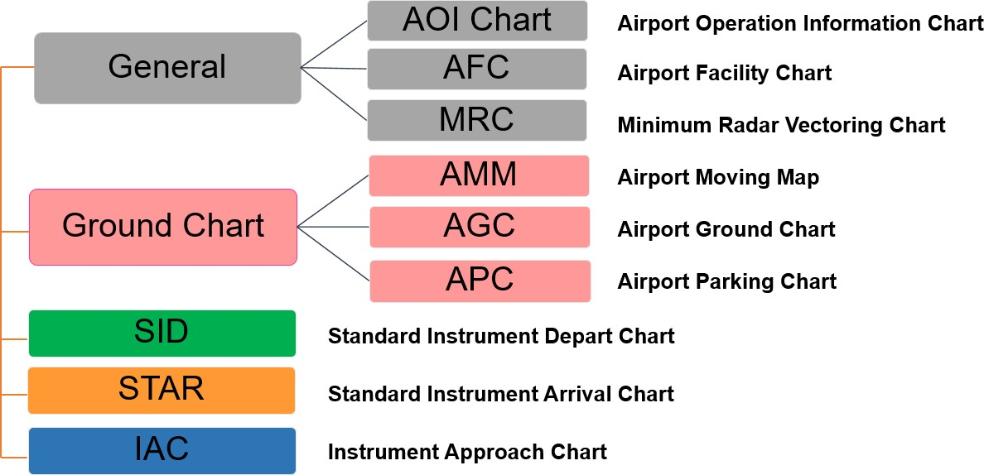


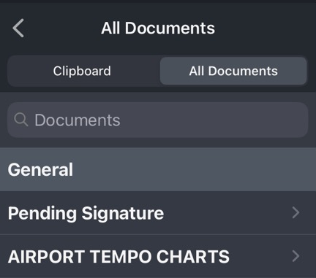
- For more instruction details, refer to LIDO eRoute Manual - Chapter 1.1.3. The Lido Route Manual Structure

- Sample chart view

- AOI Chart: | - AFC:
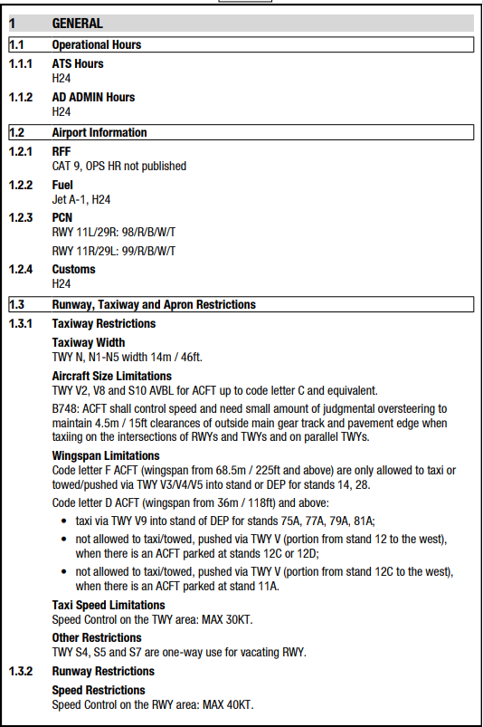 | 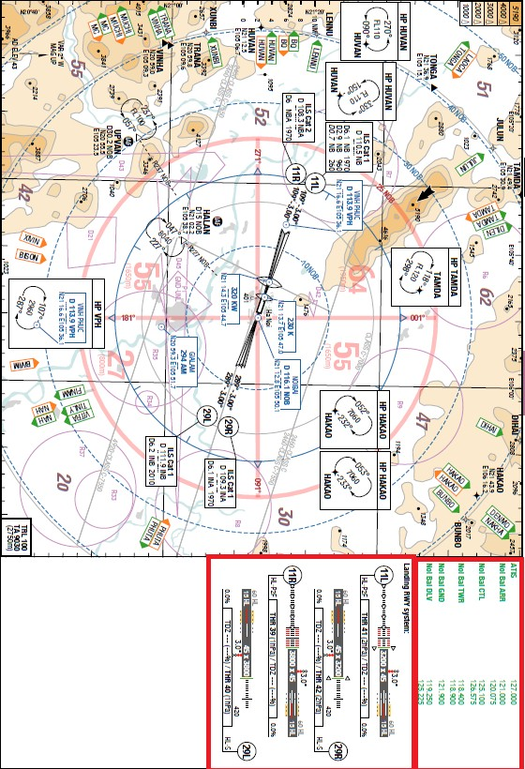

- MRC: | - AMM:
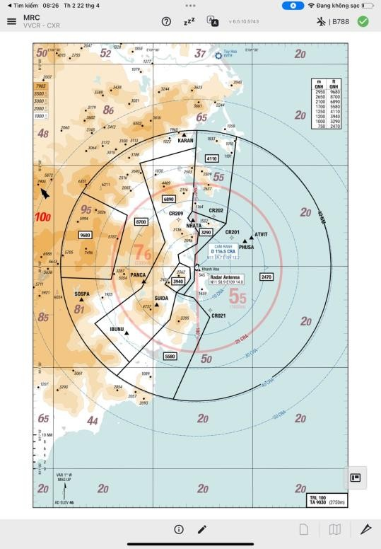 | 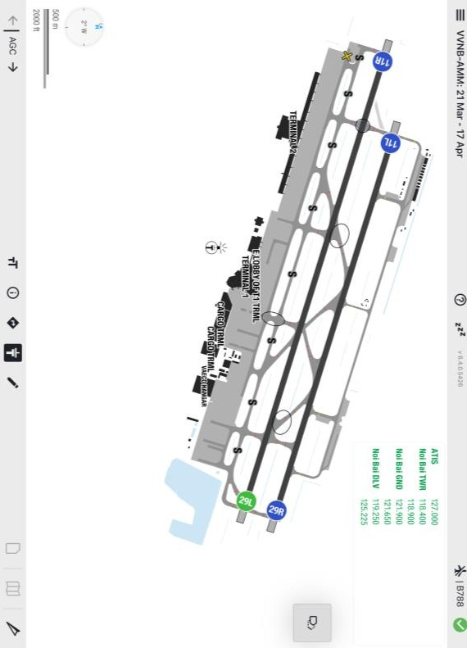

- AGC: | - APC:
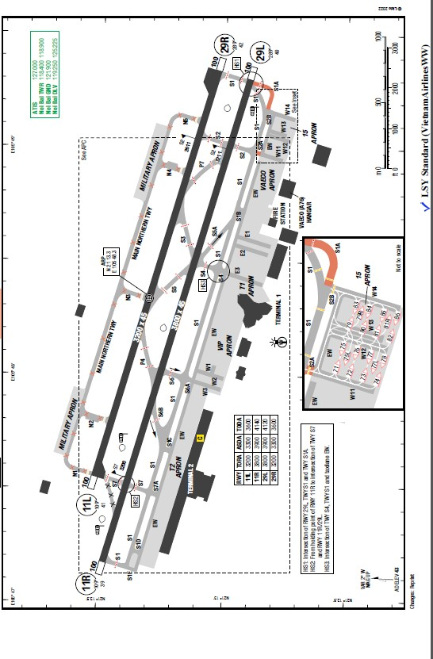 | 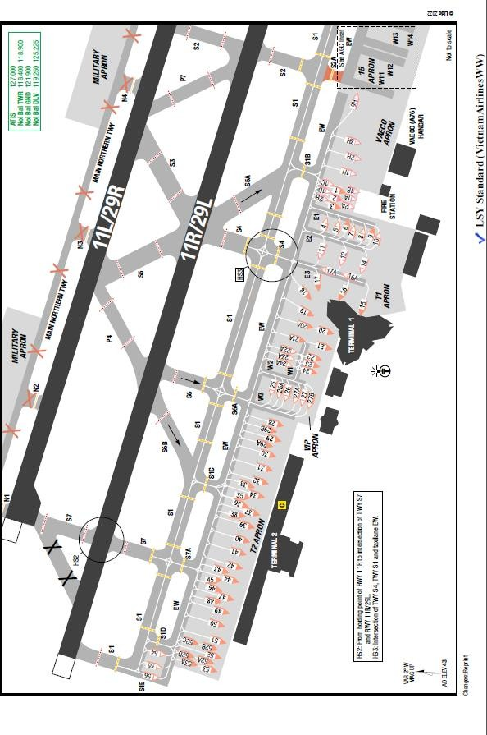

- SID: | - STAR:
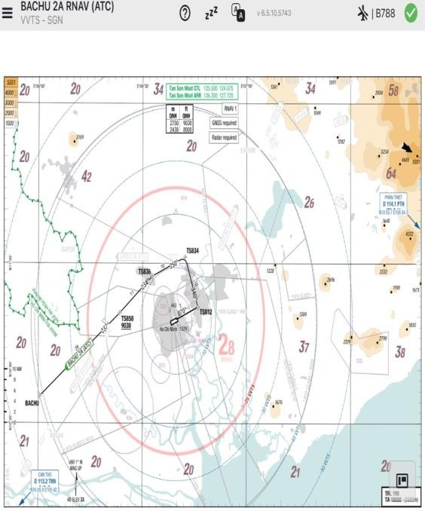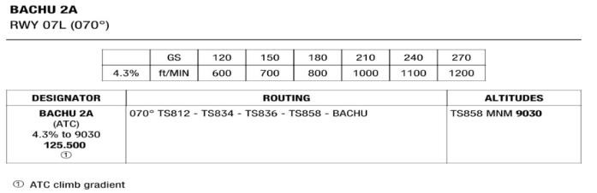 | 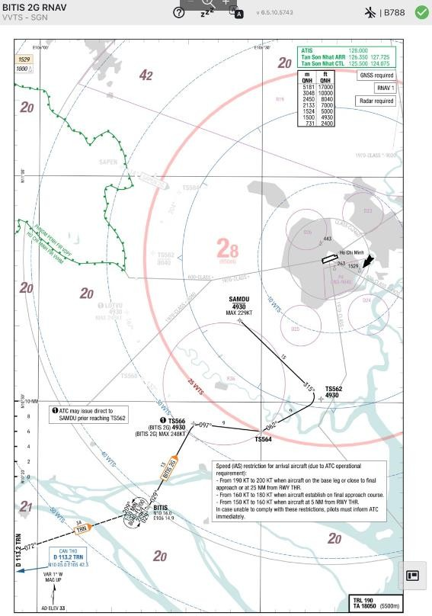

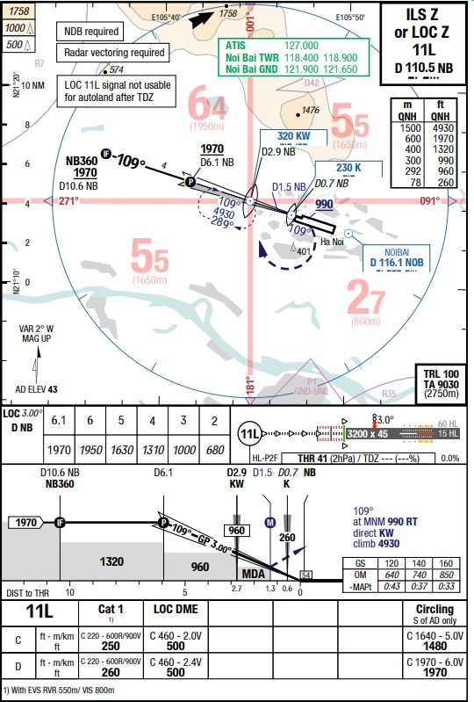
- IAC:

